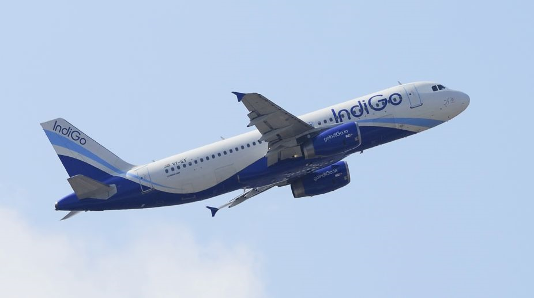

Offer Engine
Solution Design Document
Version:v1.0

Document Information
Project Name:
Prepared By: |  | Document Version No:
Title: |  | Document Version Date:
Reviewed By: |  | Review Date:
Distribution List
Name | Email | Role

*
Document Version History
Version  Number | Version  Date | Revised By | Description | Filename

1. Introduction 5
1.1. Purpose 5
1.2. Scope 5
1.3. Definitions, Acronyms and Abbreviations 5
1.4. Summary of Existing Functionality 5
1.5. Requirement Details 5
1.6. Reference Documents 5
2. Business Architecture: Capability Map 6
2.1. Capability Map: Level 1 6
2.2. Capability Map: Level 2 7
2.3. Application Impacted 9
3. GENERAL OVERVIEW AND DESIGN GUIDELINES/APPROACH 12
3.1. ASSUMPTIONS / CONSTRAINTS / STANDARDS 12
3.2. ALIGNMENT WITH TARGET ARCHITECTURE 12
4. Current Architecture design 12
4.1. Current Application business capability 12
4.2. Current application Architecture 12
5. Proposed Architecture Design 12
5.1. Impact Analysis 13
5.2. High Level Designs 13
5.3. Low Level Design 14
UI Screen 14
API URL Request and Response format 15
HTTP Request HTTP Response 15
5.4. Database Design 15
5.5. System Integration Design 19
5.5.1. External Interfaces 19
5.5.2. Internal Interfaces 19
5.6. Security Design 19
5.7. Deployment Design 19
5.8. Tech Stack 19
6. Non-Functional Requirements 21
6.1. Archiving 21
6.2. Logging 21
6.3. Auditing 21
6.4. Scalability 21
6.5. Fault Tolerance 21
6.6. Performance 21
6.7. System Management and Monitoring 21
6.8. User Role and access Management 21
7. Risk and Mitigation 21
8. Appendices 21

Introduction
As we know our organization is planning to implement a loyalty system aimed at enhancing customer engagement and retention. This initiative has been designed to improve customer base of IndiGo website, foster long-term relationships, and increase customer loyalty.

Loyalty members will be entitled for discounted fare on IndiGo website and app, this feature of loyalty program create a need of a software/module or service for discount offering.

According to organization strategy, discount offering shall be based on forecasted load factor of flight and number of days of prior booking from travelling date.

Fortunately, forecasted load and other information require for discount offering, is already available in RM system, hence it is possible and make sense to develop inhouse service.

Loyalty program will add additional responsibility on flight search micro service of Skyplus. Currently flight search MS gets information from Navitaire API but after incorporating the requirement of loyalty program, it has to get discount detail from discount service (offer engine) and member detail such as balance points from loyalty service. Hence these two additional integration point may degrade the performance of flight search on website and app. This concern is triggering us to think about introducing caching for fight search result.

Purpose
Purpose of this document is to outline the approach to offer engine design and the caching strategy for flight search MS.

It aims to provide a detailed framework for the system’s architecture, ensuring efficient performance and scalability. Additionally, the document outline caching mechanisms to be employed to optimize the retrieval and display flight search data.

Scope

In scope

This section defines the scope of offer engine in terms of both business and technical capabilities. It also defines the responsibilities of each relevant module/service.

The solution design comprises following three applications.

- Skyplus (existing)
- Revenue management system (existing)
- Offer engine service (new)

All the business capabilities of discount offering including are already implemented by RMS and offering information is stored in database.

Offering engine service will be responsibly to copy discount offering data from RM system to its local DB and expose it through API and maintains performance, high availability, historical data, data purging and logs and auditing detail.

Skyplus will be responsible to implement caching mechanism.

Out of scope

UI capabilities to manage discounts and configurable data.

Any business rule, validation of data, discount code are out of scope for offer engine service. Offer engine completely dependent on data in RMS database.

Any report or analytics

Discount based on loyalty member’s profile.

Discount based on season, holiday etc.

Definitions, Acronyms and Abbreviations

Summary of Existing Functionality
Loyalty Engine is a new feature which is going to be implemented in Indigo to provide offers based on the customer bookings with number of days of prior booking and travelling class, Engine will determine the discount fare based on the selection criteria.

Requirement Details
Offer Engine should provide the discount % to customers for their booking tickets based on their selection criteria such as travelling date, flight details and the travelling class. Engine should have the intelligence to calculate the discount %.

Reference Documents
S.NO | Description | Provided By
1 | Offer Engine PRD ver2.0 | Inform
2 | Indigo Technology Sta | Inform

Business Architecture: Capability Map

Capability Map: Level 1

Please highlight the applicable capability that will be enhanced by application.
Customer Engagement

Customer Interaction Experience Management (Channels)

Order Management
Marketing
Customer Lifecycle management
Airport Experience Management
Inflight Experience Management
Loyalty Management
Offer Management
Customer Service & Issue resolution

Sales

Customer Service Delivery
Cargo Management
Network Management
Fleet Management
Marketplace Management
Crew Management
Baggage Management
Operations & Dispatch Management
Health & Safety management

External Relationship & Communications
Legal, Regulatory, Risk & Compliance
Strategy & Business Management
IT Management
Procurement & 3rd Party Management
HR Management
Financial management
Corporate Enablers

Capability Map: Level 2
New
Existing
Please highlight the applicable capability as per following text: csscd (New: New application in capability, Existing: Change in existing capability area)
Customer Engagement
Customer Interaction Management (Channels)

Mobile
Web
Agent
Kiosk
Social
Chat
Sensors
EDI
Channel Planning
Channel Performance Management
Brand Management
Marketing
Campaign Management
Sales
Sales Planning
Customer Relations
Airport Experience Management
Group Booking
Payment management
Booking
Pricing
Order Management
Check in Management
Lounge Management
Customer Special Needs Management
Departure Gate Management
Arrival Baggage Area Management
Passenger Connection management
Inflight F&B, commerce
Inflight Entertainment
Inflight Experience management
Loyalty planning
Rewards
Redemption
Loyalty Management
Customer Lifecycle management
Offer Management
Yield management
Product management
Fare management
Revenue management

Account management

Customer Onboarding

Customer 360-degree view

Customer Service Management
Issue Resolution
Case Management
Service Agent Management
Customer Service Delivery

Network Management
Fleet Management
Crew Management
Operations & Dispatch Management
Health & Safety management
Inflight Operations
Schedule Management
Inventory Management
Codeshare & Partnerships
Fleet maintenance/
engineering
Fleet planning
Fleet Acquisition
Crew Training
Crew Planning
Crew Rostering
Operations control
Crew Operations
Ground dispatch service
Route Planning
Crew Health
Flight Safety
Fuelling
Load Control
Cleaning
Ramp operations
Asset management
Air dispatch service
Partner Management
Airport Relations Management
Emergency Management
Day of Operations Management
Manpower Planning & Roster
Ground Support Equipment Management
Baggage Management
Baggage Check-in
Baggage Transport
Baggage Release
Baggage Tracking
Baggage Exceptions
Baggage Screening
Cargo Management
Marketplace Management
Cargo Forwarding
Cargo Transport
Cargo Warehousing
Cargo Tracking
Seller management
Commission Management
Supply chain integration
Cargo Capacity Planning
PO Management
Ground Operations

Corporate Enablers
External Relationship & Communications
Strategy & Business Management
Legal, Regulatory, Risk & Compliance
Business Risk Management
Litigation Management
Contract Review Management
Fraud Management
IP Management
Privacy and Consumer Protection
Regulations/Legislation Management
Business change management
Transformation management
Business Performance management
Investment management
Demand management
Environment management
Facilities management
Research and Development
Market analysis
Innovation management
Customer 360 View & Insights
Strategy planning
Industrial Relations &
Public relations
Corporate social responsibility
Internal communications
Lobbying
External communications
IT Management
Procurement & 3rd Party Management
HR Management
Financial Management
Information management
Recruitment Management
Supplier / vendor
selection
Accounting & Financial reporting
Content management
Talent Management
Supplier / vendor contract mgmt
Payroll Management
Compensations & Benefits
Learning & Development
People Performance Management
Document management
Supplier / vendor relationship mgmt
Auditing

Information security mgmt.
Insurance Management
Supplier / vendor invoice management
Business intelligence & analytics
Treasury Management
Cultural Management
Purchase management
IT operations & service support
Inventory management
Knowledge management
End user computing provision

Infrastructure management

Application management

Application Impacted

- Capability refers to the Business capabilities defines ‘what’ IndiGo does to deliver outcomes required for achieving its Vision and Strategy. It is a combination of people, process, data and digital solutions) and it seamlessly orchestrate these components to deliver the required business outcomes.
- Area refers to the subset of business capability
- Application refers to the current application in the business capability area
- Application Impacted refers to the application that may impacted due to any change in existing application or deploying a new application in the business capability area. Possible values are Yes/No or blank
- Application Integration refers to the integration required by any application with other applications in the business capability area. Possible values will be Yes, No or blank
- Application Roadmap refers to the state of application. Possible values are New, Upgrade or Sunset.
- Application Type is COTS, SaaS or Custom

Core System | Application Source | L1-Business Capability | L-2 Business Capability | L-3 Business Capability | Application Integration | Application Roadmap | Application Impacted
AIMS | COTS | Customer Service Delivery | Crew Management | Crew Planning
NAVBLUE | COTS | Customer Service Delivery | Operations & Dispatch Management | Air/Flight Disptach service
HOTAC | In House | Customer Service Delivery | Crew Management | Crew Logistics
SITA Aircom | COTS | Customer Service Delivery | Operations & Dispatch Management | Operations Control
L&T | In House | Customer Service Delivery | Operations & Dispatch Management | Load Control
AMOS | COTS | Customer Service Delivery | Fleet Management | Fleet Maintenance/ Engineering
Navitaire
MCC MEL | In House | Customer Service Delivery | Fleet Management | Fleet Maintenance/ Engineering
UCG | In House | Customer Service Delivery | Operations & Dispatch Management | Operations Control
BRS | COTS | Customer Service Delivery | Baggage Management | Baggage Tracking
COPS | In-House | Customer Service Delivery | Airport Operations | Inflight F&B. Commerce
Jeppesen Ops Control | COTS | Customer Service Delivery | Operations & Dispatch Management | Operations Control
RMS | In House | Customer Engagement | Offer Management | Revenue Management | Y
AvioBook | COTS | Customer Service Delivery | Operations & Dispatch Management | Flight Dispatch
SmartKargo | COTS | Customer Service Delivery | Cargo Management | Cargo Operations
6ePort | In House | Customer Service Delivery | Operations & Dispatch Management | Load Control
Air Vision(Sabre) | COTS | Customer Service Delivery | Network Management | Route Planning
Inform | COTS | Customer Service Delivery | Operations & Dispatch Management | Ground Dispatch Service
Liquidice | COTS | Corporate Enablers | Financial Management | Treasury Management
PAX invoicing | In House | Corporate Enablers | Financial Management | Accounting and Financial Reporting
Crew Pal | In House | Customer Service Delivery | Operations & Dispatch Management | Crew Operations
MPOS (Catering App, Crew App) | In House | Customer Service Delivery | Operations & Dispatch Management | In-flight Operations
Crew Pass | In House | Customer Service Delivery | Operations & Dispatch Management | Crew Operations
Crew Portal | In House | Customer Service Delivery | Operations & Dispatch Management | Crew Operations
Staff Travel (SLT) | In House | Customer Engagement | Order Management | Booking
6e Breez | In House | Corporate Enablers | HR Management | People and Performance Management
SAP Success Factor (SAAS solution) | In House | Corporate Enablers | HR Management | People and Performance Management
CLMS | In House | Corporate Enablers | HR Management | People and Performance Management
SAP HANA | In House | Corporate Enablers | Financial Management | Accounting and Reporting
LMS | In House | Corporate Enablers | HR Management | Learning & Development
Salesforce | COTS | Customer Engagement | Customer Service Management | Case Management
WEFA | COTS | Customer Service Delivery | Health & Safety Management | Flight Safety
Group Booking | In House | Customer Engagement | Order Management | Group Booking
PAX Re-accommodation | In House | Customer Service Delivery | Operations & Dispatch Management | Day of Operation Management
BPM (New Gen) | COTS | Corporate Enablers | Strategy & Business Management | Business Performance management
IMS (Ideagen) | SaaS | Customer Service Delivery | Health & Safety Management | Audit
Comp port | In House | Corporate Enablers | HR Management | People and Performance Management
6EMyPay | In House | Corporate Enablers | HR Management | People and Performance Management
Agent Portal - New | In House | Customer Engagement | Sales | Customer Relations
6egems | In House | Customer Service Delivery | Airport Operations | Ground Support Equipment
Skywise | SaaS | Customer Service Delivery | Fleet Management | Fleet Planning
AGS | COTS | Customer Service Delivery | Health & Safety Management | Flight Safety
Codeshare | COTS | Customer Service Delivery | Network Management | Code share and Partnership
Iron Mountain | COTS | Corporate Enablers | IT Management | Document Management
Agent Portal - Old | In House | Customer Engagement | Sales | Customer Relations
EFB Control system | COTS | Customer Service Delivery | Operations & Dispatch Management | Asset Management
Skyplus | In-House | B2C | B2C |  | Y

GENERAL OVERVIEW AND DESIGN GUIDELINES/APPROACH

ASSUMPTIONS / CONSTRAINTS / STANDARDS
- Integration between Skyplus and offer engine will be API based and API contract will be finalized with mutual understanding of Skyplus and offer engine team.
- The Major Constraint in the current design is that the RM resides in Cloud platform, Querying the seat factor file from RM at periodic intervals is a challenge one.
- There will be no change in schema or data structure at RMS without mutual understanding of Skyplus and Offer engine service.
- RMS will provide data on time.

ALIGNMENT WITH TARGET ARCHITECTURE
Architecture is cloud agnostic and designed withing the boundary and guideline of IndiGo’s target architecture.

- Tech stack and DB has been chosen as per architecture guideline.

- Integration between Skyplus and offer engine through API.

- Proposed deployment platform is OCP.

- Code repository on Github

- Container based deployment through CICD

Current Architecture design

Current Application business capability
Offer engine is a new service.

Current application Architecture
Offer engine is a new service.

Proposed Architecture Design
In the proposed Architecture Offer Engine Service will be running individually in the same eco – system. During the ticket booking process parallel call will be triggered to Navigator System and to Offer Engine to get the discount details for the booking.

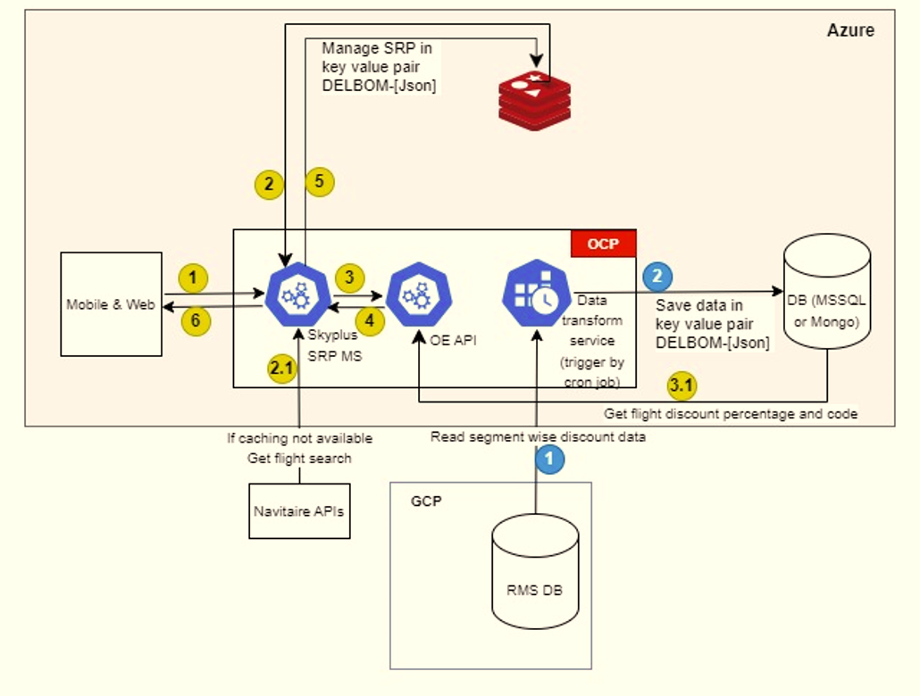

Above architecture encompasses the design of offer engine service and its integration with Skyplus.
Offer engine consists of three components.
- RMS DB – revenue management system compute discount at segment level basis on algorithms and store computed discount along with discount code in a table. This is data is core of offer engine.
- Cron job – a service which is responsible to copy data from discount table (RMS DB), transform it in key value format and store it in local DB. Service is triggered by Cron job on a certain time
- OE API - a API responsible to expose segment wise discount data
- Skyplus SRP MS – an microservice used in Skyplus for flight search.
Flow of offer engine complete in below 3 steps.
Step 1 – copy data from discount table (RMS DB)
Step 2 – transform data in memory using c# code and save it into local DB
Step 3 – expose data through API

Impact Analysis

Offer Engine will be integrated with Skyplus. Below diagram highlights the impact.

High Level Designs
Offer Engine requirements could be broadly classified in to following functional areas.
- Data Ingestion and Data store
- Data cache
- Cache Key Creator
- Discount calculation.
- API Component
- Final Offer Attribute Saver

Low Level Design
Data cache
Cache Key - The purpose is to keep a unique key that enables the fast retrieval from the cache.
Cache key format will be
<origin>|<destination>|<traveldate>|<bookingdate>
Cache key would be constructed at API end then it will be compared with the Redis cache table for fetching the details.
Format for the table of data cache is given below:
Cache Key | Discount | Seat Factor | NOD
DEL|LKO|20122024|30042024 | 20disc20 | 40F102 | 30

Cache Mechanism
- Redis cache will hold the same set of data as it from target table with cache key as the primary key for data retrieval. The Key helps to retrieve the data very Fast.
- When cache updates then it will lock the cache, query the database, and update the data after that unlock the cache. This process will take the minimal time.
- API call will be redirected to DB if Cache takes too long or failed to respond. It will add some latency, but user would get required data.
- For filling the data cache there would be a schedular job /window service run on a schedule time
- Service (API) component – The Rest APIs will be implemented to get the Seat factor and the discount percentage and discount code. Response will be constructed by splitting the columns of the cache table and returned in a JSON format.
- Exception handling and Error logging will be done at API level, all exception will log into the text file in memory.
- In application layer we use Enum to store the Seat_Factor_File_id , which will be used at the time of refreshing the cache.
UI Screen

- UI has been created for configuration of the Discount Matrix. All CRUD operations have been performed.

- Added UI for refresh the data cache, on click Refresh button, job has been triggered for fetching the latest data from target table.

- Once Refresh button clicked for data cache, it will query database target table and fetch data based on flag =”isEffective=Y” and “Seat_Factor_File_Id”.
The Seat_Factor_file_Id will be incremented by 1 in query to make sure that if any new set of records available in Target table.

If new Record available, then data cache will be refreshed by deleting the old data and update with new data. If the query returns empty it means there is no data, So Logger will be updated as “No New data to complete the Refresh operation”.

- UI can be access by Admin role only.

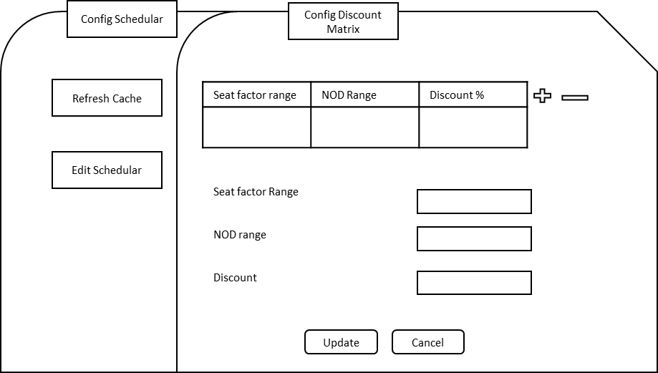

API URL Request and Response format for getting SeatFactor Data

HTTP Request format (HTTP GET)
{
“data”:{
"criteria": [
{
"stations": { // One Way
"originStationCodes": "DEL",
"destinationStationCodes": "PAT",
}
"travel date":"2022-06-24”,
"journeyReference": "DELHYD20240610T16456E171",
“datacollection”:[]
}
}

HTTP Response Format (HTTP POST)

{
"data": {
"trips": [
{
"origin": "DEL",
"destination": "HYD",
"journeysAvailable": [
{
"journeyReference": "DELHYD20240610T16456E171",
"segments": [
{
"designator": {
"destination": "HYD",
"origin": "DEL",
"departure": "2024-06-10T16:45:00"
},
"identifier": {
"identifier": "2204",
"carrierCode": "6E",
"opSuffix": null,
"equipmentType": "321"
},
"segmentReference": "DELHYD20240610T16456E171",
"promotioncode": "Loyalty30",
"promotionDiscountPercent": 30,
"loadfactor": 0.56
},
],
"notForGeneralUser": false
}
]
}
]
},
"errors": null
}

Database Design

Seat Factor Data Load

- API call will be triggered from Offer Engine to RM/GCP at regular interval (scheduler) to fetch Seat factor data. Received Seat Factor data will be loaded into staging table.
- Data will be received as multiple batches and completion of loading will be notified with the flag.
- Once data load completed into Staging table, stored procedure call will be triggered to calculate the Discount factor and Seat Factor details.
- Once the calculation completed data will be persisted into target table.

The Stage table format STG_SEAT_FACTOR_DATA is given below.

Column Name | Data Type | Constraint
DomInt | VARCHAR(20) | NOT NULL
Sector | VARCHAR(20) | NOT NULL
Flt | VARCHAR(20) | NOT NULL
DepartureDate | VARCHAR(20) | NOT NULL
DepartureTime | VARCHAR(20) | NOT NULL
Lid | VARCHAR(20) | NOT NULL
EquipmentType | VARCHAR(20) | NOT NULL
PaxForecast | VARCHAR(20) | NOT NULL
FareClass | VARCHAR(20) | NOT NULL
RunDate | VARCHAR(20) | NOT NULL

- Once data load is completed in staging table STG_SEAT_FACTOR_DATA, an entry will be made with Stg_Tbl_Load_Status as Y in SEAT_FACTOR_BATCH_DETAILS table to indicate data load via API to staging table is completed.

The Master table format SEAT_FACTOR_BATCH_DETAILS is given below.

Column Name | Data Type | Constraint
BatchID | INT | GENERATED ALWAYS AS IDENTITY
Stg_Tbl_Load_Status | VARCHAR(2)
IsEffective | VARCHAR(2)
ArrivalTime | TIMESTAMP
EffectiveTime | TIMESTAMP
LoadStatus | VARCHAR(20)

- If any bad record is identified during loading process, that same record will be written in error table ERR_SEAT_FACTOR_DATA. The Error table format is given below.

Column Name | Data Type | Constraint
err_seat_factor_data_id | INT | GENERATED ALWAYS AS IDENTITY
err_seat_factor_batch_id | INT | Foreign Key with BatchID column of SEAT_FACTOR_BATCH_DETAILS
err_record | VARCHAR(2000)
err_message | VARCHAR(100)
err_state | VARCHAR(100)
error_log_date | VARCHAR(100)

The entries of this table will be sent as an attachment via mail to RM team to inform to analyze those records and sent the correct file. Upon receiving the correct records from RM, it will be updated in Target table.

- If data load to Stage table is successful, then data will be loaded from Stage to Target table TGT_SEAT_FACTOR_DATA

Column Name | Data Type | Constraint
Seat_Factor_Data_Id | INT | GENERATED ALWAYS AS IDENTITY
Seat_Factor_Batch_Id | INT | Foreign Key with BatchID column of SEAT_FACTOR_BATCH_DETAILS table
DomInt | VARCHAR(20) | NOT NULL
Sector | VARCHAR(20) | NOT NULL
Flt | INT | NOT NULL
DepartureDate | DATE | NOT NULL
DepartureTime | TIME | NOT NULL
Lid | INT | NOT NULL
EquipmentType | VARCHAR(20) | NOT NULL
PaxForecast | INT | NOT NULL
FareClass | VARCHAR(20) | NOT NULL
RunDate | DATE | NOT NULL
SeatFactor | INT
NOD | INT
DiscountParcent | INT
DiscountCode | VARCHAR(20)
CacheKey | VARCHAR(200) | NOT NULL
LoadDate | DATE | DEFAULT CURRENT_DATE

Logic to load data in derived fields is as follows.

- SeatFactor = (PaxForecast / Lid)*100
- NOD = DepartureDate – CurrentDate. It stands for Number of Days.
- DiscountParcent = This logic will be written using IF-ELSE statement referring the static data of Discount Matrix table.
- DiscountCode = This will have discount code.
- CacheKey = Its combination of Sector, Departure Date and Booking Date, For example – DEL|LKO|20122024|30042024, Here DEL is Delhi which is the Origin, LKO is Kolkata which is Destination, D denotes Departure Date and date is 20122024 (20th December, 2024) and B denotes Booking Date and date is 30042024 (30th April, 2024).

Once loading is completed, IsEffective column will be set as Y for the current BatchID and will be set as N for the previous BatchIDin SEAT_FACTOR_BATCH_DETAILS table.

To overcome the revenue loss impact due to erroneous records, SQL MINUS operation will be done to identify the missing records from previous set of data and those records will be inserted into Target table with current BatchID.

- Once the first load of a day is successfully completed in Target table, then previous day’s data will be moved to archived table ARC_SEAT_FACTOR_DATA. Archived data will be maintained for 3 Months.

Column Name | Data Type | Constraint
Arc_Seat_Factor_Data_Id | INT | GENERATED ALWAYS AS IDENTITY
Seat_Factor_Data_Id | INT
Seat_Factor_File_Id | INT
DomInt | VARCHAR(20)
Sector | VARCHAR(20)
Flt | INT
DepartureDate | DATE
DepartureTime | TIME
Lid | INT
EquipmentType | VARCHAR(20)
PaxForecast | INT
FareClass | VARCHAR(20)
RunDate | DATE
SeatFactor | INT
NOD | INT
DiscountParcent | INT
DiscountCode | VARCHAR(20)
CacheKey | VARCHAR(200)
LoadDate | DATE
ArchivalDate | DATE | DEFAULT CURRENT_DATE

- Also, before archiving the data from Target table, a CSV will be generated with previous day’s data set and that will be maintained in a Archive directory for 18 months.
- For each of these steps, logs will be written in a log file that will be maintained in file server.
- Any failures will send alerts via email.
Discount Matrix Data Load

Discount matrix will be maintained into this reference table REF_DISCOUNT_DETAILS. The Reference table format is given below.

Column Name | Data Type | Constraint
Ref_Discount_Details_Id | INT | GENERATED ALWAYS AS IDENTITY
Seat_Factor_Range | VARCHAR(20) | NOT NULL
NOD_Range | VARCHAR(20) | NOT NULL
FareClass | VARCHAR(20) | NOT NULL
DiscountParcent | VARCHAR(20) | NOT NULL
DiscountCode | VARCHAR(20) | NOT NULL
CreatedOn | DATE | NOT NULL
CreatedBy | VARCHAR(200) | NOT NULL
ModifiedOn | DATE | NOT NULL
ModifiedBy | VARCHAR(200) | NOT NULL

An audit table AUDIT_REF_DISCOUNT_DETAILS will be maintained to capture any data modification in this table REF_DISCOUNT_DETAILS. A database trigger TRG_REF_DISCOUNT_DETAILS will be defined for the same purpose on this reference table REF_DISCOUNT_DETAILS.

Column Name | Data Type | Constraint
Aud_Ref_Discount_Details_Id | INT | GENERATED ALWAYS AS IDENTITY
Ref_Discount_Details_Id | INT | NOT NULL
New_Seat_Factor_Range | VARCHAR(20) | NOT NULL
Old_Seat_Factor_Range | VARCHAR(20) | NOT NULL
New_NOD_Range | VARCHAR(20) | NOT NULL
Old_NOD_Range | VARCHAR(20) | NOT NULL
New_FareClass | VARCHAR(20) | NOT NULL
Old_FareClass | VARCHAR(20) | NOT NULL
New_DiscountParcent | VARCHAR(20) | NOT NULL
Old_DiscountParcent | VARCHAR(20) | NOT NULL
New_DiscountCode | VARCHAR(20) | NOT NULL
Old_DiscountCode | VARCHAR(20) | NOT NULL
CreatedOn | DATE | NOT NULL
CreatedBy | VARCHAR(200) | NOT NULL
ModifiedOn | DATE | NOT NULL
ModifiedBy | VARCHAR(200) | NOT NULL

Job Run Status Log

This table JOB_RUN_STATUS_LOG will be used to capture the run status of Seat factor job.

Column Name | Data Type | Constraint
Job_Run_Status_Log_Id | INT | GENERATED ALWAYS AS IDENTITY
No_of_records_processed | INT | NOT NULL
Job_Start_Time | DATETIME | NOT NULL
Job_End_Time | DATETIME | NOT NULL
Total_Run_Time | INTERVAL | NOT NULL
Job_Run_Status | VARCHAR(20) | NOT NULL
Log_Date | DATE | DEFAULT CURRENT_DATE

This table JOB_STEP_DETAILS_LOG will be used to capture step wise log entry.

Column Name | Data Type | Constraint
job_step_details_log_id | INT | GENERATED ALWAYS AS IDENTITY
job_run_log_id | INT | Foreign Key with JOB_RUN_STATUS_LOG_ID of table JOB_RUN_STATUS_LOG
job_step | VARCHAR(200) | NOT NULL
log_date | VARCHAR(200) | NOT NULL

System Integration Design

External Interfaces
NA

Internal Interfaces
- API
- TCP/IP

Security Design
All data at rest is encrypted using industry standard AES-256 encryption. For data in transit, we mandate TLS 1.2 encryption or higher. While data masking can strengthen privacy protections, it would inhibit our ability to understand user intent and improve the service.

Only internal system/service can access API calls.
Security headers implementation in API
Managed DB – data encryption as a native feature of managed DB
Azure Key vault service for managing DB credentials.

Deployment Design

Tech Stack
Dotnet core 7
Mongo DB - 2023 — MongoDB 7.0.
Redis

Non-Functional Requirements

Archiving
The Seat factor file which pulled from RM service will be archived for 18 months in the database. The design has been captured in the section 5.4

Logging
Logs has been implemented at middleware to capture exception/error using standard Python logging library. Application running in OCP write logs into /app directory which could be viewed on OCP console at real time.

On Console logs are available for last 24 hours. Old logs in aggregated form will be stored in Kibana for 7 days.

Auditing
Auditing logs are required at segment level of each data which will me maintained in DB by retaining old data.
Infra Auditing logs are captured and maintained by OCP.

Scalability
API is proposed to be deployed on OCP and leverage the inbuilt feature of horizontal scalability.
The deployment methodology used is Replica Set and this ensures the minimum number of
pod should be running at any given point of time. For this application the below configuration
is used-
• Minimum Replicas – 2
• Maximum Replicas – 5

Elastic scaling of Mongo DB

Fault Tolerance

Performance

System Management and Monitoring

User Role and access Management
Offer Engine is an internal service which will be communicated by Skyplus and RM the user role and access Management will be taken care by Skyplus.
Configuration screens related to offer Engine will be accessed by Admin privilege.

Risk and Mitigation

System will not be able to provide discount for such segments which are available in Skyplus but not in offering discount data coming from RMS.

System may apply discount as per previous day data, if data transfer from RMS to Local DB fails

If data transfer from RMS to Local DB fails, system will have only 364 days discounts.

Any update or correction in discount offering data at RMS post schedule time will not reflect in discount.

Dependency on discount database.

Appendices

