

**Home Based Working – Code of Conduct Agreement**

I hereby agree & undertake that during the period of ‘Work from Home’:

● I will fully abide by all company policies relating to Information Security, Intellectual Property, Non –Disclosure & Non – Solicitation agreements.

● I will work diligently & ensure fulfillment of KPIs/ deliverables as agreed with my Manager ▪ My attendance will be regulated through system log-in

▪ I will have no specific seat allocation in the office during this period. I will use the common seat area to operate whenever I am required to be in office.

▪ I will adhere to lunch break and attendance schedules agreed upon with their manager ▪ In the case of the Electricity issue, I will compensate for working hours and weekly allocated tasks.

▪ I will not request for any short breaks during the working hours or any lunch break extension request during the working hours.

▪ I will not print any documents at home & printing of documents will be strictly done through office printer set-up only

▪ I would ensure my availability on phone during working hours and prior information would be given to my PM/Manager, if otherwise

▪ I would be physically available at home during working hours and would take prior approval from his PM/manager, if otherwise

▪ I would be physically located at my designated office location and not from any other geographic location and prior information would be given to my PM/Manager, if otherwise ▪ I would ensure a noise free/ disturbance free environment during official calls. ▪ If any of the above terms and conditions are not followed or if manager found any performance related issue then Manager has all rights to ask to start work from the office with immediate effect.

▪ I understand that the sanction to ‘work from home’ can be revoked at any time due to business exigencies or due to non – adherence to Code of Conduct.

Employee Code : **MIS1136** Name: **MILAN PATHAK**

Place/ Date: **AHMEDABAD** **11-01-2022** Signature: 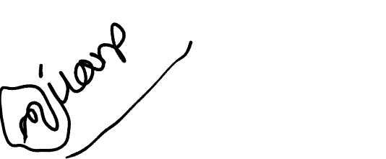

Signature of the Project Manager/ Reporting Manager:

Name:

Signature:

Date: