

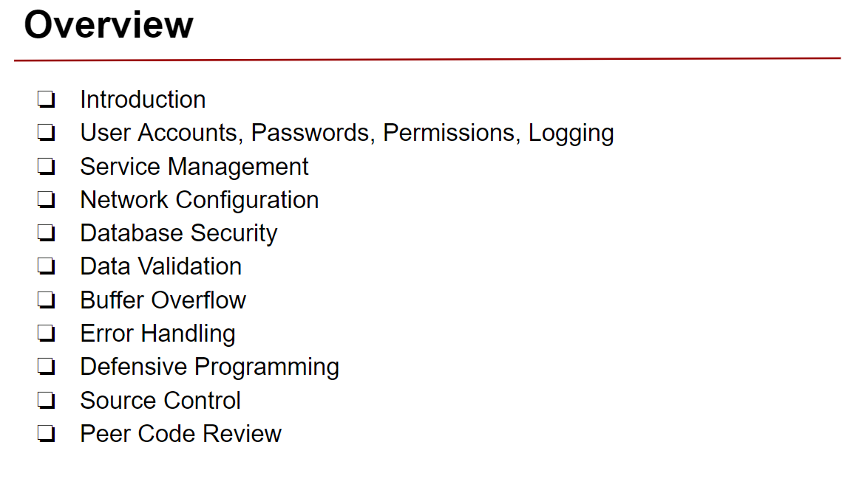

**by Michael Taylor (7/31/17)**



**Unix and Linux are multi-user operating systems. User accounts enable:**

* **Individual home folders**
* **Individual environment configuration**
* **In conjunction with groups/file permissions, what individual users are able to access?**

**The Principle of Least Privilege**

**This principle means giving a user account only those privileges which are essential to that user’s work**

**Benefits:**

* + **Better system stability**
  + **Better system security**
  + **Ease of deployment**

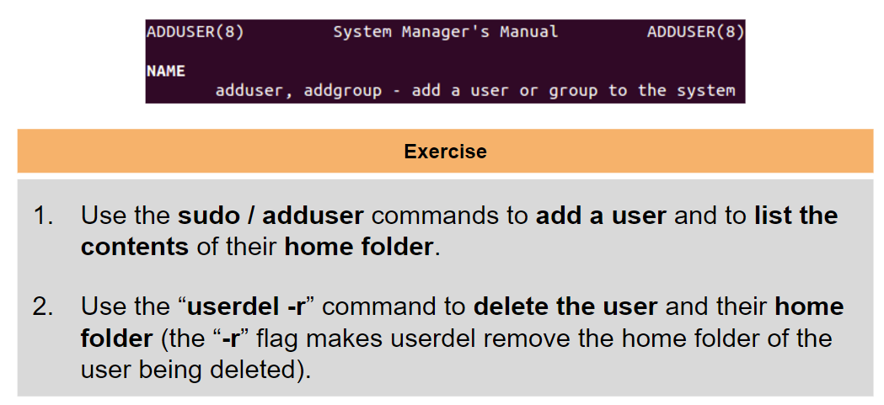**Creating a User Account**

**Adding a User**

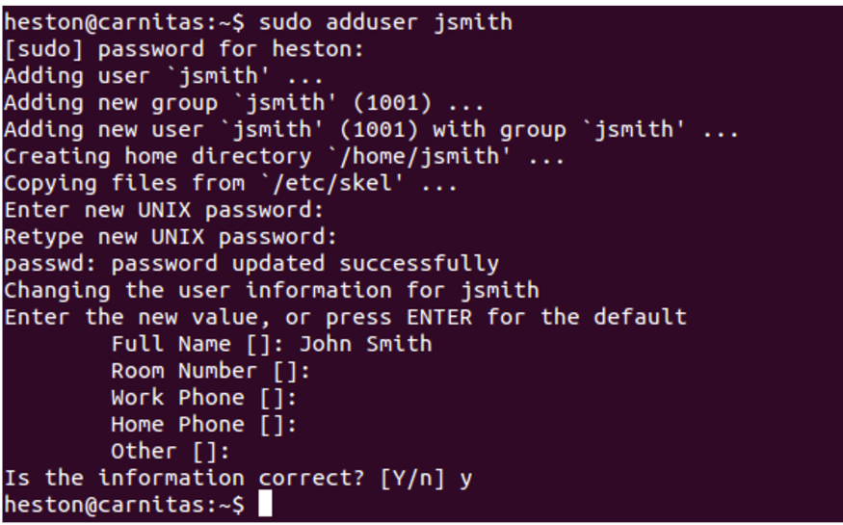

**Listing Contents of User’s Home folder**

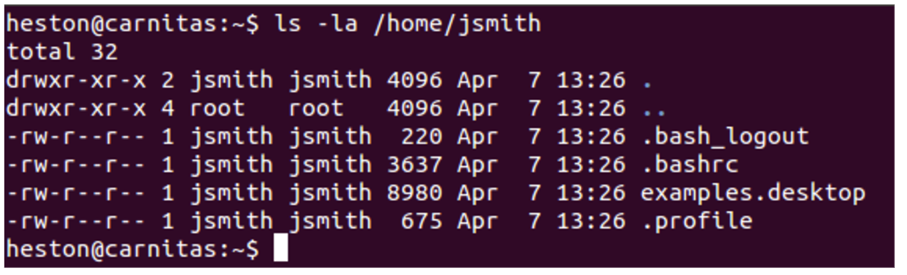

.bash_logout, .bashrc, and .profile are environment/shell configuration files.

**Deleting a User**

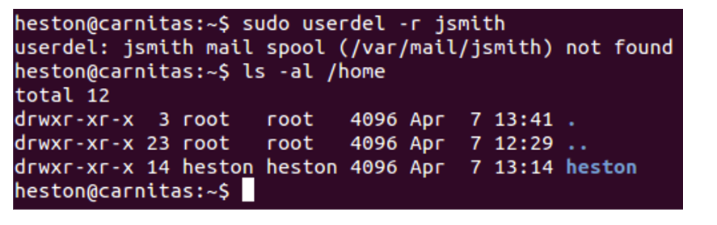

Listing the contents of the /home folder reveals that confirms that jsmith’s home folder has been removed.

**Separation of Privileges**

* With the exception of processes ran as root, each process runs with specific privileges, and can only execute a limited number of tasks/access certain files.
* For this reason, you will always hear not to use the root account.

**System Accounts**

* **To enforce the separation of privileges, specific system accounts are created for each task. These accounts are not usable by regular users.**
* **The adduser command has a number of flags that determine what kind of account is being created, whether a home directory/group will be created, etc.**
* **We can create a service account with “adduser –system service_example” command.**