Titel: Robotics Übung 02 Abgabe

Verfasserin: Maximilian Wolf, FH Campus;  
 Michael Sükar, FH Campus;

Datum: 12.06.2021 15:45

* **Aufgabe 02.01**: 1/1 pt

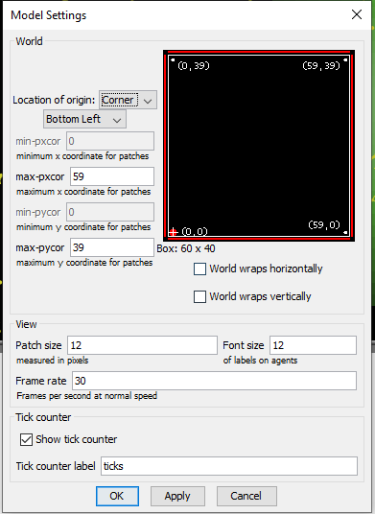

* **Aufgabe 02.02**: 3/3 pt

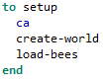

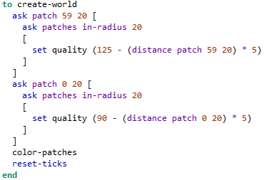

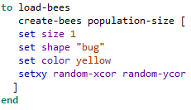

* **Aufgabe 02.03**: 1/1 pt

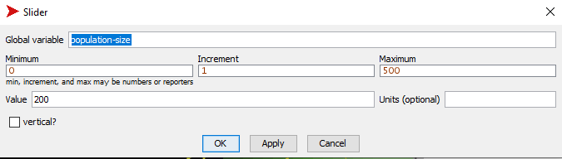

**Entire go method:**

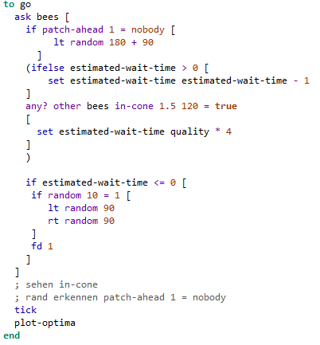

* **Aufgabe 02.04**: 3/3 pt

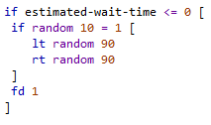

* **Aufgabe 02.05**: 2/2 pt



* **Aufgabe 02.06**: 1/1 pt



* **Aufgabe 02**.**07**: 1/1 pt
* **Aufgabe 02**.**08**: 3/3 pt

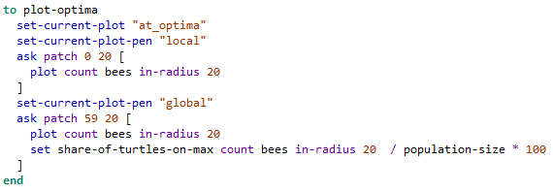

* **Aufgabe 02**.**09**: 1/1 pt

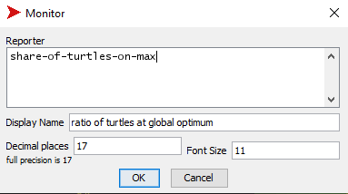



* **Aufgabe 02**.**10**: 2/2 pt

The behavior of one single bee is random (or as random as the code allows it to be). The only thing which is not decided randomly is the wait time on a patch as said wait time is directly proportional to the quality of the patch the bee is waiting on. The quality of a patch is not random but centered around two maxima, one local and one global with ever decreasing quality the further the patch from the maxima.

This leads to that bees stay stationary for longer on patches which are of better quality. And because bees stop when they “see” another bee, being stationary for longer increases the likelihood of being spotted, which then again leads to more bees stopping and so forth.

* **Summe der Punkte Self Assessment**: 18 / 18 Punkten

**Interface:**

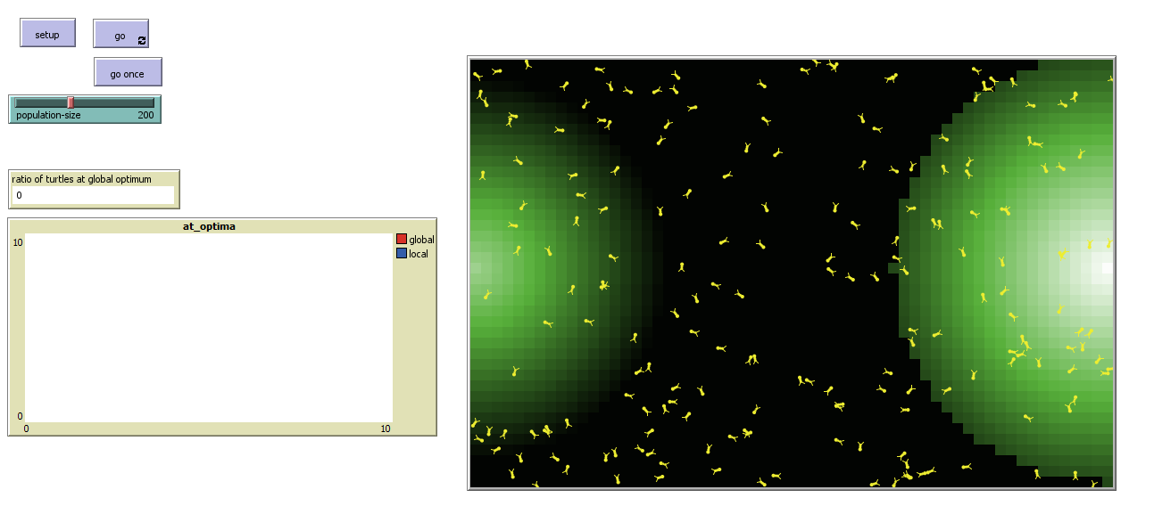

**Bedienung**:

Setup -> go

**Beschreibung:**

Es funktioniert alles wie gefordert.