Design Sheet

Team Members
Team member: Ansh Patel
Team member: Macarios Atia

Design Overview
Explain the set of instructions, clocking methodology (falling or rising edge triggered), registers file, and other specifications.

Word Size and Memory: 16-bit machine = 512 bytes. PC starts at 0x0000 and increments by 2 each instruction (half-word aligned)

Clocking: Synchronous, rising edge triggered for the register file and PC.

Register File 8 general purpose registers ($r0-$r15), 16-bit each. Read happens on the falling edge and write

Instruction format
Example:

R-Format:

Opcode | rs | rt | rd | Func
4 bits | 3 bits | 3 bits | 3 bits | 3 bits
I–Format:

Opcode | rs | rt | Immediate  Func
4 bits | 3 bits | 3 bits | 6 bits

J- Format:

Opcode | address  rt  rd  Func
4 bits | 12 bits  3 bits  3 bits  3 bits

Instructions
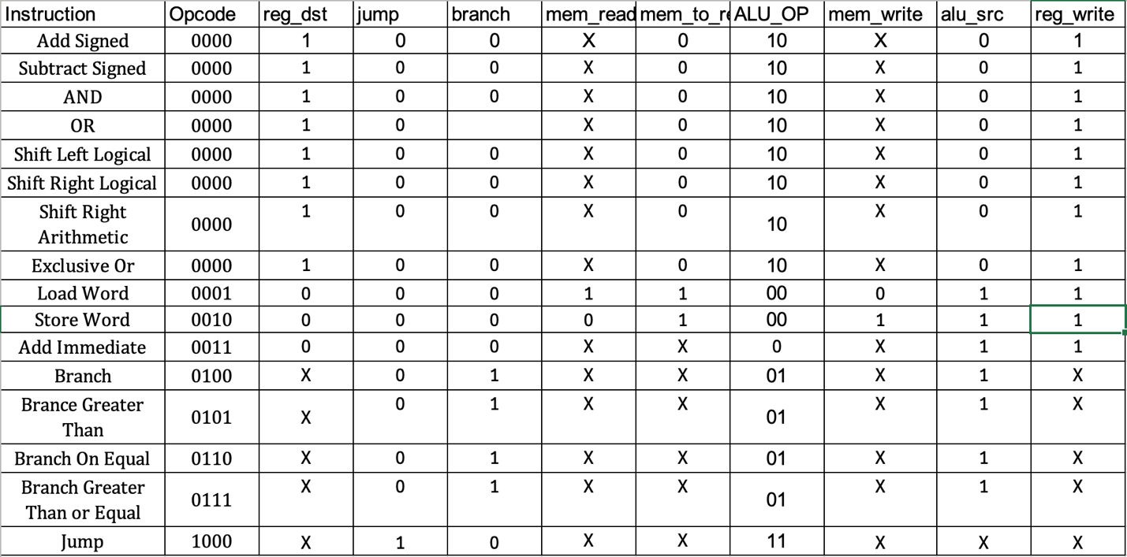

Assembly language and machine code for the test program (Pseudocode)
Pseudocode for the test program (refer to the project handout):

while ($a1 > 0) {
$a1 = $a1 –1;
$t0 = Mem[$a0];
if ($t0 > 0100hex) then {
$v0 = $v0 ÷ 8;
$v1 = $v1 | $v0; //or
Mem[$a0] = FF00hex;
}
else {
$v2 = $v2 × 4;
$v3 = $v3 ⊕ $v2; //xor
Mem[$a0] = 00FFhex;
}
$a0 = $a0 + 2;
}
return;

Assembly Language | Machine Code (Hex -> Formatted binary -> binary
addi $r2, $r2, -1; | 0x34BF → 0011 010 010 101111 → 0011 0100 1010 1111
lw $r3, 0($r1); | 0x10C0 → 0001 001 011 000000 → 0001 0010 1100 0000
lw $r6, 48($r0); | 0x118C → 0001 000 110 110000 → 0001 0001 1011 0000
bgt $r3, $r6, +5; | 0x58A5 → 0101 011 110 000101 → 0101 1011 1100 0101
sll $r6, $r6, 2; | 0x0D90 → 0000 110 110 110 100 → 0000 1101 1011 0100
xor $r7, $r7, $r6; | 0x0FEF → 0000 111 110 111 111 → 0000 1111 1110 1111
lw $r3, 52($r0); | 0x11D0 → 0001 000 011 110100 → 0001 0000 1111 0100
sw $r3, 0($r1); | 0x20C0 → 0010 001 011 000000 → 0010 0010 1100 0000
j ENDIF | 0x801E → 1000 000000011110 → 1000 0000 0001 1110
srl $r4, $r4, 1; | 0x0D85 → 0000 100 100 100 101 → 0000 1001 0010 0101
srl $r4, $r4, 1; | 0x0D85 → 0000 100 100 100 101 → 0000 1001 0010 0101
srl $r4, $r4, 1; | 0x0D85 → 0000 100 100 100 101 → 0000 1001 0010 0101
or $r5, $r5, $r4; | 0x0B6B → 0000 101 100 101 011 → 0000101100101011
lw $r3, 50($r0); | 0x11B8 → 0001 000 011 110010 → 0001 0000 1111 0010
sw $r3, 0($r1); | 0x20C0 → 0010 001 011 000000 → 0010 0010 1100 0000
addi $r1, $r1, 2; | 0x3902 → 0011 100 100 000010 → 0011 1001 0000 0010
bgt $r2, $r0, -17; | 0x541F → 0101 010 000 101111 → 0101 0100 0001 0111
return (no encoding) — halts simulation) | —

