Linear based model:
Cost Function: For linear regression, the cost function is typically the Mean Squared Error (MSE):
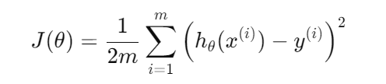
Where:
- θ are the model parameters,
- hθ​(x) is the predicted values
- y(i) are the true values,
- m is the number of observations.
Gradient Descent: To minimize the cost function, gradient descent updates the model parameters: θ
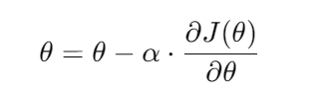
Where:
- alpha is the learning rate.

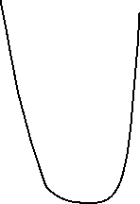
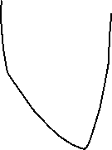
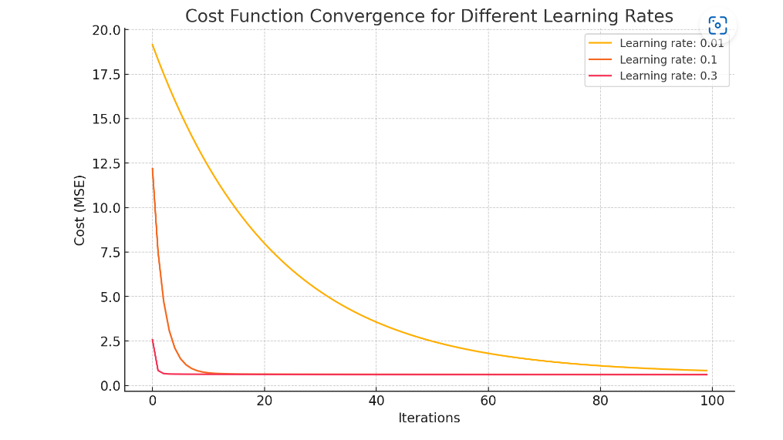
High learning rate (0.3): The cost decreases rapidly, but it might overshoot the minimum and cause instability.
Medium learning rate (0.1): The cost decreases steadily and balances convergence speed with precision.
Low learning rate (0.01): The cost decreases slowly but consistently, ensuring that the solution approaches the minimum without overshooting.

Tree-Based Models
For regression tasks in boosting, the typical cost function is Mean Squared Error (MSE), similar to linear models:
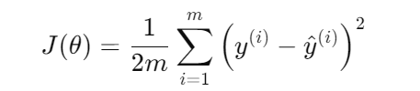
Where:
- mmm is the number of data points,
- y(i) is the true label,
- y^​(i) is the prediction (a combination of all trees up to that point).
At each step, a new tree 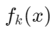 is added to correct the residuals from the previous trees. The model prediction after adding k-th tree is:
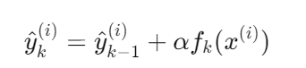
Where α\alphaα is the learning rate, and 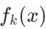 is the prediction from the k-th tree.
Learning Rate’s Impact:
- High learning rate (alpha): Each new tree contributes more to correcting the residuals, resulting in faster cost reduction, but it might overfit.
- Low learning rate (alpha): The model makes smaller corrections, requiring more trees to reduce the cost, but it leads to better generalization.

Support Vector Machines (SVM)
In SVM, the goal is to find a hyperplane that maximizes the margin between two classes. The cost function is designed to minimize misclassifications and maximize the margin.
Cost Function for SVM (Hinge Loss):
For classification, SVM uses a cost function known as hinge loss:
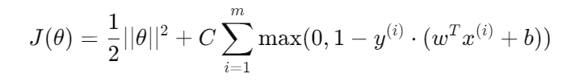
Where:
- ∣∣θ∣∣ is a regularization term (keeps the weights small to prevent overfitting),
- y(i) is the actual class label (+1 or -1),
- 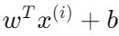 is the decision boundary function,
- C is a regularization parameter controlling the trade-off between margin size and classification errors.
The term 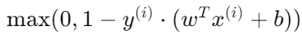 penalizes points that are misclassified or fall within the margin.

Learning Rate’s Impact (when using gradient-based optimization):
When using gradient-based optimization (e.g., Stochastic Gradient Descent (SGD)) to minimize this cost function, the learning rate alpha controls how much the parameters w and b are updated:
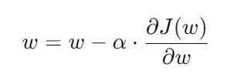
High learning rate (alpha): Faster boundary adjustments but risks overshooting the optimal boundary.
Low learning rate (alpha): Slower but more precise updates, leading to a better decision boundary.

