**Experiential Learning Unit 5.2: Virtual Laboratory**

**ELU 5.2.1**

It is time to start experiments on Vice Lab. Given a solar panels, voltmeter, and ammeter as shown herewith. Using the components, perform the following tasks using the ViCE Lab software by clicking this link.

1. Connect a Voltmeter across and Wattmeter along the terminal of a solar panel as shown herewith.
2. With the panel facing a source of light directly, record the Voltmeter and Wattmeter readings.
3. Increase the number of solar panel in series connection to 5, 10, and 15 respectively.
4. Record the voltmeter and Wattmeter readings at each of these instances.
5. Repeat step iii. In parallel connections.
6. Record the voltmeter and Wattmeter readings at each of these instances.
7. What are your observations?

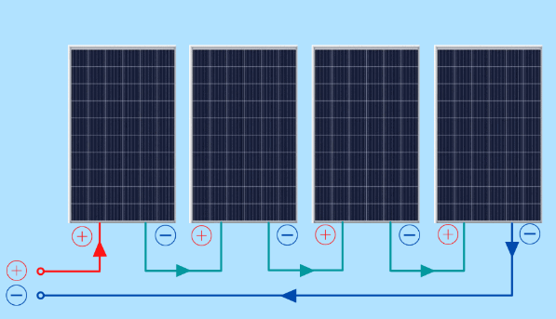 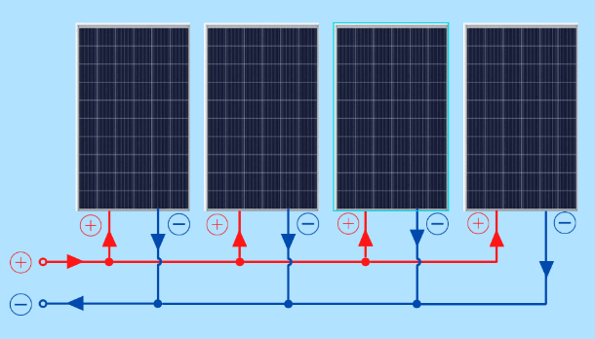

Solar panels connected in series Solar panels connected in parallel