**MODULE 1**

**EXPERIENTIAL LEARNING UNIT (ELU)**

**ELU 1.1: ACTIVITIES OUTLINE**

1. You would have come across some electricity transmission and distribution networks in your area, right? Good. Then you should get your book and your pencil, make a sketch of the distribution or transmission pole and label them.

The transmission wires you are looking for should sometimes look like the figure you have here now, try to sketch the distribution pole in your area.

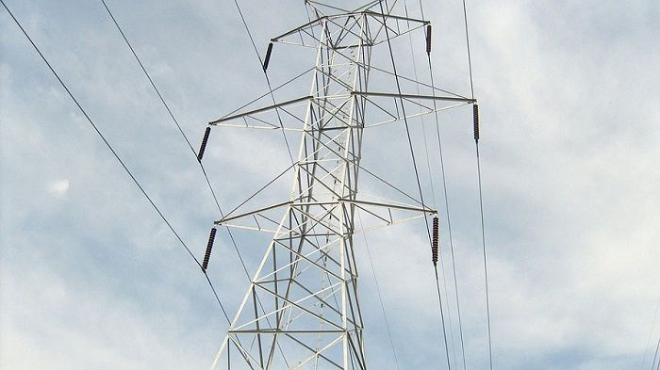

1. Do you remember you were introduced to types of transmission line in this module? You need to see how they look like. You should take a walk around your area and check the type of conductor used in the transmission line if you have a transmission line in your area. The conductors on those transmission lines on close proximity looks like what we have here.

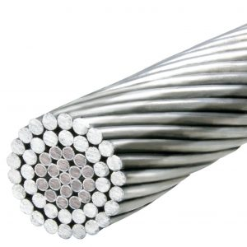

1. You need to see how some appliances such as refrigerator, hot plate, boiling ring, television, heater, reduces the flow of current been generated in your home. Get your multimeter and note the changes that occur to your current when any of these devices are in their ON and OFF state. If you cannot conveniently measure the voltage then you should be able to listen to change in sound. Do you observe any change in sound when appliances are connected to a generating set? Describe your experience.
2. Do you know there are some devices that uses direct current in your home? It is time to find out the ones that uses a Direct Current (DC) source without the need to convert from alternating current to direct current. List the items and state your reasons for thinking those items are powered directly by a DC source.
3. You would have come across commercial generators, right? Pictures of commercially available electricity generating sets are shown herewith. Now, list the different types of commercial electricity generators you came across with the model types, physical feature and power rating.

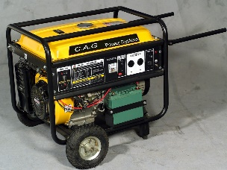 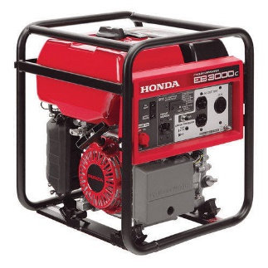

1. You must have seen some fuse made with ceramics, some made with plastic right? Draw the different types of switches you see around you. These are examples of fuses.

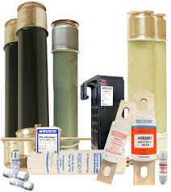 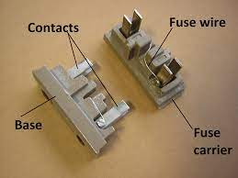

**Experiential Learning Unit 1.2: Virtual Laboratory**

**ELU 1.2.1** It is time to start our circuit connection on ViceLab. Given three resistors 3 Ohms, 5 Ohms and10 Ohms with a 12V battery as shown herewith. Using the components, perform the following tasks using the ViCE Lab software by clicking this link.

Add pictures of the three resistors and voltage source

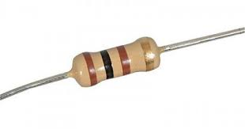

3 Resistor

**Task 1.2.1.1:** Now that you are in the ViCE Lab, get the three resistors and connect the resistors in series with the battery.

Add the circuit diagram

**Task 1.2.1.2:** Also, connect the resistors in parallel with the battery.

Add the circuit diagram

**Experiment 1.2.2: Measurements**

By now, you should have finished the first experiment in ViCE Lab, so lets move on to this new experiment. Now perform the following tasks:

**Task 1.2.2.1:** Measure and observe the power developed in the circuit for both the series and the parallel connection. Is there any difference in the measured value? If yes record your observation.

**Task 1.2.2.2:** Calculate the current across each circuit element, and the total current in the circuit. Record your observation on the measured value in both circuit connection.

**Task 1.2.2.3:** Find the total resistance of the circuit and note the change in the measured value of the connections.

**Task 1.2.2.4:** Measure and record the voltage across each circuit element in the circuit connection. What do you observe in the measured value of each connection?

**Experiential Learning Unit 1.3: Projects**

**ELU 1.3.1: Learning from Others**

Now that we have studied current, voltage and resistance and have familiarized ourselves with some quantities related to electronics, let us take our time and go through the video whose links are provided herewith. Let us now see what others have done and learn from them too.

1. **Topic:** Electronic Load Constant Current Explained

**Reference Link:** <https://www.youtube.com/watch?v=xVLSKb-_Fqc>

**Description:** In this electronic load and its applications were explained and a design circuit was used to show this.

1. **Topic:** Voltage, Current, and Power Explained - Laying the Foundation forBasic Circuits | Basic Electronics

**Reference Link:** <https://www.youtube.com/watch?v=zH-5ls0YAI0>

**Description:** in this, basic terms like voltage, current and power were explained in details using practical illustration like the water analogy.

1. **Topic:** How to Make an Electric Table Fan using Bottle - Easy Way

**Reference Link:** <https://www.youtube.com/watch?v=XsuYTL1kvsI>

**Description:** In this, an electric fan was made using a water bottle and a motor.

1. **Topic:** How to make a pinwheel - Perpetual Motion - Free Energy

**Reference Link:** [**https://www.youtube.com/watch?v=cbwZrqGonec**](https://www.youtube.com/watch?v=cbwZrqGonec)

**Description:** in this work a perpetual fan was made using permanent magnet and cupper wire.

1. **Topic:** Get Free energy generator with latest technology 2019 _ New Science project

**Reference Link:** <https://www.youtube.com/watch?v=KfjKgWtEu6w>

**Description:** in this video a permanent magnet was used to drive a motor to turn on a led without external battery source.

**ELU 1.3.2: Personal Projects**

Great! Now that we have been able to go through the videos and have watched what others have done, it is time for us to think of what we too can do. Provided herewith are some projects that you can try to implement on your own so as to improve your knowledge and skills regarding the content of this module.

1. You need to use direct current to power a 5V LED and the power output from the socket of your house is alternating current. Design an AC to DC power rectification circuit using 4 diodes and 2 capacitors with a center tapped transformer that you can use to power the LED.
2. In a very hot environment, you need to cool off, think of a way to design a simple fan using materials in your environment, a battery, capacitor and a switch.
3. Design a perpetual fan using permanent magnet that you can use for exhibition in the annual exhibition program.
4. You were working with your laptop one morning and you discovered that it was heating up due to the program you were running on it, think of a way to design a laptop stand that can cool it when in operation.
5. At night there is no light from the electricity distribution company and you need to work. Design a standing lamp with LED and switch that can solve this problem.