**Experiential Learning Unit 5.2: Virtual Laboratory**

**ELU 5.2.1**

It is time to start experiments on Vice Lab. Given a solar panels, voltmeter, and ammeter as shown herewith. Using the components, perform the following tasks using the ViCE Lab software by clicking this link.

**Task 5.2.1.1: Solar Grid**

1. Connect a voltmeter across the terminal of a solar panel as shown herewith.
2. With the panel facing a source of light directly, record the voltmeter readings.
3. Increase the number of solar panel in series connection to 5, 10, and 15 respectively.
4. Record the voltmeter readings at each of these instances.
5. Repeat step iii. In parallel connections.
6. Record the voltmeter readings at each of these instances.
7. What are your observations?

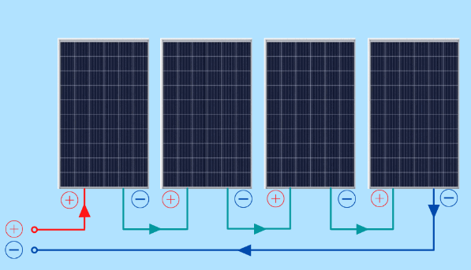 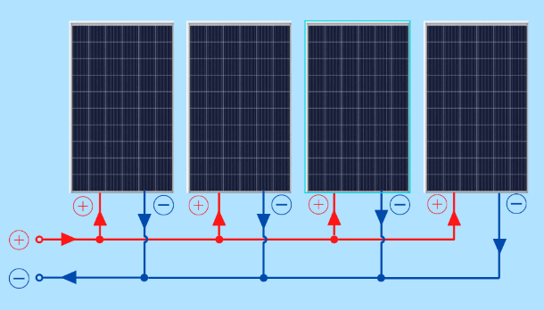

Solar panels connected in series Solar panels connected in parallel

**Task 4.2.1.2:** Connect the circuit as shown herewith with a voltmeter and measure the terminal voltage. Also with an Ammeter and measure current.

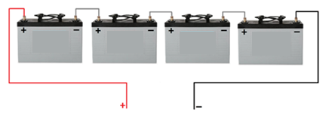

Four batteries all connected in series.

**Task 4.2.1.3:** Connect the Solar panel as shown herewith with a voltmeter and measure the terminal voltage. Also with an Ammeter and measure the Current.

Solar panels connected in series

**Task 4.2.1.4:** Connect the Solar panel as shown herewith with a voltmeter and measure the terminal voltage. Also with an Ammeter and measure the Current.

**Experiment 4.2.2**

By now, you should have finished the first experiment in ViCE Lab, so lets move on to this new experiment. Now perform the following tasks

1. Connect a voltmeter across, then an ammeter along with the terminal of a solar panel.
2. Record the voltmeter and ammeter readings.
3. Increase the number of solar panel in series connection to 2, 3 and 4 respectively.
4. Record the voltmeter and ammeter readings at each of these instances.
5. Repeat step iii. in parallel connections.
6. Record the voltmeter and ammeter readings at each of these instances.
7. What are your observations?

