**Experiential Learning Unit 3.2: Virtual Laboratory**

**ELU 3.2.1**

It is time to start experiments on Vice Lab. Given a solar panel, voltmeter, and ammeter as shown herewith. Using the components, perform the following tasks using the ViCE Lab software by clicking this link.

**Task 3.2.1:** Connect the circuit as shown herewith and measure the Open circuit voltage

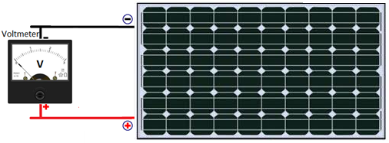

**Task 3.2.1:** Connect the circuit as shown herewith and measure the Short Circuit Current

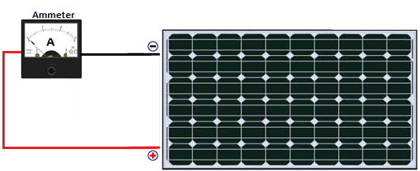

**Experiment 3.2.2: Measurements**

By now, you should have finished the first experiment in ViCE Lab, so lets move on to this new experiment. Now perform the following tasks

1. Connect a rheostat and voltmeter across, then an ammeter along the terminal of a solar panel as shown in the herewith.
2. With the panel facing a source of light directly, vary the rheostat from maximum resistance setting to the lowest resistance settings.
3. Record the voltmeter and ammeter readings at regular intervals of the rheostat settings.
4. Plot a graph of the current readings against the voltage.
5. What is your observation?

