jSYSTEMS ENGINEERING COURSE 2026 · PROBLEM SET 1 · PART B
Stakeholder Analysis and its Representation in Capella
Team answer - autonomous UAV ground station network for the Northern Sea Route
Team | Jad Fayad, Varvara, Yasir, Macmillan
System of interest | Network of autonomous UAV ground stations at the NSR ports

1. Method
- List the stakeholders from the problem statement and the system boundary of Part A.
- stakeholder value network, including relationships between stakeholders and not only with the system, because indirect relationships can make a project fail if they are ignored.
- Interactions classification into the four value-flow types of the lecture: political, information, goods/service and financial.
- Elicit the needs of each stakeholder
- Rank the stakeholders to find the most important ones.

2. Stakeholders
Market stakeholders exchange goods, services or money with the project; nonmarket stakeholders influence it through rules, permission or public acceptance (Feng, Cameron and Crawley, 2008).
Stakeholder | Type | Role | Needs from the station network
UAV Operators and Service Providers | Market | Primary user and customer | UAVs turned around at every port without sending staff; station status visible remotely; reliable operation in the cold
Port Authorities (9 NSR ports) | Nonmarket | Host of each station | Safe operation inside the port zone; small, predictable power demand; status and safety reports
NSR Route Administration | Nonmarket | Route authority | UAV operations coordinated with navigation and icebreaker convoys; ice and weather data from the route
Aviation and Maritime Regulators | Nonmarket | Regulator | Operations within approved corridors; complete flight and cycle records; fail-safe behaviour
Shipping Companies and Industrial Operators | Market | Paying customer of UAV services | UAV support available along the whole route at a reasonable cost
Ship Crews and Masters | Market | End beneficiary | UAV support (parts, medicine, ice data) available when requested, without handling any equipment
Emergency and Medical Services | Nonmarket | End beneficiary | Stations ready at any time so urgent UAV missions are not delayed
Maintenance Technicians | Market | Maintainer | Long intervals between visits; quick and safe replacement of parts
UAV Manufacturers and Partner Projects | Market | Interface partner | One documented landing, charging and data interface usable by their UAVs
Satellite Communication Providers | Market | Supplier | Predictable data traffic and service contracts
Local Communities and Indigenous Peoples | Nonmarket | Affected party | Safe, quiet stations with no harm to wildlife; access to the services UAVs bring
Table B1 - Stakeholders and their needs.
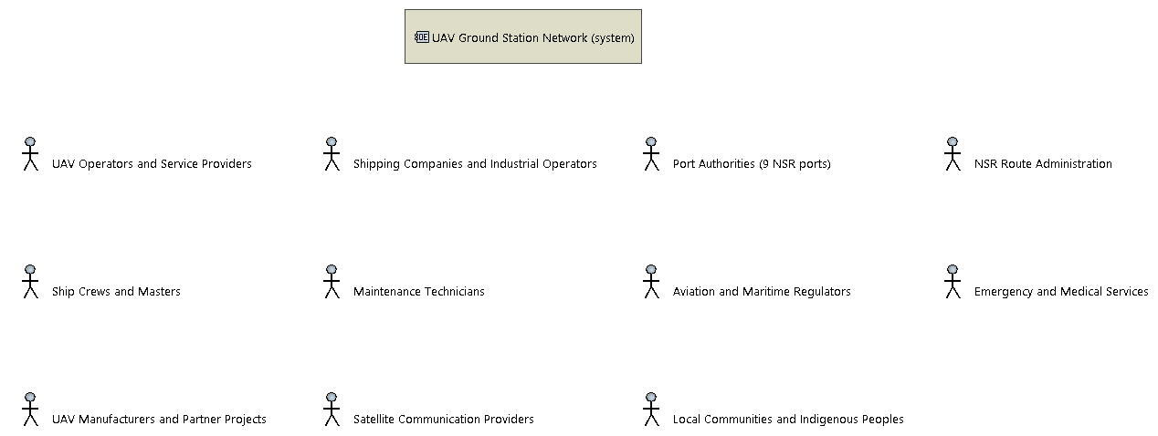
Figure B1 - Capella [OEBD] stakeholder breakdown: the system on top, market stakeholders (left) and nonmarket stakeholders (right).

3. Types of interactions
Each interaction is a value flow from one party to another. We used the four types of the stakeholder value network:
Type | What flows | Examples in our project
Political | Permission, rules, approval, acceptance | Site permit and port-zone rules from the port authority; approval of corridors by regulators; local acceptance from communities
Information | Data, reports, requests | Next routes and commands from the operator; station status and cycle reports; flight records to regulators; ice and weather data to the NSR administration
Goods / service | Physical goods and services | Autonomous UAV turnaround for the operator; site and electrical power from the port; maintenance; satellite data link to both ends
Financial | Money | Investment, site lease, airtime and maintenance contracts paid by the operator; service contracts between shipping companies and the operator
Table B2 - Interaction types

3.1 Stakeholder value network
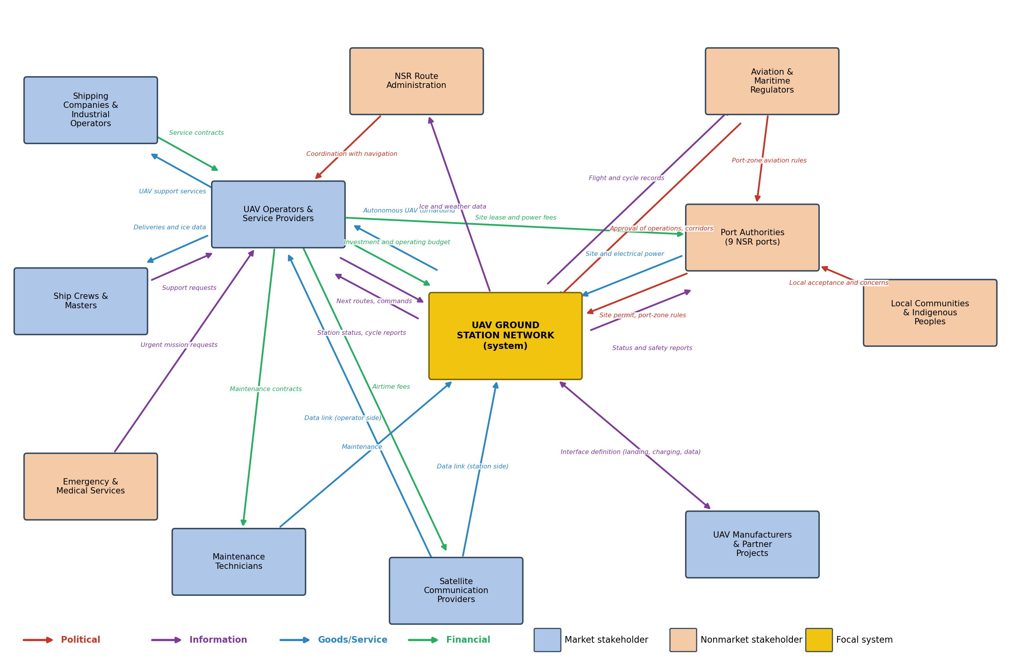
Figure B2 - Stakeholder value network of the station network. Arrows show value flows; colours show the type.
The network shows that several important stakeholders interact with the system only indirectly. Shipping companies, ship crews and emergency services never touch a station: they receive their value through the UAV operator. Regulators act on the system directly (approval) and through the port authorities (port-zone rules), and local communities act through the port. Ignoring these indirect paths could lose the support of a stakeholder the project depends on.

4. Most important stakeholders
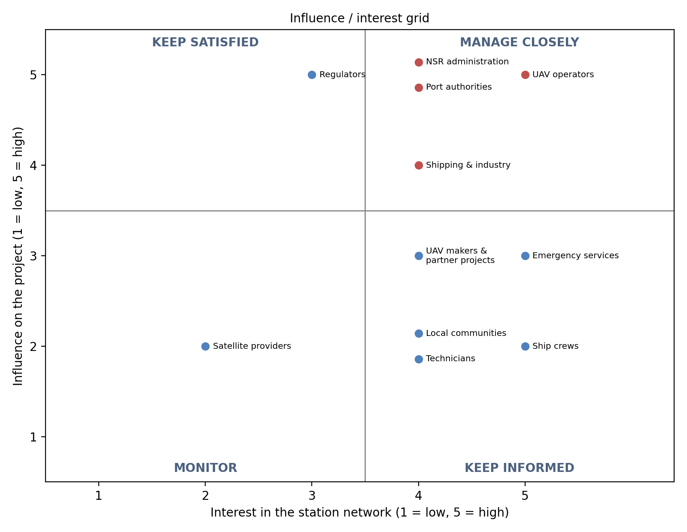
Figure B3 - Influence / interest grid.
Rank | Stakeholder | Influence | Interest | Score | Value flows | Strategy
1 | UAV Operators and Service Providers | 5 | 5 | 25 | 14 | Manage closely
2 | Port Authorities (9 NSR ports) | 5 | 4 | 20 | 6 | Manage closely
3 | NSR Route Administration | 5 | 4 | 20 | 2 | Manage closely
4 | Shipping Companies and Industrial Operators | 4 | 4 | 16 | 2 | Manage closely
5 | Aviation and Maritime Regulators | 5 | 3 | 15 | 3 | Keep satisfied
6 | Emergency and Medical Services | 3 | 5 | 15 | 1 | Keep informed
7 | UAV Manufacturers and Partner Projects | 3 | 4 | 12 | 1 | Keep informed
8 | Ship Crews and Masters | 2 | 5 | 10 | 2 | Keep informed
9 | Maintenance Technicians | 2 | 4 | 8 | 2 | Keep informed
10 | Local Communities and Indigenous Peoples | 2 | 4 | 8 | 1 | Keep informed
11 | Satellite Communication Providers | 2 | 2 | 4 | 3 | Monitor
Table B3 - Stakeholder ranking.

5. Stakeholder needs
The needs of the stakeholders are grouped into 7 stakeholder needs. They are written as needs, not as requirements; the system requirements will be derived from them in the next step.
ID | Stakeholder need | Stakeholders | Team goal
SN-01 | Turn UAVs around without staff on site | UAV Operators and Service Providers, Port Authorities, Maintenance Technicians | G1, G2, G4
SN-02 | Keep UAV support available along the whole route | UAV Operators and Service Providers, Shipping Companies and Industrial Operators, Ship Crews and Masters, Emergency and Medical Services | G1-G5
SN-03 | Operate safely and within the rules | Aviation and Maritime Regulators, Port Authorities, NSR Route Administration, Local Communities and Indigenous Peoples | G6
SN-04 | Work through the Arctic year | UAV Operators and Service Providers, Shipping Companies and Industrial Operators, NSR Route Administration | G5
SN-05 | Give status, records and route data | UAV Operators and Service Providers, Port Authorities, Aviation and Maritime Regulators, NSR Route Administration | G4, G6
SN-06 | Offer one interface for different UAVs | UAV Manufacturers and Partner Projects, UAV Operators and Service Providers | G5
SN-07 | Need little maintenance and little power | Maintenance Technicians, Port Authorities, UAV Operators and Service Providers | G2, G5
Table B4 - Stakeholder needs and the stakeholders who hold them.
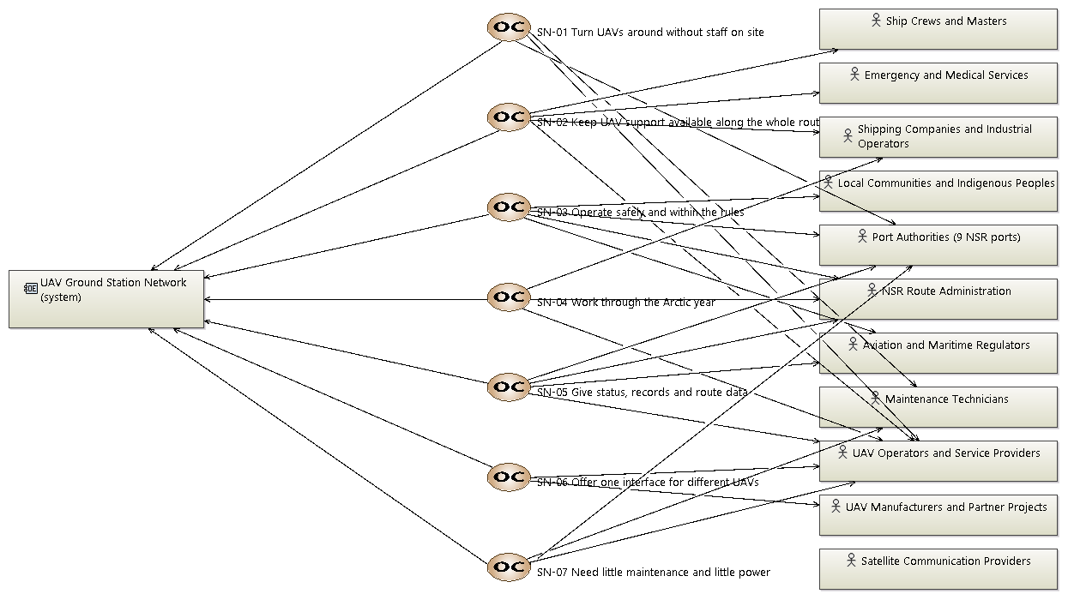
Figure B4 - Capella [OCB] diagram: each stakeholder need (centre) linked to the system (left) and to the stakeholders who hold it (right).
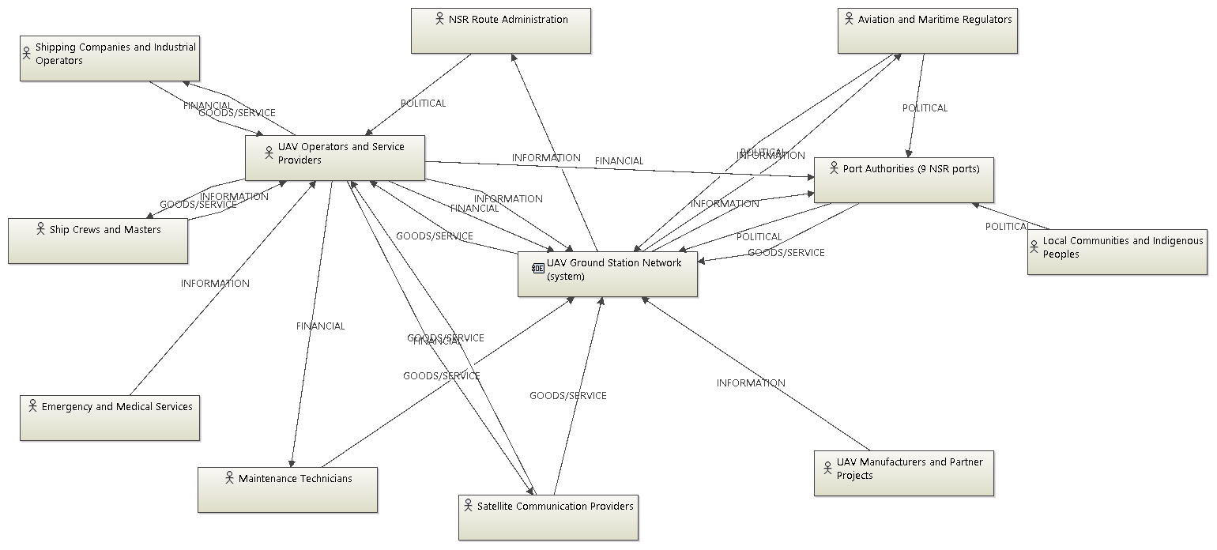
Figure B6 - Capella [OAB] diagram: the stakeholder value network (each link is a communication mean named by type).
The four type views below show the same network filtered on one value-flow type each.
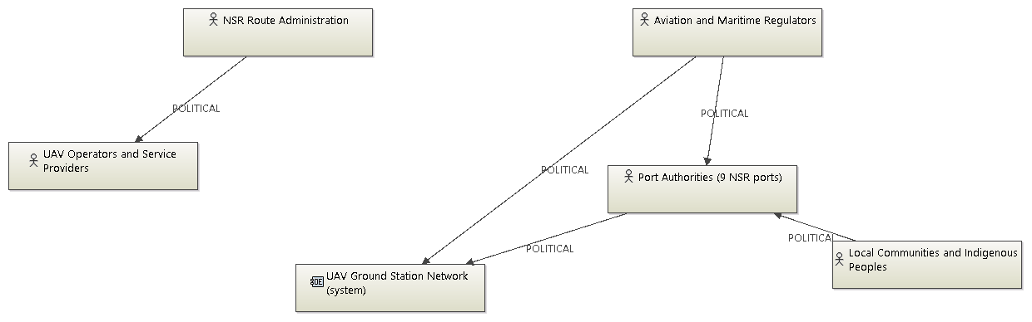
Figure B7 - Capella [OAB] view: political flows only.
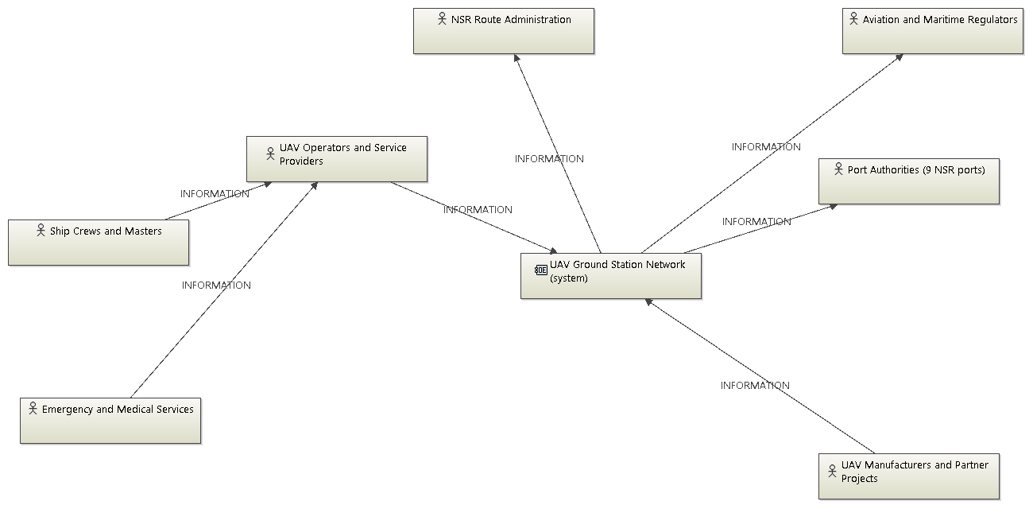
Figure B8 - Capella [OAB] view: information flows only.
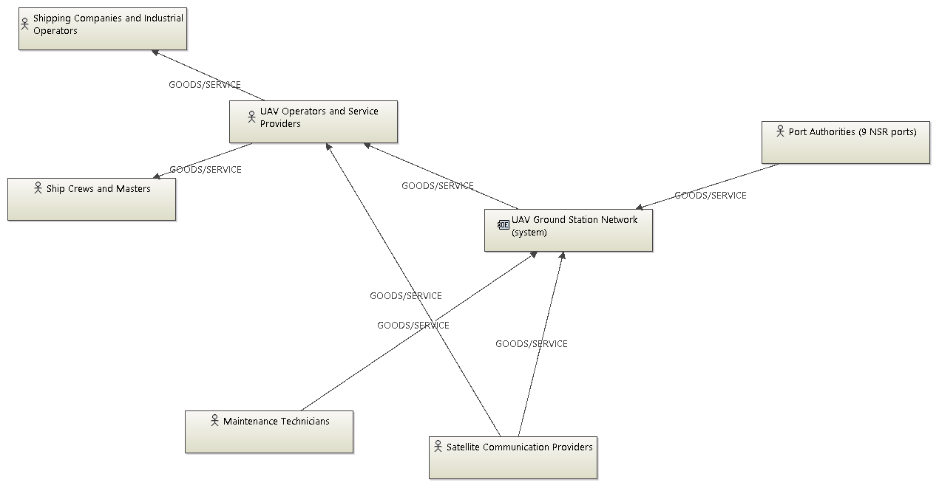
Figure B9 - Capella [OAB] view: goods/service flows only.
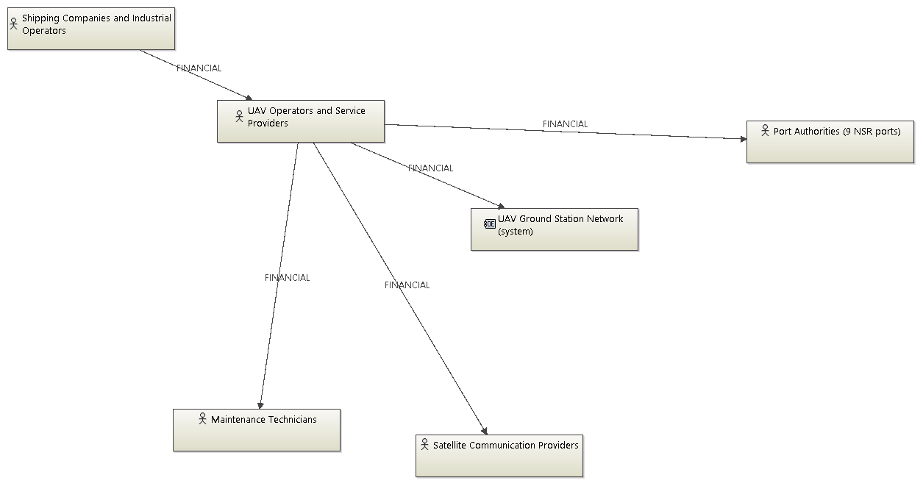
Figure B10 - Capella [OAB] view: financial flows only.

