SYSTEMS ENGINEERING 2026 · PROBLEM SET 2 · PART 2
System Analysis
NSR UAV Ground Station Network
Team | Team 4: Jad Fayad, Varvara Vylusk, Yasir Khan, Macmillan Gudo
Date | 26.10.2026

1. Overview
The stakeholder analysis of Problem Set 1 is slightly changed. So the report contains a review of the stakeholder analysis
Changes made for Problem Set 2:
- OA: stakeholders grouped into Authorities, Customers and Beneficiaries, and Suppliers and Service Partners. OAIB re-arranged for readability; two operational scenarios added (drug delivery, spare-parts delivery) with the activity and interaction they need.

2. Operational Analysis (traceability from Problem Set 1)

2.1 Stakeholders and groups
Group | Stakeholder | Role
Authorities | Aviation and Maritime Regulators | Regulator
Authorities | NSR Route Administration | Route authority
Authorities | Port Authorities (9 NSR ports) | Host of the operations at each port
Customers and Beneficiaries | Emergency and Medical Services | End beneficiary
Customers and Beneficiaries | Ship Crews and Masters | End beneficiary
Customers and Beneficiaries | Shipping Companies and Industrial Operators | Paying customer of UAV services
Suppliers and Service Partners | Maintenance Technicians | Maintainer
Suppliers and Service Partners | Satellite Communication Providers | Supplier
Suppliers and Service Partners | UAV Manufacturers and Partner Projects | Supplier and interface partner
- | Local Communities and Indigenous Peoples | Affected party
- | UAV Operators and Service Providers | Primary user and customer

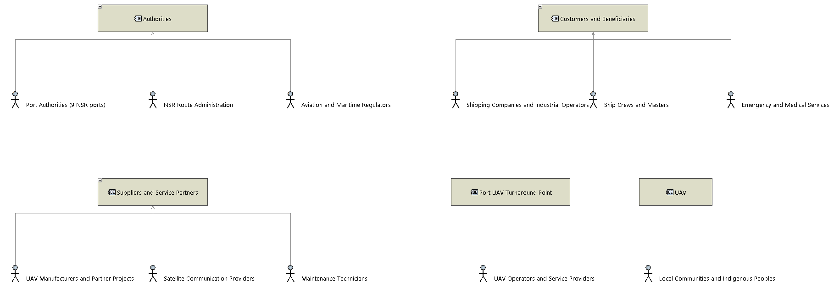
Figure 1. [OEBD] Stakeholders grouped into three groups.

2.2 Stakeholder needs (operational capabilities)
Need | Involved entities
SN-01 Turn UAVs around at the ports without staff on site | Port UAV Turnaround Point, UAV Operators and Service Providers, Port Authorities (9 NSR ports), Maintenance Technicians, UAV
SN-02 Keep UAVs ready for flight along the whole route | Port UAV Turnaround Point, UAV Operators and Service Providers, Shipping Companies and Industrial Operators, Ship Crews and Masters, Emergency and Medical Services, UAV
SN-03 Operate safely and within the rules | Port UAV Turnaround Point, Aviation and Maritime Regulators, Port Authorities (9 NSR ports), NSR Route Administration, Local Communities and Indigenous Peoples
SN-04 Work through the Arctic year | Port UAV Turnaround Point, UAV Operators and Service Providers, Shipping Companies and Industrial Operators, NSR Route Administration
SN-05 Share status, records and route data | Port UAV Turnaround Point, UAV Operators and Service Providers, Port Authorities (9 NSR ports), Aviation and Maritime Regulators, NSR Route Administration
SN-06 Use one interface for different UAVs | Port UAV Turnaround Point, UAV Manufacturers and Partner Projects, UAV Operators and Service Providers, UAV
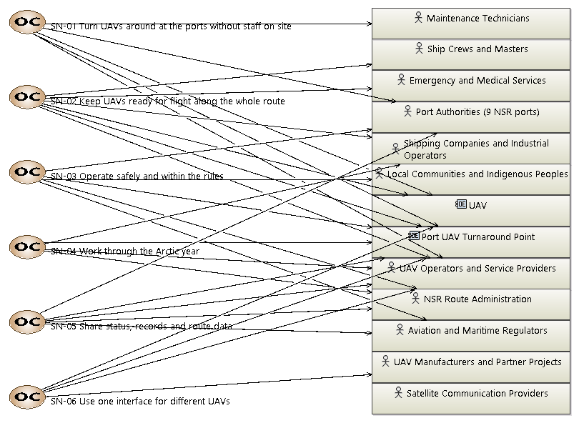
Figure 2. [OCB] Stakeholder needs and involved entities (SN-07 removed).

2.3 Operational activities and interactions
The turnaround activities sit in the middle column, the UAV side on the left and the operator, authorities and customers on the right.

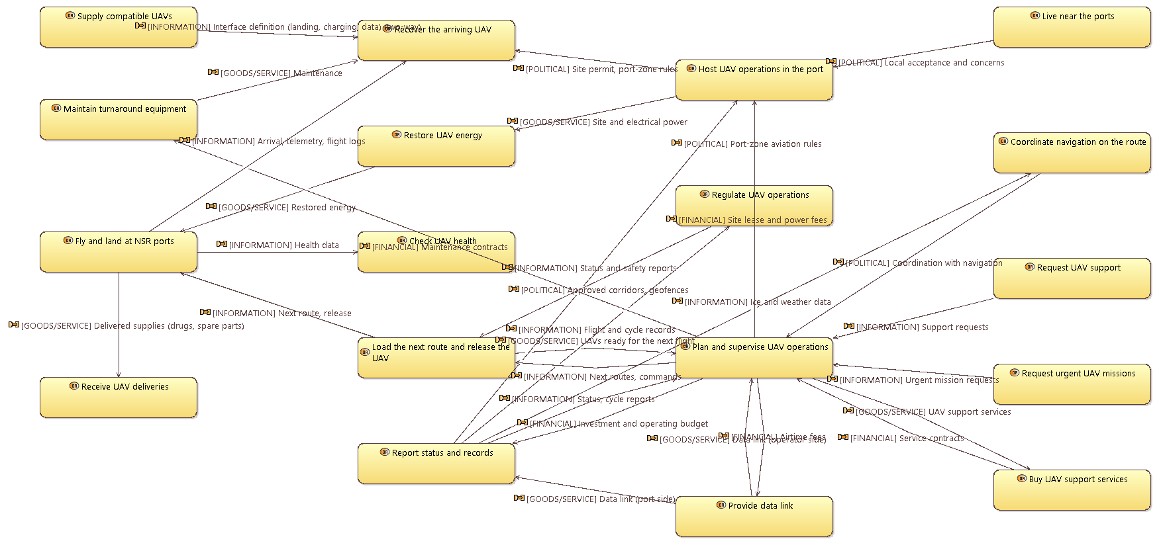
Figure 3. [OAIB] Operational activities and interactions.

2.4 Operational scenarios
Drug and spare-parts deliveries are flown by different UAVs. Both scenarios belong to SN-02 and include the Port UAV Turnaround Point. Faults are handled separately in the system scenario SA2.

OA1 Drug delivery mission
# | Entity | Activity | Interaction sent
1 | Ship Crews and Masters | Request UAV support | Support requests
2 | UAV Operators and Service Providers | Plan and supervise UAV operations | Next routes, commands
3 | Port UAV Turnaround Point | Restore UAV energy | Restored energy
4 | UAV | Fly and land at NSR ports | Health data
5 | Port UAV Turnaround Point | Check UAV health | -
6 | Port UAV Turnaround Point | Load the next route and release the UAV | Next route, release
7 | UAV | Fly and land at NSR ports | Delivered supplies (drugs, spare parts)
8 | Ship Crews and Masters | Receive UAV deliveries | -
9 | UAV | Fly and land at NSR ports | Arrival, telemetry, flight logs
10 | Port UAV Turnaround Point | Recover the arriving UAV | -
11 | Port UAV Turnaround Point | Report status and records | Status, cycle reports
12 | UAV Operators and Service Providers | Plan and supervise UAV operations | -

OA2 Spare-parts delivery mission
# | Entity | Activity | Interaction sent
1 | Ship Crews and Masters | Request UAV support | Support requests
2 | NSR Route Administration | Coordinate navigation on the route | Coordination with navigation
3 | UAV Operators and Service Providers | Plan and supervise UAV operations | Next routes, commands
4 | Port UAV Turnaround Point | Restore UAV energy | Restored energy
5 | UAV | Fly and land at NSR ports | Health data
6 | Port UAV Turnaround Point | Check UAV health | -
7 | Port UAV Turnaround Point | Load the next route and release the UAV | Next route, release
8 | UAV | Fly and land at NSR ports | Delivered supplies (drugs, spare parts)
9 | Ship Crews and Masters | Receive UAV deliveries | -
10 | UAV | Fly and land at NSR ports | Arrival, telemetry, flight logs
11 | Port UAV Turnaround Point | Recover the arriving UAV | -
12 | Port UAV Turnaround Point | Report status and records | Status, cycle reports
13 | UAV Operators and Service Providers | Plan and supervise UAV operations | -
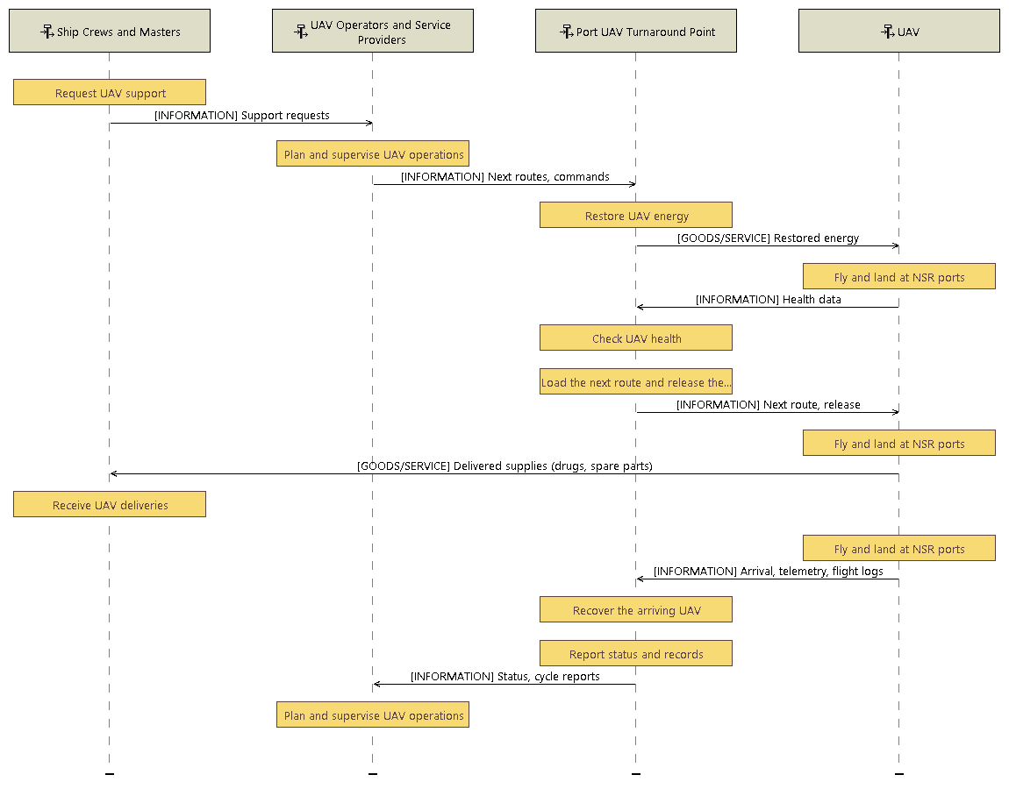
Figure 4. [OES] OA1 Drug delivery mission.
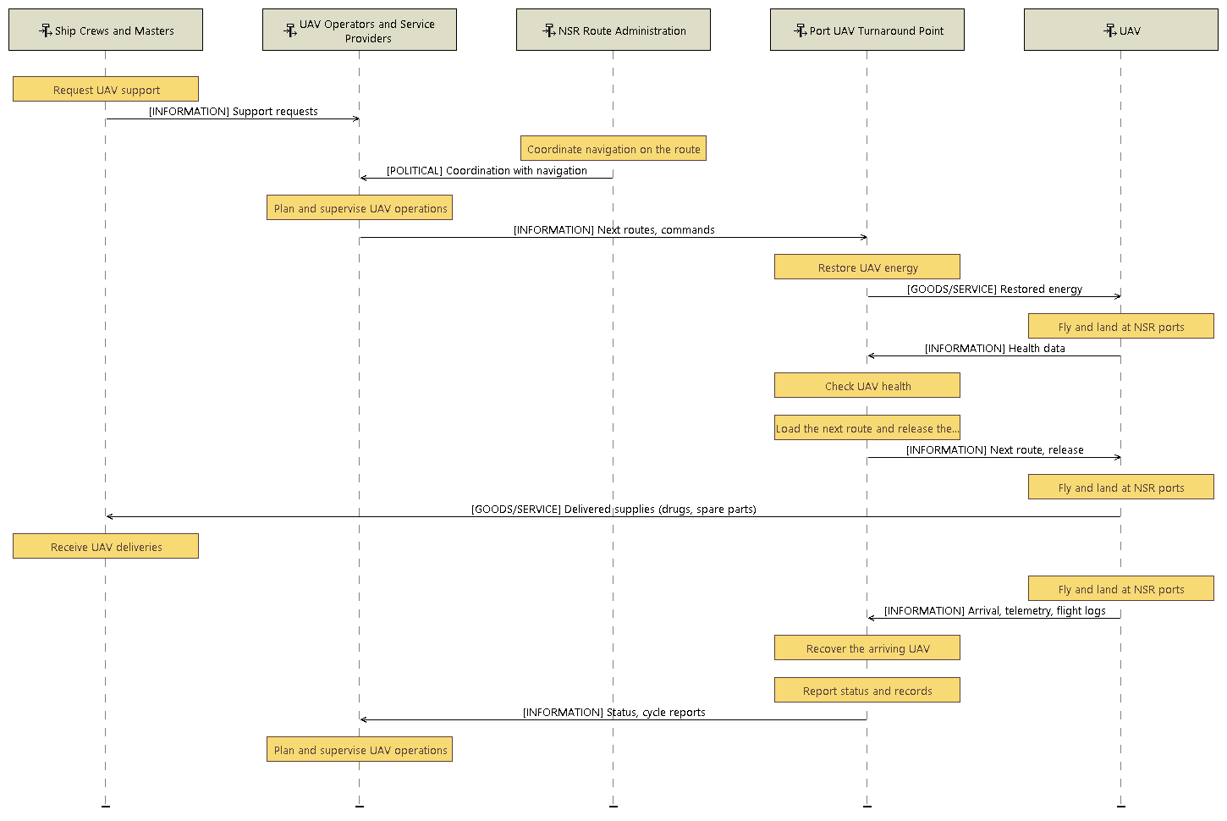
Figure 5. [OES] OA2 Spare-parts delivery mission.

3. System Analysis

3.1 Mission and system context
M-1 Maintain UAV operational readiness between missions: The station network prepares each UAV for its next flight at the NSR ports: receive, restore energy, system check, upload the next route and release, without on-site personnel.
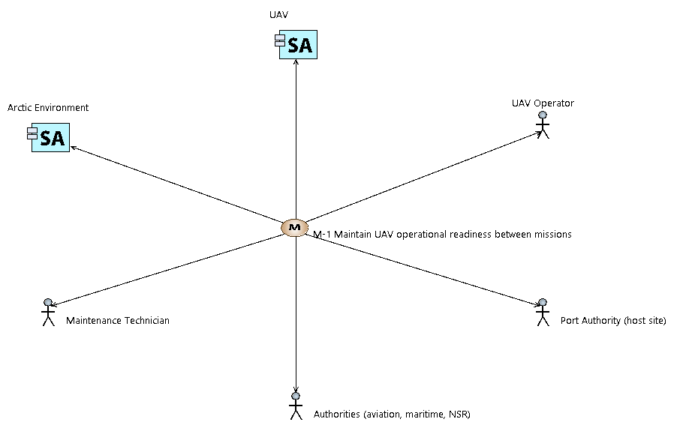
Figure 6. [MB] Mission M-1 and the system actors.
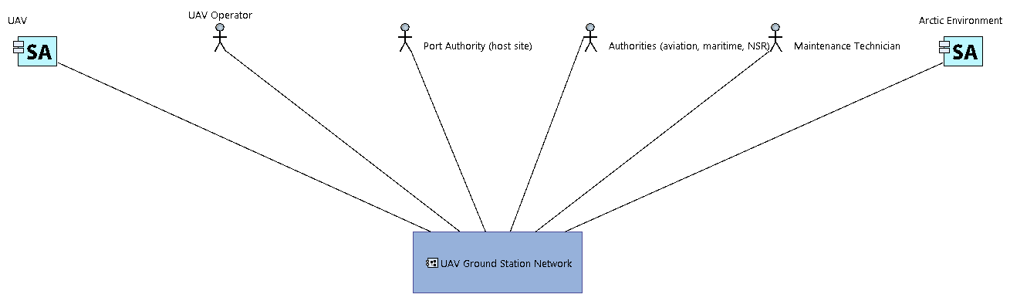
Figure 7. [CSA] System context: the station network and its six actors.

3.2 Capabilities and constraints
Capability | Purpose | Realises
SC1 Receive UAV | Guide the arriving UAV to a precise landing and secure it. | SN-01
SC2 Restore energy | Restore the UAV battery energy. | SN-01, SN-02
SC3 System check | Check motors, sensors, battery and ice; decide GO / NO-GO. | SN-02
SC4 Upload next route | Receive the next route from the operator and upload it to the UAV. | SN-02, SN-05
SC5 Release UAV | Release the ready UAV for its next mission. | SN-02
SC6 Report status and faults | Report status to the operator and faults to maintenance. | SN-05
SC7 Support UAV interface | Provide the appropriate landing, charging and data interface for the UAV. | SN-06
Operating within the rules and in the Arctic all year round are not things the station delivers; they limit how it delivers everything else. They are therefore modelled as constraints on the mission:
Constraint | Related need
CN1 Operate within the rules (aviation, maritime, port) | SN-03
CN2 Work through the whole year | SN-04
CN3 Work in Arctic weather (cold, ice, wind, polar night) | SN-04
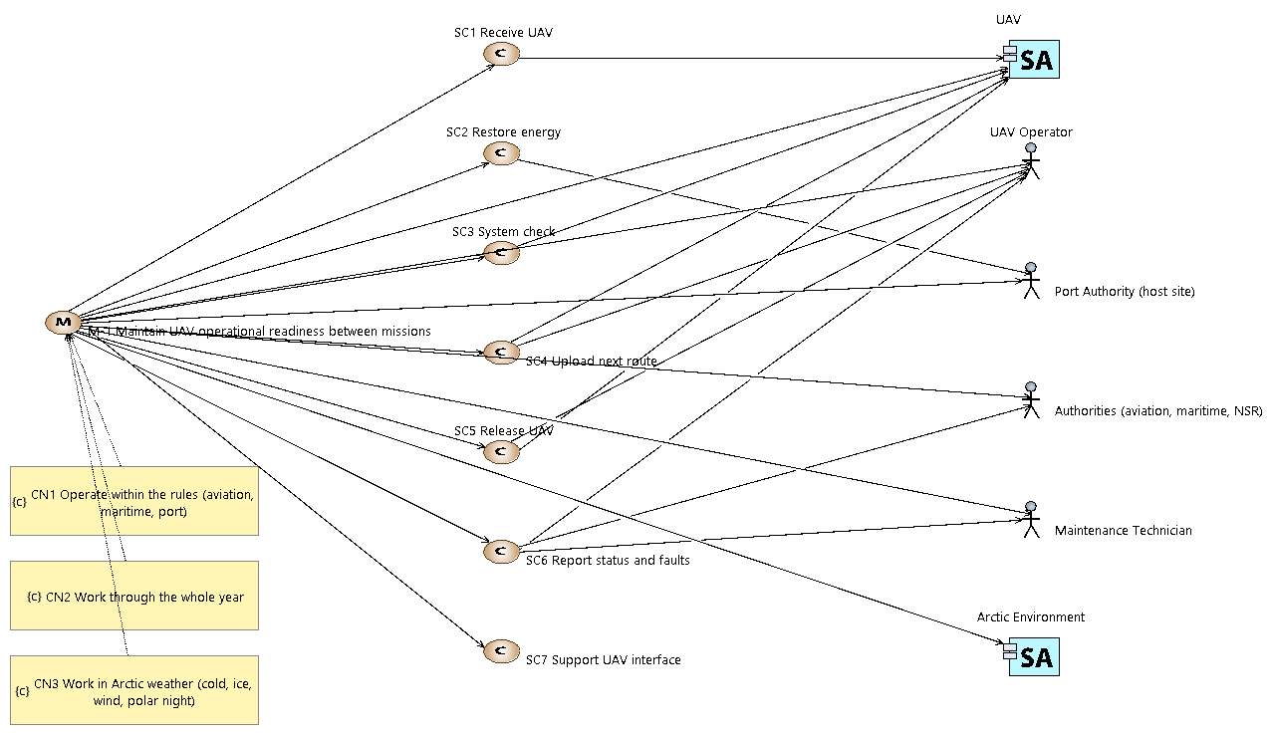
Figure 8. [MCB] Mission, capabilities SC1-SC7, actors and constraints.

3.3 System architecture and interfaces
Interface | Between
UAV interface (landing, charging, data) | UAV Ground Station Network - UAV
Operator data link (satellite) | UAV Ground Station Network - UAV Operator
Site and power interface | UAV Ground Station Network - Port Authority (host site)
Records interface | UAV Ground Station Network - Authorities (aviation, maritime, NSR)
Maintenance access | UAV Ground Station Network - Maintenance Technician
Environmental exposure | UAV Ground Station Network - Arctic Environment
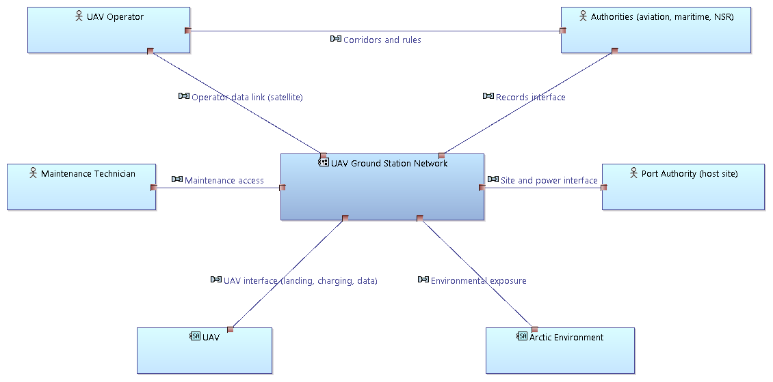
Figure 9. [SAB] System, actors and interfaces.

3.4 System functions
Function | Performed by | Capability | Realises OA activity
Guide the UAV to a precise landing and secure it | UAV Ground Station Network | SC1 | Recover the arriving UAV
Restore UAV energy (contact charging or battery swap) | UAV Ground Station Network | SC2 | Restore UAV energy
System check (motors, sensors, battery, ice) | UAV Ground Station Network | SC3 | Check UAV health
Upload the next validated route | UAV Ground Station Network | SC4 | Load the next route and release the UAV
Release the UAV | UAV Ground Station Network | SC5 | Load the next route and release the UAV
Keep the UAV in safe state | UAV Ground Station Network | SC3 | -
Report status and records | UAV Ground Station Network | SC6 | Report status and records
Provide the UAV interface (landing, charging, data) | UAV Ground Station Network | SC7 | Recover the arriving UAV
Protect the station from the environment | UAV Ground Station Network | (constraints) | -
Fly, land and take off | UAV | SC1, SC5 | Fly and land at NSR ports
Send telemetry and health data | UAV | SC3 | Fly and land at NSR ports
Load the route | UAV | SC4 | Fly and land at NSR ports
Plan routes and supervise | UAV Operator | SC4, SC6 | Plan and supervise UAV operations
Authorize release | UAV Operator | SC5 | Plan and supervise UAV operations
Provide site and power | Port Authority (host site) | SC2 | Host UAV operations in the port
Set rules and audit records | Authorities (aviation, maritime, NSR) | SC6 | Regulate UAV operations, Coordinate navigation on the route
Maintain the station | Maintenance Technician | SC6 | Maintain turnaround equipment
Impose cold, wind, ice and darkness | Arctic Environment | (constraints) | -

3.5 System data flow and functional chains
Functional chain | Exchanges in order
FC1 Nominal turnaround | Secured UAV → Charged UAV → GO/no GO decision → Next route upload → Route-loaded confirmation → Release command
FC2 Fault handling | Secured UAV → Charged UAV → NO-GO decision → Health and fault data → Status, cycle reports → Fault report, maintenance request

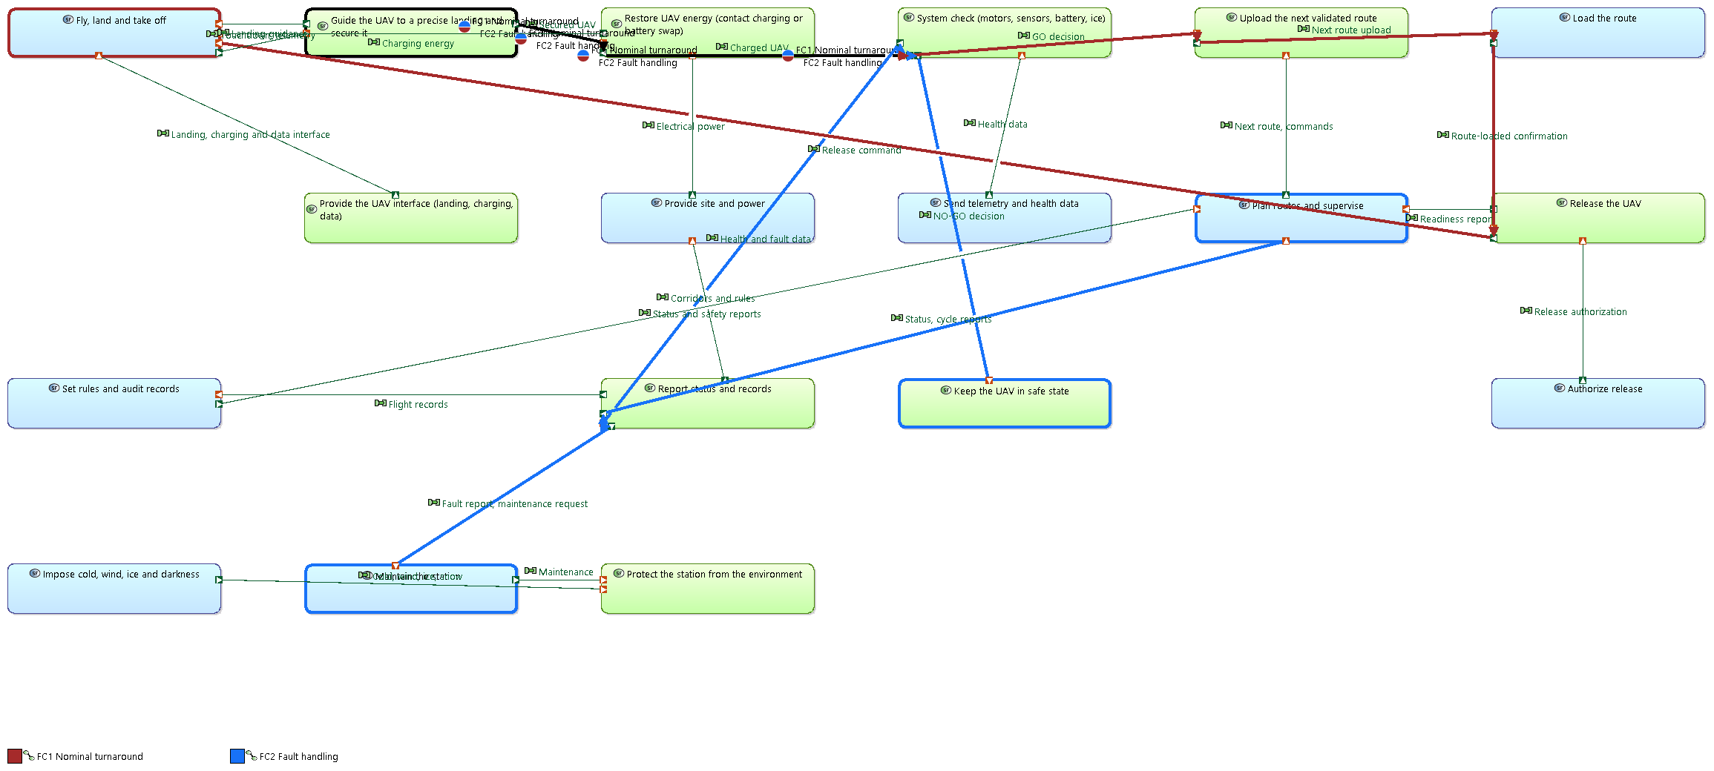
Figure 10. [SDFB] System data flow; FC1 nominal turnaround and FC2 fault handling are highlighted.
Note: this view is dense and some labels overlap. The same exchanges are shown step by step, in time order, in the exchange scenarios (ES) of Section 3.6, where they are clearer.

3.6 System scenarios

SA1 Nominal UAV turnaround (capability SC5, functional chain FC1)
# | Actor / system | Function | Exchange sent → to
1 | UAV Ground Station Network | Guide the UAV to a precise landing and secure it | Landing guidance → UAV
2 | UAV | Fly, land and take off | Touchdown, telemetry → UAV Ground Station Network
3 | UAV Ground Station Network | Guide the UAV to a precise landing and secure it | -
4 | UAV Ground Station Network | Restore UAV energy (contact charging or battery swap) | Charging energy → UAV
5 | UAV | Send telemetry and health data | Health data → UAV Ground Station Network
6 | UAV Ground Station Network | System check (motors, sensors, battery, ice) | -
7 | UAV Operator | Plan routes and supervise | Next route, commands → UAV Ground Station Network
8 | UAV Ground Station Network | Upload the next validated route | Next route upload → UAV
9 | UAV | Load the route | Route-loaded confirmation → UAV Ground Station Network
10 | UAV Ground Station Network | Release the UAV | Readiness report → UAV Operator
11 | UAV Operator | Authorize release | Release authorization → UAV Ground Station Network
12 | UAV Ground Station Network | Release the UAV | Release command → UAV
13 | UAV | Fly, land and take off | -
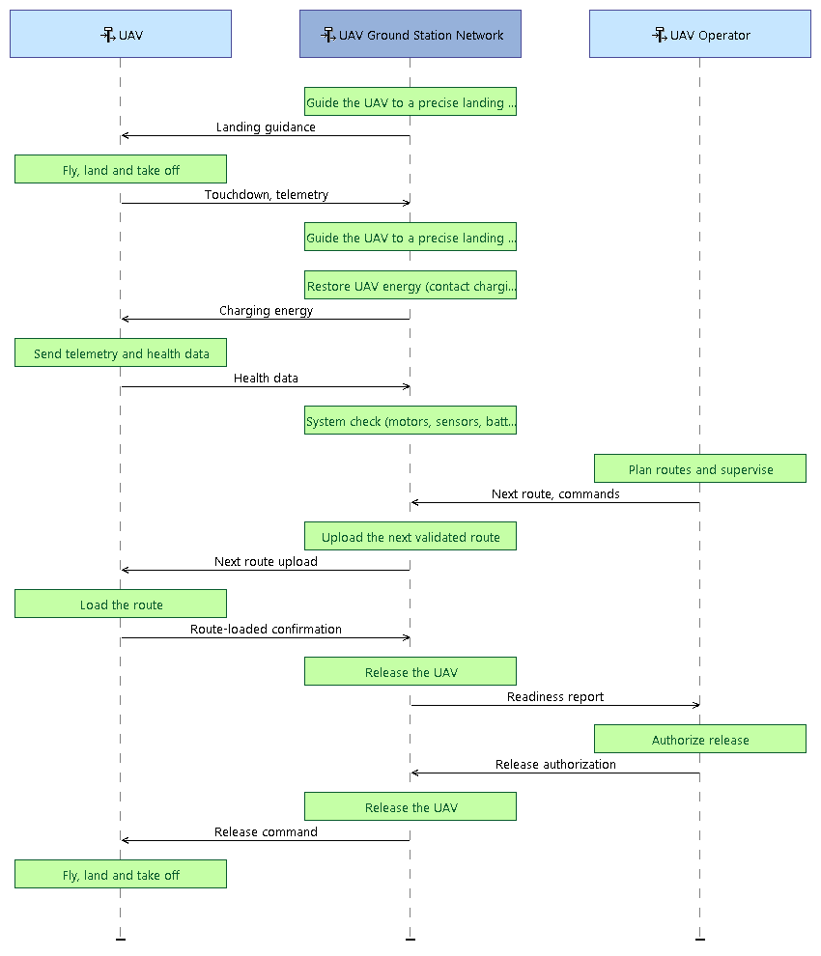
Figure 11. [ES] SA1 Nominal UAV turnaround.

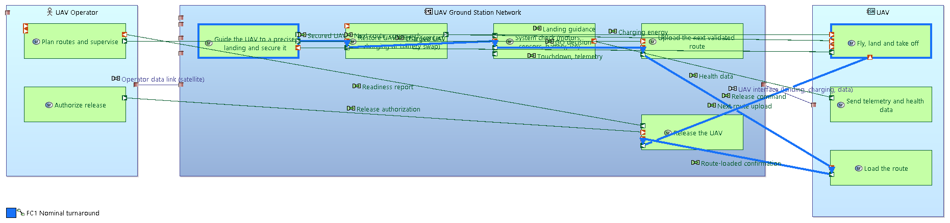
Figure 12. [SAB] Architecture view of the nominal uav turnaround scenario with its functional chain.
Note: this view is dense and some labels overlap. The same exchanges are shown step by step, in time order, in the exchange scenarios (ES) of Section 3.6, where they are clearer.

SA2 System check fails, fault reported (capability SC6, functional chain FC2)
# | Actor / system | Function | Exchange sent → to
1 | UAV Ground Station Network | Guide the UAV to a precise landing and secure it | Landing guidance → UAV
2 | UAV | Fly, land and take off | Touchdown, telemetry → UAV Ground Station Network
3 | UAV Ground Station Network | Guide the UAV to a precise landing and secure it | -
4 | UAV Ground Station Network | Restore UAV energy (contact charging or battery swap) | Charging energy → UAV
5 | UAV | Send telemetry and health data | Health data → UAV Ground Station Network
6 | UAV Ground Station Network | System check (motors, sensors, battery, ice) | -
7 | UAV Ground Station Network | Keep the UAV in safe state | -
8 | UAV Ground Station Network | Report status and records | Status, cycle reports → UAV Operator
9 | UAV Operator | Plan routes and supervise | -
10 | UAV Ground Station Network | Report status and records | Fault report, maintenance request → Maintenance Technician
11 | Maintenance Technician | Maintain the station | -
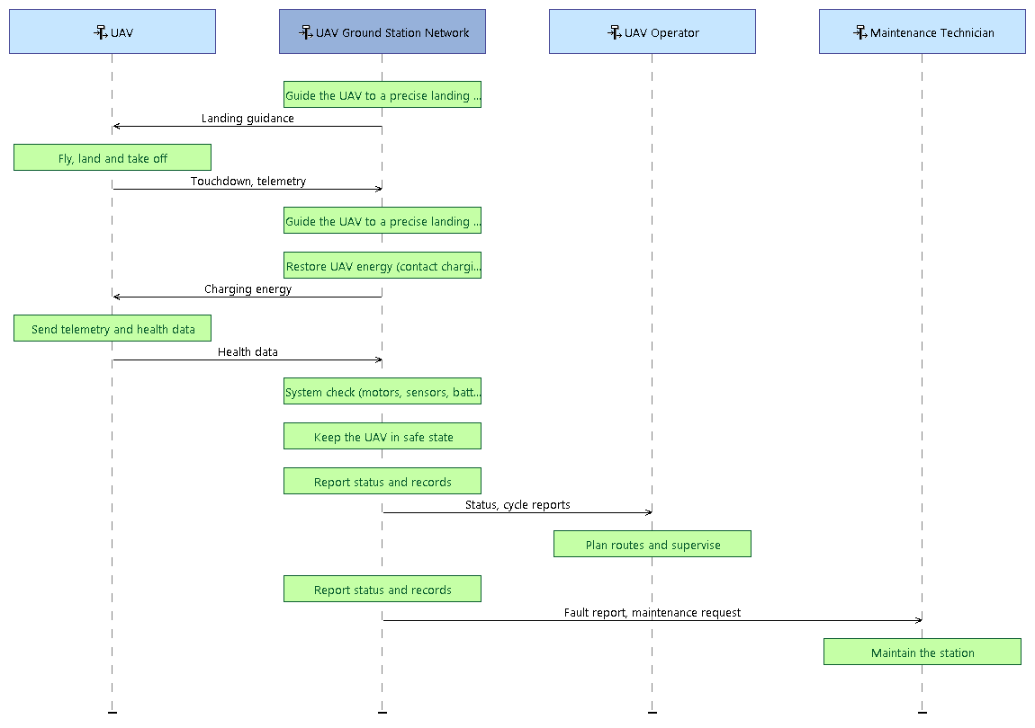
Figure 13. [ES] SA2 System check fails, fault reported.

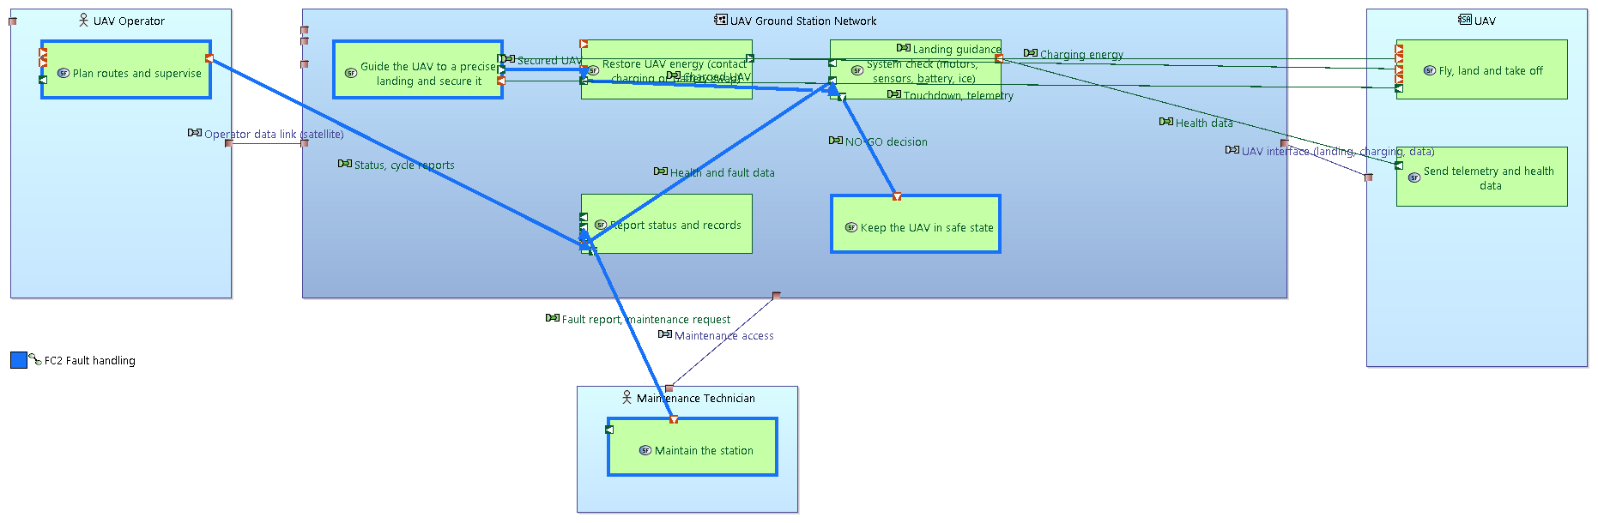
Figure 14. [SAB] Architecture view of the system check fails, fault reported scenario with its functional chain.
Note: this view is dense and some labels overlap. The same exchanges are shown step by step, in time order, in the exchange scenarios (ES) of Section 3.6, where they are clearer.

4. Traceability summary
Stakeholder need (OA) | System capability / constraint (SA)
SN-01 Turn UAVs around at the ports without staff on site | SC1 Receive UAV, SC2 Restore energy
SN-02 Keep UAVs ready for flight along the whole route | SC2 Restore energy, SC3 System check, SC4 Upload next route, SC5 Release UAV
SN-03 Operate safely and within the rules | CN1 Operate within the rules (aviation, maritime, port)
SN-04 Work through the Arctic year | CN2 Work through the whole year, CN3 Work in Arctic weather (cold, ice, wind, polar night)
SN-05 Share status, records and route data | SC4 Upload next route, SC6 Report status and faults
SN-06 Use one interface for different UAVs | SC7 Support UAV interface
The model passes Capella validation with 0 errors.

