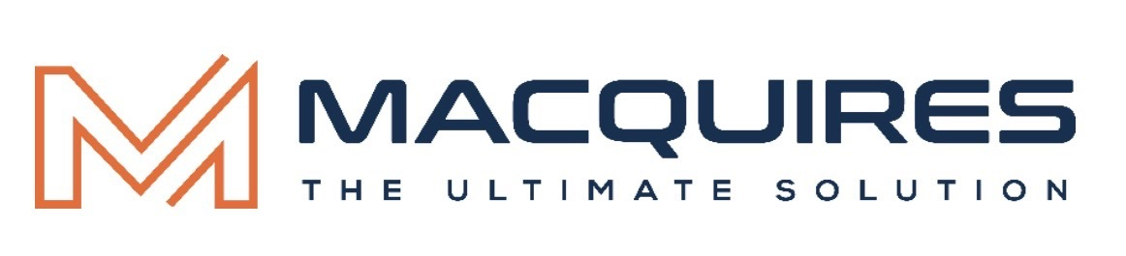

SyriaTel CRM Transformation Blueprint
Prepared for Syriatel CRM Opportunity

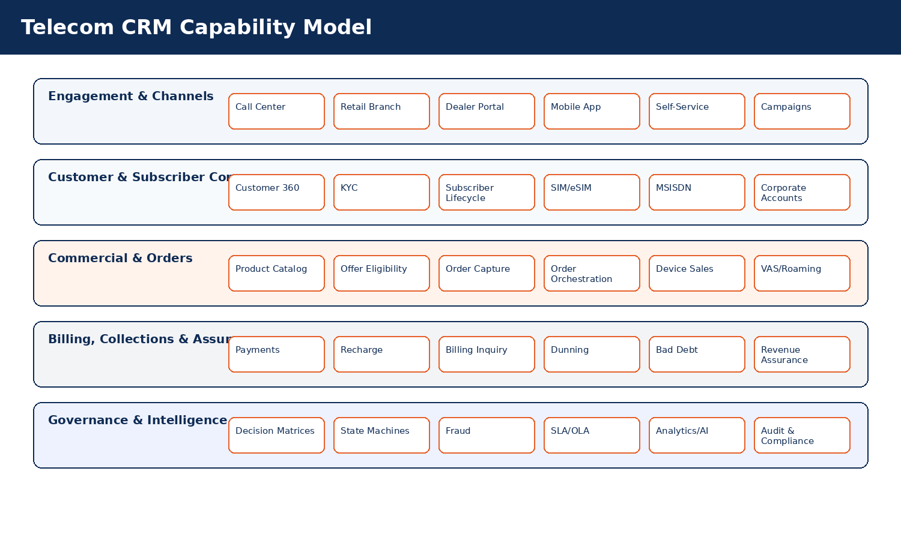
Prepared by Macquires | The Ultimate Solution

Document Control
Item | Details
Document Title | Enterprise Telecom CRM/BSS Transformation Blueprint
Version | V1 - Macquires Executive Design Edition
Prepared For | Syriatel CRM Opportunity
Prepared By | Macquires Solution Team
Purpose | Master business and functional blueprint for telecom CRM/BSS transformation, supported by standalone UI/UX, API/Integration and Technical Architecture documents.
Audience | Executive stakeholders, business owners, telecom operations, PMO, product owners, QA/UAT, functional analysts and development leads.

How to Read This Blueprint
This version intentionally combines consulting-grade sequencing with implementation-level telecom engineering. The document starts with transformation context and capability architecture, then moves into lifecycle/state logic, decision governance, functional domains, rules, validations, data controls, process flows, reporting and appendices.
Key Consideration: Balanced Depth and Readability
The content is structured to avoid repetition by centralizing shared policies, validations, decision matrices and governance repositories while still giving each telecom process enough operational detail for implementation planning.
Design Standard: Macquires Executive Design Standard
This edition applies the Macquires navy and orange visual identity, premium consulting-style section hierarchy, branded headers and footers, and infographic-led explanations while preserving the full V9 telecom engineering depth.

Part | Purpose | Primary Audience
Part 1 - Executive & Transformation Context | Position the CRM/BSS program and explain the operating-model ambition. | Executives, steering committee, PMO
Part 2 - Telecom Capability & Lifecycle Architecture | Show how customers, subscribers, SIM, order and complaint lifecycles are governed. | Architects, business owners, operations
Part 3 - Functional Engineering Domains | Detail each telecom CRM/BSS process with fields, rules, flows and controls. | Product owners, functional analysts, developers, QA
Part 4 - Governance Repositories | Centralized business rules, validations, decision matrices, SLA and data controls. | PMO, compliance, QA, operations
Part 5 - Reporting, Testing & Appendices | KPI framework, test strategy, glossary and reference catalogs. | QA, reporting, support, training

Part 1 - Executive & Transformation Context

Executive Summary
Syriatel requires a telecom-native CRM platform that manages the complete customer and subscriber lifecycle across retail, corporate, dealer, digital and service channels. The target solution is not only a traditional CRM; it is an enterprise CRM/BSS operating model integrating customer management, sales, subscription operations, provisioning, billing interactions, collections, fraud, revenue assurance, dealer operations, network-aware support and analytics.
Key Telecom Consideration: Transformation Objective
Establish a unified customer and subscriber operating layer that improves service activation quality, customer experience, operational governance, revenue protection, dealer control and digital-service scalability.

Strategic Business Outcomes
Outcome | Business Value | Enabling CRM/BSS Capabilities
Unified Customer 360 | Single view of customer, subscriber, services, payments, complaints and interactions. | Customer Master, Subscriber Profile, Timeline Engine, Case Management
Faster Service Activation | Reduce activation delays and fallout. | Order Orchestration, Provisioning Monitoring, Inventory Validation
Improved Revenue Protection | Reduce leakage and mismatches. | Revenue Assurance, Billing Reconciliation, Event Catalog
Fraud & Risk Control | Prevent SIM takeover, suspicious activations and dealer abuse. | Fraud Scoring, Decision Matrices, Blacklist Controls
Operational Governance | Standardized approvals, SLAs, queues and escalations. | Workflow, SLA/OLA Framework, Command Center
Digital Readiness | Support self-service, campaigns, AI and omnichannel interactions. | Digital Channels, Consent, AI Analytics, Notification Engine

Transformation Principles
Principle | Implication for Design
Lifecycle-driven design | Every customer, subscriber, SIM, order, device installment and complaint follows governed states and allowed transitions.
Decision-led operations | Eligibility, approval, rejection and escalation decisions are executed through transparent decision matrices.
Event-driven synchronization | CRM processes emit and consume events from billing, provisioning, inventory, network and payment systems.
Centralized controls | Shared rules, validations, SLAs and fraud controls are centralized and referenced by processes to avoid duplication.
Auditability by design | Critical data and lifecycle changes are logged with before/after values, actor, source channel and approval trace.
Customer experience protection | VIP, corporate, impacted-outage and high-risk customers receive differentiated routing and controls.

SyriaTel CRM Ecosystem Overview
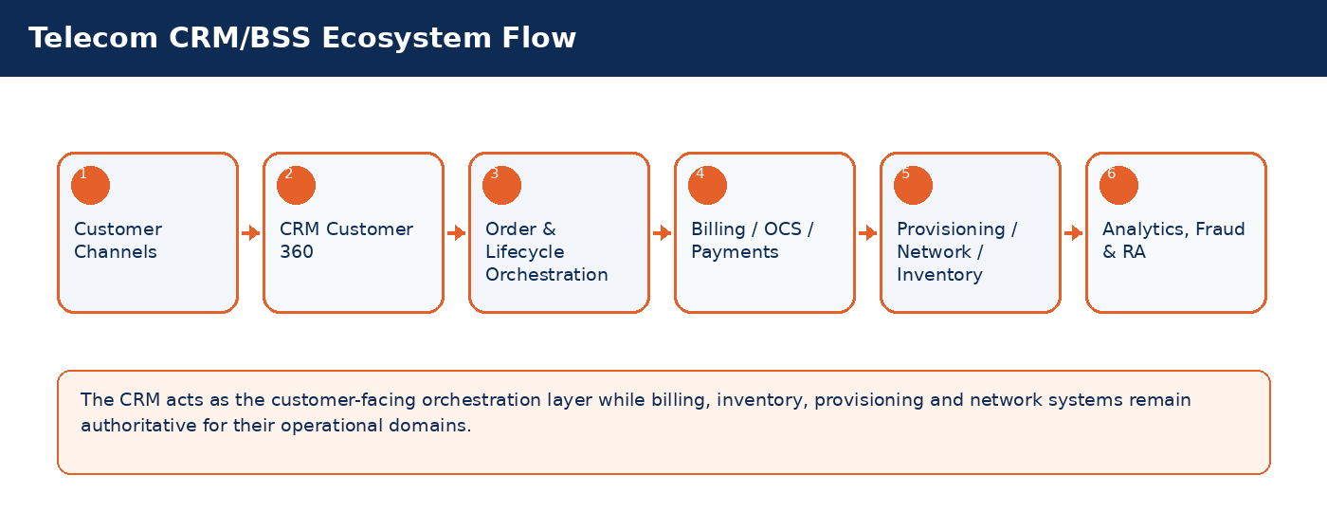

Part 2 - SyriaTel Capability & Lifecycle Architecture

SyriaTel CRM Capability Model
The capability model organizes CRM/BSS functions into business capability layers. This allows the program to communicate scope, align ownership, identify integration domains and reduce overlap between functional modules.


Capability Ownership Matrix
Capability Domain | Primary Owner | Key Systems | Representative Processes
Customer & KYC Management | Customer Operations / Compliance | CRM, KYC, DMS | Customer onboarding, profile update, consent, duplicate management
Subscriber Lifecycle | Subscriber Operations | CRM, Billing, Provisioning, Inventory | Selling line, change GSM, suspension, reconnect, termination
Commercial Catalog | Product Management | CRM, Billing, Campaign System | Offers, bundles, eligibility, VAS, roaming packages
Order Fulfillment | Operations / IT | CRM, Order Orchestrator, Provisioning | Order decomposition, fulfillment, fallout, retries
Billing Interaction | Finance / Billing Operations | Billing, OCS, CRM, Payment Gateway | Payments, recharge, disputes, refunds, collections
Dealer & Retail | Sales Operations | CRM, POS, Inventory, Finance | Dealer quota, SIM allocation, device stock, reconciliation
Assurance & Fraud | Fraud / RA Teams | Fraud Engine, Billing, Network, CRM | Leakage detection, SIM-box alerts, activation mismatches
Network-Aware CRM | NOC / Customer Experience | Network Assurance, CRM, Notification | Outage correlation, impacted customers, proactive notification

Customer Lifecycle Journey
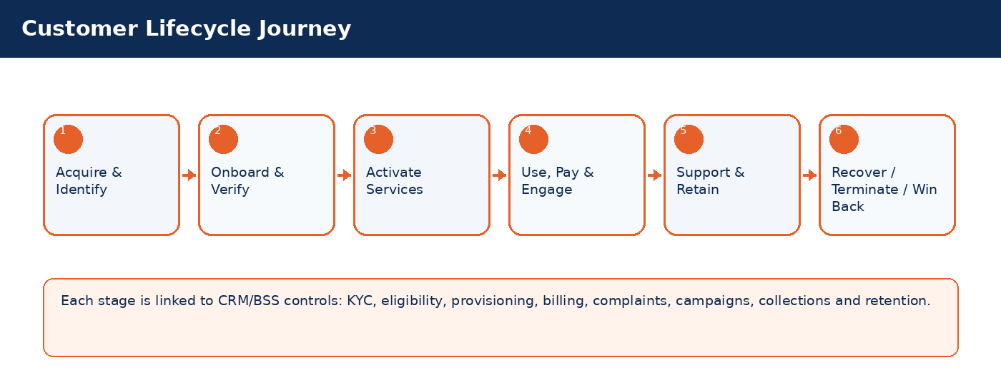

Lifecycle State Machines
State machines define allowed lifecycle transitions. They should be configured in the CRM workflow/rules engine and referenced by UI, API, reporting and audit controls.
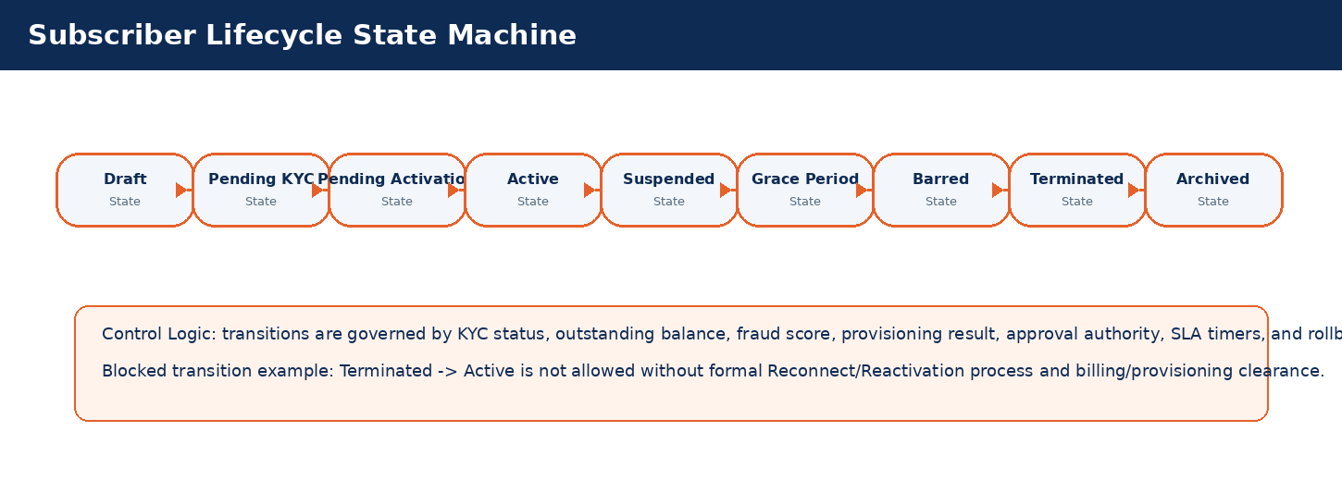
Current State | Typical Next State | Trigger | Blocking / Control Logic
Draft | Pending KYC | Workflow action, system event, scheduled timer or supervisor approval | Transition is blocked when KYC, billing, fraud, inventory or provisioning prerequisites are not satisfied.
Pending KYC | Pending Activation | Workflow action, system event, scheduled timer or supervisor approval | Transition is blocked when KYC, billing, fraud, inventory or provisioning prerequisites are not satisfied.
Pending Activation | Active | Workflow action, system event, scheduled timer or supervisor approval | Transition is blocked when KYC, billing, fraud, inventory or provisioning prerequisites are not satisfied.
Active | Suspended | Workflow action, system event, scheduled timer or supervisor approval | Transition is blocked when KYC, billing, fraud, inventory or provisioning prerequisites are not satisfied.
Suspended | Grace Period | Workflow action, system event, scheduled timer or supervisor approval | Transition is blocked when KYC, billing, fraud, inventory or provisioning prerequisites are not satisfied.
Grace Period | Barred | Workflow action, system event, scheduled timer or supervisor approval | Transition is blocked when KYC, billing, fraud, inventory or provisioning prerequisites are not satisfied.
Barred | Terminated | Workflow action, system event, scheduled timer or supervisor approval | Transition is blocked when KYC, billing, fraud, inventory or provisioning prerequisites are not satisfied.
Terminated | Archived | Workflow action, system event, scheduled timer or supervisor approval | Transition is blocked when KYC, billing, fraud, inventory or provisioning prerequisites are not satisfied.
Archived | No forward state unless archive/reopen policy permits | Workflow action, system event, scheduled timer or supervisor approval | Transition is blocked when KYC, billing, fraud, inventory or provisioning prerequisites are not satisfied.

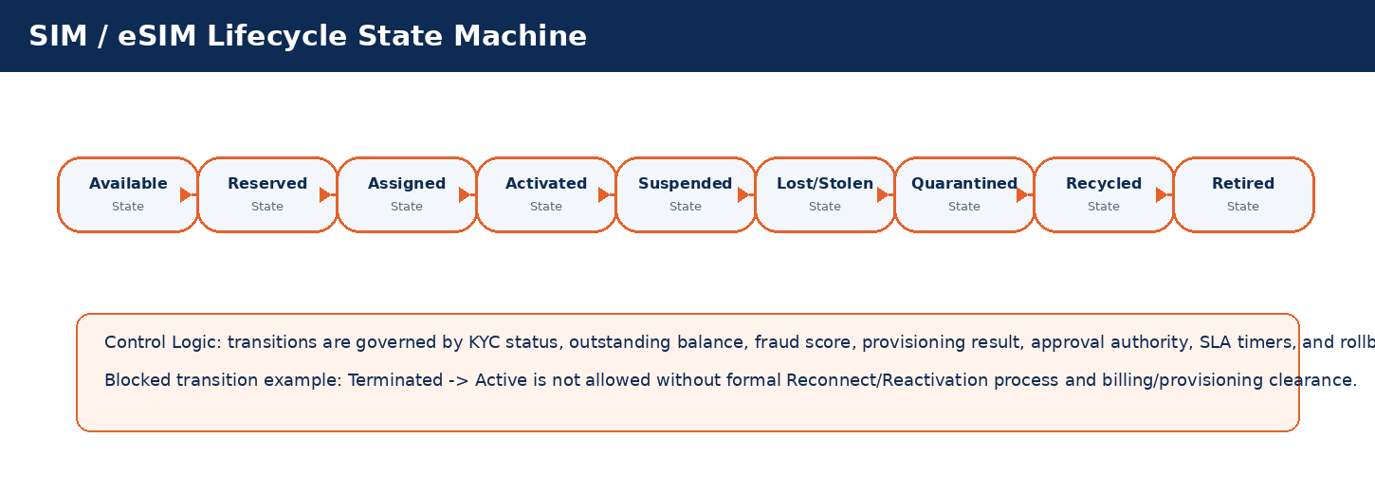
Current State | Typical Next State | Trigger | Blocking / Control Logic
Available | Reserved | Workflow action, system event, scheduled timer or supervisor approval | Transition is blocked when KYC, billing, fraud, inventory or provisioning prerequisites are not satisfied.
Reserved | Assigned | Workflow action, system event, scheduled timer or supervisor approval | Transition is blocked when KYC, billing, fraud, inventory or provisioning prerequisites are not satisfied.
Assigned | Activated | Workflow action, system event, scheduled timer or supervisor approval | Transition is blocked when KYC, billing, fraud, inventory or provisioning prerequisites are not satisfied.
Activated | Suspended | Workflow action, system event, scheduled timer or supervisor approval | Transition is blocked when KYC, billing, fraud, inventory or provisioning prerequisites are not satisfied.
Suspended | Lost/Stolen | Workflow action, system event, scheduled timer or supervisor approval | Transition is blocked when KYC, billing, fraud, inventory or provisioning prerequisites are not satisfied.
Lost/Stolen | Quarantined | Workflow action, system event, scheduled timer or supervisor approval | Transition is blocked when KYC, billing, fraud, inventory or provisioning prerequisites are not satisfied.
Quarantined | Recycled | Workflow action, system event, scheduled timer or supervisor approval | Transition is blocked when KYC, billing, fraud, inventory or provisioning prerequisites are not satisfied.
Recycled | Retired | Workflow action, system event, scheduled timer or supervisor approval | Transition is blocked when KYC, billing, fraud, inventory or provisioning prerequisites are not satisfied.
Retired | No forward state unless archive/reopen policy permits | Workflow action, system event, scheduled timer or supervisor approval | Transition is blocked when KYC, billing, fraud, inventory or provisioning prerequisites are not satisfied.

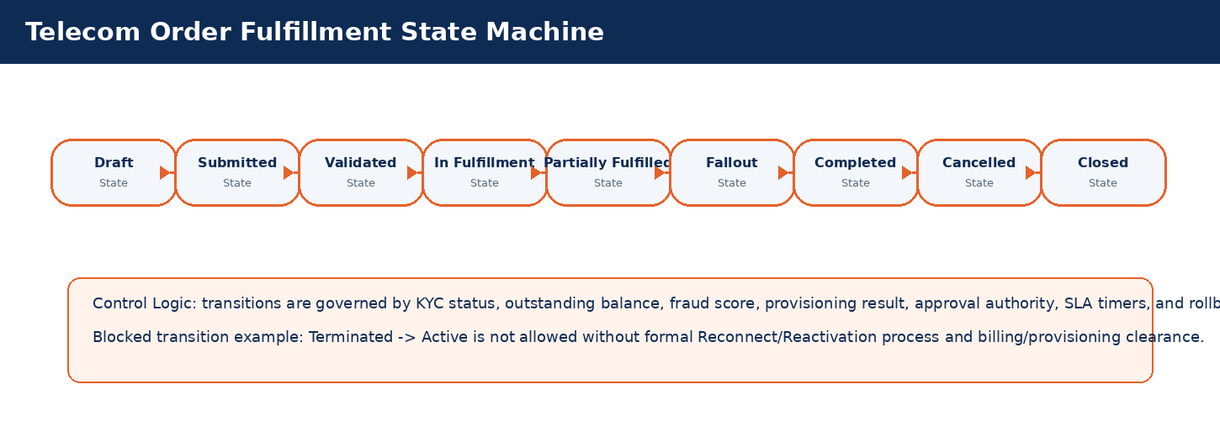
Current State | Typical Next State | Trigger | Blocking / Control Logic
Draft | Submitted | Workflow action, system event, scheduled timer or supervisor approval | Transition is blocked when KYC, billing, fraud, inventory or provisioning prerequisites are not satisfied.
Submitted | Validated | Workflow action, system event, scheduled timer or supervisor approval | Transition is blocked when KYC, billing, fraud, inventory or provisioning prerequisites are not satisfied.
Validated | In Fulfillment | Workflow action, system event, scheduled timer or supervisor approval | Transition is blocked when KYC, billing, fraud, inventory or provisioning prerequisites are not satisfied.
In Fulfillment | Partially Fulfilled | Workflow action, system event, scheduled timer or supervisor approval | Transition is blocked when KYC, billing, fraud, inventory or provisioning prerequisites are not satisfied.
Partially Fulfilled | Fallout | Workflow action, system event, scheduled timer or supervisor approval | Transition is blocked when KYC, billing, fraud, inventory or provisioning prerequisites are not satisfied.
Fallout | Completed | Workflow action, system event, scheduled timer or supervisor approval | Transition is blocked when KYC, billing, fraud, inventory or provisioning prerequisites are not satisfied.
Completed | Cancelled | Workflow action, system event, scheduled timer or supervisor approval | Transition is blocked when KYC, billing, fraud, inventory or provisioning prerequisites are not satisfied.
Cancelled | Closed | Workflow action, system event, scheduled timer or supervisor approval | Transition is blocked when KYC, billing, fraud, inventory or provisioning prerequisites are not satisfied.
Closed | No forward state unless archive/reopen policy permits | Workflow action, system event, scheduled timer or supervisor approval | Transition is blocked when KYC, billing, fraud, inventory or provisioning prerequisites are not satisfied.
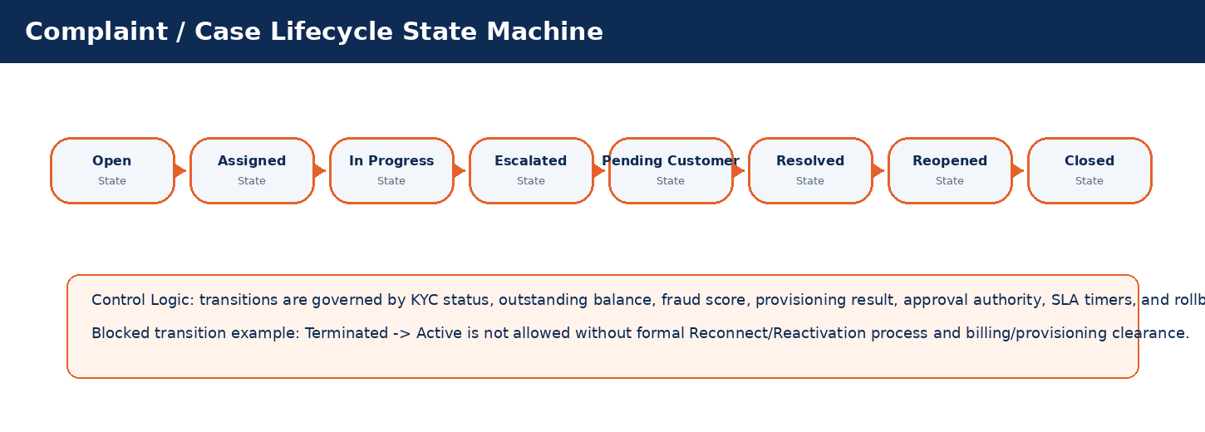
Current State | Typical Next State | Trigger | Blocking / Control Logic
Open | Assigned | Workflow action, system event, scheduled timer or supervisor approval | Transition is blocked when KYC, billing, fraud, inventory or provisioning prerequisites are not satisfied.
Assigned | In Progress | Workflow action, system event, scheduled timer or supervisor approval | Transition is blocked when KYC, billing, fraud, inventory or provisioning prerequisites are not satisfied.
In Progress | Escalated | Workflow action, system event, scheduled timer or supervisor approval | Transition is blocked when KYC, billing, fraud, inventory or provisioning prerequisites are not satisfied.
Escalated | Pending Customer | Workflow action, system event, scheduled timer or supervisor approval | Transition is blocked when KYC, billing, fraud, inventory or provisioning prerequisites are not satisfied.
Pending Customer | Resolved | Workflow action, system event, scheduled timer or supervisor approval | Transition is blocked when KYC, billing, fraud, inventory or provisioning prerequisites are not satisfied.
Resolved | Reopened | Workflow action, system event, scheduled timer or supervisor approval | Transition is blocked when KYC, billing, fraud, inventory or provisioning prerequisites are not satisfied.
Reopened | Closed | Workflow action, system event, scheduled timer or supervisor approval | Transition is blocked when KYC, billing, fraud, inventory or provisioning prerequisites are not satisfied.
Closed | No forward state unless archive/reopen policy permits | Workflow action, system event, scheduled timer or supervisor approval | Transition is blocked when KYC, billing, fraud, inventory or provisioning prerequisites are not satisfied.

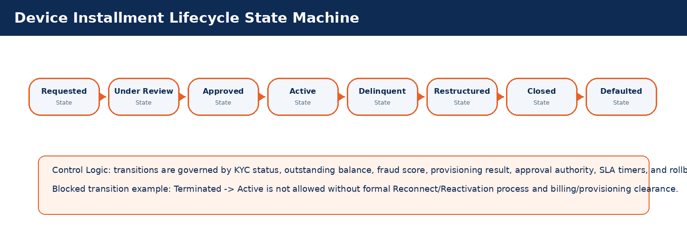

Current State | Typical Next State | Trigger | Blocking / Control Logic
Requested | Under Review | Workflow action, system event, scheduled timer or supervisor approval | Transition is blocked when KYC, billing, fraud, inventory or provisioning prerequisites are not satisfied.
Under Review | Approved | Workflow action, system event, scheduled timer or supervisor approval | Transition is blocked when KYC, billing, fraud, inventory or provisioning prerequisites are not satisfied.
Approved | Active | Workflow action, system event, scheduled timer or supervisor approval | Transition is blocked when KYC, billing, fraud, inventory or provisioning prerequisites are not satisfied.
Active | Delinquent | Workflow action, system event, scheduled timer or supervisor approval | Transition is blocked when KYC, billing, fraud, inventory or provisioning prerequisites are not satisfied.
Delinquent | Restructured | Workflow action, system event, scheduled timer or supervisor approval | Transition is blocked when KYC, billing, fraud, inventory or provisioning prerequisites are not satisfied.
Restructured | Closed | Workflow action, system event, scheduled timer or supervisor approval | Transition is blocked when KYC, billing, fraud, inventory or provisioning prerequisites are not satisfied.
Closed | Defaulted | Workflow action, system event, scheduled timer or supervisor approval | Transition is blocked when KYC, billing, fraud, inventory or provisioning prerequisites are not satisfied.
Defaulted | No forward state unless archive/reopen policy permits | Workflow action, system event, scheduled timer or supervisor approval | Transition is blocked when KYC, billing, fraud, inventory or provisioning prerequisites are not satisfied.

Telecom Decision Matrices

SIM Replacement Eligibility Matrix
Condition | Decision / Result | Approval Required | SLA | Escalation / Exception
Customer KYC approved + active subscriber + no fraud flag | Allow replacement | CSR only | Standard SLA | Provisioning failure to fallout queue
Lost/stolen SIM reported | Allow with OTP and quarantine old SIM | Supervisor for high-risk | Priority SLA | Fraud team if repeated cases
Outstanding balance above threshold | Hold or require payment | Collections approval | Pending until cleared | Collections queue
Fraud score high or blacklisted | Reject / suspend pending investigation | Fraud manager | Immediate | Fraud case

Reconnect Eligibility Matrix
Condition | Decision / Result | Approval Required | SLA | Escalation / Exception
Suspended for customer request and end date reached | Auto or CSR reconnect | No approval | Same business day | Provisioning retry
Billing suspension with paid balance | Reconnect after payment confirmation | No approval if within limit | Near real-time | Billing sync failure queue
Fraud suspension cleared | Reconnect | Fraud approval | Controlled SLA | Fraud governance
Regulatory bar | Blocked | Compliance authority only | As mandated | Compliance escalation

Device Financing Eligibility Matrix
Condition | Decision / Result | Approval Required | SLA | Escalation / Exception
Good payment history + low risk score | Approve installment | Finance officer | Standard | Contract generation
New customer with insufficient history | Require deposit/down payment | Supervisor | Standard | Manual review
Existing delinquent installment | Reject | No approval | Immediate | Collections action
VIP customer exception | Conditional approval | Manager | Priority | VIP relationship manager

Roaming Activation Matrix
Condition | Decision / Result | Approval Required | SLA | Escalation / Exception
Postpaid active + credit limit available | Allow | CSR | Immediate | Fraud monitoring
Prepaid active + sufficient balance | Allow package | CSR | Immediate | OCS validation failure
High risk destination / high fraud score | Hold | Fraud approval | Controlled | Fraud queue
Delinquent account | Reject or require payment | Collections | Pending | Collections queue

Part 3 - Deep Functional Engineering Domains
Each functional domain below follows the same structure: purpose, actors, prerequisites, process flow, field context, business rules, validations, exception handling, integrations, notifications, audit requirements, KPIs and acceptance criteria. Shared rules and validations are centralized later in the governance repositories.

1. Customer 360 & KYC Management
Create and govern a unified customer master profile across retail, corporate, VIP, dealer-assisted and digital channels.
Domain Summary: Domain Objective
Create and govern a unified customer master profile across retail, corporate, VIP, dealer-assisted and digital channels.

Actors and Stakeholders
Actor / Role | Responsibility
CSR Agent | Participates in initiation, validation, approval, fulfillment, monitoring or exception handling for this domain.
KYC Officer | Participates in initiation, validation, approval, fulfillment, monitoring or exception handling for this domain.
Supervisor | Participates in initiation, validation, approval, fulfillment, monitoring or exception handling for this domain.
Compliance Officer | Participates in initiation, validation, approval, fulfillment, monitoring or exception handling for this domain.

Preconditions and Postconditions
Preconditions | Postconditions
Customer has provided identity documents; Authorized channel is selected; KYC validation service is available | Customer profile is created/updated; Duplicate checks are completed; Audit trail and consent record are stored

Process Flow Infographic
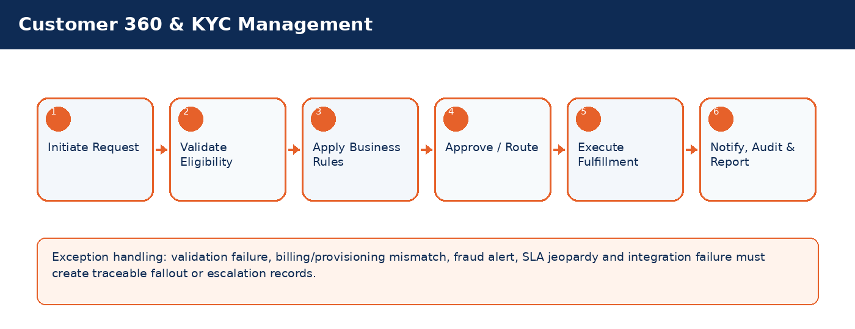

Detailed Process Flow
# | Stage | Business Activity | System Behavior | Exception Handling
1 | Request Initiation | Authorized user selects customer/subscriber and transaction type. | System loads customer, subscriber, service, billing and risk context. | Missing context blocks submission.
2 | Eligibility Validation | System validates KYC, status, balances, inventory, offer compatibility and fraud indicators. | Eligibility result stored against transaction. | Failed rule creates visible reason and next action.
3 | Business Rule Execution | Rules engine applies telecom policy, approval thresholds and lifecycle transition controls. | Decision generated: approve, reject, hold, escalate, or request additional data. | Manual override requires authority and audit reason.
4 | Approval / Queue Routing | Workflow routes request to supervisor, finance, fraud, compliance, NOC or back-office team where required. | Approver action captured with timestamp. | SLA timer and escalation path activated.
5 | Fulfillment / Integration | CRM calls billing, inventory, payment, provisioning or network systems as applicable. | Transaction reaches completed, pending, failed or fallout state. | Retry/rollback/fallout rules applied.
6 | Closure & Communication | Customer/internal notifications issued; audit and reports updated. | Lifecycle state, timeline and KPIs updated. | Unresolved exceptions remain in operational queue.

Functional Field Context and Data Controls
Field | Business Meaning | Source of Truth | Mandatory Rule | Editability | Security/Data Control | Audit Rule
National ID | Business-critical telecom field used to control lifecycle, eligibility, reporting or integration behavior. | Source system / CRM master depending on domain | Mandatory or conditional based on transaction type | Editable in Draft; locked after fulfillment unless controlled correction process is used | Masked/encrypted when PII, financial or network-sensitive | Full before/after audit for changes after submission
Customer Type | Business-critical telecom field used to control lifecycle, eligibility, reporting or integration behavior. | Source system / CRM master depending on domain | Mandatory or conditional based on transaction type | Editable in Draft; locked after fulfillment unless controlled correction process is used | Masked/encrypted when PII, financial or network-sensitive | Full before/after audit for changes after submission
Customer Name Arabic | Business-critical telecom field used to control lifecycle, eligibility, reporting or integration behavior. | Source system / CRM master depending on domain | Mandatory or conditional based on transaction type | Editable in Draft; locked after fulfillment unless controlled correction process is used | Masked/encrypted when PII, financial or network-sensitive | Full before/after audit for changes after submission
Customer Name English | Business-critical telecom field used to control lifecycle, eligibility, reporting or integration behavior. | Source system / CRM master depending on domain | Mandatory or conditional based on transaction type | Editable in Draft; locked after fulfillment unless controlled correction process is used | Masked/encrypted when PII, financial or network-sensitive | Full before/after audit for changes after submission
Date of Birth | Business-critical telecom field used to control lifecycle, eligibility, reporting or integration behavior. | Source system / CRM master depending on domain | Mandatory or conditional based on transaction type | Editable in Draft; locked after fulfillment unless controlled correction process is used | Masked/encrypted when PII, financial or network-sensitive | Full before/after audit for changes after submission
Primary MSISDN | Business-critical telecom field used to control lifecycle, eligibility, reporting or integration behavior. | Source system / CRM master depending on domain | Mandatory or conditional based on transaction type | Editable in Draft; locked after fulfillment unless controlled correction process is used | Masked/encrypted when PII, financial or network-sensitive | Full before/after audit for changes after submission
Segment | Business-critical telecom field used to control lifecycle, eligibility, reporting or integration behavior. | Source system / CRM master depending on domain | Mandatory or conditional based on transaction type | Editable in Draft; locked after fulfillment unless controlled correction process is used | Masked/encrypted when PII, financial or network-sensitive | Full before/after audit for changes after submission
KYC Status | Business-critical telecom field used to control lifecycle, eligibility, reporting or integration behavior. | CRM | Mandatory or conditional based on transaction type | Editable in Draft; locked after fulfillment unless controlled correction process is used | Masked/encrypted when PII, financial or network-sensitive | Full before/after audit for changes after submission
Consent Flag | Business-critical telecom field used to control lifecycle, eligibility, reporting or integration behavior. | Source system / CRM master depending on domain | Mandatory or conditional based on transaction type | Editable in Draft; locked after fulfillment unless controlled correction process is used | Masked/encrypted when PII, financial or network-sensitive | Full before/after audit for changes after submission
Risk Score | Business-critical telecom field used to control lifecycle, eligibility, reporting or integration behavior. | Source system / CRM master depending on domain | Mandatory or conditional based on transaction type | Editable in Draft; locked after fulfillment unless controlled correction process is used | Masked/encrypted when PII, financial or network-sensitive | Full before/after audit for changes after submission

Business Rules
Rule ID | Rule Area | Rule Statement | Severity | System Action
BR-01 | Lifecycle control | Requested action must be valid for the current customer/subscriber/SIM/order state. | High | Reject action and display reason.
BR-02 | Eligibility control | Customer, subscriber, offer, inventory and billing conditions must satisfy the applicable decision matrix. | High | Hold, reject or route for approval.
BR-03 | Fraud and risk control | High fraud score, blacklist or suspicious pattern must route to fraud governance before completion. | Critical | Suspend fulfillment and open fraud review.
BR-04 | Approval authority | Approval levels depend on transaction amount, customer segment, risk score, corporate authority and operational impact. | High | Route to required approver.
BR-05 | Integration consistency | Fulfillment is not complete until authoritative downstream systems confirm success. | Critical | Place transaction in pending/fallout and trigger retry.
BR-06 | Auditability | Manual override, rejection, approval and lifecycle transition must capture reason, actor, timestamp and channel. | Critical | Block completion if reason missing.

Validation Logic
Validation ID | Validation Rule | Validation Mode | Failure Behavior | Message Guidance
VAL-01-01 | ID format and uniqueness validation | Real-time where possible; asynchronous for cross-system checks | Block, hold, escalate or create fallout based on severity | User-friendly message with corrective action
VAL-01-02 | Sanctions/blacklist screening | Real-time where possible; asynchronous for cross-system checks | Block, hold, escalate or create fallout based on severity | User-friendly message with corrective action
VAL-01-03 | Duplicate fuzzy match on name/date of birth/mobile | Real-time where possible; asynchronous for cross-system checks | Block, hold, escalate or create fallout based on severity | User-friendly message with corrective action
VAL-01-04 | Mandatory consent capture before marketing opt-in | Real-time where possible; asynchronous for cross-system checks | Block, hold, escalate or create fallout based on severity | User-friendly message with corrective action
VAL-01-05 | Sensitive fields masked unless user has privilege | Real-time where possible; asynchronous for cross-system checks | Block, hold, escalate or create fallout based on severity | User-friendly message with corrective action

Alternate and Exception Flows
Scenario | Trigger | Expected Handling | Owner
Cross-system validation unavailable | Billing/provisioning/payment/KYC service timeout | Set request to Pending Validation, retry according to policy, notify operations if SLA jeopardy occurs. | Integration / Operations
Eligibility failed | Business rule violation such as unpaid balance, invalid state, unavailable inventory or blacklisted customer | Display reason, prevent completion, provide allowed next action such as collect payment, select different offer or escalate. | CSR / Supervisor
Fulfillment fallout | Downstream activation/provisioning/billing step fails after CRM submission | Create fallout case with correlation ID, retry if safe, rollback if required, route to responsible team. | Provisioning / IT
Manual override requested | Business user requests exception to standard rule | Require authority limit, reason code, evidence attachment and audit entry. | Supervisor / Compliance
SLA jeopardy | Transaction approaches or breaches defined SLA | Escalate to next level and expose in operational dashboard. | Operations Manager

Integration Touchpoints and Events
Integration / Event | Direction | Purpose | Failure Handling
Customer / KYC validation | CRM -> KYC | Identity verification and duplicate/risk checks. | Pending validation with retry and manual review queue.
Billing / OCS validation | CRM <-> Billing | Balance, credit limit, invoice, recharge, payment and subscription checks. | Hold transaction or create billing reconciliation task.
Inventory validation | CRM <-> Inventory | SIM, MSISDN, device and stock availability confirmation. | Release reservation or retry inventory synchronization.
Provisioning request | CRM -> Provisioning | Activate, suspend, reconnect, terminate or modify service. | Fallout queue, retry, rollback and manual intervention.
Notification event | CRM -> SMS/Email/Push | Customer/internal communication. | Retry and log notification delivery status.

Notifications, Audit, KPIs and Acceptance Criteria
Area | Detailed Requirement
Notifications | Send customer notification when request is received, approved/rejected, completed, failed or requires action. Internal escalation notification must be sent for SLA jeopardy and high-risk exceptions.
Audit | Capture actor, channel, timestamp, request state, before/after values, external correlation IDs, approval comments and override reasons.
KPIs | Track volume, completion rate, fallout rate, SLA compliance, average handling time, rejection reasons, manual override count and customer impact for Customer 360 & KYC Management.
Acceptance Criteria | Given authorized user and valid conditions, when transaction is submitted, then system validates eligibility, applies rules, routes approvals, triggers fulfillment, updates lifecycle state, creates audit entry and sends notifications. Given failed downstream fulfillment, then request must be moved to fallout with correlation ID and visible recovery action.

2. Selling Line & New Activation
Manage the full new line selling process from customer identification through SIM/MSISDN assignment, offer selection, payment, provisioning and activation confirmation.
Domain Summary: Domain Objective
Manage the full new line selling process from customer identification through SIM/MSISDN assignment, offer selection, payment, provisioning and activation confirmation.

Actors and Stakeholders
Actor / Role | Responsibility
Branch CSR | Participates in initiation, validation, approval, fulfillment, monitoring or exception handling for this domain.
Dealer Agent | Participates in initiation, validation, approval, fulfillment, monitoring or exception handling for this domain.
Activation Officer | Participates in initiation, validation, approval, fulfillment, monitoring or exception handling for this domain.
Billing System | Participates in initiation, validation, approval, fulfillment, monitoring or exception handling for this domain.
Provisioning System | Participates in initiation, validation, approval, fulfillment, monitoring or exception handling for this domain.

Preconditions and Postconditions
Preconditions | Postconditions
Customer profile exists or is created; Available SIM and MSISDN inventory exists; Offer is active and eligible | Subscriber is active or pending activation; Billing account is created; Provisioning completion is recorded

Process Flow Infographic
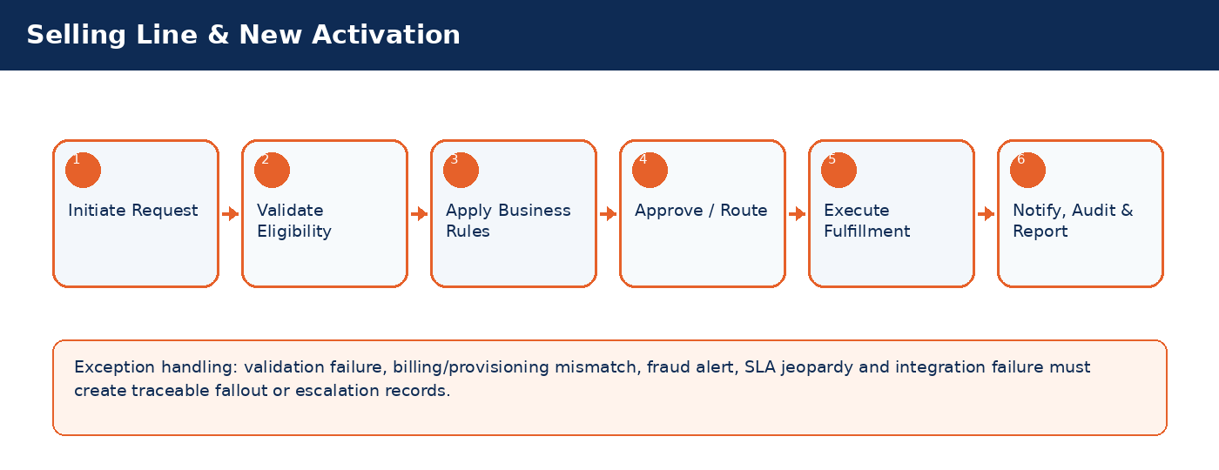

Detailed Process Flow
# | Stage | Business Activity | System Behavior | Exception Handling
1 | Request Initiation | Authorized user selects customer/subscriber and transaction type. | System loads customer, subscriber, service, billing and risk context. | Missing context blocks submission.
2 | Eligibility Validation | System validates KYC, status, balances, inventory, offer compatibility and fraud indicators. | Eligibility result stored against transaction. | Failed rule creates visible reason and next action.
3 | Business Rule Execution | Rules engine applies telecom policy, approval thresholds and lifecycle transition controls. | Decision generated: approve, reject, hold, escalate, or request additional data. | Manual override requires authority and audit reason.
4 | Approval / Queue Routing | Workflow routes request to supervisor, finance, fraud, compliance, NOC or back-office team where required. | Approver action captured with timestamp. | SLA timer and escalation path activated.
5 | Fulfillment / Integration | CRM calls billing, inventory, payment, provisioning or network systems as applicable. | Transaction reaches completed, pending, failed or fallout state. | Retry/rollback/fallout rules applied.
6 | Closure & Communication | Customer/internal notifications issued; audit and reports updated. | Lifecycle state, timeline and KPIs updated. | Unresolved exceptions remain in operational queue.

Functional Field Context and Data Controls
Field | Business Meaning | Source of Truth | Mandatory Rule | Editability | Security/Data Control | Audit Rule
Order ID | Business-critical telecom field used to control lifecycle, eligibility, reporting or integration behavior. | CRM | Mandatory or conditional based on transaction type | Editable in Draft; locked after fulfillment unless controlled correction process is used | Masked/encrypted when PII, financial or network-sensitive | Full before/after audit for changes after submission
MSISDN | Business-critical telecom field used to control lifecycle, eligibility, reporting or integration behavior. | Source system / CRM master depending on domain | Mandatory or conditional based on transaction type | Editable in Draft; locked after fulfillment unless controlled correction process is used | Masked/encrypted when PII, financial or network-sensitive | Full before/after audit for changes after submission
ICCID | Business-critical telecom field used to control lifecycle, eligibility, reporting or integration behavior. | Source system / CRM master depending on domain | Mandatory or conditional based on transaction type | Editable in Draft; locked after fulfillment unless controlled correction process is used | Masked/encrypted when PII, financial or network-sensitive | Full before/after audit for changes after submission
IMSI | Business-critical telecom field used to control lifecycle, eligibility, reporting or integration behavior. | Source system / CRM master depending on domain | Mandatory or conditional based on transaction type | Editable in Draft; locked after fulfillment unless controlled correction process is used | Masked/encrypted when PII, financial or network-sensitive | Full before/after audit for changes after submission
Offer Code | Business-critical telecom field used to control lifecycle, eligibility, reporting or integration behavior. | Source system / CRM master depending on domain | Mandatory or conditional based on transaction type | Editable in Draft; locked after fulfillment unless controlled correction process is used | Masked/encrypted when PII, financial or network-sensitive | Full before/after audit for changes after submission
Activation Channel | Business-critical telecom field used to control lifecycle, eligibility, reporting or integration behavior. | Source system / CRM master depending on domain | Mandatory or conditional based on transaction type | Editable in Draft; locked after fulfillment unless controlled correction process is used | Masked/encrypted when PII, financial or network-sensitive | Full before/after audit for changes after submission
Dealer/Branch | Business-critical telecom field used to control lifecycle, eligibility, reporting or integration behavior. | Source system / CRM master depending on domain | Mandatory or conditional based on transaction type | Editable in Draft; locked after fulfillment unless controlled correction process is used | Masked/encrypted when PII, financial or network-sensitive | Full before/after audit for changes after submission
Payment Reference | Business-critical telecom field used to control lifecycle, eligibility, reporting or integration behavior. | Source system / CRM master depending on domain | Mandatory or conditional based on transaction type | Editable in Draft; locked after fulfillment unless controlled correction process is used | Masked/encrypted when PII, financial or network-sensitive | Full before/after audit for changes after submission
Provisioning Status | Business-critical telecom field used to control lifecycle, eligibility, reporting or integration behavior. | CRM | Mandatory or conditional based on transaction type | Editable in Draft; locked after fulfillment unless controlled correction process is used | Masked/encrypted when PII, financial or network-sensitive | Full before/after audit for changes after submission
Activation Timestamp | Business-critical telecom field used to control lifecycle, eligibility, reporting or integration behavior. | Source system / CRM master depending on domain | Mandatory or conditional based on transaction type | Editable in Draft; locked after fulfillment unless controlled correction process is used | Masked/encrypted when PII, financial or network-sensitive | Full before/after audit for changes after submission

Business Rules
Rule ID | Rule Area | Rule Statement | Severity | System Action
BR-01 | Lifecycle control | Requested action must be valid for the current customer/subscriber/SIM/order state. | High | Reject action and display reason.
BR-02 | Eligibility control | Customer, subscriber, offer, inventory and billing conditions must satisfy the applicable decision matrix. | High | Hold, reject or route for approval.
BR-03 | Fraud and risk control | High fraud score, blacklist or suspicious pattern must route to fraud governance before completion. | Critical | Suspend fulfillment and open fraud review.
BR-04 | Approval authority | Approval levels depend on transaction amount, customer segment, risk score, corporate authority and operational impact. | High | Route to required approver.
BR-05 | Integration consistency | Fulfillment is not complete until authoritative downstream systems confirm success. | Critical | Place transaction in pending/fallout and trigger retry.
BR-06 | Auditability | Manual override, rejection, approval and lifecycle transition must capture reason, actor, timestamp and channel. | Critical | Block completion if reason missing.

Validation Logic
Validation ID | Validation Rule | Validation Mode | Failure Behavior | Message Guidance
VAL-02-01 | KYC Approved required before activation | Real-time where possible; asynchronous for cross-system checks | Block, hold, escalate or create fallout based on severity | User-friendly message with corrective action
VAL-02-02 | MSISDN status must be Available or Reserved | Real-time where possible; asynchronous for cross-system checks | Block, hold, escalate or create fallout based on severity | User-friendly message with corrective action
VAL-02-03 | SIM state must be Available/Assigned | Real-time where possible; asynchronous for cross-system checks | Block, hold, escalate or create fallout based on severity | User-friendly message with corrective action
VAL-02-04 | Offer must match customer segment and subscriber type | Real-time where possible; asynchronous for cross-system checks | Block, hold, escalate or create fallout based on severity | User-friendly message with corrective action
VAL-02-05 | Provisioning failure triggers fallout queue and rollback decision | Real-time where possible; asynchronous for cross-system checks | Block, hold, escalate or create fallout based on severity | User-friendly message with corrective action

Alternate and Exception Flows
Scenario | Trigger | Expected Handling | Owner
Cross-system validation unavailable | Billing/provisioning/payment/KYC service timeout | Set request to Pending Validation, retry according to policy, notify operations if SLA jeopardy occurs. | Integration / Operations
Eligibility failed | Business rule violation such as unpaid balance, invalid state, unavailable inventory or blacklisted customer | Display reason, prevent completion, provide allowed next action such as collect payment, select different offer or escalate. | CSR / Supervisor
Fulfillment fallout | Downstream activation/provisioning/billing step fails after CRM submission | Create fallout case with correlation ID, retry if safe, rollback if required, route to responsible team. | Provisioning / IT
Manual override requested | Business user requests exception to standard rule | Require authority limit, reason code, evidence attachment and audit entry. | Supervisor / Compliance
SLA jeopardy | Transaction approaches or breaches defined SLA | Escalate to next level and expose in operational dashboard. | Operations Manager

Integration Touchpoints and Events
Integration / Event | Direction | Purpose | Failure Handling
Customer / KYC validation | CRM -> KYC | Identity verification and duplicate/risk checks. | Pending validation with retry and manual review queue.
Billing / OCS validation | CRM <-> Billing | Balance, credit limit, invoice, recharge, payment and subscription checks. | Hold transaction or create billing reconciliation task.
Inventory validation | CRM <-> Inventory | SIM, MSISDN, device and stock availability confirmation. | Release reservation or retry inventory synchronization.
Provisioning request | CRM -> Provisioning | Activate, suspend, reconnect, terminate or modify service. | Fallout queue, retry, rollback and manual intervention.
Notification event | CRM -> SMS/Email/Push | Customer/internal communication. | Retry and log notification delivery status.

Notifications, Audit, KPIs and Acceptance Criteria
Area | Detailed Requirement
Notifications | Send customer notification when request is received, approved/rejected, completed, failed or requires action. Internal escalation notification must be sent for SLA jeopardy and high-risk exceptions.
Audit | Capture actor, channel, timestamp, request state, before/after values, external correlation IDs, approval comments and override reasons.
KPIs | Track volume, completion rate, fallout rate, SLA compliance, average handling time, rejection reasons, manual override count and customer impact for Selling Line & New Activation.
Acceptance Criteria | Given authorized user and valid conditions, when transaction is submitted, then system validates eligibility, applies rules, routes approvals, triggers fulfillment, updates lifecycle state, creates audit entry and sends notifications. Given failed downstream fulfillment, then request must be moved to fallout with correlation ID and visible recovery action.

3. SyriaTel Order Management & Fulfillment
Orchestrate complex SyriaTel service orders across CRM, billing, inventory, provisioning and network systems.
Domain Summary: Domain Objective
Orchestrate complex SyriaTel service orders across CRM, billing, inventory, provisioning and network systems.

Actors and Stakeholders
Actor / Role | Responsibility
CSR | Participates in initiation, validation, approval, fulfillment, monitoring or exception handling for this domain.
Order Orchestrator | Participates in initiation, validation, approval, fulfillment, monitoring or exception handling for this domain.
Provisioning Analyst | Participates in initiation, validation, approval, fulfillment, monitoring or exception handling for this domain.
Billing System | Participates in initiation, validation, approval, fulfillment, monitoring or exception handling for this domain.
Network System | Participates in initiation, validation, approval, fulfillment, monitoring or exception handling for this domain.

Preconditions and Postconditions
Preconditions | Postconditions
Customer/subscriber exists; Order type is configured; All dependent services are identified | Order completed, failed, cancelled or parked in fallout; Downstream systems synchronized

Process Flow Infographic
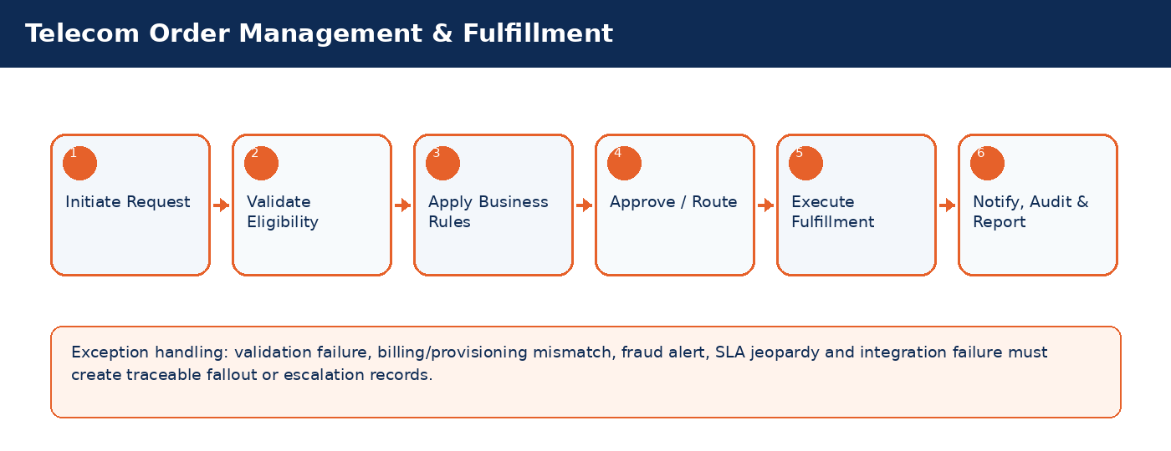

Detailed Process Flow
# | Stage | Business Activity | System Behavior | Exception Handling
1 | Request Initiation | Authorized user selects customer/subscriber and transaction type. | System loads customer, subscriber, service, billing and risk context. | Missing context blocks submission.
2 | Eligibility Validation | System validates KYC, status, balances, inventory, offer compatibility and fraud indicators. | Eligibility result stored against transaction. | Failed rule creates visible reason and next action.
3 | Business Rule Execution | Rules engine applies telecom policy, approval thresholds and lifecycle transition controls. | Decision generated: approve, reject, hold, escalate, or request additional data. | Manual override requires authority and audit reason.
4 | Approval / Queue Routing | Workflow routes request to supervisor, finance, fraud, compliance, NOC or back-office team where required. | Approver action captured with timestamp. | SLA timer and escalation path activated.
5 | Fulfillment / Integration | CRM calls billing, inventory, payment, provisioning or network systems as applicable. | Transaction reaches completed, pending, failed or fallout state. | Retry/rollback/fallout rules applied.
6 | Closure & Communication | Customer/internal notifications issued; audit and reports updated. | Lifecycle state, timeline and KPIs updated. | Unresolved exceptions remain in operational queue.

Functional Field Context and Data Controls
Field | Business Meaning | Source of Truth | Mandatory Rule | Editability | Security/Data Control | Audit Rule
Order ID | Business-critical telecom field used to control lifecycle, eligibility, reporting or integration behavior. | CRM | Mandatory or conditional based on transaction type | Editable in Draft; locked after fulfillment unless controlled correction process is used | Masked/encrypted when PII, financial or network-sensitive | Full before/after audit for changes after submission
Order Type | Business-critical telecom field used to control lifecycle, eligibility, reporting or integration behavior. | Source system / CRM master depending on domain | Mandatory or conditional based on transaction type | Editable in Draft; locked after fulfillment unless controlled correction process is used | Masked/encrypted when PII, financial or network-sensitive | Full before/after audit for changes after submission
Order State | Business-critical telecom field used to control lifecycle, eligibility, reporting or integration behavior. | Source system / CRM master depending on domain | Mandatory or conditional based on transaction type | Editable in Draft; locked after fulfillment unless controlled correction process is used | Masked/encrypted when PII, financial or network-sensitive | Full before/after audit for changes after submission
Fulfillment Step | Business-critical telecom field used to control lifecycle, eligibility, reporting or integration behavior. | Source system / CRM master depending on domain | Mandatory or conditional based on transaction type | Editable in Draft; locked after fulfillment unless controlled correction process is used | Masked/encrypted when PII, financial or network-sensitive | Full before/after audit for changes after submission
Dependency Group | Business-critical telecom field used to control lifecycle, eligibility, reporting or integration behavior. | Source system / CRM master depending on domain | Mandatory or conditional based on transaction type | Editable in Draft; locked after fulfillment unless controlled correction process is used | Masked/encrypted when PII, financial or network-sensitive | Full before/after audit for changes after submission
Fallout Reason | Business-critical telecom field used to control lifecycle, eligibility, reporting or integration behavior. | Source system / CRM master depending on domain | Mandatory or conditional based on transaction type | Editable in Draft; locked after fulfillment unless controlled correction process is used | Masked/encrypted when PII, financial or network-sensitive | Full before/after audit for changes after submission
Retry Count | Business-critical telecom field used to control lifecycle, eligibility, reporting or integration behavior. | Source system / CRM master depending on domain | Mandatory or conditional based on transaction type | Editable in Draft; locked after fulfillment unless controlled correction process is used | Masked/encrypted when PII, financial or network-sensitive | Full before/after audit for changes after submission
Jeopardy Flag | Business-critical telecom field used to control lifecycle, eligibility, reporting or integration behavior. | Source system / CRM master depending on domain | Mandatory or conditional based on transaction type | Editable in Draft; locked after fulfillment unless controlled correction process is used | Masked/encrypted when PII, financial or network-sensitive | Full before/after audit for changes after submission
SLA Timer | Business-critical telecom field used to control lifecycle, eligibility, reporting or integration behavior. | Source system / CRM master depending on domain | Mandatory or conditional based on transaction type | Editable in Draft; locked after fulfillment unless controlled correction process is used | Masked/encrypted when PII, financial or network-sensitive | Full before/after audit for changes after submission
External Reference | Business-critical telecom field used to control lifecycle, eligibility, reporting or integration behavior. | Source system / CRM master depending on domain | Mandatory or conditional based on transaction type | Editable in Draft; locked after fulfillment unless controlled correction process is used | Masked/encrypted when PII, financial or network-sensitive | Full before/after audit for changes after submission

Business Rules
Rule ID | Rule Area | Rule Statement | Severity | System Action
BR-01 | Lifecycle control | Requested action must be valid for the current customer/subscriber/SIM/order state. | High | Reject action and display reason.
BR-02 | Eligibility control | Customer, subscriber, offer, inventory and billing conditions must satisfy the applicable decision matrix. | High | Hold, reject or route for approval.
BR-03 | Fraud and risk control | High fraud score, blacklist or suspicious pattern must route to fraud governance before completion. | Critical | Suspend fulfillment and open fraud review.
BR-04 | Approval authority | Approval levels depend on transaction amount, customer segment, risk score, corporate authority and operational impact. | High | Route to required approver.
BR-05 | Integration consistency | Fulfillment is not complete until authoritative downstream systems confirm success. | Critical | Place transaction in pending/fallout and trigger retry.
BR-06 | Auditability | Manual override, rejection, approval and lifecycle transition must capture reason, actor, timestamp and channel. | Critical | Block completion if reason missing.

Validation Logic
Validation ID | Validation Rule | Validation Mode | Failure Behavior | Message Guidance
VAL-03-01 | Order cannot complete if any mandatory child task fails | Real-time where possible; asynchronous for cross-system checks | Block, hold, escalate or create fallout based on severity | User-friendly message with corrective action
VAL-03-02 | Partial fulfillment must be visible | Real-time where possible; asynchronous for cross-system checks | Block, hold, escalate or create fallout based on severity | User-friendly message with corrective action
VAL-03-03 | Retry count capped by policy | Real-time where possible; asynchronous for cross-system checks | Block, hold, escalate or create fallout based on severity | User-friendly message with corrective action
VAL-03-04 | Jeopardy flag set before SLA breach | Real-time where possible; asynchronous for cross-system checks | Block, hold, escalate or create fallout based on severity | User-friendly message with corrective action
VAL-03-05 | Cancellation only allowed before irreversible provisioning step | Real-time where possible; asynchronous for cross-system checks | Block, hold, escalate or create fallout based on severity | User-friendly message with corrective action

Alternate and Exception Flows
Scenario | Trigger | Expected Handling | Owner
Cross-system validation unavailable | Billing/provisioning/payment/KYC service timeout | Set request to Pending Validation, retry according to policy, notify operations if SLA jeopardy occurs. | Integration / Operations
Eligibility failed | Business rule violation such as unpaid balance, invalid state, unavailable inventory or blacklisted customer | Display reason, prevent completion, provide allowed next action such as collect payment, select different offer or escalate. | CSR / Supervisor
Fulfillment fallout | Downstream activation/provisioning/billing step fails after CRM submission | Create fallout case with correlation ID, retry if safe, rollback if required, route to responsible team. | Provisioning / IT
Manual override requested | Business user requests exception to standard rule | Require authority limit, reason code, evidence attachment and audit entry. | Supervisor / Compliance
SLA jeopardy | Transaction approaches or breaches defined SLA | Escalate to next level and expose in operational dashboard. | Operations Manager

Integration Touchpoints and Events
Integration / Event | Direction | Purpose | Failure Handling
Customer / KYC validation | CRM -> KYC | Identity verification and duplicate/risk checks. | Pending validation with retry and manual review queue.
Billing / OCS validation | CRM <-> Billing | Balance, credit limit, invoice, recharge, payment and subscription checks. | Hold transaction or create billing reconciliation task.
Inventory validation | CRM <-> Inventory | SIM, MSISDN, device and stock availability confirmation. | Release reservation or retry inventory synchronization.
Provisioning request | CRM -> Provisioning | Activate, suspend, reconnect, terminate or modify service. | Fallout queue, retry, rollback and manual intervention.
Notification event | CRM -> SMS/Email/Push | Customer/internal communication. | Retry and log notification delivery status.

Notifications, Audit, KPIs and Acceptance Criteria
Area | Detailed Requirement
Notifications | Send customer notification when request is received, approved/rejected, completed, failed or requires action. Internal escalation notification must be sent for SLA jeopardy and high-risk exceptions.
Audit | Capture actor, channel, timestamp, request state, before/after values, external correlation IDs, approval comments and override reasons.
KPIs | Track volume, completion rate, fallout rate, SLA compliance, average handling time, rejection reasons, manual override count and customer impact for Telecom Order Management & Fulfillment.
Acceptance Criteria | Given authorized user and valid conditions, when transaction is submitted, then system validates eligibility, applies rules, routes approvals, triggers fulfillment, updates lifecycle state, creates audit entry and sends notifications. Given failed downstream fulfillment, then request must be moved to fallout with correlation ID and visible recovery action.

4. SIM/eSIM Lifecycle Management
Manage physical SIM and eSIM lifecycle including allocation, reservation, activation, replacement, quarantine, recycling and retirement.
Domain Summary: Domain Objective
Manage physical SIM and eSIM lifecycle including allocation, reservation, activation, replacement, quarantine, recycling and retirement.

Actors and Stakeholders
Actor / Role | Responsibility
Inventory Officer | Participates in initiation, validation, approval, fulfillment, monitoring or exception handling for this domain.
CSR | Participates in initiation, validation, approval, fulfillment, monitoring or exception handling for this domain.
Dealer Agent | Participates in initiation, validation, approval, fulfillment, monitoring or exception handling for this domain.
Provisioning System | Participates in initiation, validation, approval, fulfillment, monitoring or exception handling for this domain.

Preconditions and Postconditions
Preconditions | Postconditions
SIM inventory loaded; SIM state allows assignment; Subscriber eligibility verified | SIM state updated; Old SIM deactivated or quarantined; Provisioning synchronized

Process Flow Infographic
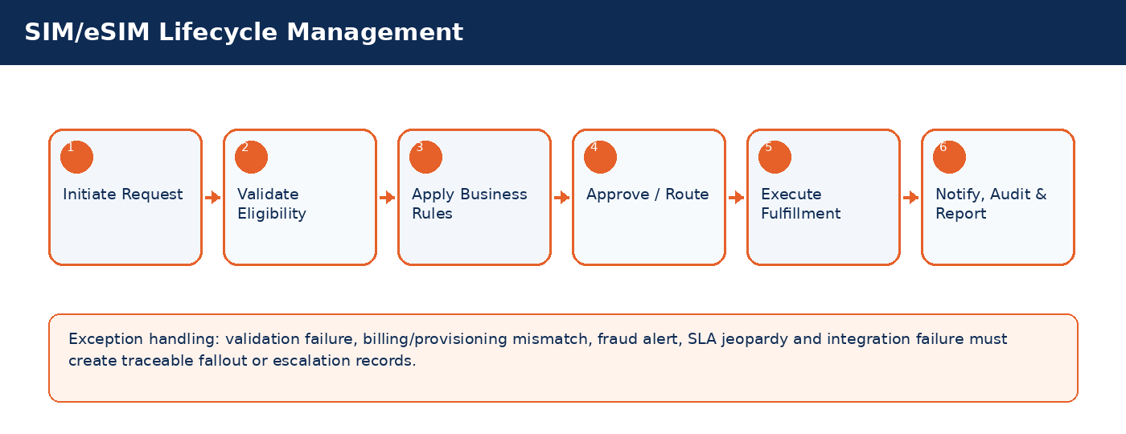

Detailed Process Flow
# | Stage | Business Activity | System Behavior | Exception Handling
1 | Request Initiation | Authorized user selects customer/subscriber and transaction type. | System loads customer, subscriber, service, billing and risk context. | Missing context blocks submission.
2 | Eligibility Validation | System validates KYC, status, balances, inventory, offer compatibility and fraud indicators. | Eligibility result stored against transaction. | Failed rule creates visible reason and next action.
3 | Business Rule Execution | Rules engine applies telecom policy, approval thresholds and lifecycle transition controls. | Decision generated: approve, reject, hold, escalate, or request additional data. | Manual override requires authority and audit reason.
4 | Approval / Queue Routing | Workflow routes request to supervisor, finance, fraud, compliance, NOC or back-office team where required. | Approver action captured with timestamp. | SLA timer and escalation path activated.
5 | Fulfillment / Integration | CRM calls billing, inventory, payment, provisioning or network systems as applicable. | Transaction reaches completed, pending, failed or fallout state. | Retry/rollback/fallout rules applied.
6 | Closure & Communication | Customer/internal notifications issued; audit and reports updated. | Lifecycle state, timeline and KPIs updated. | Unresolved exceptions remain in operational queue.

Functional Field Context and Data Controls
Field | Business Meaning | Source of Truth | Mandatory Rule | Editability | Security/Data Control | Audit Rule
ICCID | Business-critical telecom field used to control lifecycle, eligibility, reporting or integration behavior. | Source system / CRM master depending on domain | Mandatory or conditional based on transaction type | Editable in Draft; locked after fulfillment unless controlled correction process is used | Masked/encrypted when PII, financial or network-sensitive | Full before/after audit for changes after submission
IMSI | Business-critical telecom field used to control lifecycle, eligibility, reporting or integration behavior. | Source system / CRM master depending on domain | Mandatory or conditional based on transaction type | Editable in Draft; locked after fulfillment unless controlled correction process is used | Masked/encrypted when PII, financial or network-sensitive | Full before/after audit for changes after submission
SIM Type | Business-critical telecom field used to control lifecycle, eligibility, reporting or integration behavior. | Source system / CRM master depending on domain | Mandatory or conditional based on transaction type | Editable in Draft; locked after fulfillment unless controlled correction process is used | Masked/encrypted when PII, financial or network-sensitive | Full before/after audit for changes after submission
SIM State | Business-critical telecom field used to control lifecycle, eligibility, reporting or integration behavior. | Source system / CRM master depending on domain | Mandatory or conditional based on transaction type | Editable in Draft; locked after fulfillment unless controlled correction process is used | Masked/encrypted when PII, financial or network-sensitive | Full before/after audit for changes after submission
Warehouse | Business-critical telecom field used to control lifecycle, eligibility, reporting or integration behavior. | Source system / CRM master depending on domain | Mandatory or conditional based on transaction type | Editable in Draft; locked after fulfillment unless controlled correction process is used | Masked/encrypted when PII, financial or network-sensitive | Full before/after audit for changes after submission
Dealer Allocation | Business-critical telecom field used to control lifecycle, eligibility, reporting or integration behavior. | Source system / CRM master depending on domain | Mandatory or conditional based on transaction type | Editable in Draft; locked after fulfillment unless controlled correction process is used | Masked/encrypted when PII, financial or network-sensitive | Full before/after audit for changes after submission
QR Code Status | Business-critical telecom field used to control lifecycle, eligibility, reporting or integration behavior. | CRM | Mandatory or conditional based on transaction type | Editable in Draft; locked after fulfillment unless controlled correction process is used | Masked/encrypted when PII, financial or network-sensitive | Full before/after audit for changes after submission
Replacement Reason | Business-critical telecom field used to control lifecycle, eligibility, reporting or integration behavior. | Source system / CRM master depending on domain | Mandatory or conditional based on transaction type | Editable in Draft; locked after fulfillment unless controlled correction process is used | Masked/encrypted when PII, financial or network-sensitive | Full before/after audit for changes after submission
Quarantine End Date | Business-critical telecom field used to control lifecycle, eligibility, reporting or integration behavior. | Source system / CRM master depending on domain | Mandatory or conditional based on transaction type | Editable in Draft; locked after fulfillment unless controlled correction process is used | Masked/encrypted when PII, financial or network-sensitive | Full before/after audit for changes after submission
Recycle Eligibility | Business-critical telecom field used to control lifecycle, eligibility, reporting or integration behavior. | Source system / CRM master depending on domain | Mandatory or conditional based on transaction type | Editable in Draft; locked after fulfillment unless controlled correction process is used | Masked/encrypted when PII, financial or network-sensitive | Full before/after audit for changes after submission

Business Rules
Rule ID | Rule Area | Rule Statement | Severity | System Action
BR-01 | Lifecycle control | Requested action must be valid for the current customer/subscriber/SIM/order state. | High | Reject action and display reason.
BR-02 | Eligibility control | Customer, subscriber, offer, inventory and billing conditions must satisfy the applicable decision matrix. | High | Hold, reject or route for approval.
BR-03 | Fraud and risk control | High fraud score, blacklist or suspicious pattern must route to fraud governance before completion. | Critical | Suspend fulfillment and open fraud review.
BR-04 | Approval authority | Approval levels depend on transaction amount, customer segment, risk score, corporate authority and operational impact. | High | Route to required approver.
BR-05 | Integration consistency | Fulfillment is not complete until authoritative downstream systems confirm success. | Critical | Place transaction in pending/fallout and trigger retry.
BR-06 | Auditability | Manual override, rejection, approval and lifecycle transition must capture reason, actor, timestamp and channel. | Critical | Block completion if reason missing.

Validation Logic
Validation ID | Validation Rule | Validation Mode | Failure Behavior | Message Guidance
VAL-04-01 | ICCID unique and immutable | Real-time where possible; asynchronous for cross-system checks | Block, hold, escalate or create fallout based on severity | User-friendly message with corrective action
VAL-04-02 | Assigned SIM cannot be reassigned without release process | Real-time where possible; asynchronous for cross-system checks | Block, hold, escalate or create fallout based on severity | User-friendly message with corrective action
VAL-04-03 | eSIM QR can be downloaded limited number of times | Real-time where possible; asynchronous for cross-system checks | Block, hold, escalate or create fallout based on severity | User-friendly message with corrective action
VAL-04-04 | Lost/stolen SIM must be quarantined | Real-time where possible; asynchronous for cross-system checks | Block, hold, escalate or create fallout based on severity | User-friendly message with corrective action
VAL-04-05 | Replacement requires OTP or supervisor approval for high-risk cases | Real-time where possible; asynchronous for cross-system checks | Block, hold, escalate or create fallout based on severity | User-friendly message with corrective action

Alternate and Exception Flows
Scenario | Trigger | Expected Handling | Owner
Cross-system validation unavailable | Billing/provisioning/payment/KYC service timeout | Set request to Pending Validation, retry according to policy, notify operations if SLA jeopardy occurs. | Integration / Operations
Eligibility failed | Business rule violation such as unpaid balance, invalid state, unavailable inventory or blacklisted customer | Display reason, prevent completion, provide allowed next action such as collect payment, select different offer or escalate. | CSR / Supervisor
Fulfillment fallout | Downstream activation/provisioning/billing step fails after CRM submission | Create fallout case with correlation ID, retry if safe, rollback if required, route to responsible team. | Provisioning / IT
Manual override requested | Business user requests exception to standard rule | Require authority limit, reason code, evidence attachment and audit entry. | Supervisor / Compliance
SLA jeopardy | Transaction approaches or breaches defined SLA | Escalate to next level and expose in operational dashboard. | Operations Manager

Integration Touchpoints and Events
Integration / Event | Direction | Purpose | Failure Handling
Customer / KYC validation | CRM -> KYC | Identity verification and duplicate/risk checks. | Pending validation with retry and manual review queue.
Billing / OCS validation | CRM <-> Billing | Balance, credit limit, invoice, recharge, payment and subscription checks. | Hold transaction or create billing reconciliation task.
Inventory validation | CRM <-> Inventory | SIM, MSISDN, device and stock availability confirmation. | Release reservation or retry inventory synchronization.
Provisioning request | CRM -> Provisioning | Activate, suspend, reconnect, terminate or modify service. | Fallout queue, retry, rollback and manual intervention.
Notification event | CRM -> SMS/Email/Push | Customer/internal communication. | Retry and log notification delivery status.

Notifications, Audit, KPIs and Acceptance Criteria
Area | Detailed Requirement
Notifications | Send customer notification when request is received, approved/rejected, completed, failed or requires action. Internal escalation notification must be sent for SLA jeopardy and high-risk exceptions.
Audit | Capture actor, channel, timestamp, request state, before/after values, external correlation IDs, approval comments and override reasons.
KPIs | Track volume, completion rate, fallout rate, SLA compliance, average handling time, rejection reasons, manual override count and customer impact for SIM/eSIM Lifecycle Management.
Acceptance Criteria | Given authorized user and valid conditions, when transaction is submitted, then system validates eligibility, applies rules, routes approvals, triggers fulfillment, updates lifecycle state, creates audit entry and sends notifications. Given failed downstream fulfillment, then request must be moved to fallout with correlation ID and visible recovery action.

5. Number/MSISDN Lifecycle Management
Control number inventory, premium number sales, reservation, quarantine, recycling, change number and portability states.
Domain Summary: Domain Objective
Control number inventory, premium number sales, reservation, quarantine, recycling, change number and portability states.

Actors and Stakeholders
Actor / Role | Responsibility
Number Admin | Participates in initiation, validation, approval, fulfillment, monitoring or exception handling for this domain.
CSR | Participates in initiation, validation, approval, fulfillment, monitoring or exception handling for this domain.
Dealer Agent | Participates in initiation, validation, approval, fulfillment, monitoring or exception handling for this domain.
Billing System | Participates in initiation, validation, approval, fulfillment, monitoring or exception handling for this domain.

Preconditions and Postconditions
Preconditions | Postconditions
MSISDN inventory exists; Number state permits action; Customer eligibility verified | Number state updated; Billing/provisioning references synchronized

Process Flow Infographic
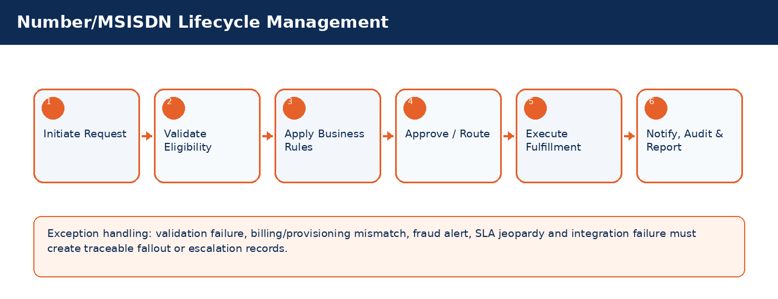

Detailed Process Flow
# | Stage | Business Activity | System Behavior | Exception Handling
1 | Request Initiation | Authorized user selects customer/subscriber and transaction type. | System loads customer, subscriber, service, billing and risk context. | Missing context blocks submission.
2 | Eligibility Validation | System validates KYC, status, balances, inventory, offer compatibility and fraud indicators. | Eligibility result stored against transaction. | Failed rule creates visible reason and next action.
3 | Business Rule Execution | Rules engine applies telecom policy, approval thresholds and lifecycle transition controls. | Decision generated: approve, reject, hold, escalate, or request additional data. | Manual override requires authority and audit reason.
4 | Approval / Queue Routing | Workflow routes request to supervisor, finance, fraud, compliance, NOC or back-office team where required. | Approver action captured with timestamp. | SLA timer and escalation path activated.
5 | Fulfillment / Integration | CRM calls billing, inventory, payment, provisioning or network systems as applicable. | Transaction reaches completed, pending, failed or fallout state. | Retry/rollback/fallout rules applied.
6 | Closure & Communication | Customer/internal notifications issued; audit and reports updated. | Lifecycle state, timeline and KPIs updated. | Unresolved exceptions remain in operational queue.

Functional Field Context and Data Controls
Field | Business Meaning | Source of Truth | Mandatory Rule | Editability | Security/Data Control | Audit Rule
MSISDN | Business-critical telecom field used to control lifecycle, eligibility, reporting or integration behavior. | Source system / CRM master depending on domain | Mandatory or conditional based on transaction type | Editable in Draft; locked after fulfillment unless controlled correction process is used | Masked/encrypted when PII, financial or network-sensitive | Full before/after audit for changes after submission
Number Category | Business-critical telecom field used to control lifecycle, eligibility, reporting or integration behavior. | Source system / CRM master depending on domain | Mandatory or conditional based on transaction type | Editable in Draft; locked after fulfillment unless controlled correction process is used | Masked/encrypted when PII, financial or network-sensitive | Full before/after audit for changes after submission
Number State | Business-critical telecom field used to control lifecycle, eligibility, reporting or integration behavior. | Source system / CRM master depending on domain | Mandatory or conditional based on transaction type | Editable in Draft; locked after fulfillment unless controlled correction process is used | Masked/encrypted when PII, financial or network-sensitive | Full before/after audit for changes after submission
Reservation Expiry | Business-critical telecom field used to control lifecycle, eligibility, reporting or integration behavior. | Source system / CRM master depending on domain | Mandatory or conditional based on transaction type | Editable in Draft; locked after fulfillment unless controlled correction process is used | Masked/encrypted when PII, financial or network-sensitive | Full before/after audit for changes after submission
Premium Fee | Business-critical telecom field used to control lifecycle, eligibility, reporting or integration behavior. | Source system / CRM master depending on domain | Mandatory or conditional based on transaction type | Editable in Draft; locked after fulfillment unless controlled correction process is used | Masked/encrypted when PII, financial or network-sensitive | Full before/after audit for changes after submission
Quarantine Start | Business-critical telecom field used to control lifecycle, eligibility, reporting or integration behavior. | Source system / CRM master depending on domain | Mandatory or conditional based on transaction type | Editable in Draft; locked after fulfillment unless controlled correction process is used | Masked/encrypted when PII, financial or network-sensitive | Full before/after audit for changes after submission
Portability Status | Business-critical telecom field used to control lifecycle, eligibility, reporting or integration behavior. | CRM | Mandatory or conditional based on transaction type | Editable in Draft; locked after fulfillment unless controlled correction process is used | Masked/encrypted when PII, financial or network-sensitive | Full before/after audit for changes after submission
Previous Owner | Business-critical telecom field used to control lifecycle, eligibility, reporting or integration behavior. | Source system / CRM master depending on domain | Mandatory or conditional based on transaction type | Editable in Draft; locked after fulfillment unless controlled correction process is used | Masked/encrypted when PII, financial or network-sensitive | Full before/after audit for changes after submission
Recycle Date | Business-critical telecom field used to control lifecycle, eligibility, reporting or integration behavior. | Source system / CRM master depending on domain | Mandatory or conditional based on transaction type | Editable in Draft; locked after fulfillment unless controlled correction process is used | Masked/encrypted when PII, financial or network-sensitive | Full before/after audit for changes after submission
Assignment Channel | Business-critical telecom field used to control lifecycle, eligibility, reporting or integration behavior. | Source system / CRM master depending on domain | Mandatory or conditional based on transaction type | Editable in Draft; locked after fulfillment unless controlled correction process is used | Masked/encrypted when PII, financial or network-sensitive | Full before/after audit for changes after submission

Business Rules
Rule ID | Rule Area | Rule Statement | Severity | System Action
BR-01 | Lifecycle control | Requested action must be valid for the current customer/subscriber/SIM/order state. | High | Reject action and display reason.
BR-02 | Eligibility control | Customer, subscriber, offer, inventory and billing conditions must satisfy the applicable decision matrix. | High | Hold, reject or route for approval.
BR-03 | Fraud and risk control | High fraud score, blacklist or suspicious pattern must route to fraud governance before completion. | Critical | Suspend fulfillment and open fraud review.
BR-04 | Approval authority | Approval levels depend on transaction amount, customer segment, risk score, corporate authority and operational impact. | High | Route to required approver.
BR-05 | Integration consistency | Fulfillment is not complete until authoritative downstream systems confirm success. | Critical | Place transaction in pending/fallout and trigger retry.
BR-06 | Auditability | Manual override, rejection, approval and lifecycle transition must capture reason, actor, timestamp and channel. | Critical | Block completion if reason missing.

Validation Logic
Validation ID | Validation Rule | Validation Mode | Failure Behavior | Message Guidance
VAL-05-01 | Reserved numbers expire automatically | Real-time where possible; asynchronous for cross-system checks | Block, hold, escalate or create fallout based on severity | User-friendly message with corrective action
VAL-05-02 | Premium number fee required before activation | Real-time where possible; asynchronous for cross-system checks | Block, hold, escalate or create fallout based on severity | User-friendly message with corrective action
VAL-05-03 | Quarantined numbers cannot be assigned | Real-time where possible; asynchronous for cross-system checks | Block, hold, escalate or create fallout based on severity | User-friendly message with corrective action
VAL-05-04 | Number change requires active subscriber and billing clearance | Real-time where possible; asynchronous for cross-system checks | Block, hold, escalate or create fallout based on severity | User-friendly message with corrective action
VAL-05-05 | Port-in/out states block incompatible changes | Real-time where possible; asynchronous for cross-system checks | Block, hold, escalate or create fallout based on severity | User-friendly message with corrective action

Alternate and Exception Flows
Scenario | Trigger | Expected Handling | Owner
Cross-system validation unavailable | Billing/provisioning/payment/KYC service timeout | Set request to Pending Validation, retry according to policy, notify operations if SLA jeopardy occurs. | Integration / Operations
Eligibility failed | Business rule violation such as unpaid balance, invalid state, unavailable inventory or blacklisted customer | Display reason, prevent completion, provide allowed next action such as collect payment, select different offer or escalate. | CSR / Supervisor
Fulfillment fallout | Downstream activation/provisioning/billing step fails after CRM submission | Create fallout case with correlation ID, retry if safe, rollback if required, route to responsible team. | Provisioning / IT
Manual override requested | Business user requests exception to standard rule | Require authority limit, reason code, evidence attachment and audit entry. | Supervisor / Compliance
SLA jeopardy | Transaction approaches or breaches defined SLA | Escalate to next level and expose in operational dashboard. | Operations Manager

Integration Touchpoints and Events
Integration / Event | Direction | Purpose | Failure Handling
Customer / KYC validation | CRM -> KYC | Identity verification and duplicate/risk checks. | Pending validation with retry and manual review queue.
Billing / OCS validation | CRM <-> Billing | Balance, credit limit, invoice, recharge, payment and subscription checks. | Hold transaction or create billing reconciliation task.
Inventory validation | CRM <-> Inventory | SIM, MSISDN, device and stock availability confirmation. | Release reservation or retry inventory synchronization.
Provisioning request | CRM -> Provisioning | Activate, suspend, reconnect, terminate or modify service. | Fallout queue, retry, rollback and manual intervention.
Notification event | CRM -> SMS/Email/Push | Customer/internal communication. | Retry and log notification delivery status.

Notifications, Audit, KPIs and Acceptance Criteria
Area | Detailed Requirement
Notifications | Send customer notification when request is received, approved/rejected, completed, failed or requires action. Internal escalation notification must be sent for SLA jeopardy and high-risk exceptions.
Audit | Capture actor, channel, timestamp, request state, before/after values, external correlation IDs, approval comments and override reasons.
KPIs | Track volume, completion rate, fallout rate, SLA compliance, average handling time, rejection reasons, manual override count and customer impact for Number/MSISDN Lifecycle Management.
Acceptance Criteria | Given authorized user and valid conditions, when transaction is submitted, then system validates eligibility, applies rules, routes approvals, triggers fulfillment, updates lifecycle state, creates audit entry and sends notifications. Given failed downstream fulfillment, then request must be moved to fallout with correlation ID and visible recovery action.

6. Change GSM Type / Service Technology
Manage service technology changes and plan migrations across GSM/service types while validating eligibility, billing compatibility and provisioning dependencies.
Domain Summary: Domain Objective
Manage service technology changes and plan migrations across GSM/service types while validating eligibility, billing compatibility and provisioning dependencies.

Actors and Stakeholders
Actor / Role | Responsibility
CSR | Participates in initiation, validation, approval, fulfillment, monitoring or exception handling for this domain.
Supervisor | Participates in initiation, validation, approval, fulfillment, monitoring or exception handling for this domain.
Provisioning System | Participates in initiation, validation, approval, fulfillment, monitoring or exception handling for this domain.
Billing System | Participates in initiation, validation, approval, fulfillment, monitoring or exception handling for this domain.

Preconditions and Postconditions
Preconditions | Postconditions
Subscriber active; Target GSM/service type configured; No blocking orders in progress | Subscriber service type updated; Billing plan migrated; Provisioning completed

Process Flow Infographic
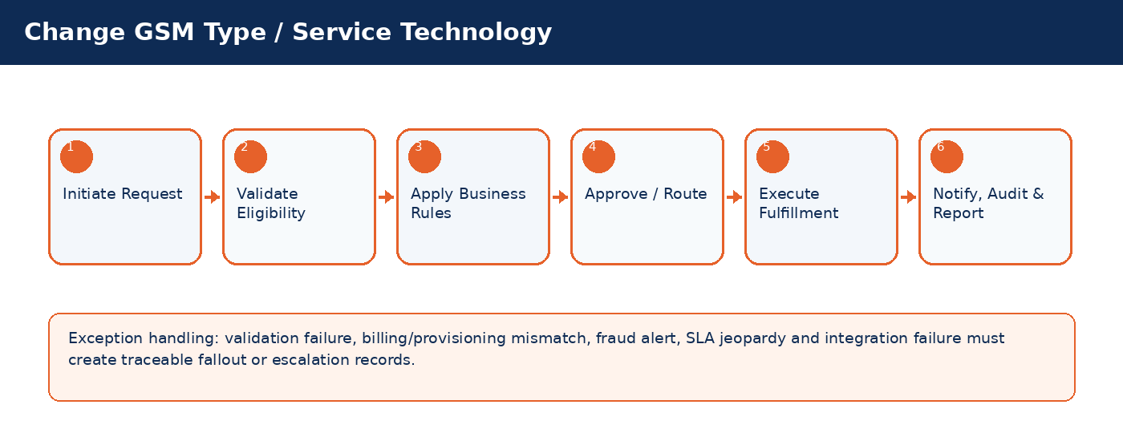

Detailed Process Flow
# | Stage | Business Activity | System Behavior | Exception Handling
1 | Request Initiation | Authorized user selects customer/subscriber and transaction type. | System loads customer, subscriber, service, billing and risk context. | Missing context blocks submission.
2 | Eligibility Validation | System validates KYC, status, balances, inventory, offer compatibility and fraud indicators. | Eligibility result stored against transaction. | Failed rule creates visible reason and next action.
3 | Business Rule Execution | Rules engine applies telecom policy, approval thresholds and lifecycle transition controls. | Decision generated: approve, reject, hold, escalate, or request additional data. | Manual override requires authority and audit reason.
4 | Approval / Queue Routing | Workflow routes request to supervisor, finance, fraud, compliance, NOC or back-office team where required. | Approver action captured with timestamp. | SLA timer and escalation path activated.
5 | Fulfillment / Integration | CRM calls billing, inventory, payment, provisioning or network systems as applicable. | Transaction reaches completed, pending, failed or fallout state. | Retry/rollback/fallout rules applied.
6 | Closure & Communication | Customer/internal notifications issued; audit and reports updated. | Lifecycle state, timeline and KPIs updated. | Unresolved exceptions remain in operational queue.

Functional Field Context and Data Controls
Field | Business Meaning | Source of Truth | Mandatory Rule | Editability | Security/Data Control | Audit Rule
Current GSM Type | Business-critical telecom field used to control lifecycle, eligibility, reporting or integration behavior. | Source system / CRM master depending on domain | Mandatory or conditional based on transaction type | Editable in Draft; locked after fulfillment unless controlled correction process is used | Masked/encrypted when PII, financial or network-sensitive | Full before/after audit for changes after submission
Target GSM Type | Business-critical telecom field used to control lifecycle, eligibility, reporting or integration behavior. | Source system / CRM master depending on domain | Mandatory or conditional based on transaction type | Editable in Draft; locked after fulfillment unless controlled correction process is used | Masked/encrypted when PII, financial or network-sensitive | Full before/after audit for changes after submission
Migration Reason | Business-critical telecom field used to control lifecycle, eligibility, reporting or integration behavior. | Source system / CRM master depending on domain | Mandatory or conditional based on transaction type | Editable in Draft; locked after fulfillment unless controlled correction process is used | Masked/encrypted when PII, financial or network-sensitive | Full before/after audit for changes after submission
Compatibility Status | Business-critical telecom field used to control lifecycle, eligibility, reporting or integration behavior. | CRM | Mandatory or conditional based on transaction type | Editable in Draft; locked after fulfillment unless controlled correction process is used | Masked/encrypted when PII, financial or network-sensitive | Full before/after audit for changes after submission
Effective Date | Business-critical telecom field used to control lifecycle, eligibility, reporting or integration behavior. | Source system / CRM master depending on domain | Mandatory or conditional based on transaction type | Editable in Draft; locked after fulfillment unless controlled correction process is used | Masked/encrypted when PII, financial or network-sensitive | Full before/after audit for changes after submission
Approval Status | Business-critical telecom field used to control lifecycle, eligibility, reporting or integration behavior. | CRM | Mandatory or conditional based on transaction type | Editable in Draft; locked after fulfillment unless controlled correction process is used | Masked/encrypted when PII, financial or network-sensitive | Full before/after audit for changes after submission
Provisioning Status | Business-critical telecom field used to control lifecycle, eligibility, reporting or integration behavior. | CRM | Mandatory or conditional based on transaction type | Editable in Draft; locked after fulfillment unless controlled correction process is used | Masked/encrypted when PII, financial or network-sensitive | Full before/after audit for changes after submission
Fallback Plan | Business-critical telecom field used to control lifecycle, eligibility, reporting or integration behavior. | Source system / CRM master depending on domain | Mandatory or conditional based on transaction type | Editable in Draft; locked after fulfillment unless controlled correction process is used | Masked/encrypted when PII, financial or network-sensitive | Full before/after audit for changes after submission

Business Rules
Rule ID | Rule Area | Rule Statement | Severity | System Action
BR-01 | Lifecycle control | Requested action must be valid for the current customer/subscriber/SIM/order state. | High | Reject action and display reason.
BR-02 | Eligibility control | Customer, subscriber, offer, inventory and billing conditions must satisfy the applicable decision matrix. | High | Hold, reject or route for approval.
BR-03 | Fraud and risk control | High fraud score, blacklist or suspicious pattern must route to fraud governance before completion. | Critical | Suspend fulfillment and open fraud review.
BR-04 | Approval authority | Approval levels depend on transaction amount, customer segment, risk score, corporate authority and operational impact. | High | Route to required approver.
BR-05 | Integration consistency | Fulfillment is not complete until authoritative downstream systems confirm success. | Critical | Place transaction in pending/fallout and trigger retry.
BR-06 | Auditability | Manual override, rejection, approval and lifecycle transition must capture reason, actor, timestamp and channel. | Critical | Block completion if reason missing.

Validation Logic
Validation ID | Validation Rule | Validation Mode | Failure Behavior | Message Guidance
VAL-06-01 | Only compatible transitions allowed | Real-time where possible; asynchronous for cross-system checks | Block, hold, escalate or create fallout based on severity | User-friendly message with corrective action
VAL-06-02 | Future-dated changes require scheduler | Real-time where possible; asynchronous for cross-system checks | Block, hold, escalate or create fallout based on severity | User-friendly message with corrective action
VAL-06-03 | Outstanding unpaid balance may block postpaid upgrades | Real-time where possible; asynchronous for cross-system checks | Block, hold, escalate or create fallout based on severity | User-friendly message with corrective action
VAL-06-04 | Provisioning failure triggers rollback to previous service type | Real-time where possible; asynchronous for cross-system checks | Block, hold, escalate or create fallout based on severity | User-friendly message with corrective action
VAL-06-05 | Customer notified of package impact | Real-time where possible; asynchronous for cross-system checks | Block, hold, escalate or create fallout based on severity | User-friendly message with corrective action

Alternate and Exception Flows
Scenario | Trigger | Expected Handling | Owner
Cross-system validation unavailable | Billing/provisioning/payment/KYC service timeout | Set request to Pending Validation, retry according to policy, notify operations if SLA jeopardy occurs. | Integration / Operations
Eligibility failed | Business rule violation such as unpaid balance, invalid state, unavailable inventory or blacklisted customer | Display reason, prevent completion, provide allowed next action such as collect payment, select different offer or escalate. | CSR / Supervisor
Fulfillment fallout | Downstream activation/provisioning/billing step fails after CRM submission | Create fallout case with correlation ID, retry if safe, rollback if required, route to responsible team. | Provisioning / IT
Manual override requested | Business user requests exception to standard rule | Require authority limit, reason code, evidence attachment and audit entry. | Supervisor / Compliance
SLA jeopardy | Transaction approaches or breaches defined SLA | Escalate to next level and expose in operational dashboard. | Operations Manager

Integration Touchpoints and Events
Integration / Event | Direction | Purpose | Failure Handling
Customer / KYC validation | CRM -> KYC | Identity verification and duplicate/risk checks. | Pending validation with retry and manual review queue.
Billing / OCS validation | CRM <-> Billing | Balance, credit limit, invoice, recharge, payment and subscription checks. | Hold transaction or create billing reconciliation task.
Inventory validation | CRM <-> Inventory | SIM, MSISDN, device and stock availability confirmation. | Release reservation or retry inventory synchronization.
Provisioning request | CRM -> Provisioning | Activate, suspend, reconnect, terminate or modify service. | Fallout queue, retry, rollback and manual intervention.
Notification event | CRM -> SMS/Email/Push | Customer/internal communication. | Retry and log notification delivery status.

Notifications, Audit, KPIs and Acceptance Criteria
Area | Detailed Requirement
Notifications | Send customer notification when request is received, approved/rejected, completed, failed or requires action. Internal escalation notification must be sent for SLA jeopardy and high-risk exceptions.
Audit | Capture actor, channel, timestamp, request state, before/after values, external correlation IDs, approval comments and override reasons.
KPIs | Track volume, completion rate, fallout rate, SLA compliance, average handling time, rejection reasons, manual override count and customer impact for Change GSM Type / Service Technology.
Acceptance Criteria | Given authorized user and valid conditions, when transaction is submitted, then system validates eligibility, applies rules, routes approvals, triggers fulfillment, updates lifecycle state, creates audit entry and sends notifications. Given failed downstream fulfillment, then request must be moved to fallout with correlation ID and visible recovery action.

7. Transfer of Ownership
Execute controlled subscriber ownership transfer including old/new owner verification, obligation clearance, billing settlement and approvals.
Domain Summary: Domain Objective
Execute controlled subscriber ownership transfer including old/new owner verification, obligation clearance, billing settlement and approvals.

Actors and Stakeholders
Actor / Role | Responsibility
CSR | Participates in initiation, validation, approval, fulfillment, monitoring or exception handling for this domain.
Old Owner | Participates in initiation, validation, approval, fulfillment, monitoring or exception handling for this domain.
New Owner | Participates in initiation, validation, approval, fulfillment, monitoring or exception handling for this domain.
Supervisor | Participates in initiation, validation, approval, fulfillment, monitoring or exception handling for this domain.
Billing Officer | Participates in initiation, validation, approval, fulfillment, monitoring or exception handling for this domain.

Preconditions and Postconditions
Preconditions | Postconditions
Old owner verified; New customer profile exists; No fraud lock exists | Ownership updated; Contract and billing responsibility transferred; Audit trail completed

Process Flow Infographic
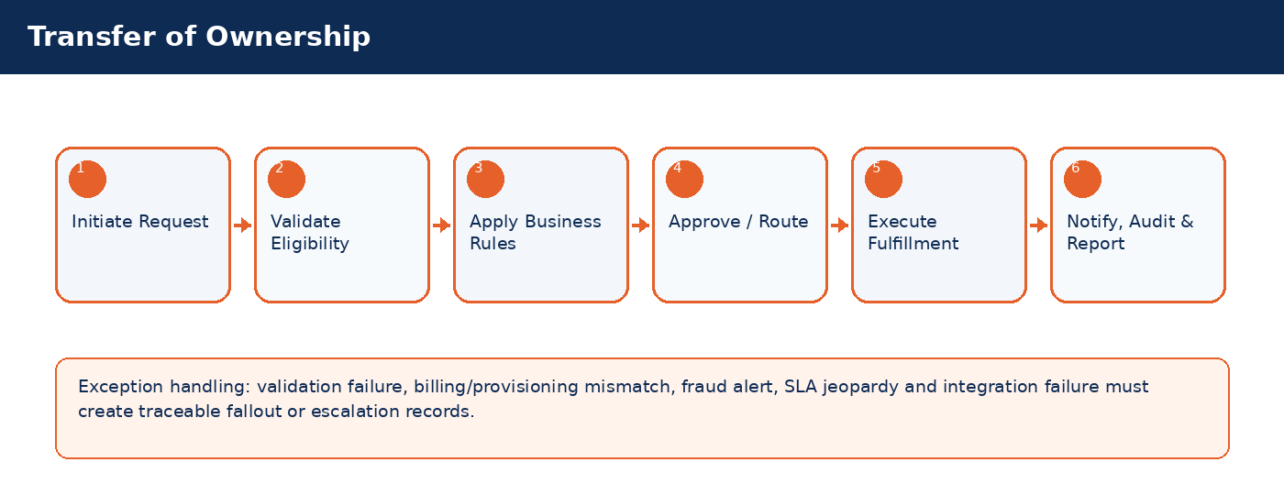

Detailed Process Flow
# | Stage | Business Activity | System Behavior | Exception Handling
1 | Request Initiation | Authorized user selects customer/subscriber and transaction type. | System loads customer, subscriber, service, billing and risk context. | Missing context blocks submission.
2 | Eligibility Validation | System validates KYC, status, balances, inventory, offer compatibility and fraud indicators. | Eligibility result stored against transaction. | Failed rule creates visible reason and next action.
3 | Business Rule Execution | Rules engine applies telecom policy, approval thresholds and lifecycle transition controls. | Decision generated: approve, reject, hold, escalate, or request additional data. | Manual override requires authority and audit reason.
4 | Approval / Queue Routing | Workflow routes request to supervisor, finance, fraud, compliance, NOC or back-office team where required. | Approver action captured with timestamp. | SLA timer and escalation path activated.
5 | Fulfillment / Integration | CRM calls billing, inventory, payment, provisioning or network systems as applicable. | Transaction reaches completed, pending, failed or fallout state. | Retry/rollback/fallout rules applied.
6 | Closure & Communication | Customer/internal notifications issued; audit and reports updated. | Lifecycle state, timeline and KPIs updated. | Unresolved exceptions remain in operational queue.

Functional Field Context and Data Controls
Field | Business Meaning | Source of Truth | Mandatory Rule | Editability | Security/Data Control | Audit Rule
Old Customer ID | Business-critical telecom field used to control lifecycle, eligibility, reporting or integration behavior. | Source system / CRM master depending on domain | Mandatory or conditional based on transaction type | Editable in Draft; locked after fulfillment unless controlled correction process is used | Masked/encrypted when PII, financial or network-sensitive | Full before/after audit for changes after submission
New Customer ID | Business-critical telecom field used to control lifecycle, eligibility, reporting or integration behavior. | Source system / CRM master depending on domain | Mandatory or conditional based on transaction type | Editable in Draft; locked after fulfillment unless controlled correction process is used | Masked/encrypted when PII, financial or network-sensitive | Full before/after audit for changes after submission
MSISDN | Business-critical telecom field used to control lifecycle, eligibility, reporting or integration behavior. | Source system / CRM master depending on domain | Mandatory or conditional based on transaction type | Editable in Draft; locked after fulfillment unless controlled correction process is used | Masked/encrypted when PII, financial or network-sensitive | Full before/after audit for changes after submission
Transfer Reason | Business-critical telecom field used to control lifecycle, eligibility, reporting or integration behavior. | Source system / CRM master depending on domain | Mandatory or conditional based on transaction type | Editable in Draft; locked after fulfillment unless controlled correction process is used | Masked/encrypted when PII, financial or network-sensitive | Full before/after audit for changes after submission
Obligation Status | Business-critical telecom field used to control lifecycle, eligibility, reporting or integration behavior. | CRM | Mandatory or conditional based on transaction type | Editable in Draft; locked after fulfillment unless controlled correction process is used | Masked/encrypted when PII, financial or network-sensitive | Full before/after audit for changes after submission
Deposit Transfer Flag | Business-critical telecom field used to control lifecycle, eligibility, reporting or integration behavior. | Source system / CRM master depending on domain | Mandatory or conditional based on transaction type | Editable in Draft; locked after fulfillment unless controlled correction process is used | Masked/encrypted when PII, financial or network-sensitive | Full before/after audit for changes after submission
Approval Level | Business-critical telecom field used to control lifecycle, eligibility, reporting or integration behavior. | Source system / CRM master depending on domain | Mandatory or conditional based on transaction type | Editable in Draft; locked after fulfillment unless controlled correction process is used | Masked/encrypted when PII, financial or network-sensitive | Full before/after audit for changes after submission
Effective Date | Business-critical telecom field used to control lifecycle, eligibility, reporting or integration behavior. | Source system / CRM master depending on domain | Mandatory or conditional based on transaction type | Editable in Draft; locked after fulfillment unless controlled correction process is used | Masked/encrypted when PII, financial or network-sensitive | Full before/after audit for changes after submission
Document Checklist | Business-critical telecom field used to control lifecycle, eligibility, reporting or integration behavior. | Source system / CRM master depending on domain | Mandatory or conditional based on transaction type | Editable in Draft; locked after fulfillment unless controlled correction process is used | Masked/encrypted when PII, financial or network-sensitive | Full before/after audit for changes after submission

Business Rules
Rule ID | Rule Area | Rule Statement | Severity | System Action
BR-01 | Lifecycle control | Requested action must be valid for the current customer/subscriber/SIM/order state. | High | Reject action and display reason.
BR-02 | Eligibility control | Customer, subscriber, offer, inventory and billing conditions must satisfy the applicable decision matrix. | High | Hold, reject or route for approval.
BR-03 | Fraud and risk control | High fraud score, blacklist or suspicious pattern must route to fraud governance before completion. | Critical | Suspend fulfillment and open fraud review.
BR-04 | Approval authority | Approval levels depend on transaction amount, customer segment, risk score, corporate authority and operational impact. | High | Route to required approver.
BR-05 | Integration consistency | Fulfillment is not complete until authoritative downstream systems confirm success. | Critical | Place transaction in pending/fallout and trigger retry.
BR-06 | Auditability | Manual override, rejection, approval and lifecycle transition must capture reason, actor, timestamp and channel. | Critical | Block completion if reason missing.

Validation Logic
Validation ID | Validation Rule | Validation Mode | Failure Behavior | Message Guidance
VAL-07-01 | Both parties identity verification required | Real-time where possible; asynchronous for cross-system checks | Block, hold, escalate or create fallout based on severity | User-friendly message with corrective action
VAL-07-02 | Outstanding obligations must be cleared or transferred by policy | Real-time where possible; asynchronous for cross-system checks | Block, hold, escalate or create fallout based on severity | User-friendly message with corrective action
VAL-07-03 | Corporate ownership transfer requires authorized signatory | Real-time where possible; asynchronous for cross-system checks | Block, hold, escalate or create fallout based on severity | User-friendly message with corrective action
VAL-07-04 | Deposit transfer/refund rule must be selected | Real-time where possible; asynchronous for cross-system checks | Block, hold, escalate or create fallout based on severity | User-friendly message with corrective action
VAL-07-05 | Blacklist status blocks transfer | Real-time where possible; asynchronous for cross-system checks | Block, hold, escalate or create fallout based on severity | User-friendly message with corrective action

Alternate and Exception Flows
Scenario | Trigger | Expected Handling | Owner
Cross-system validation unavailable | Billing/provisioning/payment/KYC service timeout | Set request to Pending Validation, retry according to policy, notify operations if SLA jeopardy occurs. | Integration / Operations
Eligibility failed | Business rule violation such as unpaid balance, invalid state, unavailable inventory or blacklisted customer | Display reason, prevent completion, provide allowed next action such as collect payment, select different offer or escalate. | CSR / Supervisor
Fulfillment fallout | Downstream activation/provisioning/billing step fails after CRM submission | Create fallout case with correlation ID, retry if safe, rollback if required, route to responsible team. | Provisioning / IT
Manual override requested | Business user requests exception to standard rule | Require authority limit, reason code, evidence attachment and audit entry. | Supervisor / Compliance
SLA jeopardy | Transaction approaches or breaches defined SLA | Escalate to next level and expose in operational dashboard. | Operations Manager

Integration Touchpoints and Events
Integration / Event | Direction | Purpose | Failure Handling
Customer / KYC validation | CRM -> KYC | Identity verification and duplicate/risk checks. | Pending validation with retry and manual review queue.
Billing / OCS validation | CRM <-> Billing | Balance, credit limit, invoice, recharge, payment and subscription checks. | Hold transaction or create billing reconciliation task.
Inventory validation | CRM <-> Inventory | SIM, MSISDN, device and stock availability confirmation. | Release reservation or retry inventory synchronization.
Provisioning request | CRM -> Provisioning | Activate, suspend, reconnect, terminate or modify service. | Fallout queue, retry, rollback and manual intervention.
Notification event | CRM -> SMS/Email/Push | Customer/internal communication. | Retry and log notification delivery status.

Notifications, Audit, KPIs and Acceptance Criteria
Area | Detailed Requirement
Notifications | Send customer notification when request is received, approved/rejected, completed, failed or requires action. Internal escalation notification must be sent for SLA jeopardy and high-risk exceptions.
Audit | Capture actor, channel, timestamp, request state, before/after values, external correlation IDs, approval comments and override reasons.
KPIs | Track volume, completion rate, fallout rate, SLA compliance, average handling time, rejection reasons, manual override count and customer impact for Transfer of Ownership.
Acceptance Criteria | Given authorized user and valid conditions, when transaction is submitted, then system validates eligibility, applies rules, routes approvals, triggers fulfillment, updates lifecycle state, creates audit entry and sends notifications. Given failed downstream fulfillment, then request must be moved to fallout with correlation ID and visible recovery action.

8. Temporary Suspension & Barring
Manage customer-requested, fraud, billing, regulatory and operational suspension/barred states with automatic timers and reconnection conditions.
Domain Summary: Domain Objective
Manage customer-requested, fraud, billing, regulatory and operational suspension/barred states with automatic timers and reconnection conditions.

Actors and Stakeholders
Actor / Role | Responsibility
CSR | Participates in initiation, validation, approval, fulfillment, monitoring or exception handling for this domain.
Collections Officer | Participates in initiation, validation, approval, fulfillment, monitoring or exception handling for this domain.
Fraud Analyst | Participates in initiation, validation, approval, fulfillment, monitoring or exception handling for this domain.
Supervisor | Participates in initiation, validation, approval, fulfillment, monitoring or exception handling for this domain.
Provisioning System | Participates in initiation, validation, approval, fulfillment, monitoring or exception handling for this domain.

Preconditions and Postconditions
Preconditions | Postconditions
Subscriber active; Suspension reason selected; Authority identified | Service suspended/barred; Timer and reconnection criteria stored; Customer notified unless restricted

Process Flow Infographic
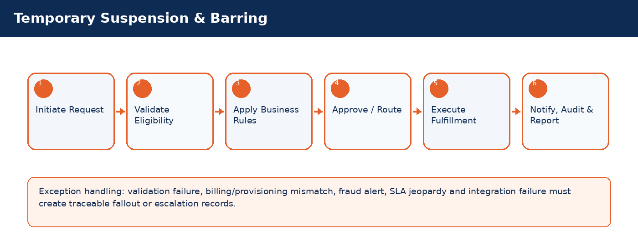

Detailed Process Flow
# | Stage | Business Activity | System Behavior | Exception Handling
1 | Request Initiation | Authorized user selects customer/subscriber and transaction type. | System loads customer, subscriber, service, billing and risk context. | Missing context blocks submission.
2 | Eligibility Validation | System validates KYC, status, balances, inventory, offer compatibility and fraud indicators. | Eligibility result stored against transaction. | Failed rule creates visible reason and next action.
3 | Business Rule Execution | Rules engine applies telecom policy, approval thresholds and lifecycle transition controls. | Decision generated: approve, reject, hold, escalate, or request additional data. | Manual override requires authority and audit reason.
4 | Approval / Queue Routing | Workflow routes request to supervisor, finance, fraud, compliance, NOC or back-office team where required. | Approver action captured with timestamp. | SLA timer and escalation path activated.
5 | Fulfillment / Integration | CRM calls billing, inventory, payment, provisioning or network systems as applicable. | Transaction reaches completed, pending, failed or fallout state. | Retry/rollback/fallout rules applied.
6 | Closure & Communication | Customer/internal notifications issued; audit and reports updated. | Lifecycle state, timeline and KPIs updated. | Unresolved exceptions remain in operational queue.

Functional Field Context and Data Controls
Field | Business Meaning | Source of Truth | Mandatory Rule | Editability | Security/Data Control | Audit Rule
Suspension Type | Business-critical telecom field used to control lifecycle, eligibility, reporting or integration behavior. | Source system / CRM master depending on domain | Mandatory or conditional based on transaction type | Editable in Draft; locked after fulfillment unless controlled correction process is used | Masked/encrypted when PII, financial or network-sensitive | Full before/after audit for changes after submission
Reason Code | Business-critical telecom field used to control lifecycle, eligibility, reporting or integration behavior. | Source system / CRM master depending on domain | Mandatory or conditional based on transaction type | Editable in Draft; locked after fulfillment unless controlled correction process is used | Masked/encrypted when PII, financial or network-sensitive | Full before/after audit for changes after submission
Start Date | Business-critical telecom field used to control lifecycle, eligibility, reporting or integration behavior. | Source system / CRM master depending on domain | Mandatory or conditional based on transaction type | Editable in Draft; locked after fulfillment unless controlled correction process is used | Masked/encrypted when PII, financial or network-sensitive | Full before/after audit for changes after submission
End Date | Business-critical telecom field used to control lifecycle, eligibility, reporting or integration behavior. | Source system / CRM master depending on domain | Mandatory or conditional based on transaction type | Editable in Draft; locked after fulfillment unless controlled correction process is used | Masked/encrypted when PII, financial or network-sensitive | Full before/after audit for changes after submission
Barring Level | Business-critical telecom field used to control lifecycle, eligibility, reporting or integration behavior. | Source system / CRM master depending on domain | Mandatory or conditional based on transaction type | Editable in Draft; locked after fulfillment unless controlled correction process is used | Masked/encrypted when PII, financial or network-sensitive | Full before/after audit for changes after submission
Auto-Reconnect Flag | Business-critical telecom field used to control lifecycle, eligibility, reporting or integration behavior. | Source system / CRM master depending on domain | Mandatory or conditional based on transaction type | Editable in Draft; locked after fulfillment unless controlled correction process is used | Masked/encrypted when PII, financial or network-sensitive | Full before/after audit for changes after submission
Approval Status | Business-critical telecom field used to control lifecycle, eligibility, reporting or integration behavior. | CRM | Mandatory or conditional based on transaction type | Editable in Draft; locked after fulfillment unless controlled correction process is used | Masked/encrypted when PII, financial or network-sensitive | Full before/after audit for changes after submission
Notification Suppression Flag | Business-critical telecom field used to control lifecycle, eligibility, reporting or integration behavior. | Source system / CRM master depending on domain | Mandatory or conditional based on transaction type | Editable in Draft; locked after fulfillment unless controlled correction process is used | Masked/encrypted when PII, financial or network-sensitive | Full before/after audit for changes after submission

Business Rules
Rule ID | Rule Area | Rule Statement | Severity | System Action
BR-01 | Lifecycle control | Requested action must be valid for the current customer/subscriber/SIM/order state. | High | Reject action and display reason.
BR-02 | Eligibility control | Customer, subscriber, offer, inventory and billing conditions must satisfy the applicable decision matrix. | High | Hold, reject or route for approval.
BR-03 | Fraud and risk control | High fraud score, blacklist or suspicious pattern must route to fraud governance before completion. | Critical | Suspend fulfillment and open fraud review.
BR-04 | Approval authority | Approval levels depend on transaction amount, customer segment, risk score, corporate authority and operational impact. | High | Route to required approver.
BR-05 | Integration consistency | Fulfillment is not complete until authoritative downstream systems confirm success. | Critical | Place transaction in pending/fallout and trigger retry.
BR-06 | Auditability | Manual override, rejection, approval and lifecycle transition must capture reason, actor, timestamp and channel. | Critical | Block completion if reason missing.

Validation Logic
Validation ID | Validation Rule | Validation Mode | Failure Behavior | Message Guidance
VAL-08-01 | Billing suspension may be automated by dunning stage | Real-time where possible; asynchronous for cross-system checks | Block, hold, escalate or create fallout based on severity | User-friendly message with corrective action
VAL-08-02 | Fraud suspension requires fraud authority | Real-time where possible; asynchronous for cross-system checks | Block, hold, escalate or create fallout based on severity | User-friendly message with corrective action
VAL-08-03 | Regulatory suspension cannot be removed by CSR | Real-time where possible; asynchronous for cross-system checks | Block, hold, escalate or create fallout based on severity | User-friendly message with corrective action
VAL-08-04 | Auto-reconnect only after conditions satisfied | Real-time where possible; asynchronous for cross-system checks | Block, hold, escalate or create fallout based on severity | User-friendly message with corrective action
VAL-08-05 | Long suspension may trigger termination review | Real-time where possible; asynchronous for cross-system checks | Block, hold, escalate or create fallout based on severity | User-friendly message with corrective action

Alternate and Exception Flows
Scenario | Trigger | Expected Handling | Owner
Cross-system validation unavailable | Billing/provisioning/payment/KYC service timeout | Set request to Pending Validation, retry according to policy, notify operations if SLA jeopardy occurs. | Integration / Operations
Eligibility failed | Business rule violation such as unpaid balance, invalid state, unavailable inventory or blacklisted customer | Display reason, prevent completion, provide allowed next action such as collect payment, select different offer or escalate. | CSR / Supervisor
Fulfillment fallout | Downstream activation/provisioning/billing step fails after CRM submission | Create fallout case with correlation ID, retry if safe, rollback if required, route to responsible team. | Provisioning / IT
Manual override requested | Business user requests exception to standard rule | Require authority limit, reason code, evidence attachment and audit entry. | Supervisor / Compliance
SLA jeopardy | Transaction approaches or breaches defined SLA | Escalate to next level and expose in operational dashboard. | Operations Manager

Integration Touchpoints and Events
Integration / Event | Direction | Purpose | Failure Handling
Customer / KYC validation | CRM -> KYC | Identity verification and duplicate/risk checks. | Pending validation with retry and manual review queue.
Billing / OCS validation | CRM <-> Billing | Balance, credit limit, invoice, recharge, payment and subscription checks. | Hold transaction or create billing reconciliation task.
Inventory validation | CRM <-> Inventory | SIM, MSISDN, device and stock availability confirmation. | Release reservation or retry inventory synchronization.
Provisioning request | CRM -> Provisioning | Activate, suspend, reconnect, terminate or modify service. | Fallout queue, retry, rollback and manual intervention.
Notification event | CRM -> SMS/Email/Push | Customer/internal communication. | Retry and log notification delivery status.

Notifications, Audit, KPIs and Acceptance Criteria
Area | Detailed Requirement
Notifications | Send customer notification when request is received, approved/rejected, completed, failed or requires action. Internal escalation notification must be sent for SLA jeopardy and high-risk exceptions.
Audit | Capture actor, channel, timestamp, request state, before/after values, external correlation IDs, approval comments and override reasons.
KPIs | Track volume, completion rate, fallout rate, SLA compliance, average handling time, rejection reasons, manual override count and customer impact for Temporary Suspension & Barring.
Acceptance Criteria | Given authorized user and valid conditions, when transaction is submitted, then system validates eligibility, applies rules, routes approvals, triggers fulfillment, updates lifecycle state, creates audit entry and sends notifications. Given failed downstream fulfillment, then request must be moved to fallout with correlation ID and visible recovery action.

9. Reconnect / Reactivation
Restore suspended or barred services after resolving payment, fraud, compliance or customer-requested suspension conditions.
Domain Summary: Domain Objective
Restore suspended or barred services after resolving payment, fraud, compliance or customer-requested suspension conditions.

Actors and Stakeholders
Actor / Role | Responsibility
CSR | Participates in initiation, validation, approval, fulfillment, monitoring or exception handling for this domain.
Collections Officer | Participates in initiation, validation, approval, fulfillment, monitoring or exception handling for this domain.
Fraud Analyst | Participates in initiation, validation, approval, fulfillment, monitoring or exception handling for this domain.
Provisioning System | Participates in initiation, validation, approval, fulfillment, monitoring or exception handling for this domain.
Billing System | Participates in initiation, validation, approval, fulfillment, monitoring or exception handling for this domain.

Preconditions and Postconditions
Preconditions | Postconditions
Subscriber suspended/barred; Reconnect eligibility validated; Payment/fraud/compliance conditions cleared | Service restored; Subscriber state active; Customer notified

Process Flow Infographic
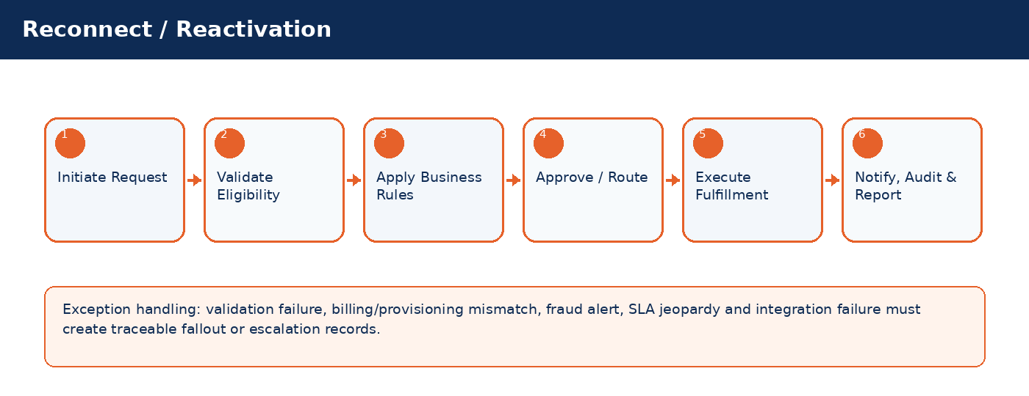

Detailed Process Flow
# | Stage | Business Activity | System Behavior | Exception Handling
1 | Request Initiation | Authorized user selects customer/subscriber and transaction type. | System loads customer, subscriber, service, billing and risk context. | Missing context blocks submission.
2 | Eligibility Validation | System validates KYC, status, balances, inventory, offer compatibility and fraud indicators. | Eligibility result stored against transaction. | Failed rule creates visible reason and next action.
3 | Business Rule Execution | Rules engine applies telecom policy, approval thresholds and lifecycle transition controls. | Decision generated: approve, reject, hold, escalate, or request additional data. | Manual override requires authority and audit reason.
4 | Approval / Queue Routing | Workflow routes request to supervisor, finance, fraud, compliance, NOC or back-office team where required. | Approver action captured with timestamp. | SLA timer and escalation path activated.
5 | Fulfillment / Integration | CRM calls billing, inventory, payment, provisioning or network systems as applicable. | Transaction reaches completed, pending, failed or fallout state. | Retry/rollback/fallout rules applied.
6 | Closure & Communication | Customer/internal notifications issued; audit and reports updated. | Lifecycle state, timeline and KPIs updated. | Unresolved exceptions remain in operational queue.

Functional Field Context and Data Controls
Field | Business Meaning | Source of Truth | Mandatory Rule | Editability | Security/Data Control | Audit Rule
Reconnect Request ID | Business-critical telecom field used to control lifecycle, eligibility, reporting or integration behavior. | Source system / CRM master depending on domain | Mandatory or conditional based on transaction type | Editable in Draft; locked after fulfillment unless controlled correction process is used | Masked/encrypted when PII, financial or network-sensitive | Full before/after audit for changes after submission
Current State | Business-critical telecom field used to control lifecycle, eligibility, reporting or integration behavior. | Source system / CRM master depending on domain | Mandatory or conditional based on transaction type | Editable in Draft; locked after fulfillment unless controlled correction process is used | Masked/encrypted when PII, financial or network-sensitive | Full before/after audit for changes after submission
Reconnect Reason | Business-critical telecom field used to control lifecycle, eligibility, reporting or integration behavior. | Source system / CRM master depending on domain | Mandatory or conditional based on transaction type | Editable in Draft; locked after fulfillment unless controlled correction process is used | Masked/encrypted when PII, financial or network-sensitive | Full before/after audit for changes after submission
Clearance Type | Business-critical telecom field used to control lifecycle, eligibility, reporting or integration behavior. | Source system / CRM master depending on domain | Mandatory or conditional based on transaction type | Editable in Draft; locked after fulfillment unless controlled correction process is used | Masked/encrypted when PII, financial or network-sensitive | Full before/after audit for changes after submission
Payment Reference | Business-critical telecom field used to control lifecycle, eligibility, reporting or integration behavior. | Source system / CRM master depending on domain | Mandatory or conditional based on transaction type | Editable in Draft; locked after fulfillment unless controlled correction process is used | Masked/encrypted when PII, financial or network-sensitive | Full before/after audit for changes after submission
Fraud Clearance | Business-critical telecom field used to control lifecycle, eligibility, reporting or integration behavior. | Source system / CRM master depending on domain | Mandatory or conditional based on transaction type | Editable in Draft; locked after fulfillment unless controlled correction process is used | Masked/encrypted when PII, financial or network-sensitive | Full before/after audit for changes after submission
Provisioning Result | Business-critical telecom field used to control lifecycle, eligibility, reporting or integration behavior. | Source system / CRM master depending on domain | Mandatory or conditional based on transaction type | Editable in Draft; locked after fulfillment unless controlled correction process is used | Masked/encrypted when PII, financial or network-sensitive | Full before/after audit for changes after submission
Reactivation Time | Business-critical telecom field used to control lifecycle, eligibility, reporting or integration behavior. | Source system / CRM master depending on domain | Mandatory or conditional based on transaction type | Editable in Draft; locked after fulfillment unless controlled correction process is used | Masked/encrypted when PII, financial or network-sensitive | Full before/after audit for changes after submission

Business Rules
Rule ID | Rule Area | Rule Statement | Severity | System Action
BR-01 | Lifecycle control | Requested action must be valid for the current customer/subscriber/SIM/order state. | High | Reject action and display reason.
BR-02 | Eligibility control | Customer, subscriber, offer, inventory and billing conditions must satisfy the applicable decision matrix. | High | Hold, reject or route for approval.
BR-03 | Fraud and risk control | High fraud score, blacklist or suspicious pattern must route to fraud governance before completion. | Critical | Suspend fulfillment and open fraud review.
BR-04 | Approval authority | Approval levels depend on transaction amount, customer segment, risk score, corporate authority and operational impact. | High | Route to required approver.
BR-05 | Integration consistency | Fulfillment is not complete until authoritative downstream systems confirm success. | Critical | Place transaction in pending/fallout and trigger retry.
BR-06 | Auditability | Manual override, rejection, approval and lifecycle transition must capture reason, actor, timestamp and channel. | Critical | Block completion if reason missing.

Validation Logic
Validation ID | Validation Rule | Validation Mode | Failure Behavior | Message Guidance
VAL-09-01 | Reconnect blocked if blacklist active | Real-time where possible; asynchronous for cross-system checks | Block, hold, escalate or create fallout based on severity | User-friendly message with corrective action
VAL-09-02 | Payment clearance required for billing suspension | Real-time where possible; asynchronous for cross-system checks | Block, hold, escalate or create fallout based on severity | User-friendly message with corrective action
VAL-09-03 | Fraud clearance required for fraud suspension | Real-time where possible; asynchronous for cross-system checks | Block, hold, escalate or create fallout based on severity | User-friendly message with corrective action
VAL-09-04 | Provisioning retry allowed before manual escalation | Real-time where possible; asynchronous for cross-system checks | Block, hold, escalate or create fallout based on severity | User-friendly message with corrective action
VAL-09-05 | Terminated subscriber requires reactivation process not simple reconnect | Real-time where possible; asynchronous for cross-system checks | Block, hold, escalate or create fallout based on severity | User-friendly message with corrective action

Alternate and Exception Flows
Scenario | Trigger | Expected Handling | Owner
Cross-system validation unavailable | Billing/provisioning/payment/KYC service timeout | Set request to Pending Validation, retry according to policy, notify operations if SLA jeopardy occurs. | Integration / Operations
Eligibility failed | Business rule violation such as unpaid balance, invalid state, unavailable inventory or blacklisted customer | Display reason, prevent completion, provide allowed next action such as collect payment, select different offer or escalate. | CSR / Supervisor
Fulfillment fallout | Downstream activation/provisioning/billing step fails after CRM submission | Create fallout case with correlation ID, retry if safe, rollback if required, route to responsible team. | Provisioning / IT
Manual override requested | Business user requests exception to standard rule | Require authority limit, reason code, evidence attachment and audit entry. | Supervisor / Compliance
SLA jeopardy | Transaction approaches or breaches defined SLA | Escalate to next level and expose in operational dashboard. | Operations Manager

Integration Touchpoints and Events
Integration / Event | Direction | Purpose | Failure Handling
Customer / KYC validation | CRM -> KYC | Identity verification and duplicate/risk checks. | Pending validation with retry and manual review queue.
Billing / OCS validation | CRM <-> Billing | Balance, credit limit, invoice, recharge, payment and subscription checks. | Hold transaction or create billing reconciliation task.
Inventory validation | CRM <-> Inventory | SIM, MSISDN, device and stock availability confirmation. | Release reservation or retry inventory synchronization.
Provisioning request | CRM -> Provisioning | Activate, suspend, reconnect, terminate or modify service. | Fallout queue, retry, rollback and manual intervention.
Notification event | CRM -> SMS/Email/Push | Customer/internal communication. | Retry and log notification delivery status.

Notifications, Audit, KPIs and Acceptance Criteria
Area | Detailed Requirement
Notifications | Send customer notification when request is received, approved/rejected, completed, failed or requires action. Internal escalation notification must be sent for SLA jeopardy and high-risk exceptions.
Audit | Capture actor, channel, timestamp, request state, before/after values, external correlation IDs, approval comments and override reasons.
KPIs | Track volume, completion rate, fallout rate, SLA compliance, average handling time, rejection reasons, manual override count and customer impact for Reconnect / Reactivation.
Acceptance Criteria | Given authorized user and valid conditions, when transaction is submitted, then system validates eligibility, applies rules, routes approvals, triggers fulfillment, updates lifecycle state, creates audit entry and sends notifications. Given failed downstream fulfillment, then request must be moved to fallout with correlation ID and visible recovery action.

10. Service Termination
Manage voluntary, involuntary, regulatory and fraud-driven termination with final billing, deposit settlement, number quarantine and service deprovisioning.
Domain Summary: Domain Objective
Manage voluntary, involuntary, regulatory and fraud-driven termination with final billing, deposit settlement, number quarantine and service deprovisioning.

Actors and Stakeholders
Actor / Role | Responsibility
CSR | Participates in initiation, validation, approval, fulfillment, monitoring or exception handling for this domain.
Collections Officer | Participates in initiation, validation, approval, fulfillment, monitoring or exception handling for this domain.
Compliance Officer | Participates in initiation, validation, approval, fulfillment, monitoring or exception handling for this domain.
Billing System | Participates in initiation, validation, approval, fulfillment, monitoring or exception handling for this domain.
Provisioning System | Participates in initiation, validation, approval, fulfillment, monitoring or exception handling for this domain.

Preconditions and Postconditions
Preconditions | Postconditions
Subscriber exists; Termination authority confirmed; Open orders reviewed | Service deactivated; Final bill generated; MSISDN/SIM lifecycle updated

Process Flow Infographic
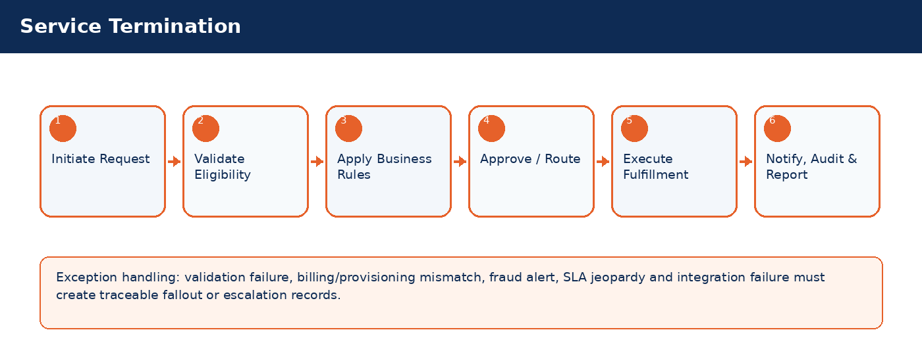

Detailed Process Flow
# | Stage | Business Activity | System Behavior | Exception Handling
1 | Request Initiation | Authorized user selects customer/subscriber and transaction type. | System loads customer, subscriber, service, billing and risk context. | Missing context blocks submission.
2 | Eligibility Validation | System validates KYC, status, balances, inventory, offer compatibility and fraud indicators. | Eligibility result stored against transaction. | Failed rule creates visible reason and next action.
3 | Business Rule Execution | Rules engine applies telecom policy, approval thresholds and lifecycle transition controls. | Decision generated: approve, reject, hold, escalate, or request additional data. | Manual override requires authority and audit reason.
4 | Approval / Queue Routing | Workflow routes request to supervisor, finance, fraud, compliance, NOC or back-office team where required. | Approver action captured with timestamp. | SLA timer and escalation path activated.
5 | Fulfillment / Integration | CRM calls billing, inventory, payment, provisioning or network systems as applicable. | Transaction reaches completed, pending, failed or fallout state. | Retry/rollback/fallout rules applied.
6 | Closure & Communication | Customer/internal notifications issued; audit and reports updated. | Lifecycle state, timeline and KPIs updated. | Unresolved exceptions remain in operational queue.

Functional Field Context and Data Controls
Field | Business Meaning | Source of Truth | Mandatory Rule | Editability | Security/Data Control | Audit Rule
Termination Type | Business-critical telecom field used to control lifecycle, eligibility, reporting or integration behavior. | Source system / CRM master depending on domain | Mandatory or conditional based on transaction type | Editable in Draft; locked after fulfillment unless controlled correction process is used | Masked/encrypted when PII, financial or network-sensitive | Full before/after audit for changes after submission
Termination Reason | Business-critical telecom field used to control lifecycle, eligibility, reporting or integration behavior. | Source system / CRM master depending on domain | Mandatory or conditional based on transaction type | Editable in Draft; locked after fulfillment unless controlled correction process is used | Masked/encrypted when PII, financial or network-sensitive | Full before/after audit for changes after submission
Effective Date | Business-critical telecom field used to control lifecycle, eligibility, reporting or integration behavior. | Source system / CRM master depending on domain | Mandatory or conditional based on transaction type | Editable in Draft; locked after fulfillment unless controlled correction process is used | Masked/encrypted when PII, financial or network-sensitive | Full before/after audit for changes after submission
Final Bill Amount | Business-critical telecom field used to control lifecycle, eligibility, reporting or integration behavior. | Source system / CRM master depending on domain | Mandatory or conditional based on transaction type | Editable in Draft; locked after fulfillment unless controlled correction process is used | Masked/encrypted when PII, financial or network-sensitive | Full before/after audit for changes after submission
Deposit Settlement | Business-critical telecom field used to control lifecycle, eligibility, reporting or integration behavior. | Source system / CRM master depending on domain | Mandatory or conditional based on transaction type | Editable in Draft; locked after fulfillment unless controlled correction process is used | Masked/encrypted when PII, financial or network-sensitive | Full before/after audit for changes after submission
Number Quarantine | Business-critical telecom field used to control lifecycle, eligibility, reporting or integration behavior. | Source system / CRM master depending on domain | Mandatory or conditional based on transaction type | Editable in Draft; locked after fulfillment unless controlled correction process is used | Masked/encrypted when PII, financial or network-sensitive | Full before/after audit for changes after submission
Deprovision Status | Business-critical telecom field used to control lifecycle, eligibility, reporting or integration behavior. | CRM | Mandatory or conditional based on transaction type | Editable in Draft; locked after fulfillment unless controlled correction process is used | Masked/encrypted when PII, financial or network-sensitive | Full before/after audit for changes after submission
Retention Offer Outcome | Business-critical telecom field used to control lifecycle, eligibility, reporting or integration behavior. | Source system / CRM master depending on domain | Mandatory or conditional based on transaction type | Editable in Draft; locked after fulfillment unless controlled correction process is used | Masked/encrypted when PII, financial or network-sensitive | Full before/after audit for changes after submission

Business Rules
Rule ID | Rule Area | Rule Statement | Severity | System Action
BR-01 | Lifecycle control | Requested action must be valid for the current customer/subscriber/SIM/order state. | High | Reject action and display reason.
BR-02 | Eligibility control | Customer, subscriber, offer, inventory and billing conditions must satisfy the applicable decision matrix. | High | Hold, reject or route for approval.
BR-03 | Fraud and risk control | High fraud score, blacklist or suspicious pattern must route to fraud governance before completion. | Critical | Suspend fulfillment and open fraud review.
BR-04 | Approval authority | Approval levels depend on transaction amount, customer segment, risk score, corporate authority and operational impact. | High | Route to required approver.
BR-05 | Integration consistency | Fulfillment is not complete until authoritative downstream systems confirm success. | Critical | Place transaction in pending/fallout and trigger retry.
BR-06 | Auditability | Manual override, rejection, approval and lifecycle transition must capture reason, actor, timestamp and channel. | Critical | Block completion if reason missing.

Validation Logic
Validation ID | Validation Rule | Validation Mode | Failure Behavior | Message Guidance
VAL-10-01 | Active disputes may require supervisor decision | Real-time where possible; asynchronous for cross-system checks | Block, hold, escalate or create fallout based on severity | User-friendly message with corrective action
VAL-10-02 | Final bill must be generated or scheduled | Real-time where possible; asynchronous for cross-system checks | Block, hold, escalate or create fallout based on severity | User-friendly message with corrective action
VAL-10-03 | Number moves to quarantine not available | Real-time where possible; asynchronous for cross-system checks | Block, hold, escalate or create fallout based on severity | User-friendly message with corrective action
VAL-10-04 | Corporate termination requires contract review | Real-time where possible; asynchronous for cross-system checks | Block, hold, escalate or create fallout based on severity | User-friendly message with corrective action
VAL-10-05 | Retention offer must be logged before voluntary termination completion | Real-time where possible; asynchronous for cross-system checks | Block, hold, escalate or create fallout based on severity | User-friendly message with corrective action

Alternate and Exception Flows
Scenario | Trigger | Expected Handling | Owner
Cross-system validation unavailable | Billing/provisioning/payment/KYC service timeout | Set request to Pending Validation, retry according to policy, notify operations if SLA jeopardy occurs. | Integration / Operations
Eligibility failed | Business rule violation such as unpaid balance, invalid state, unavailable inventory or blacklisted customer | Display reason, prevent completion, provide allowed next action such as collect payment, select different offer or escalate. | CSR / Supervisor
Fulfillment fallout | Downstream activation/provisioning/billing step fails after CRM submission | Create fallout case with correlation ID, retry if safe, rollback if required, route to responsible team. | Provisioning / IT
Manual override requested | Business user requests exception to standard rule | Require authority limit, reason code, evidence attachment and audit entry. | Supervisor / Compliance
SLA jeopardy | Transaction approaches or breaches defined SLA | Escalate to next level and expose in operational dashboard. | Operations Manager

Integration Touchpoints and Events
Integration / Event | Direction | Purpose | Failure Handling
Customer / KYC validation | CRM -> KYC | Identity verification and duplicate/risk checks. | Pending validation with retry and manual review queue.
Billing / OCS validation | CRM <-> Billing | Balance, credit limit, invoice, recharge, payment and subscription checks. | Hold transaction or create billing reconciliation task.
Inventory validation | CRM <-> Inventory | SIM, MSISDN, device and stock availability confirmation. | Release reservation or retry inventory synchronization.
Provisioning request | CRM -> Provisioning | Activate, suspend, reconnect, terminate or modify service. | Fallout queue, retry, rollback and manual intervention.
Notification event | CRM -> SMS/Email/Push | Customer/internal communication. | Retry and log notification delivery status.

Notifications, Audit, KPIs and Acceptance Criteria
Area | Detailed Requirement
Notifications | Send customer notification when request is received, approved/rejected, completed, failed or requires action. Internal escalation notification must be sent for SLA jeopardy and high-risk exceptions.
Audit | Capture actor, channel, timestamp, request state, before/after values, external correlation IDs, approval comments and override reasons.
KPIs | Track volume, completion rate, fallout rate, SLA compliance, average handling time, rejection reasons, manual override count and customer impact for Service Termination.
Acceptance Criteria | Given authorized user and valid conditions, when transaction is submitted, then system validates eligibility, applies rules, routes approvals, triggers fulfillment, updates lifecycle state, creates audit entry and sends notifications. Given failed downstream fulfillment, then request must be moved to fallout with correlation ID and visible recovery action.

11. Product Catalog, Offers & Subscription Management
Manage telecom product catalog, bundles, VAS, promotions, eligibility, subscriptions, renewals and expirations.
Domain Summary: Domain Objective
Manage telecom product catalog, bundles, VAS, promotions, eligibility, subscriptions, renewals and expirations.

Actors and Stakeholders
Actor / Role | Responsibility
Product Manager | Participates in initiation, validation, approval, fulfillment, monitoring or exception handling for this domain.
Campaign Manager | Participates in initiation, validation, approval, fulfillment, monitoring or exception handling for this domain.
CSR | Participates in initiation, validation, approval, fulfillment, monitoring or exception handling for this domain.
Billing System | Participates in initiation, validation, approval, fulfillment, monitoring or exception handling for this domain.

Preconditions and Postconditions
Preconditions | Postconditions
Catalog item active; Eligibility rules configured; Offer mapped to billing/provisioning product | Subscription created/modified/expired; Billing and provisioning synchronized

Process Flow Infographic
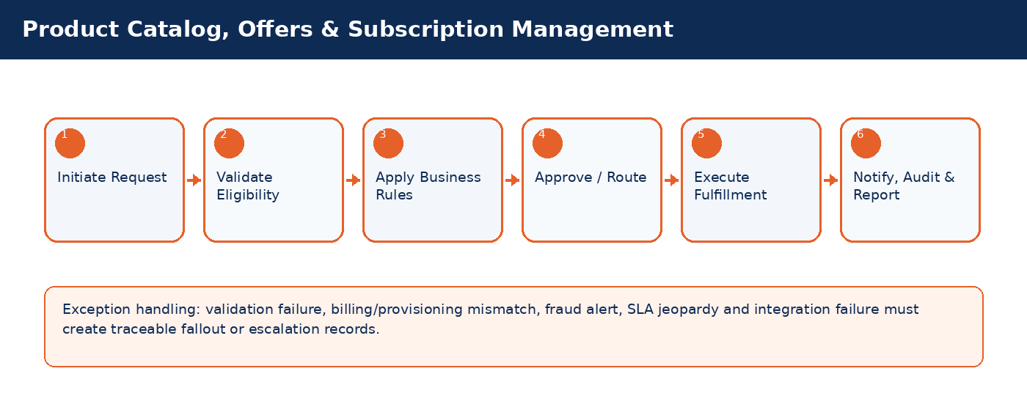

Detailed Process Flow
# | Stage | Business Activity | System Behavior | Exception Handling
1 | Request Initiation | Authorized user selects customer/subscriber and transaction type. | System loads customer, subscriber, service, billing and risk context. | Missing context blocks submission.
2 | Eligibility Validation | System validates KYC, status, balances, inventory, offer compatibility and fraud indicators. | Eligibility result stored against transaction. | Failed rule creates visible reason and next action.
3 | Business Rule Execution | Rules engine applies telecom policy, approval thresholds and lifecycle transition controls. | Decision generated: approve, reject, hold, escalate, or request additional data. | Manual override requires authority and audit reason.
4 | Approval / Queue Routing | Workflow routes request to supervisor, finance, fraud, compliance, NOC or back-office team where required. | Approver action captured with timestamp. | SLA timer and escalation path activated.
5 | Fulfillment / Integration | CRM calls billing, inventory, payment, provisioning or network systems as applicable. | Transaction reaches completed, pending, failed or fallout state. | Retry/rollback/fallout rules applied.
6 | Closure & Communication | Customer/internal notifications issued; audit and reports updated. | Lifecycle state, timeline and KPIs updated. | Unresolved exceptions remain in operational queue.

Functional Field Context and Data Controls
Field | Business Meaning | Source of Truth | Mandatory Rule | Editability | Security/Data Control | Audit Rule
Product Code | Business-critical telecom field used to control lifecycle, eligibility, reporting or integration behavior. | Source system / CRM master depending on domain | Mandatory or conditional based on transaction type | Editable in Draft; locked after fulfillment unless controlled correction process is used | Masked/encrypted when PII, financial or network-sensitive | Full before/after audit for changes after submission
Offer Code | Business-critical telecom field used to control lifecycle, eligibility, reporting or integration behavior. | Source system / CRM master depending on domain | Mandatory or conditional based on transaction type | Editable in Draft; locked after fulfillment unless controlled correction process is used | Masked/encrypted when PII, financial or network-sensitive | Full before/after audit for changes after submission
Bundle Type | Business-critical telecom field used to control lifecycle, eligibility, reporting or integration behavior. | Source system / CRM master depending on domain | Mandatory or conditional based on transaction type | Editable in Draft; locked after fulfillment unless controlled correction process is used | Masked/encrypted when PII, financial or network-sensitive | Full before/after audit for changes after submission
Eligibility Segment | Business-critical telecom field used to control lifecycle, eligibility, reporting or integration behavior. | Source system / CRM master depending on domain | Mandatory or conditional based on transaction type | Editable in Draft; locked after fulfillment unless controlled correction process is used | Masked/encrypted when PII, financial or network-sensitive | Full before/after audit for changes after submission
Price | Business-critical telecom field used to control lifecycle, eligibility, reporting or integration behavior. | Source system / CRM master depending on domain | Mandatory or conditional based on transaction type | Editable in Draft; locked after fulfillment unless controlled correction process is used | Masked/encrypted when PII, financial or network-sensitive | Full before/after audit for changes after submission
Validity | Business-critical telecom field used to control lifecycle, eligibility, reporting or integration behavior. | Source system / CRM master depending on domain | Mandatory or conditional based on transaction type | Editable in Draft; locked after fulfillment unless controlled correction process is used | Masked/encrypted when PII, financial or network-sensitive | Full before/after audit for changes after submission
Auto-Renewal | Business-critical telecom field used to control lifecycle, eligibility, reporting or integration behavior. | Source system / CRM master depending on domain | Mandatory or conditional based on transaction type | Editable in Draft; locked after fulfillment unless controlled correction process is used | Masked/encrypted when PII, financial or network-sensitive | Full before/after audit for changes after submission
Dependency Product | Business-critical telecom field used to control lifecycle, eligibility, reporting or integration behavior. | Source system / CRM master depending on domain | Mandatory or conditional based on transaction type | Editable in Draft; locked after fulfillment unless controlled correction process is used | Masked/encrypted when PII, financial or network-sensitive | Full before/after audit for changes after submission
Promotion Code | Business-critical telecom field used to control lifecycle, eligibility, reporting or integration behavior. | Source system / CRM master depending on domain | Mandatory or conditional based on transaction type | Editable in Draft; locked after fulfillment unless controlled correction process is used | Masked/encrypted when PII, financial or network-sensitive | Full before/after audit for changes after submission
Subscription State | Business-critical telecom field used to control lifecycle, eligibility, reporting or integration behavior. | Source system / CRM master depending on domain | Mandatory or conditional based on transaction type | Editable in Draft; locked after fulfillment unless controlled correction process is used | Masked/encrypted when PII, financial or network-sensitive | Full before/after audit for changes after submission

Business Rules
Rule ID | Rule Area | Rule Statement | Severity | System Action
BR-01 | Lifecycle control | Requested action must be valid for the current customer/subscriber/SIM/order state. | High | Reject action and display reason.
BR-02 | Eligibility control | Customer, subscriber, offer, inventory and billing conditions must satisfy the applicable decision matrix. | High | Hold, reject or route for approval.
BR-03 | Fraud and risk control | High fraud score, blacklist or suspicious pattern must route to fraud governance before completion. | Critical | Suspend fulfillment and open fraud review.
BR-04 | Approval authority | Approval levels depend on transaction amount, customer segment, risk score, corporate authority and operational impact. | High | Route to required approver.
BR-05 | Integration consistency | Fulfillment is not complete until authoritative downstream systems confirm success. | Critical | Place transaction in pending/fallout and trigger retry.
BR-06 | Auditability | Manual override, rejection, approval and lifecycle transition must capture reason, actor, timestamp and channel. | Critical | Block completion if reason missing.

Validation Logic
Validation ID | Validation Rule | Validation Mode | Failure Behavior | Message Guidance
VAL-11-01 | Offer must be active and within validity window | Real-time where possible; asynchronous for cross-system checks | Block, hold, escalate or create fallout based on severity | User-friendly message with corrective action
VAL-11-02 | Add-on dependencies enforced | Real-time where possible; asynchronous for cross-system checks | Block, hold, escalate or create fallout based on severity | User-friendly message with corrective action
VAL-11-03 | Prepaid offers require balance check | Real-time where possible; asynchronous for cross-system checks | Block, hold, escalate or create fallout based on severity | User-friendly message with corrective action
VAL-11-04 | Postpaid offers require credit limit check | Real-time where possible; asynchronous for cross-system checks | Block, hold, escalate or create fallout based on severity | User-friendly message with corrective action
VAL-11-05 | Campaign offers may be single-use or segment-specific | Real-time where possible; asynchronous for cross-system checks | Block, hold, escalate or create fallout based on severity | User-friendly message with corrective action

Alternate and Exception Flows
Scenario | Trigger | Expected Handling | Owner
Cross-system validation unavailable | Billing/provisioning/payment/KYC service timeout | Set request to Pending Validation, retry according to policy, notify operations if SLA jeopardy occurs. | Integration / Operations
Eligibility failed | Business rule violation such as unpaid balance, invalid state, unavailable inventory or blacklisted customer | Display reason, prevent completion, provide allowed next action such as collect payment, select different offer or escalate. | CSR / Supervisor
Fulfillment fallout | Downstream activation/provisioning/billing step fails after CRM submission | Create fallout case with correlation ID, retry if safe, rollback if required, route to responsible team. | Provisioning / IT
Manual override requested | Business user requests exception to standard rule | Require authority limit, reason code, evidence attachment and audit entry. | Supervisor / Compliance
SLA jeopardy | Transaction approaches or breaches defined SLA | Escalate to next level and expose in operational dashboard. | Operations Manager

Integration Touchpoints and Events
Integration / Event | Direction | Purpose | Failure Handling
Customer / KYC validation | CRM -> KYC | Identity verification and duplicate/risk checks. | Pending validation with retry and manual review queue.
Billing / OCS validation | CRM <-> Billing | Balance, credit limit, invoice, recharge, payment and subscription checks. | Hold transaction or create billing reconciliation task.
Inventory validation | CRM <-> Inventory | SIM, MSISDN, device and stock availability confirmation. | Release reservation or retry inventory synchronization.
Provisioning request | CRM -> Provisioning | Activate, suspend, reconnect, terminate or modify service. | Fallout queue, retry, rollback and manual intervention.
Notification event | CRM -> SMS/Email/Push | Customer/internal communication. | Retry and log notification delivery status.

Notifications, Audit, KPIs and Acceptance Criteria
Area | Detailed Requirement
Notifications | Send customer notification when request is received, approved/rejected, completed, failed or requires action. Internal escalation notification must be sent for SLA jeopardy and high-risk exceptions.
Audit | Capture actor, channel, timestamp, request state, before/after values, external correlation IDs, approval comments and override reasons.
KPIs | Track volume, completion rate, fallout rate, SLA compliance, average handling time, rejection reasons, manual override count and customer impact for Product Catalog, Offers & Subscription Management.
Acceptance Criteria | Given authorized user and valid conditions, when transaction is submitted, then system validates eligibility, applies rules, routes approvals, triggers fulfillment, updates lifecycle state, creates audit entry and sends notifications. Given failed downstream fulfillment, then request must be moved to fallout with correlation ID and visible recovery action.

12. Recharge, Voucher & Payment Services
Support recharge, voucher validation, bill payments, wallet payments, reversals, failed payment handling and fraud monitoring.
Domain Summary: Domain Objective
Support recharge, voucher validation, bill payments, wallet payments, reversals, failed payment handling and fraud monitoring.

Actors and Stakeholders
Actor / Role | Responsibility
CSR | Participates in initiation, validation, approval, fulfillment, monitoring or exception handling for this domain.
Customer | Participates in initiation, validation, approval, fulfillment, monitoring or exception handling for this domain.
Payment Gateway | Participates in initiation, validation, approval, fulfillment, monitoring or exception handling for this domain.
Billing/OCS | Participates in initiation, validation, approval, fulfillment, monitoring or exception handling for this domain.
Finance Officer | Participates in initiation, validation, approval, fulfillment, monitoring or exception handling for this domain.

Preconditions and Postconditions
Preconditions | Postconditions
Customer/subscriber exists; Payment channel available; Recharge product active | Payment/recharge recorded; Balance updated; Receipt and notification generated

Process Flow Infographic
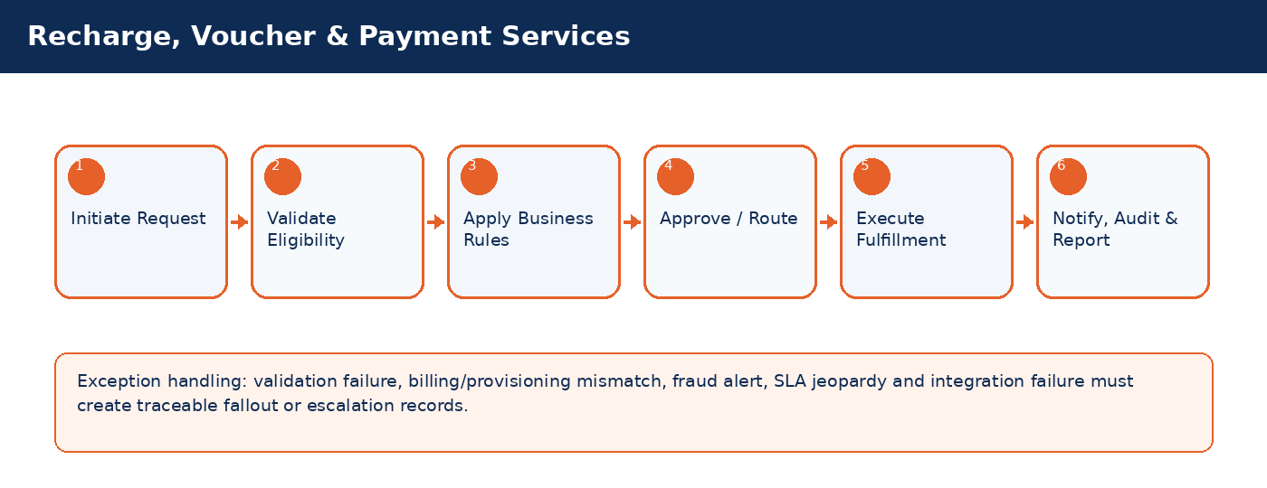

Detailed Process Flow
# | Stage | Business Activity | System Behavior | Exception Handling
1 | Request Initiation | Authorized user selects customer/subscriber and transaction type. | System loads customer, subscriber, service, billing and risk context. | Missing context blocks submission.
2 | Eligibility Validation | System validates KYC, status, balances, inventory, offer compatibility and fraud indicators. | Eligibility result stored against transaction. | Failed rule creates visible reason and next action.
3 | Business Rule Execution | Rules engine applies telecom policy, approval thresholds and lifecycle transition controls. | Decision generated: approve, reject, hold, escalate, or request additional data. | Manual override requires authority and audit reason.
4 | Approval / Queue Routing | Workflow routes request to supervisor, finance, fraud, compliance, NOC or back-office team where required. | Approver action captured with timestamp. | SLA timer and escalation path activated.
5 | Fulfillment / Integration | CRM calls billing, inventory, payment, provisioning or network systems as applicable. | Transaction reaches completed, pending, failed or fallout state. | Retry/rollback/fallout rules applied.
6 | Closure & Communication | Customer/internal notifications issued; audit and reports updated. | Lifecycle state, timeline and KPIs updated. | Unresolved exceptions remain in operational queue.

Functional Field Context and Data Controls
Field | Business Meaning | Source of Truth | Mandatory Rule | Editability | Security/Data Control | Audit Rule
Payment ID | Business-critical telecom field used to control lifecycle, eligibility, reporting or integration behavior. | Source system / CRM master depending on domain | Mandatory or conditional based on transaction type | Editable in Draft; locked after fulfillment unless controlled correction process is used | Masked/encrypted when PII, financial or network-sensitive | Full before/after audit for changes after submission
Channel | Business-critical telecom field used to control lifecycle, eligibility, reporting or integration behavior. | Source system / CRM master depending on domain | Mandatory or conditional based on transaction type | Editable in Draft; locked after fulfillment unless controlled correction process is used | Masked/encrypted when PII, financial or network-sensitive | Full before/after audit for changes after submission
Payment Method | Business-critical telecom field used to control lifecycle, eligibility, reporting or integration behavior. | Source system / CRM master depending on domain | Mandatory or conditional based on transaction type | Editable in Draft; locked after fulfillment unless controlled correction process is used | Masked/encrypted when PII, financial or network-sensitive | Full before/after audit for changes after submission
Amount | Business-critical telecom field used to control lifecycle, eligibility, reporting or integration behavior. | Source system / CRM master depending on domain | Mandatory or conditional based on transaction type | Editable in Draft; locked after fulfillment unless controlled correction process is used | Masked/encrypted when PII, financial or network-sensitive | Full before/after audit for changes after submission
Currency | Business-critical telecom field used to control lifecycle, eligibility, reporting or integration behavior. | Source system / CRM master depending on domain | Mandatory or conditional based on transaction type | Editable in Draft; locked after fulfillment unless controlled correction process is used | Masked/encrypted when PII, financial or network-sensitive | Full before/after audit for changes after submission
Voucher Code | Business-critical telecom field used to control lifecycle, eligibility, reporting or integration behavior. | Source system / CRM master depending on domain | Mandatory or conditional based on transaction type | Editable in Draft; locked after fulfillment unless controlled correction process is used | Masked/encrypted when PII, financial or network-sensitive | Full before/after audit for changes after submission
Gateway Reference | Business-critical telecom field used to control lifecycle, eligibility, reporting or integration behavior. | Source system / CRM master depending on domain | Mandatory or conditional based on transaction type | Editable in Draft; locked after fulfillment unless controlled correction process is used | Masked/encrypted when PII, financial or network-sensitive | Full before/after audit for changes after submission
Payment Status | Business-critical telecom field used to control lifecycle, eligibility, reporting or integration behavior. | CRM | Mandatory or conditional based on transaction type | Editable in Draft; locked after fulfillment unless controlled correction process is used | Masked/encrypted when PII, financial or network-sensitive | Full before/after audit for changes after submission
Failure Reason | Business-critical telecom field used to control lifecycle, eligibility, reporting or integration behavior. | Source system / CRM master depending on domain | Mandatory or conditional based on transaction type | Editable in Draft; locked after fulfillment unless controlled correction process is used | Masked/encrypted when PII, financial or network-sensitive | Full before/after audit for changes after submission
Reversal Flag | Business-critical telecom field used to control lifecycle, eligibility, reporting or integration behavior. | Source system / CRM master depending on domain | Mandatory or conditional based on transaction type | Editable in Draft; locked after fulfillment unless controlled correction process is used | Masked/encrypted when PII, financial or network-sensitive | Full before/after audit for changes after submission

Business Rules
Rule ID | Rule Area | Rule Statement | Severity | System Action
BR-01 | Lifecycle control | Requested action must be valid for the current customer/subscriber/SIM/order state. | High | Reject action and display reason.
BR-02 | Eligibility control | Customer, subscriber, offer, inventory and billing conditions must satisfy the applicable decision matrix. | High | Hold, reject or route for approval.
BR-03 | Fraud and risk control | High fraud score, blacklist or suspicious pattern must route to fraud governance before completion. | Critical | Suspend fulfillment and open fraud review.
BR-04 | Approval authority | Approval levels depend on transaction amount, customer segment, risk score, corporate authority and operational impact. | High | Route to required approver.
BR-05 | Integration consistency | Fulfillment is not complete until authoritative downstream systems confirm success. | Critical | Place transaction in pending/fallout and trigger retry.
BR-06 | Auditability | Manual override, rejection, approval and lifecycle transition must capture reason, actor, timestamp and channel. | Critical | Block completion if reason missing.

Validation Logic
Validation ID | Validation Rule | Validation Mode | Failure Behavior | Message Guidance
VAL-12-01 | Duplicate gateway reference rejected | Real-time where possible; asynchronous for cross-system checks | Block, hold, escalate or create fallout based on severity | User-friendly message with corrective action
VAL-12-02 | Voucher must be valid, unused and not expired | Real-time where possible; asynchronous for cross-system checks | Block, hold, escalate or create fallout based on severity | User-friendly message with corrective action
VAL-12-03 | Payment confirmation required before balance update | Real-time where possible; asynchronous for cross-system checks | Block, hold, escalate or create fallout based on severity | User-friendly message with corrective action
VAL-12-04 | High-frequency recharge pattern triggers fraud alert | Real-time where possible; asynchronous for cross-system checks | Block, hold, escalate or create fallout based on severity | User-friendly message with corrective action
VAL-12-05 | Reversal allowed only within policy window and approval level | Real-time where possible; asynchronous for cross-system checks | Block, hold, escalate or create fallout based on severity | User-friendly message with corrective action

Alternate and Exception Flows
Scenario | Trigger | Expected Handling | Owner
Cross-system validation unavailable | Billing/provisioning/payment/KYC service timeout | Set request to Pending Validation, retry according to policy, notify operations if SLA jeopardy occurs. | Integration / Operations
Eligibility failed | Business rule violation such as unpaid balance, invalid state, unavailable inventory or blacklisted customer | Display reason, prevent completion, provide allowed next action such as collect payment, select different offer or escalate. | CSR / Supervisor
Fulfillment fallout | Downstream activation/provisioning/billing step fails after CRM submission | Create fallout case with correlation ID, retry if safe, rollback if required, route to responsible team. | Provisioning / IT
Manual override requested | Business user requests exception to standard rule | Require authority limit, reason code, evidence attachment and audit entry. | Supervisor / Compliance
SLA jeopardy | Transaction approaches or breaches defined SLA | Escalate to next level and expose in operational dashboard. | Operations Manager

Integration Touchpoints and Events
Integration / Event | Direction | Purpose | Failure Handling
Customer / KYC validation | CRM -> KYC | Identity verification and duplicate/risk checks. | Pending validation with retry and manual review queue.
Billing / OCS validation | CRM <-> Billing | Balance, credit limit, invoice, recharge, payment and subscription checks. | Hold transaction or create billing reconciliation task.
Inventory validation | CRM <-> Inventory | SIM, MSISDN, device and stock availability confirmation. | Release reservation or retry inventory synchronization.
Provisioning request | CRM -> Provisioning | Activate, suspend, reconnect, terminate or modify service. | Fallout queue, retry, rollback and manual intervention.
Notification event | CRM -> SMS/Email/Push | Customer/internal communication. | Retry and log notification delivery status.

Notifications, Audit, KPIs and Acceptance Criteria
Area | Detailed Requirement
Notifications | Send customer notification when request is received, approved/rejected, completed, failed or requires action. Internal escalation notification must be sent for SLA jeopardy and high-risk exceptions.
Audit | Capture actor, channel, timestamp, request state, before/after values, external correlation IDs, approval comments and override reasons.
KPIs | Track volume, completion rate, fallout rate, SLA compliance, average handling time, rejection reasons, manual override count and customer impact for Recharge, Voucher & Payment Services.
Acceptance Criteria | Given authorized user and valid conditions, when transaction is submitted, then system validates eligibility, applies rules, routes approvals, triggers fulfillment, updates lifecycle state, creates audit entry and sends notifications. Given failed downstream fulfillment, then request must be moved to fallout with correlation ID and visible recovery action.

13. Billing Inquiry & Dispute Management
Manage customer billing visibility, invoice inquiries, disputed charges, adjustment requests and escalation to billing/finance teams.
Domain Summary: Domain Objective
Manage customer billing visibility, invoice inquiries, disputed charges, adjustment requests and escalation to billing/finance teams.

Actors and Stakeholders
Actor / Role | Responsibility
CSR | Participates in initiation, validation, approval, fulfillment, monitoring or exception handling for this domain.
Billing Officer | Participates in initiation, validation, approval, fulfillment, monitoring or exception handling for this domain.
Supervisor | Participates in initiation, validation, approval, fulfillment, monitoring or exception handling for this domain.
Customer | Participates in initiation, validation, approval, fulfillment, monitoring or exception handling for this domain.

Preconditions and Postconditions
Preconditions | Postconditions
Invoice or charge exists; Customer authenticated; Dispute category selected | Dispute case opened/resolved; Adjustment request approved/rejected; Customer notified

Process Flow Infographic
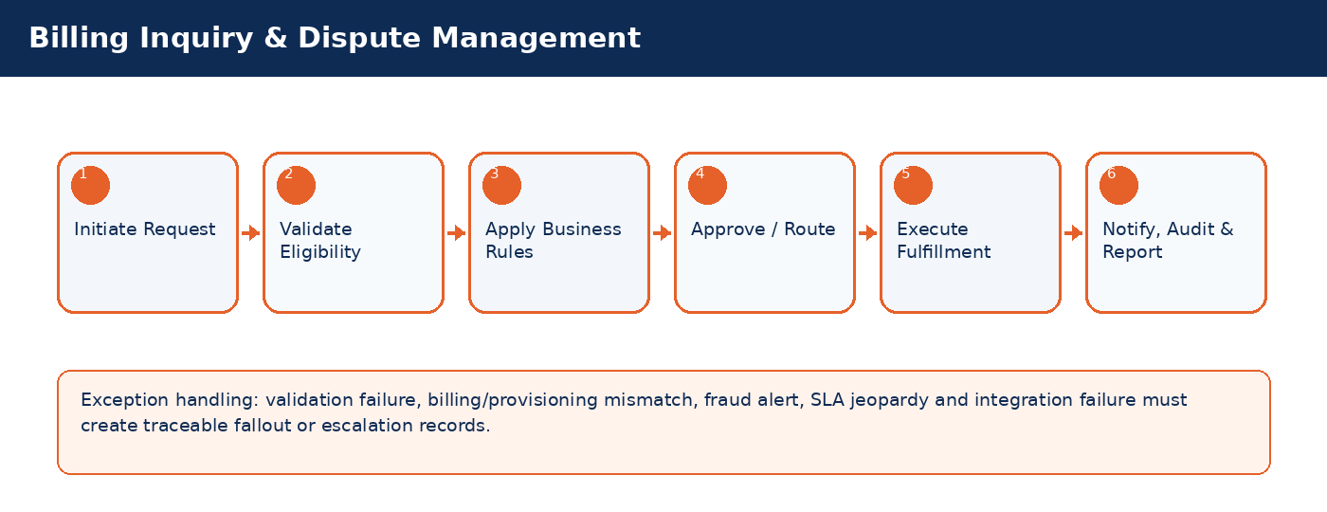

Detailed Process Flow
# | Stage | Business Activity | System Behavior | Exception Handling
1 | Request Initiation | Authorized user selects customer/subscriber and transaction type. | System loads customer, subscriber, service, billing and risk context. | Missing context blocks submission.
2 | Eligibility Validation | System validates KYC, status, balances, inventory, offer compatibility and fraud indicators. | Eligibility result stored against transaction. | Failed rule creates visible reason and next action.
3 | Business Rule Execution | Rules engine applies telecom policy, approval thresholds and lifecycle transition controls. | Decision generated: approve, reject, hold, escalate, or request additional data. | Manual override requires authority and audit reason.
4 | Approval / Queue Routing | Workflow routes request to supervisor, finance, fraud, compliance, NOC or back-office team where required. | Approver action captured with timestamp. | SLA timer and escalation path activated.
5 | Fulfillment / Integration | CRM calls billing, inventory, payment, provisioning or network systems as applicable. | Transaction reaches completed, pending, failed or fallout state. | Retry/rollback/fallout rules applied.
6 | Closure & Communication | Customer/internal notifications issued; audit and reports updated. | Lifecycle state, timeline and KPIs updated. | Unresolved exceptions remain in operational queue.

Functional Field Context and Data Controls
Field | Business Meaning | Source of Truth | Mandatory Rule | Editability | Security/Data Control | Audit Rule
Invoice Number | Business-critical telecom field used to control lifecycle, eligibility, reporting or integration behavior. | Source system / CRM master depending on domain | Mandatory or conditional based on transaction type | Editable in Draft; locked after fulfillment unless controlled correction process is used | Masked/encrypted when PII, financial or network-sensitive | Full before/after audit for changes after submission
Billing Cycle | Business-critical telecom field used to control lifecycle, eligibility, reporting or integration behavior. | Source system / CRM master depending on domain | Mandatory or conditional based on transaction type | Editable in Draft; locked after fulfillment unless controlled correction process is used | Masked/encrypted when PII, financial or network-sensitive | Full before/after audit for changes after submission
Dispute Amount | Business-critical telecom field used to control lifecycle, eligibility, reporting or integration behavior. | Source system / CRM master depending on domain | Mandatory or conditional based on transaction type | Editable in Draft; locked after fulfillment unless controlled correction process is used | Masked/encrypted when PII, financial or network-sensitive | Full before/after audit for changes after submission
Dispute Reason | Business-critical telecom field used to control lifecycle, eligibility, reporting or integration behavior. | Source system / CRM master depending on domain | Mandatory or conditional based on transaction type | Editable in Draft; locked after fulfillment unless controlled correction process is used | Masked/encrypted when PII, financial or network-sensitive | Full before/after audit for changes after submission
Charge Type | Business-critical telecom field used to control lifecycle, eligibility, reporting or integration behavior. | Source system / CRM master depending on domain | Mandatory or conditional based on transaction type | Editable in Draft; locked after fulfillment unless controlled correction process is used | Masked/encrypted when PII, financial or network-sensitive | Full before/after audit for changes after submission
Evidence Attachment | Business-critical telecom field used to control lifecycle, eligibility, reporting or integration behavior. | Source system / CRM master depending on domain | Mandatory or conditional based on transaction type | Editable in Draft; locked after fulfillment unless controlled correction process is used | Masked/encrypted when PII, financial or network-sensitive | Full before/after audit for changes after submission
Adjustment Status | Business-critical telecom field used to control lifecycle, eligibility, reporting or integration behavior. | CRM | Mandatory or conditional based on transaction type | Editable in Draft; locked after fulfillment unless controlled correction process is used | Masked/encrypted when PII, financial or network-sensitive | Full before/after audit for changes after submission
Resolution Code | Business-critical telecom field used to control lifecycle, eligibility, reporting or integration behavior. | Source system / CRM master depending on domain | Mandatory or conditional based on transaction type | Editable in Draft; locked after fulfillment unless controlled correction process is used | Masked/encrypted when PII, financial or network-sensitive | Full before/after audit for changes after submission

Business Rules
Rule ID | Rule Area | Rule Statement | Severity | System Action
BR-01 | Lifecycle control | Requested action must be valid for the current customer/subscriber/SIM/order state. | High | Reject action and display reason.
BR-02 | Eligibility control | Customer, subscriber, offer, inventory and billing conditions must satisfy the applicable decision matrix. | High | Hold, reject or route for approval.
BR-03 | Fraud and risk control | High fraud score, blacklist or suspicious pattern must route to fraud governance before completion. | Critical | Suspend fulfillment and open fraud review.
BR-04 | Approval authority | Approval levels depend on transaction amount, customer segment, risk score, corporate authority and operational impact. | High | Route to required approver.
BR-05 | Integration consistency | Fulfillment is not complete until authoritative downstream systems confirm success. | Critical | Place transaction in pending/fallout and trigger retry.
BR-06 | Auditability | Manual override, rejection, approval and lifecycle transition must capture reason, actor, timestamp and channel. | Critical | Block completion if reason missing.

Validation Logic
Validation ID | Validation Rule | Validation Mode | Failure Behavior | Message Guidance
VAL-13-01 | Dispute amount cannot exceed eligible invoice amount | Real-time where possible; asynchronous for cross-system checks | Block, hold, escalate or create fallout based on severity | User-friendly message with corrective action
VAL-13-02 | Closed billing cycles require higher approval | Real-time where possible; synchronous for cross-system checks | Block, hold, escalate or create fallout based on severity | User-friendly message with corrective action
VAL-13-03 | Adjustment requires reason and evidence | Real-time where possible; asynchronous for cross-system checks | Block, hold, escalate or create fallout based on severity | User-friendly message with corrective action
VAL-13-04 | Repeated disputes trigger quality review | Real-time where possible; asynchronous for cross-system checks | Block, hold, escalate or create fallout based on severity | User-friendly message with corrective action
VAL-13-05 | VIP disputes route to priority queue | Real-time where possible; asynchronous for cross-system checks | Block, hold, escalate or create fallout based on severity | User-friendly message with corrective action

Alternate and Exception Flows
Scenario | Trigger | Expected Handling | Owner
Cross-system validation unavailable | Billing/provisioning/payment/KYC service timeout | Set request to Pending Validation, retry according to policy, notify operations if SLA jeopardy occurs. | Integration / Operations
Eligibility failed | Business rule violation such as unpaid balance, invalid state, unavailable inventory or blacklisted customer | Display reason, prevent completion, provide allowed next action such as collect payment, select different offer or escalate. | CSR / Supervisor
Fulfillment fallout | Downstream activation/provisioning/billing step fails after CRM submission | Create fallout case with correlation ID, retry if safe, rollback if required, route to responsible team. | Provisioning / IT
Manual override requested | Business user requests exception to standard rule | Require authority limit, reason code, evidence attachment and audit entry. | Supervisor / Compliance
SLA jeopardy | Transaction approaches or breaches defined SLA | Escalate to next level and expose in operational dashboard. | Operations Manager

Integration Touchpoints and Events
Integration / Event | Direction | Purpose | Failure Handling
Customer / KYC validation | CRM -> KYC | Identity verification and duplicate/risk checks. | Pending validation with retry and manual review queue.
Billing / OCS validation | CRM <-> Billing | Balance, credit limit, invoice, recharge, payment and subscription checks. | Hold transaction or create billing reconciliation task.
Inventory validation | CRM <-> Inventory | SIM, MSISDN, device and stock availability confirmation. | Release reservation or retry inventory synchronization.
Provisioning request | CRM -> Provisioning | Activate, suspend, reconnect, terminate or modify service. | Fallout queue, retry, rollback and manual intervention.
Notification event | CRM -> SMS/Email/Push | Customer/internal communication. | Retry and log notification delivery status.

Notifications, Audit, KPIs and Acceptance Criteria
Area | Detailed Requirement
Notifications | Send customer notification when request is received, approved/rejected, completed, failed or requires action. Internal escalation notification must be sent for SLA jeopardy and high-risk exceptions.
Audit | Capture actor, channel, timestamp, request state, before/after values, external correlation IDs, approval comments and override reasons.
KPIs | Track volume, completion rate, fallout rate, SLA compliance, average handling time, rejection reasons, manual override count and customer impact for Billing Inquiry & Dispute Management.
Acceptance Criteria | Given authorized user and valid conditions, when transaction is submitted, then system validates eligibility, applies rules, routes approvals, triggers fulfillment, updates lifecycle state, creates audit entry and sends notifications. Given failed downstream fulfillment, then request must be moved to fallout with correlation ID and visible recovery action.

14. Device Sales & Installment Lifecycle
Manage device sales, installment eligibility, inventory reservation, contract, payment schedule, delinquency and closure.
Domain Summary: Domain Objective
Manage device sales, installment eligibility, inventory reservation, contract, payment schedule, delinquency and closure.

Actors and Stakeholders
Actor / Role | Responsibility
Sales Agent | Participates in initiation, validation, approval, fulfillment, monitoring or exception handling for this domain.
Finance Officer | Participates in initiation, validation, approval, fulfillment, monitoring or exception handling for this domain.
Inventory System | Participates in initiation, validation, approval, fulfillment, monitoring or exception handling for this domain.
Collections Officer | Participates in initiation, validation, approval, fulfillment, monitoring or exception handling for this domain.

Preconditions and Postconditions
Preconditions | Postconditions
Device available; Customer eligible; Installment plan configured | Device sold/reserved; Installment contract active or rejected; Payment schedule created

Process Flow Infographic
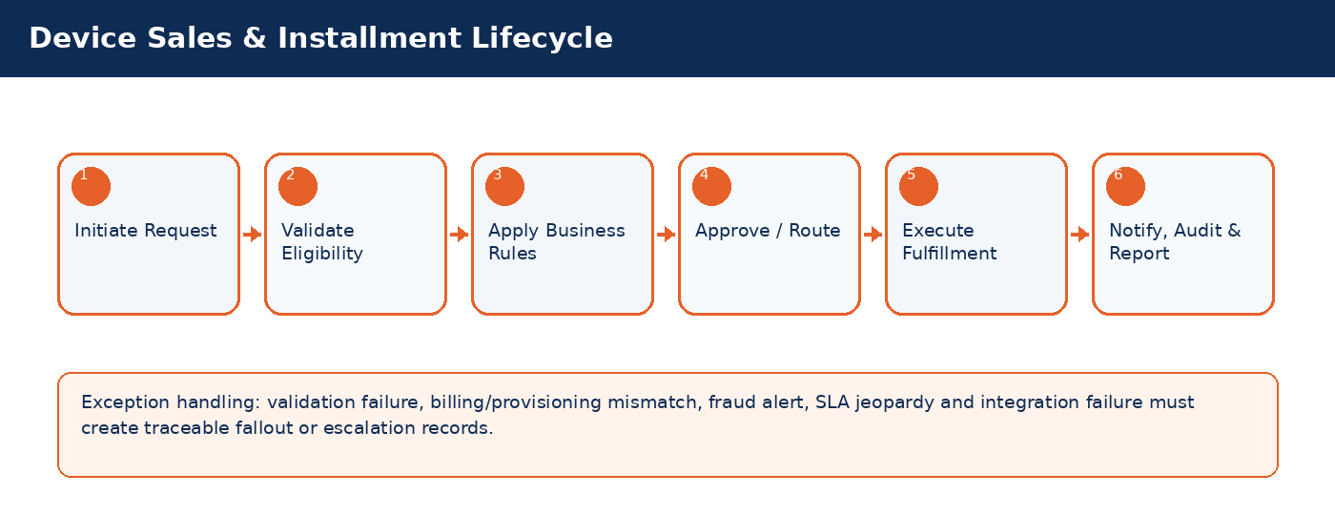

Detailed Process Flow
# | Stage | Business Activity | System Behavior | Exception Handling
1 | Request Initiation | Authorized user selects customer/subscriber and transaction type. | System loads customer, subscriber, service, billing and risk context. | Missing context blocks submission.
2 | Eligibility Validation | System validates KYC, status, balances, inventory, offer compatibility and fraud indicators. | Eligibility result stored against transaction. | Failed rule creates visible reason and next action.
3 | Business Rule Execution | Rules engine applies telecom policy, approval thresholds and lifecycle transition controls. | Decision generated: approve, reject, hold, escalate, or request additional data. | Manual override requires authority and audit reason.
4 | Approval / Queue Routing | Workflow routes request to supervisor, finance, fraud, compliance, NOC or back-office team where required. | Approver action captured with timestamp. | SLA timer and escalation path activated.
5 | Fulfillment / Integration | CRM calls billing, inventory, payment, provisioning or network systems as applicable. | Transaction reaches completed, pending, failed or fallout state. | Retry/rollback/fallout rules applied.
6 | Closure & Communication | Customer/internal notifications issued; audit and reports updated. | Lifecycle state, timeline and KPIs updated. | Unresolved exceptions remain in operational queue.

Functional Field Context and Data Controls
Field | Business Meaning | Source of Truth | Mandatory Rule | Editability | Security/Data Control | Audit Rule
Device IMEI | Business-critical telecom field used to control lifecycle, eligibility, reporting or integration behavior. | Source system / CRM master depending on domain | Mandatory or conditional based on transaction type | Editable in Draft; locked after fulfillment unless controlled correction process is used | Masked/encrypted when PII, financial or network-sensitive | Full before/after audit for changes after submission
Device Model | Business-critical telecom field used to control lifecycle, eligibility, reporting or integration behavior. | Source system / CRM master depending on domain | Mandatory or conditional based on transaction type | Editable in Draft; locked after fulfillment unless controlled correction process is used | Masked/encrypted when PII, financial or network-sensitive | Full before/after audit for changes after submission
Sale Type | Business-critical telecom field used to control lifecycle, eligibility, reporting or integration behavior. | Source system / CRM master depending on domain | Mandatory or conditional based on transaction type | Editable in Draft; locked after fulfillment unless controlled correction process is used | Masked/encrypted when PII, financial or network-sensitive | Full before/after audit for changes after submission
Installment Plan | Business-critical telecom field used to control lifecycle, eligibility, reporting or integration behavior. | Source system / CRM master depending on domain | Mandatory or conditional based on transaction type | Editable in Draft; locked after fulfillment unless controlled correction process is used | Masked/encrypted when PII, financial or network-sensitive | Full before/after audit for changes after submission
Down Payment | Business-critical telecom field used to control lifecycle, eligibility, reporting or integration behavior. | Source system / CRM master depending on domain | Mandatory or conditional based on transaction type | Editable in Draft; locked after fulfillment unless controlled correction process is used | Masked/encrypted when PII, financial or network-sensitive | Full before/after audit for changes after submission
Monthly Amount | Business-critical telecom field used to control lifecycle, eligibility, reporting or integration behavior. | Source system / CRM master depending on domain | Mandatory or conditional based on transaction type | Editable in Draft; locked after fulfillment unless controlled correction process is used | Masked/encrypted when PII, financial or network-sensitive | Full before/after audit for changes after submission
Credit Score | Business-critical telecom field used to control lifecycle, eligibility, reporting or integration behavior. | Source system / CRM master depending on domain | Mandatory or conditional based on transaction type | Editable in Draft; locked after fulfillment unless controlled correction process is used | Masked/encrypted when PII, financial or network-sensitive | Full before/after audit for changes after submission
Contract ID | Business-critical telecom field used to control lifecycle, eligibility, reporting or integration behavior. | Source system / CRM master depending on domain | Mandatory or conditional based on transaction type | Editable in Draft; locked after fulfillment unless controlled correction process is used | Masked/encrypted when PII, financial or network-sensitive | Full before/after audit for changes after submission
Delinquency Status | Business-critical telecom field used to control lifecycle, eligibility, reporting or integration behavior. | CRM | Mandatory or conditional based on transaction type | Editable in Draft; locked after fulfillment unless controlled correction process is used | Masked/encrypted when PII, financial or network-sensitive | Full before/after audit for changes after submission

Business Rules
Rule ID | Rule Area | Rule Statement | Severity | System Action
BR-01 | Lifecycle control | Requested action must be valid for the current customer/subscriber/SIM/order state. | High | Reject action and display reason.
BR-02 | Eligibility control | Customer, subscriber, offer, inventory and billing conditions must satisfy the applicable decision matrix. | High | Hold, reject or route for approval.
BR-03 | Fraud and risk control | High fraud score, blacklist or suspicious pattern must route to fraud governance before completion. | Critical | Suspend fulfillment and open fraud review.
BR-04 | Approval authority | Approval levels depend on transaction amount, customer segment, risk score, corporate authority and operational impact. | High | Route to required approver.
BR-05 | Integration consistency | Fulfillment is not complete until authoritative downstream systems confirm success. | Critical | Place transaction in pending/fallout and trigger retry.
BR-06 | Auditability | Manual override, rejection, approval and lifecycle transition must capture reason, actor, timestamp and channel. | Critical | Block completion if reason missing.

Validation Logic
Validation ID | Validation Rule | Validation Mode | Failure Behavior | Message Guidance
VAL-14-01 | IMEI unique and available | Real-time where possible; asynchronous for cross-system checks | Block, hold, escalate or create fallout based on severity | User-friendly message with corrective action
VAL-14-02 | Installment eligibility based on credit and payment history | Real-time where possible; asynchronous for cross-system checks | Block, hold, escalate or create fallout based on severity | User-friendly message with corrective action
VAL-14-03 | Down payment required before release | Real-time where possible; asynchronous for cross-system checks | Block, hold, escalate or create fallout based on severity | User-friendly message with corrective action
VAL-14-04 | Delinquent contracts feed collections | Real-time where possible; asynchronous for cross-system checks | Block, hold, escalate or create fallout based on severity | User-friendly message with corrective action
VAL-14-05 | Device warranty begins after sale completion | Real-time where possible; asynchronous for cross-system checks | Block, hold, escalate or create fallout based on severity | User-friendly message with corrective action

Alternate and Exception Flows
Scenario | Trigger | Expected Handling | Owner
Cross-system validation unavailable | Billing/provisioning/payment/KYC service timeout | Set request to Pending Validation, retry according to policy, notify operations if SLA jeopardy occurs. | Integration / Operations
Eligibility failed | Business rule violation such as unpaid balance, invalid state, unavailable inventory or blacklisted customer | Display reason, prevent completion, provide allowed next action such as collect payment, select different offer or escalate. | CSR / Supervisor
Fulfillment fallout | Downstream activation/provisioning/billing step fails after CRM submission | Create fallout case with correlation ID, retry if safe, rollback if required, route to responsible team. | Provisioning / IT
Manual override requested | Business user requests exception to standard rule | Require authority limit, reason code, evidence attachment and audit entry. | Supervisor / Compliance
SLA jeopardy | Transaction approaches or breaches defined SLA | Escalate to next level and expose in operational dashboard. | Operations Manager

Integration Touchpoints and Events
Integration / Event | Direction | Purpose | Failure Handling
Customer / KYC validation | CRM -> KYC | Identity verification and duplicate/risk checks. | Pending validation with retry and manual review queue.
Billing / OCS validation | CRM <-> Billing | Balance, credit limit, invoice, recharge, payment and subscription checks. | Hold transaction or create billing reconciliation task.
Inventory validation | CRM <-> Inventory | SIM, MSISDN, device and stock availability confirmation. | Release reservation or retry inventory synchronization.
Provisioning request | CRM -> Provisioning | Activate, suspend, reconnect, terminate or modify service. | Fallout queue, retry, rollback and manual intervention.
Notification event | CRM -> SMS/Email/Push | Customer/internal communication. | Retry and log notification delivery status.

Notifications, Audit, KPIs and Acceptance Criteria
Area | Detailed Requirement
Notifications | Send customer notification when request is received, approved/rejected, completed, failed or requires action. Internal escalation notification must be sent for SLA jeopardy and high-risk exceptions.
Audit | Capture actor, channel, timestamp, request state, before/after values, external correlation IDs, approval comments and override reasons.
KPIs | Track volume, completion rate, fallout rate, SLA compliance, average handling time, rejection reasons, manual override count and customer impact for Device Sales & Installment Lifecycle.
Acceptance Criteria | Given authorized user and valid conditions, when transaction is submitted, then system validates eligibility, applies rules, routes approvals, triggers fulfillment, updates lifecycle state, creates audit entry and sends notifications. Given failed downstream fulfillment, then request must be moved to fallout with correlation ID and visible recovery action.

15. Refund, Deposit & Wallet Balance Settlement
Control refund of deposits, overpayments, wallet balance and Syriatel Cash balances with financial approval and compliance controls.
Domain Summary: Domain Objective
Control refund of deposits, overpayments, wallet balance and Syriatel Cash balances with financial approval and compliance controls.

Actors and Stakeholders
Actor / Role | Responsibility
CSR | Participates in initiation, validation, approval, fulfillment, monitoring or exception handling for this domain.
Finance Officer | Participates in initiation, validation, approval, fulfillment, monitoring or exception handling for this domain.
Supervisor | Participates in initiation, validation, approval, fulfillment, monitoring or exception handling for this domain.
Wallet System | Participates in initiation, validation, approval, fulfillment, monitoring or exception handling for this domain.

Preconditions and Postconditions
Preconditions | Postconditions
Refundable balance exists; Customer identity verified; No blocking dispute/fraud case | Refund approved/rejected/paid; Ledger/wallet adjusted; Audit record stored

Process Flow Infographic
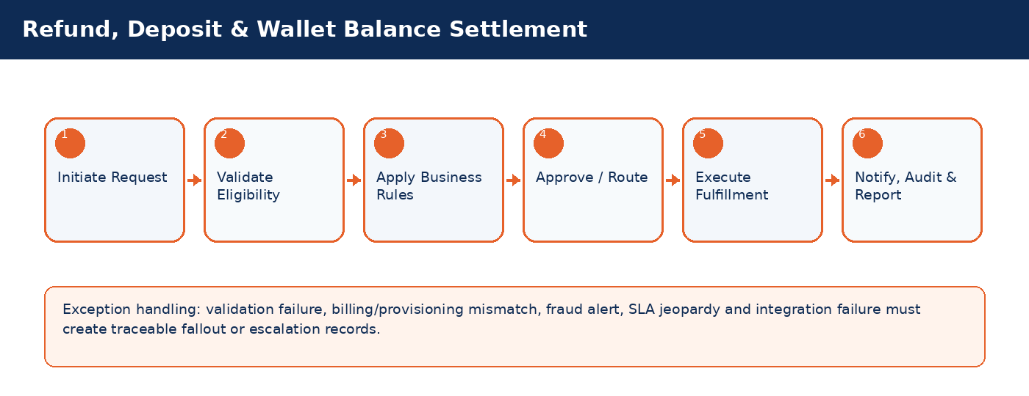

Detailed Process Flow
# | Stage | Business Activity | System Behavior | Exception Handling
1 | Request Initiation | Authorized user selects customer/subscriber and transaction type. | System loads customer, subscriber, service, billing and risk context. | Missing context blocks submission.
2 | Eligibility Validation | System validates KYC, status, balances, inventory, offer compatibility and fraud indicators. | Eligibility result stored against transaction. | Failed rule creates visible reason and next action.
3 | Business Rule Execution | Rules engine applies telecom policy, approval thresholds and lifecycle transition controls. | Decision generated: approve, reject, hold, escalate, or request additional data. | Manual override requires authority and audit reason.
4 | Approval / Queue Routing | Workflow routes request to supervisor, finance, fraud, compliance, NOC or back-office team where required. | Approver action captured with timestamp. | SLA timer and escalation path activated.
5 | Fulfillment / Integration | CRM calls billing, inventory, payment, provisioning or network systems as applicable. | Transaction reaches completed, pending, failed or fallout state. | Retry/rollback/fallout rules applied.
6 | Closure & Communication | Customer/internal notifications issued; audit and reports updated. | Lifecycle state, timeline and KPIs updated. | Unresolved exceptions remain in operational queue.

Functional Field Context and Data Controls
Field | Business Meaning | Source of Truth | Mandatory Rule | Editability | Security/Data Control | Audit Rule
Refund Request ID | Business-critical telecom field used to control lifecycle, eligibility, reporting or integration behavior. | Source system / CRM master depending on domain | Mandatory or conditional based on transaction type | Editable in Draft; locked after fulfillment unless controlled correction process is used | Masked/encrypted when PII, financial or network-sensitive | Full before/after audit for changes after submission
Refund Type | Business-critical telecom field used to control lifecycle, eligibility, reporting or integration behavior. | Source system / CRM master depending on domain | Mandatory or conditional based on transaction type | Editable in Draft; locked after fulfillment unless controlled correction process is used | Masked/encrypted when PII, financial or network-sensitive | Full before/after audit for changes after submission
Refund Amount | Business-critical telecom field used to control lifecycle, eligibility, reporting or integration behavior. | Source system / CRM master depending on domain | Mandatory or conditional based on transaction type | Editable in Draft; locked after fulfillment unless controlled correction process is used | Masked/encrypted when PII, financial or network-sensitive | Full before/after audit for changes after submission
Refund Method | Business-critical telecom field used to control lifecycle, eligibility, reporting or integration behavior. | Source system / CRM master depending on domain | Mandatory or conditional based on transaction type | Editable in Draft; locked after fulfillment unless controlled correction process is used | Masked/encrypted when PII, financial or network-sensitive | Full before/after audit for changes after submission
Deposit Balance | Business-critical telecom field used to control lifecycle, eligibility, reporting or integration behavior. | Source system / CRM master depending on domain | Mandatory or conditional based on transaction type | Editable in Draft; locked after fulfillment unless controlled correction process is used | Masked/encrypted when PII, financial or network-sensitive | Full before/after audit for changes after submission
Wallet Balance | Business-critical telecom field used to control lifecycle, eligibility, reporting or integration behavior. | Source system / CRM master depending on domain | Mandatory or conditional based on transaction type | Editable in Draft; locked after fulfillment unless controlled correction process is used | Masked/encrypted when PII, financial or network-sensitive | Full before/after audit for changes after submission
Approval Level | Business-critical telecom field used to control lifecycle, eligibility, reporting or integration behavior. | Source system / CRM master depending on domain | Mandatory or conditional based on transaction type | Editable in Draft; locked after fulfillment unless controlled correction process is used | Masked/encrypted when PII, financial or network-sensitive | Full before/after audit for changes after submission
Payment Reference | Business-critical telecom field used to control lifecycle, eligibility, reporting or integration behavior. | Source system / CRM master depending on domain | Mandatory or conditional based on transaction type | Editable in Draft; locked after fulfillment unless controlled correction process is used | Masked/encrypted when PII, financial or network-sensitive | Full before/after audit for changes after submission
Settlement Status | Business-critical telecom field used to control lifecycle, eligibility, reporting or integration behavior. | CRM | Mandatory or conditional based on transaction type | Editable in Draft; locked after fulfillment unless controlled correction process is used | Masked/encrypted when PII, financial or network-sensitive | Full before/after audit for changes after submission

Business Rules
Rule ID | Rule Area | Rule Statement | Severity | System Action
BR-01 | Lifecycle control | Requested action must be valid for the current customer/subscriber/SIM/order state. | High | Reject action and display reason.
BR-02 | Eligibility control | Customer, subscriber, offer, inventory and billing conditions must satisfy the applicable decision matrix. | High | Hold, reject or route for approval.
BR-03 | Fraud and risk control | High fraud score, blacklist or suspicious pattern must route to fraud governance before completion. | Critical | Suspend fulfillment and open fraud review.
BR-04 | Approval authority | Approval levels depend on transaction amount, customer segment, risk score, corporate authority and operational impact. | High | Route to required approver.
BR-05 | Integration consistency | Fulfillment is not complete until authoritative downstream systems confirm success. | Critical | Place transaction in pending/fallout and trigger retry.
BR-06 | Auditability | Manual override, rejection, approval and lifecycle transition must capture reason, actor, timestamp and channel. | Critical | Block completion if reason missing.

Validation Logic
Validation ID | Validation Rule | Validation Mode | Failure Behavior | Message Guidance
VAL-15-01 | Refund amount cannot exceed refundable balance | Real-time where possible; asynchronous for cross-system checks | Block, hold, escalate or create fallout based on severity | User-friendly message with corrective action
VAL-15-02 | High-value refunds require dual approval | Real-time where possible; asynchronous for cross-system checks | Block, hold, escalate or create fallout based on severity | User-friendly message with corrective action
VAL-15-03 | Wallet refund requires wallet system confirmation | Real-time where possible; asynchronous for cross-system checks | Block, hold, escalate or create fallout based on severity | User-friendly message with corrective action
VAL-15-04 | Refund blocked for fraud/blacklist cases | Real-time where possible; asynchronous for cross-system checks | Block, hold, escalate or create fallout based on severity | User-friendly message with corrective action
VAL-15-05 | All refunds require reason code and audit attachment if manual | Real-time where possible; asynchronous for cross-system checks | Block, hold, escalate or create fallout based on severity | User-friendly message with corrective action

Alternate and Exception Flows
Scenario | Trigger | Expected Handling | Owner
Cross-system validation unavailable | Billing/provisioning/payment/KYC service timeout | Set request to Pending Validation, retry according to policy, notify operations if SLA jeopardy occurs. | Integration / Operations
Eligibility failed | Business rule violation such as unpaid balance, invalid state, unavailable inventory or blacklisted customer | Display reason, prevent completion, provide allowed next action such as collect payment, select different offer or escalate. | CSR / Supervisor
Fulfillment fallout | Downstream activation/provisioning/billing step fails after CRM submission | Create fallout case with correlation ID, retry if safe, rollback if required, route to responsible team. | Provisioning / IT
Manual override requested | Business user requests exception to standard rule | Require authority limit, reason code, evidence attachment and audit entry. | Supervisor / Compliance
SLA jeopardy | Transaction approaches or breaches defined SLA | Escalate to next level and expose in operational dashboard. | Operations Manager

Integration Touchpoints and Events
Integration / Event | Direction | Purpose | Failure Handling
Customer / KYC validation | CRM -> KYC | Identity verification and duplicate/risk checks. | Pending validation with retry and manual review queue.
Billing / OCS validation | CRM <-> Billing | Balance, credit limit, invoice, recharge, payment and subscription checks. | Hold transaction or create billing reconciliation task.
Inventory validation | CRM <-> Inventory | SIM, MSISDN, device and stock availability confirmation. | Release reservation or retry inventory synchronization.
Provisioning request | CRM -> Provisioning | Activate, suspend, reconnect, terminate or modify service. | Fallout queue, retry, rollback and manual intervention.
Notification event | CRM -> SMS/Email/Push | Customer/internal communication. | Retry and log notification delivery status.

Notifications, Audit, KPIs and Acceptance Criteria
Area | Detailed Requirement
Notifications | Send customer notification when request is received, approved/rejected, completed, failed or requires action. Internal escalation notification must be sent for SLA jeopardy and high-risk exceptions.
Audit | Capture actor, channel, timestamp, request state, before/after values, external correlation IDs, approval comments and override reasons.
KPIs | Track volume, completion rate, fallout rate, SLA compliance, average handling time, rejection reasons, manual override count and customer impact for Refund, Deposit & Wallet Balance Settlement.
Acceptance Criteria | Given authorized user and valid conditions, when transaction is submitted, then system validates eligibility, applies rules, routes approvals, triggers fulfillment, updates lifecycle state, creates audit entry and sends notifications. Given failed downstream fulfillment, then request must be moved to fallout with correlation ID and visible recovery action.

16. Collections, Dunning & Bad Debt Recovery
Manage overdue accounts, dunning stages, promise-to-pay, payment plans, barring, legal escalation and bad debt recovery.
Domain Summary: Domain Objective
Manage overdue accounts, dunning stages, promise-to-pay, payment plans, barring, legal escalation and bad debt recovery.

Actors and Stakeholders
Actor / Role | Responsibility
Collections Officer | Participates in initiation, validation, approval, fulfillment, monitoring or exception handling for this domain.
Supervisor | Participates in initiation, validation, approval, fulfillment, monitoring or exception handling for this domain.
Legal Officer | Participates in initiation, validation, approval, fulfillment, monitoring or exception handling for this domain.
Billing System | Participates in initiation, validation, approval, fulfillment, monitoring or exception handling for this domain.

Preconditions and Postconditions
Preconditions | Postconditions
Outstanding debt exists; Dunning policy configured; Customer contact details available | Collection action completed; Dunning stage updated; Recovery amount recorded

Process Flow Infographic
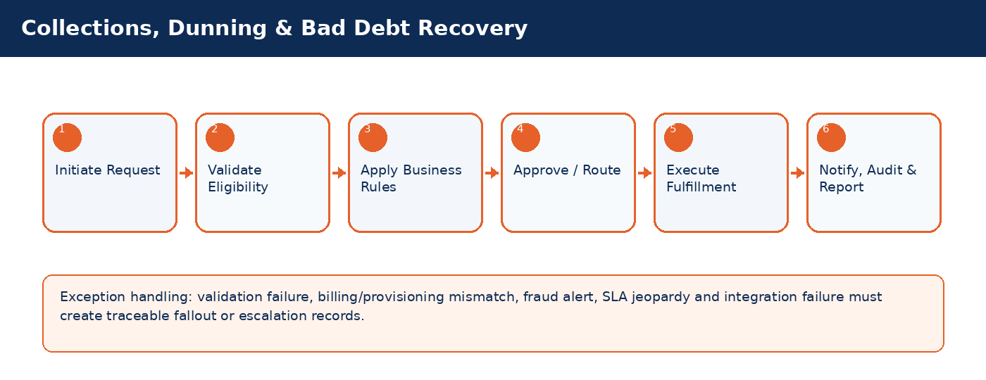

Detailed Process Flow
# | Stage | Business Activity | System Behavior | Exception Handling
1 | Request Initiation | Authorized user selects customer/subscriber and transaction type. | System loads customer, subscriber, service, billing and risk context. | Missing context blocks submission.
2 | Eligibility Validation | System validates KYC, status, balances, inventory, offer compatibility and fraud indicators. | Eligibility result stored against transaction. | Failed rule creates visible reason and next action.
3 | Business Rule Execution | Rules engine applies telecom policy, approval thresholds and lifecycle transition controls. | Decision generated: approve, reject, hold, escalate, or request additional data. | Manual override requires authority and audit reason.
4 | Approval / Queue Routing | Workflow routes request to supervisor, finance, fraud, compliance, NOC or back-office team where required. | Approver action captured with timestamp. | SLA timer and escalation path activated.
5 | Fulfillment / Integration | CRM calls billing, inventory, payment, provisioning or network systems as applicable. | Transaction reaches completed, pending, failed or fallout state. | Retry/rollback/fallout rules applied.
6 | Closure & Communication | Customer/internal notifications issued; audit and reports updated. | Lifecycle state, timeline and KPIs updated. | Unresolved exceptions remain in operational queue.

Functional Field Context and Data Controls
Field | Business Meaning | Source of Truth | Mandatory Rule | Editability | Security/Data Control | Audit Rule
Collection Case ID | Business-critical telecom field used to control lifecycle, eligibility, reporting or integration behavior. | Source system / CRM master depending on domain | Mandatory or conditional based on transaction type | Editable in Draft; locked after fulfillment unless controlled correction process is used | Masked/encrypted when PII, financial or network-sensitive | Full before/after audit for changes after submission
Debt Amount | Business-critical telecom field used to control lifecycle, eligibility, reporting or integration behavior. | Source system / CRM master depending on domain | Mandatory or conditional based on transaction type | Editable in Draft; locked after fulfillment unless controlled correction process is used | Masked/encrypted when PII, financial or network-sensitive | Full before/after audit for changes after submission
Aging Bucket | Business-critical telecom field used to control lifecycle, eligibility, reporting or integration behavior. | Source system / CRM master depending on domain | Mandatory or conditional based on transaction type | Editable in Draft; locked after fulfillment unless controlled correction process is used | Masked/encrypted when PII, financial or network-sensitive | Full before/after audit for changes after submission
Dunning Stage | Business-critical telecom field used to control lifecycle, eligibility, reporting or integration behavior. | Source system / CRM master depending on domain | Mandatory or conditional based on transaction type | Editable in Draft; locked after fulfillment unless controlled correction process is used | Masked/encrypted when PII, financial or network-sensitive | Full before/after audit for changes after submission
Promise-to-Pay Date | Business-critical telecom field used to control lifecycle, eligibility, reporting or integration behavior. | Source system / CRM master depending on domain | Mandatory or conditional based on transaction type | Editable in Draft; locked after fulfillment unless controlled correction process is used | Masked/encrypted when PII, financial or network-sensitive | Full before/after audit for changes after submission
Payment Plan | Business-critical telecom field used to control lifecycle, eligibility, reporting or integration behavior. | Source system / CRM master depending on domain | Mandatory or conditional based on transaction type | Editable in Draft; locked after fulfillment unless controlled correction process is used | Masked/encrypted when PII, financial or network-sensitive | Full before/after audit for changes after submission
Barring Status | Business-critical telecom field used to control lifecycle, eligibility, reporting or integration behavior. | CRM | Mandatory or conditional based on transaction type | Editable in Draft; locked after fulfillment unless controlled correction process is used | Masked/encrypted when PII, financial or network-sensitive | Full before/after audit for changes after submission
Legal Status | Business-critical telecom field used to control lifecycle, eligibility, reporting or integration behavior. | CRM | Mandatory or conditional based on transaction type | Editable in Draft; locked after fulfillment unless controlled correction process is used | Masked/encrypted when PII, financial or network-sensitive | Full before/after audit for changes after submission
Recovery Amount | Business-critical telecom field used to control lifecycle, eligibility, reporting or integration behavior. | Source system / CRM master depending on domain | Mandatory or conditional based on transaction type | Editable in Draft; locked after fulfillment unless controlled correction process is used | Masked/encrypted when PII, financial or network-sensitive | Full before/after audit for changes after submission

Business Rules
Rule ID | Rule Area | Rule Statement | Severity | System Action
BR-01 | Lifecycle control | Requested action must be valid for the current customer/subscriber/SIM/order state. | High | Reject action and display reason.
BR-02 | Eligibility control | Customer, subscriber, offer, inventory and billing conditions must satisfy the applicable decision matrix. | High | Hold, reject or route for approval.
BR-03 | Fraud and risk control | High fraud score, blacklist or suspicious pattern must route to fraud governance before completion. | Critical | Suspend fulfillment and open fraud review.
BR-04 | Approval authority | Approval levels depend on transaction amount, customer segment, risk score, corporate authority and operational impact. | High | Route to required approver.
BR-05 | Integration consistency | Fulfillment is not complete until authoritative downstream systems confirm success. | Critical | Place transaction in pending/fallout and trigger retry.
BR-06 | Auditability | Manual override, rejection, approval and lifecycle transition must capture reason, actor, timestamp and channel. | Critical | Block completion if reason missing.

Validation Logic
Validation ID | Validation Rule | Validation Mode | Failure Behavior | Message Guidance
VAL-16-01 | Dunning stage calculated from aging and risk score | Real-time where possible; asynchronous for cross-system checks | Block, hold, escalate or create fallout based on severity | User-friendly message with corrective action
VAL-16-02 | Promise-to-pay breach escalates automatically | Real-time where possible; asynchronous for cross-system checks | Block, hold, escalate or create fallout based on severity | User-friendly message with corrective action
VAL-16-03 | Auto-barring follows configured stage | Real-time where possible; asynchronous for cross-system checks | Block, hold, escalate or create fallout based on severity | User-friendly message with corrective action
VAL-16-04 | Payment plan requires approval based on amount | Real-time where possible; asynchronous for cross-system checks | Block, hold, escalate or create fallout based on severity | User-friendly message with corrective action
VAL-16-05 | Legal escalation requires minimum debt threshold | Real-time where possible; asynchronous for cross-system checks | Block, hold, escalate or create fallout based on severity | User-friendly message with corrective action

Alternate and Exception Flows
Scenario | Trigger | Expected Handling | Owner
Cross-system validation unavailable | Billing/provisioning/payment/KYC service timeout | Set request to Pending Validation, retry according to policy, notify operations if SLA jeopardy occurs. | Integration / Operations
Eligibility failed | Business rule violation such as unpaid balance, invalid state, unavailable inventory or blacklisted customer | Display reason, prevent completion, provide allowed next action such as collect payment, select different offer or escalate. | CSR / Supervisor
Fulfillment fallout | Downstream activation/provisioning/billing step fails after CRM submission | Create fallout case with correlation ID, retry if safe, rollback if required, route to responsible team. | Provisioning / IT
Manual override requested | Business user requests exception to standard rule | Require authority limit, reason code, evidence attachment and audit entry. | Supervisor / Compliance
SLA jeopardy | Transaction approaches or breaches defined SLA | Escalate to next level and expose in operational dashboard. | Operations Manager

Integration Touchpoints and Events
Integration / Event | Direction | Purpose | Failure Handling
Customer / KYC validation | CRM -> KYC | Identity verification and duplicate/risk checks. | Pending validation with retry and manual review queue.
Billing / OCS validation | CRM <-> Billing | Balance, credit limit, invoice, recharge, payment and subscription checks. | Hold transaction or create billing reconciliation task.
Inventory validation | CRM <-> Inventory | SIM, MSISDN, device and stock availability confirmation. | Release reservation or retry inventory synchronization.
Provisioning request | CRM -> Provisioning | Activate, suspend, reconnect, terminate or modify service. | Fallout queue, retry, rollback and manual intervention.
Notification event | CRM -> SMS/Email/Push | Customer/internal communication. | Retry and log notification delivery status.

Notifications, Audit, KPIs and Acceptance Criteria
Area | Detailed Requirement
Notifications | Send customer notification when request is received, approved/rejected, completed, failed or requires action. Internal escalation notification must be sent for SLA jeopardy and high-risk exceptions.
Audit | Capture actor, channel, timestamp, request state, before/after values, external correlation IDs, approval comments and override reasons.
KPIs | Track volume, completion rate, fallout rate, SLA compliance, average handling time, rejection reasons, manual override count and customer impact for Collections, Dunning & Bad Debt Recovery.
Acceptance Criteria | Given authorized user and valid conditions, when transaction is submitted, then system validates eligibility, applies rules, routes approvals, triggers fulfillment, updates lifecycle state, creates audit entry and sends notifications. Given failed downstream fulfillment, then request must be moved to fallout with correlation ID and visible recovery action.

17. Complaint, Case & SLA Management
Manage customer complaints, service requests, tickets, SLA timers, escalation, resolution and reopening.
Domain Summary: Domain Objective
Manage customer complaints, service requests, tickets, SLA timers, escalation, resolution and reopening.

Actors and Stakeholders
Actor / Role | Responsibility
Call Center Agent | Participates in initiation, validation, approval, fulfillment, monitoring or exception handling for this domain.
Back Office Team | Participates in initiation, validation, approval, fulfillment, monitoring or exception handling for this domain.
Supervisor | Participates in initiation, validation, approval, fulfillment, monitoring or exception handling for this domain.
NOC User | Participates in initiation, validation, approval, fulfillment, monitoring or exception handling for this domain.

Preconditions and Postconditions
Preconditions | Postconditions
Customer identified; Complaint category selected; SLA policy available | Case resolved/closed/reopened; SLA outcome recorded; Customer feedback captured

Process Flow Infographic
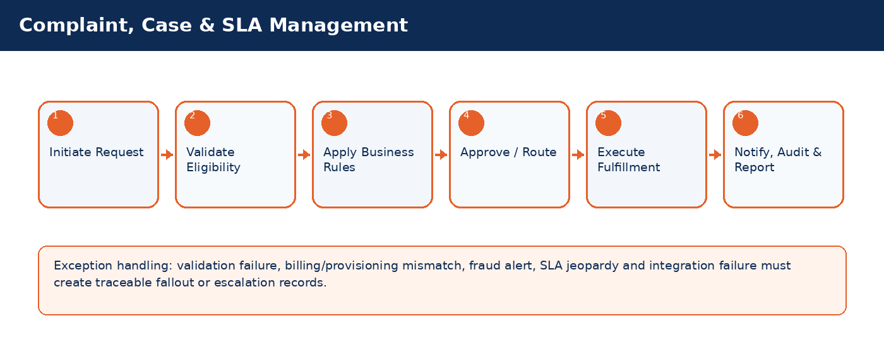

Detailed Process Flow
# | Stage | Business Activity | System Behavior | Exception Handling
1 | Request Initiation | Authorized user selects customer/subscriber and transaction type. | System loads customer, subscriber, service, billing and risk context. | Missing context blocks submission.
2 | Eligibility Validation | System validates KYC, status, balances, inventory, offer compatibility and fraud indicators. | Eligibility result stored against transaction. | Failed rule creates visible reason and next action.
3 | Business Rule Execution | Rules engine applies telecom policy, approval thresholds and lifecycle transition controls. | Decision generated: approve, reject, hold, escalate, or request additional data. | Manual override requires authority and audit reason.
4 | Approval / Queue Routing | Workflow routes request to supervisor, finance, fraud, compliance, NOC or back-office team where required. | Approver action captured with timestamp. | SLA timer and escalation path activated.
5 | Fulfillment / Integration | CRM calls billing, inventory, payment, provisioning or network systems as applicable. | Transaction reaches completed, pending, failed or fallout state. | Retry/rollback/fallout rules applied.
6 | Closure & Communication | Customer/internal notifications issued; audit and reports updated. | Lifecycle state, timeline and KPIs updated. | Unresolved exceptions remain in operational queue.

Functional Field Context and Data Controls
Field | Business Meaning | Source of Truth | Mandatory Rule | Editability | Security/Data Control | Audit Rule
Case ID | Business-critical telecom field used to control lifecycle, eligibility, reporting or integration behavior. | CRM | Mandatory or conditional based on transaction type | Editable in Draft; locked after fulfillment unless controlled correction process is used | Masked/encrypted when PII, financial or network-sensitive | Full before/after audit for changes after submission
Category | Business-critical telecom field used to control lifecycle, eligibility, reporting or integration behavior. | Source system / CRM master depending on domain | Mandatory or conditional based on transaction type | Editable in Draft; locked after fulfillment unless controlled correction process is used | Masked/encrypted when PII, financial or network-sensitive | Full before/after audit for changes after submission
Subcategory | Business-critical telecom field used to control lifecycle, eligibility, reporting or integration behavior. | Source system / CRM master depending on domain | Mandatory or conditional based on transaction type | Editable in Draft; locked after fulfillment unless controlled correction process is used | Masked/encrypted when PII, financial or network-sensitive | Full before/after audit for changes after submission
Priority | Business-critical telecom field used to control lifecycle, eligibility, reporting or integration behavior. | Source system / CRM master depending on domain | Mandatory or conditional based on transaction type | Editable in Draft; locked after fulfillment unless controlled correction process is used | Masked/encrypted when PII, financial or network-sensitive | Full before/after audit for changes after submission
Severity | Business-critical telecom field used to control lifecycle, eligibility, reporting or integration behavior. | Source system / CRM master depending on domain | Mandatory or conditional based on transaction type | Editable in Draft; locked after fulfillment unless controlled correction process is used | Masked/encrypted when PII, financial or network-sensitive | Full before/after audit for changes after submission
Assigned Queue | Business-critical telecom field used to control lifecycle, eligibility, reporting or integration behavior. | Source system / CRM master depending on domain | Mandatory or conditional based on transaction type | Editable in Draft; locked after fulfillment unless controlled correction process is used | Masked/encrypted when PII, financial or network-sensitive | Full before/after audit for changes after submission
SLA Due Date | Business-critical telecom field used to control lifecycle, eligibility, reporting or integration behavior. | Source system / CRM master depending on domain | Mandatory or conditional based on transaction type | Editable in Draft; locked after fulfillment unless controlled correction process is used | Masked/encrypted when PII, financial or network-sensitive | Full before/after audit for changes after submission
Escalation Level | Business-critical telecom field used to control lifecycle, eligibility, reporting or integration behavior. | Source system / CRM master depending on domain | Mandatory or conditional based on transaction type | Editable in Draft; locked after fulfillment unless controlled correction process is used | Masked/encrypted when PII, financial or network-sensitive | Full before/after audit for changes after submission
Resolution Code | Business-critical telecom field used to control lifecycle, eligibility, reporting or integration behavior. | Source system / CRM master depending on domain | Mandatory or conditional based on transaction type | Editable in Draft; locked after fulfillment unless controlled correction process is used | Masked/encrypted when PII, financial or network-sensitive | Full before/after audit for changes after submission
Reopen Count | Business-critical telecom field used to control lifecycle, eligibility, reporting or integration behavior. | Source system / CRM master depending on domain | Mandatory or conditional based on transaction type | Editable in Draft; locked after fulfillment unless controlled correction process is used | Masked/encrypted when PII, financial or network-sensitive | Full before/after audit for changes after submission

Business Rules
Rule ID | Rule Area | Rule Statement | Severity | System Action
BR-01 | Lifecycle control | Requested action must be valid for the current customer/subscriber/SIM/order state. | High | Reject action and display reason.
BR-02 | Eligibility control | Customer, subscriber, offer, inventory and billing conditions must satisfy the applicable decision matrix. | High | Hold, reject or route for approval.
BR-03 | Fraud and risk control | High fraud score, blacklist or suspicious pattern must route to fraud governance before completion. | Critical | Suspend fulfillment and open fraud review.
BR-04 | Approval authority | Approval levels depend on transaction amount, customer segment, risk score, corporate authority and operational impact. | High | Route to required approver.
BR-05 | Integration consistency | Fulfillment is not complete until authoritative downstream systems confirm success. | Critical | Place transaction in pending/fallout and trigger retry.
BR-06 | Auditability | Manual override, rejection, approval and lifecycle transition must capture reason, actor, timestamp and channel. | Critical | Block completion if reason missing.

Validation Logic
Validation ID | Validation Rule | Validation Mode | Failure Behavior | Message Guidance
VAL-17-01 | Priority derived from severity, segment and impact | Real-time where possible; asynchronous for cross-system checks | Block, hold, escalate or create fallout based on severity | User-friendly message with corrective action
VAL-17-02 | VIP cases auto-route to premium queue | Real-time where possible; asynchronous for cross-system checks | Block, hold, escalate or create fallout based on severity | User-friendly message with corrective action
VAL-17-03 | Network outage cases can be bulk-linked | Real-time where possible; asynchronous for cross-system checks | Block, hold, escalate or create fallout based on severity | User-friendly message with corrective action
VAL-17-04 | SLA breach triggers escalation | Real-time where possible; asynchronous for cross-system checks | Block, hold, escalate or create fallout based on severity | User-friendly message with corrective action
VAL-17-05 | Closed case can reopen within policy window | Real-time where possible; asynchronous for cross-system checks | Block, hold, escalate or create fallout based on severity | User-friendly message with corrective action

Alternate and Exception Flows
Scenario | Trigger | Expected Handling | Owner
Cross-system validation unavailable | Billing/provisioning/payment/KYC service timeout | Set request to Pending Validation, retry according to policy, notify operations if SLA jeopardy occurs. | Integration / Operations
Eligibility failed | Business rule violation such as unpaid balance, invalid state, unavailable inventory or blacklisted customer | Display reason, prevent completion, provide allowed next action such as collect payment, select different offer or escalate. | CSR / Supervisor
Fulfillment fallout | Downstream activation/provisioning/billing step fails after CRM submission | Create fallout case with correlation ID, retry if safe, rollback if required, route to responsible team. | Provisioning / IT
Manual override requested | Business user requests exception to standard rule | Require authority limit, reason code, evidence attachment and audit entry. | Supervisor / Compliance
SLA jeopardy | Transaction approaches or breaches defined SLA | Escalate to next level and expose in operational dashboard. | Operations Manager

Integration Touchpoints and Events
Integration / Event | Direction | Purpose | Failure Handling
Customer / KYC validation | CRM -> KYC | Identity verification and duplicate/risk checks. | Pending validation with retry and manual review queue.
Billing / OCS validation | CRM <-> Billing | Balance, credit limit, invoice, recharge, payment and subscription checks. | Hold transaction or create billing reconciliation task.
Inventory validation | CRM <-> Inventory | SIM, MSISDN, device and stock availability confirmation. | Release reservation or retry inventory synchronization.
Provisioning request | CRM -> Provisioning | Activate, suspend, reconnect, terminate or modify service. | Fallout queue, retry, rollback and manual intervention.
Notification event | CRM -> SMS/Email/Push | Customer/internal communication. | Retry and log notification delivery status.

Notifications, Audit, KPIs and Acceptance Criteria
Area | Detailed Requirement
Notifications | Send customer notification when request is received, approved/rejected, completed, failed or requires action. Internal escalation notification must be sent for SLA jeopardy and high-risk exceptions.
Audit | Capture actor, channel, timestamp, request state, before/after values, external correlation IDs, approval comments and override reasons.
KPIs | Track volume, completion rate, fallout rate, SLA compliance, average handling time, rejection reasons, manual override count and customer impact for Complaint, Case & SLA Management.
Acceptance Criteria | Given authorized user and valid conditions, when transaction is submitted, then system validates eligibility, applies rules, routes approvals, triggers fulfillment, updates lifecycle state, creates audit entry and sends notifications. Given failed downstream fulfillment, then request must be moved to fallout with correlation ID and visible recovery action.

18. Dealer, Branch & Retail Operations
Govern dealer/branch activities including SIM allocation, activation quotas, device inventory, settlement, cash reconciliation and performance monitoring.
Domain Summary: Domain Objective
Govern dealer/branch activities including SIM allocation, activation quotas, device inventory, settlement, cash reconciliation and performance monitoring.

Actors and Stakeholders
Actor / Role | Responsibility
Branch Manager | Participates in initiation, validation, approval, fulfillment, monitoring or exception handling for this domain.
Dealer Manager | Participates in initiation, validation, approval, fulfillment, monitoring or exception handling for this domain.
Dealer Agent | Participates in initiation, validation, approval, fulfillment, monitoring or exception handling for this domain.
Finance Officer | Participates in initiation, validation, approval, fulfillment, monitoring or exception handling for this domain.

Preconditions and Postconditions
Preconditions | Postconditions
Dealer/branch active; Inventory allocation available; User mapped to location | Retail transaction completed; Inventory/cash reconciled; Commission candidate recorded

Process Flow Infographic
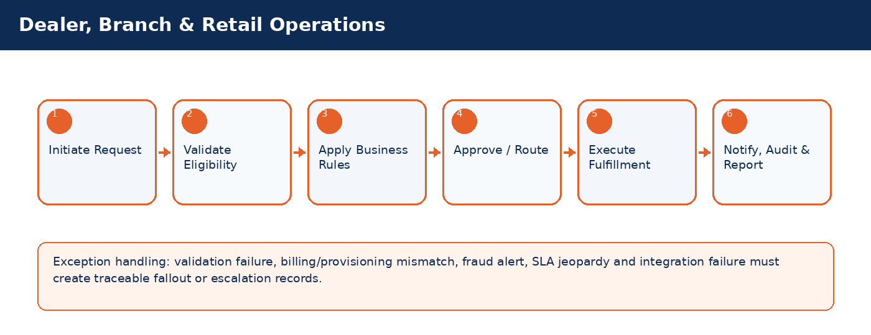

Detailed Process Flow
# | Stage | Business Activity | System Behavior | Exception Handling
1 | Request Initiation | Authorized user selects customer/subscriber and transaction type. | System loads customer, subscriber, service, billing and risk context. | Missing context blocks submission.
2 | Eligibility Validation | System validates KYC, status, balances, inventory, offer compatibility and fraud indicators. | Eligibility result stored against transaction. | Failed rule creates visible reason and next action.
3 | Business Rule Execution | Rules engine applies telecom policy, approval thresholds and lifecycle transition controls. | Decision generated: approve, reject, hold, escalate, or request additional data. | Manual override requires authority and audit reason.
4 | Approval / Queue Routing | Workflow routes request to supervisor, finance, fraud, compliance, NOC or back-office team where required. | Approver action captured with timestamp. | SLA timer and escalation path activated.
5 | Fulfillment / Integration | CRM calls billing, inventory, payment, provisioning or network systems as applicable. | Transaction reaches completed, pending, failed or fallout state. | Retry/rollback/fallout rules applied.
6 | Closure & Communication | Customer/internal notifications issued; audit and reports updated. | Lifecycle state, timeline and KPIs updated. | Unresolved exceptions remain in operational queue.

Functional Field Context and Data Controls
Field | Business Meaning | Source of Truth | Mandatory Rule | Editability | Security/Data Control | Audit Rule
Dealer ID | Business-critical telecom field used to control lifecycle, eligibility, reporting or integration behavior. | Source system / CRM master depending on domain | Mandatory or conditional based on transaction type | Editable in Draft; locked after fulfillment unless controlled correction process is used | Masked/encrypted when PII, financial or network-sensitive | Full before/after audit for changes after submission
Branch ID | Business-critical telecom field used to control lifecycle, eligibility, reporting or integration behavior. | Source system / CRM master depending on domain | Mandatory or conditional based on transaction type | Editable in Draft; locked after fulfillment unless controlled correction process is used | Masked/encrypted when PII, financial or network-sensitive | Full before/after audit for changes after submission
Agent ID | Business-critical telecom field used to control lifecycle, eligibility, reporting or integration behavior. | Source system / CRM master depending on domain | Mandatory or conditional based on transaction type | Editable in Draft; locked after fulfillment unless controlled correction process is used | Masked/encrypted when PII, financial or network-sensitive | Full before/after audit for changes after submission
Quota Limit | Business-critical telecom field used to control lifecycle, eligibility, reporting or integration behavior. | Source system / CRM master depending on domain | Mandatory or conditional based on transaction type | Editable in Draft; locked after fulfillment unless controlled correction process is used | Masked/encrypted when PII, financial or network-sensitive | Full before/after audit for changes after submission
Inventory Allocation | Business-critical telecom field used to control lifecycle, eligibility, reporting or integration behavior. | Source system / CRM master depending on domain | Mandatory or conditional based on transaction type | Editable in Draft; locked after fulfillment unless controlled correction process is used | Masked/encrypted when PII, financial or network-sensitive | Full before/after audit for changes after submission
Cash Drawer | Business-critical telecom field used to control lifecycle, eligibility, reporting or integration behavior. | Source system / CRM master depending on domain | Mandatory or conditional based on transaction type | Editable in Draft; locked after fulfillment unless controlled correction process is used | Masked/encrypted when PII, financial or network-sensitive | Full before/after audit for changes after submission
Settlement Batch | Business-critical telecom field used to control lifecycle, eligibility, reporting or integration behavior. | Source system / CRM master depending on domain | Mandatory or conditional based on transaction type | Editable in Draft; locked after fulfillment unless controlled correction process is used | Masked/encrypted when PII, financial or network-sensitive | Full before/after audit for changes after submission
Commission Tier | Business-critical telecom field used to control lifecycle, eligibility, reporting or integration behavior. | Source system / CRM master depending on domain | Mandatory or conditional based on transaction type | Editable in Draft; locked after fulfillment unless controlled correction process is used | Masked/encrypted when PII, financial or network-sensitive | Full before/after audit for changes after submission
Activation Count | Business-critical telecom field used to control lifecycle, eligibility, reporting or integration behavior. | Source system / CRM master depending on domain | Mandatory or conditional based on transaction type | Editable in Draft; locked after fulfillment unless controlled correction process is used | Masked/encrypted when PII, financial or network-sensitive | Full before/after audit for changes after submission

Business Rules
Rule ID | Rule Area | Rule Statement | Severity | System Action
BR-01 | Lifecycle control | Requested action must be valid for the current customer/subscriber/SIM/order state. | High | Reject action and display reason.
BR-02 | Eligibility control | Customer, subscriber, offer, inventory and billing conditions must satisfy the applicable decision matrix. | High | Hold, reject or route for approval.
BR-03 | Fraud and risk control | High fraud score, blacklist or suspicious pattern must route to fraud governance before completion. | Critical | Suspend fulfillment and open fraud review.
BR-04 | Approval authority | Approval levels depend on transaction amount, customer segment, risk score, corporate authority and operational impact. | High | Route to required approver.
BR-05 | Integration consistency | Fulfillment is not complete until authoritative downstream systems confirm success. | Critical | Place transaction in pending/fallout and trigger retry.
BR-06 | Auditability | Manual override, rejection, approval and lifecycle transition must capture reason, actor, timestamp and channel. | Critical | Block completion if reason missing.

Validation Logic
Validation ID | Validation Rule | Validation Mode | Failure Behavior | Message Guidance
VAL-18-01 | Dealer cannot exceed quota without approval | Real-time where possible; asynchronous for cross-system checks | Block, hold, escalate or create fallout based on severity | User-friendly message with corrective action
VAL-18-02 | SIM allocation tied to dealer stock | Real-time where possible; asynchronous for cross-system checks | Block, hold, escalate or create fallout based on severity | User-friendly message with corrective action
VAL-18-03 | Daily cash reconciliation required | Real-time where possible; asynchronous for cross-system checks | Block, hold, escalate or create fallout based on severity | User-friendly message with corrective action
VAL-18-04 | Suspicious activation ratios trigger dealer fraud review | Real-time where possible; asynchronous for cross-system checks | Block, hold, escalate or create fallout based on severity | User-friendly message with corrective action
VAL-18-05 | Commission payable only for validated activations | Real-time where possible; asynchronous for cross-system checks | Block, hold, escalate or create fallout based on severity | User-friendly message with corrective action

Alternate and Exception Flows
Scenario | Trigger | Expected Handling | Owner
Cross-system validation unavailable | Billing/provisioning/payment/KYC service timeout | Set request to Pending Validation, retry according to policy, notify operations if SLA jeopardy occurs. | Integration / Operations
Eligibility failed | Business rule violation such as unpaid balance, invalid state, unavailable inventory or blacklisted customer | Display reason, prevent completion, provide allowed next action such as collect payment, select different offer or escalate. | CSR / Supervisor
Fulfillment fallout | Downstream activation/provisioning/billing step fails after CRM submission | Create fallout case with correlation ID, retry if safe, rollback if required, route to responsible team. | Provisioning / IT
Manual override requested | Business user requests exception to standard rule | Require authority limit, reason code, evidence attachment and audit entry. | Supervisor / Compliance
SLA jeopardy | Transaction approaches or breaches defined SLA | Escalate to next level and expose in operational dashboard. | Operations Manager

Integration Touchpoints and Events
Integration / Event | Direction | Purpose | Failure Handling
Customer / KYC validation | CRM -> KYC | Identity verification and duplicate/risk checks. | Pending validation with retry and manual review queue.
Billing / OCS validation | CRM <-> Billing | Balance, credit limit, invoice, recharge, payment and subscription checks. | Hold transaction or create billing reconciliation task.
Inventory validation | CRM <-> Inventory | SIM, MSISDN, device and stock availability confirmation. | Release reservation or retry inventory synchronization.
Provisioning request | CRM -> Provisioning | Activate, suspend, reconnect, terminate or modify service. | Fallout queue, retry, rollback and manual intervention.
Notification event | CRM -> SMS/Email/Push | Customer/internal communication. | Retry and log notification delivery status.

Notifications, Audit, KPIs and Acceptance Criteria
Area | Detailed Requirement
Notifications | Send customer notification when request is received, approved/rejected, completed, failed or requires action. Internal escalation notification must be sent for SLA jeopardy and high-risk exceptions.
Audit | Capture actor, channel, timestamp, request state, before/after values, external correlation IDs, approval comments and override reasons.
KPIs | Track volume, completion rate, fallout rate, SLA compliance, average handling time, rejection reasons, manual override count and customer impact for Dealer, Branch & Retail Operations.
Acceptance Criteria | Given authorized user and valid conditions, when transaction is submitted, then system validates eligibility, applies rules, routes approvals, triggers fulfillment, updates lifecycle state, creates audit entry and sends notifications. Given failed downstream fulfillment, then request must be moved to fallout with correlation ID and visible recovery action.

19. Revenue Assurance & Fraud Management
Detect revenue leakage, abnormal activity, suspicious activations, SIM-box patterns, recharge fraud and billing/provisioning mismatch.
Domain Summary: Domain Objective
Detect revenue leakage, abnormal activity, suspicious activations, SIM-box patterns, recharge fraud and billing/provisioning mismatch.

Actors and Stakeholders
Actor / Role | Responsibility
Fraud Analyst | Participates in initiation, validation, approval, fulfillment, monitoring or exception handling for this domain.
Revenue Assurance Officer | Participates in initiation, validation, approval, fulfillment, monitoring or exception handling for this domain.
Operations Manager | Participates in initiation, validation, approval, fulfillment, monitoring or exception handling for this domain.

Preconditions and Postconditions
Preconditions | Postconditions
Events and transactions available; Rules/thresholds configured; Exception queues active | Alert generated/closed; Leakage case resolved; Corrective action logged

Process Flow Infographic
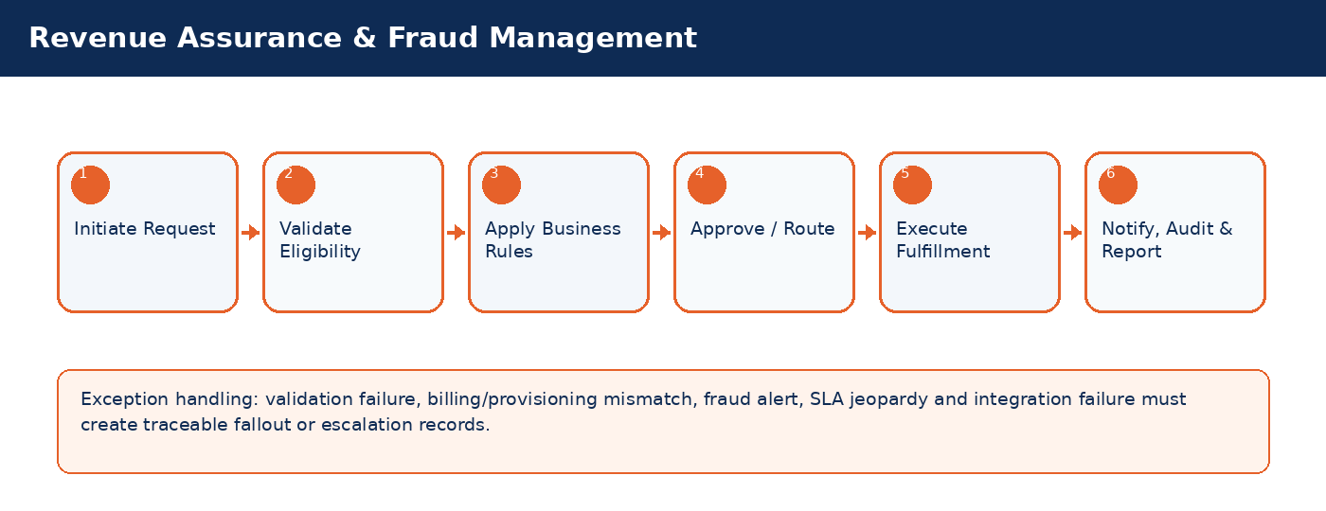

Detailed Process Flow
# | Stage | Business Activity | System Behavior | Exception Handling
1 | Request Initiation | Authorized user selects customer/subscriber and transaction type. | System loads customer, subscriber, service, billing and risk context. | Missing context blocks submission.
2 | Eligibility Validation | System validates KYC, status, balances, inventory, offer compatibility and fraud indicators. | Eligibility result stored against transaction. | Failed rule creates visible reason and next action.
3 | Business Rule Execution | Rules engine applies telecom policy, approval thresholds and lifecycle transition controls. | Decision generated: approve, reject, hold, escalate, or request additional data. | Manual override requires authority and audit reason.
4 | Approval / Queue Routing | Workflow routes request to supervisor, finance, fraud, compliance, NOC or back-office team where required. | Approver action captured with timestamp. | SLA timer and escalation path activated.
5 | Fulfillment / Integration | CRM calls billing, inventory, payment, provisioning or network systems as applicable. | Transaction reaches completed, pending, failed or fallout state. | Retry/rollback/fallout rules applied.
6 | Closure & Communication | Customer/internal notifications issued; audit and reports updated. | Lifecycle state, timeline and KPIs updated. | Unresolved exceptions remain in operational queue.

Functional Field Context and Data Controls
Field | Business Meaning | Source of Truth | Mandatory Rule | Editability | Security/Data Control | Audit Rule
Alert ID | Business-critical telecom field used to control lifecycle, eligibility, reporting or integration behavior. | Source system / CRM master depending on domain | Mandatory or conditional based on transaction type | Editable in Draft; locked after fulfillment unless controlled correction process is used | Masked/encrypted when PII, financial or network-sensitive | Full before/after audit for changes after submission
Alert Type | Business-critical telecom field used to control lifecycle, eligibility, reporting or integration behavior. | Source system / CRM master depending on domain | Mandatory or conditional based on transaction type | Editable in Draft; locked after fulfillment unless controlled correction process is used | Masked/encrypted when PII, financial or network-sensitive | Full before/after audit for changes after submission
Risk Score | Business-critical telecom field used to control lifecycle, eligibility, reporting or integration behavior. | Source system / CRM master depending on domain | Mandatory or conditional based on transaction type | Editable in Draft; locked after fulfillment unless controlled correction process is used | Masked/encrypted when PII, financial or network-sensitive | Full before/after audit for changes after submission
Leakage Amount | Business-critical telecom field used to control lifecycle, eligibility, reporting or integration behavior. | Source system / CRM master depending on domain | Mandatory or conditional based on transaction type | Editable in Draft; locked after fulfillment unless controlled correction process is used | Masked/encrypted when PII, financial or network-sensitive | Full before/after audit for changes after submission
Detection Source | Business-critical telecom field used to control lifecycle, eligibility, reporting or integration behavior. | Source system / CRM master depending on domain | Mandatory or conditional based on transaction type | Editable in Draft; locked after fulfillment unless controlled correction process is used | Masked/encrypted when PII, financial or network-sensitive | Full before/after audit for changes after submission
Case Owner | Business-critical telecom field used to control lifecycle, eligibility, reporting or integration behavior. | Source system / CRM master depending on domain | Mandatory or conditional based on transaction type | Editable in Draft; locked after fulfillment unless controlled correction process is used | Masked/encrypted when PII, financial or network-sensitive | Full before/after audit for changes after submission
Action Status | Business-critical telecom field used to control lifecycle, eligibility, reporting or integration behavior. | CRM | Mandatory or conditional based on transaction type | Editable in Draft; locked after fulfillment unless controlled correction process is used | Masked/encrypted when PII, financial or network-sensitive | Full before/after audit for changes after submission
False Positive Flag | Business-critical telecom field used to control lifecycle, eligibility, reporting or integration behavior. | Source system / CRM master depending on domain | Mandatory or conditional based on transaction type | Editable in Draft; locked after fulfillment unless controlled correction process is used | Masked/encrypted when PII, financial or network-sensitive | Full before/after audit for changes after submission
Recovery Amount | Business-critical telecom field used to control lifecycle, eligibility, reporting or integration behavior. | Source system / CRM master depending on domain | Mandatory or conditional based on transaction type | Editable in Draft; locked after fulfillment unless controlled correction process is used | Masked/encrypted when PII, financial or network-sensitive | Full before/after audit for changes after submission

Business Rules
Rule ID | Rule Area | Rule Statement | Severity | System Action
BR-01 | Lifecycle control | Requested action must be valid for the current customer/subscriber/SIM/order state. | High | Reject action and display reason.
BR-02 | Eligibility control | Customer, subscriber, offer, inventory and billing conditions must satisfy the applicable decision matrix. | High | Hold, reject or route for approval.
BR-03 | Fraud and risk control | High fraud score, blacklist or suspicious pattern must route to fraud governance before completion. | Critical | Suspend fulfillment and open fraud review.
BR-04 | Approval authority | Approval levels depend on transaction amount, customer segment, risk score, corporate authority and operational impact. | High | Route to required approver.
BR-05 | Integration consistency | Fulfillment is not complete until authoritative downstream systems confirm success. | Critical | Place transaction in pending/fallout and trigger retry.
BR-06 | Auditability | Manual override, rejection, approval and lifecycle transition must capture reason, actor, timestamp channel. | Critical | Block completion if reason missing.

Validation Logic
Validation ID | Validation Rule | Validation Mode | Failure Behavior | Message Guidance
VAL-19-01 | Risk score determines escalation | Real-time where possible; asynchronous for cross-system checks | Block, hold, escalate or create fallout based on severity | User-friendly message with corrective action
VAL-19-02 | Activation-to-billing mismatch creates RA exception | Real-time where possible; asynchronous for cross-system checks | Block, hold, escalate or create fallout based on severity | User-friendly message with corrective action
VAL-19-03 | Repeated failed recharge attempts trigger fraud alert | Real-time where possible; asynchronous for cross-system checks | Block, hold, escalate or create fallout based on severity | User-friendly message with corrective action
VAL-19-04 | SIM-box patterns use usage and location indicators | Real-time where possible; asynchronous for cross-system checks | Block, hold, escalate or create fallout based on severity | User-friendly message with corrective action
VAL-19-05 | High-risk cases can suspend service pending review | Real-time where possible; asynchronous for cross-system checks | Block, hold, escalate or create fallout based on severity | User-friendly message with corrective action

Alternate and Exception Flows
Scenario | Trigger | Expected Handling | Owner
Cross-system validation unavailable | Billing/provisioning/payment/KYC service timeout | Set request to Pending Validation, retry according to policy, notify operations if SLA jeopardy occurs. | Integration / Operations
Eligibility failed | Business rule violation such as unpaid balance, invalid state, unavailable inventory or blacklisted customer | Display reason, prevent completion, provide allowed next action such as collect payment, select different offer or escalate. | CSR / Supervisor
Fulfillment fallout | Downstream activation/provisioning/billing step fails after CRM submission | Create fallout case with correlation ID, retry if safe, rollback if required, route to responsible team. | Provisioning / IT
Manual override requested | Business user requests exception to standard rule | Require authority limit, reason code, evidence attachment and audit entry. | Supervisor / Compliance
SLA jeopardy | Transaction approaches or breaches defined SLA | Escalate to next level and expose in operational dashboard. | Operations Manager

Integration Touchpoints and Events
Integration / Event | Direction | Purpose | Failure Handling
Customer / KYC validation | CRM -> KYC | Identity verification and duplicate/risk checks. | Pending validation with retry and manual review queue.
Billing / OCS validation | CRM <-> Billing | Balance, credit limit, invoice, recharge, payment and subscription checks. | Hold transaction or create billing reconciliation task.
Inventory validation | CRM <-> Inventory | SIM, MSISDN, device and stock availability confirmation. | Release reservation or retry inventory synchronization.
Provisioning request | CRM -> Provisioning | Activate, suspend, reconnect, terminate or modify service. | Fallout queue, retry, rollback and manual intervention.
Notification event | CRM -> SMS/Email/Push | Customer/internal communication. | Retry and log notification delivery status.

Notifications, Audit, KPIs and Acceptance Criteria
Area | Detailed Requirement
Notifications | Send customer notification when request is received, approved/rejected, completed, failed or requires action. Internal escalation notification must be sent for SLA jeopardy and high-risk exceptions.
Audit | Capture actor, channel, timestamp, request state, before/after values, external correlation IDs, approval comments and override reasons.
KPIs | Track volume, completion rate, fallout rate, SLA compliance, average handling time, rejection reasons, manual override count and customer impact for Revenue Assurance & Fraud Management.
Acceptance Criteria | Given authorized user and valid conditions, when transaction is submitted, then system validates eligibility, applies rules, routes approvals, triggers fulfillment, updates lifecycle state, creates audit entry and sends notifications. Given failed downstream fulfillment, then request must be moved to fallout with correlation ID and visible recovery action.

20. Network-Aware CRM & Outage Handling
Connect CRM with network/service assurance events to identify impacted customers, suppress duplicate complaints and send proactive notifications.
Domain Summary: Domain Objective
Connect CRM with network/service assurance events to identify impacted customers, suppress duplicate complaints and send proactive notifications.

Actors and Stakeholders
Actor / Role | Responsibility
NOC User | Participates in initiation, validation, approval, fulfillment, monitoring or exception handling for this domain.
CSR | Participates in initiation, validation, approval, fulfillment, monitoring or exception handling for this domain.
Customer Experience Manager | Participates in initiation, validation, approval, fulfillment, monitoring or exception handling for this domain.
Network System | Participates in initiation, validation, approval, fulfillment, monitoring or exception handling for this domain.

Preconditions and Postconditions
Preconditions | Postconditions
Network event received; Affected area/services identified; Customer impact rules configured | Impacted subscribers linked; Customer notifications sent; Cases correlated

Process Flow Infographic
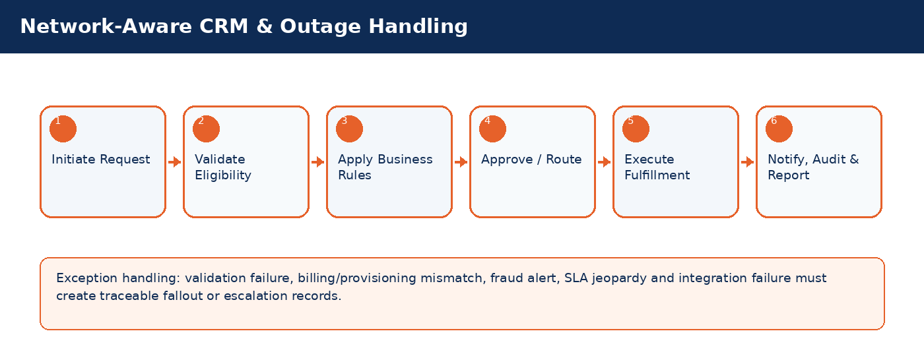

Detailed Process Flow
# | Stage | Business Activity | System Behavior | Exception Handling
1 | Request Initiation | Authorized user selects customer/subscriber and transaction type. | System loads customer, subscriber, service, billing and risk context. | Missing context blocks submission.
2 | Eligibility Validation | System validates KYC, status, balances, inventory, offer compatibility and fraud indicators. | Eligibility result stored against transaction. | Failed rule creates visible reason and next action.
3 | Business Rule Execution | Rules engine applies telecom policy, approval thresholds and lifecycle transition controls. | Decision generated: approve, reject, hold, escalate, or request additional data. | Manual override requires authority and audit reason.
4 | Approval / Queue Routing | Workflow routes request to supervisor, finance, fraud, compliance, NOC or back-office team where required. | Approver action captured with timestamp. | SLA timer and escalation path activated.
5 | Fulfillment / Integration | CRM calls billing, inventory, payment, provisioning or network systems as applicable. | Transaction reaches completed, pending, failed or fallout state. | Retry/rollback/fallout rules applied.
6 | Closure & Communication | Customer/internal notifications issued; audit and reports updated. | Lifecycle state, timeline and KPIs updated. | Unresolved exceptions remain in operational queue.

Functional Field Context and Data Controls
Field | Business Meaning | Source of Truth | Mandatory Rule | Editability | Security/Data Control | Audit Rule
Outage ID | Business-critical telecom field used to control lifecycle, eligibility, reporting or integration behavior. | Source system / CRM master depending on domain | Mandatory or conditional based on transaction type | Editable in Draft; locked after fulfillment unless controlled correction process is used | Masked/encrypted when PII, financial or network-sensitive | Full before/after audit for changes after submission
Affected Area | Business-critical telecom field used to control lifecycle, eligibility, reporting or integration behavior. | Source system / CRM master depending on domain | Mandatory or conditional based on transaction type | Editable in Draft; locked after fulfillment unless controlled correction process is used | Masked/encrypted when PII, financial or network-sensitive | Full before/after audit for changes after submission
Service Type | Business-critical telecom field used to control lifecycle, eligibility, reporting or integration behavior. | Source system / CRM master depending on domain | Mandatory or conditional based on transaction type | Editable in Draft; locked after fulfillment unless controlled correction process is used | Masked/encrypted when PII, financial or network-sensitive | Full before/after audit for changes after submission
Impact Severity | Business-critical telecom field used to control lifecycle, eligibility, reporting or integration behavior. | Source system / CRM master depending on domain | Mandatory or conditional based on transaction type | Editable in Draft; locked after fulfillment unless controlled correction process is used | Masked/encrypted when PII, financial or network-sensitive | Full before/after audit for changes after submission
Impacted Subscribers | Business-critical telecom field used to control lifecycle, eligibility, reporting or integration behavior. | Source system / CRM master depending on domain | Mandatory or conditional based on transaction type | Editable in Draft; locked after fulfillment unless controlled correction process is used | Masked/encrypted when PII, financial or network-sensitive | Full before/after audit for changes after submission
Notification Status | Business-critical telecom field used to control lifecycle, eligibility, reporting or integration behavior. | CRM | Mandatory or conditional based on transaction type | Editable in Draft; locked after fulfillment unless controlled correction process is used | Masked/encrypted when PII, financial or network-sensitive | Full before/after audit for changes after submission
Estimated Restoration | Business-critical telecom field used to control lifecycle, eligibility, reporting or integration behavior. | Source system / CRM master depending on domain | Mandatory or conditional based on transaction type | Editable in Draft; locked after fulfillment unless controlled correction process is used | Masked/encrypted when PII, financial or network-sensitive | Full before/after audit for changes after submission
Case Linkage | Business-critical telecom field used to control lifecycle, eligibility, reporting or integration behavior. | Source system / CRM master depending on domain | Mandatory or conditional based on transaction type | Editable in Draft; locked after fulfillment unless controlled correction process is used | Masked/encrypted when PII, financial or network-sensitive | Full before/after audit for changes after submission

Business Rules
Rule ID | Rule Area | Rule Statement | Severity | System Action
BR-01 | Lifecycle control | Requested action must be valid for the current customer/subscriber/SIM/order state. | High | Reject action and display reason.
BR-02 | Eligibility control | Customer, subscriber, offer, inventory and billing conditions must satisfy the applicable decision matrix. | High | Hold, reject or route for approval.
BR-03 | Fraud and risk control | High fraud score, blacklist or suspicious pattern must route to fraud governance before completion. | Critical | Suspend fulfillment and open fraud review.
BR-04 | Approval authority | Approval levels depend on transaction amount, customer segment, risk score, corporate authority and operational impact. | High | Route to required approver.
BR-05 | Integration consistency | Fulfillment is not complete until authoritative downstream systems confirm success. | Critical | Place transaction in pending/fallout and trigger retry.
BR-06 | Auditability | Manual override, rejection, approval and lifecycle transition must capture reason, actor, timestamp and channel. | Critical | Block completion if reason missing.

Validation Logic
Validation ID | Validation Rule | Validation Mode | Failure Behavior | Message Guidance
VAL-20-01 | Known outage suppresses duplicate tickets or links cases | Real-time where possible; asynchronous for cross-system checks | Block, hold, escalate or create fallout based on severity | User-friendly message with corrective action
VAL-20-02 | VIP/enterprise customers receive proactive alerts | Real-time where possible; asynchronous for cross-system checks | Block, hold, escalate or create fallout based on severity | User-friendly message with corrective action
VAL-20-03 | Restoration event updates open cases | Real-time where possible; asynchronous for cross-system checks | Block, hold, escalate or create fallout based on severity | User-friendly message with corrective action
VAL-20-04 | Compensation rules may apply by SLA | Real-time where possible; asynchronous for cross-system checks | Block, hold, escalate or create fallout based on severity | User-friendly message with corrective action
VAL-20-05 | Outage impact drives prioritization | Real-time where possible; asynchronous for cross-system checks | Block, hold, escalate or create fallout based on severity | User-friendly message with corrective action

Alternate and Exception Flows
Scenario | Trigger | Expected Handling | Owner
Cross-system validation unavailable | Billing/provisioning/payment/KYC service timeout | Set request to Pending Validation, retry according to policy, notify operations if SLA jeopardy occurs. | Integration / Operations
Eligibility failed | Business rule violation such as unpaid balance, invalid state, unavailable inventory or blacklisted customer | Display reason, prevent completion, provide allowed next action such as collect payment, select different offer or escalate. | CSR / Supervisor
Fulfillment fallout | Downstream activation/provisioning/billing step fails after CRM submission | Create fallout case with correlation ID, retry if safe, rollback if required, route to responsible team. | Provisioning / IT
Manual override requested | Business user requests exception to standard rule | Require authority limit, reason code, evidence attachment and audit entry. | Supervisor / Compliance
SLA jeopardy | Transaction approaches or breaches defined SLA | Escalate to next level and expose in operational dashboard. | Operations Manager

Integration Touchpoints and Events
Integration / Event | Direction | Purpose | Failure Handling
Customer / KYC validation | CRM -> KYC | Identity verification and duplicate/risk checks. | Pending validation with retry and manual review queue.
Billing / OCS validation | CRM <-> Billing | Balance, credit limit, invoice, recharge, payment and subscription checks. | Hold transaction or create billing reconciliation task.
Inventory validation | CRM <-> Inventory | SIM, MSISDN, device and stock availability confirmation. | Release reservation or retry inventory synchronization.
Provisioning request | CRM -> Provisioning | Activate, suspend, reconnect, terminate or modify service. | Fallout queue, retry, rollback and manual intervention.
Notification event | CRM -> SMS/Email/Push | Customer/internal communication. | Retry and log notification delivery status.

Notifications, Audit, KPIs and Acceptance Criteria
Area | Detailed Requirement
Notifications | Send customer notification when request is received, approved/rejected, completed, failed or requires action. Internal escalation notification must be sent for SLA jeopardy and high-risk exceptions.
Audit | Capture actor, channel, timestamp, request state, before/after values, external correlation IDs, approval comments and override reasons.
KPIs | Track volume, completion rate, fallout rate, SLA compliance, average handling time, rejection reasons, manual override count and customer impact for Network-Aware CRM & Outage Handling.
Acceptance Criteria | Given authorized user and valid conditions, when transaction is submitted, then system validates eligibility, applies rules, routes approvals, triggers fulfillment, updates lifecycle state, creates audit entry and sends notifications. Given failed downstream fulfillment, then request must be moved to fallout with correlation ID and visible recovery action.

21. Roaming & International Services
Manage roaming eligibility, package activation, restrictions, usage alerts, roaming fraud checks and deactivation.
Domain Summary: Domain Objective
Manage roaming eligibility, package activation, restrictions, usage alerts, roaming fraud checks and deactivation.

Actors and Stakeholders
Actor / Role | Responsibility
CSR | Participates in initiation, validation, approval, fulfillment, monitoring or exception handling for this domain.
Customer | Participates in initiation, validation, approval, fulfillment, monitoring or exception handling for this domain.
Billing/OCS | Participates in initiation, validation, approval, fulfillment, monitoring or exception handling for this domain.
Fraud System | Participates in initiation, validation, approval, fulfillment, monitoring or exception handling for this domain.

Preconditions and Postconditions
Preconditions | Postconditions
Subscriber active; Roaming product available; Customer eligible by policy | Roaming activated/deactivated; Usage threshold monitoring enabled

Process Flow Infographic
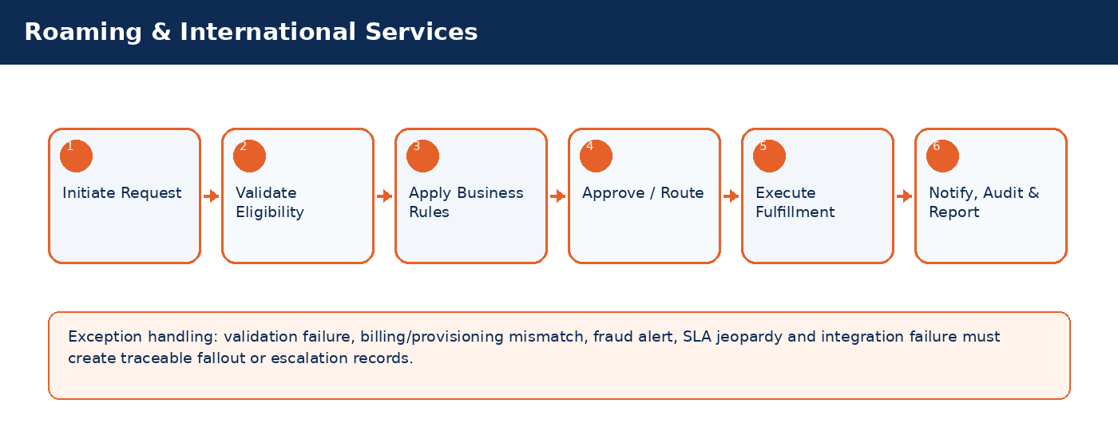

Detailed Process Flow
# | Stage | Business Activity | System Behavior | Exception Handling
1 | Request Initiation | Authorized user selects customer/subscriber and transaction type. | System loads customer, subscriber, service, billing and risk context. | Missing context blocks submission.
2 | Eligibility Validation | System validates KYC, status, balances, inventory, offer compatibility and fraud indicators. | Eligibility result stored against transaction. | Failed rule creates visible reason and next action.
3 | Business Rule Execution | Rules engine applies telecom policy, approval thresholds and lifecycle transition controls. | Decision generated: approve, reject, hold, escalate, or request additional data. | Manual override requires authority and audit reason.
4 | Approval / Queue Routing | Workflow routes request to supervisor, finance, fraud, compliance, NOC or back-office team where required. | Approver action captured with timestamp. | SLA timer and escalation path activated.
5 | Fulfillment / Integration | CRM calls billing, inventory, payment, provisioning or network systems as applicable. | Transaction reaches completed, pending, failed or fallout state. | Retry/rollback/fallout rules applied.
6 | Closure & Communication | Customer/internal notifications issued; audit and reports updated. | Lifecycle state, timeline and KPIs updated. | Unresolved exceptions remain in operational queue.

Functional Field Context and Data Controls
Field | Business Meaning | Source of Truth | Mandatory Rule | Editability | Security/Data Control | Audit Rule
Roaming Request ID | Business-critical telecom field used to control lifecycle, eligibility, reporting or integration behavior. | Source system / CRM master depending on domain | Mandatory or conditional based on transaction type | Editable in Draft; locked after fulfillment unless controlled correction process is used | Masked/encrypted when PII, financial or network-sensitive | Full before/after audit for changes after submission
Destination Zone | Business-critical telecom field used to control lifecycle, eligibility, reporting or integration behavior. | Source system / CRM master depending on domain | Mandatory or conditional based on transaction type | Editable in Draft; locked after fulfillment unless controlled correction process is used | Masked/encrypted when PII, financial or network-sensitive | Full before/after audit for changes after submission
Roaming Package | Business-critical telecom field used to control lifecycle, eligibility, reporting or integration behavior. | Source system / CRM master depending on domain | Mandatory or conditional based on transaction type | Editable in Draft; locked after fulfillment unless controlled correction process is used | Masked/encrypted when PII, financial or network-sensitive | Full before/after audit for changes after submission
Credit Limit | Business-critical telecom field used to control lifecycle, eligibility, reporting or integration behavior. | Source system / CRM master depending on domain | Mandatory or conditional based on transaction type | Editable in Draft; locked after fulfillment unless controlled correction process is used | Masked/encrypted when PII, financial or network-sensitive | Full before/after audit for changes after submission
Deposit Required | Business-critical telecom field used to control lifecycle, eligibility, reporting or integration behavior. | Source system / CRM master depending on domain | Mandatory or conditional based on transaction type | Editable in Draft; locked after fulfillment unless controlled correction process is used | Masked/encrypted when PII, financial or network-sensitive | Full before/after audit for changes after submission
Activation Date | Business-critical telecom field used to control lifecycle, eligibility, reporting or integration behavior. | Source system / CRM master depending on domain | Mandatory or conditional based on transaction type | Editable in Draft; locked after fulfillment unless controlled correction process is used | Masked/encrypted when PII, financial or network-sensitive | Full before/after audit for changes after submission
Expiry Date | Business-critical telecom field used to control lifecycle, eligibility, reporting or integration behavior. | Source system / CRM master depending on domain | Mandatory or conditional based on transaction type | Editable in Draft; locked after fulfillment unless controlled correction process is used | Masked/encrypted when PII, financial or network-sensitive | Full before/after audit for changes after submission
Fraud Check Status | Business-critical telecom field used to control lifecycle, eligibility, reporting or integration behavior. | CRM | Mandatory or conditional based on transaction type | Editable in Draft; locked after fulfillment unless controlled correction process is used | Masked/encrypted when PII, financial or network-sensitive | Full before/after audit for changes after submission

Business Rules
Rule ID | Rule Area | Rule Statement | Severity | System Action
BR-01 | Lifecycle control | Requested action must be valid for the current customer/subscriber/SIM/order state. | High | Reject action and display reason.
BR-02 | Eligibility control | Customer, subscriber, offer, inventory and billing conditions must satisfy the applicable decision matrix. | High | Hold, reject or route for approval.
BR-03 | Fraud and risk control | High fraud score, blacklist or suspicious pattern must route to fraud governance before completion. | Critical | Suspend fulfillment and open fraud review.
BR-04 | Approval authority | Approval levels depend on transaction amount, customer segment, risk score, corporate authority and operational impact. | High | Route to required approver.
BR-05 | Integration consistency | Fulfillment is not complete until authoritative downstream systems confirm success. | Critical | Place transaction in pending/fallout and trigger retry.
BR-06 | Auditability | Manual override, rejection, approval and lifecycle transition must capture reason, actor, timestamp and channel. | Critical | Block completion if reason missing.

Validation Logic
Validation ID | Validation Rule | Validation Mode | Failure Behavior | Message Guidance
VAL-21-01 | Roaming blocked for high-risk or delinquent accounts | Real-time where possible; asynchronous for cross-system checks | Block, hold, escalate or create fallout based on severity | User-friendly message with corrective action
VAL-21-02 | Deposit may be required based on customer segment | Real-time where possible; asynchronous for cross-system checks | Block, hold, escalate or create fallout based on severity | User-friendly message with corrective action
VAL-21-03 | Usage thresholds generate alerts | Real-time where possible; asynchronous for cross-system checks | Block, hold, escalate or create fallout based on severity | User-friendly message with corrective action
VAL-21-04 | International fraud alert may auto-bar roaming | Real-time where possible; asynchronous for cross-system checks | Block, hold, escalate or create fallout based on severity | User-friendly message with corrective action
VAL-21-05 | Expiry triggers auto-deactivation unless renewal enabled | Real-time where possible; asynchronous for cross-system checks | Block, hold, escalate or create fallout based on severity | User-friendly message with corrective action

Alternate and Exception Flows
Scenario | Trigger | Expected Handling | Owner
Cross-system validation unavailable | Billing/provisioning/payment/KYC service timeout | Set request to Pending Validation, retry according to policy, notify operations if SLA jeopardy occurs. | Integration / Operations
Eligibility failed | Business rule violation such as unpaid balance, invalid state, unavailable inventory or blacklisted customer | Display reason, prevent completion, provide allowed next action such as collect payment, select different offer or escalate. | CSR / Supervisor
Fulfillment fallout | Downstream activation/provisioning/billing step fails after CRM submission | Create fallout case with correlation ID, retry if safe, rollback if required, route to responsible team. | Provisioning / IT
Manual override requested | Business user requests exception to standard rule | Require authority limit, reason code, evidence attachment and audit entry. | Supervisor / Compliance
SLA jeopardy | Transaction approaches or breaches defined SLA | Escalate to next level and expose in operational dashboard. | Operations Manager

Integration Touchpoints and Events
Integration / Event | Direction | Purpose | Failure Handling
Customer / KYC validation | CRM -> KYC | Identity verification and duplicate/risk checks. | Pending validation with retry and manual review queue.
Billing / OCS validation | CRM <-> Billing | Balance, credit limit, invoice, recharge, payment and subscription checks. | Hold transaction or create billing reconciliation task.
Inventory validation | CRM <-> Inventory | SIM, MSISDN, device and stock availability confirmation. | Release reservation or retry inventory synchronization.
Provisioning request | CRM -> Provisioning | Activate, suspend, reconnect, terminate or modify service. | Fallout queue, retry, rollback and manual intervention.
Notification event | CRM -> SMS/Email/Push | Customer/internal communication. | Retry and log notification delivery status.

Notifications, Audit, KPIs and Acceptance Criteria
Area | Detailed Requirement
Notifications | Send customer notification when request is received, approved/rejected, completed, failed or requires action. Internal escalation notification must be sent for SLA jeopardy and high-risk exceptions.
Audit | Capture actor, channel, timestamp, request state, before/after values, external correlation IDs, approval comments and override reasons.
KPIs | Track volume, completion rate, fallout rate, SLA compliance, average handling time, rejection reasons, manual override count and customer impact for Roaming & International Services.
Acceptance Criteria | Given authorized user and valid conditions, when transaction is submitted, then system validates eligibility, applies rules, routes approvals, triggers fulfillment, updates lifecycle state, creates audit entry and sends notifications. Given failed downstream fulfillment, then request must be moved to fallout with correlation ID and visible recovery action.

22. Reporting, KPI & Operational Command Center
Provide operational dashboards, executive KPIs, report catalog, drill-down analytics and command-center visibility.
Domain Summary: Domain Objective
Provide operational dashboards, executive KPIs, report catalog, drill-down analytics and command-center visibility.

Actors and Stakeholders
Actor / Role | Responsibility
Executive | Participates in initiation, validation, approval, fulfillment, monitoring or exception handling for this domain.
Operations Manager | Participates in initiation, validation, approval, fulfillment, monitoring or exception handling for this domain.
CRM Admin | Participates in initiation, validation, approval, fulfillment, monitoring or exception handling for this domain.
Supervisor | Participates in initiation, validation, approval, fulfillment, monitoring or exception handling for this domain.

Preconditions and Postconditions
Preconditions | Postconditions
Data sources integrated; KPI definitions approved; User has report access | Dashboard/report generated; Exceptions visible; Actions initiated from insights

Process Flow Infographic
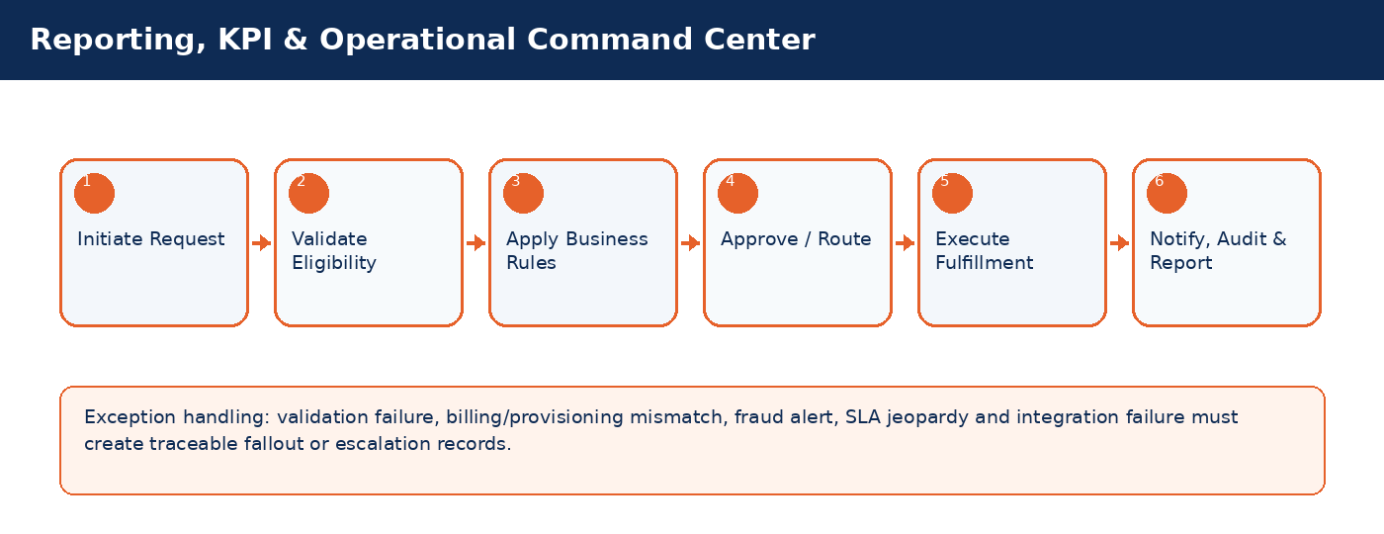

Detailed Process Flow
# | Stage | Business Activity | System Behavior | Exception Handling
1 | Request Initiation | Authorized user selects customer/subscriber and transaction type. | System loads customer, subscriber, service, billing and risk context. | Missing context blocks submission.
2 | Eligibility Validation | System validates KYC, status, balances, inventory, offer compatibility and fraud indicators. | Eligibility result stored against transaction. | Failed rule creates visible reason and next action.
3 | Business Rule Execution | Rules engine applies telecom policy, approval thresholds and lifecycle transition controls. | Decision generated: approve, reject, hold, escalate, or request additional data. | Manual override requires authority and audit reason.
4 | Approval / Queue Routing | Workflow routes request to supervisor, finance, fraud, compliance, NOC or back-office team where required. | Approver action captured with timestamp. | SLA timer and escalation path activated.
5 | Fulfillment / Integration | CRM calls billing, inventory, payment, provisioning or network systems as applicable. | Transaction reaches completed, pending, failed or fallout state. | Retry/rollback/fallout rules applied.
6 | Closure & Communication | Customer/internal notifications issued; audit and reports updated. | Lifecycle state, timeline and KPIs updated. | Unresolved exceptions remain in operational queue.

Functional Field Context and Data Controls
Field | Business Meaning | Source of Truth | Mandatory Rule | Editability | Security/Data Control | Audit Rule
Report ID | Business-critical telecom field used to control lifecycle, eligibility, reporting or integration behavior. | CRM | Mandatory or conditional based on transaction type | Editable in Draft; locked after fulfillment unless controlled correction process is used | Masked/encrypted when PII, financial or network-sensitive | Full before/after audit for changes after submission
KPI Name | Business-critical telecom field used to control lifecycle, eligibility, reporting or integration behavior. | Source system / CRM master depending on domain | Mandatory or conditional based on transaction type | Editable in Draft; locked after fulfillment unless controlled correction process is used | Masked/encrypted when PII, financial or network-sensitive | Full before/after audit for changes after submission
Data Source | Business-critical telecom field used to control lifecycle, eligibility, reporting or integration behavior. | Source system / CRM master depending on domain | Mandatory or conditional based on transaction type | Editable in Draft; locked after fulfillment unless controlled correction process is used | Masked/encrypted when PII, financial or network-sensitive | Full before/after audit for changes after submission
Refresh Frequency | Business-critical telecom field used to control lifecycle, eligibility, reporting or integration behavior. | Source system / CRM master depending on domain | Mandatory or conditional based on transaction type | Editable in Draft; locked after fulfillment unless controlled correction process is used | Masked/encrypted when PII, financial or network-sensitive | Full before/after audit for changes after submission
Owner | Business-critical telecom field used to control lifecycle, eligibility, reporting or integration behavior. | Source system / CRM master depending on domain | Mandatory or conditional based on transaction type | Editable in Draft; locked after fulfillment unless controlled correction process is used | Masked/encrypted when PII, financial or network-sensitive | Full before/after audit for changes after submission
Filter Set | Business-critical telecom field used to control lifecycle, eligibility, reporting or integration behavior. | Source system / CRM master depending on domain | Mandatory or conditional based on transaction type | Editable in Draft; locked after fulfillment unless controlled correction process is used | Masked/encrypted when PII, financial or network-sensitive | Full before/after audit for changes after submission
Drilldown Level | Business-critical telecom field used to control lifecycle, eligibility, reporting or integration behavior. | Source system / CRM master depending on domain | Mandatory or conditional based on transaction type | Editable in Draft; locked after fulfillment unless controlled correction process is used | Masked/encrypted when PII, financial or network-sensitive | Full before/after audit for changes after submission
Export Permission | Business-critical telecom field used to control lifecycle, eligibility, reporting or integration behavior. | Source system / CRM master depending on domain | Mandatory or conditional based on transaction type | Editable in Draft; locked after fulfillment unless controlled correction process is used | Masked/encrypted when PII, financial or network-sensitive | Full before/after audit for changes after submission
Threshold | Business-critical telecom field used to control lifecycle, eligibility, reporting or integration behavior. | Source system / CRM master depending on domain | Mandatory or conditional based on transaction type | Editable in Draft; locked after fulfillment unless controlled correction process is used | Masked/encrypted when PII, financial or network-sensitive | Full before/after audit for changes after submission

Business Rules
Rule ID | Rule Area | Rule Statement | Severity | System Action
BR-01 | Lifecycle control | Requested action must be valid for the current customer/subscriber/SIM/order state. | High | Reject action and display reason.
BR-02 | Eligibility control | Customer, subscriber, offer, inventory and billing conditions must satisfy the applicable decision matrix. | High | Hold, reject or route for approval.
BR-03 | Fraud and risk control | High fraud score, blacklist or suspicious pattern must route to fraud governance before completion. | Critical | Suspend fulfillment and open fraud review.
BR-04 | Approval authority | Approval levels depend on transaction amount, customer segment, risk score, corporate authority and operational impact. | High | Route to required approver.
BR-05 | Integration consistency | Fulfillment is not complete until authoritative downstream systems confirm success. | Critical | Place transaction in pending/fallout and trigger retry.
BR-06 | Auditability | Manual override, rejection, approval and lifecycle transition must capture reason, actor, timestamp and channel. | Critical | Block completion if reason missing.

Validation Logic
Validation ID | Validation Rule | Validation Mode | Failure Behavior | Message Guidance
VAL-22-01 | KPI formulas controlled centrally | Real-time where possible; asynchronous for cross-system checks | Block, hold, escalate or create fallout based on severity | User-friendly message with corrective action
VAL-22-02 | Sensitive reports require role access | Real-time where possible; asynchronous for cross-system checks | Block, hold, escalate or create fallout based on severity | User-friendly message with corrective action
VAL-22-03 | Real-time dashboards have refresh threshold | Real-time where possible; asynchronous for cross-system checks | Block, hold, escalate or create fallout based on severity | User-friendly message with corrective action
VAL-22-04 | Drill-down respects data scope | Real-time where possible; asynchronous for cross-system checks | Block, hold, escalate or create fallout based on severity | User-friendly message with corrective action
VAL-22-05 | Export actions are audited | Real-time where possible; asynchronous for cross-system checks | Block, hold, escalate or create fallout based on severity | User-friendly message with corrective action

Alternate and Exception Flows
Scenario | Trigger | Expected Handling | Owner
Cross-system validation unavailable | Billing/provisioning/payment/KYC service timeout | Set request to Pending Validation, retry according to policy, notify operations if SLA jeopardy occurs. | Integration / Operations
Eligibility failed | Business rule violation such as unpaid balance, invalid state, unavailable inventory or blacklisted customer | Display reason, prevent completion, provide allowed next action such as collect payment, select different offer or escalate. | CSR / Supervisor
Fulfillment fallout | Downstream activation/provisioning/billing step fails after CRM submission | Create fallout case with correlation ID, retry if safe, rollback if required, route to responsible team. | Provisioning / IT
Manual override requested | Business user requests exception to standard rule | Require authority limit, reason code, evidence attachment and audit entry. | Supervisor / Compliance
SLA jeopardy | Transaction approaches or breaches defined SLA | Escalate to next level and expose in operational dashboard. | Operations Manager

Integration Touchpoints and Events
Integration / Event | Direction | Purpose | Failure Handling
Customer / KYC validation | CRM -> KYC | Identity verification and duplicate/risk checks. | Pending validation with retry and manual review queue.
Billing / OCS validation | CRM <-> Billing | Balance, credit limit, invoice, recharge, payment and subscription checks. | Hold transaction or create billing reconciliation task.
Inventory validation | CRM <-> Inventory | SIM, MSISDN, device and stock availability confirmation. | Release reservation or retry inventory synchronization.
Provisioning request | CRM -> Provisioning | Activate, suspend, reconnect, terminate or modify service. | Fallout queue, retry, rollback and manual intervention.
Notification event | CRM -> SMS/Email/Push | Customer/internal communication. | Retry and log notification delivery status.

Notifications, Audit, KPIs and Acceptance Criteria
Area | Detailed Requirement
Notifications | Send customer notification when request is received, approved/rejected, completed, failed or requires action. Internal escalation notification must be sent for SLA jeopardy and high-risk exceptions.
Audit | Capture actor, channel, timestamp, request state, before/after values, external correlation IDs, approval comments and override reasons.
KPIs | Track volume, completion rate, fallout rate, SLA compliance, average handling time, rejection reasons, manual override count and customer impact for Reporting, KPI & Operational Command Center.
Acceptance Criteria | Given authorized user and valid conditions, when transaction is submitted, then system validates eligibility, applies rules, routes approvals, triggers fulfillment, updates lifecycle state, creates audit entry and sends notifications. Given failed downstream fulfillment, then request must be moved to fallout with correlation ID and visible recovery action.

Part 4 - Centralized Governance Repositories

Enterprise Functional Field Context Repository
Field / Data Element | Source of Truth | Business Owner | Editability | Security Classification | Validation Rules | Audit Policy
National ID / Registration No. | Customer Master / KYC service | Customer/KYC | Editable before activation; controlled update after activation | PII - encrypted and masked | Mandatory uniqueness, format, blacklist and duplicate fuzzy match | Stored before/after change values and approver
MSISDN | Number Inventory / Billing | Subscriber Operations | Not editable directly; changed through Change Number process | Sensitive operational identifier | Must be Available/Reserved and not quarantined; portability state checked | All assignment and lifecycle transitions logged
ICCID / IMSI | SIM Inventory / Provisioning | Inventory Operations | Immutable after SIM creation; state changes through SIM lifecycle | Sensitive network identifier | Must be unique; state must support requested action | SIM assignment, replacement and quarantine logged
Offer Code | Product Catalog / Billing | Product Management | Editable while order is draft; locked after fulfillment starts | Commercial reference | Offer active, eligible, price valid, billing mapping exists | Subscription and order changes logged
Payment Reference | Payment Gateway / Finance | Finance Operations | Read-only after gateway confirmation | Financial sensitive | Unique per gateway; reconciliation status required | Payment status transitions logged
Fraud Score | Fraud Engine | Fraud Management | System-calculated; manual override requires authority | Restricted | Threshold determines routing, hold, rejection or escalation | All overrides require reason and approver
SLA Due Date | SLA Engine | Operations Governance | System-calculated; not manually editable | Operational control | Based on category, segment, priority and calendar | SLA recalculation and breach events logged
Approval Status | Workflow Engine | Process Owner | Changed only by workflow action | Operational control | Must follow approval matrix and authority limit | Approver, timestamp and comments retained

Business Rules Repository
Rule ID | Area | Rule Statement | Severity | Control Owner | Failure Behavior
BR-001 | KYC & Customer | KYC & Customer transactions must be executed only when lifecycle state, ownership, eligibility, authority and integration prerequisites are satisfied. | High | Rules Engine / Workflow | Reject, hold, escalate or route based on decision matrix.
BR-001A | KYC & Customer | Manual exceptions in KYC & Customer require reason code, approval authority and audit trail. | High | Workflow / Audit Engine | Block completion if exception evidence is missing.
BR-002 | Subscriber Lifecycle | Subscriber Lifecycle transactions must be executed only when lifecycle state, ownership, eligibility, authority and integration prerequisites are satisfied. | High | Rules Engine / Workflow | Reject, hold, escalate or route based on decision matrix.
BR-002A | Subscriber Lifecycle | Manual exceptions in Subscriber Lifecycle require reason code, approval authority and audit trail. | High | Workflow / Audit Engine | Block completion if exception evidence is missing.
BR-003 | SIM/eSIM | SIM/eSIM transactions must be executed only when lifecycle state, ownership, eligibility, authority and integration prerequisites are satisfied. | High | Rules Engine / Workflow | Reject, hold, escalate or route based on decision matrix.
BR-003A | SIM/eSIM | Manual exceptions in SIM/eSIM require reason code, approval authority and audit trail. | High | Workflow / Audit Engine | Block completion if exception evidence is missing.
BR-004 | MSISDN | MSISDN transactions must be executed only when lifecycle state, ownership, eligibility, authority and integration prerequisites are satisfied. | High | Rules Engine / Workflow | Reject, hold, escalate or route based on decision matrix.
BR-004A | MSISDN | Manual exceptions in MSISDN require reason code, approval authority and audit trail. | High | Workflow / Audit Engine | Block completion if exception evidence is missing.
BR-005 | Offers & Subscriptions | Offers & Subscriptions transactions must be executed only when lifecycle state, ownership, eligibility, authority and integration prerequisites are satisfied. | High | Rules Engine / Workflow | Reject, hold, escalate or route based on decision matrix.
BR-005A | Offers & Subscriptions | Manual exceptions in Offers & Subscriptions require reason code, approval authority and audit trail. | High | Workflow / Audit Engine | Block completion if exception evidence is missing.
BR-006 | Billing & Payments | Billing & Payments transactions must be executed only when lifecycle state, ownership, eligibility, authority and integration prerequisites are satisfied. | Critical | Rules Engine / Workflow | Reject, hold, escalate or route based on decision matrix.
BR-006A | Billing & Payments | Manual exceptions in Billing & Payments require reason code, approval authority and audit trail. | High | Workflow / Audit Engine | Block completion if exception evidence is missing.
BR-007 | Provisioning | Provisioning transactions must be executed only when lifecycle state, ownership, eligibility, authority and integration prerequisites are satisfied. | Critical | Rules Engine / Workflow | Reject, hold, escalate or route based on decision matrix.
BR-007A | Provisioning | Manual exceptions in Provisioning require reason code, approval authority and audit trail. | High | Workflow / Audit Engine | Block completion if exception evidence is missing.
BR-008 | Dealer Operations | Dealer Operations transactions must be executed only when lifecycle state, ownership, eligibility, authority and integration prerequisites are satisfied. | High | Rules Engine / Workflow | Reject, hold, escalate or route based on decision matrix.
BR-008A | Dealer Operations | Manual exceptions in Dealer Operations require reason code, approval authority and audit trail. | High | Workflow / Audit Engine | Block completion if exception evidence is missing.
BR-009 | Fraud & Revenue Assurance | Fraud & Revenue Assurance transactions must be executed only when lifecycle state, ownership, eligibility, authority and integration prerequisites are satisfied. | Critical | Rules Engine / Workflow | Reject, hold, escalate or route based on decision matrix.
BR-009A | Fraud & Revenue Assurance | Manual exceptions in Fraud & Revenue Assurance require reason code, approval authority and audit trail. | High | Workflow / Audit Engine | Block completion if exception evidence is missing.
BR-010 | Network-Aware CRM | Network-Aware CRM transactions must be executed only when lifecycle state, ownership, eligibility, authority and integration prerequisites are satisfied. | High | Rules Engine / Workflow | Reject, hold, escalate or route based on decision matrix.
BR-010A | Network-Aware CRM | Manual exceptions in Network-Aware CRM require reason code, approval authority and audit trail. | High | Workflow / Audit Engine | Block completion if exception evidence is missing.
BR-011 | Collections | Collections transactions must be executed only when lifecycle state, ownership, eligibility, authority and integration prerequisites are satisfied. | High | Rules Engine / Workflow | Reject, hold, escalate or route based on decision matrix.
BR-011A | Collections | Manual exceptions in Collections require reason code, approval authority and audit trail. | High | Workflow / Audit Engine | Block completion if exception evidence is missing.
BR-012 | Refunds | Refunds transactions must be executed only when lifecycle state, ownership, eligibility, authority and integration prerequisites are satisfied. | High | Rules Engine / Workflow | Reject, hold, escalate or route based on decision matrix.
BR-012A | Refunds | Manual exceptions in Refunds require reason code, approval authority and audit trail. | High | Workflow / Audit Engine | Block completion if exception evidence is missing.

Validation Repository
Validation ID | Validation Rule | Process Area | Mode | Failure Behavior
VAL-KYC-001 | National ID format and uniqueness | Customer Management | Real-time | Block creation/update
VAL-KYC-002 | Duplicate customer fuzzy match | Customer Management | Real-time + manual review | Warn/hold based on score
VAL-SUB-001 | Subscriber current state allows requested action | Subscriber Lifecycle | Real-time | Block incompatible actions
VAL-SIM-001 | ICCID available/reserved/assigned according to action | SIM Lifecycle | Real-time | Block or release reservation
VAL-NUM-001 | MSISDN available and not quarantined or porting | Number Lifecycle | Real-time | Block assignment
VAL-OFFER-001 | Offer active, eligible and mapped to billing/provisioning | Subscription | Real-time | Block offer selection
VAL-PAY-001 | Gateway reference unique and confirmed | Payments | Real-time/asynchronous | Hold until confirmed
VAL-PROV-001 | Provisioning response received and correlated | Provisioning | Asynchronous | Fallout if failed/timeout
VAL-FRD-001 | Fraud score under action threshold | Fraud | Real-time/near-real-time | Escalate to fraud queue
VAL-RA-001 | Activation and billing records reconcile | Revenue Assurance | Scheduled/near-real-time | Create RA exception
VAL-DEALER-001 | Dealer quota and inventory allocation available | Dealer Operations | Real-time | Block activation or request quota approval
VAL-REF-001 | Refund does not exceed eligible balance | Refunds | Real-time | Block or route to finance approval

SLA / OLA Governance Framework
Process Category | Customer-Facing SLA | Internal OLA | Escalation Rule | Dashboard Indicator
New activation | Activation confirmation within agreed service window | Provisioning response within operational threshold | Escalate to activation supervisor before breach | Activation SLA heatmap
Complaint | Response/resolution based on priority and segment | Queue assignment within defined threshold | Escalate by priority, VIP status and aging | Case SLA dashboard
Refund | Decision and settlement within finance SLA | Finance approval within defined OLA | Escalate to finance manager | Refund aging report
Provisioning fallout | Customer update according to SLA | Technical recovery action within OLA | Escalate to provisioning lead/NOC | Fallout command center
Corporate service issue | Contractual SLA applies | Enterprise support OLA applies | Escalate to enterprise account manager | Corporate SLA cockpit

Data Governance and Control Framework
Control Area | Requirement | Implementation Guidance
Master Data Ownership | Each key entity must have a business owner and steward. | Assign ownership for Customer, Subscriber, SIM, MSISDN, Offer, Dealer, Payment and Case data.
Duplicate Management | Prevent duplicates and support controlled merge. | Use exact and fuzzy matching; preserve historical references after merge.
Data Retention | Retain KYC, billing, audit and communication records according to regulatory policy. | Implement retention calendars and controlled archival.
Masking & Encryption | PII, financial and network identifiers must be protected. | Mask in UI based on role; encrypt sensitive columns or fields.
Data Lineage | Critical reports and KPIs must trace back to source entities. | Document source table/API/event and refresh frequency.
Audit Immutability | Critical audit logs should be tamper-resistant. | Restrict update/delete and expose immutable audit views.

Event Catalog
Event Name | Producer | Consumers | Trigger Condition | Control / Retry
CUSTOMER_CREATED | CRM / Billing / Provisioning / Network depending on event | CRM timeline, reporting, notifications, fraud/RA, downstream systems | Business transactions or system state change occurs | Correlation ID, retry policy, dead-letter queue and audit log required
KYC_APPROVED | CRM / Billing / Provisioning / Network depending on event | CRM timeline, reporting, notifications, fraud/RA, downstream systems | Business transactions or system state change occurs | Correlation ID, retry policy, dead-letter queue and audit log required
SIM_RESERVED | CRM / Billing / Provisioning / Network depending on event | CRM timeline, reporting, notifications, fraud/RA, downstream systems | Business transactions or system state change occurs | Correlation ID, retry policy, dead-letter queue and audit log required
SIM_ACTIVATED | CRM / Billing / Provisioning / Network depending on event | CRM timeline, reporting, notifications, fraud/RA, downstream systems | Business transactions or system state change occurs | Correlation ID, retry policy, dead-letter queue and audit log required
MSISDN_ASSIGNED | CRM / Billing / Provisioning / Network depending on event | CRM timeline, reporting, notifications, fraud/RA, downstream systems | Business transactions or system state change occurs | Correlation ID, retry policy, dead-letter queue and audit log required
ORDER_SUBMITTED | CRM / Billing / Provisioning / Network depending on event | CRM timeline, reporting, notifications, fraud/RA, downstream systems | Business transactions or system state change occurs | Correlation ID, retry policy, dead-letter queue and audit log required
ORDER_FALLOUT | CRM / Billing / Provisioning / Network depending on event | CRM timeline, reporting, notifications, fraud/RA, downstream systems | Business transactions or system state change occurs | Correlation ID, retry policy, dead-letter queue and audit log required
SERVICE_SUSPENDED | CRM / Billing / Provisioning / Network depending on event | CRM timeline, reporting, notifications, fraud/RA, downstream systems | Business transactions or system state change occurs | Correlation ID, retry policy, dead-letter queue and audit log required
SERVICE_RECONNECTED | CRM / Billing / Provisioning / Network depending on event | CRM timeline, reporting, notifications, fraud/RA, downstream systems | Business transactions or system state change occurs | Correlation ID, retry policy, dead-letter queue and audit log required
SERVICE_TERMINATED | CRM / Billing / Provisioning / Network depending on event | CRM timeline, reporting, notifications, fraud/RA, downstream systems | Business transactions or system state change occurs | Correlation ID, retry policy, dead-letter queue and audit log required
RECHARGE_COMPLETED | CRM / Billing / Provisioning / Network depending on event | CRM timeline, reporting, notifications, fraud/RA, downstream systems | Business transactions or system state change occurs | Correlation ID, retry policy, dead-letter queue and audit log required
PAYMENT_FAILED | CRM / Billing / Provisioning / Network depending on event | CRM timeline, reporting, notifications, fraud/RA, downstream systems | Business transactions or system state change occurs | Correlation ID, retry policy, dead-letter queue and audit log required
REFUND_APPROVED | CRM / Billing / Provisioning / Network depending on event | CRM timeline, reporting, notifications, fraud/RA, downstream systems | Business transactions or system state change occurs | Correlation ID, retry policy, dead-letter queue and audit log required
COMPLAINT_ESCALATED | CRM / Billing / Provisioning / Network depending on event | CRM timeline, reporting, notifications, fraud/RA, downstream systems | Business transactions or system state change occurs | Correlation ID, retry policy, dead-letter queue and audit log required
FRAUD_ALERT_CREATED | CRM / Billing / Provisioning / Network depending on event | CRM timeline, reporting, notifications, fraud/RA, downstream systems | Business transactions or system state change occurs | Correlation ID, retry policy, dead-letter queue and audit log required
OUTAGE_DETECTED | CRM / Billing / Provisioning / Network depending on event | CRM timeline, reporting, notifications, fraud/RA, downstream systems | Business transactions or system state change occurs | Correlation ID, retry policy, dead-letter queue and audit log required
ROAMING_ENABLED | CRM / Billing / Provisioning / Network depending on event | CRM timeline, reporting, notifications, fraud/RA, downstream systems | Business transactions or system state change occurs | Correlation ID, retry policy, dead-letter queue and audit log required
DUNNING_STAGE_CHANGED | CRM / Billing / Provisioning / Network depending on event | CRM timeline, reporting, notifications, fraud/RA, downstream systems | Business transactions or system state change occurs | Correlation ID, retry policy, dead-letter queue and audit log required

Part 5 - Reporting, Testing, Migration and Appendices

Telecom KPI Dictionary
KPI | Formula | Frequency | Owner | Source
Activation Success Rate | Successful activations / Total activation attempts | Real-time / Daily | Activation Operations | CRM + Provisioning
Provisioning Fallout Rate | Failed or pending fallout orders / Total submitted orders | Real-time | Provisioning / IT | Order Orchestrator
SIM Replacement Fraud Alerts | High-risk SIM replacements flagged | Daily | Fraud Team | CRM + Fraud Engine
Recharge Success Rate | Successful recharge transactions / Total recharge attempts | Real-time | Billing Operations | OCS + Payment Gateway
Complaint SLA Compliance | Cases resolved within SLA / Total resolved cases | Daily/Weekly | Customer Care | CRM Case Management
Dealer Activation Quality | Valid activations without reversal/fraud / Total dealer activations | Weekly | Dealer Management | CRM + Fraud + Billing
Revenue Leakage Exceptions | Count/value of RA exceptions | Daily | Revenue Assurance | Billing + CRM + Provisioning
Collection Recovery Rate | Recovered amount / Assigned overdue amount | Weekly/Monthly | Collections | Billing + CRM
Outage Impact Communication Rate | Impacted customers notified / Total impacted customers | Real-time | NOC/CX | Network + CRM Notification
VIP Case Priority Compliance | VIP cases handled within priority SLA | Daily | Premium Support | CRM

Operational Command Center Design
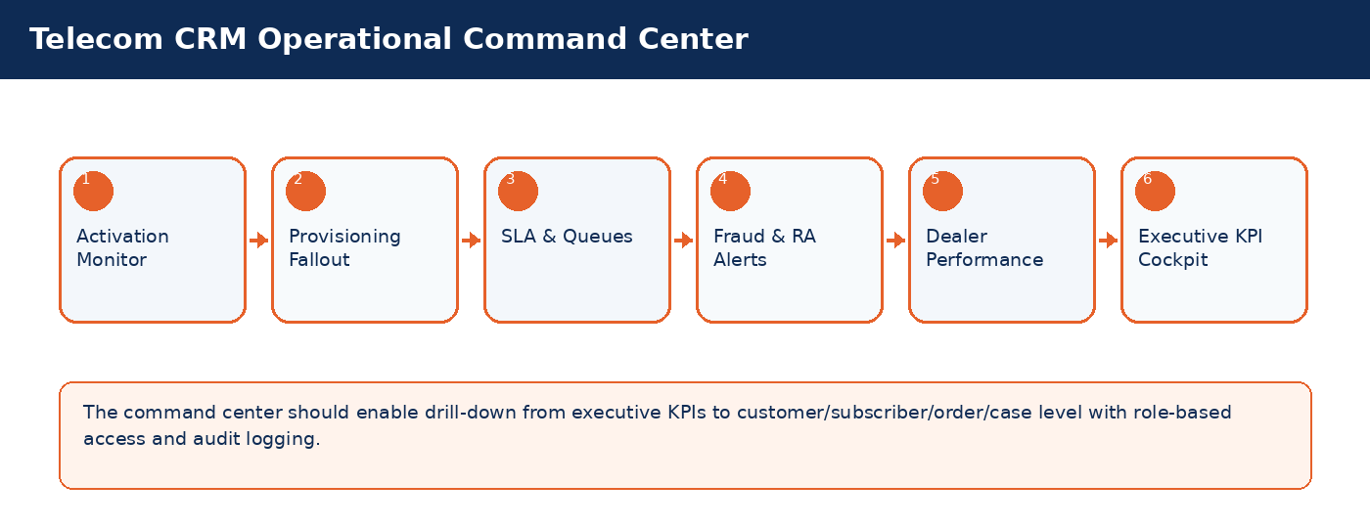
Dashboard | Purpose | Key Widgets
Activation Control Tower | Monitor new line, SIM/eSIM and offer activation performance. | Activation volume, success rate, pending provisioning, fallout aging, dealer contribution
Provisioning Fallout Dashboard | Manage failed or delayed fulfillment. | Fallout reason, retry count, owner queue, SLA risk, correlation ID
Customer Care SLA Dashboard | Track complaint and ticket performance. | Open cases, breached SLAs, VIP cases, queue workload, reopen rate
Fraud & Revenue Assurance Cockpit | Monitor suspicious activity and revenue leakage. | Fraud alerts, RA exceptions, leakage value, high-risk dealers, SIM-box indicators
Dealer Operations Dashboard | Track dealer performance and compliance. | Activation count, quota utilization, fraud ratio, inventory stock, commission candidates

Enterprise Testing Strategy
Test Layer | Scope | Key Scenarios
SIT | Cross-system functional and integration testing. | Activation, SIM replacement, recharge, payment, refund, suspension, reconnect, provisioning fallout.
UAT | Business validation by telecom operations. | End-to-end customer journeys, approval rules, decision matrices, reports and exception handling.
Performance Testing | High-volume and peak-load behavior. | Concurrent users, order TPS, dashboard refresh, payment/recharge bursts and queue load.
Security Testing | Access, masking, MFA and audit controls. | Role-based access, field masking, unauthorized API access, audit immutability.
Failover / DR Testing | Business continuity and recovery. | Integration downtime, retry queues, data recovery, RPO/RTO validation.
Regression Testing | Quarterly releases and change impacts. | Rule changes, catalog changes, UI changes, API version changes and workflow changes.

Migration and Cutover Considerations
Migration Area | Key Data | Controls
Customer Master | Customer profiles, KYC, contact details, consent | Deduplication, validation, masking, reconciliation
Subscriber Base | MSISDN, SIM mapping, status, product, billing account | State mapping, active/inactive split, billing consistency
SIM / Number Inventory | ICCID, IMSI, MSISDN, inventory state | State reconciliation, quarantine/recycle policies
Open Orders / Cases | Pending requests, complaints, fallout | Cutover freeze, migration to equivalent states
Balances / Deposits | Deposits, wallet balance, outstanding balances | Finance reconciliation and sign-off
Historical Interactions | Tickets, payments, activations, complaints | Archive strategy and searchable history

Telecom Glossary
Term | Definition
MSISDN | Mobile Station International Subscriber Directory Number; customer-facing mobile number.
ICCID | Integrated Circuit Card Identifier; unique SIM card identifier.
IMSI | International Mobile Subscriber Identity; network subscriber identity.
HLR/HSS | Home Location Register / Home Subscriber Server; network subscriber data systems.
OCS | Online Charging System used for prepaid/real-time charging.
CDR | Call Detail Record used for usage, billing and analytics.
VAS | Value Added Services such as content, entertainment, alerts or digital subscriptions.
Barring | Blocking specific service usage such as outgoing calls, roaming or data.
Provisioning | Technical activation/modification/deactivation of network services.
Fallout | Failed or delayed fulfillment requiring operational recovery.

