On my workspace , create a py package :
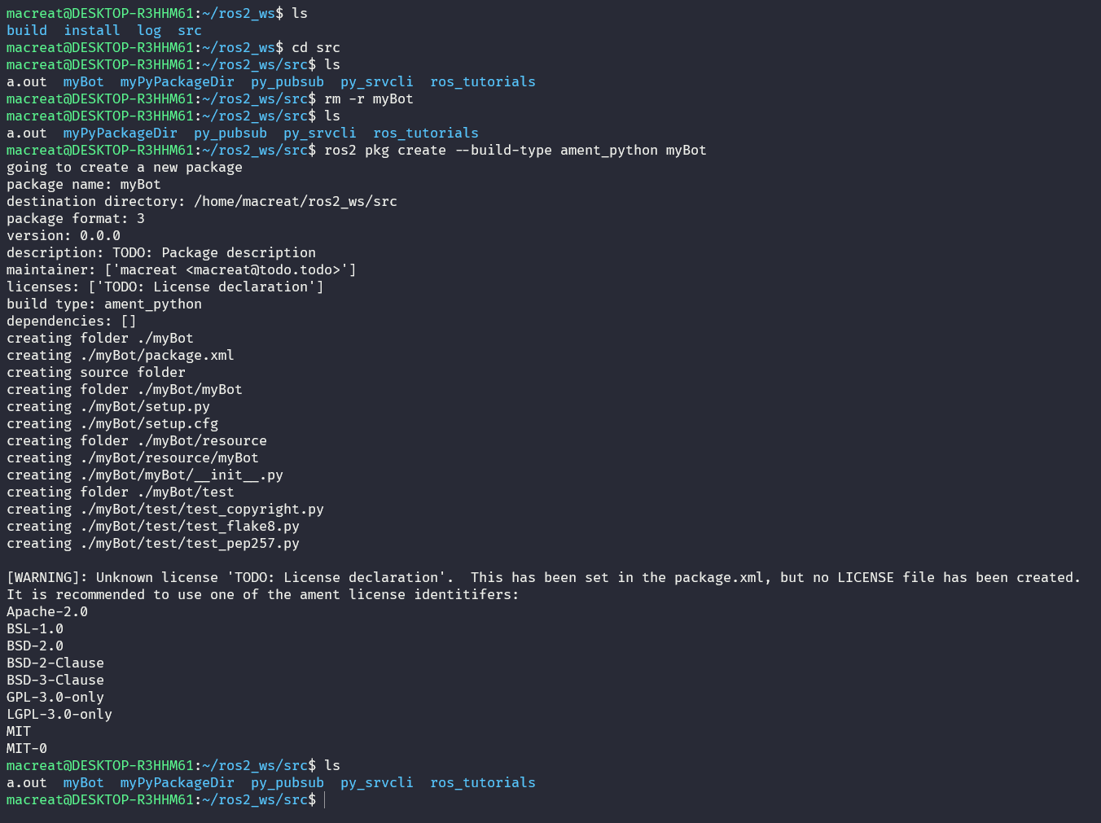

FO

