COVERING THE BASICS: CLI TOOLS :
1. Configuración del entorno
- Objetivo: Asegurar que ROS 2 esté correctamente instalado y “sourced”.
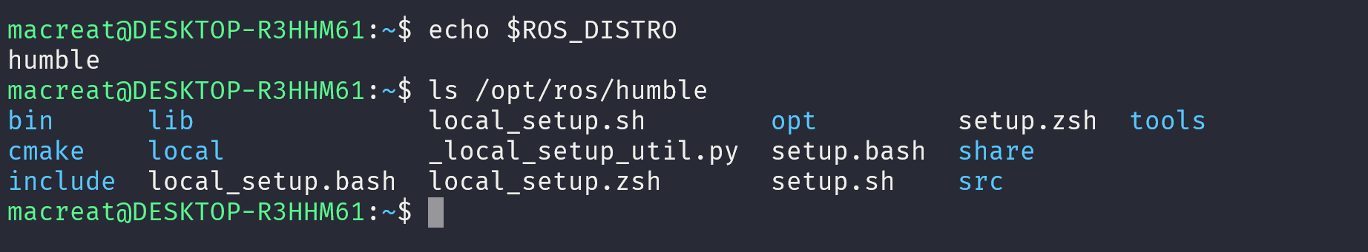
CARGAR EL ENTORNO PERO COMO UNDERLAY implica :
Source /opt/ros/humble/setup.bash+

VERIFICAR COMANDOS CLI : ME MUESTRA LOS TOPICS listos

2. Uso de Turtlesim, ros2 y rqt
- Turtlesim: Simulador liviano para experimentar con conceptos básicos de ROS.
- ros2 node list / ros2 topic list / ros2 service list / ros2 action list: Permiten descubrir la estructura del sistema ROS activo
- rqt (GUI): Permite llamar servicios visualmente (ej. /spawn, /set_pen)
- Remapeo de tópicos: Permite reenviar control a otra tortuga sin modificar código, usando --ros-args --remap turtle1/cmd_vel:=turtle2/cmd_vel
INSTALACION Y USO TURTLESIM Y RQT:
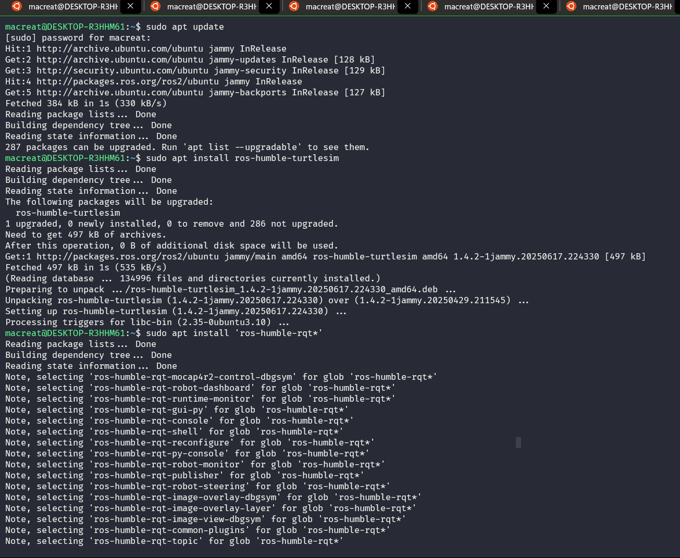
THEN, run :

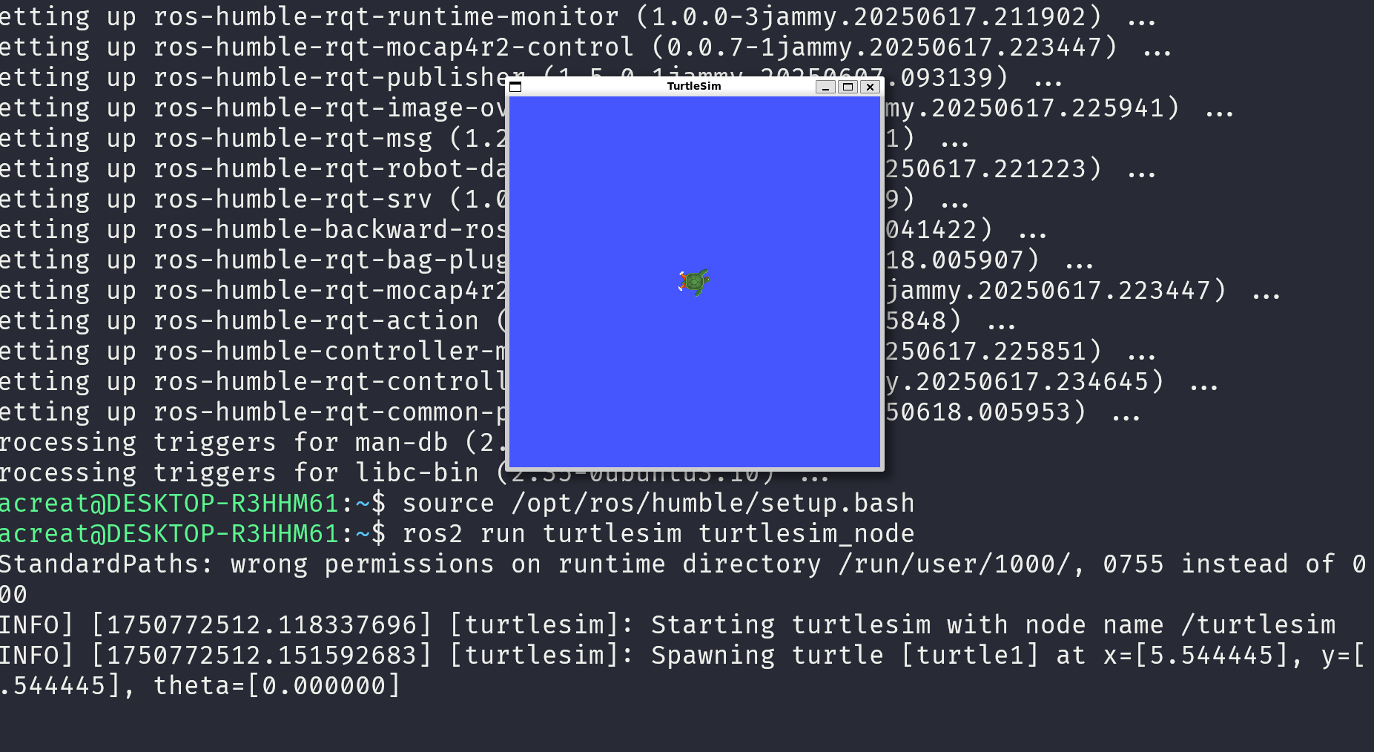

EN OTRA TERMINAR USAR TURTLE TELEOP KEY:
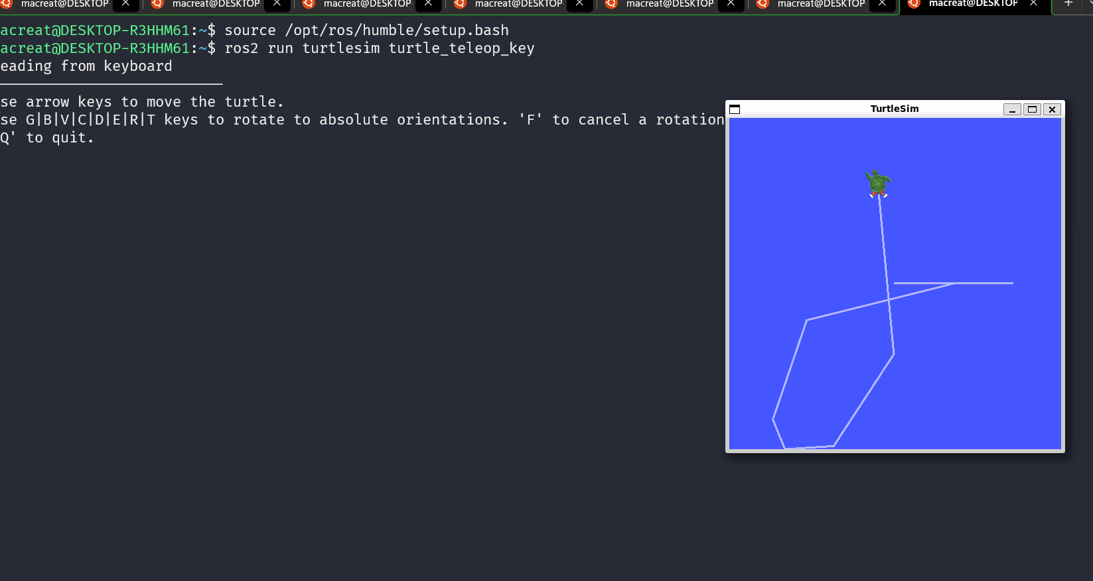

3. Comprender nodos
- ros2 node list: Muestra todos los nodos activos.
- ros2 node info <nombre>: Detalla qué tópicos, servicios y acciones usa ese nodo
- Relevancia: Fundamental para mapear conexiones en tu robot (p. ej., nodos de IMU, control, SLAM).
4. Comprender tópicos
- ros2 topic list: Lista tópicos activos.
- ros2 topic list -t: Incluye tipos de mensajes
- ros2 topic echo <topic>: Muestra en tiempo real el flujo de datos
- ros2 topic info <topic>: Informa número de publicadores y suscriptores.
- ros2 interface show <msg_type>: Muestra la estructura del mensaje
- ros2 topic pub: Permite publicar manualmente mensajes desde CLI, útil para pruebas.
5. Comprender servicios
- ros2 service list: Muestra todos los servicios activos
- ros2 service type <service>: Indica el tipo de solicitud/respuesta.
- ros2 interface show: Muestra los campos de request y response.
- ros2 service call <service> <args>: Permite invocar servicios desde CLI
- Diferencia con un topic: Es un patrón de solicitud/respuesta, no continuo.

6. Comprender parámetros
- Nodo + servicios relacionados: casi todos los nodos expone servicios /get_parameters, /set_parameters, etc.
- Uso: permiten modificar comportamiento de nodos en ejecución (velocidad, ganancias).
- ROS2 CLI: ros2 param list, ros2 param get/set <nodo> <param>.

7. Comprender acciones
- ros2 action list: Muestra acciones disponibles
- ros2 action info <action>: Muestra cliente y servidor.
- ros2 interface show <action_type>: Detalla estructura (goal, feedback, result)
- ros2 action send_goal: Envía una tarea (por ejemplo, girar), puede entregar feedback y cancelarse
- Uso ideal: tareas que duran tiempo y requieren seguimiento (p. ej., navegación autonome).

Al comienzo al listar lo nodos están vacíos :;
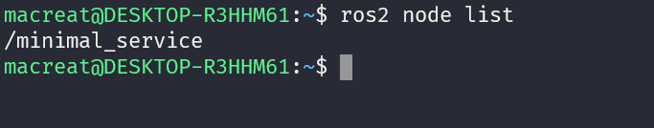
Al correr o compilar, se enlistan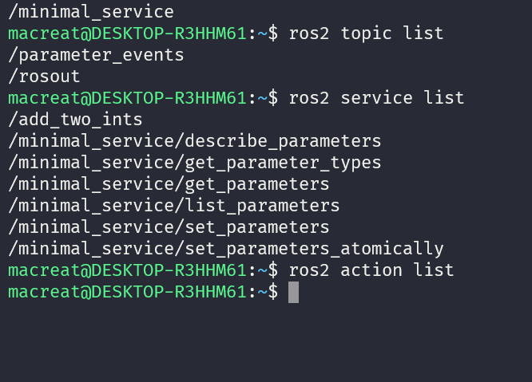

8. Usar rqt_console para ver logs
- Consola visual de mensajes del sistema.
- Útil para: inspeccionar nivel de mensajes ROS, warnings, errores, debugging.

9. NODES LAUNCH
- ros2 launch <package> <file.launch.py>: Permite iniciar múltiples nodos y configuraciones en un solo comando.
- Importancia: gestión de despliegues en tu robot autónomo (sensores, control, SLAM) con un solo script.

10. Grabación y reproducción de datos (rosbag)
- ros2 bag record: Registra tópicos.
- ros2 bag play: Reproduce datos grabados para análisis posterior.
- Aplicación: debug y re-simulación de entornos reales.

AFTER BEGINNER CLI TOOLS, CONTNINUE WITH CLIEN LIBRARIES
- FIRST, USING COLCON TU BOULD PACKAGES

As prerequisites , we have to install colcon on the wsl :
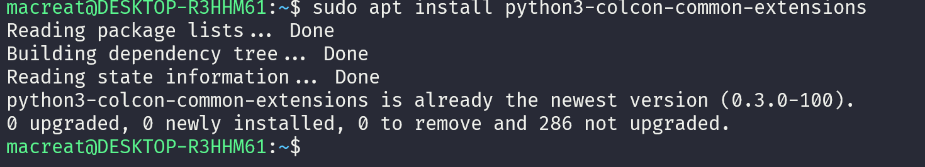

- CREATE A WORKSPACE
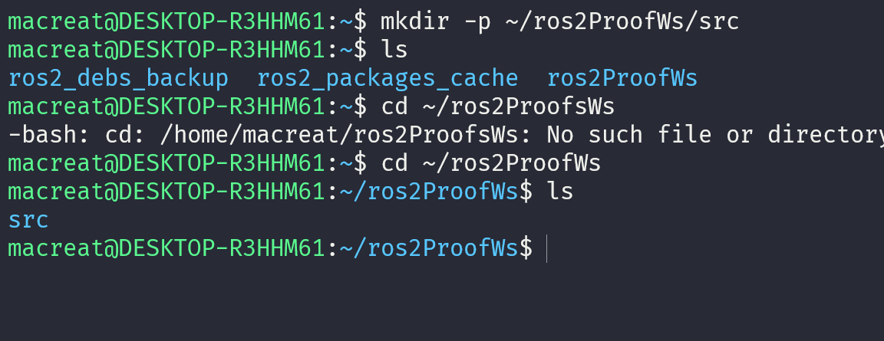
Only contain SRC folder

- Can add some source from the repository :
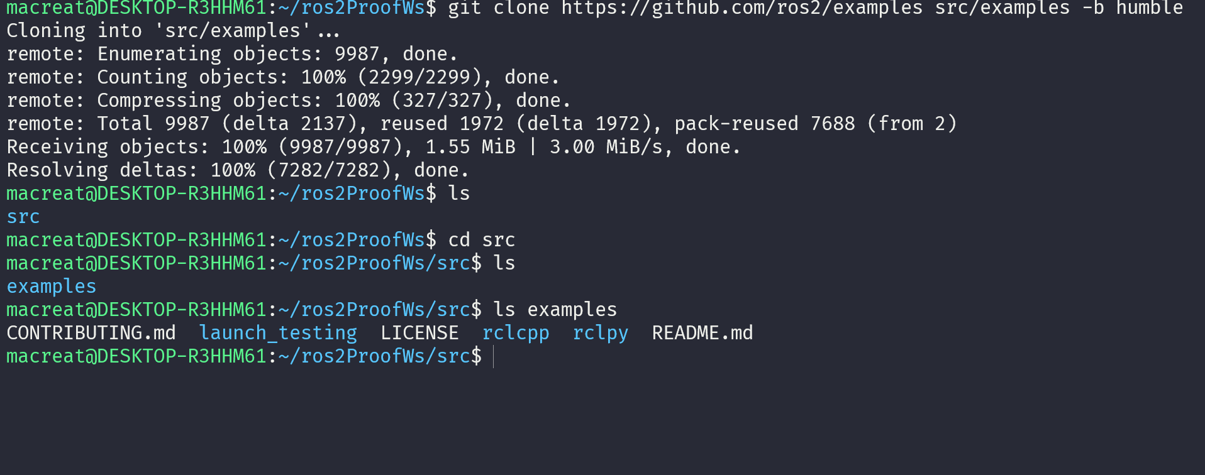
- And build in the WS root the –symlink-install packages from COLCON as
REMEMBER USE --executor sequential to aboid parallelism and get so may time

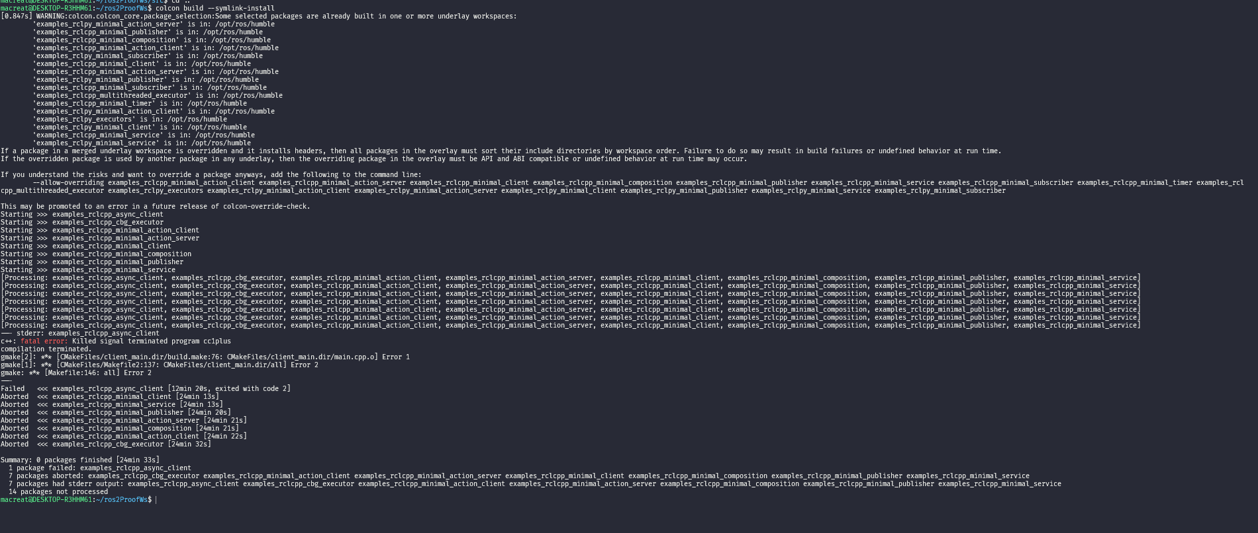

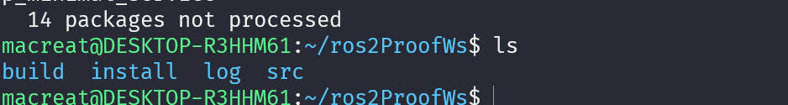

- NOW, CAN RUNA TEST.
use just colcon test
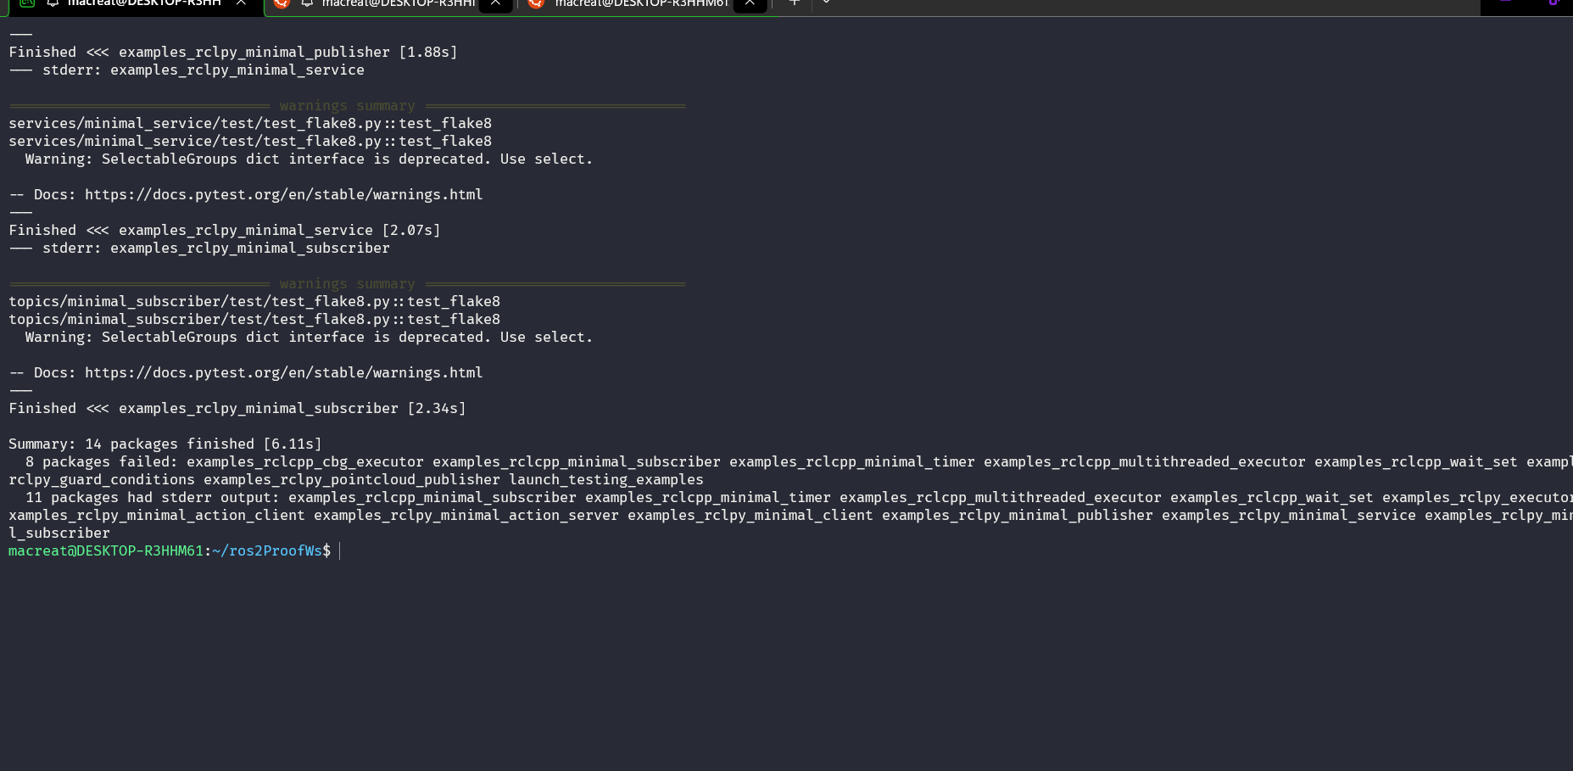

- PROCEED SOURCING THE ENVIROMENT
Source opt/ros2/humble/setup.bash : always for any term

CREATING A WS (WorkSpace)

- Source the root :
  - Source /opt/ros/humble/setup.bash
- Create a new dir
  - Mkdir…
- CLONE A REP ON SRC
  - Use a existing package…
      - A repo can have multiple branches. You need to check out the one that targets your installed ROS 2 distro. When you clone this repo, add the -b argument followed by that branch.
    - Proceed cloning the repo on a humble branch :

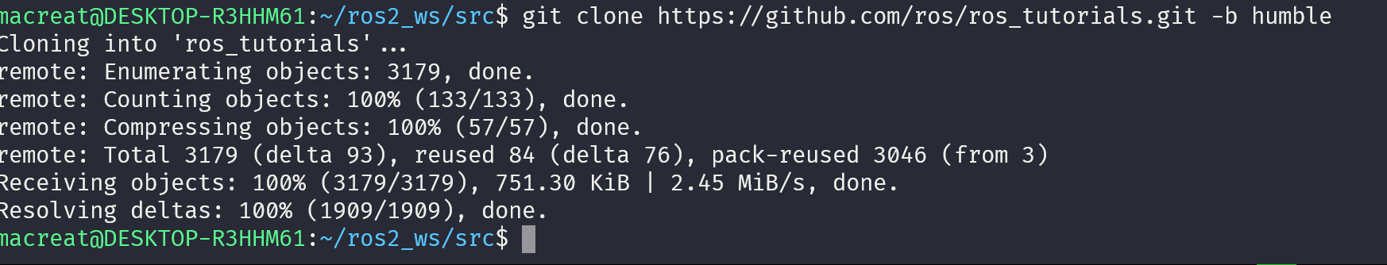
- RESOLVE DEPENDENCEIS
  - This is useful before building the workspace, cause I wouldn’t like to miss dependencies after BUILD with colcon
It is important note that packages declare their dependencies in the package.xml file

THIS IS ROSDEP CONCEPTS

- Proceed BUILDING THE WORKSPACE WITH COLOCON
Use COLCON BUILD on my ros2 workspace root
Other useful arguments for colcon build:
- --packages-up-to builds the package you want, plus all its dependencies, but not the whole workspace (saves time)
- --symlink-install saves you from having to rebuild every time you tweak python scripts
- --event-handlers console_direct+ shows console output while building (can otherwise be found in the log directory)
- --executor sequential processes the packages one by one instead of using parallelism
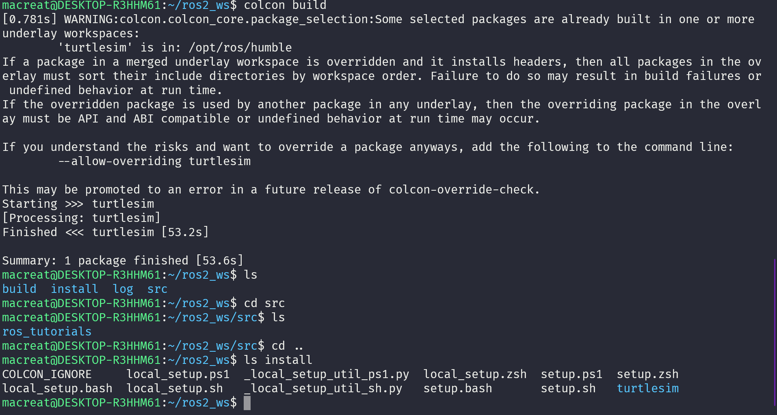
Install directory is where my WS’s setup files are, which are used to source MY OVERLAY.

- SOURCE THE OVERLAY
  - ON A NEW TERMINAL SOURCE MY MAIN ROS2 ENVIROMENT this as UNDERLAY… so I can build THE OVBELAY “ ON TOP OF” IT:

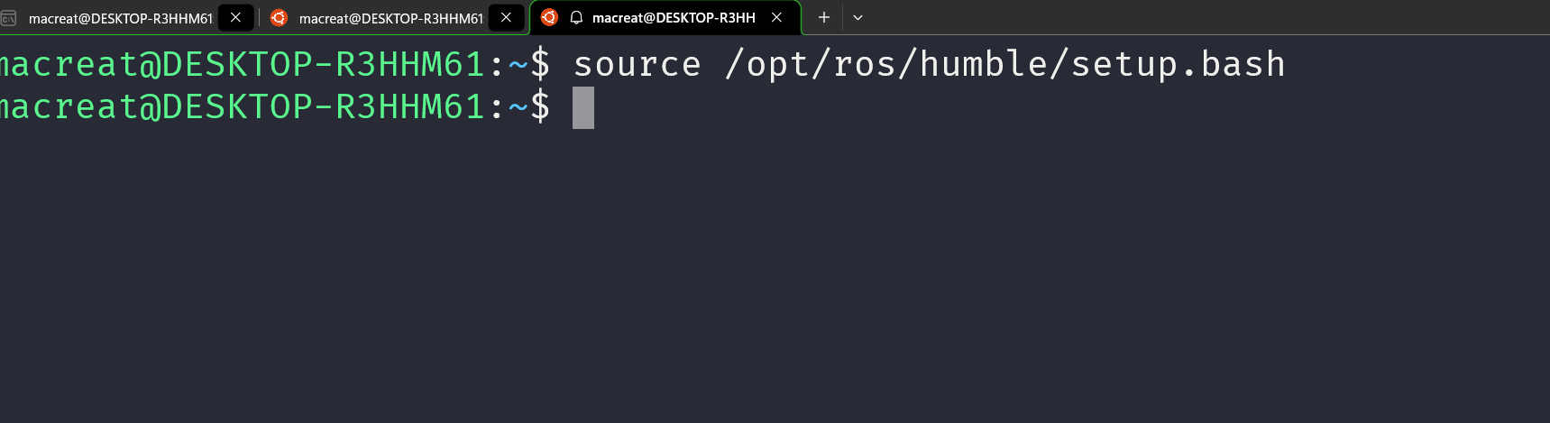
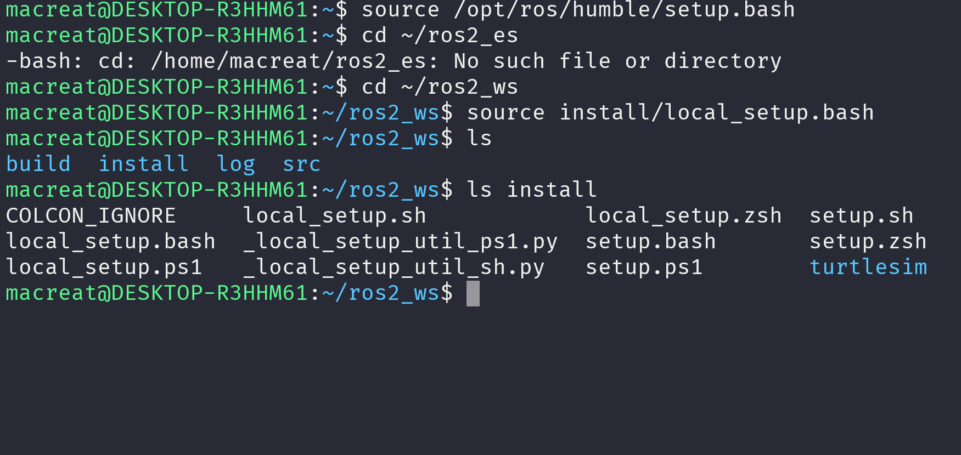
So, sourcing your main ROS 2 installation’s setup and then the ros2_ws overlay’s local_setup, like you just did, is the same as just sourcing ros2_ws’s setup, because that includes the environment of its underlay.

I CAN RUN THE TURTLESIM package FROM THE OVERLAY…
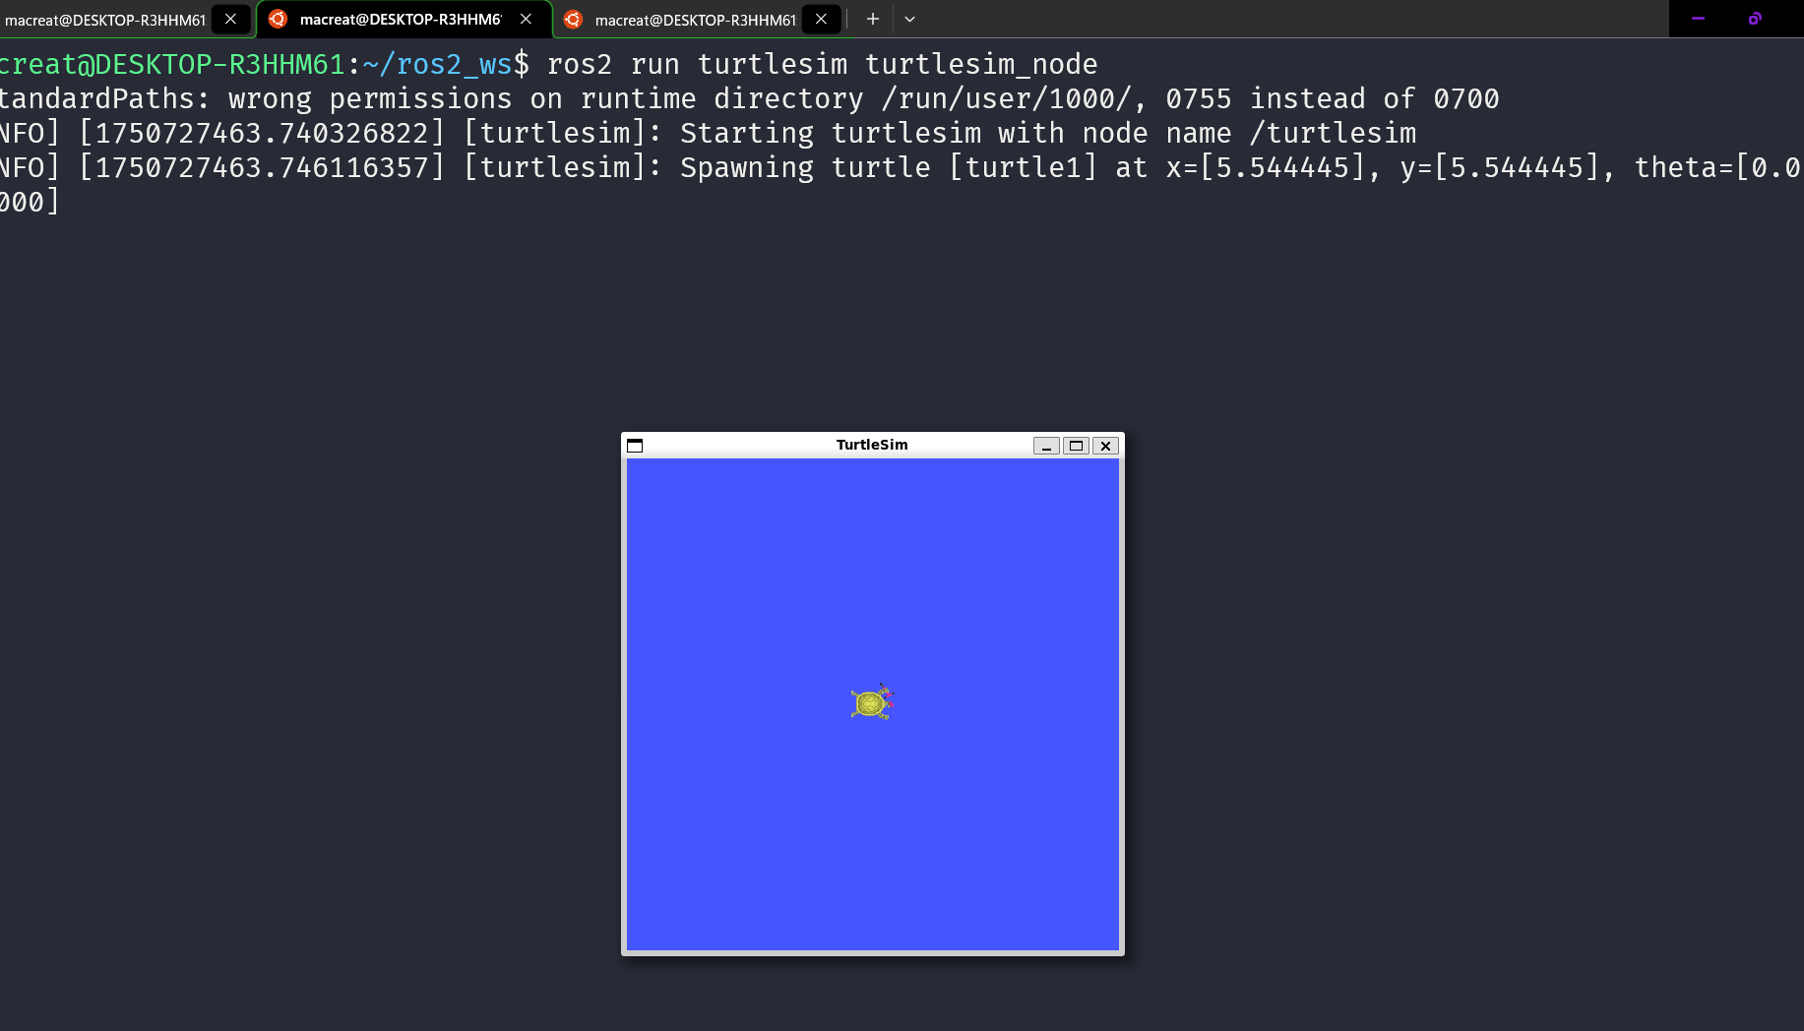

- MODIFY THE OVERLAY from the .CPP SORUCE, and then display on the screen again running the node.

CREATING A PACKAGE
THIS is useful in order to share or install my code on another space.

STRUCTURE

- ROS2 PYHON and CMake Packages have their own required contents:
- CMakeLists.txt file that describes how to build the code within the package
- include/<package_name> directory containing the public headers for the package
- package.xml file containing meta information about the package
- src directory containing the source code for the package
ON PY :

- package.xml file containing meta information about the package
- resource/<package_name> marker file for the package
- setup.cfg is required when a package has executables, so ros2 run can find them
- setup.py containing instructions for how to install the package
- <package_name> - a directory with the same name as your package, used by ROS 2 tools to find your package, contains __init__.py
- my_package/
- CMakeLists.txt
- include/my_package/
- package.xml
- src/
on py :
my_package/
package.xml
resource/my_package
setup.cfg
setup.py
my_package/

- Best practice is to have a src folder within your workspace, and to create your packages in there. This keeps the top level of the workspace “clean”

CREATING THE PACKAGE

On my src root :
in order to create a new package in ro2 :
ON C MAKE :
ros2 pkg create --build-type ament_cmake --license Apache-2.0 <package_name>

ON PY :
ros2 pkg create --build-type ament_python --license Apache-2.0 <package_name>

after this, we use an argument –node-name which creates a simple hello world type executable in my package
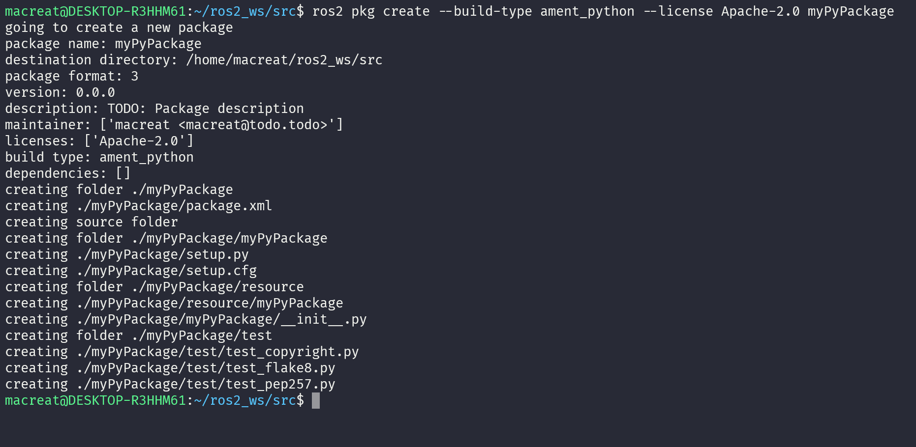
then :
ros2 pkg create --build-type ament_python --license Apache-2.0 --node-name my_node my_package
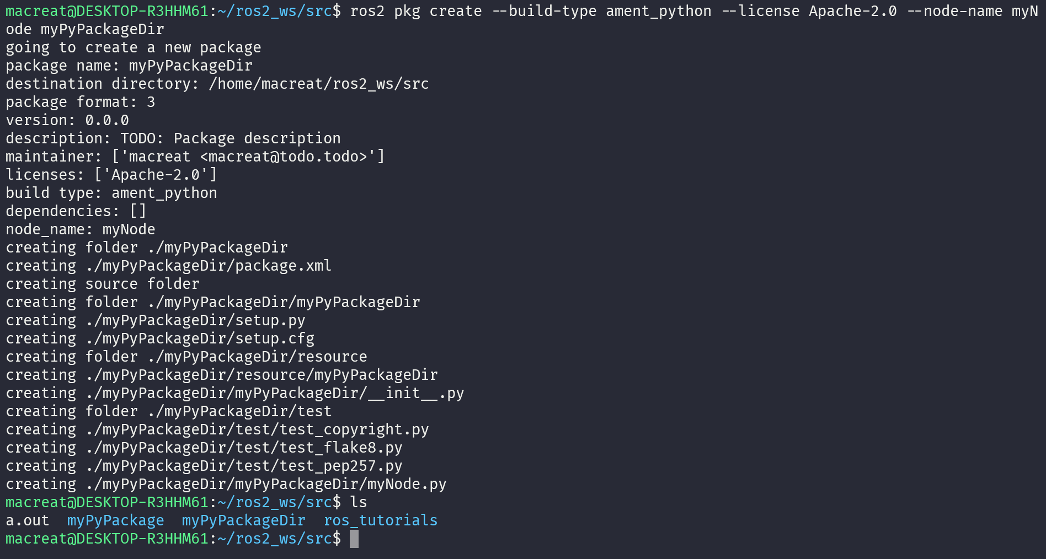

NOW I NEED TO BUILD THE PACKAGE on my WS root :
colcon build --packages-select my_package TO SELECT ONLY A PACKAGE to install
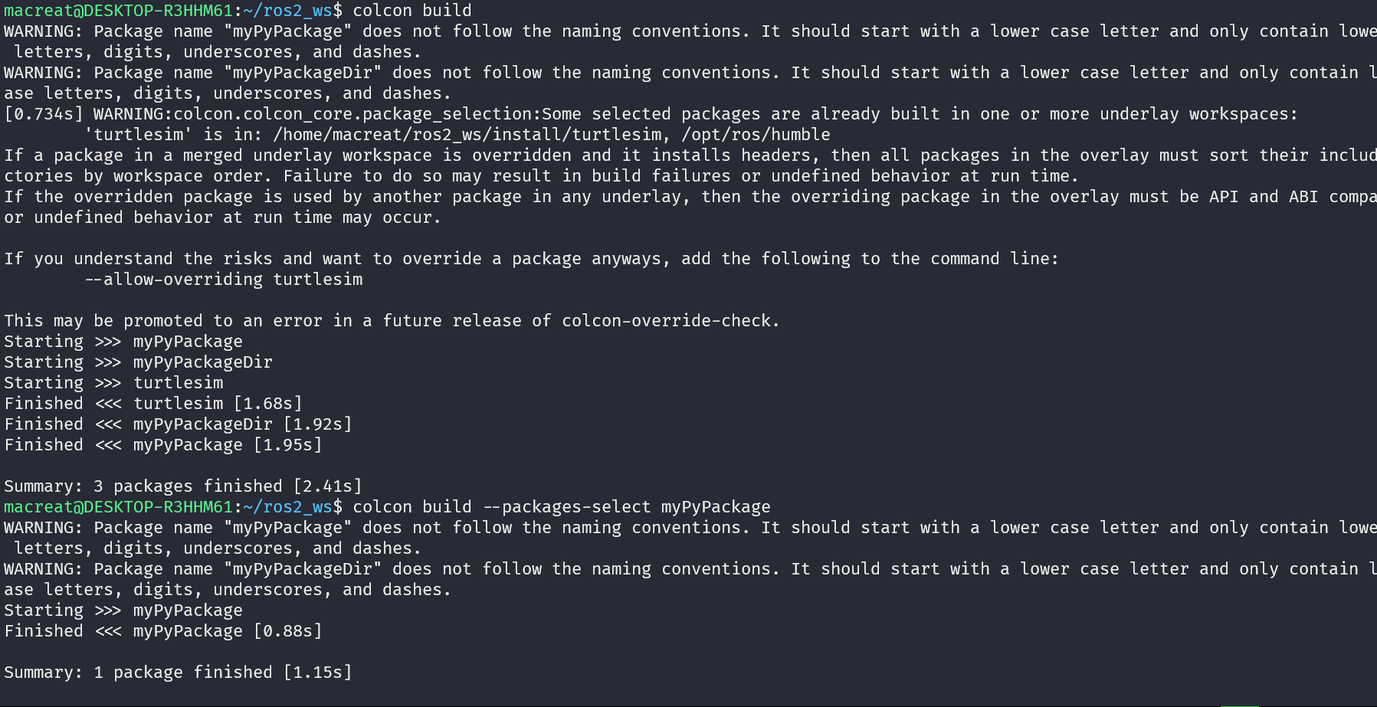

AFTER THIS, I NEED 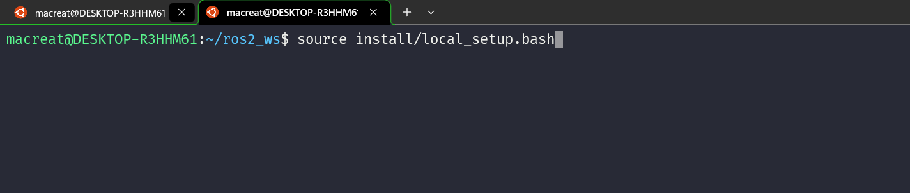TO SOURCE THE SETUP …

And then USE THE PACKAGE
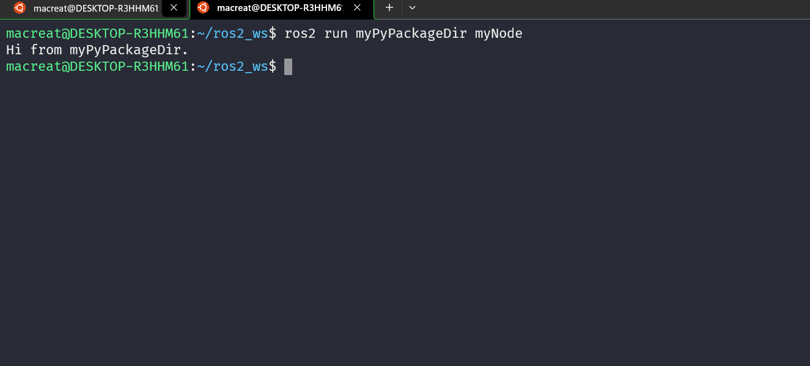

PACKAGE CONTENT :
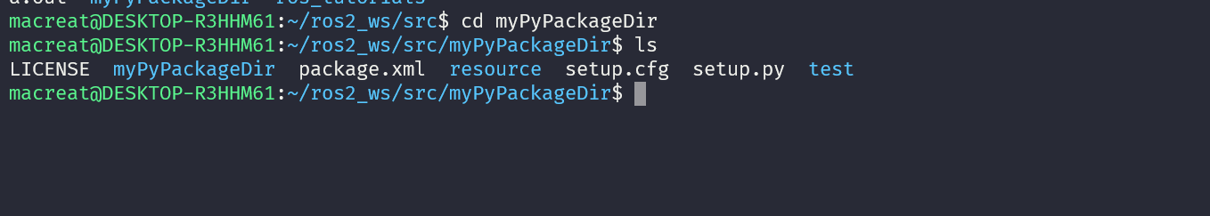

IN ORDER TO CUSTOMIZE PACKAGE.XML to deploy a personalize content :

Edit the maintainer, maintainer_email, and description lines to match package.xml. and then SAVE THE FILE to math with .xml cause ALSO HAVE TO EDIT THE SETUP.PY, NOT necessary on CMAKE CASE.

WRITING A SIMPLE PUBLISHER AND SUSCRIBER ON PY

The idea is create nodes that pass information in the form of string messages to each other over a topic. As a talker and listener system.; one node publishes data and the other subscribes to the topic so it can receive this data.

- CREATE THE PACKAGE

On src folder :
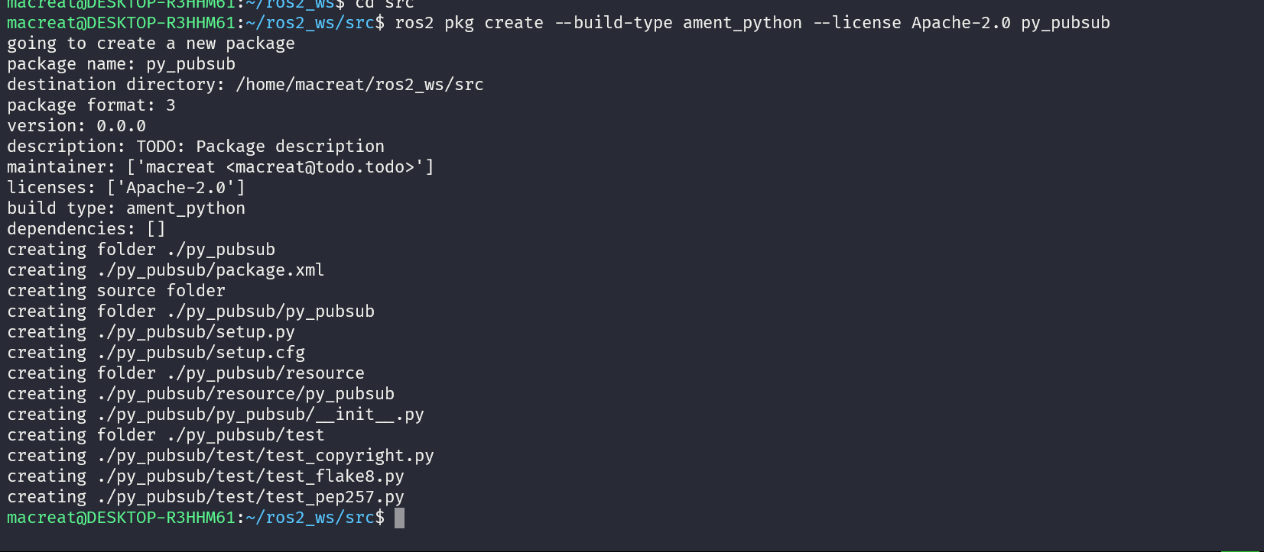

- WRITE THE PUBLISHER NODE

On my PACKAGE inside or nested in my dir package, I can download the talker example from the git content :
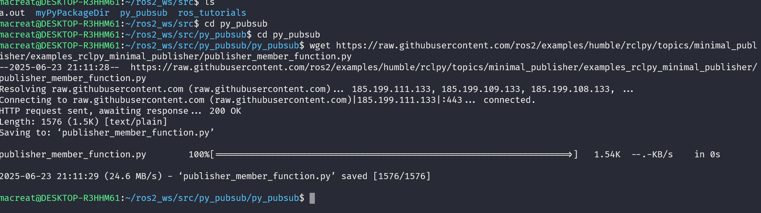

Now there will be a new file named publisher_member_function.py adjacent to __init__.py.

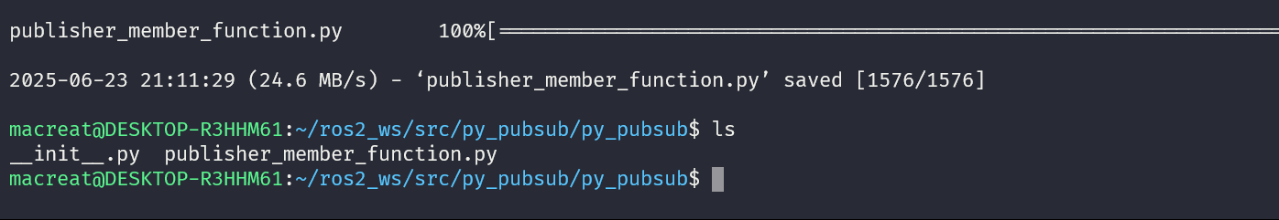
OPEN AND SEE CODE
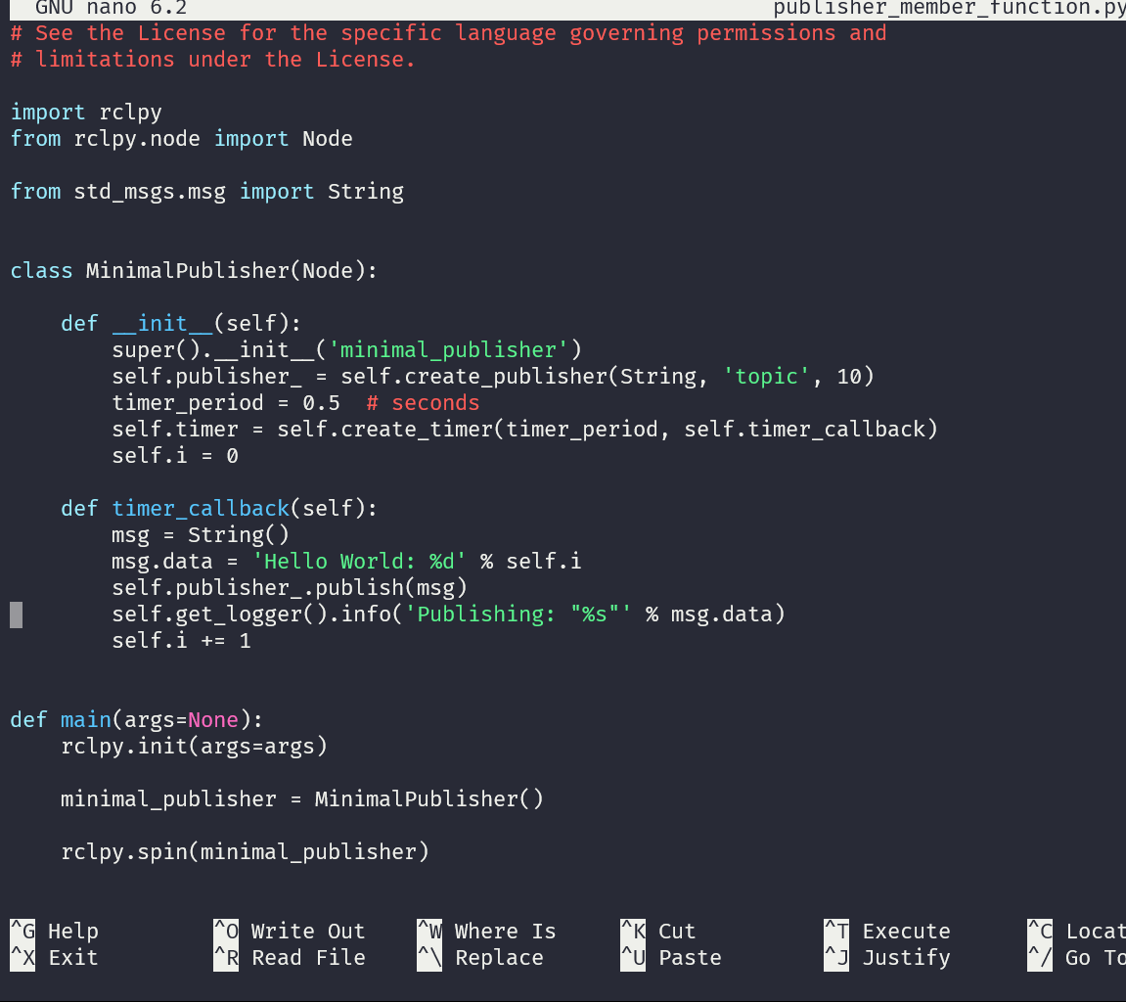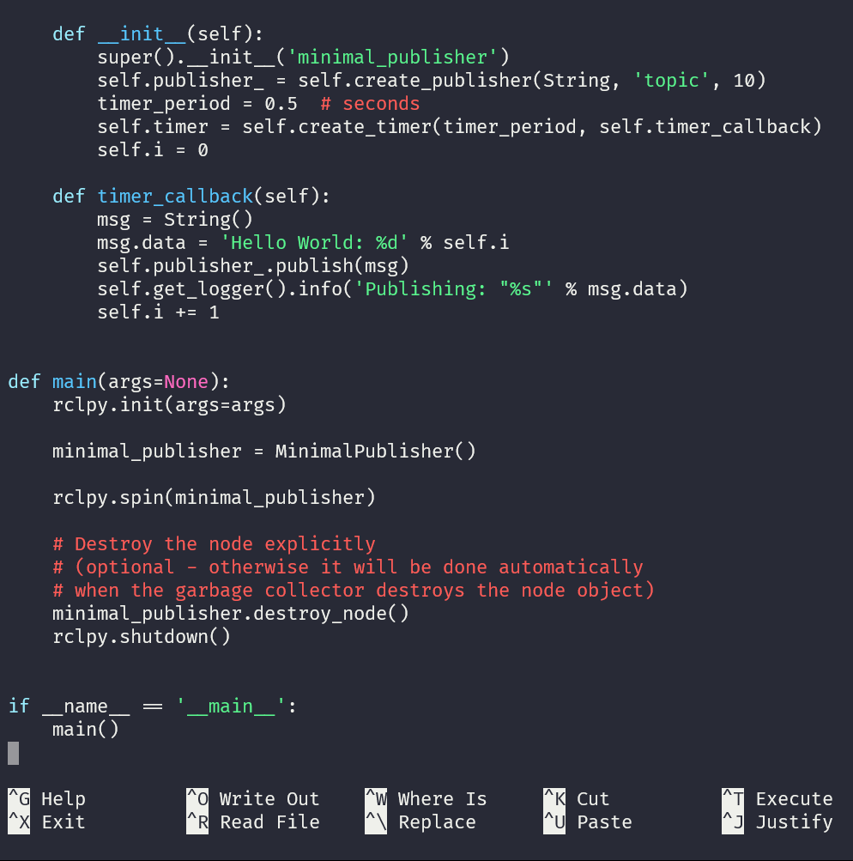

- NOW, WE NEED TO ADD DEPENDENCIES.
Go to my dir package and open the package.xml
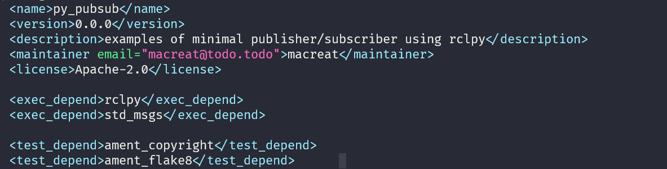
Add the execn_depend :
This declares the package needs rclpy and std_msgs when its code is executed.

- NOW ADD AN ETNRY POINT :
OPEN THE SETUP.PY and edit the same, also add
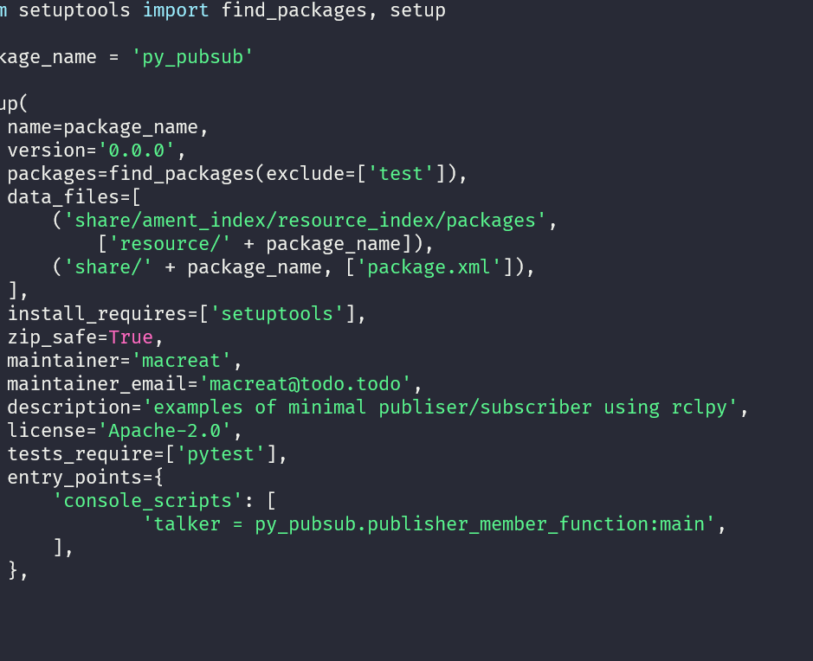
The talker on entry points

- NOW CHECK SETUP.CFG
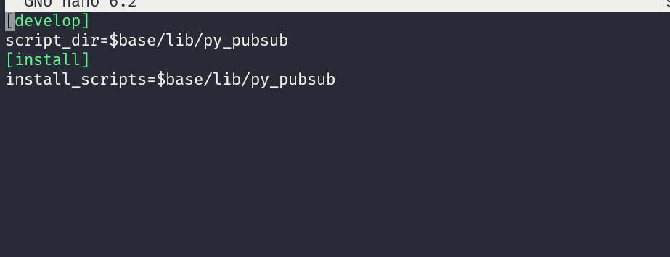

This is simply telling setuptools to put your executables in lib, because ros2 run will look for them there.
You could build your package now, source the local setup files, and run it, but let’s create the subscriber node first so you can see the full system at work.

- WRITE THE SUBSCRIBER NODE

On the package, creathe or copuy the content, now the directory has the subscribver_member_function.py
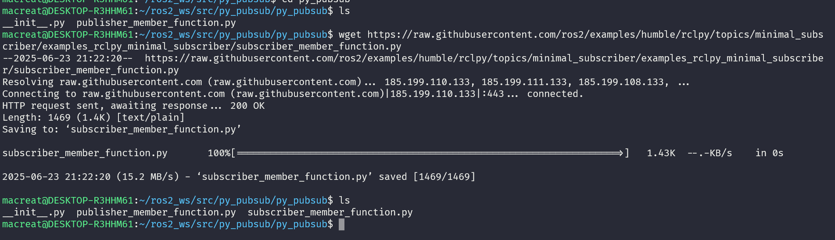
And examine the code
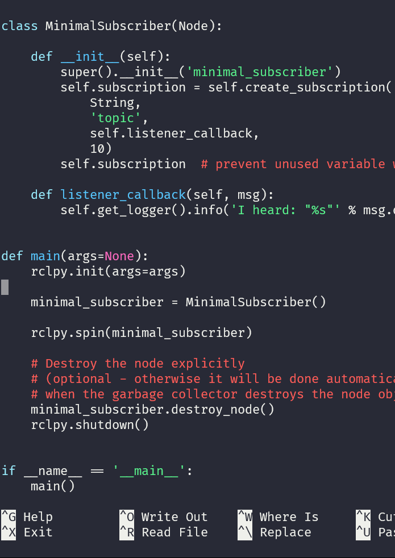
Since this node has the same dependencies as the publisher, there’s nothing new to add to package.xml. The setup.cfg file can also remain untouched.
- NOW ADD AN ENTRY POINT
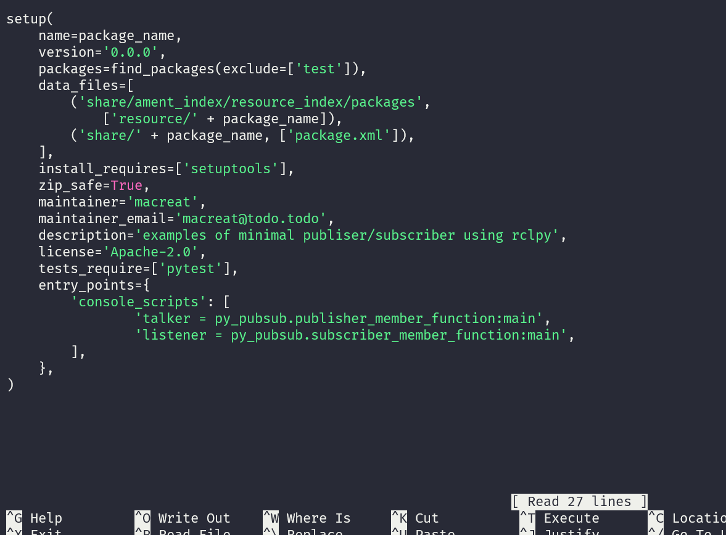

- Proceed BUILDING AND RUNNING
A GOOD PRACTice is RUN ROSDEP in the root of my current workspace (ros2_ws) to check for missing dependencies before building
rosdep install -i --from-path src --rosdistro humble -y

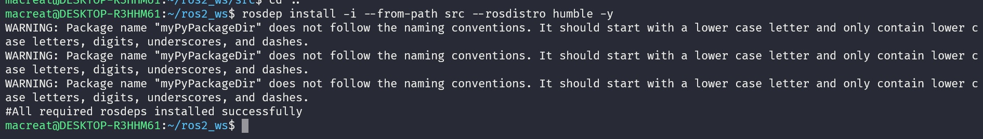
On this root, build my py_pubsub PACKAGE :
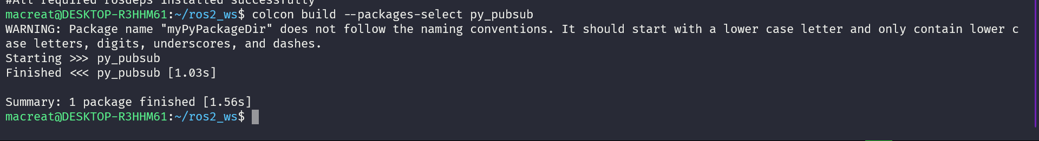

PROCEED SOURCING THE ENVIROMENT :
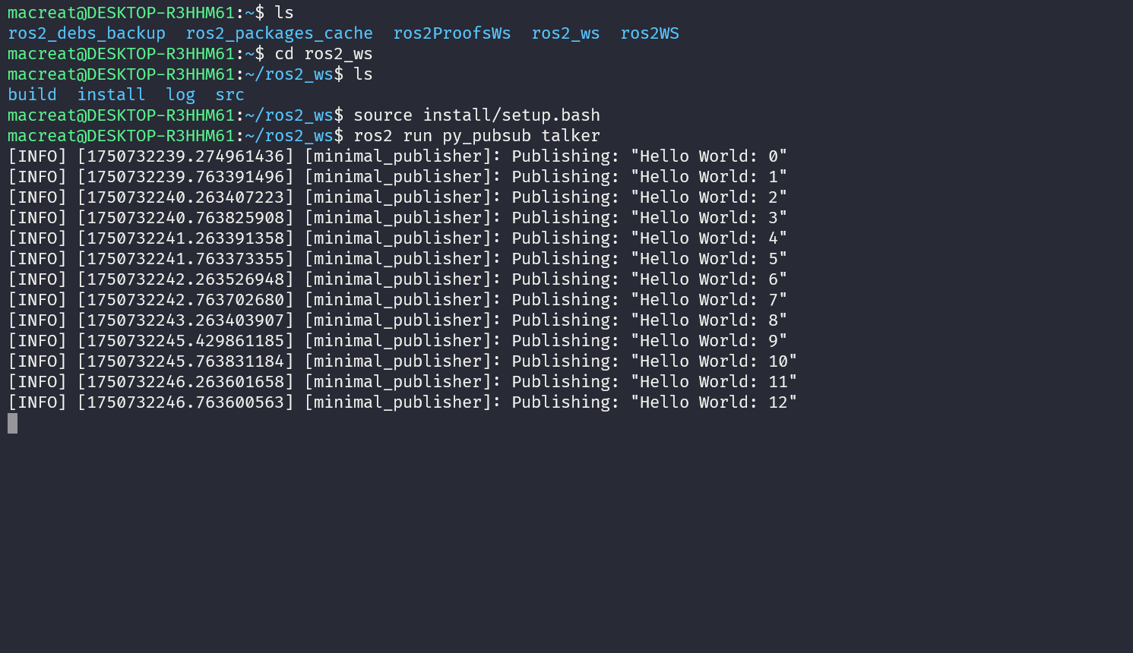

THIS IS MY OVERLAY , then in my UNDERLAY, whereis my LISTENER , that actually doesn’t modify any

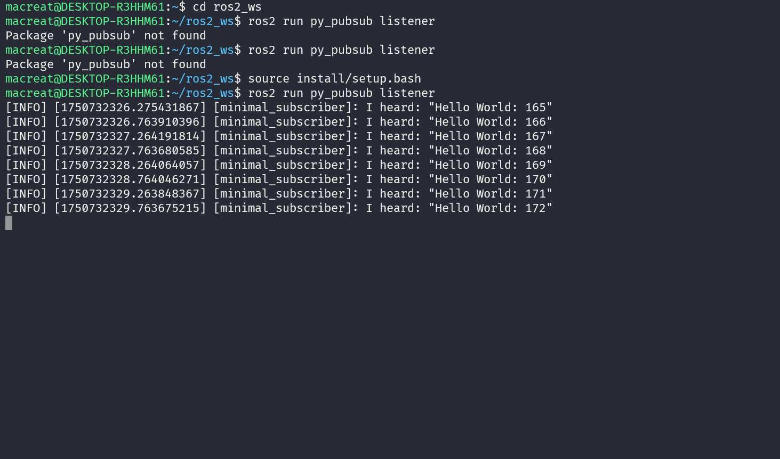
NOTE THAT ALSO HAS TO SOUrce to my bash
Until here, I created two nodes to publish and subscribe to data over a topic. Before running them, added their dependencies and entry points to the package configuration files.

WRITING A SERVICE AND CLIENT ON PY

When nodes communicate using services, the node that sends a request for data is called the client node, and the one that responds to the request is the service node. The structure of the request and response is determined by a .srv file.

The example used here is a simple integer addition system; one node requests the sum of two integers, and the other responds with the result.

TASKS
      - CREATE A PACKAGE
  - On a new terminal, used as underlay sourcing to my ROS2 installation
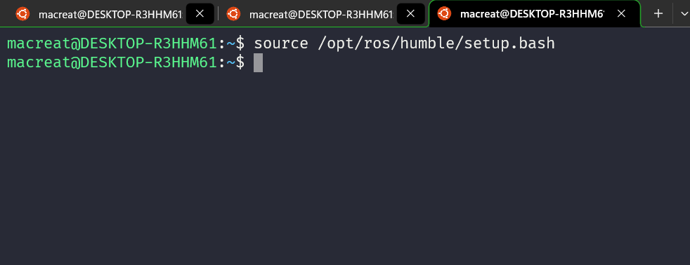

Then, create a package from my src dir

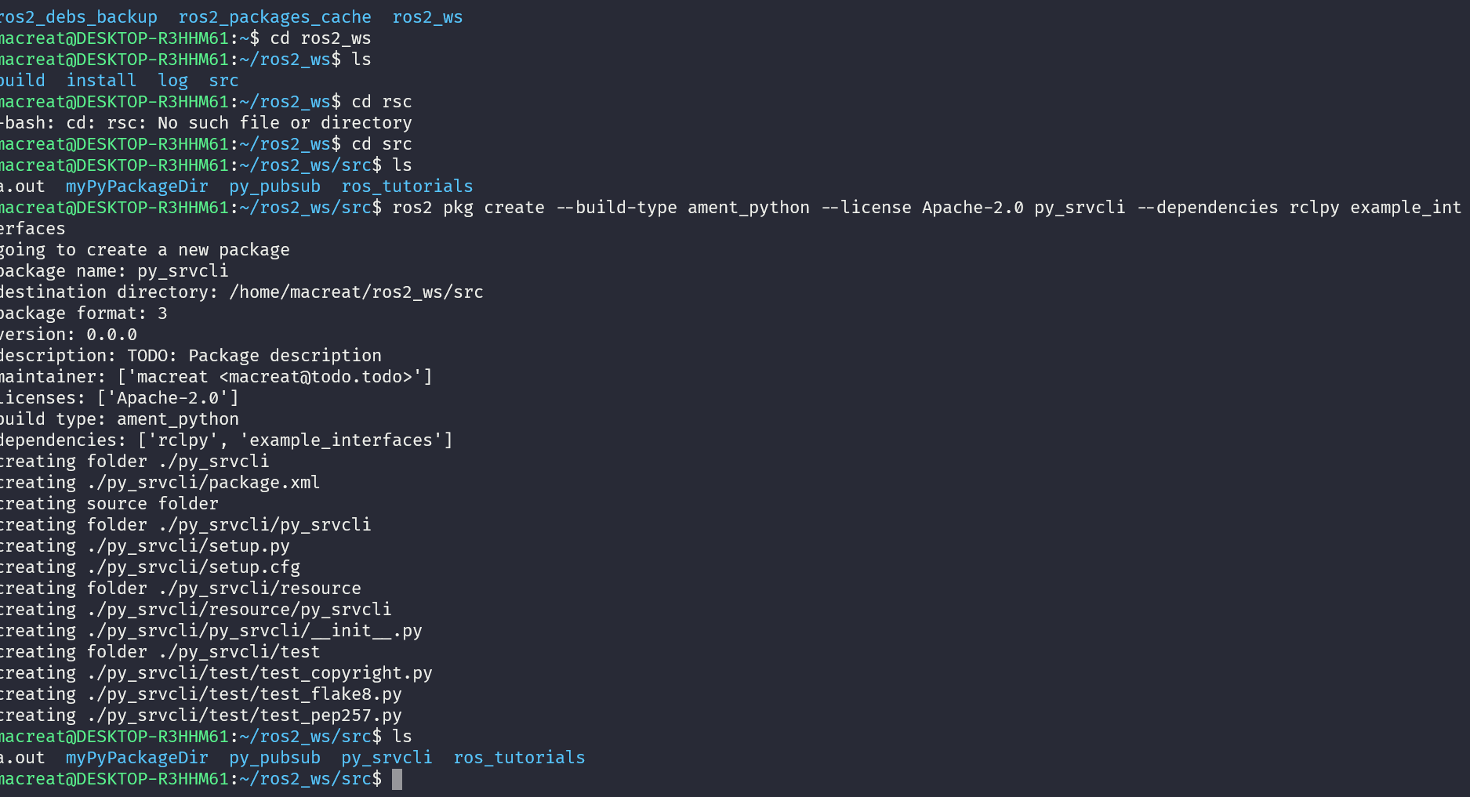

my terminal will return a message verifying the creation of package py_srvcli and all its necessary files and folders.

The --dependencies argument will automatically add the necessary dependency lines to package.xml. example_interfaces is the package that includes the .srv file that i will need to structure requests and response as :
int64 a
int64 b
---
int64 sum
  - update package.xlm

as I used the –dependencies option during package creation, I don’t have to manually add dependencies to this file, also, though, add the description, maintainer email and name, and license information to my package.xlm
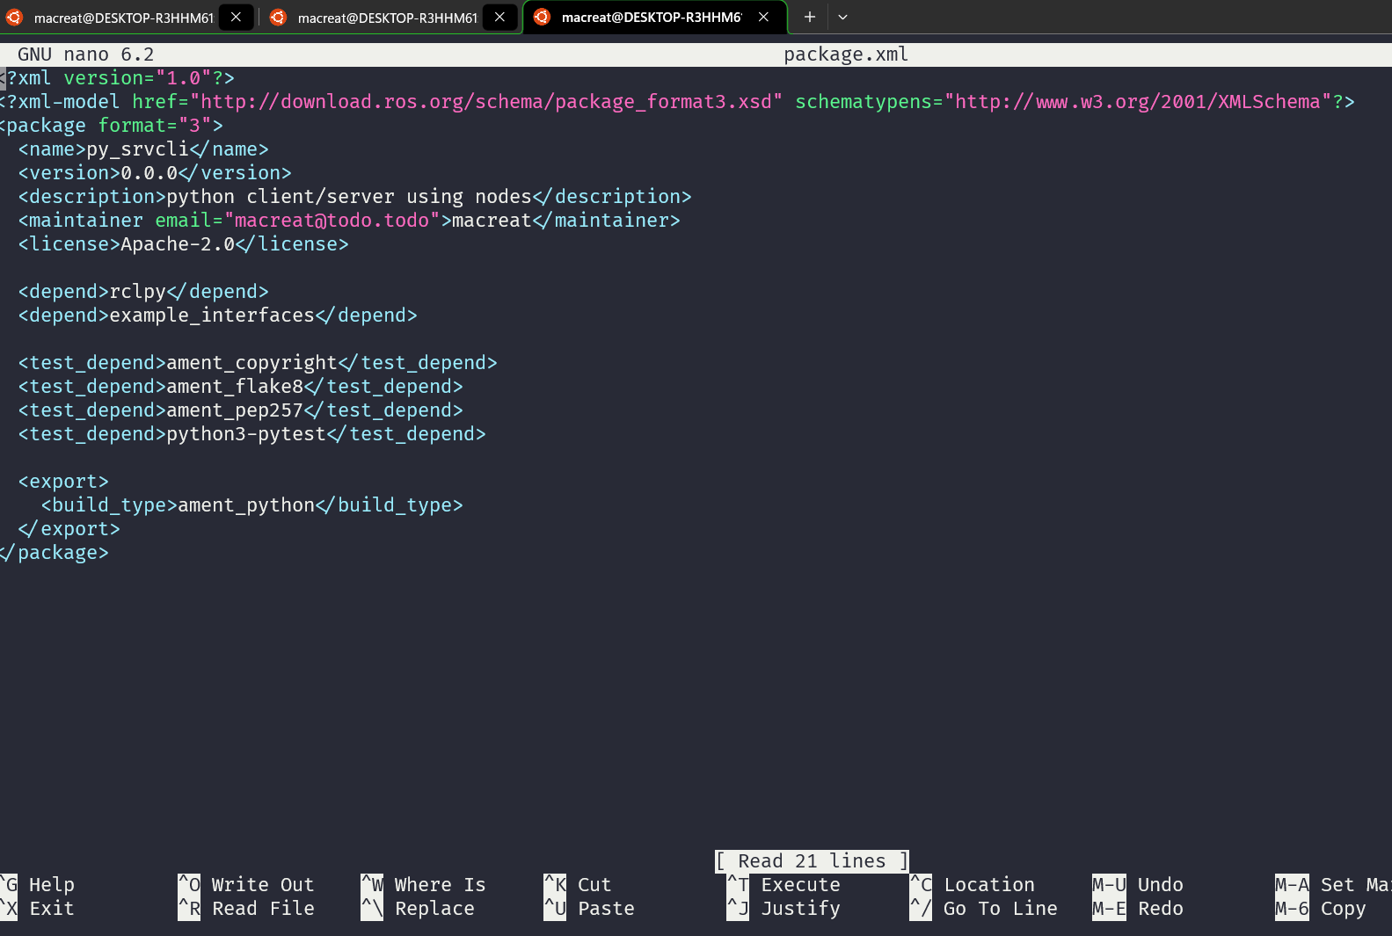
to match with the setup.py

  - update setup.py
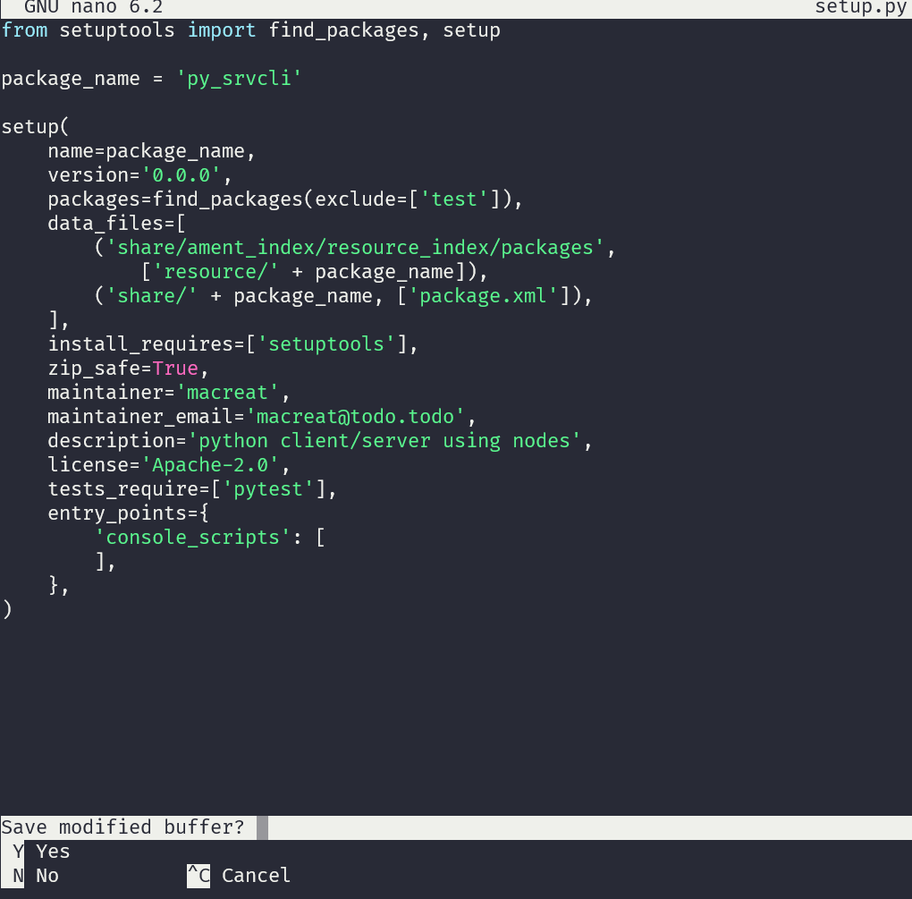

2. WRITING THE SERVICE NODE +
On the package folder, not the dir of my package, create a file called
Service_member_function.py and paste the following code
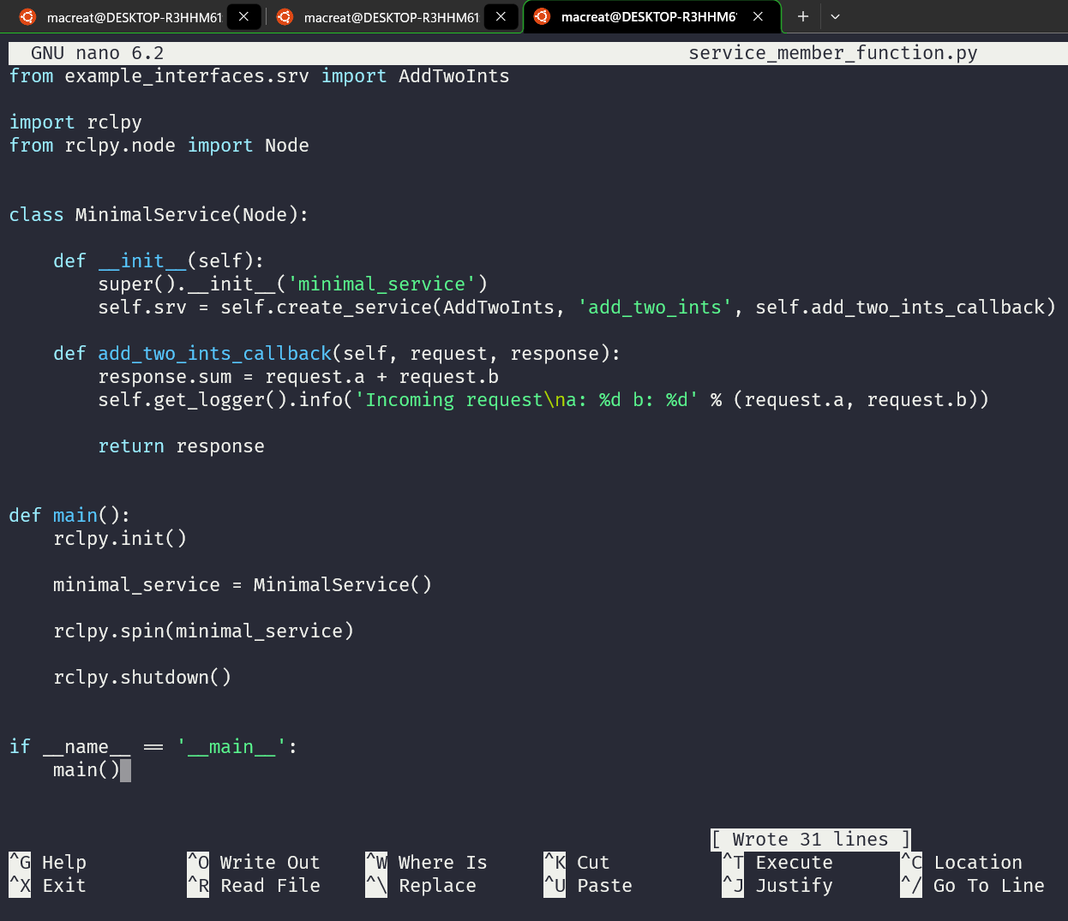

2.2 now ADD AN ENTRY POINT
To allow THE ROS2 RUN COMMAND ON MY RUN NODE, I must add the entry point to setup.py located on my package folder, not the package as well .

BETWEEN CONSOLE SCRIPTS:
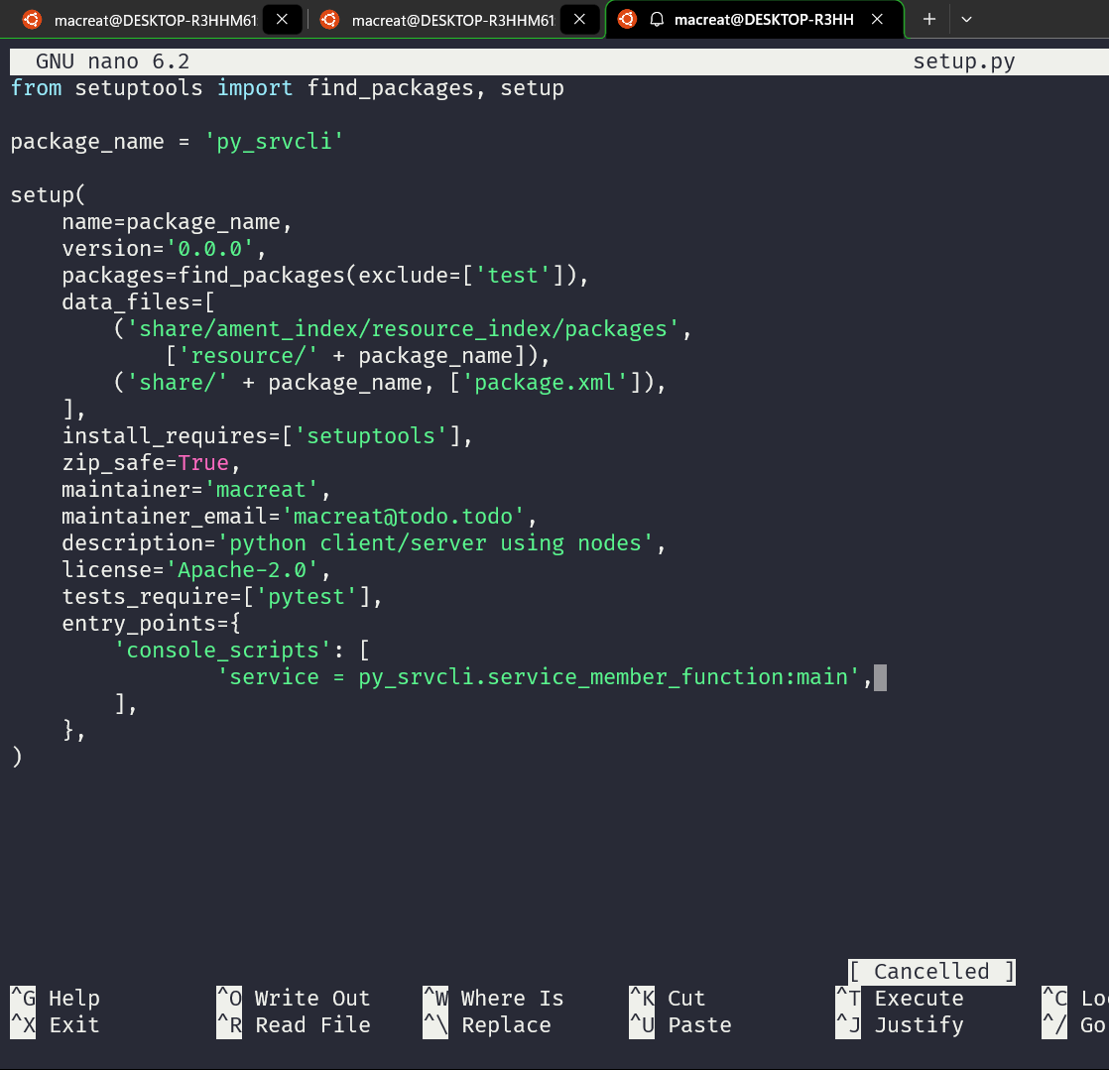
Add the service from my package as my .py file, where its called the main function

3. WRITE NOW THE CLIENT NODE :

Using a client_member function and also copying this process :

Inside of my package :

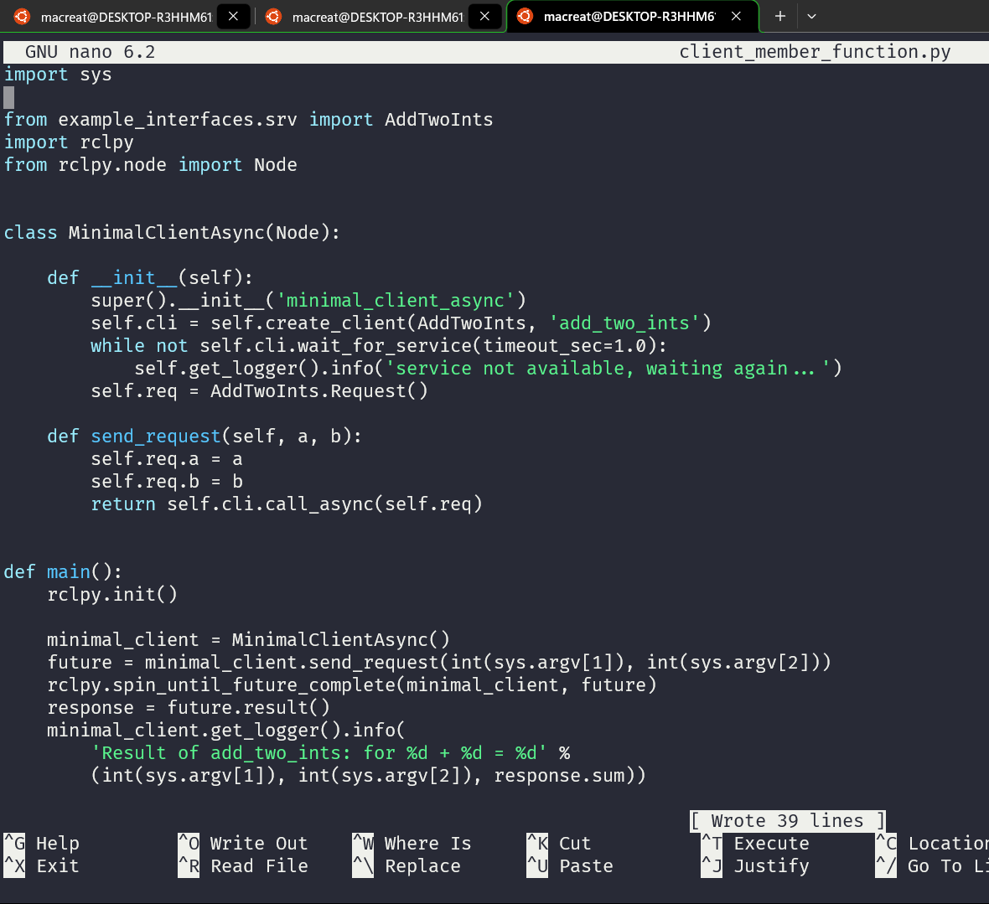
3.2 also make sure that I add the entry point bellow my service member function point

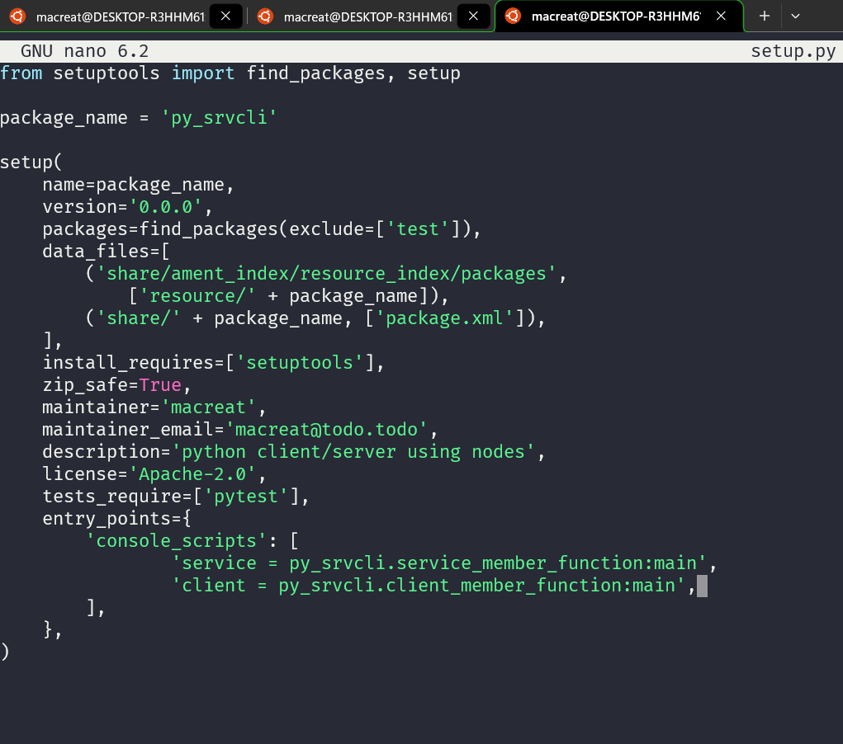

4. PROCEED BUILDING AND RUNNING
Remember that It’s good practice to run rosdep in the root of your workspace (ros2_ws) to check for missing dependencies before building:

Also remember that this has to be run on my ws root .:
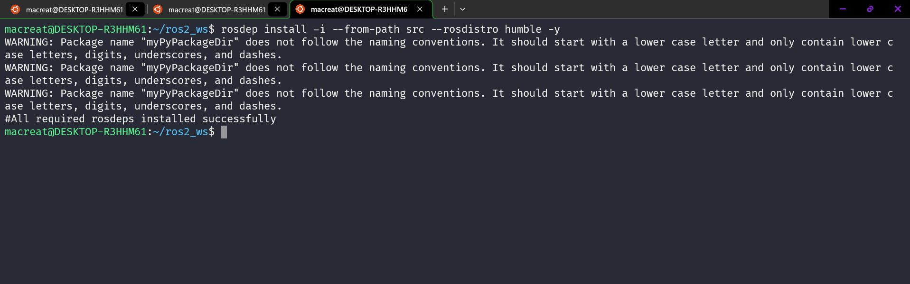
Another thing to do this is build the package using colcon

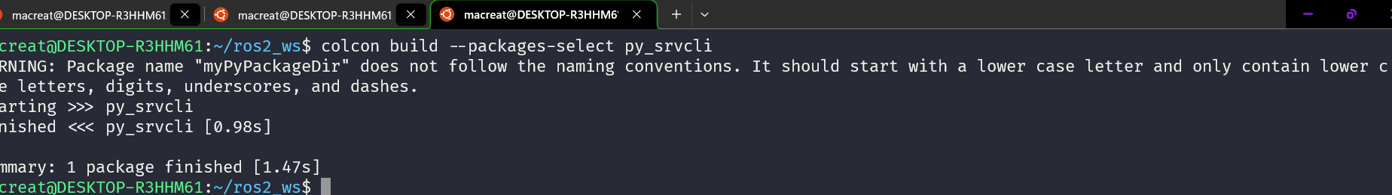
5. RUN

OPEN A NEW TERMINAL, THEN NAVIGATE TO MY WS, and sourcing the bash, then run a service node, this is my OVERLAY LABEL
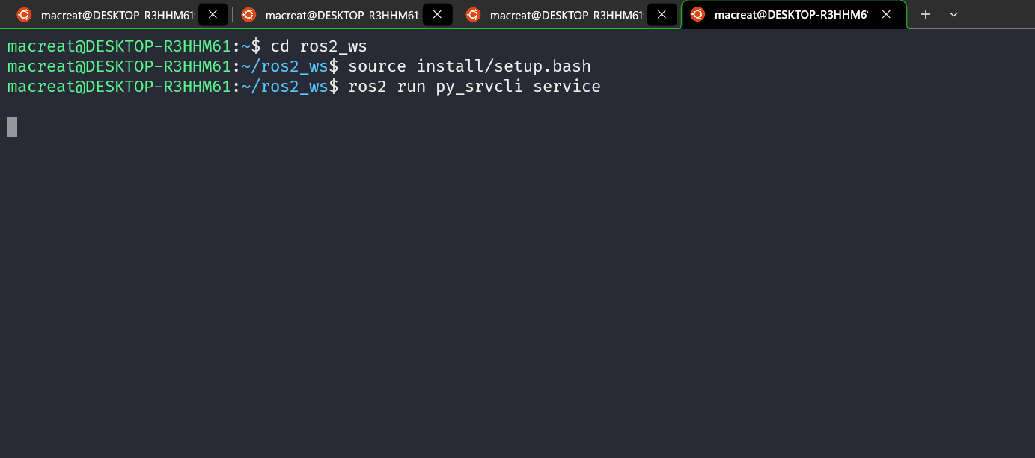

The service node will wait fort the client’s request.
Now, I OPEN ANEW TERMINAL, SOURCE WITH THE BASH ON MY INSTALL AND THEN RUN MY CLIENT NODE followed by two integers known as the integers to make the sum

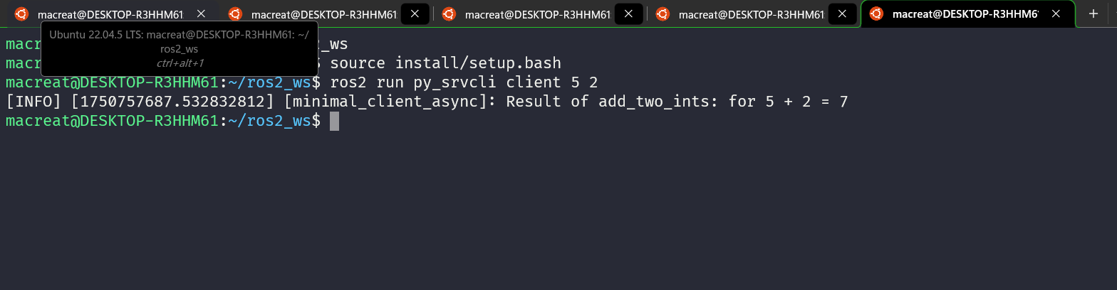
Now seeing my SERVICE NODE :
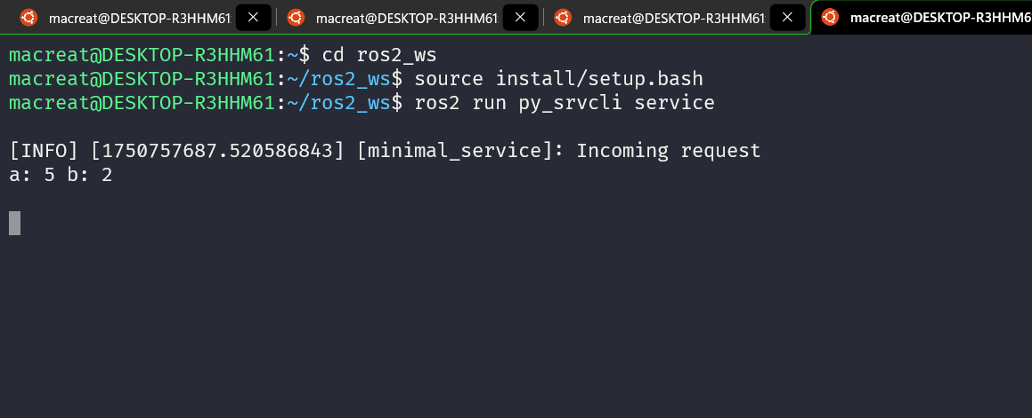
NOTE THAT MY CLIENT NODE PUBLISH THE RESULT :
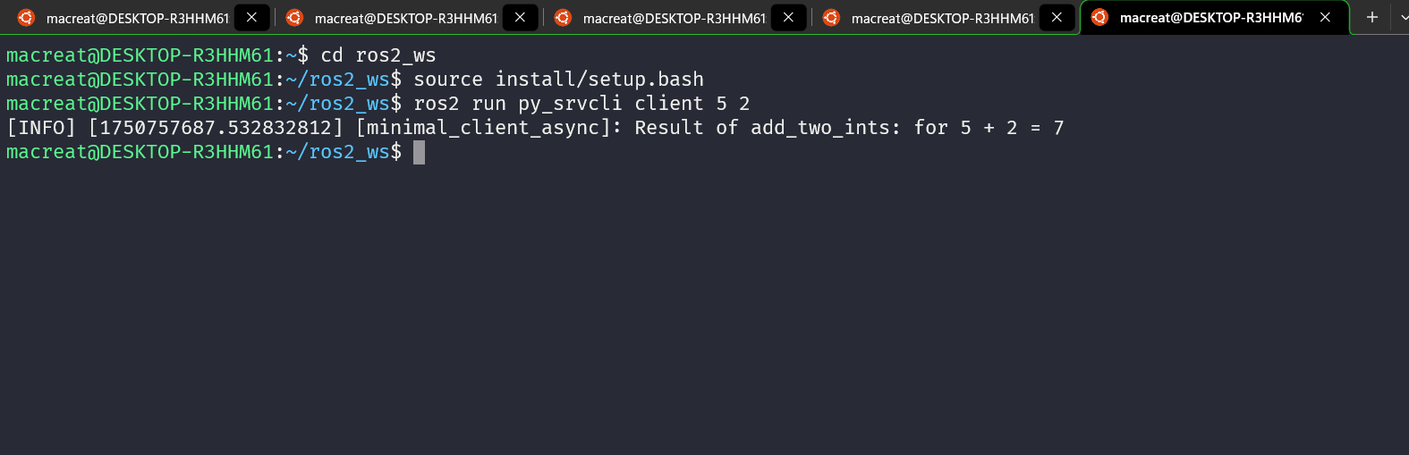

CUSTOM MSG AND SRV FILE

CUSTOM INTERFACES

PARAMETERS on CLASS
ROS2DOCTOR

Ros2 doctor command :

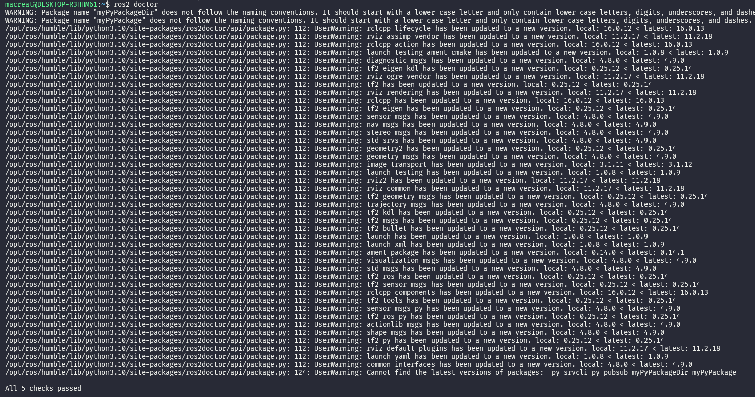
This will conduct checks over all setup modules and return warnings and errors.

2. CHECK A SYSTEM
3. DOING A FULL REPORT

IMPLEMENTING ROS2 ON AUTONOMOUS ROBOT NAVIGATION

      - PUB SUBS
    - Para transmission continua de datos
Publicador (Publisher) | Suscriptor (Subscriber) | Ejemplo en robot
Nodo que emite datos | Nodo que escucha datos | IMU → Nodo de navegación
Se usa para sensores, telemetría, comandos periódicos | Toma decisiones o actúa en base a esos datos | Sensores publican posición, otro nodo decide qué hacer

En el Proyecto :
- El IMU (unidad inercial) publica orientación y aceleración.
- Un nodo de navegación suscribe esa información para estimar posición o detectar movimientos.
- Puedes tener otro nodo que publique comandos de velocidad (/cmd_vel) y un nodo controlador que los escuche para mover las ruedas Mecanum.
2. CLIENT /SERVICE

PATRON REQUERIDO CUANDO SE NECESITA UNA ACCION PUNTUAL

Cliente | Servidor (Service) | Ejemplo robot
Hace una solicitud | Ejecuta la acción y devuelve una respuesta | "Gira 90°" → el robot lo hace y responde "OK"

Componente | Rol ROS2 | Tipo de comunicación
IMU (unidad inercial) | Publicador de orientación/velocidad | publisher
Encoders / motores | Publicadores de odometría y receptores de comandos | pub/sub
Nodo de control (embebido en RPi) | Suscriptor de datos / Publicador de comandos | pub/sub
Nodo de navegación (SLAM o Path planning) | Cliente de servicios / Subscriptor de mapa | services y subscribers
Interfaz de usuario web | Cliente que envía comandos por ROS Bridge | service client
Simulación (Rviz, Gazebo) | Visualización de sensores y estado | pub/sub

