COVERING THE BASICS:

After beginner CLI tools , continue with Client libraries.
- FIRST, USING COLCON TU BOULD PACKAGES

As prerequisites , we have to install colcon on the wsl :
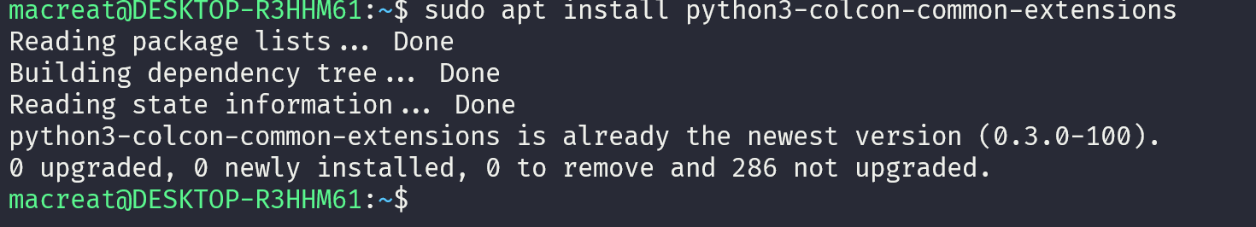

- CREATE A WORKSPACE
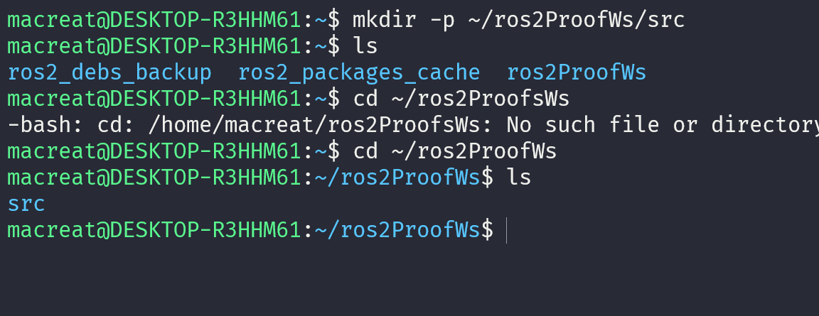
Only contain SRC folder

- Can add some source from the repository :
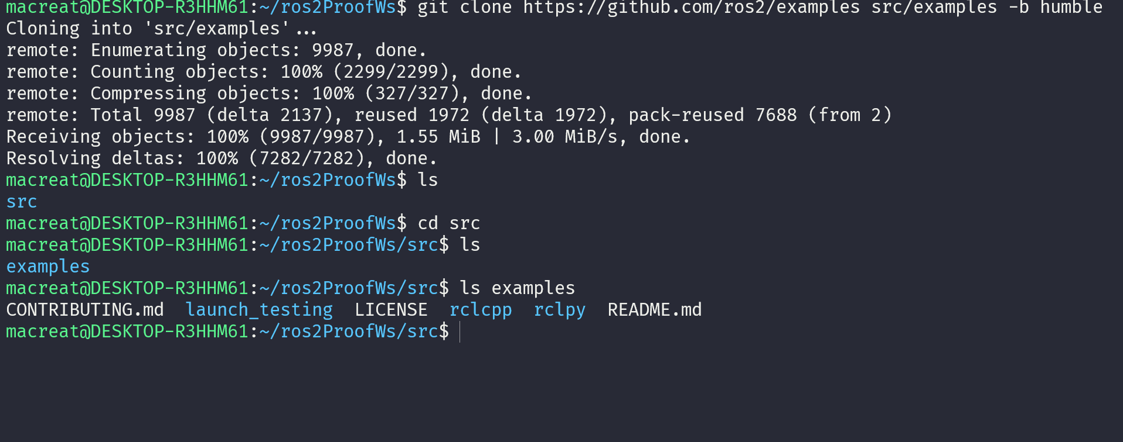
- And build in the WS root the –symlink-install packages from COLCON as
REMEMBER USE --executor sequential to aboid parallelism and get so may time

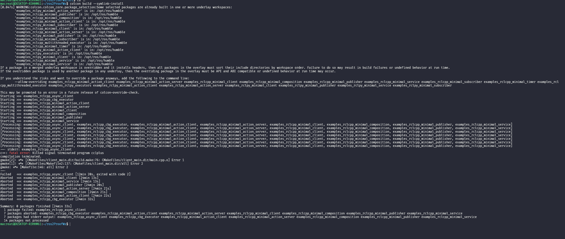

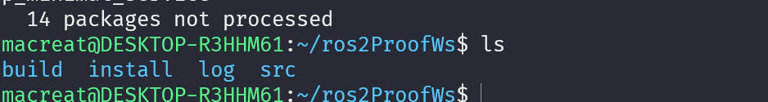

- NOW, CAN RUNA TEST.
use just colcon test
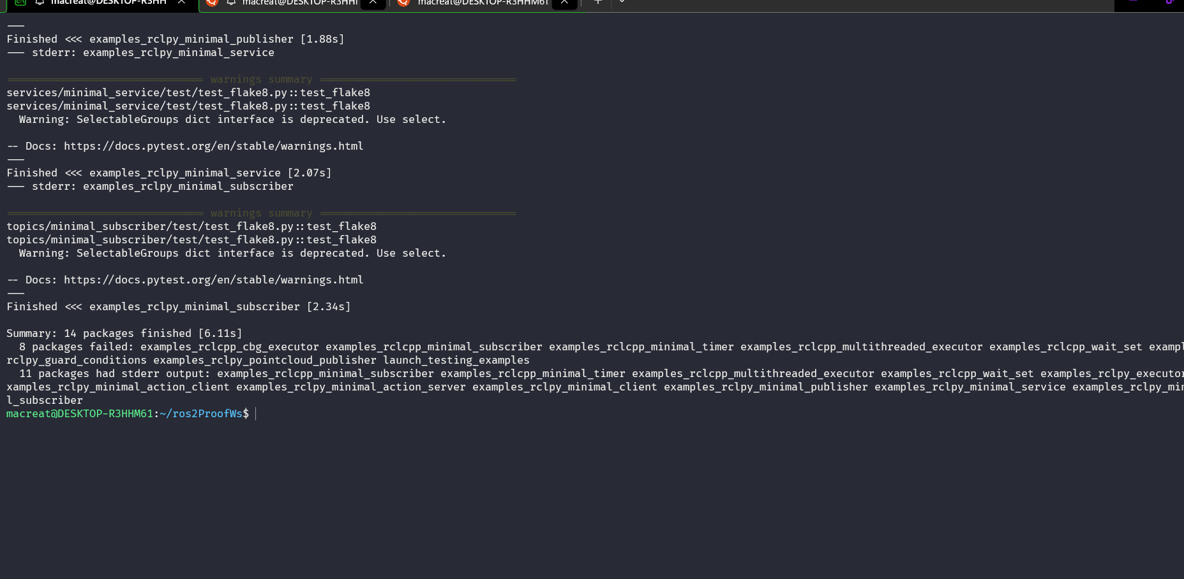

- PROCEED SOURCING THE ENVIROMENT
Source opt/ros2/humble/setup.bash : always for any term

CREATING A WS (WorkSpace)

- Source the root :
  - Source /opt/ros/humble/setup.bash
- Create a new dir
  - Mkdir…
- CLONE A REP ON SRC
  - Use a existing package…
      - A repo can have multiple branches. You need to check out the one that targets your installed ROS 2 distro. When you clone this repo, add the -b argument followed by that branch.
    - Proceed cloning the repo on a humble branch :

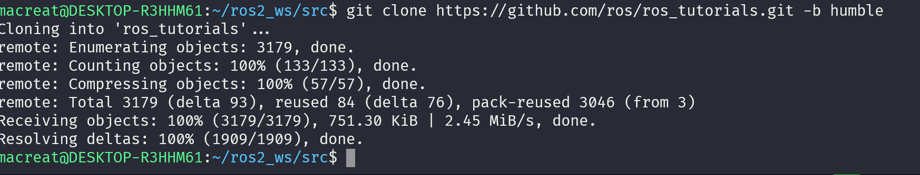
- RESOLVE DEPENDENCEIS
  - This is useful before building the workspace, cause I wouldn’t like to miss dependencies after BUILD with colcon
It is important note that packages declare their dependencies in the package.xml file

THIS IS ROSDEP CONCEPTS

- Proceed BUILDING THE WORKSPACE WITH COLOCON
Use COLCON BUILD on my ros2 workspace root
Other useful arguments for colcon build:
- --packages-up-to builds the package you want, plus all its dependencies, but not the whole workspace (saves time)
- --symlink-install saves you from having to rebuild every time you tweak python scripts
- --event-handlers console_direct+ shows console output while building (can otherwise be found in the log directory)
- --executor sequential processes the packages one by one instead of using parallelism
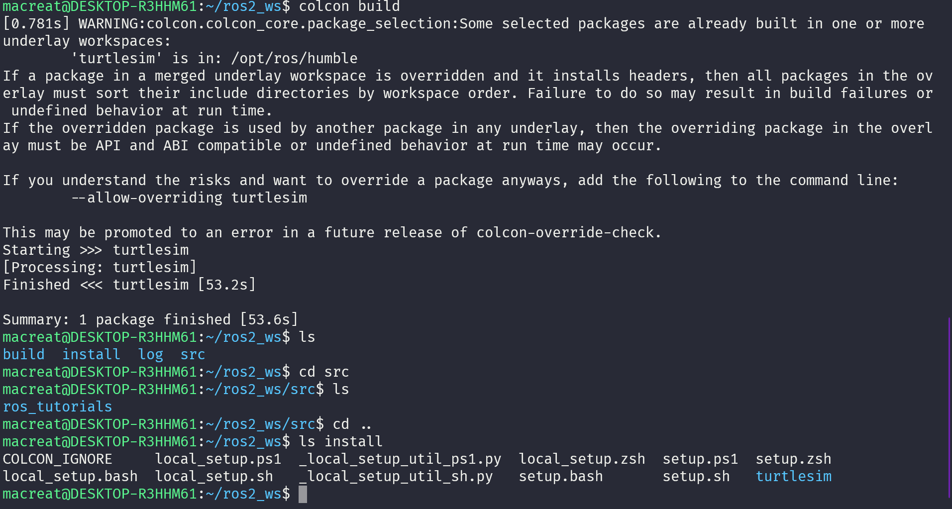
Install directory is where my WS’s setup files are, which are used to source MY OVERLAY.

- SOURCE THE OVERLAY
  - ON A NEW TERMINAL SOURCE MY MAIN ROS2 ENVIROMENT this as UNDERLAY… so I can build THE OVBELAY “ ON TOP OF” IT:

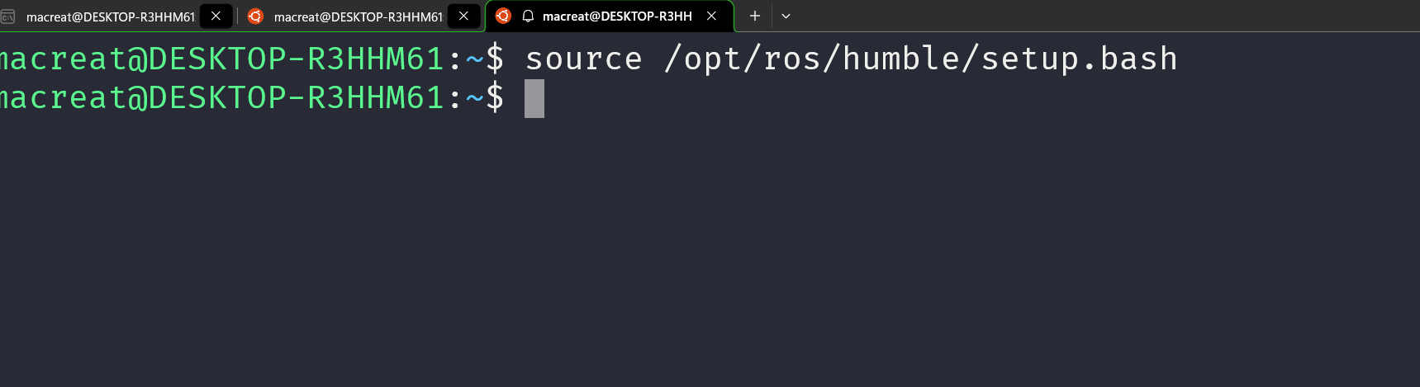
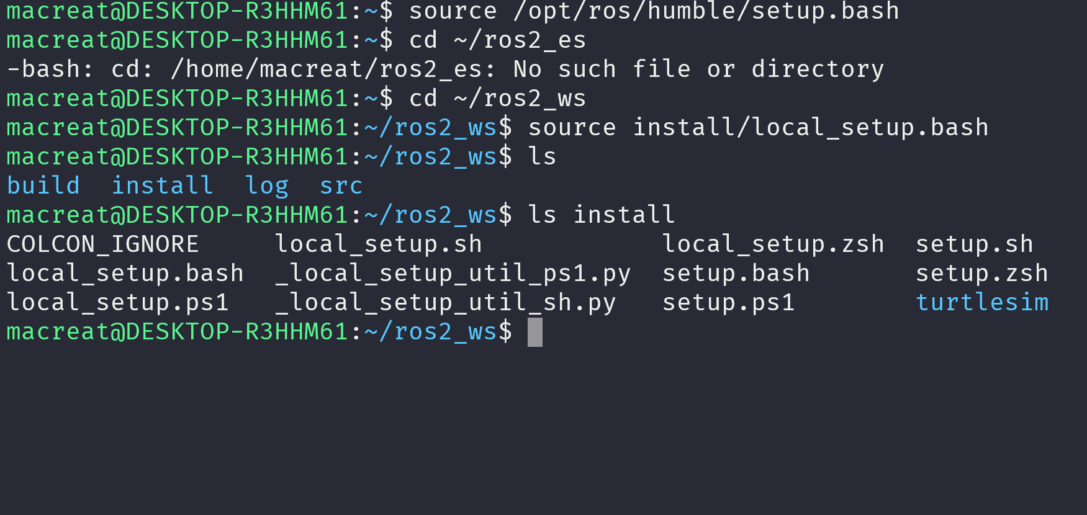
So, sourcing your main ROS 2 installation’s setup and then the ros2_ws overlay’s local_setup, like you just did, is the same as just sourcing ros2_ws’s setup, because that includes the environment of its underlay.

I CAN RUN THE TURTLESIM package FROM THE OVERLAY…
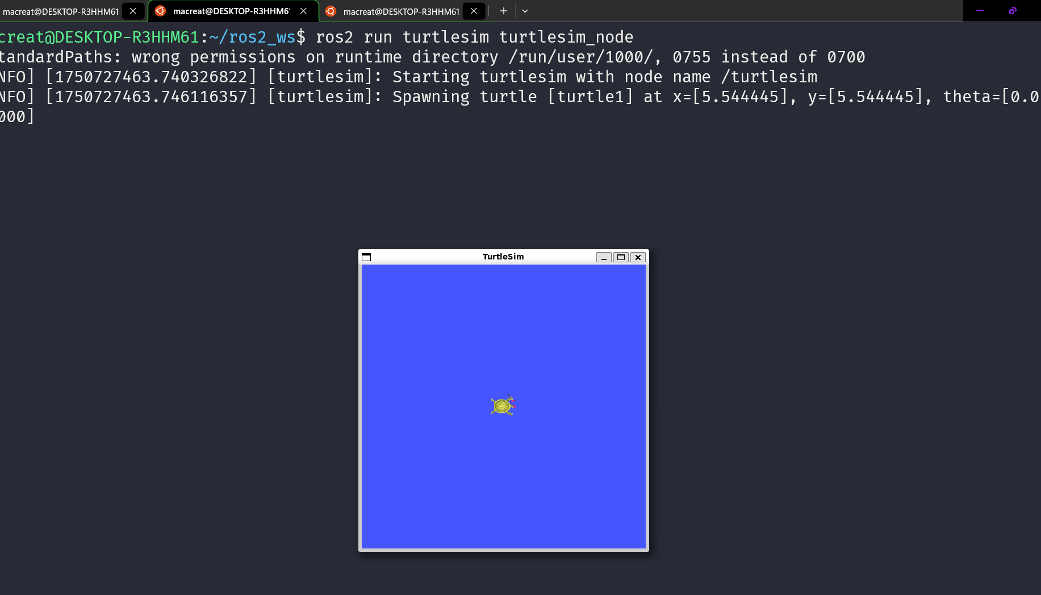

- MODIFY THE OVERLAY from the .CPP SORUCE, and then display on the screen again running the node.

CREATING A PACKAGE
THIS is useful in order to share or install my code on another space.

STRUCTURE

- ROS2 PYHON and CMake Packages have their own required contents:
- CMakeLists.txt file that describes how to build the code within the package
- include/<package_name> directory containing the public headers for the package
- package.xml file containing meta information about the package
- src directory containing the source code for the package
ON PY :

- package.xml file containing meta information about the package
- resource/<package_name> marker file for the package
- setup.cfg is required when a package has executables, so ros2 run can find them
- setup.py containing instructions for how to install the package
- <package_name> - a directory with the same name as your package, used by ROS 2 tools to find your package, contains __init__.py
- my_package/
- CMakeLists.txt
- include/my_package/
- package.xml
- src/
on py :
my_package/
package.xml
resource/my_package
setup.cfg
setup.py
my_package/

- Best practice is to have a src folder within your workspace, and to create your packages in there. This keeps the top level of the workspace “clean”

CREATING THE PACKAGE

On my src root :
in order to create a new package in ro2 :
ON C MAKE :
ros2 pkg create --build-type ament_cmake --license Apache-2.0 <package_name>

ON PY :
ros2 pkg create --build-type ament_python --license Apache-2.0 <package_name>

after this, we use an argument –node-name which creates a simple hello world type executable in my package
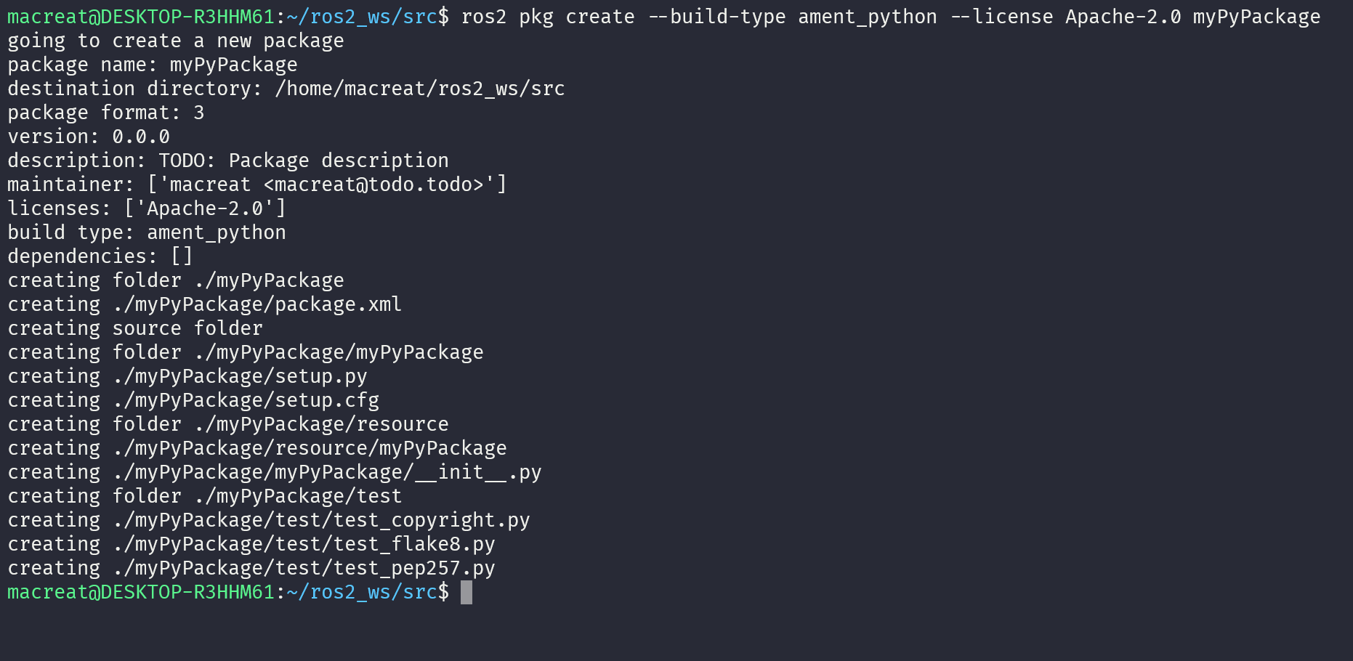
then :
ros2 pkg create --build-type ament_python --license Apache-2.0 --node-name my_node my_package
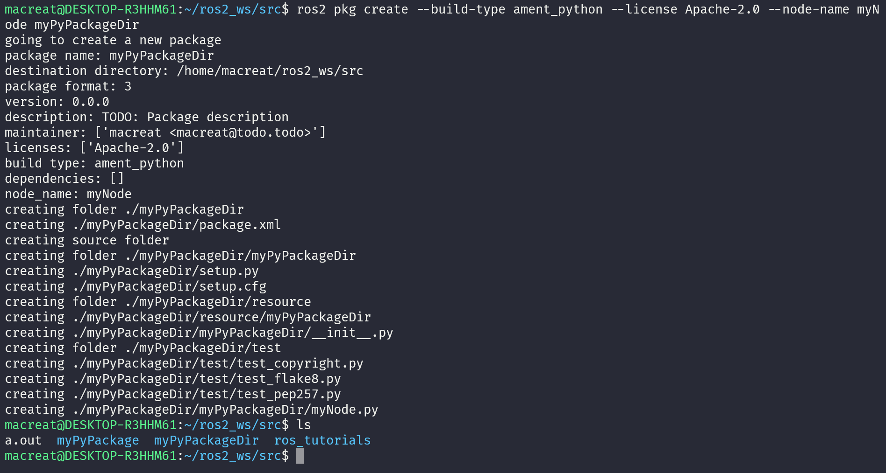

NOW I NEED TO BUILD THE PACKAGE on my WS root :
colcon build --packages-select my_package TO SELECT ONLY A PACKAGE to install
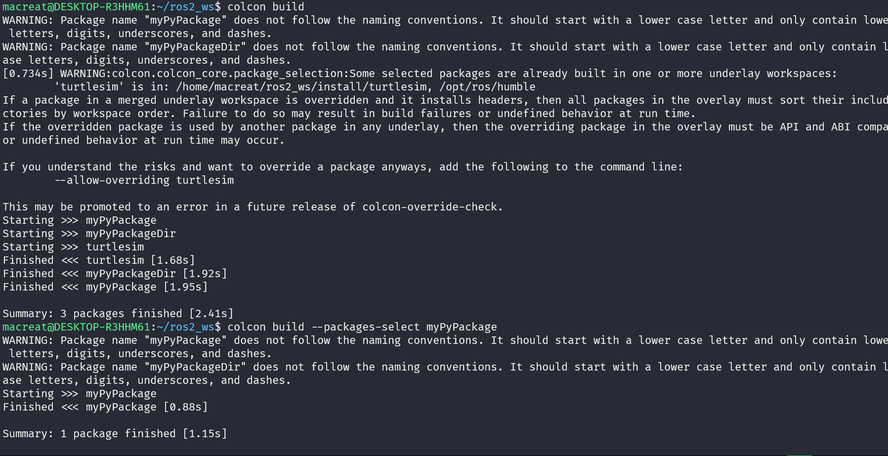

AFTER THIS, I NEED 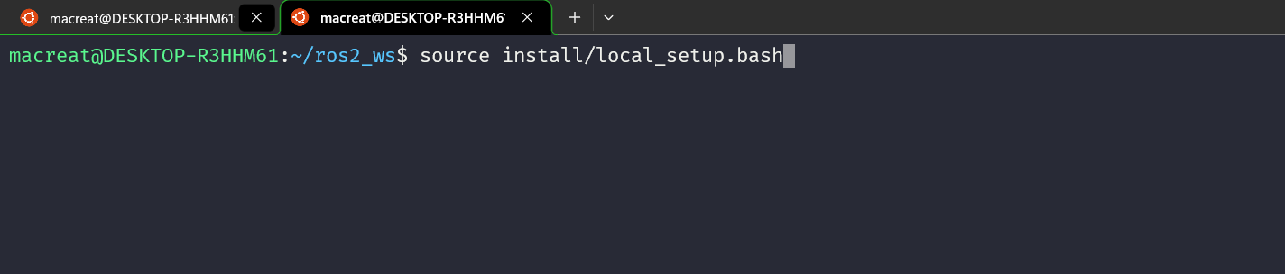TO SOURCE THE SETUP …

And then USE THE PACKAGE
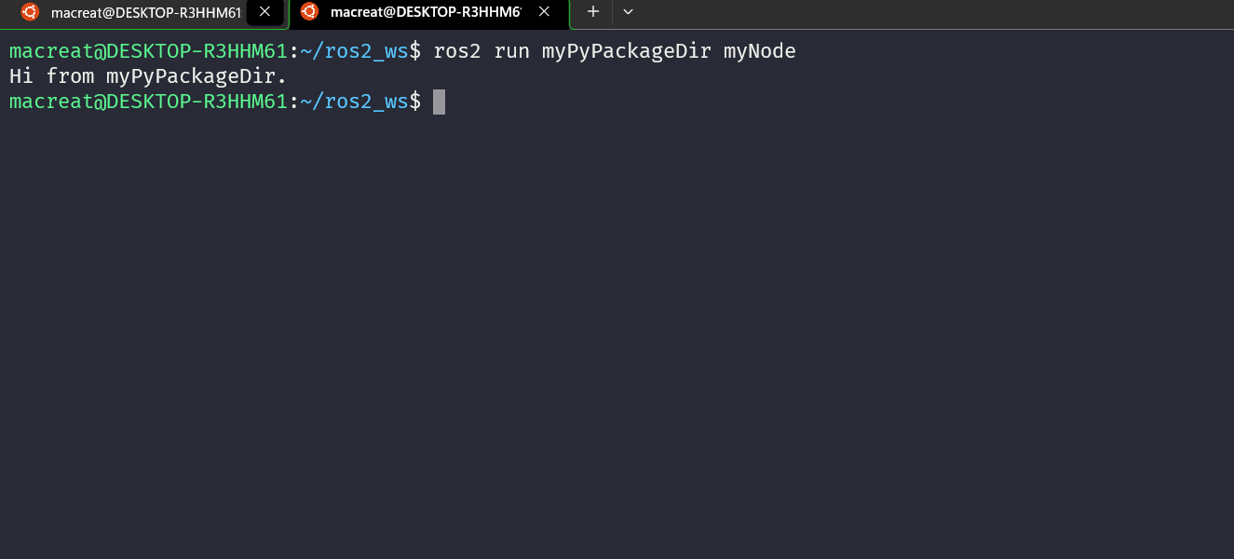

PACKAGE CONTENT :
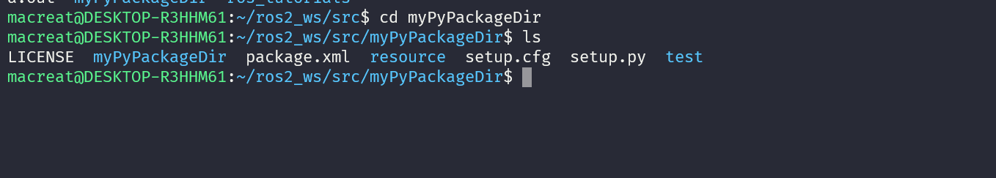

IN ORDER TO CUSTOMIZE PACKAGE.XML to deploy a personalize content :

Edit the maintainer, maintainer_email, and description lines to match package.xml. and then SAVE THE FILE to math with .xml cause ALSO HAVE TO EDIT THE SETUP.PY, NOT necessary on CMAKE CASE.

WRITING A SIMPLE PUBLISHER AND SUSCRIBER ON PY

The idea is create nodes that pass information in the form of string messages to each other over a topic. As a talker and listener system.; one node publishes data and the other subscribes to the topic so it can receive this data.

- CREATE THE PACKAGE

On src folder :
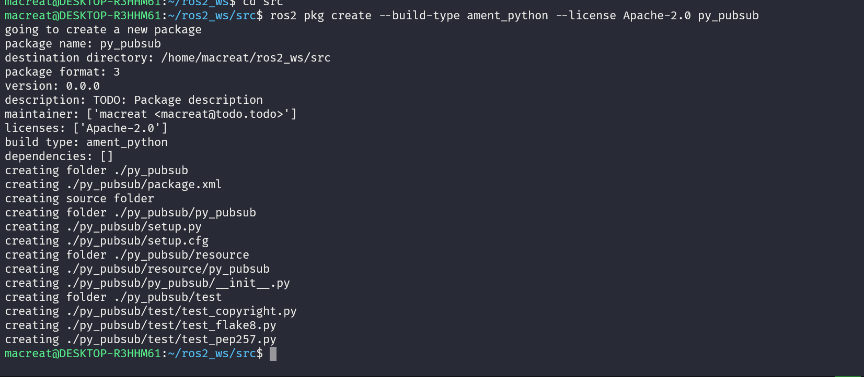

- WRITE THE PUBLISHER NODE

On my PACKAGE inside or nested in my dir package, I can download the talker example from the git content :
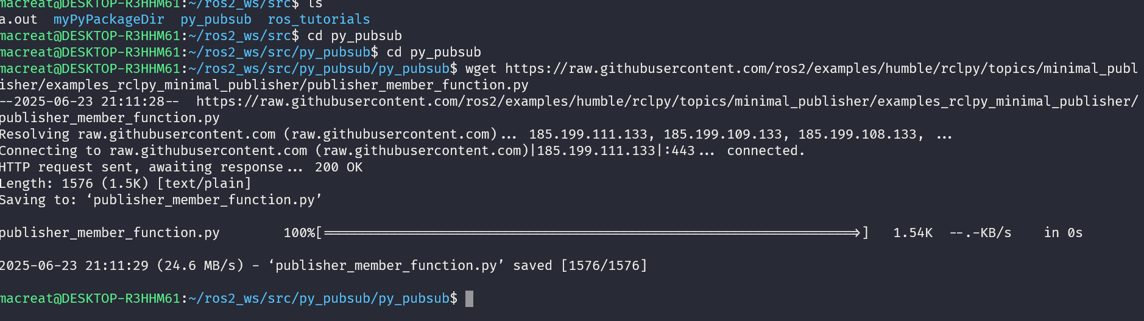

Now there will be a new file named publisher_member_function.py adjacent to __init__.py.

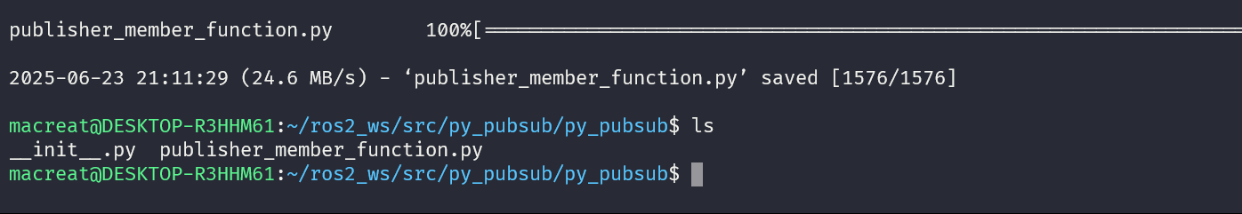
OPEN AND SEE CODE
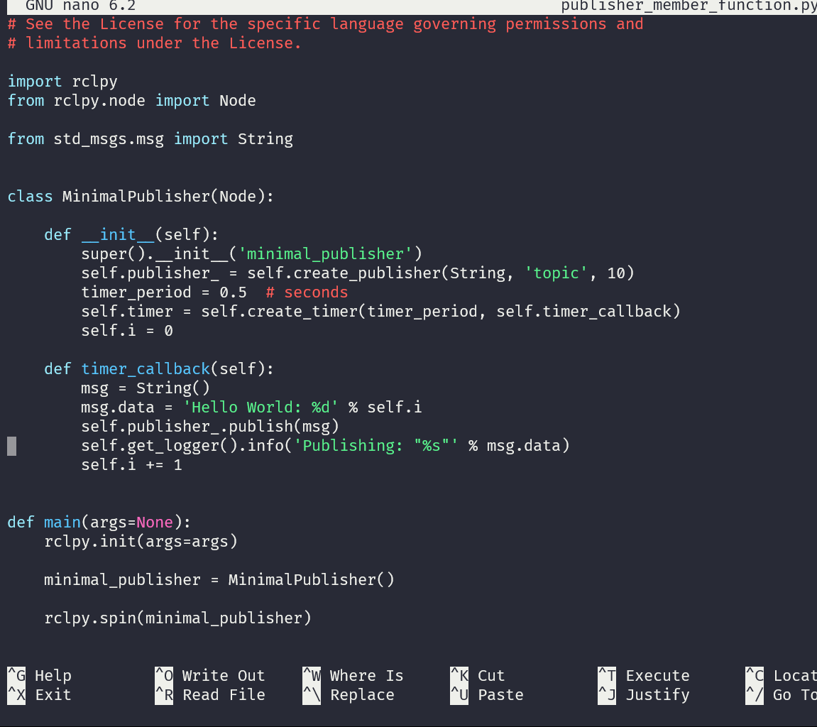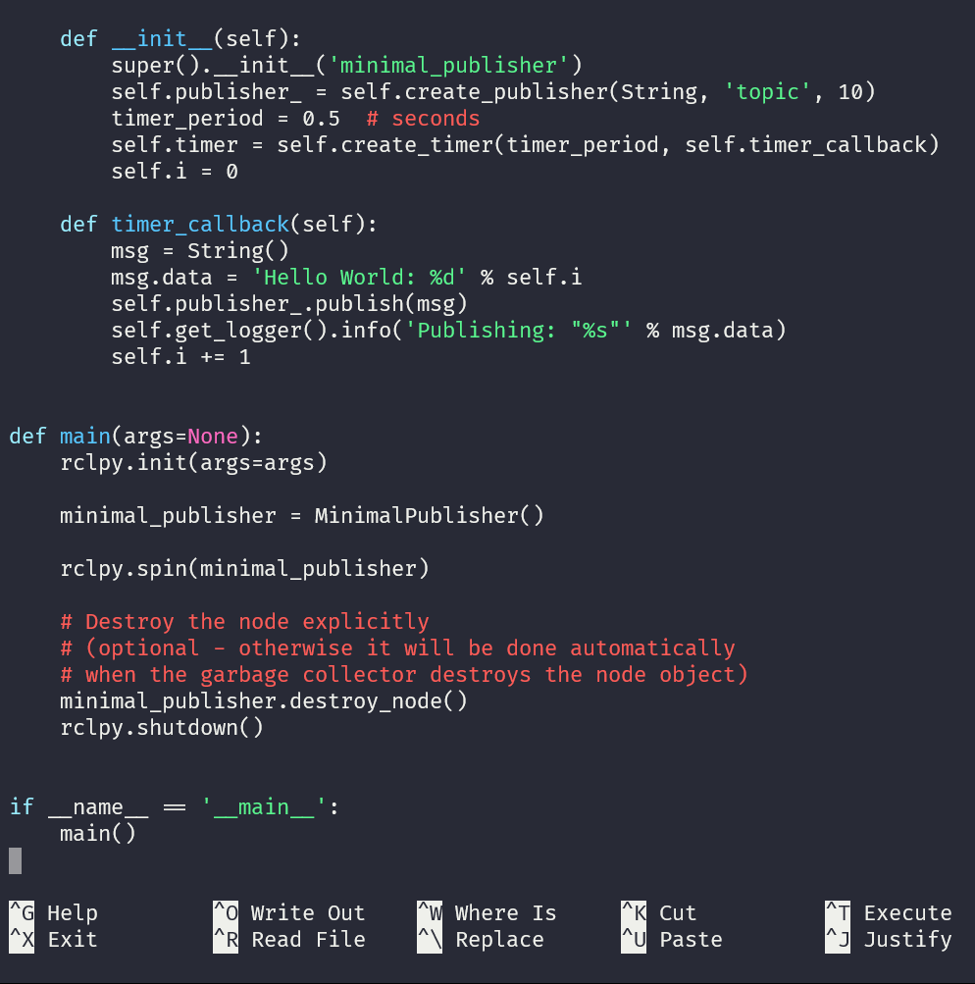

- NOW, WE NEED TO ADD DEPENDENCIES.
Go to my dir package and open the package.xml
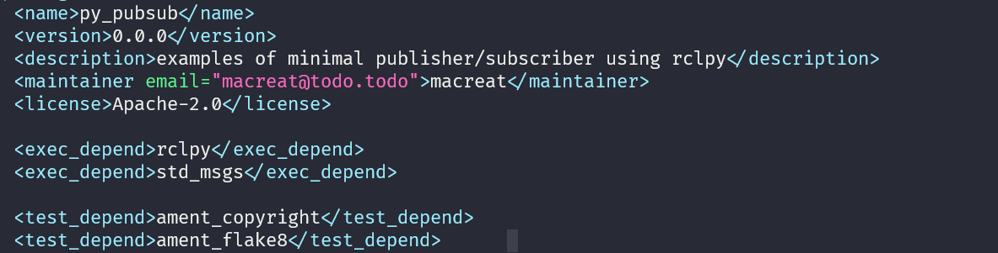
Add the execn_depend :
This declares the package needs rclpy and std_msgs when its code is executed.

- NOW ADD AN ETNRY POINT :
OPEN THE SETUP.PY and edit the same, also add
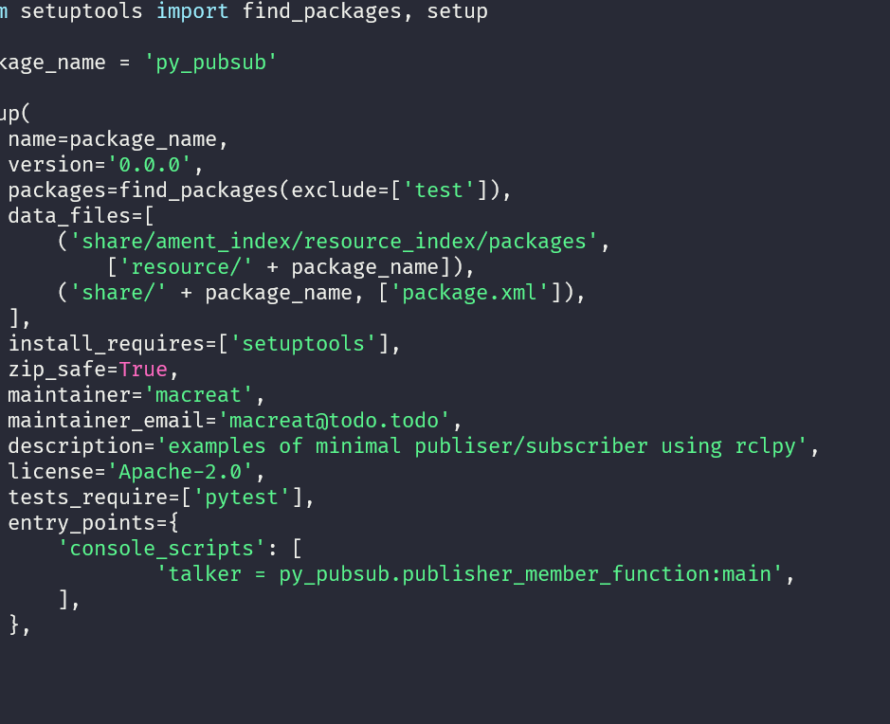
The talker on entry points

- NOW CHECK SETUP.CFG
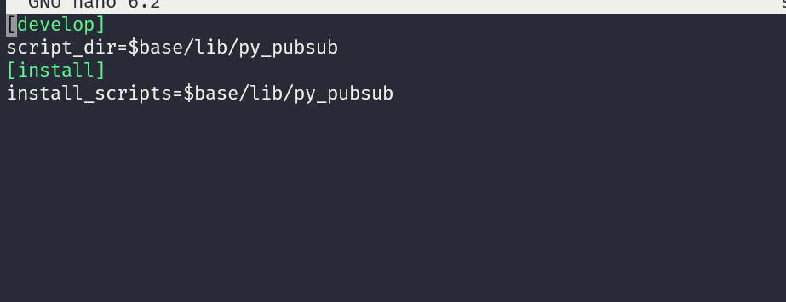

This is simply telling setuptools to put your executables in lib, because ros2 run will look for them there.
You could build your package now, source the local setup files, and run it, but let’s create the subscriber node first so you can see the full system at work.

- WRITE THE SUBSCRIBER NODE

On the package, creathe or copuy the content, now the directory has the subscribver_member_function.py
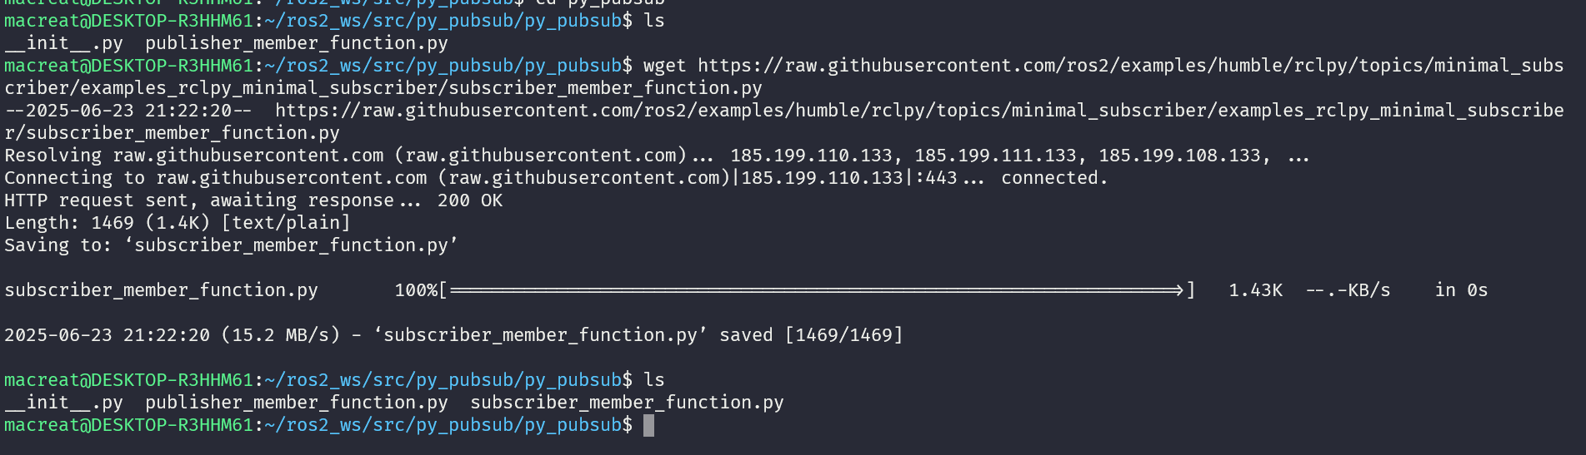
And examine the code
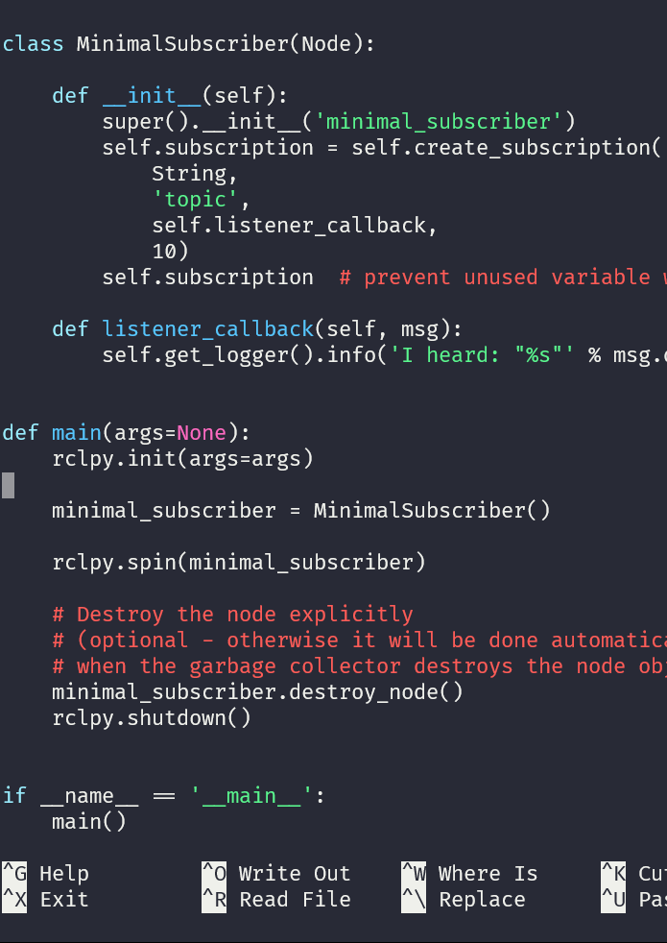
Since this node has the same dependencies as the publisher, there’s nothing new to add to package.xml. The setup.cfg file can also remain untouched.
- NOW ADD AN ENTRY POINT
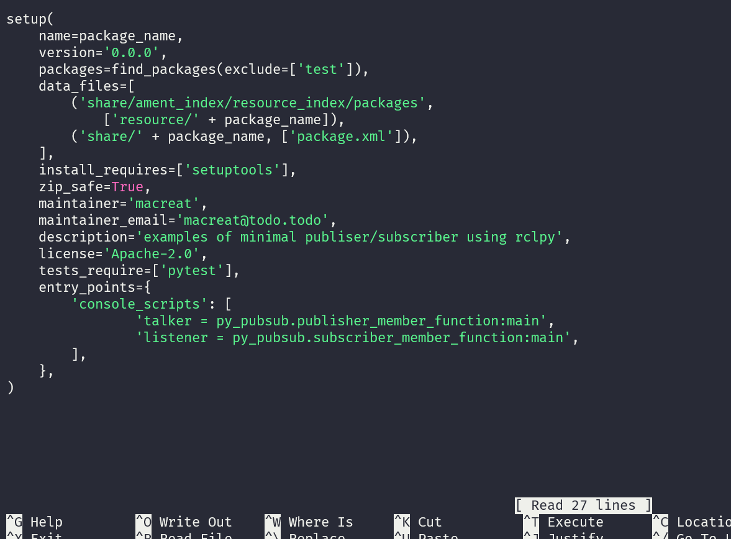

- Proceed BUILDING AND RUNNING
A GOOD PRACTice is RUN ROSDEP in the root of my current workspace (ros2_ws) to check for missing dependencies before building
rosdep install -i --from-path src --rosdistro humble -y

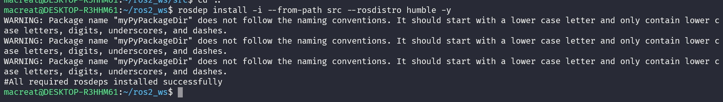
On this root, build my py_pubsub PACKAGE :
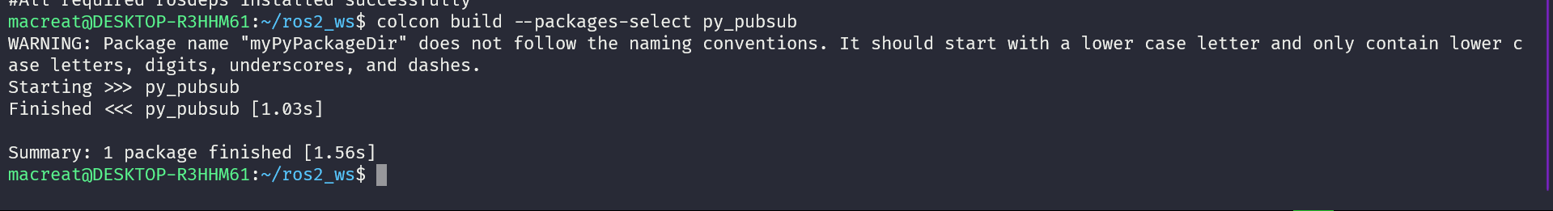

PROCEED SOURCING THE ENVIROMENT :
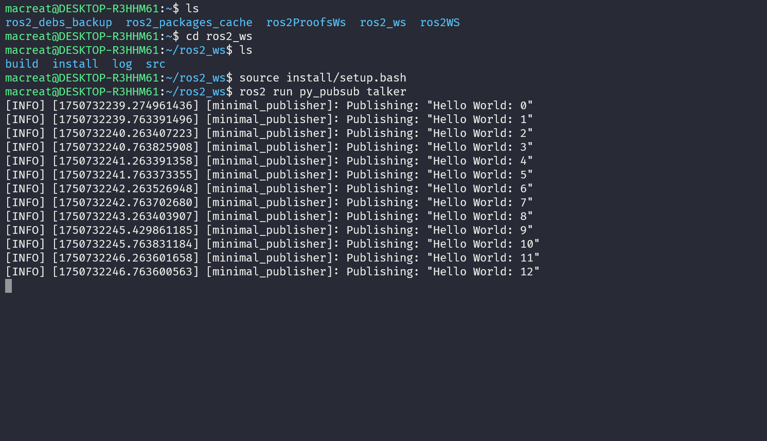

THIS IS MY OVERLAY , then in my UNDERLAY, whereis my LISTENER , that actually doesn’t modify any

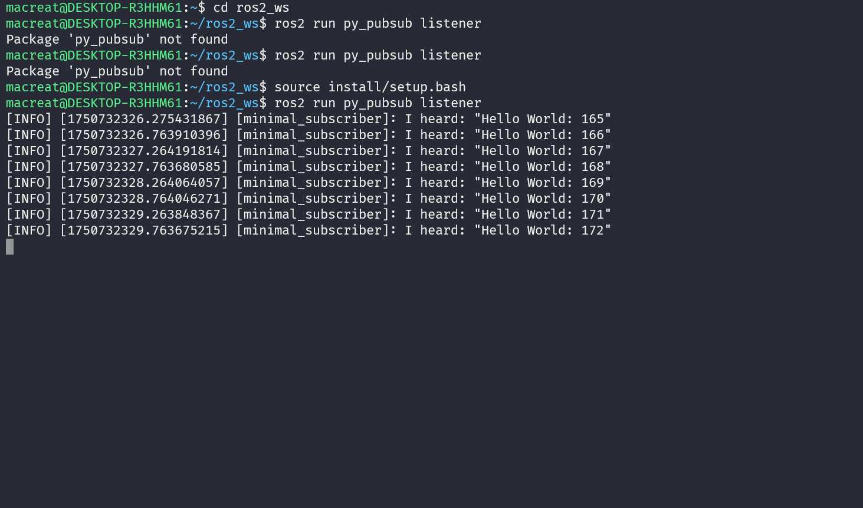
NOTE THAT ALSO HAS TO SOUrce to my bash
Until here, I created two nodes to publish and subscribe to data over a topic. Before running them, added their dependencies and entry points to the package configuration files.

WRITING A SERVICE AND CLIENT ON PY

CUSTOM MSG AND SRV FILES

CUSTOM INTERFACES

PARAMETERS
ROS2DOCTOR

