**Written Summary: BPMN and UML Representation of Patient-Doctor Interaction in Drug Addiction Treatment**

This summary outlines the structure and key elements of Business Process Model and Notation (BPMN) and Unified Modeling Language (UML) diagrams for a patient with drug addiction problems seeking and receiving treatment. The process starts with the patient approaching the doctor, moves through symptom reporting, diagnostic testing, and culminates in medication dispensation.

**1. Overview**

A patient experiencing symptoms related to drug addiction decides to seek medical help. They approach a doctor, report their symptoms, undergo necessary tests, await results, receive a diagnosis and prescription, and finally obtain their medication from a pharmacy. This process involves multiple interactions and potential decision points.

**2. BPMN Diagram Summary: "Patient Treatment Pathway for Drug Addiction"**

A BPMN diagram would visually map the flow of activities, decisions, and participants involved in the patient's journey.

* **Purpose:** To model the operational steps and responsibilities in the treatment process, highlighting handoffs and decisions.
* **Key Pools (Major Participants/Systems):**
  + **Patient:** The individual seeking treatment.
  + **Healthcare Provider:** Encompasses the doctor and potentially their administrative staff.
  + **Laboratory:** The facility responsible for conducting diagnostic tests.
  + **Pharmacy:** The entity dispensing medications.
* **Swimlanes (Roles within Pools):**
  + *Within Healthcare Provider:* Doctor, Nurse/Assistant
  + *Within Laboratory:* Lab Technician
  + *Within Pharmacy:* Pharmacist
* **Main Flow of Activities (Tasks - Rectangles with rounded corners):**
  + **Patient:** Approaches Doctor/Clinic (Start Event: "Patient Seeks Help")
  + **Healthcare Provider (Nurse/Assistant):** Registers Patient & Gathers Basic Info
  + **Healthcare Provider (Doctor):** Conducts Initial Consultation & Symptom Assessment (Patient provides symptoms here)
  + **Healthcare Provider (Doctor):** Orders Diagnostic Tests (e.g., blood work, toxicology screen)
  + **Patient:** Undergoes Required Tests (at the Lab)
  + **Laboratory (Lab Technician):** Processes Samples & Generates Results
  + **Laboratory:** Sends Test Results to Doctor (Message Flow)
  + **Healthcare Provider (Doctor):** Reviews Test Results & Diagnoses
  + **Healthcare Provider (Doctor):** Develops Treatment Plan & Prescribes Medication
  + **Healthcare Provider (Doctor):** Sends Prescription to Pharmacy (Message Flow)
  + **Pharmacy (Pharmacist):** Receives & Verifies Prescription
  + **Pharmacy (Pharmacist):** Dispenses Medication
  + **Patient:** Receives Medication (End Event: "Medication Obtained")
* **Decision Points (Gateways - Diamonds):**
  + After Reviews Test Results & Diagnoses:
    - Diagnosis Confirmed? (Exclusive Gateway 'X')
      * Yes Path: Proceed to Develop Treatment Plan & Prescribe Medication.
      * No Path: Loop back to Orders Diagnostic Tests (if more tests needed) or Conducts Initial Consultation (if reassessment required).
  + After Dispenses Medication:
    - Patient Questions? (Inclusive Gateway '+')
      * Yes Path: Pharmacist Provides Counseling
      * No Path: Proceed to Medication Obtained.
* **Sequence Flows (Arrows):** Connect tasks, gateways, and events to show the order of operations.
* **Message Flows (Dashed Arrows):** Show communication between different pools (e.g., Lab sending results to Doctor, Doctor sending prescription to Pharmacy).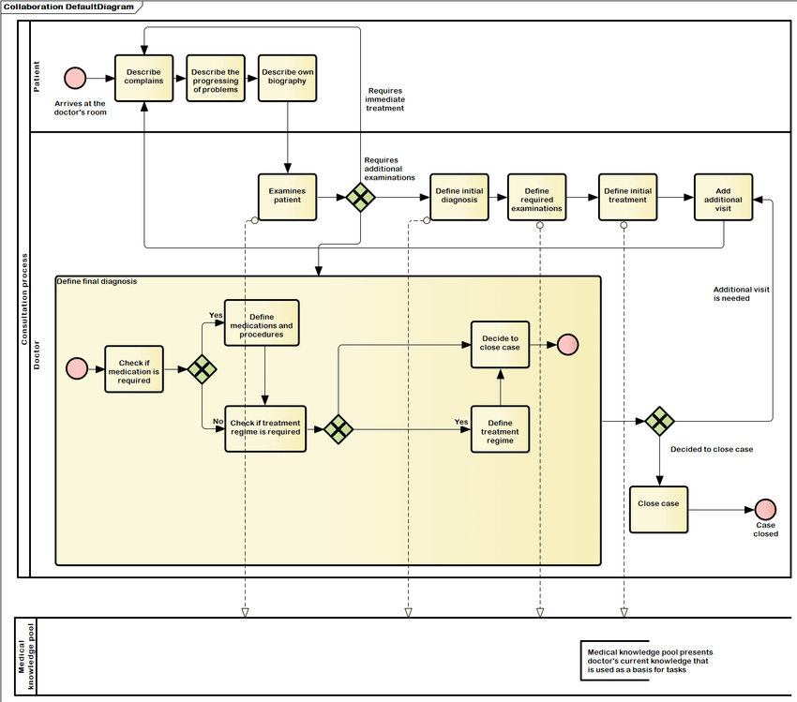

**3. UML Class Diagram Summary: "Clinical Treatment Data Model"**

A UML Class Diagram would represent the static structure of the information involved in this process, showing the types of objects and their relationships.

* **Purpose:** To define the system's core entities (data structures) and their relationships.
* **Key Classes (Entities - Rectangles):**
  + **Patient**
    - Attributes: patientID, name, DOB, gender, contactInfo, addictionHistory, currentStatus
  + **Doctor**
    - Attributes: doctorID, name, specialty, contactInfo
  + **Symptom**
    - Attributes: symptomID, description, severity, reportedDate
  + **Test**
    - Attributes: testID, testType, orderedDate, status
  + **TestResult**
    - Attributes: resultID, testID (FK), resultValue, unit, resultDate, interpretation
  + **Medication**
    - Attributes: medicationID, name, dosage, form, sideEffects
  + **Prescription**
    - Attributes: prescriptionID, doctorID (FK), patientID (FK), medicationID (FK), issueDate, expiryDate, instructions, refills
  + **Pharmacy**
    - Attributes: pharmacyID, name, address, contactInfo
* **Relationships (Associations - Lines with Cardinalities):**
  + **Patient (1) --- * Symptom**: A Patient can report many Symptoms. A Symptom is reported by one Patient.
  + **Doctor (1) --- * Patient**: A Doctor can treat many Patients. A Patient is treated by one Doctor (simplified, could be many-to-many).
  + **Doctor (1) --- * Test**: A Doctor orders many Tests. A Test is ordered by one Doctor.
  + **Patient (1) --- * Test**: A Patient undergoes many Tests. A Test is for one Patient.
  + **Test (1) --- 1 TestResult**: A Test has exactly one TestResult. A TestResult belongs to one Test.
  + **Doctor (1) --- * Prescription**: A Doctor writes many Prescriptions. A Prescription is written by one Doctor.
  + **Patient (1) --- * Prescription**: A Patient receives many Prescriptions. A Prescription is for one Patient.
  + **Medication (1) --- * Prescription**: A Medication can be part of many Prescriptions. A Prescription is for one Medication (simplified, could be many-to-many if a prescription has multiple meds).
  + **Pharmacy (1) --- * Prescription**: A Pharmacy dispenses many Prescriptions. A Prescription is dispensed by one Pharmacy.

**4. UML Sequence Diagram Summary: "Medication Dispensation Process"**

A UML Sequence Diagram would illustrate the dynamic interaction between the patient, doctor, lab, and pharmacy over time, focusing on the order of messages.

* **Purpose:** To show the precise order of messages and interactions between objects/actors to achieve a specific outcome.
* **Key Lifelines (Vertical Dashed Lines representing participants/objects):**
  + :Patient
  + :Docto
  + :LabSystem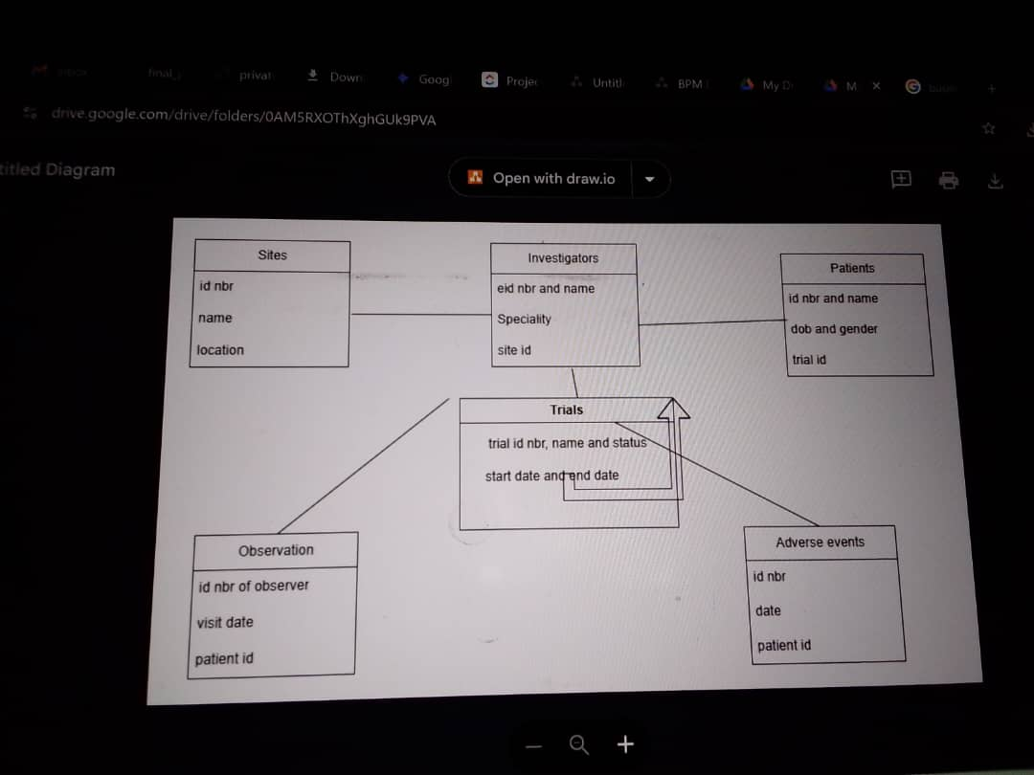
  + :PharmacySystem
* **Messages (Horizontal Arrows):** Represent calls or communications between lifelines, ordered chronologically from top to bottom.
* **Activation Bars (Rectangles on Lifelines):** Indicate when an object is active or performing an action.
* **Main Sequence of Interactions:**
  + :Patient -> :Doctor: requestConsultation()
  + :Doctor -> :Patient: conductConsultation(symptoms)
  + :Doctor -> :LabSystem: orderTest(patientID, testType)
  + :Patient -> :LabSystem: undergoTest(testID) (Implicit physical interaction)
  + :LabSystem -> :Doctor: sendTestResults(testID, results)
  + :Doctor -> :Doctor: reviewResultsAndDiagnose() (Self-message/internal processing)
  + :Doctor -> :PharmacySystem: sendPrescription(patientID, medicationDetails, instructions)
  + :Patient -> :PharmacySystem: requestMedicationDispense(prescriptionID) (Implicit physical interaction)
  + :PharmacySystem -> :PharmacySystem: verifyPrescriptionAndStock() (Self-message)
  + :PharmacySystem -> :Patient: dispenseMedication(medication)
  + :Patient -> :Patient: takeMedication() (Self-message/internal action)
* **Alternative Flows/Loops (Represented by Combined Fragments like alt or loop):**
  + An alt (alternative) fragment could show the decision after reviewResultsAndDiagnose(): either prescribeMedication() or orderFurtherTests().
  + A loop fragment could represent repeated takeMedication() actions over time