# AB组

## A组：长宽比小于其中位数的数据

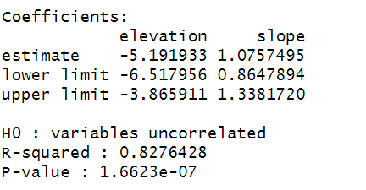

## B组：长宽比大于其中位数的数据

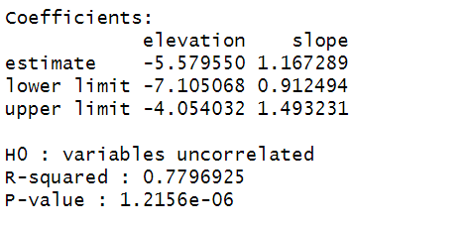

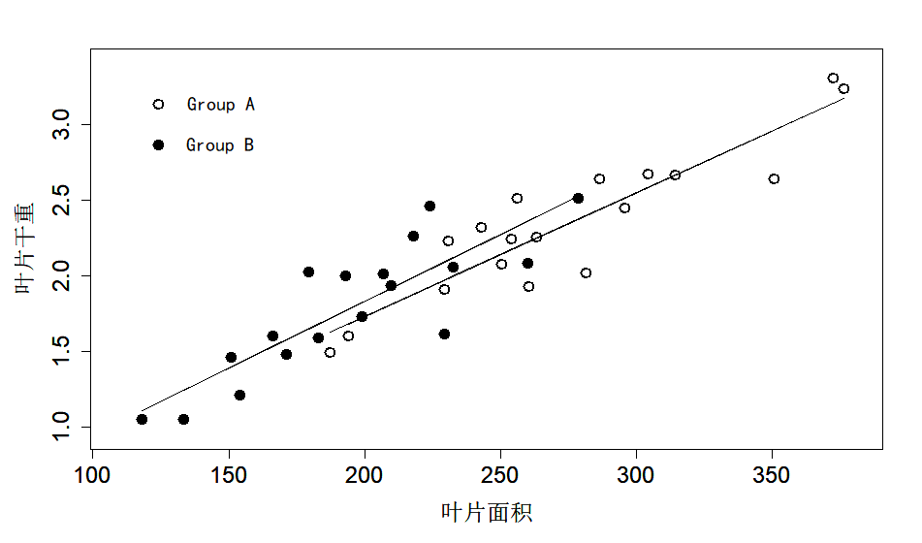

# 2、CD组

## C组：侧枝萌发率小于其中位数的数据

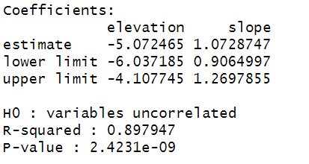

## D组：侧枝萌发率大于其中位数的数据

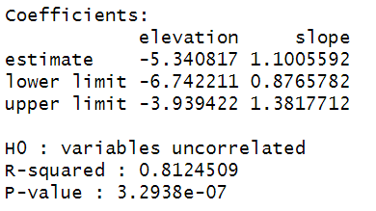

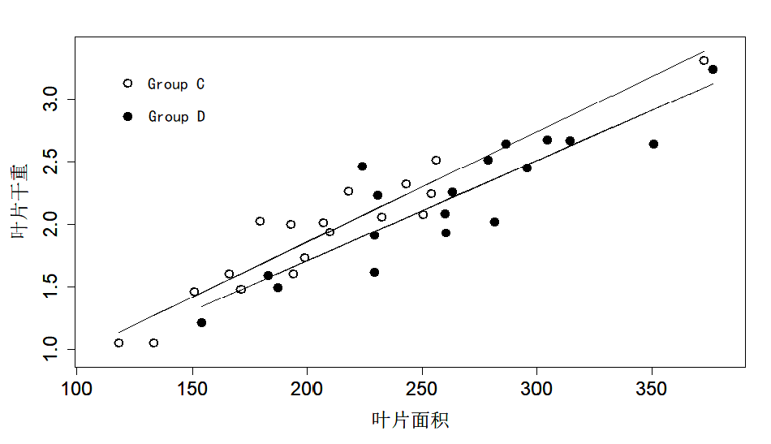

# 3、全部数据

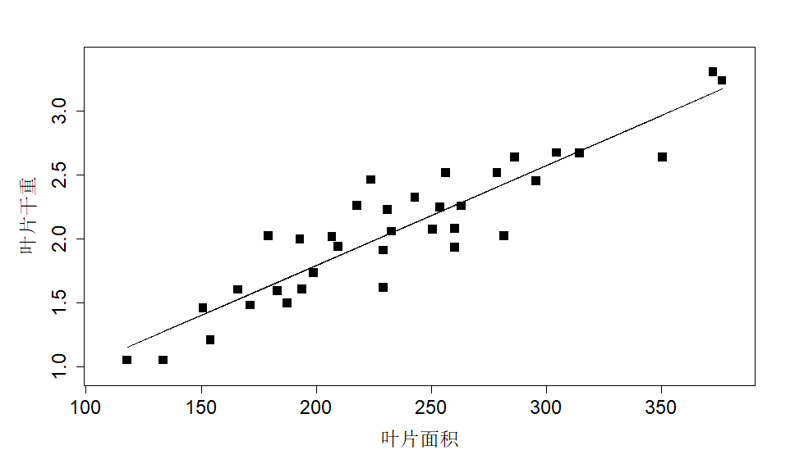

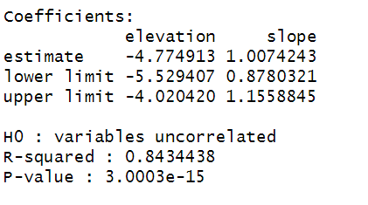

# EF组

E组：总回归线之上的点

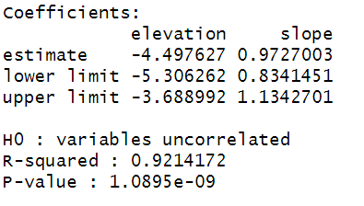

F组：总回归线之下的点

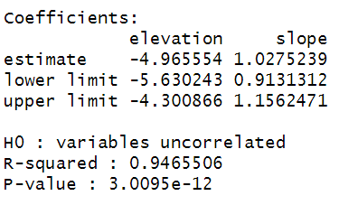

# 相应表格

|  |  |  |  |  |  |
| --- | --- | --- | --- | --- | --- |
|  |  | elevation | slope | R-squared | P-value |
| A |  |  |  | 0.827643 | 1.66E-07 |
| estimate | -5.19193 | 1.07575 |
| lower limit | -6.51796 | 0.864789 |
| upper limit | -3.86591 | 1.338172 |
| B |  |  |  | 0.779693 | 1.22E-06 |
| estimate | -5.57955 | 1.167289 |
| lower limit | -7.10507 | 0.912494 |
| upper limit | -4.05403 | 1.493231 |
| C |  |  |  | 0.897947 | 2.42E-09 |
| estimate | -5.07247 | 1.072875 |
| lower limit | -6.03719 | 0.9065 |
| upper limit | -4.10775 | 1.269786 |
| D |  |  |  | 0.812451 | 3.29E-07 |
| estimate | -5.34082 | 1.100559 |
| lower limit | -6.74221 | 0.876578 |
| upper limit | -3.93942 | 1.381771 |
| E |  |  |  | 0.921417 | 1.09E-09 |
| estimate | -4.49763 | 0.9727 |
| lower limit | -5.30626 | 0.834145 |
| upper limit | -3.68899 | 1.13427 |
| F |  |  |  | 0.946551 | 3.01E-12 |
| estimate | -4.96555 | 1.027524 |
| lower limit | -5.63024 | 0.913131 |
| upper limit | -4.30087 | 1.156247 |
| ALL |  |  |  | 0.843444 | 3.00E-15 |
| estimate | -4.77491 | 1.007424 |
| lower limit | -5.52941 | 0.878032 |
| upper limit | -4.02042 | 1.155885 |