****Name:**** MKS DLC + MKS TFT24 Display

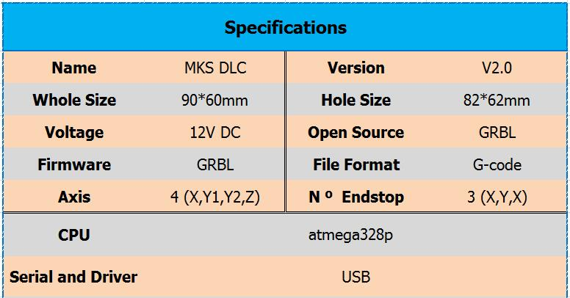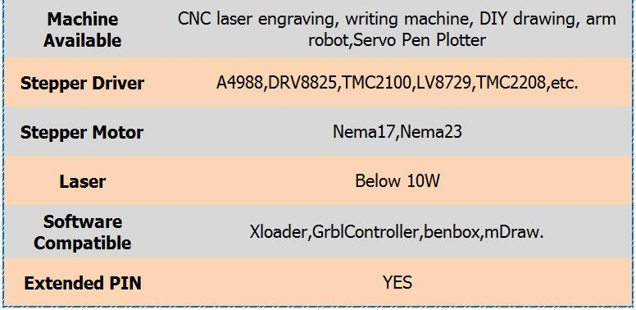

****Wiring****

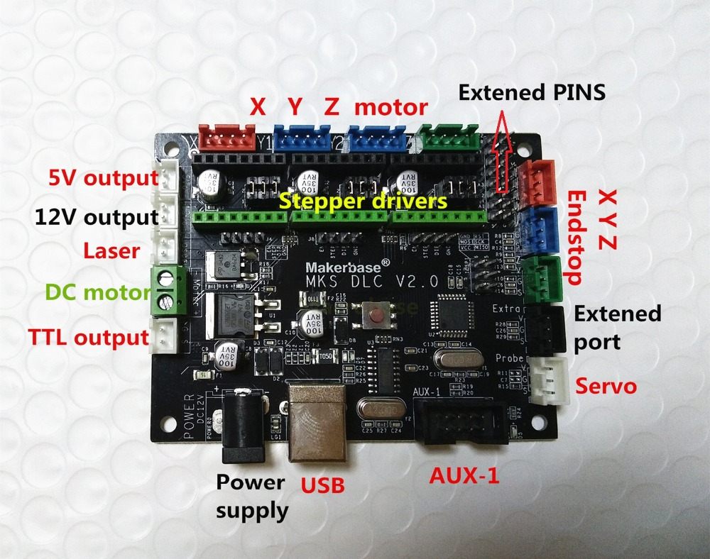

****PINOUT****

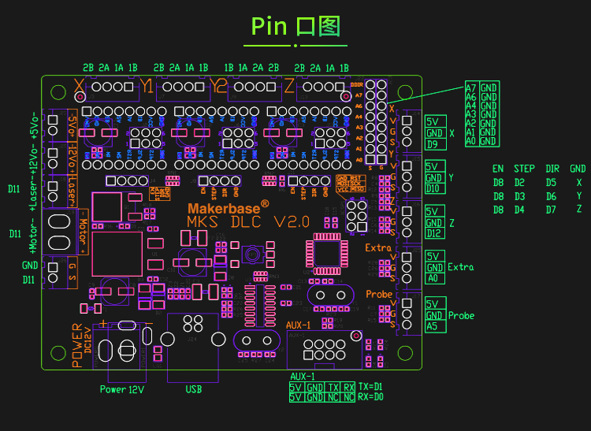

****DLC Size Diagram****

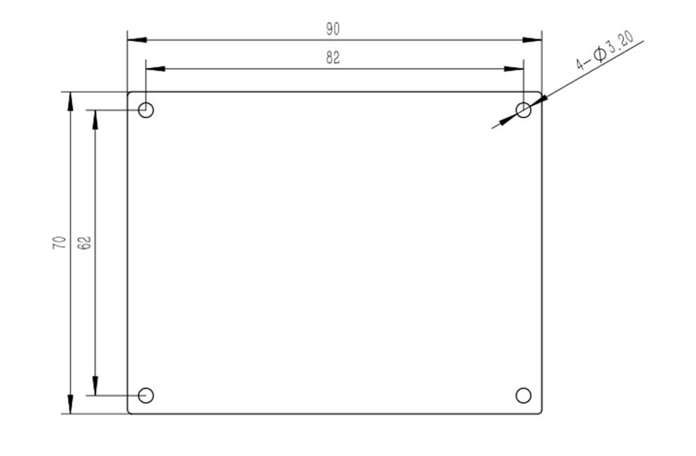

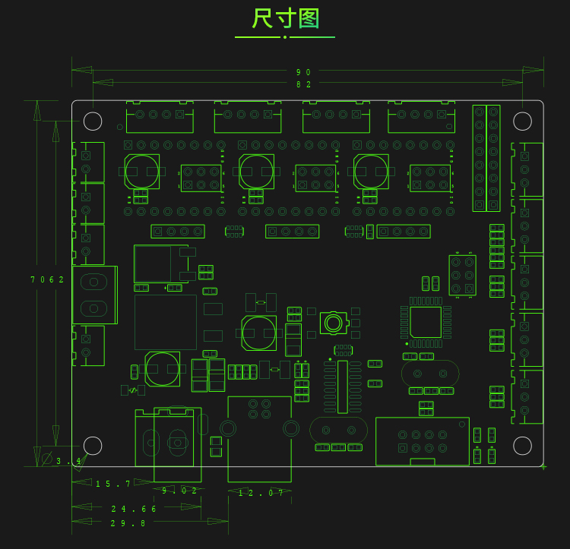

****MKS TFT24 Touch Screen****

****Wiring****

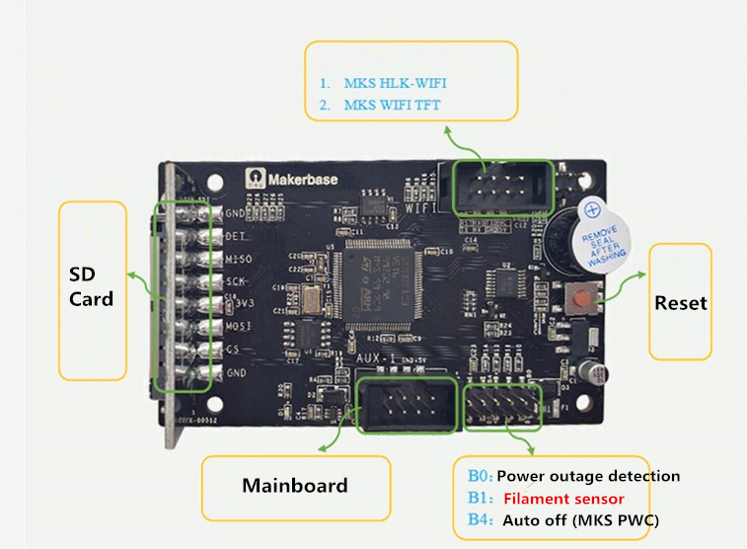

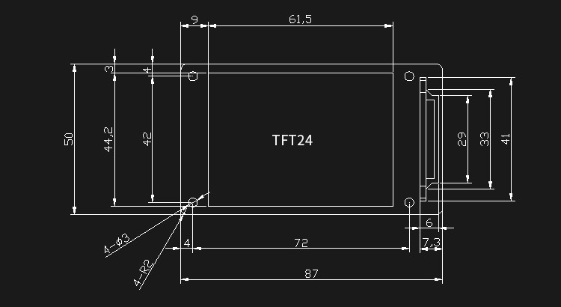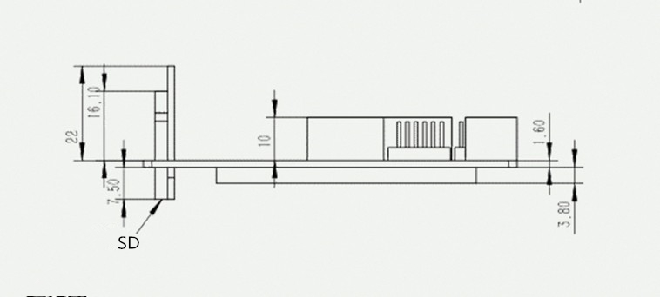

****How to Use****

1. Install Xloader to PC,upload GRBL firmware to MKS DLC mainboard.  
Select baud rate 115200.

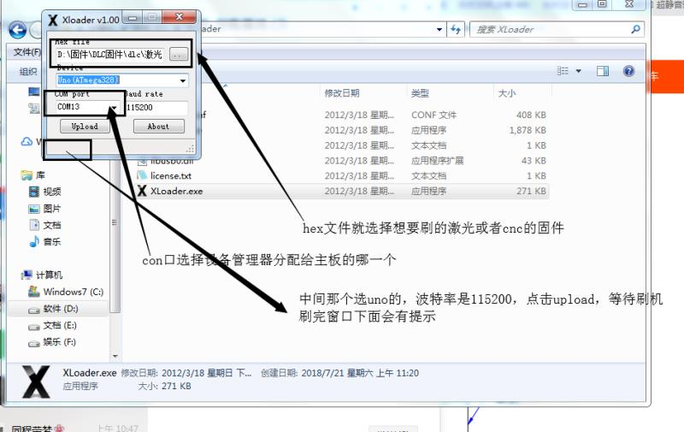

2. MKS TFT24 has  pre-uploaded firmware for 3D printer,

need to upload CNC TFT24 firmware.  Select baud rate 115200.

Copy config to SD card and plug SD card to TFT24 display.  
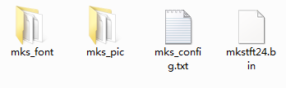

Then put power on,it  will update  automatically.

3. After firmwares upload alreadyconnect TFT24 to Aux-1 of MKS DLC.

4. Read G-code

   Copy G-code to SD card,plug it to TFT24 display.