SPACE EXPLORATION TECHNOLOGIES CORP. (SPCX)
Q2 2026 EARNINGS UPDATE
Revenue and EBITDA Beat; AI Capex Becomes the Valuation Battleground
5 August 2026 | Rating: UPGRADE TO OUTPERFORM | Price: $115.10 | PT: $150 | Upside: 30.3%
Market cap: $1.52T | Since-listing range: $104.83-$225.64 | IPO price: $135

Earnings summary
Metric | Reported | Reference | Variance | Reference basis
Revenue | $7.814B | $6.900B | +$0.914B / +13.2% | S&P Visible Alpha consensus
GAAP EPS | $(0.09) | $(0.29) | +$0.20 better | Pre-results Street consensus
Adjusted EBITDA | $3.538B | $1.127B | +214% QoQ | Q1 2026 actual
Capital expenditures | $18.369B | $10.107B | +81.7% QoQ | Q1 2026 actual
Source: Q2 earnings release; Form 10-Q; Axios / Visible Alpha consensus; Kiplinger pre-results consensus. Results released and filed 4 August 2026

Investment impact
- The P&L beat was real and broad-based. Revenue rose 92% YoY and beat consensus by 13%; adjusted EBITDA nearly tripled to $3.5B. Connectivity remained the earnings engine, while AI adjusted EBITDA turned positive as contracted cloud capacity began to monetize.
- The cash-flow debate worsened materially. Q2 capex reached $18.4B, 86% of it in AI. H1 operating cash flow of $3.5B was overwhelmed by $28.5B of capex, leaving roughly $(25.0)B of free cash flow before acquisitions.
- Starlink quality improved despite lower ARPU. Subscribers doubled YoY to 12.0M and ARPU held at $66 QoQ. Connectivity operating income rose 79% to $1.7B and adjusted EBITDA margin remained above 60%.
- Upgrade to Outperform; maintain $150 PT. The share-price reset to $115.10 creates 30.3% upside to our unchanged target. We raise revenue and EBITDA estimates sharply, but the target remains capped by higher capex, execution risk, and the near-term post-IPO unlock overhang.

1. Detailed results: a genuine operating beat
SpaceX reported Q2 revenue of $7.814B, up 92% YoY and 66% QoQ, exceeding S&P Visible Alpha consensus of $6.9B by $914M, or 13.2%. GAAP loss per share of $0.09 was $0.20 better than the pre-results Street expectation of a $0.29 loss. The quarter therefore cleared the two headline hurdles decisively; the negative share reaction was driven by investment intensity and supply mechanics rather than a weak P&L.
Adjusted EBITDA of $3.538B increased 191% YoY and 214% QoQ, lifting consolidated adjusted EBITDA margin to 45.3% from 24.0% in Q1. Operating loss narrowed to $143M from $1.943B in Q1 and $970M a year ago. Net loss of $541M improved by $467M YoY despite higher interest expense, reflecting operating leverage and a sharply better AI contribution.
Comparability requires care. xAI was combined with SpaceX in February 2026, and the AI segment is ramping large cloud-services contracts. YoY growth therefore captures both organic expansion and a materially different operating perimeter. We treat the Q2 run-rate as a forward indicator, but not as a clean steady-state margin.
The quality of the beat is stronger than the headline revenue variance alone suggests. All three reportable segments grew sequentially, consolidated operating loss nearly disappeared, and the AI segment crossed into positive adjusted EBITDA. At the same time, $3.679B of depreciation, amortization, and share-based compensation add-backs explain why adjusted EBITDA exceeded operating income by such a wide margin. The correct read-through is accelerating commercial traction, not near-term free-cash-flow maturity.
Figure 1 - Q2 2026 beat/miss snapshot
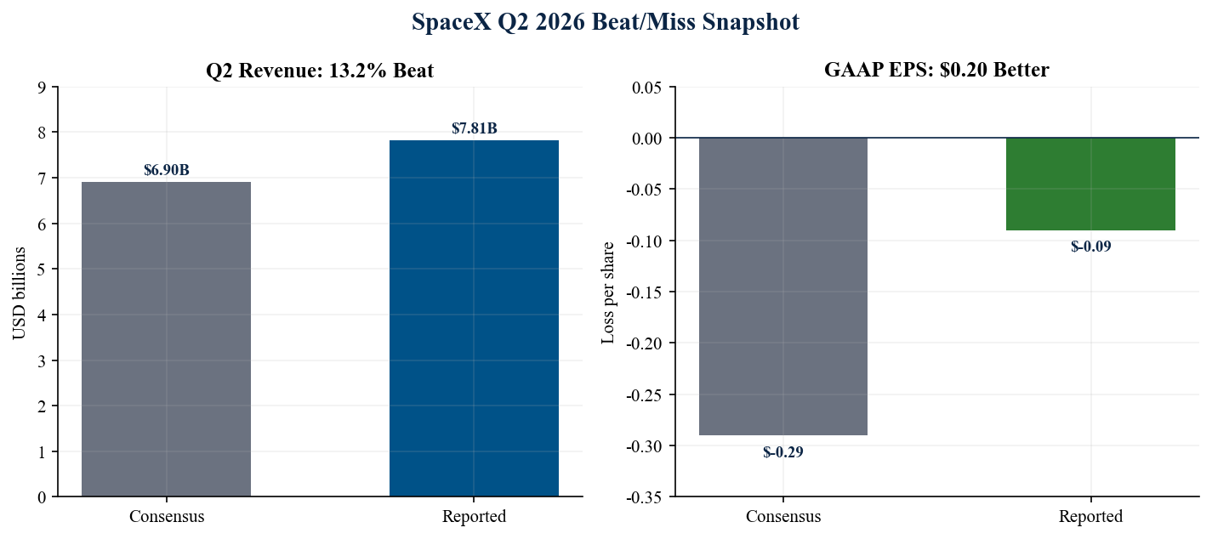
Source: Q2 earnings release (4 Aug 2026); Axios / Visible Alpha consensus (4 Aug 2026); Kiplinger pre-results consensus (31 Jul 2026)

2. Segment mix: Connectivity funds two option-heavy businesses
Connectivity contributed 55% of Q2 revenue but more than all consolidated operating profit. AI revenue inflected sharply and adjusted EBITDA turned positive, while Space remained loss-making as Starship R&D accelerated. The portfolio is becoming more balanced on revenue, yet still highly concentrated on Starlink for cash earnings.
For portfolio construction, the segment mix creates a barbell. Connectivity is a scaled, recurring-revenue asset with visible subscriber economics; Space and AI are long-duration options whose outcomes are driven by technical milestones and utilization. This structure supports premium valuation when execution is strong, but it also increases covariance in a risk-off market because both optional businesses require external capital or Starlink cash generation before they can fund themselves.
Figure 2 - Segment revenue progression
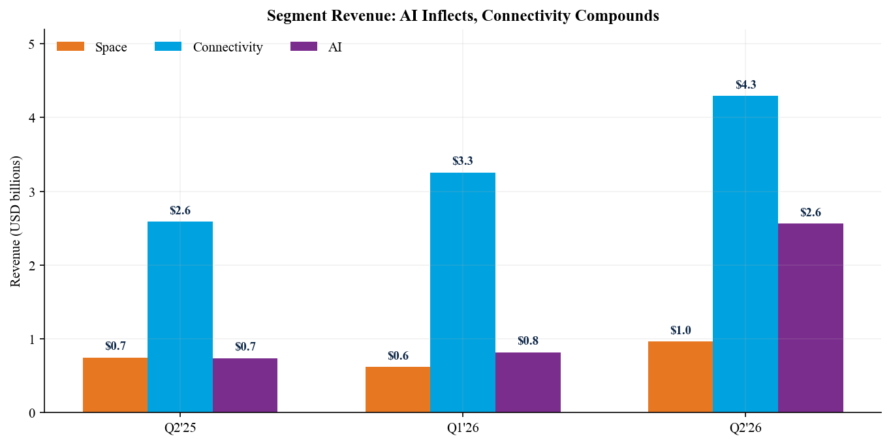
Source: Q2 earnings release (4 Aug 2026), financial highlights; Form 10-Q (filed 4 Aug 2026)
Figure 3 - Segment operating income and loss
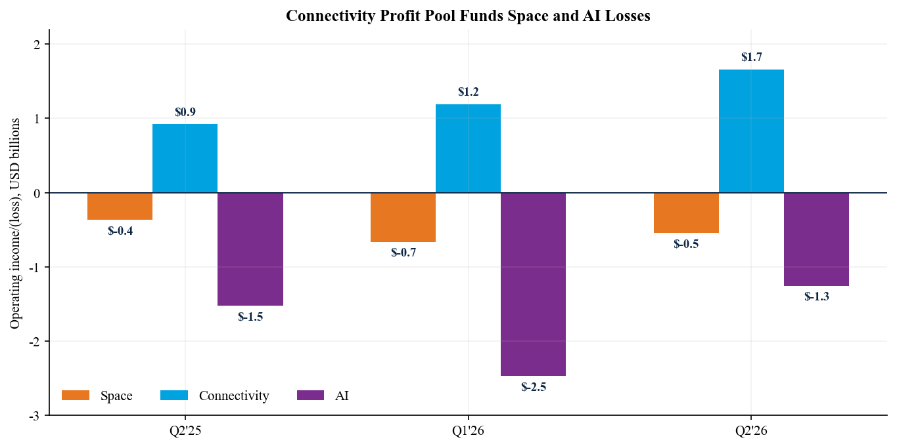
Source: Q2 earnings release (4 Aug 2026), segment schedules; Form 10-Q (filed 4 Aug 2026)

3. Segment scorecard and margin bridge
Segment | Revenue | YoY | Op. income/(loss) | Adj. EBITDA | Capex
Space | $0.962B | +29% | $(0.542)B | $(0.205)B | $1.174B
Connectivity | $4.291B | +66% | $1.656B | $2.597B | $1.367B
AI | $2.561B | +247% | $(1.257)B | $1.146B | $15.828B
Total | $7.814B | +92% | $(0.143)B | $3.538B | $18.369B
Source: Q2 earnings release (4 Aug 2026), pages 2-8; Form 10-Q (4 Aug 2026), pages 5 and 34-49. Three months ended 30 June 2026
The consolidated adjusted EBITDA improvement was driven by three effects: higher Connectivity scale, initial monetization of AI cloud-service agreements, and the large non-cash depreciation and share-based compensation add-backs embedded in the non-GAAP measure. Depreciation and amortization alone totaled $2.848B in Q2, while share-based compensation was $831M. Investors should therefore avoid treating adjusted EBITDA as cash generation.
On a GAAP basis, Connectivity operating margin expanded to 38.6% from 35.7% a year ago. AI operating loss narrowed 17% YoY and 49% QoQ, but remained $1.257B. Space operating loss worsened YoY to $542M as R&D rose to $1.076B, more than the segment's quarterly revenue. This is the central cross-subsidy: Starlink earnings support Starship development and the AI build-out.
Figure 4 - Adjusted EBITDA and margin progression
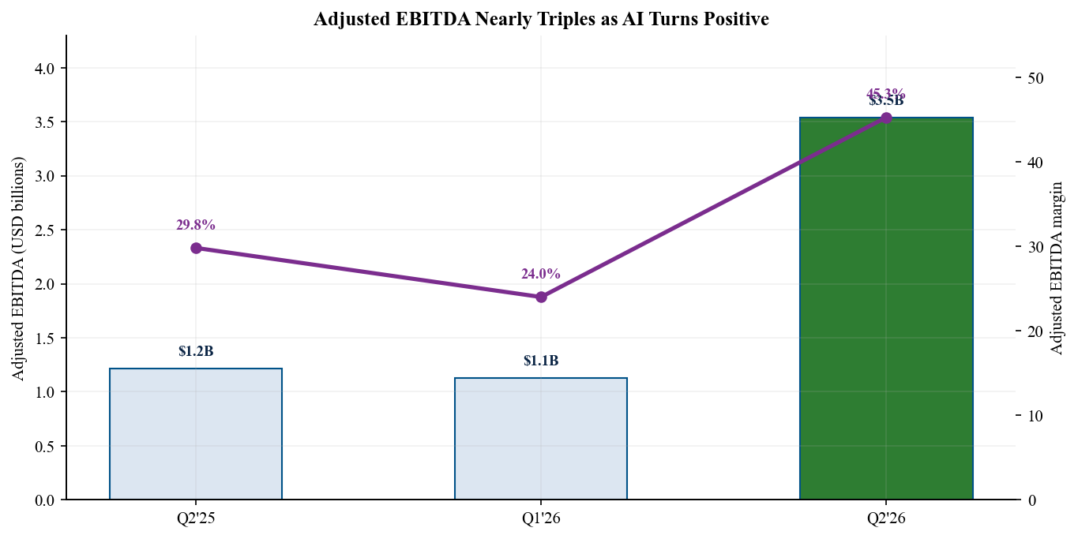
Source: Q2 earnings release (4 Aug 2026), adjusted EBITDA reconciliation; Form 10-Q (4 Aug 2026)

4. Connectivity: the thesis strengthened
Starlink subscribers reached 12.0M at quarter-end, doubling from 6.0M a year earlier and increasing 1.7M sequentially. Monthly ARPU held at $66 vs. Q1 but remained 22% below Q2 2025's $85 as international mix and lower-priced plans broadened access. Stable sequential ARPU alongside 16.5% subscriber growth is a favorable near-term combination.
Consumer revenue increased 44% YoY to $2.485B, while Enterprise & Government revenue more than doubled to $1.806B. The latter reflects airline activations, mobile partnerships, and more than $6B of multi-year U.S. government awards for Starshield. Diversification beyond residential broadband should support ARPU and reduce churn, although customer concentration and government procurement timing add volatility.
Connectivity generated $1.656B of operating income and $2.597B of adjusted EBITDA, while capex was $1.367B. The segment therefore produced positive operating economics even before considering working capital. We mark this thesis pillar as strengthened: Starlink is scaling quickly enough to fund satellite refreshes and contribute substantial cash toward group-level investment.
The key sensitivity is the interaction between subscriber additions and pricing. At the current 12M subscriber base, each $1 change in monthly ARPU represents roughly $144M of annualized revenue before churn and mix effects. That arithmetic shows why enterprise, aviation, maritime, and direct-to-device services matter: they can stabilize blended pricing while lower-cost consumer plans expand the addressable market. We expect volume to remain the dominant driver through 2027.
Figure 5 - Starlink subscribers and ARPU
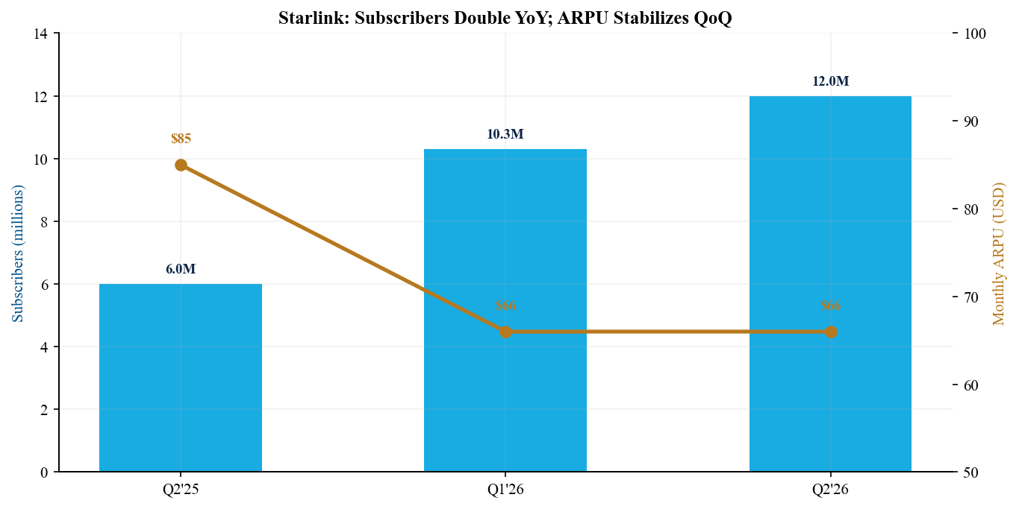
Source: Q2 earnings release (4 Aug 2026), Connectivity segment data; Form 10-Q (4 Aug 2026), segment discussion

5. AI: monetization arrives, but capital intensity dominates
AI revenue rose 247% YoY and 213% QoQ to $2.561B. AI solutions and infrastructure revenue accounted for $2.194B, while advertising contributed $367M. New cloud-service agreements generated $1.6B of incremental quarterly infrastructure revenue and brought contracted sales to $14.1B. Nameplate compute increased to 1.4 GW from 1.0 GW in Q1 and 0.4 GW a year ago.
The improvement was not cheap. AI capex reached $15.828B, 6.2x segment revenue and more than double Q1. R&D expense was $2.178B. AI adjusted EBITDA turned positive at $1.146B, but GAAP operating loss remained $1.257B after depreciation and share-based compensation. The $60B Cursor acquisition adds strategic enterprise distribution but increases integration and capital-allocation complexity.
We mark the AI thesis as improved operationally but unproven economically. Contracted revenue and positive adjusted EBITDA validate demand. However, returns depend on utilization, pricing durability, GPU depreciation, power availability, and customer concentration. A small number of cloud customers can terminate after contractual ramp periods, making backlog quality as important as headline size.
A simple capital-efficiency check remains demanding. Q2 AI capex was about $6.18 for every dollar of segment revenue and nearly ten times the quarter's incremental cloud-infrastructure revenue. Those ratios will fall if contracted capacity ramps on schedule, but the depreciation clock starts before full utilization is guaranteed. We therefore require sequential evidence on booked revenue conversion, power delivery, and cash gross profit before assigning the segment a software-like multiple.
Figure 6 - AI revenue vs. AI capital expenditures
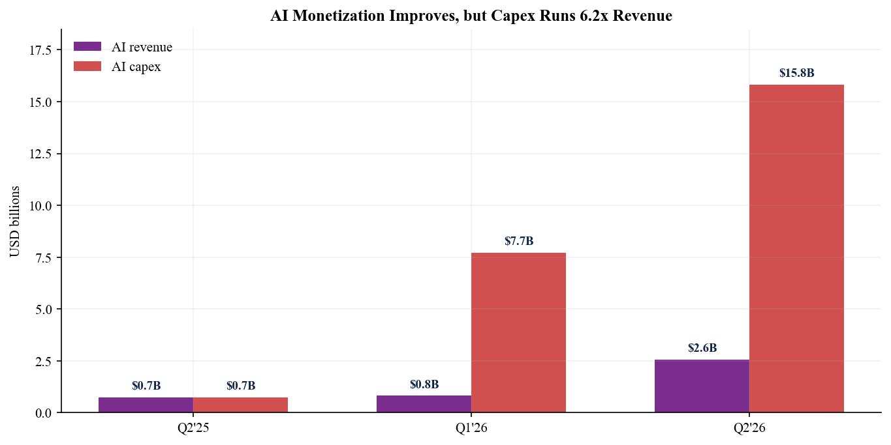
Source: Q2 earnings release (4 Aug 2026), AI segment schedule; Form 10-Q (4 Aug 2026), AI risk-factor update

6. Cash flow and balance sheet: funded, not self-funding
H1 operating cash flow was $3.466B, up from $351M a year ago. Capital expenditures of $28.476B produced approximate free cash flow of $(25.010)B. This calculation excludes acquisitions and financing flows and is the most important counterweight to the adjusted EBITDA narrative. The company is producing operating cash, but the investment program remains far larger.
Liquidity is unusually strong after the IPO and bond issuance. Cash and equivalents were $93.522B and marketable securities $6.487B, totaling $100.009B. Debt and finance leases were $39.364B, implying roughly $60.6B of net cash before acquisition consideration. The IPO generated $85.675B of net proceeds, while the June bond issuance refinanced bridge borrowing and extended maturities.
At the H1 free-cash-flow run-rate, liquidity provides meaningful but finite runway. Our FY2026 capex estimate rises to $65B, broadly assuming the Q2 investment cadence remains elevated. If AI utilization, Starship milestones, or Starlink cash conversion disappoint, management would need to moderate spending or return to capital markets. Balance-sheet capacity lowers near-term solvency risk; it does not resolve return-on-capital risk.
Liquidity should also be viewed against committed strategic uses. The Cursor consideration, continued Starship development, satellite replenishment, and multi-gigawatt data-center construction compete for the same balance sheet. Even before acquisition cash outflows, our $65B FY2026 capex estimate would consume most of reported cash and marketable securities within two years if operating cash flow did not scale. The financing question is therefore about sequencing and returns, not immediate access to capital.
Figure 7 - H1 2026 operating cash flow, capex, and free cash flow
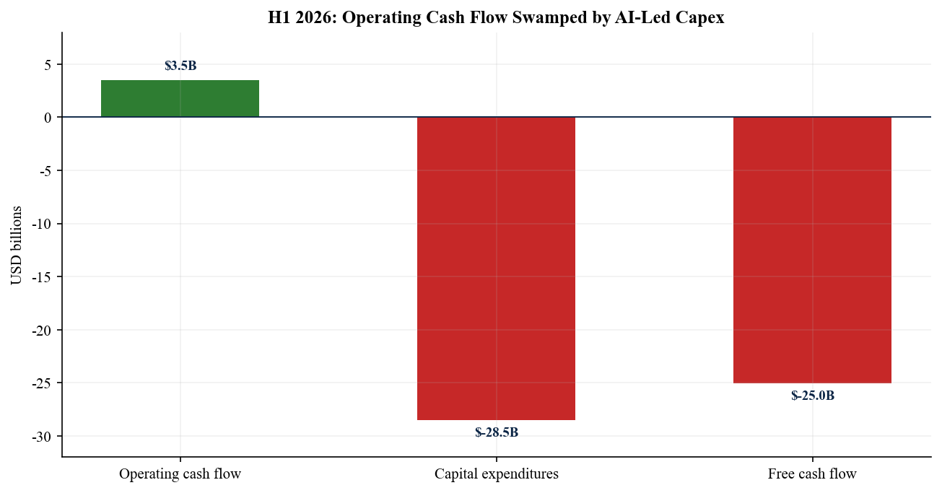
Source: Q2 earnings release (4 Aug 2026), selected cash-flow information; Form 10-Q (4 Aug 2026), cash-flow statement

7. Management outlook and catalyst calendar
SpaceX did not provide conventional quarterly revenue or EPS guidance. Instead, management framed long-duration operating targets. On the 4 August call, Elon Musk said the company's internal projection for $1T of annual revenue moved forward to 2030 from 2031, with a non-zero probability of 2029. He also described a path toward as much as 10 GW of compute capacity by the end of 2027 and said SpaceX would standardize on Nvidia's Vera Rubin architecture.
Gwynne Shotwell reiterated a goal of landing people on the Moon in 2028. The earnings release highlighted two successful Starship V3 tests in the prior 90 days and management's belief that full reusability can lower cost to orbit by 99% or more vs. historical averages. These statements are strategically important but sit well beyond the normal forecasting window and carry unusually high execution risk.

Near-term catalysts
- 6 August 2026 - first major post-IPO unlock tranche. The release of eligible insider and employee shares can increase free float sharply and may dominate near-term price discovery even after a fundamental beat.
- Q3 2026 - expected Cursor transaction close. The acquisition could accelerate enterprise distribution and recurring software revenue, but investors need clarity on consideration, integration, and incremental operating expense.
- Second half 2026 - cloud capacity ramp and compute build-out. Quarterly AI revenue, contracted sales conversion, and utilization will determine whether Q2's positive adjusted EBITDA is durable.
- Starship flight cadence and satellite V3 deployment. Successful reusability milestones would improve the economic case for launch, Starlink capacity, and future orbital compute; delays would extend R&D losses.
Transcript status: the company stated that a transcript would be available the day after the call, but an official transcript was not discoverable in the IR index at this report's cut-off. Call commentary above was cross-checked against the official webcast notice and same-day Axios/AP coverage; no unmatched third-party transcript was used.
Source: Official webcast/replay notice; Q2 earnings release; Axios call coverage; AP call coverage. Call and release dated 4 August 2026

8. Updated thesis and risk assessment
- Thesis pillar 1 - Starlink global scale: strengthened. Subscriber growth, stable sequential ARPU, and 79% operating-income growth demonstrate strong unit economics. Enterprise, aviation, mobile, and government channels broaden the addressable market beyond residential broadband.
- Thesis pillar 2 - integrated platform advantage: strengthened, but early. SpaceX can deploy satellites internally, monetize connectivity, and reuse infrastructure and capital-market access across AI. The Q2 AI revenue inflection is the first financial evidence of this platform logic.
- Thesis pillar 3 - self-funded compounding: weakened. H1 free cash flow of approximately $(25)B and $15.8B of quarterly AI capex show that strategic breadth has not yet translated into self-funding growth. Adjusted EBITDA substantially overstates cash economics during the build-out.

Principal risks
Valuation and duration remain the leading risks. At roughly $1.5T market capitalization, investors are underwriting years of high growth and successful commercialization across multiple frontier technologies. AI customer concentration, cancellable cloud agreements after ramp periods, GPU obsolescence, power constraints, Starship technical milestones, regulatory approvals, government-contract timing, dual-class governance, and management key-person risk can all impair the path.
Near-term technical risk is unusually high because the first large unlock follows immediately after earnings. The stock has already fallen below the $135 IPO price and almost 50% from its $225.64 high. A cheaper entry price improves expected return but does not eliminate the possibility of further multiple compression as free float expands.
Our upgrade is therefore tactical on entry point but strategic on duration. The post-earnings decline improves asymmetry versus the unchanged $150 target, while the operating beat raises confidence that Starlink can carry group investment through the next milestone cycle. Position sizing should still reflect an unusually wide distribution of outcomes. Investors unable to tolerate a drawdown toward the $80 bear case should wait for evidence that AI capex growth has peaked.
Figure 8 - SPCX share-price performance since IPO
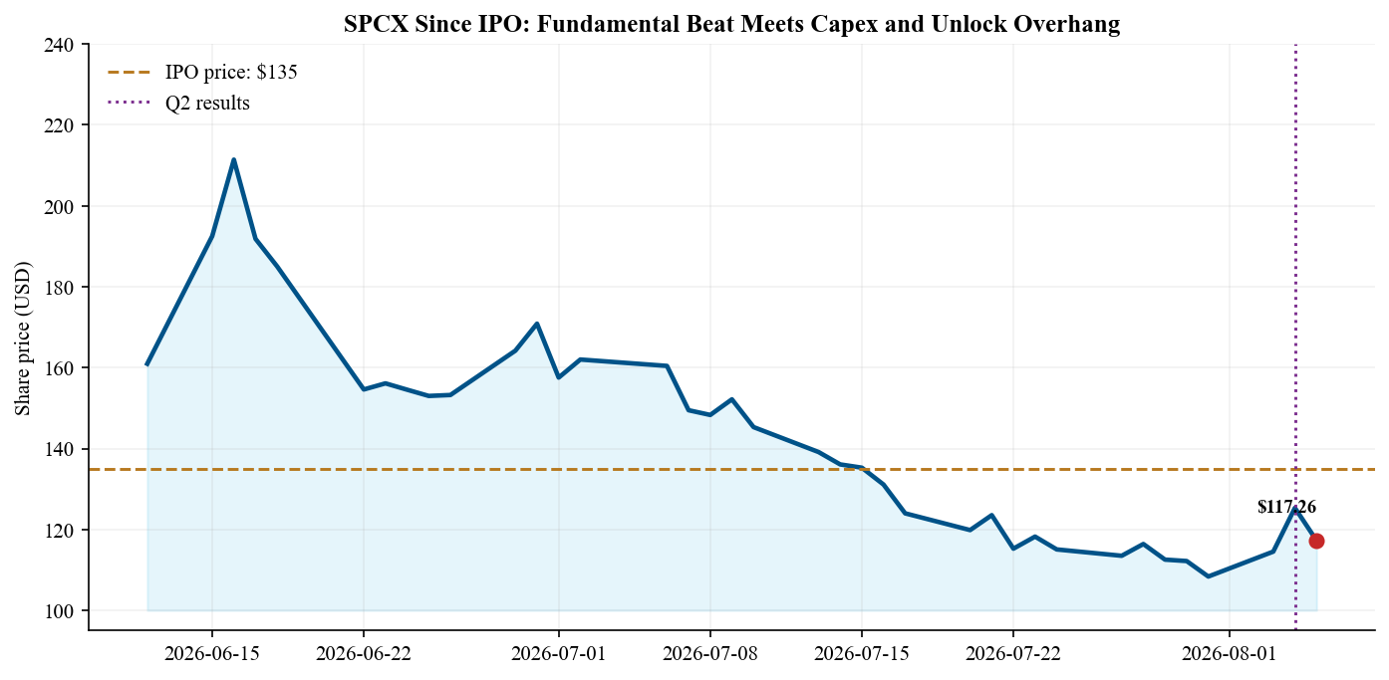
Source: yfinance market data, accessed 5 Aug 2026; Longbridge live quote, accessed 5 Aug 2026; Nasdaq listing page

9. Estimate revisions: both growth and spending reset higher
We raise FY2026 revenue to $35.0B from $22.0B and adjusted EBITDA to $15.5B from $5.5B, reflecting the Q2 beat, $14.1B of contracted AI sales, and continued Starlink momentum. We also raise capex to $65B from $35B. Our model assumes H2 revenue of $22.5B, a meaningful acceleration that still sits well below management's long-duration aspirations.
Metric | FY26 old | FY26 new | FY27 old | FY27 new | Post-Q2 rationale
Revenue | $22.0B | $35.0B | $28.0B | $58.0B | AI contracts + Starlink scale
Adj. EBITDA | $5.5B | $15.5B | $9.0B | $26.0B | AI turns positive; mix leverage
Operating income | $(6.0)B | $(3.0)B | $(3.0)B | $4.0B | Q2 near breakeven; D&A remains high
Net income | $(10.0)B | $(6.0)B | $(5.0)B | $0.0B | Operating improvement; higher interest
Capital expenditures | $35.0B | $65.0B | $30.0B | $75.0B | AI compute and power build-out
Source: Q2 earnings release; Form 10-Q; S-1 baseline. Old estimates from SPCX Q1 2026 earnings update dated 14 Jun 2026; new estimates are independent analyst estimates dated 5 Aug 2026
FY2027 estimates assume Starlink subscribers and enterprise mix continue expanding, AI contracted sales convert into revenue, and depreciation catches up with the 2026 capex surge. We forecast GAAP operating profitability in 2027 but only breakeven net income because interest and other below-the-line costs remain material. The model is highly sensitive to AI utilization and capex timing; it should be interpreted as a scenario, not company guidance.
Figure 9 - Old vs. post-Q2 financial estimates
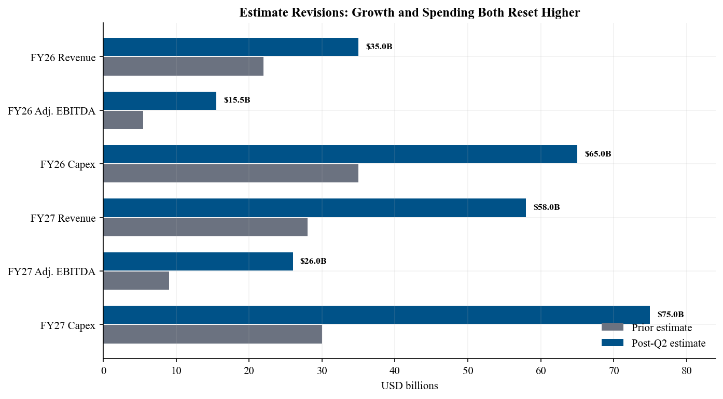
Source: SPCX Q1 2026 earnings update (14 Jun 2026), prior estimates; Q2 earnings release and 10-Q (4 Aug 2026)

10. Valuation and price target
We maintain a $150 12-month price target and upgrade SPCX to Outperform after the post-results decline. At the reference price, SpaceX trades at approximately 43x our FY2026 revenue estimate and 97x FY2026 adjusted EBITDA. Traditional near-term multiples are extreme and are distorted by heavy depreciation, so we use a scenario-weighted sum-of-the-parts framework.
Our operating SOTP values Connectivity at roughly $420B, based on 30x FY2027 adjusted EBITDA of approximately $14B; Space at $140B, including an explicit $100B Starship option value; and AI at approximately $725B, or 25x FY2027 revenue of about $29B. Adding roughly $61B of net cash yields about $1.35T, or $103 per share, before platform value. We apply a 45% strategic premium for vertical integration, cross-segment distribution, and capital-market access, producing a base value near $150 per share.
The bear case of $80 assumes slower AI utilization, capex remains elevated, and the platform premium disappears. The bull case of $225 assumes sustained Starlink margins, fast conversion of AI contracted sales, and successful Starship reuse milestones. The wide range is unavoidable: most value rests in duration-sensitive optionality rather than current free cash flow.
Figure 10 - Twelve-month valuation scenarios
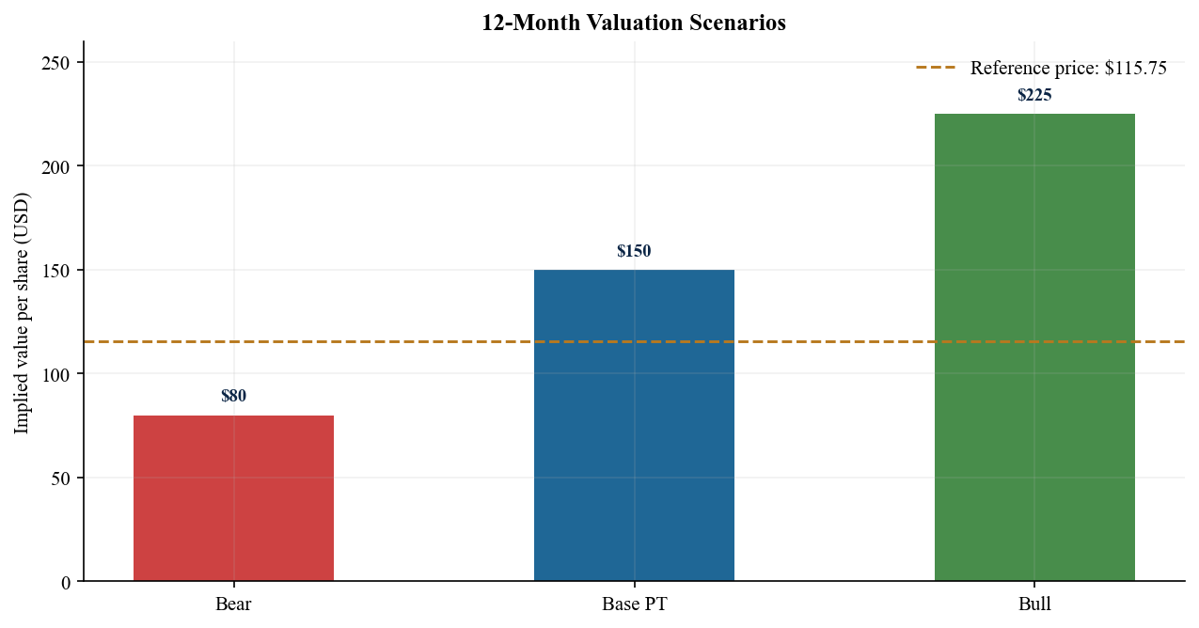
Source: Independent analyst SOTP dated 5 Aug 2026; Q2 earnings release (4 Aug 2026); Dynamic market data
Rating / target: Outperform / $150 (prior: Market Perform / $150). Reference price: $115.10. Implied upside: 30.3%.

Sources and references
Primary earnings materials
- SpaceX Q2 2026 earnings release (4 August 2026)
- Form 10-Q for quarter ended 30 June 2026 (filed 4 August 2026)
- Form 8-K and Exhibit 99.1 filing index (filed 4 August 2026)
- Official earnings webcast and replay notice (call 4 August 2026)
- Form S-1 registration statement (filed 20 May 2026; prior-estimate baseline)
Consensus, call verification, and market data
- Axios / S&P Visible Alpha Q2 results and call coverage (4 August 2026)
- Kiplinger pre-earnings revenue and EPS consensus (31 July 2026)
- Associated Press earnings-call coverage (4 August 2026)
- Yahoo Finance / yfinance dynamic market data (accessed 5 August 2026)
- Longbridge live quote and historical market data (accessed 5 August 2026)
- Nasdaq SPCX listing page
Methodology notes
Beat/miss uses pre-results public consensus. Free cash flow is operating cash flow less capital expenditures. Adjusted EBITDA is company-defined and reconciled in the earnings release; it excludes large depreciation, share-based compensation, interest, and other items. Forecasts and valuation are independent analyst estimates, not company guidance. All dates, quarter labels, and filing identifiers were verified against the company release and SEC documents.
DISCLAIMER
This report is for informational purposes only and does not constitute investment advice, an offer, or a solicitation. Estimates and price targets are based on publicly available information and may change without notice. The analyst is not a licensed investment adviser and has no position in SPCX. Investors should conduct independent due diligence and consider their own objectives and risk tolerance.

