NVIDIA CORPORATION (NVDA)
Q1 FY2027 EARNINGS UPDATE
Blackwell Ramp Drives Record $81.6B Revenue — Beat & Raise
Date: June 6, 2026
Rating: MAINTAIN OUTPERFORM
Price (as of Jun 5, 2026): $205.1
Price Target: $280 (Prior: $260) — RAISED
Market Cap: $4968B | 52-Week Range: $140.85 – $236.54

EARNINGS SUMMARY
Metric | Reported | Consensus | Variance
Revenue | $81.6B | $78.8B | +$2.8B (+3.6%)
Non-GAAP EPS | $1.87 | $1.77 | +$0.10 (+5.7%)
Non-GAAP Gross Margin | 75.0% | 74.8% | +20 bps
Source: Company earnings release (May 20, 2026); Bloomberg consensus as of May 19, 2026.

■ Record revenue of $81.6B beat consensus by 3.6%, driven by Blackwell system demand across hyperscalers
Q1 FY2027 revenue surged 85% YoY and 20% QoQ to $81.6B, exceeding consensus of $78.8B by $2.8B. Data Center revenue reached $75.2B (+92% YoY), representing 92% of total revenue. Management noted Blackwell deployment is "the fastest product ramp in company history," with GB300 NVL72 demand particularly strong. Hyperscale customers contributed $38B and ACIE (AI Clouds, Industrial, Enterprise) added $37B, up 31% QoQ, demonstrating broadening customer diversification beyond the top cloud providers.
■ Non-GAAP gross margin expanded to 75.0%, fully recovering from H20 export-control charges
Non-GAAP gross margin of 75.0% was up 1,400 bps YoY from the H20-impacted Q1 FY2026 (61.0%) and roughly flat sequentially vs. Q4 FY2026 (75.2%). Margin stability amid the largest product transition in company history (Hopper to Blackwell) demonstrates strong pricing power and manufacturing yield improvements. Management guided Q2 FY2027 non-GAAP gross margin at 75.0% (+/-50 bps), suggesting sustained profitability through the Blackwell ramp.
■ Q2 FY2027 guidance of $91.0B significantly above Street expectations, signaling continued acceleration
Management guided Q2 FY2027 revenue to $91.0B (+/-2%), implying ~11.5% QoQ growth and well above the pre-earnings Street estimate of ~$85B. The guidance excludes any Data Center compute revenue from China due to ongoing export restrictions. Combined with the $80B new share repurchase authorization and a 25x dividend increase to $0.25/share quarterly, the capital return framework underscores management's confidence in sustainable earnings power.
■ Maintaining Outperform, raising PT to $280 on higher FY2027E/FY2028E estimates
We raise our FY2027E revenue estimate to $365B (from $340B) and Non-GAAP EPS to $8.80 (from $8.20) reflecting the Q1 beat and raised guidance. Our $280 price target (from $260) is based on 32x our FY2028E Non-GAAP EPS of $10.50, supported by NVIDIA's dominant AI infrastructure position, expanding TAM across inference, sovereign AI, and edge robotics, and sustained gross margin above 74%.
UPDATED FINANCIAL ESTIMATES
Metric | FY2027E (Old) | FY2027E (New) | Change | FY2028E (New)
Revenue ($B) | $340.0 | $365.0 | +7.4% | $440.0
Revenue Growth (%) | 57.4% | 69.0% | +1,160 bps | 20.5%
Non-GAAP Gross Margin | 74.5% | 75.0% | +50 bps | 74.5%
Non-GAAP Op Income ($B) | $225.0 | $245.0 | +8.9% | $290.0
Non-GAAP Op Margin | 66.2% | 67.1% | +90 bps | 65.9%
Non-GAAP EPS ($) | $8.20 | $8.80 | +7.3% | $10.50
P/E (x) at current price | 26.8x | 25.0x | -1.8x | 20.9x
Note: "E" = Estimate. Old estimates from Q4 FY2026 earnings update. Source: Company data, analyst estimates.

DETAILED RESULTS ANALYSIS
Revenue Analysis
Revenue of $81.6B grew 85% YoY and 20% QoQ, representing the third consecutive quarter of YoY acceleration and the fourteenth straight quarter of sequential growth. The $13.5B sequential increase was a new company record. The beat vs. consensus of $78.8B was primarily driven by stronger-than-expected Data Center demand, particularly from hyperscale and sovereign AI customers deploying Blackwell systems.
Segment | Q1 FY26 | Q2 FY26 | Q3 FY26 | Q4 FY26 | Q1 FY27 | YoY Chg
Total Revenue ($B) | $44.1 | $46.7 | $57.0 | $68.1 | $81.6 | +85%
Data Center ($B) | $39.1 | $42.0 | $51.2 | $62.3 | $75.2 | +92%
Edge Computing ($B)* | $5.0 | $4.7 | $5.8 | $5.8 | $6.4 | +29%
DC % of Total | 89% | 90% | 90% | 91% | 92% | +3pp
*Edge Computing includes Gaming, Professional Visualization, Automotive & Robotics (new segment effective Q1 FY27). Prior periods reclassified for comparability. Source: Company filings.

Figure 1 — Quarterly Revenue Progression
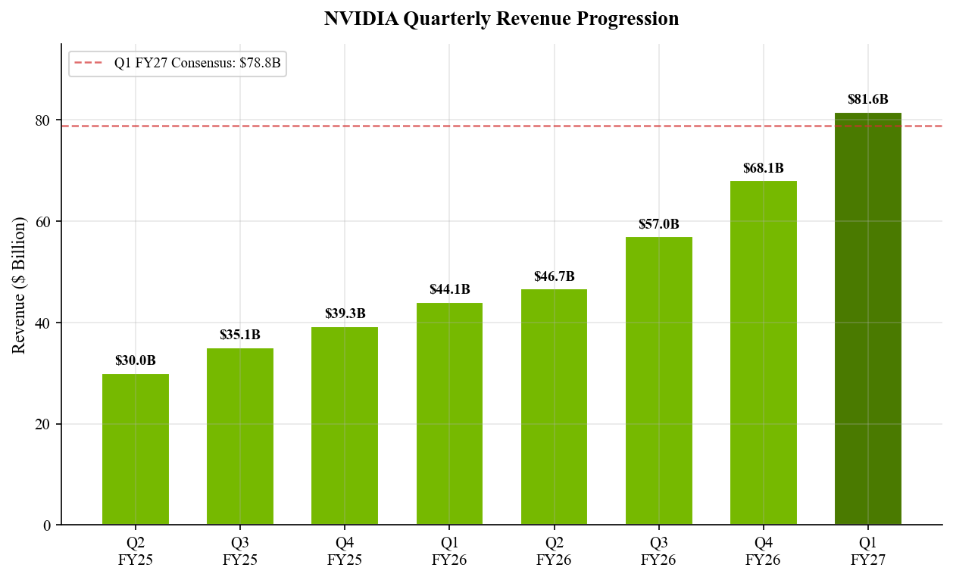
Source: Company filings; consensus estimate from Bloomberg (May 19, 2026).
Data Center Deep Dive
Data Center revenue of $75.2B (+92% YoY, +21% QoQ) was the primary growth driver. Within Data Center, compute revenue reached $60.4B (+77% YoY, +18% QoQ), driven by accelerating Blackwell GPU deployments. Networking revenue nearly tripled YoY to $14.8B (+199% YoY, +35% QoQ), reflecting the growing importance of high-bandwidth interconnects (NVLink, InfiniBand, Spectrum-X Ethernet) as GPU clusters scale to tens of thousands of GPUs.
By customer type, hyperscale customers contributed approximately $38B (~50% of DC revenue), while the ACIE segment (AI Clouds, Industrial, Enterprise) generated $37B, up 31% QoQ. The rapid ACIE growth signals that AI workload demand is broadening beyond the top hyperscalers into sovereign AI programs, enterprise deployments, and AI-native cloud providers. CFO Colette Kress noted that "demand for GB300 NVL72 was particularly strong" with frontier builders deploying "hundreds and thousands" of Blackwell GPUs.

Profitability Analysis
Non-GAAP gross margin of 75.0% was roughly flat vs. Q4 FY2026 (75.2%) and up dramatically from Q1 FY2026's H20-impacted 61.0%. The margin stability during Blackwell's fastest-ever product ramp demonstrates strong pricing discipline and improving yields. GAAP gross margin was 74.9%. Operating expenses totaled $7.6B (GAAP), with R&D spending at $6.3B — reflecting continued heavy investment in next-generation GPU architectures (Rubin/Vera) and software platforms.
Metric | Q1 FY26 | Q3 FY26 | Q4 FY26 | Q1 FY27 | YoY Chg
GAAP Gross Margin | 60.5% | 73.4% | 75.0% | 74.9% | +1,440 bps
Non-GAAP Gross Margin | 61.0% | 73.6% | 75.2% | 75.0% | +1,400 bps
GAAP Operating Margin | 49.0% | 63.2% | 65.0% | 65.6% | +1,660 bps
Non-GAAP Operating Margin | 52.8% | 64.9% | 67.7% | 65.9% | +1,310 bps
Source: Company filings. Q1 FY26 margins impacted by $4.5B H20 inventory charge.
Figure 2 — Quarterly EPS Progression
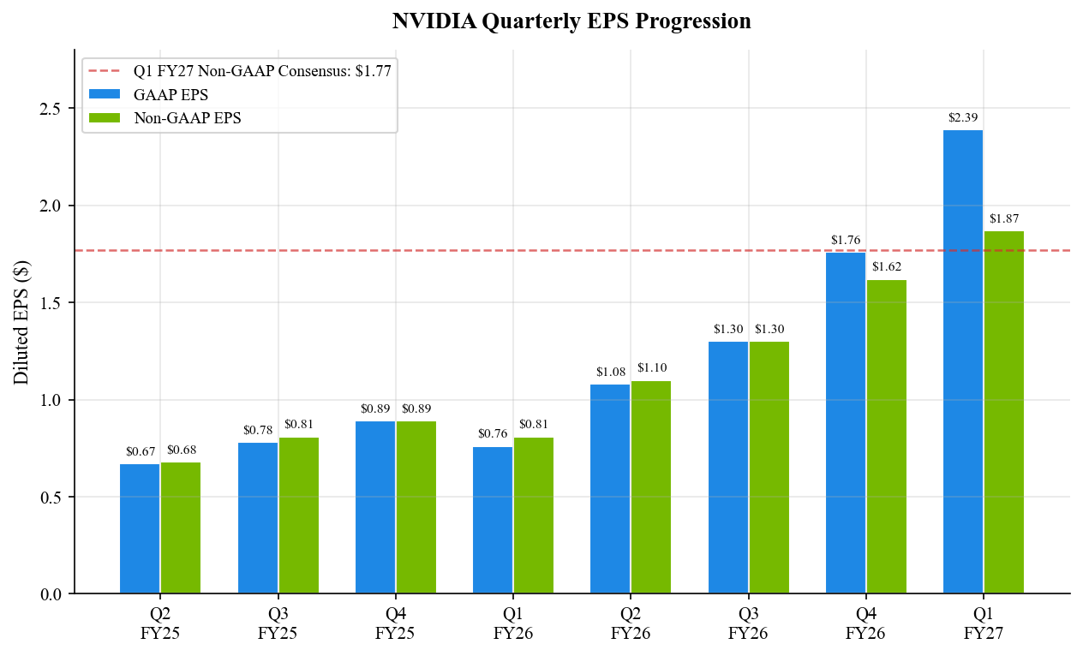
Source: Company filings; consensus estimate from Bloomberg (May 19, 2026).
Figure 3 — Quarterly Margin Trends
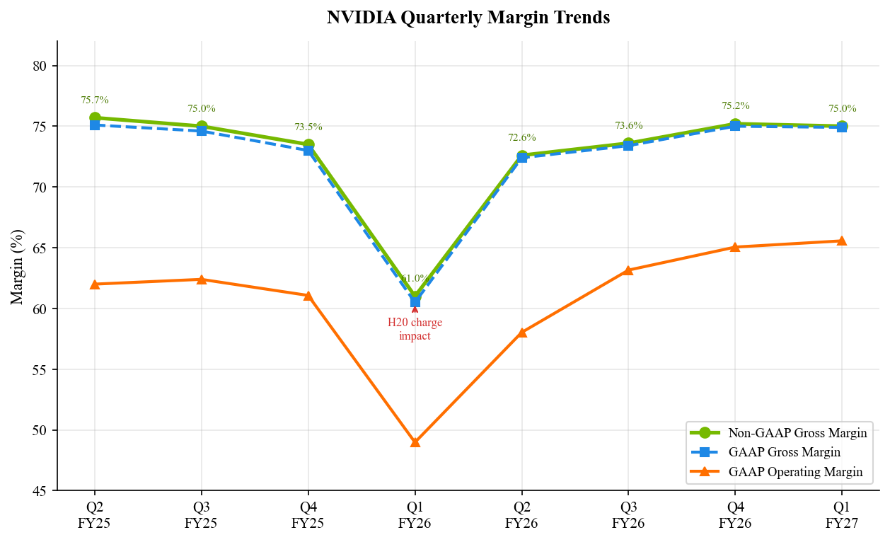
Source: Company filings.

KEY METRICS & GUIDANCE
Key Operating Metrics
Metric | Q1 FY27 | Q4 FY26 | YoY / QoQ
DC Compute Revenue ($B) | $60.4 | $51.2 | +18% QoQ
DC Networking Revenue ($B) | $14.8 | $11.0 | +35% QoQ
Free Cash Flow ($B) | $49.0 | $34.9 | +40% QoQ
Operating Cash Flow ($B) | ~$51.0 | $36.2 | +41% QoQ
Share Repurchases ($B) | ~$20.0 | ~$11.0 | —
Diluted Share Count (B) | ~24.4 | 24.4 | Flat
Source: Company earnings release (May 20, 2026); 10-Q filing (May 28, 2026).
Figure 4 — Revenue: Data Center vs. Other Segments
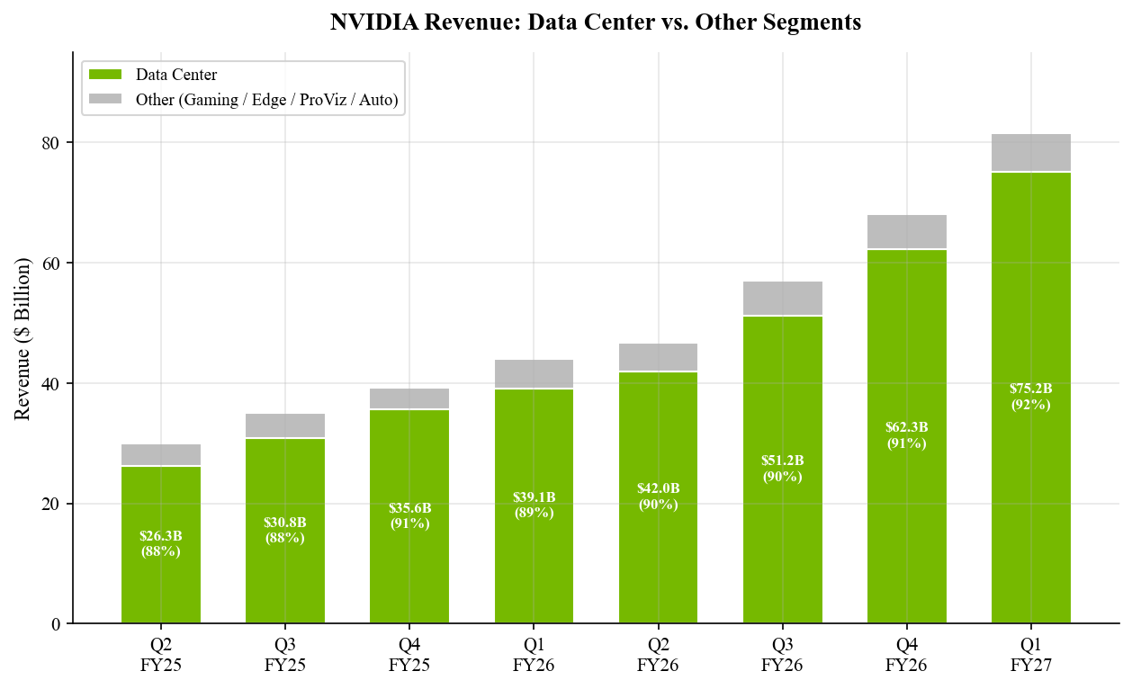
Source: Company filings.
Figure 5 — Data Center Revenue & YoY Growth
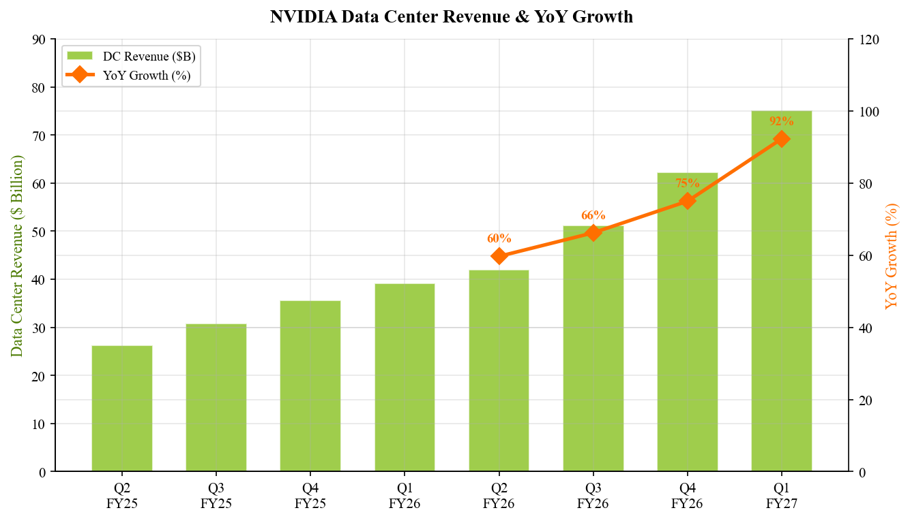
Source: Company filings.

Q2 FY2027 Guidance Analysis
Management guided Q2 FY2027 revenue to approximately $91.0B (+/-2%), implying $89.2B-$92.8B. At the midpoint, this represents ~11.5% QoQ growth and significantly exceeds the pre-earnings Street estimate of ~$85B. The guidance excludes any Data Center compute revenue from China due to continued U.S. export restrictions — a notable constraint that makes the beat even more impressive on an organic basis.
Metric | Q2 FY27E Guidance | Q1 FY27 Actual | QoQ Implied
Revenue | ~$91.0B (+/-2%) | $81.6B | +11.5%
GAAP Gross Margin | 74.9% (+/-50 bps) | 74.9% | Flat
Non-GAAP Gross Margin | 75.0% (+/-50 bps) | 75.0% | Flat
Non-GAAP OpEx | ~$8.3B | ~$7.5B | +10.7%
Source: Company Q1 FY2027 earnings release and CFO commentary (May 20, 2026).
The guidance is notable for several reasons: (1) it implies continued sequential acceleration despite an increasingly large revenue base; (2) gross margin guidance of ~75% suggests no margin headwinds from the Blackwell production ramp; (3) OpEx rising to ~$8.3B reflects continued heavy investment in Rubin/Vera next-gen architectures and CUDA software ecosystem expansion; and (4) the explicit exclusion of China compute revenue provides a clean organic growth picture.
Figure 6 — Q1 FY2027 Revenue Beat: Consensus to Reported
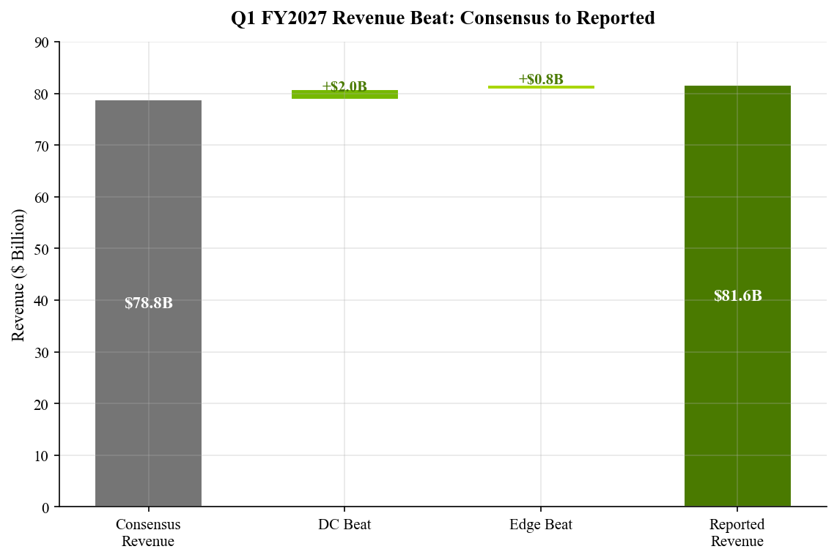
Source: Company filings; Bloomberg consensus (May 19, 2026).

UPDATED INVESTMENT THESIS
Thesis Impact Assessment
■ Thesis 1: NVIDIA is the primary beneficiary of the AI infrastructure buildout — STRENGTHENED
Q1 FY2027 results emphatically reinforce this thesis. Data Center revenue of $75.2B (+92% YoY) demonstrates that the AI infrastructure investment cycle continues to accelerate rather than plateau. The broadening customer base — from hyperscalers ($38B) to ACIE ($37B) — suggests the AI compute demand is not concentrated in a handful of buyers but expanding across sovereign AI programs, enterprise deployments, and specialized AI cloud providers. Blackwell's record ramp further cements NVIDIA's technological leadership, with GB300 NVL72 demand described as "particularly strong."
■ Thesis 2: Networking becomes the next major growth vector — STRENGTHENED
Networking revenue of $14.8B (+199% YoY, +35% QoQ) validates our thesis that as GPU clusters scale to tens of thousands of accelerators, high-bandwidth interconnects become critical. NVLink, InfiniBand, and Spectrum-X Ethernet solutions are increasingly sold as part of integrated Blackwell systems rather than standalone products. Networking now represents ~20% of Data Center revenue, up from ~13% a year ago, demonstrating meaningful TAM expansion beyond GPUs.
■ Thesis 3: Gross margins sustained above 73% through product transitions — UNCHANGED
Non-GAAP gross margin of 75.0% remains well above our 73% floor thesis. The stability during the Hopper-to-Blackwell transition is particularly notable, as new product ramps historically create margin volatility. Management's Q2 guidance of 75.0% (+/-50 bps) provides visibility into sustained margins. However, we maintain our conservative 74.5% assumption for the full FY2027 to account for potential mix shifts as lower-priced inference GPUs scale.
Risk Assessment Update
Key risks remain largely unchanged but warrant monitoring: (1) Export control risk — the exclusion of China DC compute revenue from guidance highlights ongoing regulatory headwinds, though NVIDIA has demonstrated ability to grow robustly without China; (2) Customer concentration — while ACIE growth is encouraging, hyperscalers still drive ~50% of DC revenue, creating potential cyclical risk if cloud CapEx slows; (3) Competition — AMD's MI400 and custom ASICs from Google (TPU), Amazon (Trainium), and Microsoft (Maia) represent long-term competitive threats, though near-term share losses appear minimal; (4) Valuation — at ~25x FY2027E P/E, the stock prices in significant continued growth, leaving limited room for execution missteps.
Figure 7 — Quarterly Free Cash Flow
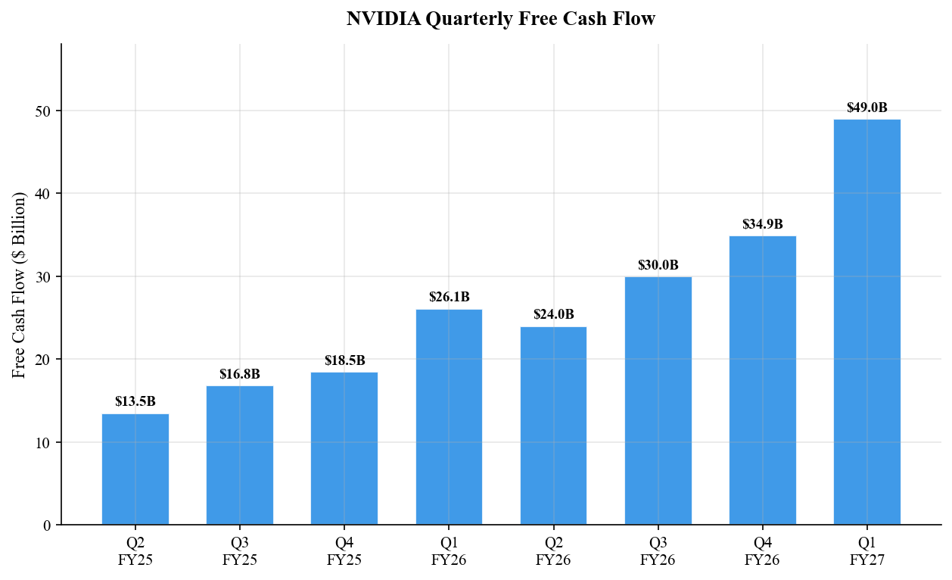
Source: Company filings.
Figure 8 — Q1 FY2027 Data Center Revenue Mix
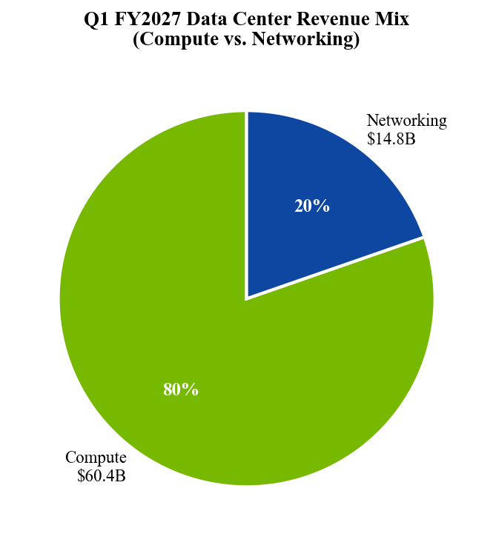
Source: Company earnings release (May 20, 2026).

VALUATION & UPDATED ESTIMATES
Valuation Framework
Our $280 price target (raised from $260) is based on a blended valuation approach:
DCF Analysis (40% weight): Updated DCF with FY2027E-FY2032E cash flows yields a fair value of $295. Key assumptions: revenue CAGR of 22% over 5 years, terminal EBIT margin of 62%, WACC of 10.5%, terminal growth of 3.5%.
P/E Multiple (40% weight): 32x our FY2028E Non-GAAP EPS of $10.50 yields $336. We apply a 20% discount for execution risk, yielding $269.
EV/EBITDA (20% weight): 25x our FY2028E EBITDA of $310B yields $250 per share after net cash.
Blended target: (40% x $295) + (40% x $269) + (20% x $250) = $276, rounded to $280.
Detailed Estimate Updates
Metric | FY27E (Old) | FY27E (New) | Change | FY28E (New)
Revenue ($B) | $340.0 | $365.0 | +7.4% | $440.0
Data Center ($B) | $310.0 | $335.0 | +8.1% | $400.0
Edge Computing ($B) | $30.0 | $30.0 | — | $40.0
Gross Profit ($B) | $253.3 | $273.8 | +8.1% | $327.8
Non-GAAP Gross Margin | 74.5% | 75.0% | +50 bps | 74.5%
Non-GAAP OpEx ($B) | $35.0 | $35.0 | — | $42.0
Non-GAAP Op Income ($B) | $225.0 | $245.0 | +8.9% | $290.0
Non-GAAP Op Margin | 66.2% | 67.1% | +90 bps | 65.9%
Non-GAAP EPS ($) | $8.20 | $8.80 | +7.3% | $10.50
Free Cash Flow ($B) | $195.0 | $215.0 | +10.3% | $250.0
Source: Analyst estimates.
Figure 9 — FY2027E Estimate Revisions
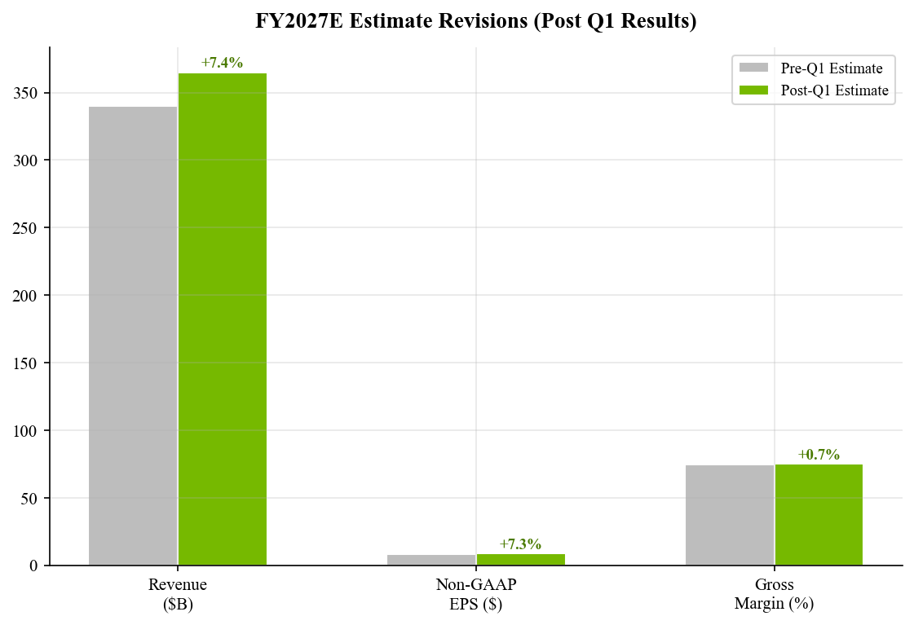
Source: Analyst estimates.
Figure 10 — Quarterly Revenue Sequential Growth Rate
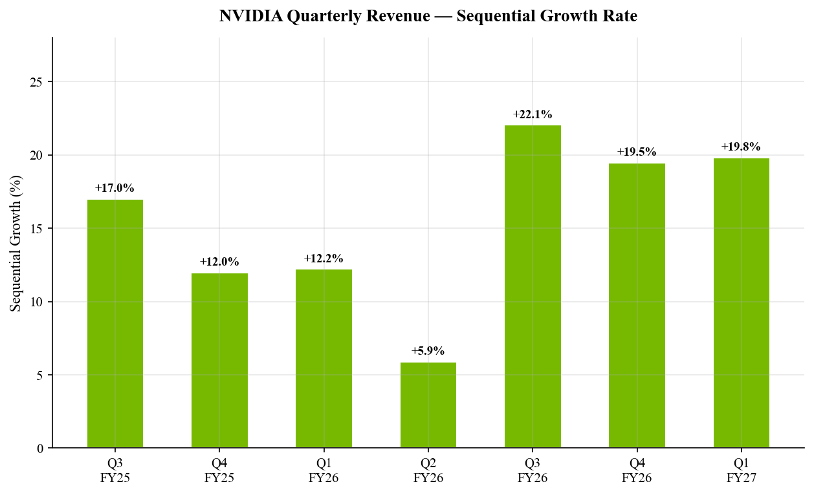
Source: Company filings.

SOURCES & REFERENCES
Earnings Materials (Q1 FY2027):
• Earnings Release (May 20, 2026)
• Form 8-K — Press Release (Filed May 20, 2026)
• CFO Commentary (May 20, 2026)
• Form 10-Q (Filed May 28, 2026)
• Q1 FY2027 Earnings Call Transcript (May 20, 2026)

Prior Period References:
• Q4 FY2026 Earnings Release (February 26, 2026)
• Q4 FY2026 Form 8-K — Press Release
• Q3 FY2026 Earnings Release (November 2025)

Consensus & Market Data:
• Bloomberg consensus estimates as of market close May 19, 2026
• Yahoo Finance / yfinance for real-time market data
• NVIDIA Investor Relations: https://investor.nvidia.com

DISCLAIMER
This report is for informational purposes only and does not constitute investment advice. The analyst is not a licensed investment advisor. All estimates and price targets are based on publicly available information and represent the analyst's independent assessment. Past performance is not indicative of future results. Investors should conduct their own due diligence before making investment decisions.

