SPACE EXPLORATION TECHNOLOGIES CORP SPCX
Q3 2026 EARNINGS UPDATE
SI Profit Inflection Resets the Earnings Curve while Capex Accelerates Again
21 October 2026 | Rating: MAINTAIN OUTPERFORM | Price: N/A | PT: $150 to $210 | Upside: N/A
Market cap: N/A | 52-week range: N/A | After-hours: $159.71 (+8.1%)

Earnings summary
Metric | Reported | Consensus | Variance | Read-through
Revenue | $14.575B | $12.900B | +$1.675B / +13.0% | All three segments beat
GAAP diluted EPS | $0.35 | $0.14 | +$0.21 / +150% | Operating and other income
Adjusted EBITDA | $8.809B | $6.590B | +$2.219B / +33.7% | Cloud-service mix
Capital expenditures | $19.593B | $18.369B | +6.7% QoQ | SI infrastructure
Source: Q3 earnings release and Exhibit 99.1; SEC Form 8-K; TipRanks pre-earnings consensus; Zacks segment consensus. Results filed 20 October 2026; consensus dated 19 October 2026

Investment impact
- The beat was broad and the earnings curve changed shape. Revenue exceeded pre-earnings consensus by 13%, while diluted EPS of $0.35 was $0.21 above consensus. SI contributed $7.56B of revenue and $431M of GAAP operating income, crossing profitability earlier and at greater scale than our post-Q2 model assumed.
- Connectivity remains the quality anchor. Revenue increased 69% YoY to $5.25B, operating income rose 99% to $2.37B, subscribers reached 13.6M, and monthly ARPU improved 5% QoQ to $69. Starlink remains the most dependable source of recurring earnings and group-level funding.
- Management raised the growth and spending ceiling. The call introduced $33-37B of Q1 2027 revenue guidance and $35-40B of Q4 2026 capex. The $100B December ARR target and 2.5-3.0 GW year-end compute target imply another rapid step-up, but free cash flow remains deeply negative during deployment.
- Maintain Outperform; raise PT to $210 from $150. Higher SI utilization, a $63B backlog, and positive GAAP segment profit support a higher SOTP. We retain an Outperform rating, but use a wide $110-$320 scenario range because capital intensity, customer concentration, merger uncertainty, and execution risk remain exceptional.

1 Results were materially ahead of a moving consensus
SpaceX reported Q3 revenue of $14.575B, up 161% YoY and 87% QoQ. Against the $12.9B pre-earnings consensus published on 19 October, the company beat by $1.675B, or 13.0%. GAAP diluted EPS of $0.35 exceeded the $0.14 consensus by $0.21. Zacks' nine-analyst segment expectations were $1.43B for Space, $4.78B for Connectivity, and $6.03B for SI; reported results exceeded each by 24%, 10%, and 25%, respectively.
The beat was not merely a below-the-line event. Consolidated operating income improved to $2.791B from a $273M loss a year ago and a $143M loss in Q2. Adjusted EBITDA reached $8.809B, up 306% YoY and 149% QoQ. Revenue mix mattered: higher-margin SI cloud-service agreements scaled rapidly, while Connectivity maintained strong incremental margins. Other income of $1.025B and a $390M tax benefit also lifted net income, so the $0.35 EPS result should not be treated as a pure recurring run-rate.
Comparability remains imperfect. SI includes the August acquisition of Cursor, which contributed $608M of revenue from closing through quarter-end. The acquisition also generated $1.217B of Q3 share-based compensation, depressing GAAP SI operating income. Excluding that acquisition-related charge, management indicated SI would have produced about $1.6B of operating profit. We therefore view the SI margin inflection as economically meaningful but still subject to purchase-accounting and customer-mix volatility.
Figure 1 - Q3 2026 beat and miss snapshot
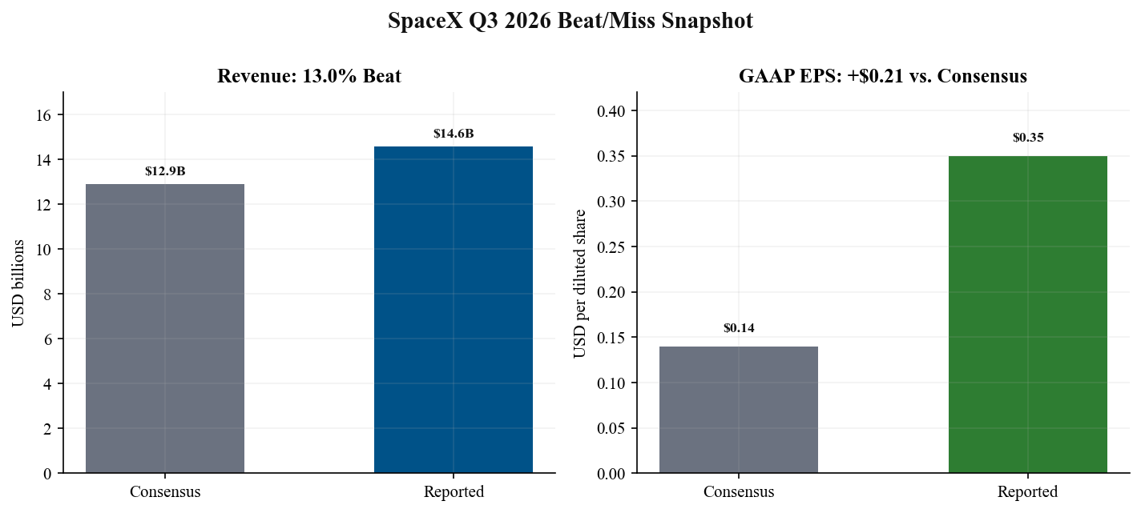
Source: Q3 earnings release, 20 Oct 2026, pp. 1 and 9; TipRanks pre-earnings consensus, 19 Oct 2026; Zacks key-metric consensus, 20 Oct 2026
Figure 2 - Quarterly revenue and adjusted EBITDA
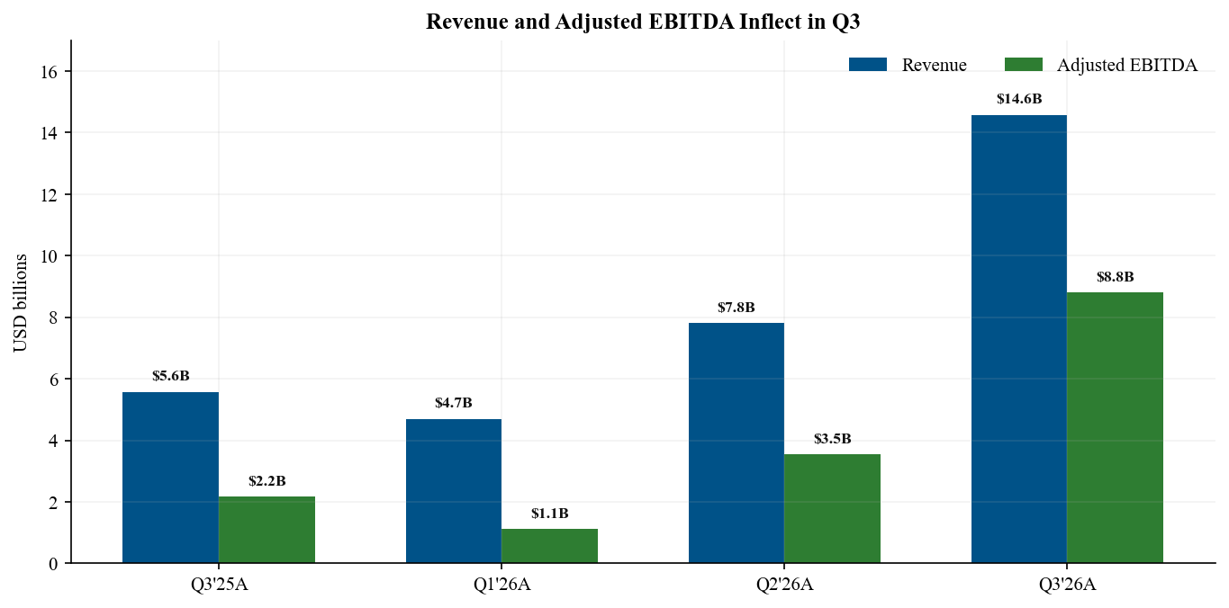
Source: Q3 earnings release, 20 Oct 2026, pp. 3 and 9; Q2 Form 10-Q, filed 4 Aug 2026, pp. 5 and 40

2 Segment mix now has two profit engines
SI became the largest revenue segment in Q3, contributing 52% of consolidated sales vs. 36% from Connectivity and 12% from Space. SI revenue rose 195% QoQ and 830% YoY to $7.560B, driven by new cloud-service activations, Cursor, and higher Grok adoption. More important, SI moved from a $1.257B operating loss in Q2 to $431M of operating income, while adjusted EBITDA expanded from $1.146B to $4.953B.
Connectivity remains the cleaner earnings stream. Revenue increased 22% QoQ and 69% YoY to $5.248B. Operating income of $2.367B equated to a 45.1% margin, up from 38.6% in Q2, while adjusted EBITDA reached $3.499B. Consumer revenue grew to $3.121B and Enterprise and Government revenue to $2.127B, reducing reliance on any single channel.
Space revenue improved 84% QoQ to $1.767B, helped by customer mix and 12 customer launches. The segment was almost breakeven at a $7M operating loss, but adjusted EBITDA was $357M. R&D remained $1.225B as Starship work accelerated. The first revenue-generating Starship mission deployed 26 Starlink V3 satellites, providing strategic proof that launch economics can improve connectivity capacity, even though the near-term Space P&L remains burdened by development spending.
The portfolio is therefore no longer a single-profit-engine story. Connectivity still supplies the highest-quality recurring cash earnings, but SI has crossed into positive GAAP contribution and can become the dominant value driver if utilization remains high. The key analytical shift is from asking whether SI can monetize to asking whether its returns can remain attractive after depreciation, stock compensation, and a much larger capital base are fully reflected.
Figure 3 - Segment revenue progression
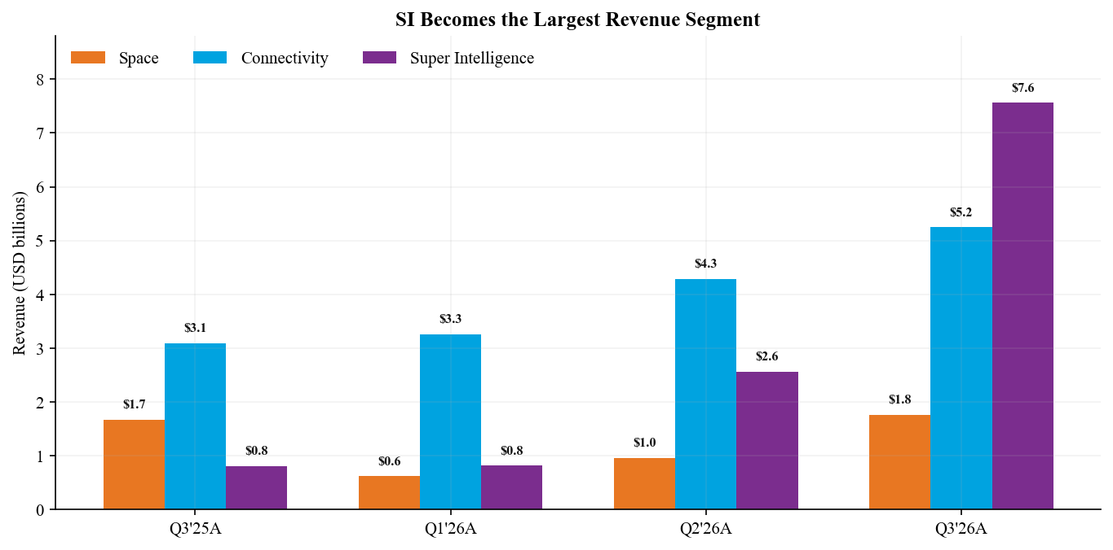
Source: Q3 earnings release, 20 Oct 2026, pp. 3-7; Q2 Form 10-Q, filed 4 Aug 2026, pp. 37-44
Figure 4 - Segment operating income and loss
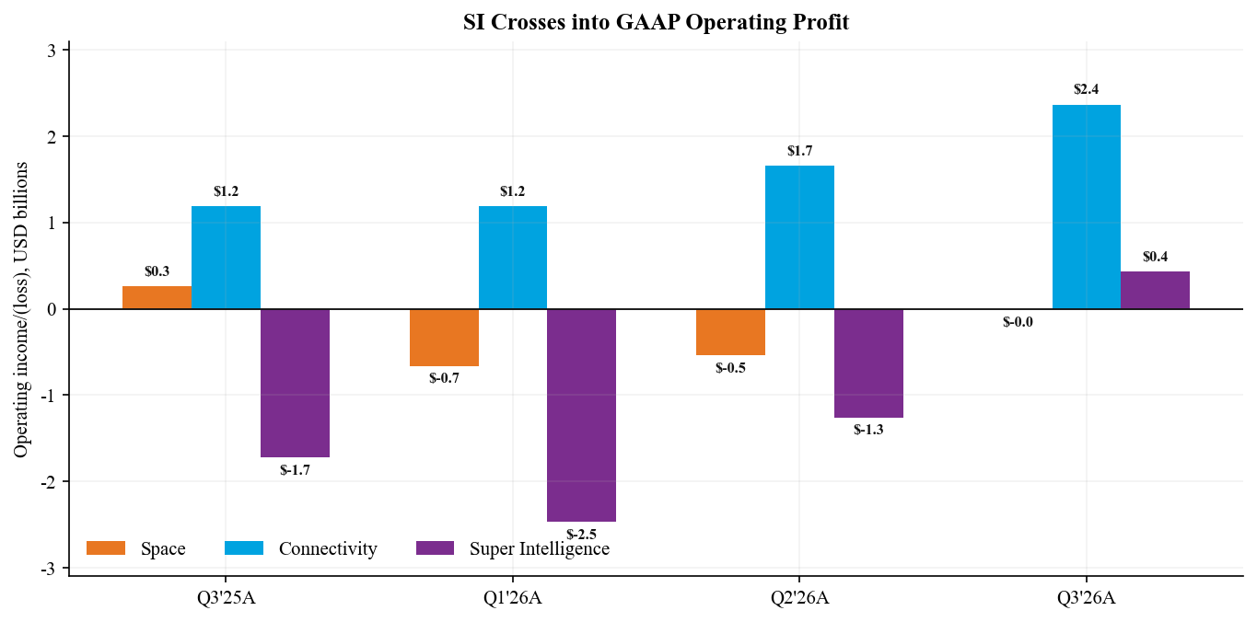
Source: Q3 earnings release, 20 Oct 2026, pp. 3-7; Q2 Form 10-Q, filed 4 Aug 2026, segment note

3 Profitability crossed a threshold but quality needs adjustment
Segment | Revenue | YoY | Op income | Adj EBITDA | Capex
Space | $1.767B | +6% | $(0.007)B | $0.357B | $1.606B
Connectivity | $5.248B | +69% | $2.367B | $3.499B | $1.543B
Super Intelligence | $7.560B | +830% | $0.431B | $4.953B | $16.444B
Total | $14.575B | +161% | $2.791B | $8.809B | $19.593B
Source: Q3 earnings release, pp. 3-7; SEC Form 8-K, filed 20 Oct 2026. Three months ended 30 September 2026
Gross margin expanded to 62.4% from 51.5% a year ago and 55.3% in Q2 as higher-margin cloud agreements increased SI mix. Operating margin reached 19.1%, a 24-point YoY improvement, and net margin reached 30.2%. Management cautioned that Q3 benefited from one-time items and customer mix, and expects Q4 gross margin to be closer to Q2. We therefore model partial normalization rather than extrapolating the Q3 peak.
Adjusted EBITDA requires a disciplined bridge. The $8.809B figure adds back $3.644B of depreciation and amortization, $1.146B of recurring share-based compensation, $1.217B of acquisition-related share-based compensation, and other items. Those add-backs are economically relevant for a company investing $19.6B in a single quarter. Adjusted EBITDA demonstrates utilization and pricing power, but it substantially overstates cash available to equity holders during the build-out.
Below the operating line, $873M of interest income and $1.025B of other income more than offset $675M of interest expense. The resulting $4.404B net income exceeded operating income by $1.613B. Our forecast normalizes other income and the tax benefit, while retaining positive operating leverage from SI and Connectivity. This approach produces lower near-term EPS than a simple annualization of Q3 but a more durable base for valuation.
Figure 5 - Consolidated margin progression
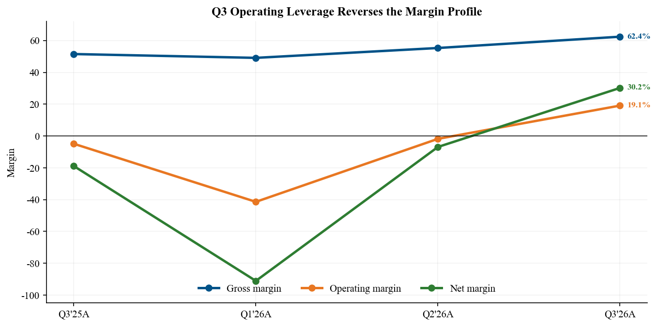
Source: Q3 earnings release, 20 Oct 2026, pp. 9-10; Q2 Form 10-Q, filed 4 Aug 2026, consolidated statements

4 Connectivity strengthened the core thesis
Starlink consumer subscribers reached 13.6M at quarter-end, up 89% YoY and 13% QoQ. Monthly consumer ARPU improved 5% sequentially to $69, reversing the prior decline even as the company continued expanding internationally. Consumer revenue increased 57% YoY to $3.121B. Enterprise and Government revenue rose 91% to $2.127B, supported by aviation, maritime, government, and other managed deployments.
Operating economics improved faster than revenue. Connectivity operating income rose 99% YoY to $2.367B and adjusted EBITDA increased 82% to $3.499B. Capex of $1.543B was only modestly above Q2 despite rapid growth, implying that the deployed constellation and customer base are generating operating leverage. The segment's 45.1% operating margin and 66.7% adjusted EBITDA margin are the strongest evidence that Starlink can finance broader group ambitions.
The next growth vector is Starlink Mobile. SpaceX agreed on 8 October to acquire up to 14 MHz of paired nationwide 800 MHz spectrum, with closing expected in H1 2027. Management described a hybrid architecture using S-band capacity, low-band spectrum for building penetration, and radios installed at existing Starlink locations. This expands the addressable market but introduces regulatory, integration, and capital-allocation risk.
V3 satellites should improve capacity economics. Flight 14 deployed 26 V3 satellites with roughly ten times the downlink capacity added by a Falcon 9 Starlink launch. Management expects users to feel a meaningful improvement after a few hundred V3 satellites are operating, potentially by mid-2027. Execution on Starship cadence therefore directly influences Starlink service quality and long-term margin.
Figure 6 - Starlink consumer subscribers and ARPU
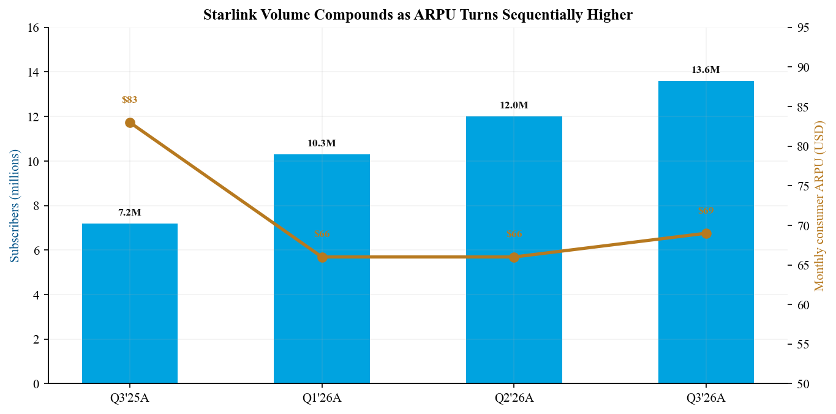
Source: Q3 earnings release, 20 Oct 2026, pp. 5-6; Q3 earnings call transcript, 20 Oct 2026

5 SI monetization validated demand but not yet cash returns
SI revenue increased to $7.560B, of which $7.022B came from solutions and infrastructure and $538M from advertising. Nameplate compute reached 1.7 GW, up from 1.4 GW in Q2 and 0.6 GW a year ago. The revenue step-up shows that new capacity is being monetized quickly: management described robust third-party demand and flexibility to allocate compute between internal model training and external cloud customers.
The segment's adjusted EBITDA of $4.953B exceeded revenue less cash operating costs by a wide margin, but capex remained $16.444B, or 2.2 times quarterly revenue. Management plans to deploy roughly 200,000-220,000 GB300 systems per month through year-end, reach 2.5-3.0 GW of nameplate compute in Q4, and add at least 10 GW during 2027. The upside case contemplates 20 GW, but management explicitly framed that as difficult and uncertain.
Cursor broadens the stack from infrastructure and models into applications. The acquisition carried a $60B implied equity value and $42.5B GAAP purchase consideration. Approximately $23.4B of equity awards are tied to post-acquisition service and will create material stock compensation over roughly three years. Cursor contributed $608M of Q3 revenue, but the retention package dilutes the translation from adjusted EBITDA to shareholder earnings.
Our thesis status is strengthened on demand and weakened on capital intensity. A backlog of $63B, including about $42B expected within twelve months, supports near-term visibility. Yet Q4 capex guidance of $35-40B is almost twice Q3 spending, and GPU, power, cooling, networking, customer concentration, contract repricing, and technology obsolescence can all compress returns. The debate is no longer whether SI can grow; it is whether return on invested capital remains attractive through a much larger depreciation cycle.
Figure 7 - SI revenue capex and nameplate compute
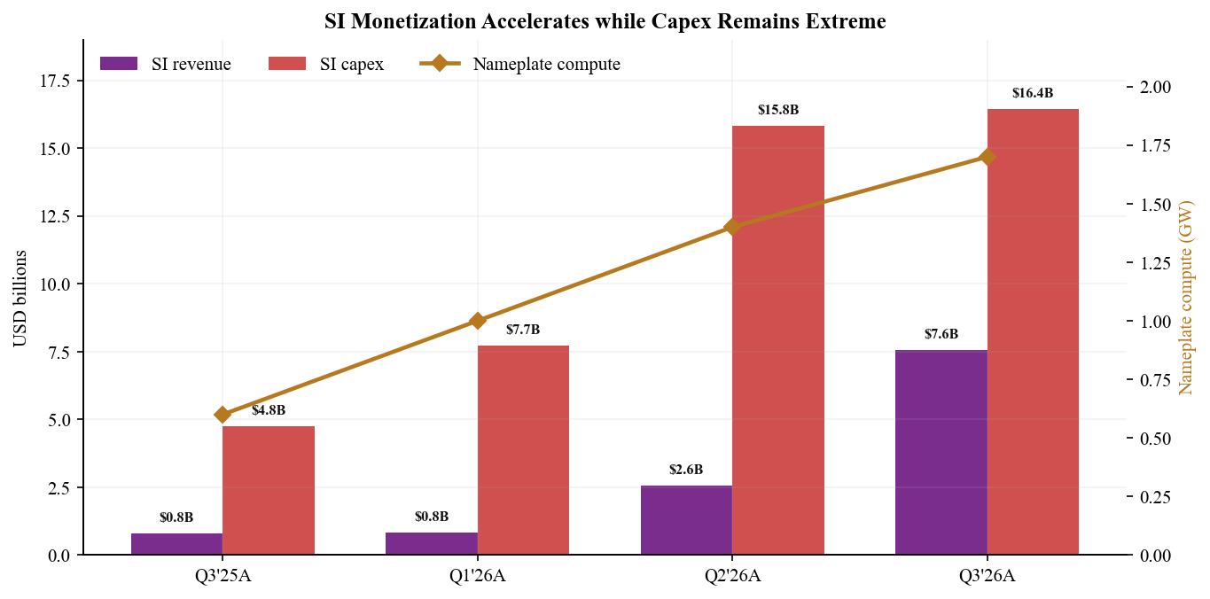
Source: Q3 earnings release, 20 Oct 2026, pp. 6-7; Q3 earnings call transcript, 20 Oct 2026, CFO remarks; Q2 Form 10-Q, filed 4 Aug 2026

6 Cash flow remains the limiting variable
Nine-month operating cash flow improved to $13.097B from $4.120B a year ago, supported by higher earnings, depreciation, stock compensation, and a $4.922B increase in deferred revenue. Capex nevertheless reached $48.069B, producing approximately $(34.972)B of free cash flow before acquisitions and marketable-securities activity. The business is operationally profitable but not self-funding at the current deployment pace.
Liquidity is substantial. SpaceX ended Q3 with $51.294B of cash and $38.561B of marketable securities against $38.844B of debt and finance leases, implying roughly $51.0B of net cash. The IPO contributed $85.675B of net financing proceeds during the first nine months. Those resources can absorb another investment surge, but the midpoint of Q4 capex guidance alone equals about 74% of quarter-end cash.
Working capital also deserves attention. Accounts receivable increased by $2.882B and inventory by $1.381B during the first nine months, while deferred revenue rose by $4.922B. Large upfront customer commitments improve cash visibility, but growth in receivables and inventory can consume cash rapidly as compute and satellite deployments accelerate. Backlog conversion is therefore as important as signed contract value.
Management cited operating cash flow, investment-grade debt markets, and partnerships across suppliers and customers as the funding stack for 2027. We consider that credible given the balance sheet and demand, but not costless. Higher debt, vendor financing, customer prepayments, and additional equity-linked compensation each transfer risk differently. Our valuation applies a discount for the possibility that capital needs grow faster than contract cash receipts.
Figure 8 - Nine-month operating cash flow capex and free cash flow
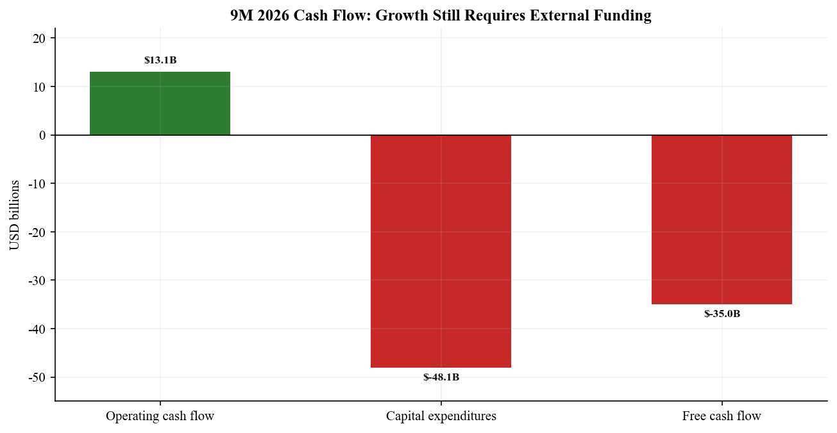
Source: Q3 earnings release, 20 Oct 2026, pp. 11-12; SEC Form 8-K and Exhibit 99.1

7 Guidance moves the debate from quarter to capacity conversion
Management introduced Q1 2027 revenue guidance of $33-37B, more than double Q3 actual revenue. It also reiterated a target to exit 2026 at a $100B annualized revenue run-rate based on December revenue. The difference between a run-rate target and recognized quarterly revenue is important: the ARR target implies roughly $8.3B of December revenue, while the Q1 guidance midpoint implies $11.7B per month on average. Both require a rapid contract-conversion curve.
Q4 capex guidance of $35-40B is the clearest near-term risk. At the midpoint, full-year 2026 capex would approach $85.6B, above our prior $65B estimate. Management expects gross margin to normalize toward Q2 because Q3 included one-time benefits and favorable customer mix. We therefore forecast a sharp Q4 revenue increase but lower margin than Q3, followed by renewed operating leverage as Q1 2027 capacity ramps.
Operational milestones support the revenue plan but are aggressive. Management expects 2.5-3.0 GW of compute by year-end, at least 10 GW of incremental capacity during 2027, weekly Starship launches in H1 2027, and twice-weekly cadence later in the year. A few hundred V3 satellites should begin producing noticeable Starlink service improvements around mid-2027. Each milestone requires coordinated execution across power, cooling, chips, launch licensing, manufacturing, and network operations.
We rate guidance credibility as medium-high on demand and medium on timing. The $63B backlog and strong Q3 conversion substantiate customer demand, while the balance sheet supports procurement. However, management is simultaneously scaling cloud infrastructure, Starship, V3 satellites, Starlink Mobile, and internal chip fabrication. The number of critical paths makes schedule slippage likely even if long-term demand remains intact.
Figure 9 - Revenue and capital spending outlook
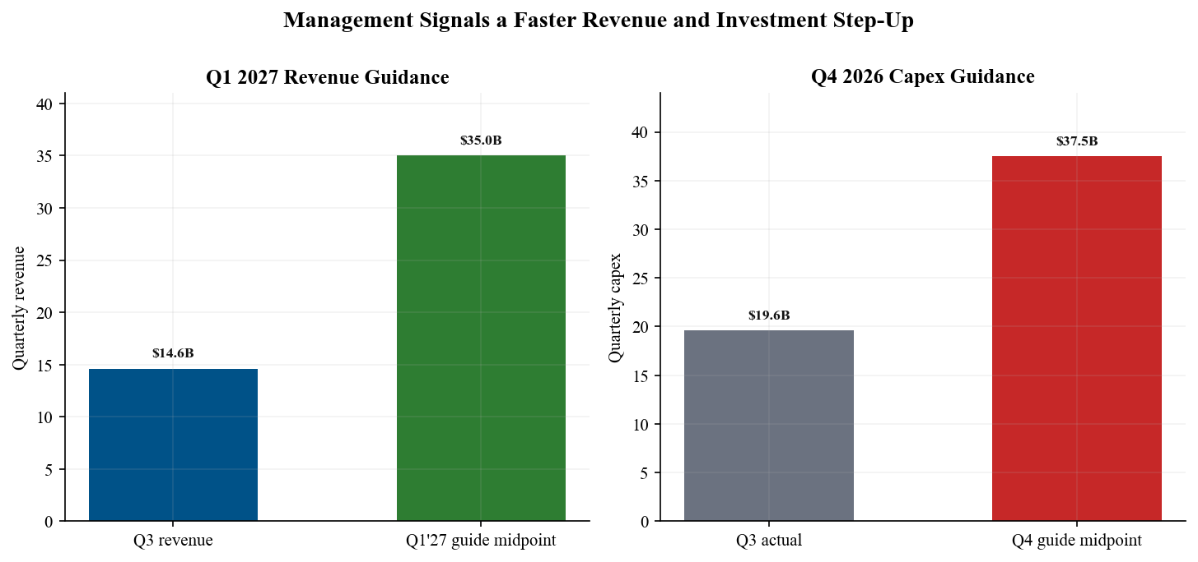
Source: Q3 earnings call transcript, 20 Oct 2026, CFO guidance; Q3 earnings release, 20 Oct 2026; Q2 earnings webcast, 4 Aug 2026, prior ARR target

8 Estimate revisions incorporate Q1 visibility and Q4 spending
We raise FY2026 revenue to $50.5B from $35.0B and adjusted EBITDA to $29.0B from $15.5B. Nine-month reported revenue of $27.1B leaves $23.4B for Q4 in our model, consistent with the year-end ARR target but below a simple extrapolation of Q1 2027 guidance. We lift FY2026 capex to $85.5B from $65.0B, reflecting management's $35-40B Q4 range.
Metric | FY26 old | FY26 new | Change | FY27 old | FY27 new
Revenue | $35.0B | $50.5B | +44% | $58.0B | $142.0B
Adjusted EBITDA | $15.5B | $29.0B | +87% | $26.0B | $72.0B
Operating income | $(3.0)B | $8.5B | NM | $4.0B | $31.0B
Net income | $(6.0)B | $9.1B | NM | $0.0B | $27.0B
GAAP diluted EPS | $(0.50) | $0.69 | NM | $0.00 | $1.95
Capital expenditures | $65.0B | $85.5B | +32% | $75.0B | $150.0B
Source: Q3 earnings release; Q3 earnings call guidance; Q2 Form 10-Q baseline. Old estimates from independent post-Q2 update dated 5 Aug 2026; new estimates dated 21 Oct 2026
For FY2027, we raise revenue to $142B and adjusted EBITDA to $72B. The revenue forecast assumes Q1 guidance is achieved near the midpoint, followed by continued SI and Connectivity growth but some sequential normalization after the initial capacity ramp. We forecast $31B of operating income and $27B of net income, below management's most ambitious ARR scenarios and before any Tesla combination.
Our FY2027 capex estimate rises to $150B because 10 GW of incremental compute, higher Starship cadence, V3 deployment, and mobile-spectrum integration require sustained spending. The model therefore shows strong accounting earnings alongside negative free cash flow. The largest sensitivities are SI utilization, realized cloud pricing, power availability, depreciation life, stock compensation, and the timing of customer prepayments.
Figure 10 - Old and post-Q3 estimates
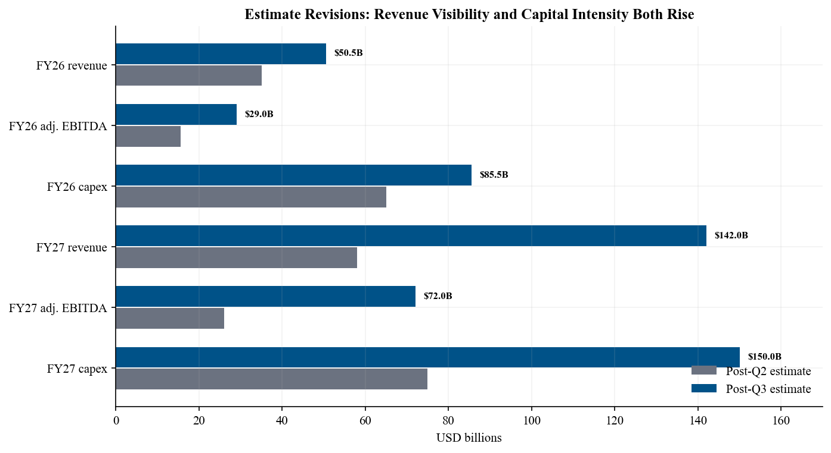
Source: Independent post-Q2 estimates, 5 Aug 2026; Q3 results and guidance, 20 Oct 2026; Q3 earnings call transcript

9 Valuation supports a higher target but not a narrow range
We raise our 12-month price target to $210 from $150 and maintain Outperform. The target implies an equity value of approximately $2.62T on the current diluted share base. At the 20 October regular close of $147.79, it represents 42% upside; at the $159.71 after-hours close, upside is 31%. The market is already capitalizing substantial long-duration optionality, so our rating depends on continued capacity conversion rather than multiple expansion alone.
Our SOTP assigns approximately $650B to Connectivity, reflecting its recurring revenue, improving ARPU, 45% operating margin, and mobile optionality. We assign $250B to Space, including launch leadership and explicit Starship option value. SI receives $1.67T, supported by the $63B backlog, Q1 2027 revenue guidance, positive Q3 operating income, and the possibility of rapid compute scaling. Adding roughly $51B of net cash and modest corporate adjustments produces the $2.62T equity value.
The base target equates to about 18.5x FY2027 revenue and 36x FY2027 adjusted EBITDA. Those multiples are extreme for mature infrastructure but lower than the current value placed on FY2026 earnings because our model assumes a large step-up. We do not use near-term P/E as the primary tool: below-the-line volatility, acquisition stock compensation, and a rapidly growing share base make it unstable.
The $110 bear case assumes slower SI utilization, lower cloud pricing, delayed power and Starship milestones, and no strategic premium for a Tesla combination. The $320 bull case assumes Q1 guidance is exceeded, 2027 compute approaches the high end of management's capacity ambition, Connectivity sustains current margins, and Starship achieves rapid reuse. No merger value is included in the $210 base case because the special committees have not agreed terms and shareholder approval is uncertain.
Figure 11 - Twelve-month valuation scenarios
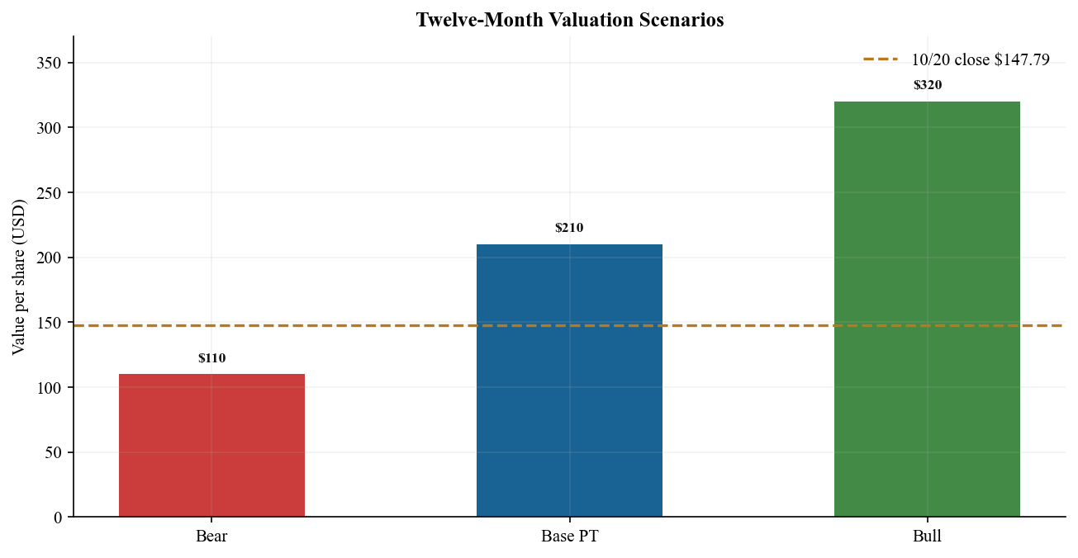
Source: Independent analyst SOTP dated 21 Oct 2026; Q3 earnings call transcript, 20 Oct 2026; Longbridge close and market cap, accessed 21 Oct 2026

10 Updated thesis catalysts and risks
- Thesis pillar 1 Connectivity scale strengthened. Subscriber growth, sequential ARPU improvement, and 99% operating-income growth confirm that Starlink is a high-quality recurring earnings engine. Enterprise, aviation, government, mobile, and V3 capacity broaden the opportunity beyond consumer broadband.
- Thesis pillar 2 Vertical integration strengthened. Flight 14 connected Starship economics directly to V3 deployment, while SI combines compute, models, and applications after Cursor. The same engineering and capital base is increasingly shared across launch, connectivity, and compute.
- Thesis pillar 3 Self-funded compounding remains weakened. Despite positive GAAP operating income, nine-month free cash flow was about $(35)B and Q4 capex guidance is $35-40B. The company still depends on IPO cash, debt markets, supplier and customer financing, and stock compensation.

Catalysts
The next twelve months include Starship Flight 15 and a planned dual-stage catch attempt; progress toward weekly Starship launches; visible V3 service improvements; the 800 MHz spectrum transaction; Q4 year-end ARR evidence; Q1 2027 revenue delivery; Cursor enterprise adoption; and updates on Terafab test chips. Each can materially change either the revenue curve or the cost of capital.

Principal risks
The leading risks are SI customer concentration and contract duration, cloud pricing, GPU and power availability, depreciation and obsolescence, launch failures or licensing delays, spectrum approval, Starlink competition, government-contract timing, acquisition integration, stock-based compensation, dual-class governance, key-person dependence, and further capital needs. A potential Tesla transaction adds conflict, valuation, approval, dilution, and execution risks before any synergy is realized.

Call takeaways
Management's tone was highly confident on demand and technically ambitious on capacity. It framed 10 GW of incremental 2027 compute as highly likely and 20 GW as possible but difficult. The company disclosed a rough 50/50 target for internal vs. external compute allocation, with flexibility to shift. On a Tesla combination, Elon Musk confirmed independent special committees but emphasized that no terms have been agreed and a transaction is not certain. Our estimates exclude merger effects.
Source: Official earnings event and replay; Q3 earnings call transcript; Associated Press call coverage. Call held 20 October 2026; transcript date matches the earnings release

Sources and references
Primary earnings materials
• SpaceX Q3 2026 earnings release and unaudited financial statements, 20 October 2026
• SEC Form 8-K and filing index, filed 20 October 2026
• Official Q3 2026 earnings event, webcast, Q&A, and earnings update, 20 October 2026
• Q3 2026 earnings call transcript, 20 October 2026
• Form 10-Q for quarter ended 30 June 2026, filed 4 August 2026
• Official Q2 2026 earnings event and prior outlook, 4 August 2026
Consensus and market context
• TipRanks Q3 preview and pre-earnings consensus, 19 October 2026
• Zacks key-metric consensus and results comparison, 20 October 2026
• Associated Press results and call coverage, 20 October 2026
• Longbridge live quote and calculated market data, accessed 21 October 2026
• Yahoo Finance yfinance check attempted 21 October 2026; unavailable, so dynamic fields are N/A
Methodology notes
Beat and miss calculations use public pre-earnings consensus dated 19 October 2026. Free cash flow equals operating cash flow less purchases of property, plant, and equipment. Adjusted EBITDA is company-defined and excludes depreciation, share-based compensation, interest, taxes, and other items. Forecasts, SOTP, rating, and price target are independent analyst estimates, not company guidance. Dynamic yfinance fields are shown as N/A because the 21 October query failed; valuation references instead use the independently retrieved 20 October Longbridge close. The Q3 Form 10-Q had not been filed as of publication; Q3 figures use the SEC-filed 8-K and Exhibit 99.1, while the Q2 Form 10-Q supplies detailed accounting and historical context.
DISCLAIMER
This report is for informational purposes only and does not constitute investment advice, an offer, or a solicitation. Forecasts and price targets are independent estimates based on public information and may change without notice. Investors should perform their own due diligence and consider their objectives and risk tolerance.

