SPACE EXPLORATION TECHNOLOGIES CORP. (SPCX)
Q1 2026 POST-IPO EARNINGS UPDATE
Starlink Prints $1.2B Profit, but xAI Losses Drive $(4.3)B Net Loss
Date: June 14, 2026
Rating: INITIATE AT MARKET PERFORM
Price (as of Jun 13, 2026): $160.95
Price Target: $150 — 12-Month
Market Cap: $2.11T | IPO Price: $135 | Day-1 Close: ~$161 (+19%)

Q1 2026 FINANCIAL SUMMARY
Metric | Q1 2026 | Q1 2025 | YoY Change
Revenue | $4.69B | $4.07B | +15.4%
Adj. EBITDA | $1.13B | N/A | —
Operating Income / (Loss) | $(1.94)B | $0.03B | NM
Net Income / (Loss) | $(4.28)B | $(0.53)B | NM
Basic Loss Per Share | $(1.27) | $(0.18) | NM
Free Cash Flow | $(9.1)B | N/A | —
Source: SpaceX S-1 Registration Statement (filed May 20, 2026); Amendment No.1 (June 1, 2026).

■ Starlink is the crown jewel — $3.3B revenue and $1.2B operating profit in Q1, with 10.3M subscribers
The Connectivity segment generated $3.26B in Q1 revenue (69% of total) with $1.19B operating income and $2.09B Adjusted EBITDA (64% margin). Starlink subscribers reached 10.3M across 164 markets, up from 8.9M at year-end 2025. The segment's profitability effectively subsidizes the rest of the business. However, ARPU has declined from $99/month in 2023 to $66/month as Starlink expands into lower-income markets and faces competitive pricing pressure, a trend that bears watching.
■ xAI losses accelerate: $(2.5)B operating loss in Q1 alone, with $7.7B CapEx on AI infrastructure
The AI segment (xAI, Grok, X platform) posted ~$815M revenue but incurred ~$(2.5)B in operating losses — annualising to $(10)B. Q1 AI CapEx of $7.7B (76% of total $10.1B CapEx) reflects the buildout of the Colossus data center (220K NVIDIA GPUs, 300MW). While the $45B Anthropic compute contract provides revenue visibility, the cash burn rate is extraordinary and the path to segment profitability remains highly uncertain.
■ Space segment revenue declined 28% YoY to $619M, weighed by Starship R&D cycle
Falcon 9 remains the workhorse launch vehicle but Space segment revenue dropped to $619M as the company invested $3.0B in FY2025 alone on Starship development. The Space segment posted a $(0.6)B operating loss in Q1 (annualised). While Starship's eventual commercialisation could be transformative, near-term Space economics are dilutive to overall profitability.
■ Initiating at Market Perform with $150 PT — extraordinary business, extraordinary valuation
At ~$2.1T market cap (94x 2025 revenue), SpaceX trades at a significant premium to any comparable company. Starlink's growth and profitability are genuinely exceptional, but xAI losses are accelerating and aggregate FCF is deeply negative ($(9.1)B in Q1). Our $150 PT implies ~7% downside from current levels, reflecting our view that the IPO pop has priced in optimistic scenarios and near-term earnings visibility is limited by the xAI investment cycle.
FINANCIAL ESTIMATES
Metric | FY2025A | FY2026E | FY2027E
Revenue ($B) | $18.7 | $22.0 | $28.0
Revenue Growth | +33% | +18% | +27%
Adj. EBITDA ($B) | $6.6 | $5.5 | $9.0
Adj. EBITDA Margin | 35.2% | 25.0% | 32.1%
Operating Income / (Loss) ($B) | $(2.6) | $(6.0) | $(3.0)
Net Income / (Loss) ($B) | $(4.9) | $(10.0) | $(5.0)
CapEx ($B) | $20.7 | $35.0 | $30.0
Note: "A" = Actual, "E" = Estimate. Source: S-1 filing (actuals), analyst estimates (forward).

DETAILED RESULTS ANALYSIS
Revenue Analysis
SpaceX reported consolidated Q1 2026 revenue of $4.694B, up 15.4% YoY from $4.07B in Q1 2025. The slower topline growth (vs. 33% FY2025 annual growth) reflects a 28% decline in the Space segment partially offset by continued strong Starlink momentum. Revenue composition continues to shift toward Connectivity, which now represents 69% of total revenue, up from approximately 63% a year ago.
Segment | Q1 2026 | Q1 2025E | YoY Change | % of Total
Connectivity (Starlink) | $3,260M | $2,560M | +27% | 69%
Space (Launch/Dragon) | $619M | $860M | -28% | 13%
AI (xAI / X) | $815M | $650M | +25% | 18%
Eliminations / Other | — | — | — | —
Total Revenue | $4,694M | $4,067M | +15.4% | 100%
Source: S-1 Registration Statement. Q1 2025 segment estimates derived from YoY growth rates disclosed.
Figure 1 — SpaceX Consolidated Revenue
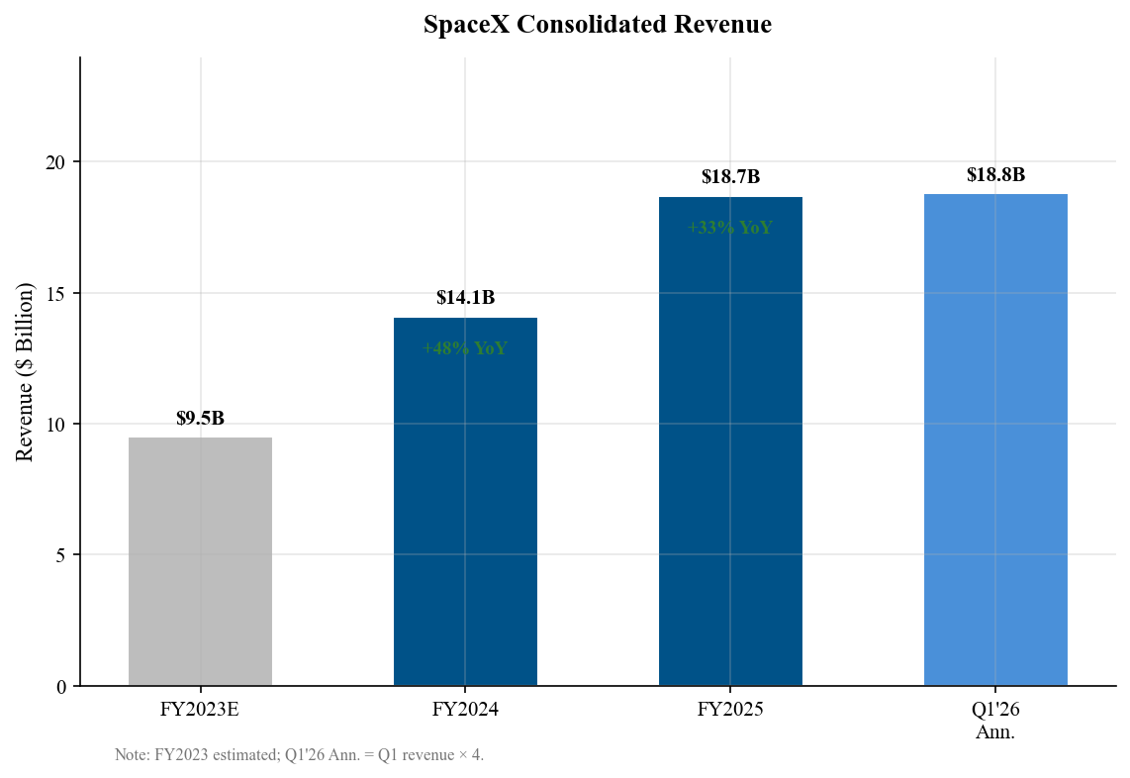
Source: S-1 Registration Statement (FY2024-2025 actuals); FY2023 estimated from industry sources.
Connectivity Segment (Starlink)
Starlink delivered $3.26B in Q1 revenue with $1.19B operating income (36% margin) and $2.09B Adjusted EBITDA (64% margin). The subscriber base reached 10.3M as of March 31, 2026, up from 8.9M at year-end 2025 (+16% in one quarter). Starlink operates in 164 markets and controls approximately 75% of all maneuverable satellites in orbit.
The key concern is ARPU compression: monthly ARPU declined from $99 in 2023 to $66 in Q1 2026 (-33% over ~2.5 years). This reflects geographic expansion into emerging markets with lower pricing, competitive offerings from Amazon Kuiper and OneWeb, and enterprise/government mix shifts. While subscriber growth more than compensates, the trajectory warrants monitoring as the addressable market for high-ARPU developed-market broadband approaches saturation.
Space Segment
Space segment revenue declined 28% YoY to $619M. The company invested $3.0B in Starship R&D during FY2025, and the Space segment posted a $(657)M operating loss for the full year. Falcon 9 remains profitable on a standalone basis — it launched ~100 times in 2025 with high reliability — but the Starship development program is a significant drag on segment economics. Government contracts contributed approximately $5.9B of total company revenue in FY2025 (~32%), providing a relatively stable revenue base.
AI Segment (xAI / X)
The AI segment (consolidated following the xAI merger in February 2026) generated ~$815M in Q1 revenue but posted ~$(2.5)B in operating losses. FY2025 AI losses totaled $(6.4)B on $3.2B revenue. The segment is anchored by a $1.25B/month compute contract with Anthropic through May 2029 (~$45B lifetime value), providing significant revenue visibility. The Colossus data center (220K NVIDIA GPUs) represents the company's bet on becoming a major AI infrastructure provider. AI CapEx consumed $12.7B in FY2025 and $7.7B in Q1 2026 alone (76% of total CapEx), reflecting the extraordinary capital intensity of this segment.

Figure 2 — Revenue by Segment
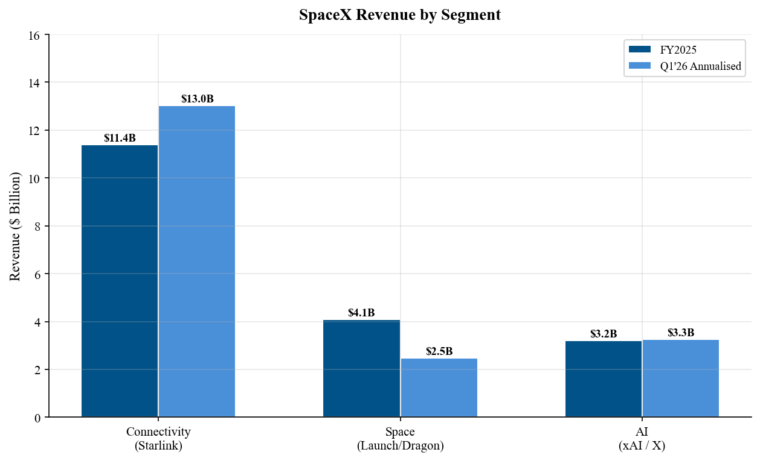
Source: S-1 Registration Statement.
Figure 3 — Segment Profitability (Annualised)
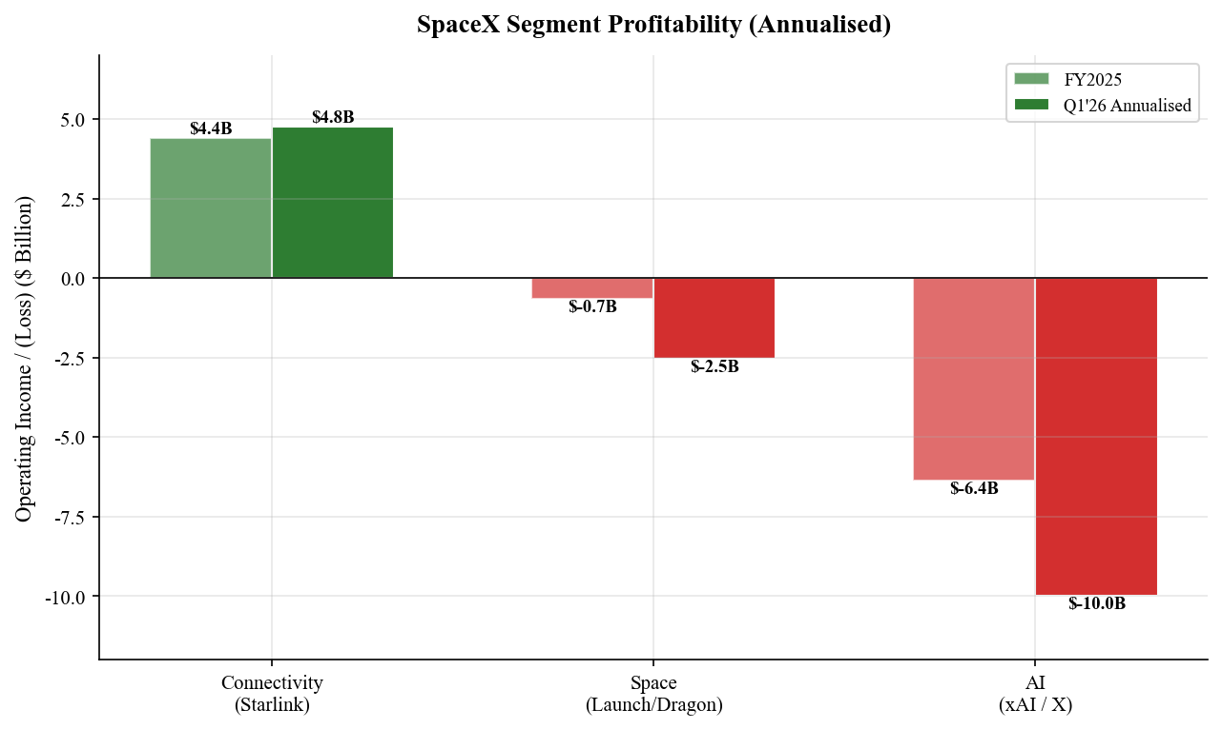
Source: S-1 Registration Statement; analyst calculations.

KEY METRICS & STARLINK ANALYSIS
Starlink Operating Metrics
Metric | YE 2023 | YE 2024 | YE 2025 | Q1 2026
Subscribers (M) | 2.3 | 4.4 | 8.9 | 10.3
YoY Sub Growth | — | +91% | +102% | +49%*
Monthly ARPU ($) | $99 | $85 | $76 | $66
ARPU YoY Change | — | -14% | -11% | -13%*
Markets Served | ~60 | ~100 | ~150 | 164
*Q1 2026 growth rates are vs. Q1 2025 estimated. Source: S-1 Registration Statement.
Figure 4 — Starlink Subscriber Growth
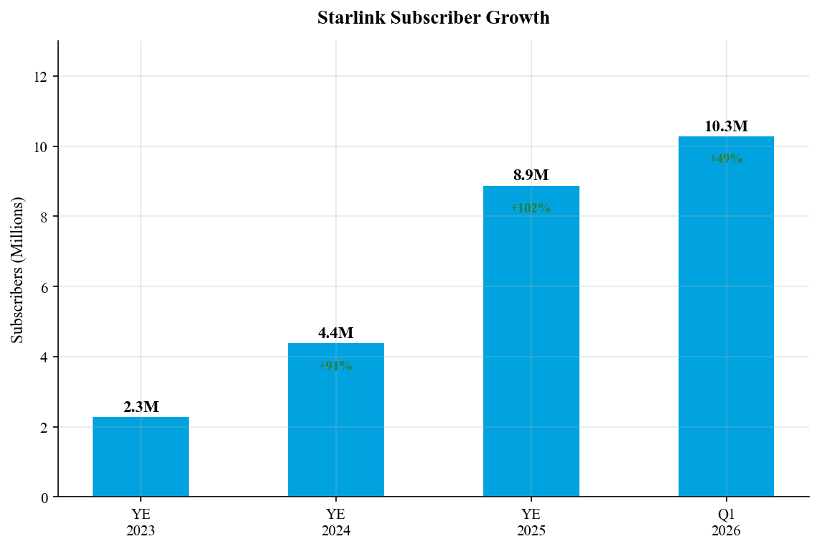
Source: S-1 Registration Statement.
Figure 5 — Starlink ARPU Trend
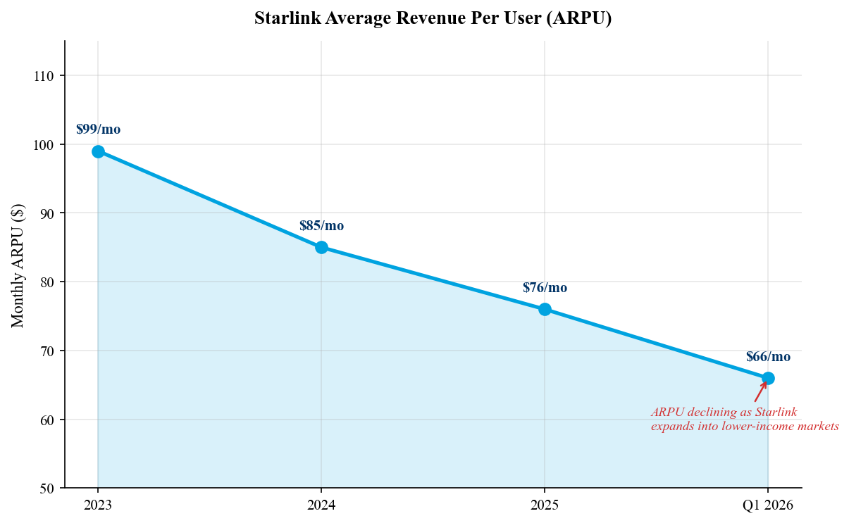
Source: S-1 Registration Statement.
Figure 6 — FY2025 Revenue Mix
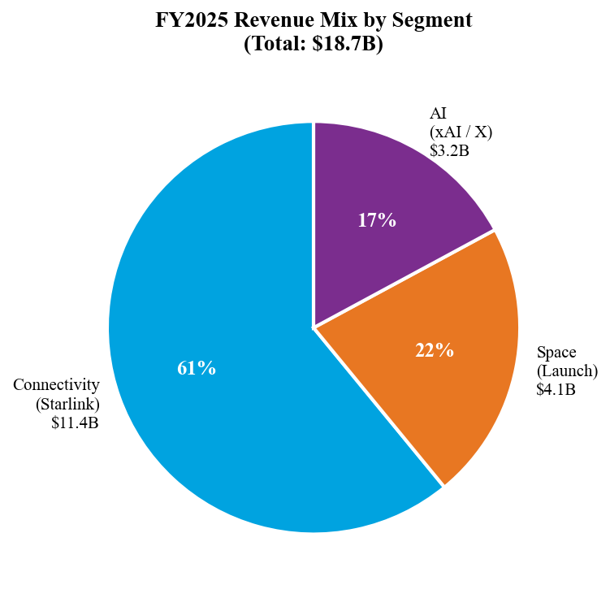
Source: S-1 Registration Statement.

CAPITAL ALLOCATION & CASH FLOW
Capital Expenditure Analysis
SpaceX deployed $20.7B in CapEx during FY2025, exceeding its total revenue of $18.7B. In Q1 2026, CapEx reached $10.1B — annualising to ~$40B — driven overwhelmingly by AI infrastructure spending. The AI segment consumed $12.7B (61%) of FY2025 CapEx and $7.7B (76%) of Q1 2026 CapEx for the Colossus data center buildout. Connectivity CapEx of $4.2B funded satellite launches and ground infrastructure, while Space CapEx of $3.8B primarily funded Starship development.
The resulting free cash flow was deeply negative: $(9.1)B in Q1 2026 alone. Post-IPO, SpaceX's cash position will be significantly bolstered by the ~$75B in IPO proceeds, providing approximately two years of runway at the current burn rate. However, sustaining this level of investment without additional capital raises or a meaningful reduction in AI spending will be challenging.
Figure 7 — FY2025 CapEx by Segment
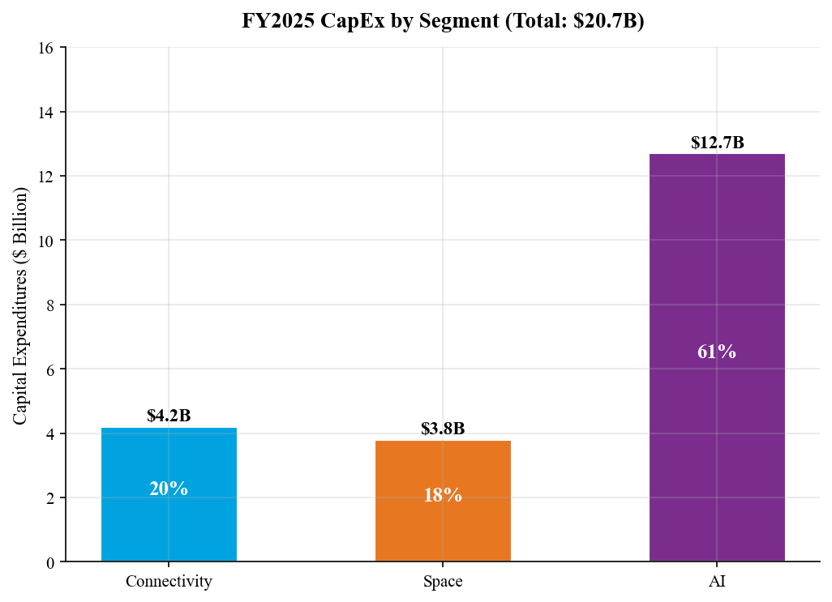
Source: S-1 Registration Statement.
Figure 8 — Q1 2026 Cash Flow Overview
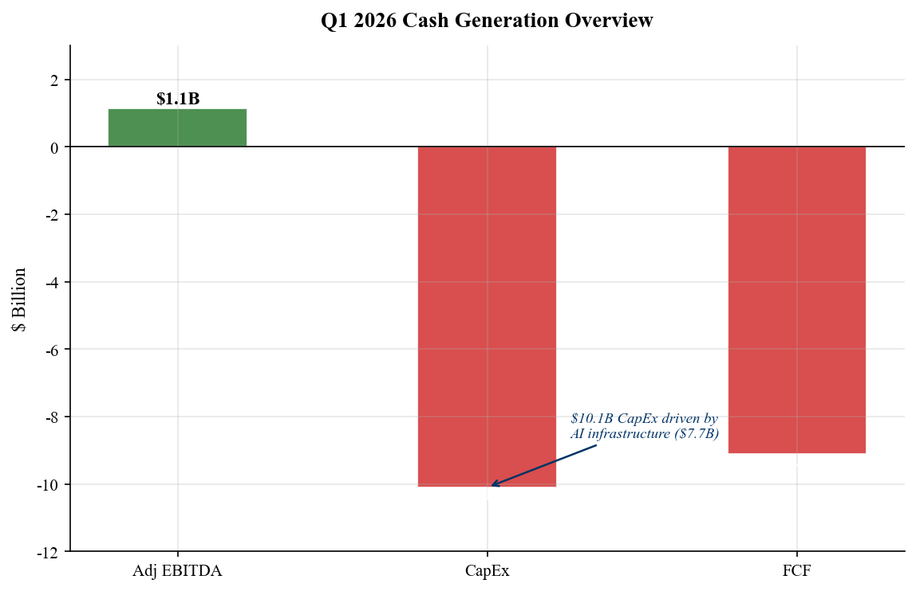
Source: S-1 Registration Statement; analyst calculations.
Balance Sheet Highlights (Pre-IPO)
Item | As of Mar 31, 2026
Cash & Cash Equivalents | $23.7B
Long-Term Debt | $28.7B
Working Capital | ~$5.3B
Accumulated Deficit | $(41.3)B
Post-IPO Pro-Forma Cash* | ~$98B
*Pro-forma includes ~$75B IPO proceeds (before underwriting fees). Source: S-1 Registration Statement.

INVESTMENT THESIS & RISKS
Bull Case
■ Starlink is a generational connectivity franchise with a clear path to $50B+ revenue
With 10.3M subscribers growing 49% YoY and an addressable market of ~5B underserved broadband users, Starlink has a long runway for subscriber growth. Enterprise, maritime, aviation, and government/military applications add TAM layers beyond consumer. If Starlink reaches 50M subscribers at $70 ARPU, it generates ~$42B annual revenue with 60%+ EBITDA margins.
■ Starship unlocks an entirely new era of space economics
Full reusability could reduce launch costs by 10-100x, enabling new markets in space stations, manufacturing, tourism, and Mars colonisation. Government contracts (NASA, DoD) provide near-term revenue stability while Starship reaches commercial viability.
■ AI infrastructure positioning via xAI/Colossus has $45B+ contracted revenue
The Anthropic contract alone provides ~$45B over three years. If SpaceX can position xAI as a top-tier AI infrastructure provider, the segment could reach profitability by FY2028-2029.
Bear Case
■ 94x P/S valuation leaves zero room for disappointment
At ~$2.1T market cap on $18.7B revenue, SpaceX trades at a P/S multiple 10-20x higher than large-cap tech. Even Palantir at ~55x P/S looks cheap by comparison. Any execution misstep or growth deceleration could trigger significant multiple compression.
■ xAI cash burn is extraordinary and path to profitability is unclear
$(2.5)B operating loss in a single quarter, $7.7B CapEx — the AI segment is burning cash at a rate that could consume a large portion of the IPO proceeds within 2-3 years. The compute infrastructure market is intensely competitive (AWS, Azure, GCP), and Grok faces strong competition from OpenAI, Anthropic, and Google.
■ Elon Musk's 85% voting control creates governance risk
Musk holds 42% economic interest but 85% voting power via dual-class shares. Investors have no practical ability to influence strategic decisions, board composition, or capital allocation. Musk's other commitments (Tesla, political activities) create distraction and key-man risk.
Figure 9 — Adjusted EBITDA by Segment (FY2025)
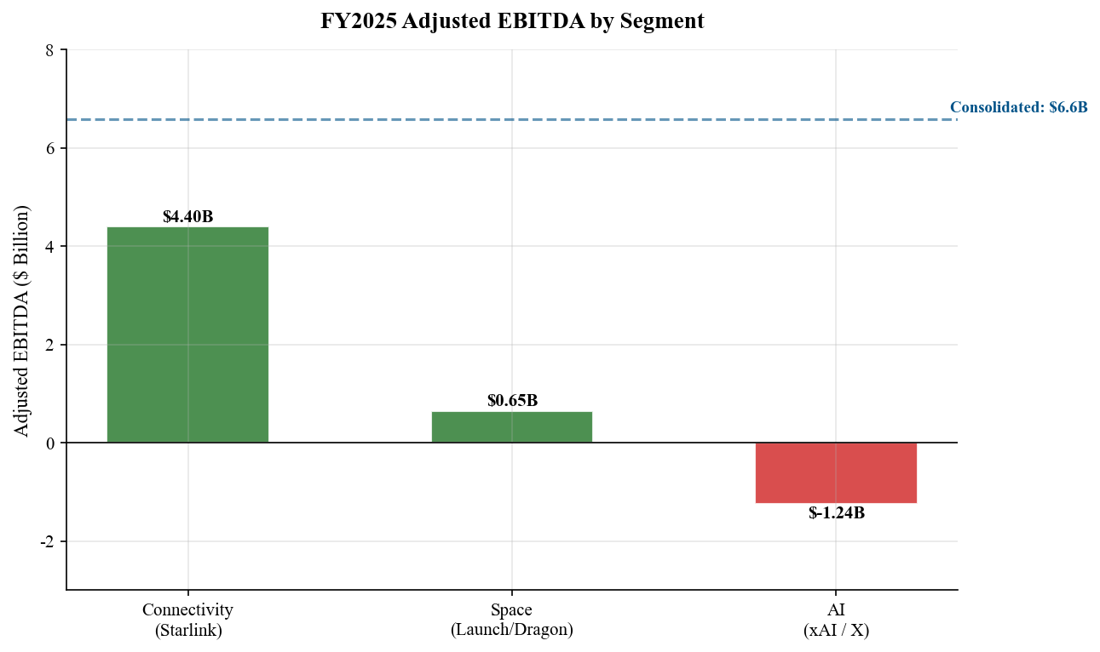
Source: S-1 Registration Statement.

VALUATION & PRICE TARGET
Valuation Framework
SpaceX presents unique valuation challenges. As a three-segment conglomerate with vastly different growth and profitability profiles, a sum-of-the-parts (SOTP) approach is most appropriate.
Connectivity (Starlink) — $800B-$1.0T value: We apply 20x FY2027E revenue of $16B, reflecting Starlink's dominant market position, 60%+ EBITDA margins, and strong subscriber growth. This represents a premium to satellite peers but a discount to high-growth SaaS multiples.
Space — $150B-$200B value: We apply 10x FY2027E Space revenue of $5B, plus a $100B option value for Starship's long-term potential (heavily discounted for execution risk and timeline uncertainty).
AI (xAI) — $80B-$120B value: The February 2026 xAI merger implied ~$80B standalone valuation. Given accelerating losses and competitive headwinds, we maintain this level as our base case.
SOTP Fair Value: $1.03T-$1.32T → ~$80-$100/share
Our $150 price target (above SOTP) incorporates a 50% "platform premium" for the unique strategic value of SpaceX's integrated space-connectivity-AI ecosystem, but remains below the current ~$161 trading level, reflecting our view that post-IPO enthusiasm has overshot near-term fundamentals.
Figure 10 — IPO Valuation: P/S Multiple vs. Peers
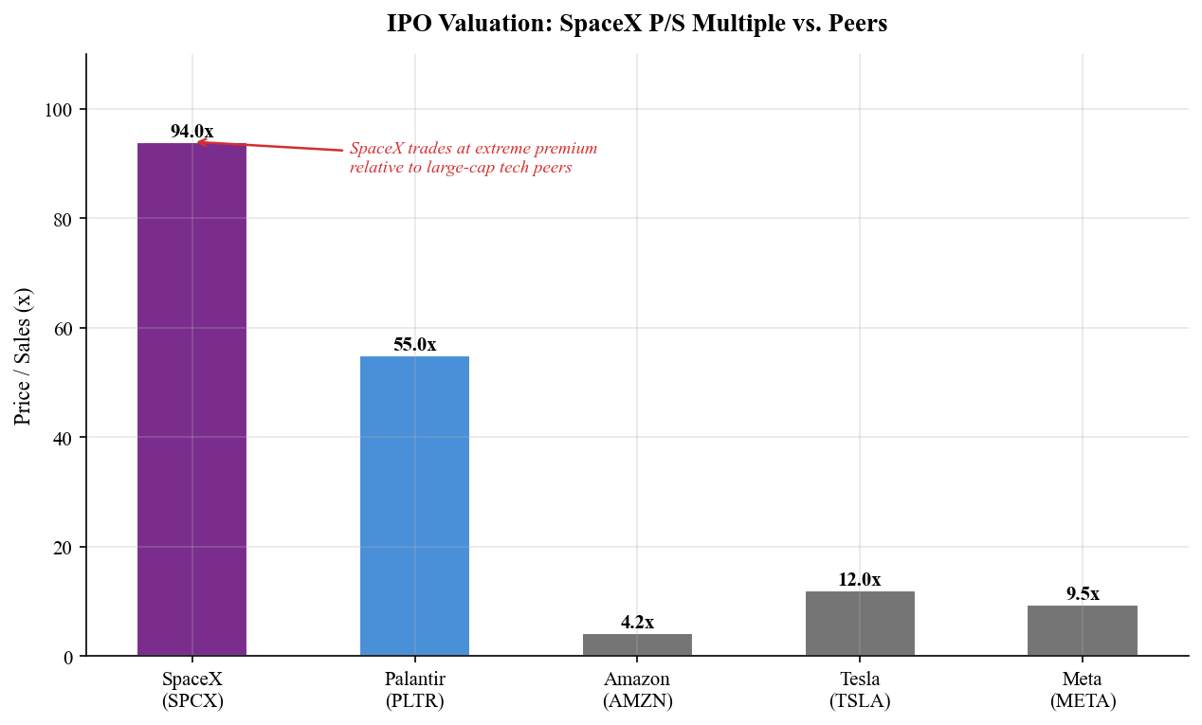
Source: Bloomberg, analyst estimates. P/S based on trailing twelve-month revenue.

SOURCES & REFERENCES
SEC Filings:
• S-1 Registration Statement (Filed May 20, 2026)
• Form 8-K — Q1 2026 Press Release (Filed May 7, 2026)

News & Analysis:
• SpaceX IPO Takes Off — CNBC (June 12, 2026)
• SpaceX files IPO prospectus — Yahoo Finance (May 20, 2026)
• Inside SpaceX's S-1: Three Companies, One Profit — SatNews (May 21, 2026)
• 6 Charts on SpaceX's Pre-IPO Financials — Morningstar
• SpaceX Just Revealed Its Finances — Yahoo Finance

Market Data:
• Bloomberg / Yahoo Finance / yfinance for real-time market data
• SpaceX Investor Relations: https://investor.spacex.com
• Nasdaq listing page: https://www.nasdaq.com/market-activity/stocks/spcx

DISCLAIMER
This report is for informational purposes only and does not constitute investment advice. The analyst is not a licensed investment advisor. All estimates and price targets are based on publicly available information and represent the analyst's independent assessment. Past performance is not indicative of future results. Investors should conduct their own due diligence before making investment decisions. The analyst has no position in SPCX.

