NVIDIA CORPORATION (NASDAQ: NVDA)
Q2 FY2027 EARNINGS UPDATE
AI compute turns into revenue: another beat, a bigger FY2028 framework, and a larger balance-sheet commitment
Published: 27 August 2026 | Results released: 26 August 2026 (within 24 hours)
Rating: MAINTAIN OUTPERFORM | Price target: $320 (prior: $280)
Reference price: $223.94 pre-market 27 Aug. | Regular close: $209.66 | Implied upside: 42.9%
Market capitalization: $5.45tn | 52-week range: $164.07-$236.54

EARNINGS SCORECARD
Metric | Reported | Pre-results consensus | Variance
Revenue | $96.22bn | $92.27bn | +$3.95bn / +4.3%
Non-GAAP diluted EPS | $2.22 | $2.09 | +$0.13 / +6.2%
Data Center revenue | $89.02bn | $85.86bn | +$3.16bn / +3.7%
Q3 revenue guide | $108.0bn +/-2% | $105.16bn | +$2.84bn / +2.7%
Sources: NVIDIA Q2 FY27 release; FactSet consensus via AP; Yahoo Finance breaking consensus.

INVESTMENT TAKEAWAYS
■ The beat was broad and higher quality than the headline alone suggests. Revenue beat FactSet consensus by $3.95bn and non-GAAP EPS by $0.13. Data Center exceeded the contemporaneous Yahoo estimate by $3.16bn, while the 75.0% non-GAAP gross margin held flat sequentially despite the Blackwell Ultra ramp and higher inventory provisions.
■ Growth broadened beyond hyperscalers. Hyperscale revenue rose 13% QoQ to $48.7bn, but ACIE increased 25% to $40.3bn and 138% YoY. That mix supports the thesis that AI-native firms, sovereigns and enterprises are becoming a second demand engine rather than a marginal extension of the four largest clouds.
■ The FY2028 framework is the main positive revision. Management said on the 26 August call that it expects revenue to grow approximately 70% in FY2028, materially above the pre-call market growth assumption. We model $700bn of FY2028 revenue and $16.50 of non-GAAP EPS, but explicitly treat the outlook as a management framework rather than formal guidance.
■ Balance-sheet intensity is now the central debate. Supply commitments increased from $119bn to $279bn in one quarter; total disclosed future commitments were $366bn, and maximum guarantee exposure reached $108.5bn after the August SB Energy arrangement. These commitments may secure scarce capacity and customer sites, but they introduce duration, counterparty and perceived circular-financing risk.
■ Maintain Outperform; raise price target to $320. The target is 19.4x our FY2028E non-GAAP EPS, a substantial de-rating from NVIDIA's five-year trailing average. We lift the target only 14% despite a much larger FY2028 earnings revision because commitments, cash conversion, customer concentration and policy risk require a wider valuation discount.

REVENUE: BLACKWELL ULTRA AND A SECOND DEMAND ENGINE
Q2 revenue reached $96.22bn, up 18% QoQ and 106% YoY. The print was $5.22bn above the midpoint of NVIDIA's own $91bn guide and $3.95bn above FactSet consensus. More important than the arithmetic, Blackwell Ultra supported an unusually clean combination of accelerating volume and stable 75% gross margin. The eight-quarter progression below shows that the company has moved from $35bn to $96bn of quarterly revenue without the margin compression normally associated with a hardware ramp of this magnitude.
Figure 1. Quarterly revenue has more than doubled year over year
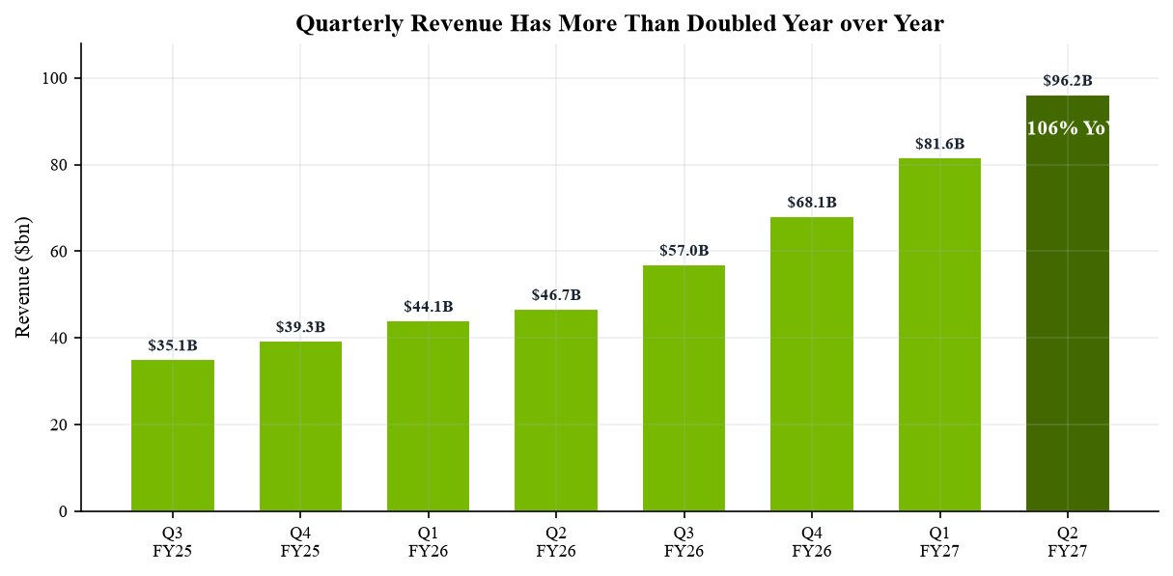
Sources: NVIDIA quarterly releases; Q4 FY26 release.
Data Center contributed $89.02bn, or 92.5% of revenue. It rose 18% sequentially and 117% from a year ago. The sequential share increase was small because Edge Computing also grew 13%, but the absolute scale is decisive: Data Center added nearly $48bn of revenue in twelve months. Blackwell remained the vast majority of shipments, while Vera Rubin entered production shipments in Q3. That overlap supports continued growth but raises execution risk because NVIDIA must manage two architectures and a much larger component envelope simultaneously.
Figure 2. Data Center reached $89.0bn and 92.5% of total revenue
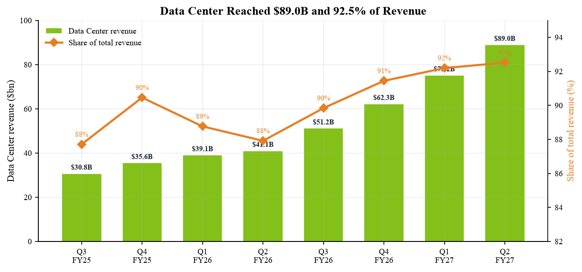
Sources: Q2 FY27 CFO Commentary, pp. 1-2; Q2 FY27 Form 10-Q.

PROFITABILITY: STRONG OPERATING LEVERAGE, LOWER CASH CONVERSION
GAAP operating income rose 124% YoY to $63.73bn, faster than revenue, while non-GAAP operating income reached $63.96bn. Non-GAAP EPS of $2.22 grew 120% and beat consensus by 6.2%. Comparability requires care: beginning in FY2027, NVIDIA's non-GAAP measures include stock-based compensation, and historical comparisons in current materials were recast. The gap between GAAP EPS of $2.46 and non-GAAP EPS also reflects $7.8bn of net equity-security gains excluded from the adjusted measure. We therefore anchor valuation to non-GAAP EPS and operating economics, not the higher GAAP result.
Figure 3. Q2 non-GAAP EPS rose 120% year over year to $2.22
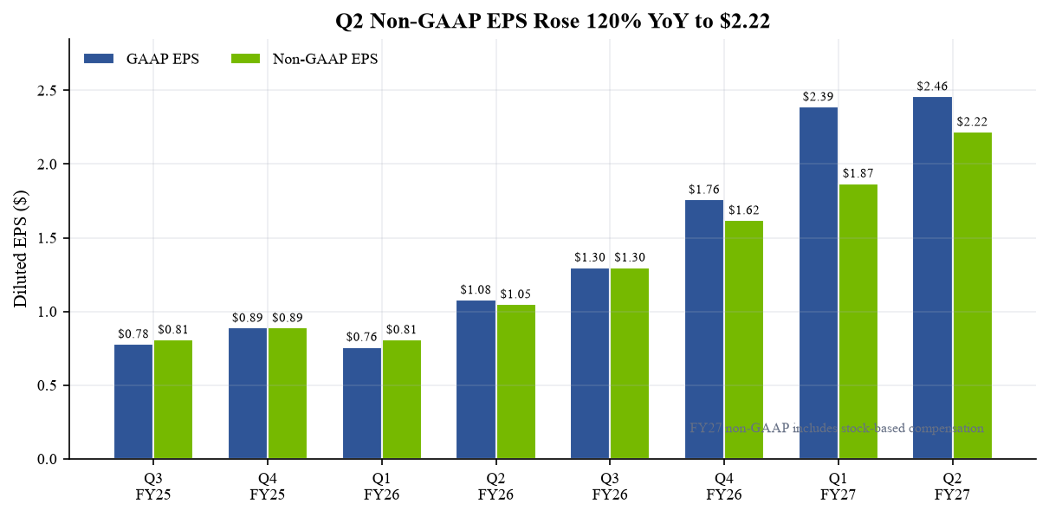
Sources: Q2 FY27 earnings release; Q2 FY27 CFO Commentary, pp. 1 and 7.
GAAP and non-GAAP gross margins were both 75.0%, flat sequentially and 260/250 bps above the prior year. Improved Blackwell Ultra mix offset $985mn of inventory and excess-purchase provisions; net of $177mn of releases, the adverse gross-margin effect was 80 bps. That resilience is encouraging, but Q3 guidance falls to 74.0% +/-50 bps. We interpret the step-down as product-transition and mix friction rather than structural pricing deterioration, while our FY2027 estimate moves to 74.5% from the prior 75.0% baseline.
Figure 4. Gross margin recovered to 75% despite the product transition
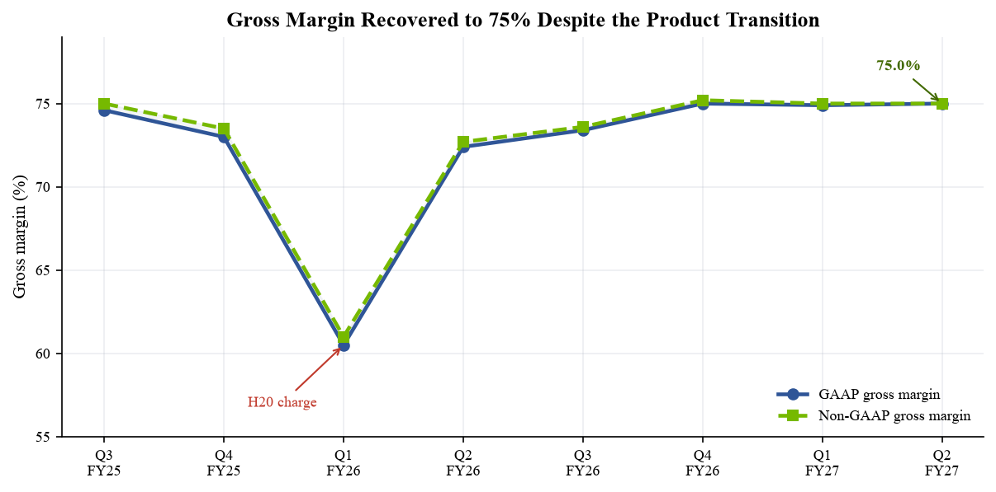
Sources: Q2 FY27 Form 10-Q, MD&A; Q2 FY27 CFO Commentary.

BEAT/MISS AND MARKET-PLATFORM MIX
Vendor snapshots differ slightly by timestamp: FactSet consensus reported by AP was $92.27bn of revenue and $2.09 of adjusted EPS, while Longbridge's release-time snapshot was $92.16bn and $2.091. The analytical conclusion is unchanged. Revenue beat by roughly 4.3%-4.4%, adjusted EPS by 6.2%, and Data Center by 3.7% against Yahoo's $85.86bn expectation. The larger EPS variance indicates that the quarter was not simply a shipment-timing beat; operating leverage and mix also exceeded the pre-results bar.
Figure 5. Q2 beat across revenue, EPS and Data Center
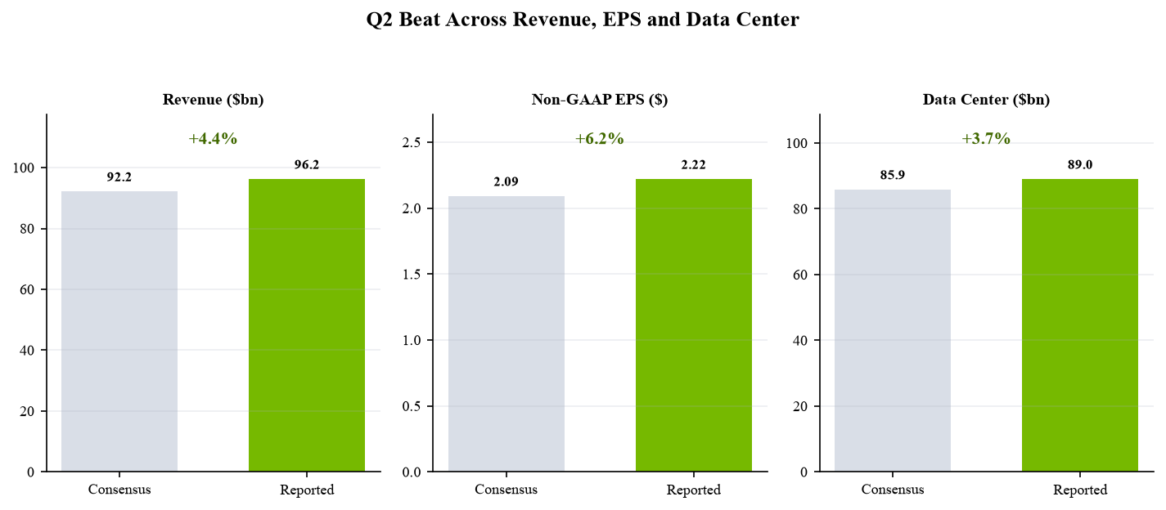
Sources: FactSet consensus via AP; Yahoo Finance results snapshot; NVIDIA release.
The new market-platform disclosure is increasingly useful. Hyperscale was $48.71bn, up 13% QoQ and 102% YoY. ACIE reached $40.31bn, up 25% QoQ and 138% YoY, driven by AI natives, enterprises, sovereign customers and hyperscalers consuming AI-cloud capacity. Edge Computing rose 13% sequentially to $7.20bn as Blackwell workstations offset softer consumer PCs. ACIE's faster growth is thesis-positive because it diversifies end demand, although the 10-Q still shows one direct customer at 16% of quarterly revenue and three direct customers at 16%, 15% and 13% of first-half revenue.
Figure 6. ACIE was the fastest-growing market platform (+25% QoQ)
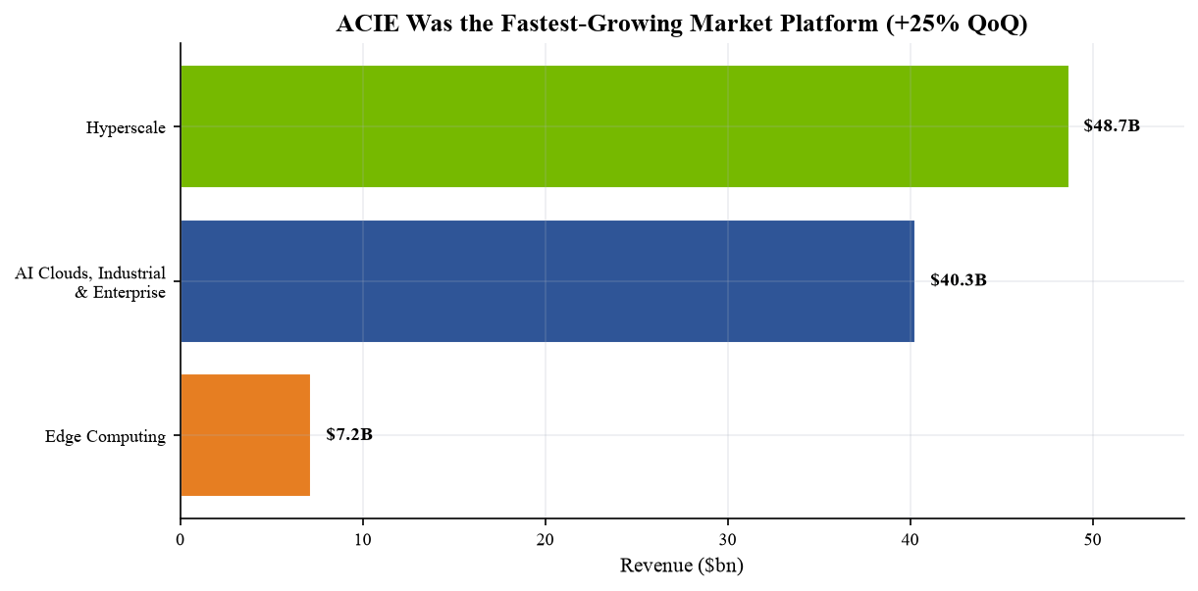
Sources: Q2 FY27 Form 10-Q, Notes 13 and MD&A; Q2 FY27 CFO Commentary, p. 2.
Platform | Q2 FY27 | QoQ | YoY
Hyperscale | $48.71bn | +13% | +102%
ACIE | $40.31bn | +25% | +138%
Edge Computing | $7.20bn | +13% | +27%
Sources: Q2 FY27 CFO Commentary, p. 2.

GUIDANCE: ANOTHER RAISE, PLUS AN UNUSUALLY LONG HORIZON
Q3 revenue guidance is $108bn +/-2%, 12.2% above Q2 at the midpoint and $2.84bn above the pre-results Street expectation cited by Yahoo. Guidance assumes no China Data Center compute revenue. Gross margin is expected at 74.0% +/-50 bps and non-GAAP operating expense at roughly $9.0bn. We forecast $110bn, modestly above the midpoint, because both Hyperscale and ACIE remain supply constrained and Rubin production shipments have begun. The principal near-term debate is therefore not demand sufficiency but whether memory, networking, power and system integration can support the planned delivery curve.
Management then extended the horizon. On the call, CFO Colette Kress said NVIDIA expects revenue to grow approximately 70% in FY2028. The company linked confidence to profitable compute backlogs at hyperscalers, rapid ACIE growth, and revenue opportunity per gigawatt rising from about $18bn for Hopper to $25bn for Grace Blackwell and $40bn for Vera Rubin. Because this was call commentary rather than a formal quarterly guide, investors should apply a wider range of outcomes; it nevertheless forces a material upward reset to outer-year estimates.
China remains excluded from guidance and should be treated as optionality, not base case. Q2 Hopper shipments to China were less than 1% of Data Center revenue. The 10-Q says NVIDIA is effectively foreclosed from broad participation in China's Data Center compute market under the present U.S. and Chinese policy environment. Any re-entry could add revenue, but inspections, a 25% tariff on licensed H200 imports into the United States, and Chinese restrictions make timing and economics uncertain.
Figure 7. Q3 guidance again cleared the pre-results bar
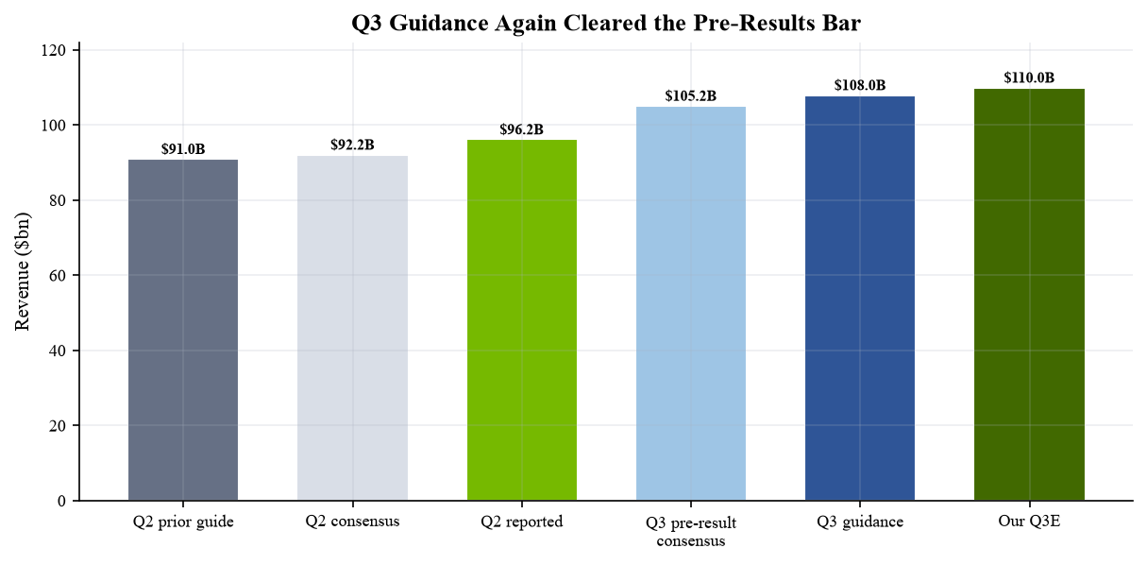
Sources: Q2 FY27 earnings release; Yahoo Finance pre-results consensus snapshot; Q2 FY27 earnings call, 26 Aug. 2026.

BALANCE SHEET: CASH GENERATION IS STRONG, BUT INTENSITY ROSE
The income statement was exceptional; cash conversion was less clean. Accounts receivable rose to $63.06bn from $40.71bn in Q1 and days sales outstanding increased to 60 from 45 because of extended payment terms on large, multi-quarter agreements with investment-grade customers. Inventory climbed to $31.58bn from $25.80bn as NVIDIA prepared for Rubin. Operating cash flow fell sequentially to $24.08bn from $50.34bn and free cash flow to $21.34bn from $48.55bn. The change is mainly working capital and cash taxes, not a collapse in unit economics, but investors should monitor whether receivables and inventory normalize relative to revenue.
Figure 8. Working capital absorbed cash as receivables and inventory rose
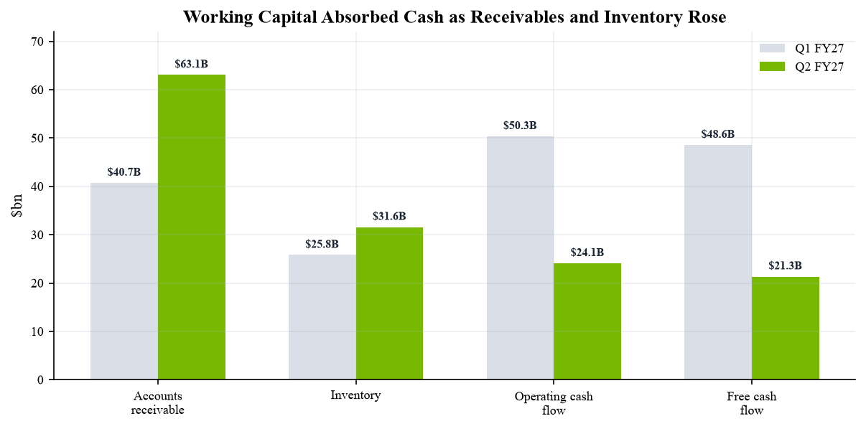
Sources: Q2 FY27 CFO Commentary, pp. 4 and 8; Q2 FY27 Form 10-Q.
Commitments expanded much faster than quarterly revenue. Supply and capacity commitments increased from $119bn to $279bn, primarily for memory and manufacturing facilities. Together with $29bn of cloud-service agreements, $25bn of data-center leases not commenced, $25bn of equity-investment commitments and $8bn of capital-expenditure commitments, disclosed future commitments totaled $366bn. Separately, maximum gross guarantee exposure was $108.5bn, including $105bn of phased support for the SB Energy PORTS-Pike buildout. These are not all current liabilities and should not be mechanically added, but they materially lengthen NVIDIA's risk duration.
Figure 9. Scale of commitments is now a core part of the risk/reward
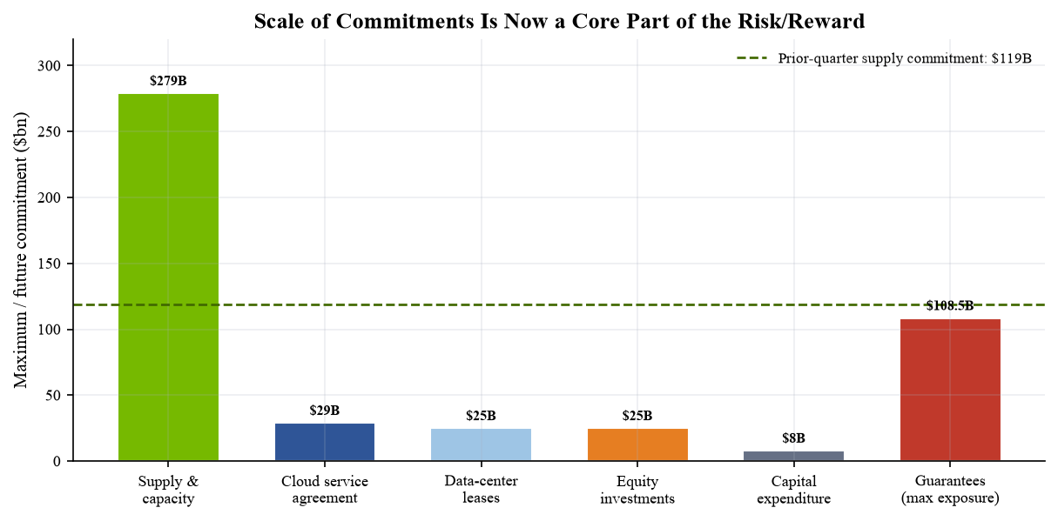
Sources: Q2 FY27 Form 10-Q, Notes 10 and MD&A; Q2 FY27 CFO Commentary, pp. 3-4.

THESIS UPDATE: STRONGER GROWTH, WIDER FINANCING DEBATE
■ Pillar 1 - Full-stack AI infrastructure leadership: strengthened. Blackwell Ultra drove 106% company growth while gross margin held at 75%. Rubin is already entering production shipments, and management claims the revenue opportunity per gigawatt rises materially with each generation. The evidence supports a platform advantage spanning GPU, CPU, networking, systems and software rather than a single-chip cycle.
■ Pillar 2 - Demand breadth and duration: strengthened. ACIE grew 25% sequentially and faster than Hyperscale, while management's FY2028 framework points to approximately 70% growth. The customer mix is broader at the end-market level, but direct-customer concentration remains high and an unnamed AI research and deployment company contributed a meaningful amount of indirect demand through cloud customers.
■ Pillar 3 - Exceptional economics: intact, with a cash-conversion caveat. Operating income more than doubled, adjusted EPS beat consensus and gross margin remained best-in-class. Yet receivables, inventory and cash taxes reduced quarterly free cash flow to $21.3bn. The thesis now requires evidence that extended customer terms are temporary and that Rubin inventory converts to shipments on schedule.
■ Pillar 4 - Capital-light ecosystem model: weakened. NVIDIA is increasingly securing memory, manufacturing, cloud capacity, sites, power and customer financing. This may be rational vertical coordination in a constrained buildout, but $366bn of commitments and $108.5bn of maximum guarantee exposure make the model less capital-light and raise questions about counterparty quality and demand circularity.
We raise FY2027 revenue to $411.8bn from $365bn and non-GAAP EPS to $9.39 from $8.80. Q1 and Q2 actuals contribute $177.84bn and $4.09 of EPS; our Q3 assumptions are $110bn and $2.50, while Q4 is $124bn and $2.80. For FY2028, our $700bn revenue estimate applies management's approximately 70% growth framework to the FY2027 base. We assume gross margin moderates to 74.0%, operating margin to 65.0%, and non-GAAP EPS reaches $16.50. The implied earnings growth is powerful but increasingly depends on working-capital discipline and counterparties outside NVIDIA's traditional supply chain.
Figure 10. Q2 beat and FY2028 framework drive estimate upgrades
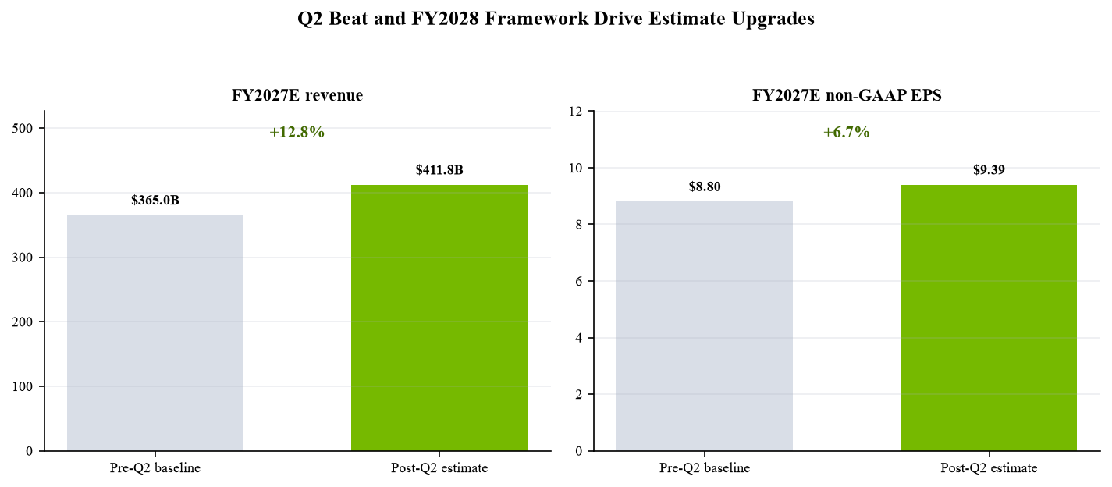
Sources: Our estimates; prior Q1 report dated 6 June 2026; Q2 FY27 earnings call, 26 Aug. 2026; Q2 FY27 CFO Commentary.

UPDATED ESTIMATES AND VALUATION
Our prior Q1 update carried FY2027 revenue of $365bn, non-GAAP EPS of $8.80 and a $280 target. We now have two quarters of actual results, Q3 guidance at $108bn, and a management FY2028 growth framework. The table below separates the mechanical uplift from explicit assumptions. Old estimates are our 6 June 2026 report, not external consensus; new estimates are independent analytical forecasts and are not company guidance.
Metric | FY2027E old | FY2027E new | Change | FY2028E new
Revenue ($bn) | 365.0 | 411.8 | +12.8% | 700.0
Revenue growth | 69.0% | 90.7% | +2,170 bps | 70.0%
Non-GAAP gross margin | 75.0% | 74.5% | -50 bps | 74.0%
Non-GAAP operating income ($bn) | 245.0 | 270.0 | +10.2% | 455.0
Non-GAAP operating margin | 67.1% | 65.6% | -150 bps | 65.0%
Non-GAAP diluted EPS | $8.80 | $9.39 | +6.7% | $16.50
P/E at $223.94 | 25.4x | 23.8x | -1.6x | 13.6x
Sources: Our estimates and 6 June 2026 Q1 update; Q2 FY27 earnings materials; Q2 FY27 earnings call.

Price target methodology
We raise our target to $320 from $280. The target applies 19.4x to FY2028E non-GAAP EPS of $16.50. This is below NVIDIA's five-year median trailing P/E of roughly 58.5x and below its current five-year 'reasonable range' reported by Longbridge, but forward and trailing multiples are not directly comparable. The chosen multiple explicitly discounts: (1) the extraordinary scale embedded in the 70% FY2028 framework; (2) margin normalization to 74%; (3) customer and geographic concentration; and (4) the transition from a capital-light supplier toward a coordinator of supply, sites, credit and cloud capacity.
Scenario framing: our bear value is $250, assuming FY2028 revenue of roughly $600bn, EPS near $13 and a 19x multiple. The $320 base assumes $700bn and $16.50. A $400 bull case assumes China optionality, faster Rubin conversion, better cash conversion and $17.50-$18.00 of EPS at 22x-23x. At the 27 August pre-market reference of $223.94, the base case implies 42.9% upside. The regular 26 August close of $209.66 implies 52.6%; we use the more conservative pre-market reference for rating decisions.

What the target does not assume
The base case assumes no China Data Center compute revenue, no valuation credit for unrealized equity gains, and no benefit from guarantee-supported sites beyond revenue captured in the FY2028 framework. It also does not assume that all commitments are drawn or that maximum guarantees become liabilities. Conversely, it does not ignore them: the lower multiple is the mechanism through which counterparty, duration and circularity risks enter valuation. This approach is more transparent than adding uncertain obligations to enterprise value today.

CATALYSTS, RISKS AND TRADING CONTEXT

Catalyst calendar
■ Q3 FY2027 execution (November 2026). Delivery against the $108bn guide, 74% gross margin and the first Rubin production shipments will test whether supply—not end demand—remains the limiting factor. ACIE growth above Hyperscale would further support demand diversification.
■ Rubin and memory supply visibility. Qualification, rack deployment, networking availability and memory procurement will determine whether NVIDIA can convert $279bn of supply commitments into timely revenue. A narrowing DSO and inventory-to-sales ratio would improve the quality of the growth narrative.
■ FY2028 framework confirmation. Subsequent management commentary, hyperscaler capital budgets and AI-cloud financing activity can validate or challenge the approximately 70% growth expectation. Evidence that third-party customers are using capacity profitably matters more than gross site announcements.

Principal risks
■ Commitment and counterparty risk. Long-dated supply, lease, cloud and guarantee structures may outlive a demand cycle. Defaults, construction delays, weaker customer financing or slower utilization could create losses, cash calls or reputational damage even if current revenue remains strong.
■ Customer concentration and circularity. One direct customer represented 16% of quarterly revenue, and a meaningful amount of demand came indirectly from one AI research and deployment company through cloud customers. NVIDIA's investments and financing support can strengthen the ecosystem while making organic demand harder to separate from enabled demand.
■ Technology and supply execution. Rubin ramps alongside Blackwell, with memory and manufacturing commitments rising sharply. Yield, networking, cooling, power, system integration or component shortages can defer revenue and create excess inventory provisions.
■ Policy and China. China is excluded from guidance and represented less than 1% of Data Center revenue. Export licensing, U.S. inspection and tariff requirements, and Chinese restrictions can limit participation or make any re-entry less profitable than headline revenue suggests.
The one-year chart shows why expectations matter. NVDA closed at $209.66 on 26 August after a 1.6% decline in the regular session, then traded at $219.53 after hours and about $223.94 pre-market on 27 August. The positive reaction confirms the beat and FY2028 framework were not fully priced, but the stock remains volatile around earnings. Our Outperform rating is based on twelve-month risk-adjusted return, not on the direction of the first post-release trading session.
Figure 11. One-year price history still leaves material upside to our base case
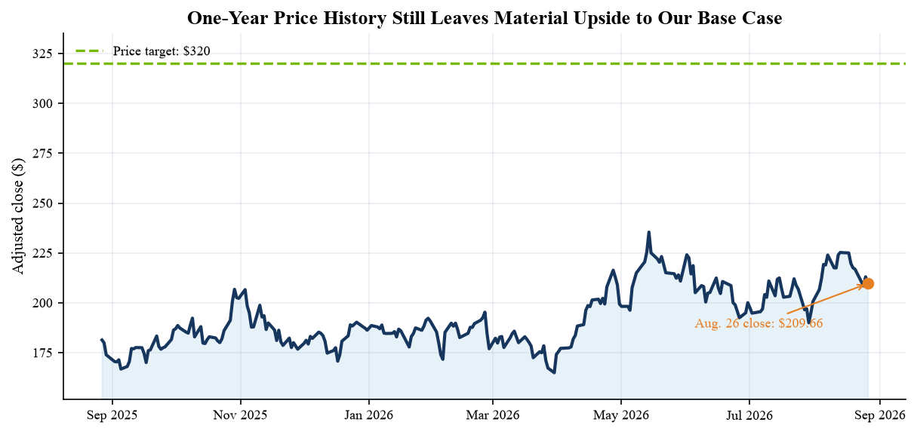
Sources: Longbridge adjusted daily K-line through 26 Aug. 2026; Yahoo Finance dynamic market data; Our valuation.

SOURCES, METHODOLOGY AND DISCLOSURES

Timeliness and identity verification
Today is 27 August 2026. NVIDIA Corporation (Nasdaq: NVDA; SEC CIK 1045810) released Q2 FY2027 results on 26 August 2026 for the quarter ended 26 July 2026. The Form 8-K and Form 10-Q were filed on the same date. The earnings call began at 2:00 p.m. Pacific / 5:00 p.m. Eastern on 26 August, matching the release date. The quarter is therefore the company's latest reported period and the materials are less than one day old.

Source hierarchy
Reported financials, market-platform data, guidance, commitments and risk factors are anchored to NVIDIA's earnings release, CFO Commentary, investor presentation and SEC filings. The official webcast page confirms call timing; the Seeking Alpha transcript and Yahoo call highlights are used for management's FY2028 growth framework and Q&A details. Consensus is FactSet as reported by AP and the release-time Yahoo/Longbridge snapshots. Differences of roughly $0.1bn across consensus vendors reflect snapshot timing and do not alter the beat/miss conclusion.

Forecast and valuation conventions
FY2027 'old' estimates and the $280 prior target are from our 6 June 2026 Q1 update. FY2027 and FY2028 'new' estimates are our independent forecasts. FY2028 revenue applies the approximately 70% management framework to our FY2027 base and is not formal company guidance. Non-GAAP estimates use NVIDIA's FY2027 definition, which includes stock-based compensation. Price target upside uses the 27 August pre-market reference; market capitalization and 52-week range were dynamically fetched through yfinance. Longbridge supplied the verified regular, after-hours and pre-market quotes and adjusted price history.

Important disclosure
This report is independent analytical research for informational purposes only. It is not investment advice, an offer, a solicitation or a fiduciary recommendation. Rating, estimates, scenarios and price target are opinions based on assumptions that may prove wrong. NVIDIA is exposed to technology transitions, manufacturing concentration, supply constraints, customer concentration, export controls, tariffs, competition, market valuation, investments, guarantees and long-duration commitments. Readers should review primary filings and obtain advice appropriate to their circumstances.

REFERENCE LINKS
• NVIDIA Q2 FY2027 earnings release (26 Aug. 2026)
• Form 8-K, filed 26 Aug. 2026
• Form 10-Q, filed 26 Aug. 2026
• Q2 FY2027 CFO Commentary (26 Aug. 2026)
• Q2 FY2027 investor presentation (Aug. 2026)
• Official earnings webcast (26 Aug. 2026)
• Earnings-call transcript (26 Aug. 2026)
• Yahoo call highlights (26 Aug. 2026)
• FactSet consensus via AP (26 Aug. 2026)
• Q1 FY2027 release and prior guidance (20 May 2026)
• Q4/FY2026 release (25 Feb. 2026)
• NVIDIA Investor Relations
• Yahoo Finance market data
• Longbridge NVDA market data

