Western Digital Q4 FY2026 Earnings Update
HDD pricing and mix lift earnings while expectations reset
Published 16 September 2026 Results released 5 August 2026 Delayed reaction update
Rating OUTPERFORM Price target $550 Reference price $411.96 Implied upside 33.5%
Market capitalization $148.5bn 52 week range $99.72 to $799.87

Earnings summary
Metric | Reported | Consensus | Variance
Revenue | $3.747bn | $3.700bn | +$47m +1.3%
Non-GAAP EPS | $3.56 | $3.31 | +$0.25 +7.6%
Non-GAAP gross margin | 54.4% | 51.0% to 52.0% guide | +290 bps vs high end
Free cash flow | $1.281bn | $0.978bn prior quarter | +31% QoQ
Sources: Q4 FY2026 earnings release dated 5 August 2026; MarketBeat consensus snapshot for 5 August 2026
■ A clean beat driven by price and mix Revenue reached the high end of management's prior range, while adjusted EPS cleared consensus by 7.6%. The more important signal was operating leverage: non-GAAP gross margin expanded 1,310 bps year over year and non-GAAP operating margin rose 1,610 bps to 44.2%.
■ AI storage demand is becoming a measurable HDD tailwind Cloud represented 89% of revenue. Exabytes shipped rose 22% year over year, and management expects growth above 25% as 40TB ePMR ramps and 44TB HAMR follows in the first half of calendar 2027.
■ The share-price reaction reflected expectations rather than weaker fundamentals WDC fell about 13% on the next regular session despite the beat. Investors focused on slower near-term exabyte growth, a gross-margin guide below a competitor's level, and the amount of upside already embedded in the pre-print valuation.
■ Outperform with a $550 price target We raise FY2027E revenue and non-GAAP EPS to $18.8bn and $18.90. Our target blends a 24x FY2028E earnings approach with a cash-flow valuation and implies 33.5% upside from the reference price.

Detailed results and beat analysis
Q4 FY2026 revenue rose 44% year over year and 12% sequentially to $3.747bn. The $47m beat versus the published $3.70bn consensus was modest in absolute terms but high quality: growth came from both 22% exabyte expansion and favorable pricing. Management said blended price per terabyte improved from high-single-digit year-over-year growth in Q3 to high-teens growth in Q4. That combination matters because volume alone can consume manufacturing resources without producing the same profit conversion.
The comparison base is clean only on a continuing-operations basis. Western Digital completed the Sandisk separation in February 2025; historical flash results are presented as discontinued operations. We therefore use the HDD-only quarterly series in company materials and do not mix pre-separation consolidated revenue into trend charts.
Figure 1. Quarterly revenue progression
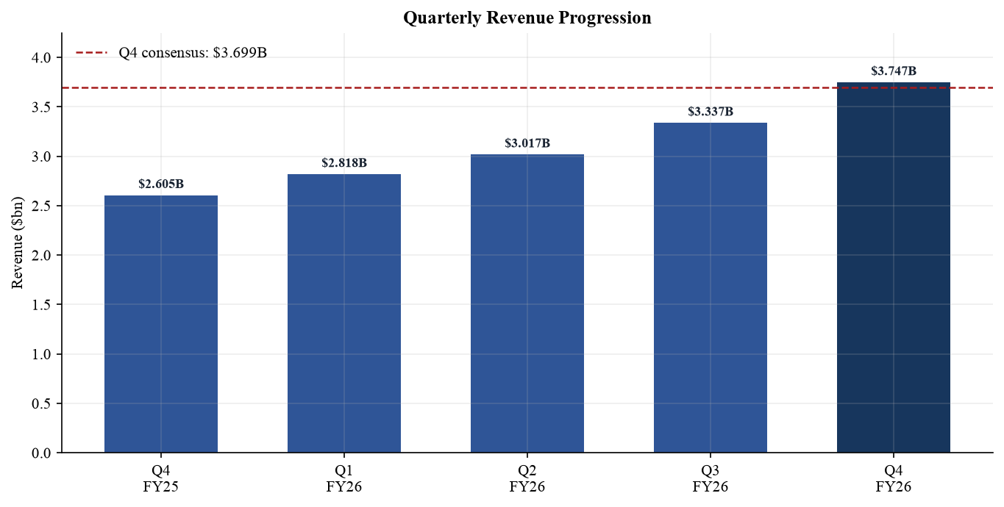
Sources: Q4 FY2026 earnings presentation slides 3 to 6; Q1 to Q3 FY2026 company releases
Figure 2. Q4 FY2026 beat versus published consensus
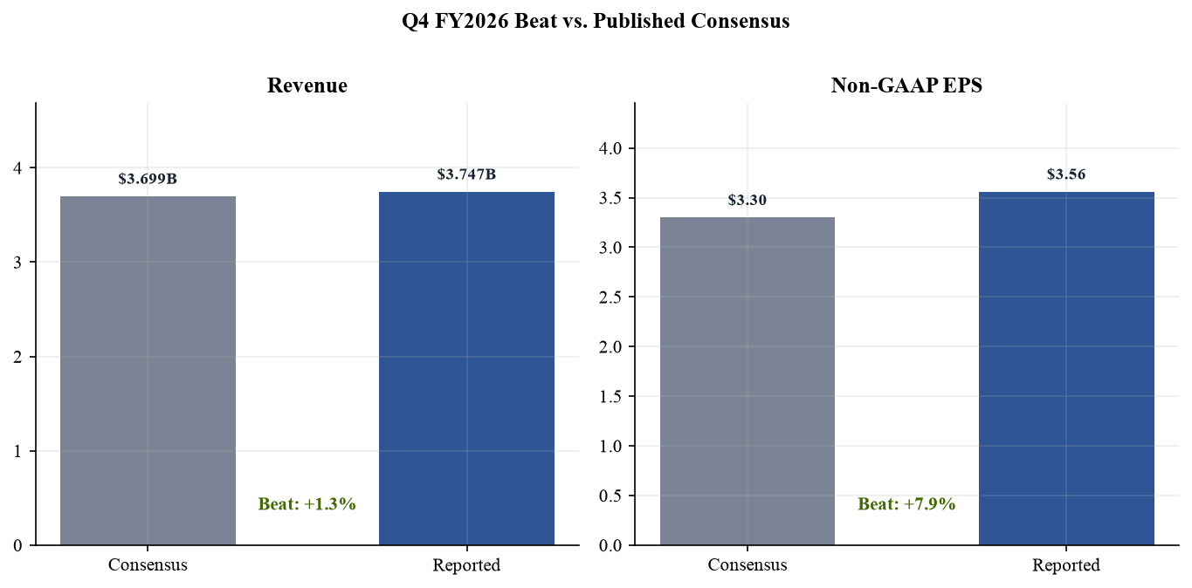
Sources: Q4 FY2026 earnings release; MarketBeat pre-announcement consensus snapshot

Profitability and earnings quality
Non-GAAP gross margin reached 54.4%, up 390 bps sequentially and 1,310 bps year over year. The drivers were a mix shift toward higher-capacity drives, favorable portfolio pricing and manufacturing execution. Operating expenses fell 4% sequentially to $382m even as revenue grew 12%, lifting non-GAAP operating margin to 44.2%. This is the clearest evidence that the current upcycle is producing operating leverage rather than merely replacing lost flash revenue.
GAAP EPS of $8.21 should not be capitalized at face value. It included a large mark-to-market gain associated with the retained Sandisk interest and transaction-related effects. Non-GAAP EPS of $3.56 is a better measure of recurring operating earnings and still increased 109% year over year. The $0.25 beat versus consensus was supported by revenue, margin and a controlled expense base, not by a single below-the-line adjustment.
Figure 3. GAAP and non-GAAP EPS progression
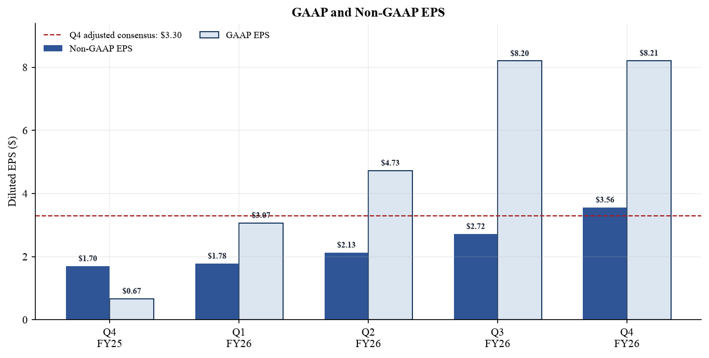
Sources: Q4 FY2026 earnings presentation slides 6 and 10; Company quarterly releases
Figure 4. Non-GAAP margin progression
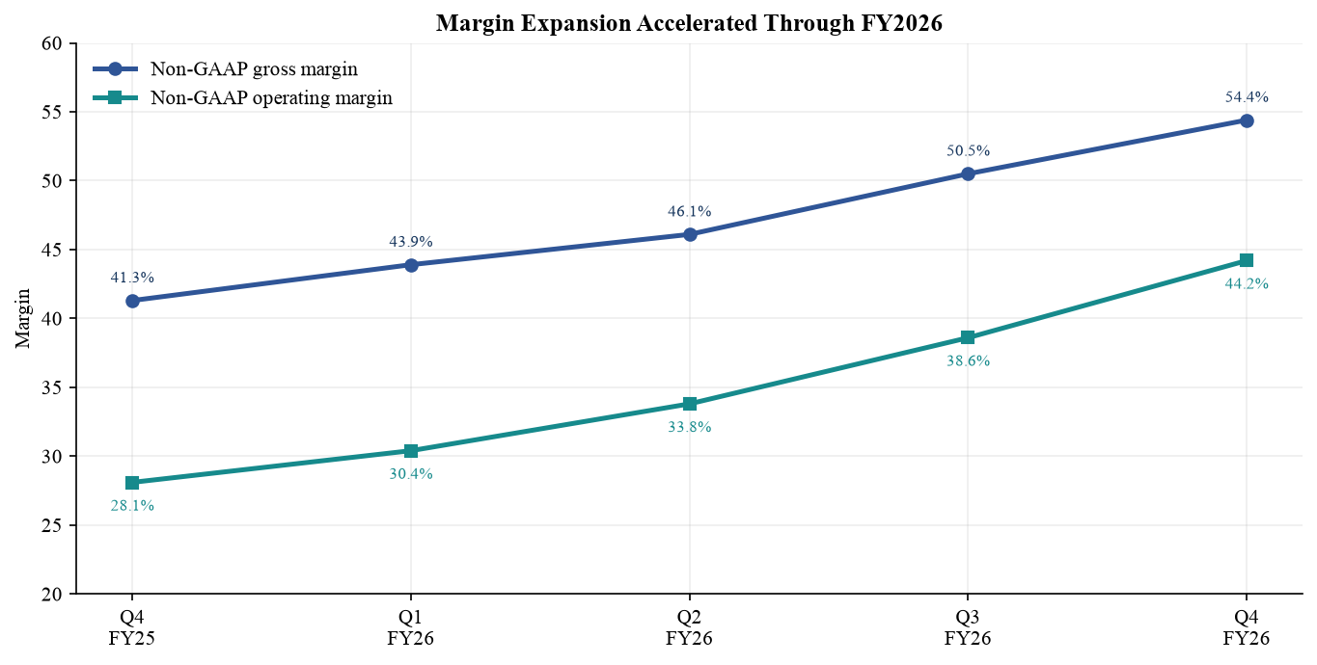
Sources: Q4 FY2026 earnings presentation slides 5 to 7; Q4 FY2026 earnings release

Operating metrics and demand mix
Total exabytes shipped reached 231 in Q4, up from 190 a year earlier. Nearline accounted for 209 exabytes and drove almost all absolute growth, while non-nearline was broadly stable at 22 exabytes. Management attributed the slower sequential cadence to customer and recording-technology mix: a quarter with more CMR demand ships fewer bits per unit than one weighted toward UltraSMR. The lumpiness is real, but it does not invalidate the medium-term capacity trajectory.
Cloud generated approximately $3.3bn and 89% of revenue; client and consumer represented 6% and 5%. FY2026 cloud revenue rose 38%, supported by 27% exabyte growth and 8% higher ASP per exabyte. Concentration is the trade-off: the top ten customers produced 73% of FY2026 revenue, and three customers individually represented 16%, 15% and 13%.
Figure 5. Quarterly exabyte shipments
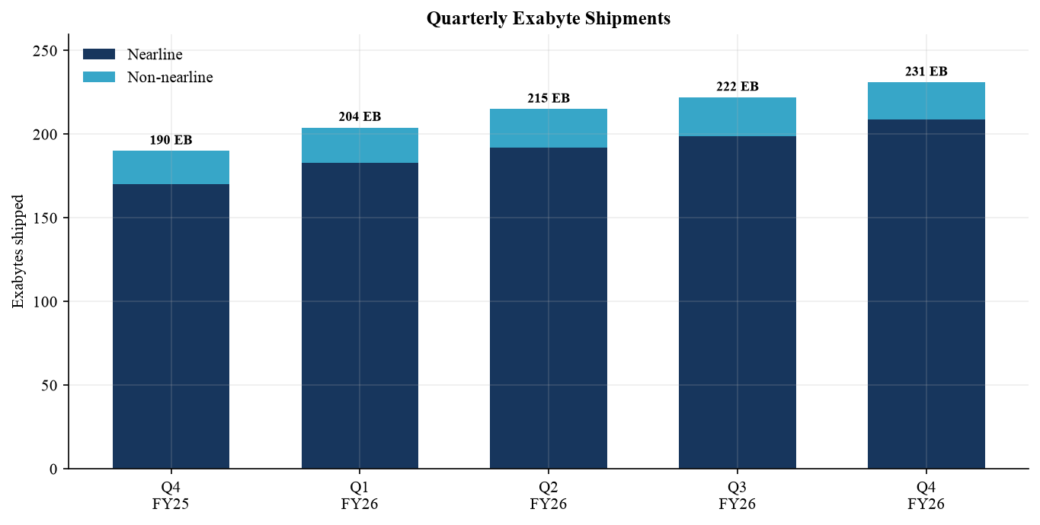
Sources: Q4 FY2026 earnings presentation slide 5; Q4 FY2026 earnings-call transcript dated 5 August 2026
Figure 6. End-market revenue mix
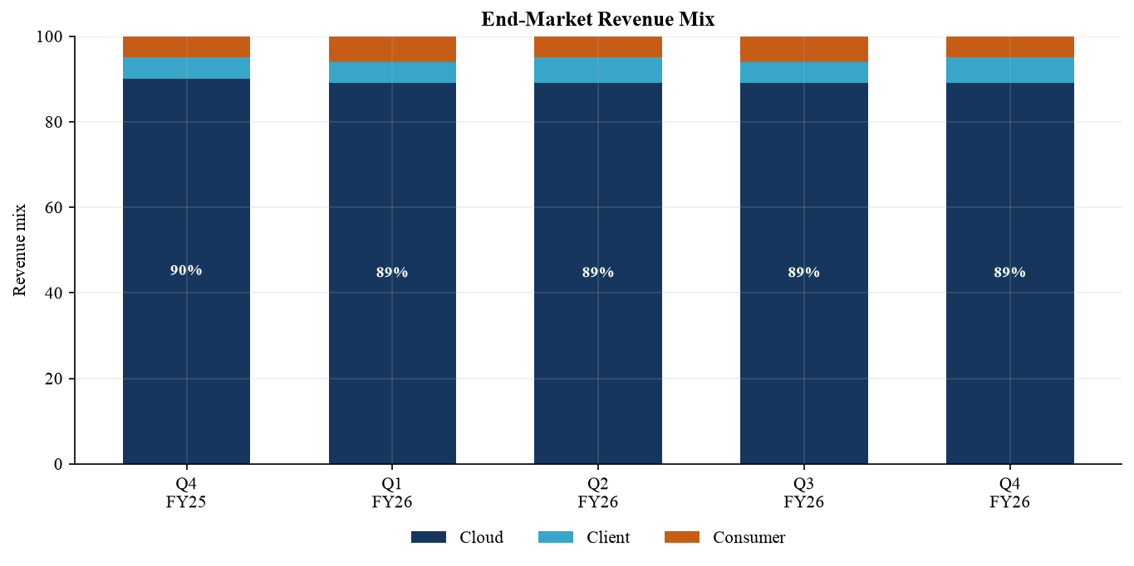
Sources: Q4 FY2026 earnings presentation slide 4; FY2026 Form 10-K filed 14 August 2026

Guidance and near-term outlook
For Q1 FY2027, management guided revenue to $4.1bn plus or minus $100m, non-GAAP gross margin to 55% to 56%, operating expenses to $390m to $400m and non-GAAP EPS to $4.00 plus or minus $0.15. At the midpoint, revenue would grow about 45% year over year and 9% sequentially. The guide implies continued margin expansion even with product-transition and investment costs.
The prior-quarter Q4 guide was $3.65bn plus or minus $100m, 51% to 52% gross margin and $3.25 plus or minus $0.15 EPS. Actual Q4 results landed at the top of the revenue range, 290 bps above the high end of the margin range and $0.16 above the high end of the EPS range. That execution record supports credibility, but investors should avoid extrapolating the same magnitude of beat every quarter.
We view management's greater long-term visibility as more important than the exact Q1 midpoint. Customer LTAs now extend across multiple quarters and years, improving demand planning and pricing discipline. They also create execution risk: if WD misses delivery commitments or a customer fails to honor purchases, contractual remedies may not fully replace lost economics.
Figure 7. Q1 FY2027 guidance versus Q4 actual
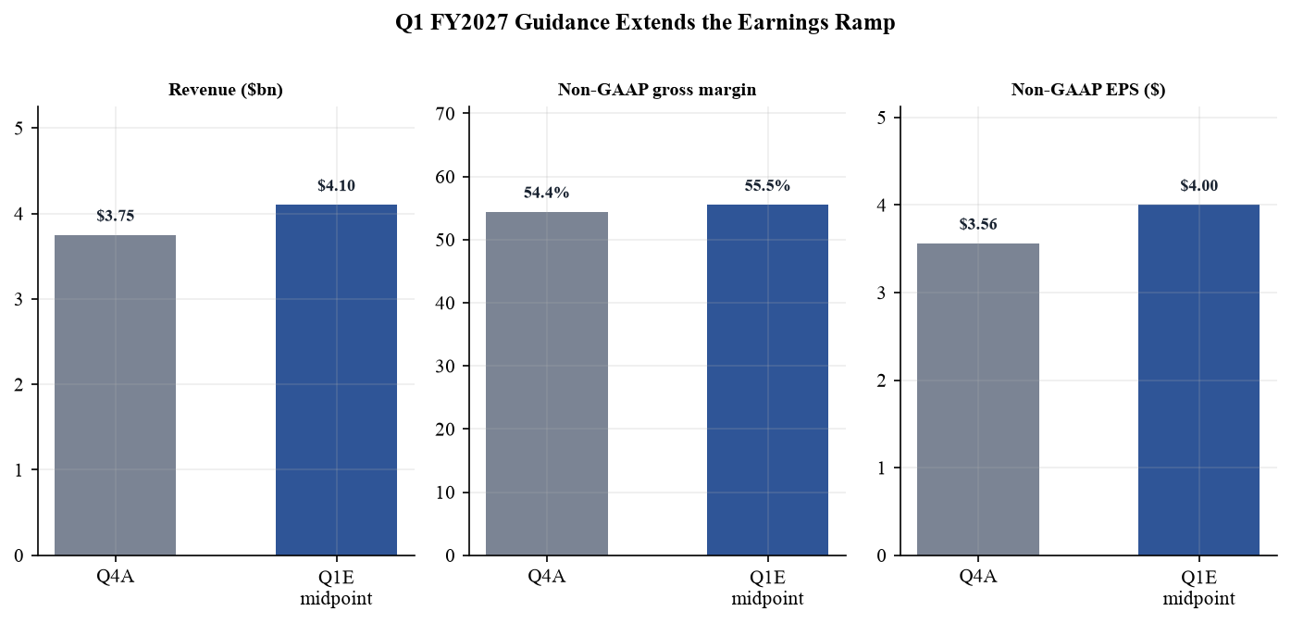
Sources: Q4 FY2026 earnings release page 3; Q4 FY2026 earnings presentation slide 8
Figure 8. Quarterly free cash flow
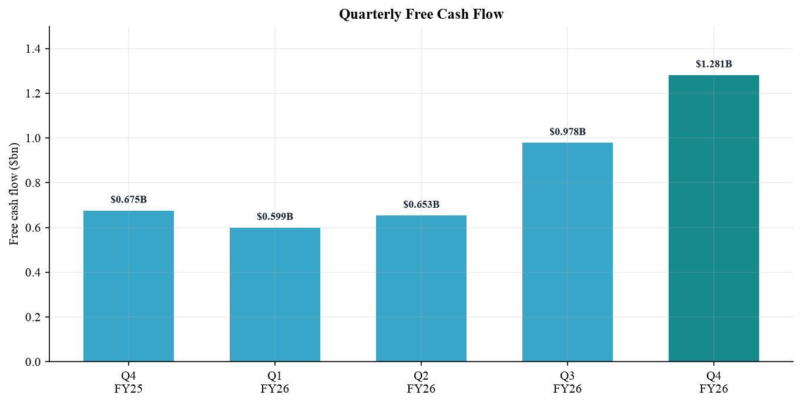
Sources: Q4 FY2026 earnings presentation slides 6 and 11; Q1 and Q2 FY2026 earnings releases

Updated investment thesis
■ Pillar one strengthened AI creates persistent storage demand Training, inference and agentic workloads generate data that must be retained economically. HDDs remain the dominant repository for large-scale cold and warm data because cost per terabyte is structurally lower than flash. Cloud revenue growth of 38% and 89% revenue mix provide direct evidence, although they also increase dependence on hyperscaler capital spending.
■ Pillar two strengthened Higher-capacity roadmap supports price cost spread WD began shipping ePMR drives up to 40TB in Q4. Management expects these products to exceed half of nearline shipments by Q3 FY2027, followed by 44TB HAMR in the first half of calendar 2027 and 50TB products in the second half. Higher areal density can lower cost per terabyte by roughly 10% over time while allowing customers to save rack space and power.
■ Pillar three strengthened Supply discipline converts demand into margins FY2026 revenue rose 36% on 25% more exabytes and 8% higher ASP per exabyte. Gross margin increased 970 bps and operating margin increased 1,290 bps. Management says capacity growth does not require a broad unit-capacity build; investment is concentrated in heads, media and automation. That framework limits the risk that today's pricing is competed away through indiscriminate capacity additions.
■ Pillar four unchanged Concentration and cyclicality remain the key debate The top ten customers produced 73% of revenue, up from 68% in FY2025. Large cloud buyers purchase unevenly and may shift between CMR and UltraSMR configurations, creating quarterly volatility. LTAs improve visibility but do not eliminate negotiation power, qualification risk or macro exposure.
Our thesis therefore depends less on a single earnings beat and more on whether WD sustains a positive spread between price-per-terabyte gains and cost-per-terabyte declines. The FY2026 evidence is encouraging, but the stock now discounts a meaningful portion of the favorable cycle. Position sizing should reflect the possibility of a sharp multiple contraction even if near-term earnings estimates remain intact.

What changed after the call
Management's commentary increased our confidence in the duration of the capacity cycle. It described stronger customer visibility, disciplined use of long-term agreements and a roadmap in which capacity growth is delivered primarily through areal-density gains rather than a large increase in drive units. That distinction matters: density-led output can expand shipped exabytes while preserving industry utilization and limiting the incentive for competitors to chase volume with price. We therefore raise our medium-term gross-margin assumptions, but we do not assume that the high-teens price-per-terabyte growth reported for Q4 persists indefinitely.
The principal debate is now timing rather than end demand. A temporary pause in quarterly exabyte growth can occur as hyperscalers digest inventory, qualify a new platform or alter the mix between CMR and UltraSMR. We would view a one-quarter volume slowdown as noise if contract pricing, customer commitments and qualification milestones remain intact. By contrast, simultaneous weakening in price per terabyte, nearline units and gross margin would challenge the thesis because it would indicate that supply discipline is no longer offsetting buyer concentration.
Figure 9. FY2026 revenue growth decomposition
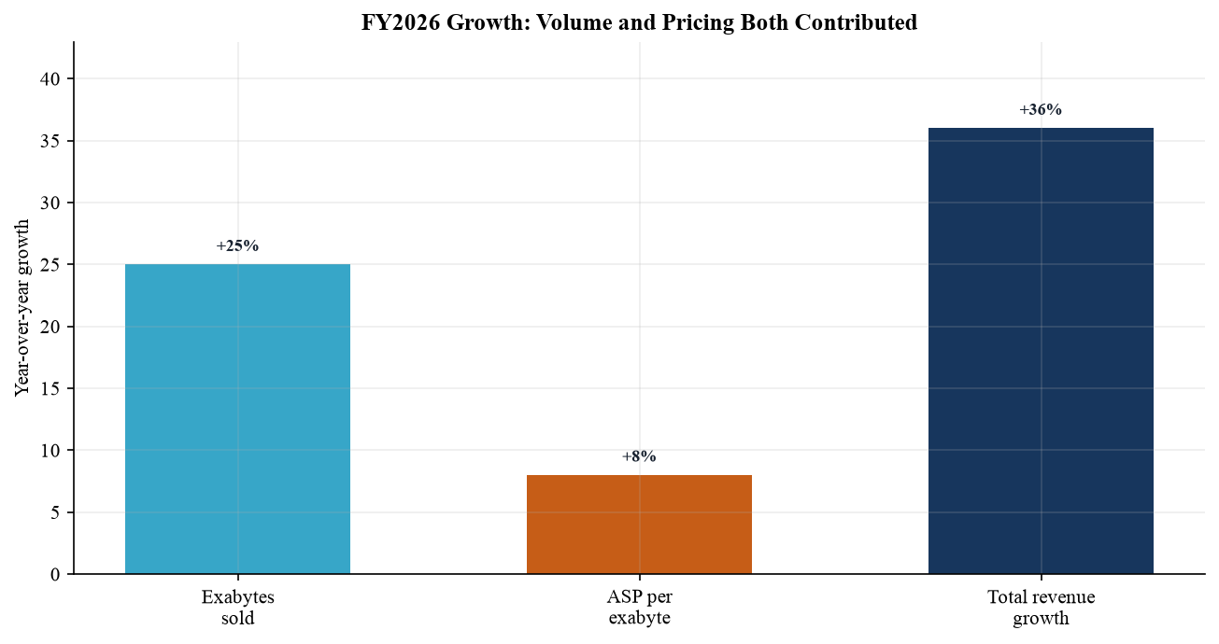
Sources: FY2026 Form 10-K MD&A filed 14 August 2026; Q4 FY2026 earnings-call transcript

Cash flow balance sheet and capital returns
Q4 operating cash flow was $1.389bn and free cash flow was $1.281bn, equal to a 34% free-cash-flow margin. FY2026 free cash flow reached $3.511bn, up 145%. Cash ended the year at $1.579bn against approximately $1.1bn of debt, leaving about $0.5bn of net cash. The balance sheet is substantially cleaner after debt repayment and monetization of the retained Sandisk stake.
Capital returns were aggressive. WD repurchased $1.0bn of shares in Q4 and returned $3.1bn during FY2026 through repurchases and dividends. The board declared a $0.15 quarterly dividend payable on 17 September 2026. Management reiterated that free cash flow will be returned through both programs, but buyback value depends on the price paid. Repurchases at cycle-peak multiples create less value than debt reduction or investment in technology.
Liquidity needs remain material. As of 3 July 2026, $710m principal of 2028 convertible notes remained outstanding and management expected cash settlement of principal, with most conversion premium settled in shares. Accounts receivable rose to $2.026bn and inventory to $1.511bn. Supplier long-term commitments totaled $310m, while fiscal 2027 capital expenditure is expected to exceed FY2026 as WD invests in heads, media and automation.
Our base case assumes FY2027 free cash flow of about $5.0bn. The principal sensitivities are gross margin, working-capital absorption and the cadence of capacity-related investment. A two-point gross-margin shortfall could reduce annual operating profit by roughly $0.38bn on our FY2027 revenue estimate before secondary effects.

Capital allocation framework
We separate cash generation from cash distribution. The first is supported by margin expansion, modest unit-capacity requirements and a low cash-tax burden; the second remains a board decision and can vary with the share price. Our valuation gives credit to repurchases only through the resulting share count, not by adding the authorization amount to enterprise value. This avoids treating a use of cash as incremental value. It also means that a slower repurchase pace would not reduce our operating forecast, although it could modestly dilute per-share earnings relative to the current model.
Working capital is the most important near-term cash-flow bridge. Receivables grew as revenue accelerated, while inventory supports product transitions and customer qualification. In a constructive scenario, collections catch up with sales and inventory turns improve as 40TB products scale, allowing cash conversion to exceed reported earnings. In a downside scenario, a customer order pushout leaves inventory elevated and turns a portion of operating profit into working-capital investment. We therefore view quarterly free cash flow as volatile and emphasize the full-year trajectory.
Balance-sheet optionality has nevertheless improved. Net cash and strong free cash flow give management room to settle the convertible principal, fund technology transitions and continue dividends without relying on external financing. This lowers financial risk relative to the previous downcycle. It does not remove operating cyclicality, but it should reduce the probability that a weak demand period forces value-destructive financing or a sharp cut in strategic investment.

Valuation and price target
At the $411.96 reference price, WDC trades at 21.8x our FY2027E non-GAAP EPS of $18.90 and 16.5x FY2028E EPS of $25.00. Longbridge's trailing P/E screen showed 16.0x on 15 September 2026, but that measure is flattered by large GAAP gains from the Sandisk stake. Forward adjusted earnings are the more decision-useful basis.
Our $550 price target blends two approaches. First, a 24x multiple on FY2028E non-GAAP EPS produces $600 per share; the premium reflects AI-related storage growth, improved LTAs and the widening price-cost spread. Second, a DCF with FY2027-FY2031 free cash flow of roughly $5.0bn, $7.5bn, $10.0bn, $12.5bn and $15.0bn, a 10.5% WACC and 3.5% terminal growth yields approximately $473 per share. A 60% earnings-multiple and 40% DCF blend gives about $549, rounded to $550.
The target implies 33.5% upside, supporting Outperform, but valuation is not undemanding. The bull case of $700 assumes FY2028 EPS of $28 and a 25x multiple; the bear case of $300 assumes EPS of $20 and a 15x multiple. The resulting range emphasizes that the investment is now highly sensitive to the durability of pricing and the timing of HAMR execution.
The market's 13% decline in the session after results illustrates this sensitivity. A strong quarter can coincide with a negative share-price reaction when consensus rises faster than reported fundamentals. We would use pullbacks to build exposure rather than treat a single target as a precise estimate of intrinsic value.

Catalysts and valuation checkpoints
The next catalysts are Q1 FY2027 results, evidence that 40TB ePMR exceeds half of nearline shipments by Q3 FY2027, and successful 44TB HAMR qualification in the first half of calendar 2027. The earnings path can support the target before HAMR contributes materially if price per terabyte remains firm and cost per terabyte continues to decline. Conversely, the market is likely to penalize even a small roadmap delay because the current multiple already assumes that density gains extend the margin cycle. We would revisit the target if FY2027 gross margin tracks below 54%, if annual exabyte growth falls below the mid-teens, or if customer concentration rises without stronger contractual protection.
Figure 10. One-year adjusted share-price history
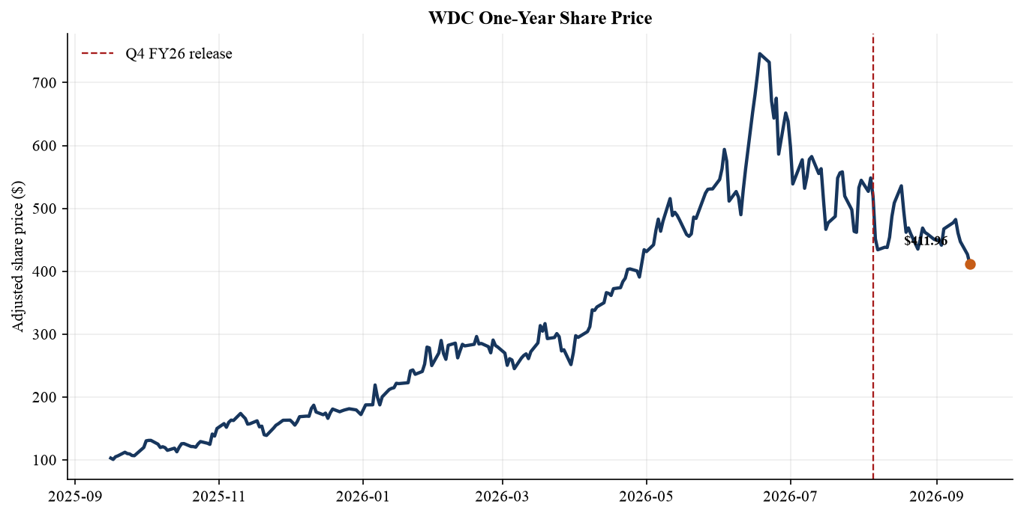
Sources: Yahoo Finance market data accessed 16 September 2026; Longbridge WDC.US daily K-line accessed 16 September 2026

Updated estimates
We raise estimates to reflect the Q4 beat, the Q1 guide and stronger price-per-terabyte assumptions. FY2027 revenue increases 3.3% to $18.8bn and non-GAAP EPS rises 7.4% to $18.90. The larger EPS revision reflects gross-margin leverage and a relatively contained expense base. FY2028 assumes the 40TB ePMR ramp is mature and 44TB HAMR has moved beyond initial qualification.
Metric | FY2027E old | FY2027E new | Change | FY2028E
Revenue ($bn) | $18.2 | $18.8 | +3.3% | $22.3
Revenue growth | +40.9% | +45.5% | +460 bps | +18.6%
Non-GAAP gross margin | 54.8% | 56.0% | +120 bps | 57.5%
Non-GAAP operating income ($bn) | $8.0 | $8.4 | +5.0% | $10.7
Non-GAAP EPS | $17.60 | $18.90 | +7.4% | $25.00
Free cash flow ($bn) | $4.5 | $5.0 | +11.1% | $7.5
P/E at $411.96 | 23.4x | 21.8x | -1.6x | 16.5x
Sources: Company results and guidance; Analyst estimates dated 16 September 2026
Estimate risk is asymmetric around gross margin. Every 100 bps change in FY2027 gross margin changes gross profit by roughly $188m, before tax and share-count effects. Exabyte growth has more muted short-term earnings sensitivity if it is accompanied by lower price per terabyte; conversely, disciplined pricing can drive EPS even when quarterly shipment mix is lumpy.
Our FY2027 quarterly framework starts with management's $4.1bn Q1 midpoint, then assumes $4.5bn, $5.0bn and $5.2bn across Q2 to Q4. The profile is not intended as point precision. It expresses a view that customer visibility and high-capacity qualification support a rising revenue base while annual comparisons remain strongest in the first half.
Figure 11. Illustrative estimate revisions
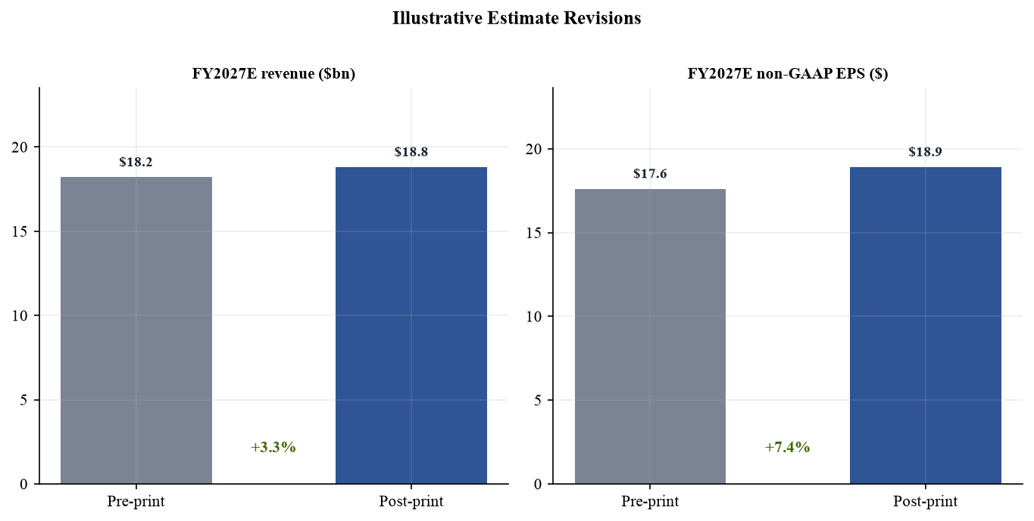
Sources: Q4 FY2026 earnings release and guidance; Analyst estimates dated 16 September 2026

Risks and sources

Risk monitor
Risk | Current evidence | What would change the view
Customer concentration | Top 10 customers were 73% of FY2026 revenue | A hyperscaler order pushout or LTA dispute
Pricing cycle | High-teens price-per-TB growth in Q4 | ASP growth falling below cost-per-TB improvement
Technology execution | 40TB ePMR shipping; 44TB HAMR due in H1 2027 | Qualification delay or weak yields
Capital allocation | $3.1bn returned in FY2026 | Buybacks at high multiples without durable FCF
Valuation | 21.8x FY2027E adjusted EPS | Multiple compression despite estimate delivery
Sources: FY2026 Form 10-K risk factors and MD&A; Q4 FY2026 earnings-call transcript

Sources and references
• Q4 FY2026 earnings release 5 August 2026
• Q4 FY2026 earnings presentation 5 August 2026
• Q4 FY2026 earnings call and webcast 5 August 2026
• Q4 FY2026 earnings-call transcript 5 August 2026
• Form 8-K filed 5 August 2026
• FY2026 Form 10-K filed 14 August 2026
• Q3 FY2026 earnings release and prior guidance 30 April 2026
• MarketBeat consensus snapshot for 5 August 2026
• Longbridge quote valuation and K-line data accessed 16 September 2026
• Yahoo Finance dynamic market data accessed 16 September 2026
Methodology and disclosure Reported figures are company data. Consensus figures are third-party pre-announcement snapshots. Forward estimates, rating and price target are analytical judgments prepared for this report and are not company guidance. This document is informational research, not personalized investment advice.

Analytical conventions
All quarterly operating comparisons use continuing HDD operations following the February 2025 Sandisk separation. Non-GAAP figures follow the company's definitions and are used for trend and valuation analysis because GAAP earnings include separation-related items and mark-to-market effects. Free cash flow is operating cash flow less capital expenditure. Market price, market capitalization and 52-week range were retrieved dynamically on 16 September 2026; the reference price is the 15 September 2026 close. Figures may not sum because of rounding.
Our DCF is a scenario tool rather than a point forecast. The stated cash flows, discount rate and terminal growth rate are explicit analyst assumptions. The earnings-multiple method is cross-checked against the company's growth, margin, customer concentration and technology-execution profile rather than mechanically adopting the market's highest target. The rating would be reconsidered if the risk-adjusted upside fell below the level required for an Outperform or if evidence emerged that the favorable price-cost spread is reversing.

