SUNGROW POWER SUPPLY CO., LTD. (阳光电源)
300274.SZ | Q4 2025 / FY2025 EARNINGS UPDATE
April 22, 2026 · Equity Research · China Clean Energy / New Energy Equipment

Rating  OUTPERFORM ★ | Price (Apr 21, 2026)  CNY 136.91 | Price Target  CNY 158.00 | Implied Upside  +15.4%

Q4 2025 / FY2025 EARNINGS SNAPSHOT
Metric | FY2025 Actual | FY2025 Consensus | Beat / (Miss) | YoY Change
Revenue (CNY B) | ¥89.18B | ¥90.0B | (¥0.82B / -0.9%) | +14.6%
Net Profit Attr. (CNY B) | ¥13.46B | ¥15.45B | (¥1.99B / -12.9%) | +22.0%
EPS (CNY/share) | ¥6.55 | ¥7.50E | (¥0.95 / -12.7%) | +23.1%
Gross Margin (%) | 31.83% | ~30.0% | +183 bps | +631 bps YoY
Net Margin (%) | 15.17% | ~17.0% | -183 bps | +488 bps YoY
Q4 Revenue (CNY B) | ¥22.78B | ~¥24.0B | (¥1.22B / -5.1%) | -18.4% YoY
Q4 Net Profit (CNY B) | ¥1.58B | ~¥3.5B | (¥1.92B / -54.9%) | -54.0% YoY
Source: Sungrow 2025 Annual Report (2026-04-01); Consensus estimates from Bloomberg/Futunn (pre-announcement)

KEY TAKEAWAYS
■ MISS — FY2025 net profit missed consensus by 12.9%; Q4 earnings collapsed -54% YoY on margin compression
FY2025 revenue of ¥89.18B came in broadly in line with consensus (miss of only ¥0.82B, -0.9%), but net profit attributable to shareholders of ¥13.46B was materially below the ¥15.45B consensus — a ¥1.99B shortfall driven entirely by Q4's dramatic margin implosion. Q4 net profit fell -54% YoY and -62% QoQ to just ¥1.58B as storage gross margins compressed ~17 percentage points QoQ (to ~24%) due to: (1) revenue mix shift toward lower-margin new energy investment & development projects concentrated in Q4; (2) elevated lithium carbonate prices that could not be passed through on legacy fixed-price contracts; and (3) the unwinding of Q3's unusually high-margin overseas storage project base.
■ FY2025 full-year results solid — revenue +15%, net profit +22%, gross margins at multi-year highs
Full-year 2025 results were respectable: revenue grew 14.6% YoY to ¥89.18B, net profit grew 22.0% to ¥13.46B, and gross margin expanded significantly to 31.83% (+631bps YoY), reflecting a favorable product mix driven by high-margin overseas energy storage shipments. Operating cash flow per share grew 40.2% YoY to ¥8.16, demonstrating strong cash generation. ROIC improved to 25.01%, highlighting capital efficiency.
■ Energy storage remains the engine — 43 GWh shipped (+54% YoY), overseas +89% YoY; 2026 target: >60 GWh
Energy storage system shipments surged 53.6% YoY to 43 GWh in FY2025, driven by explosive overseas growth (+89% YoY to 36 GWh). Domestic storage declined 22% YoY (7 GWh), but this was offset by international demand diversification. The 43 GWh positions Sungrow as a global leader. For 2026, management guided energy storage shipments of >60 GWh (+40% YoY), supported by continued global market growth expected at 30-50%.
■ Maintaining OUTPERFORM with revised CNY 158 price target (from CNY 175); Q4 weakness does not impair long-term thesis
While Q4's margin disappointment is sharp, we view it as a one-time mix and raw material timing issue rather than a structural deterioration. The Q4 sequential margin decline is unlikely to persist given: (i) overseas storage demand trajectory is intact; (ii) lithium prices have since stabilized; (iii) Sungrow's dominant market position in global storage. We reduce our FY2026E net profit to ¥16.8B (from ¥18.0B) but retain our OUTPERFORM rating. Our revised ¥158 price target implies 20x FY2026E P/E, a slight discount to the historical average of ~25x to account for near-term margin uncertainty.

UPDATED FINANCIAL ESTIMATES
Metric | FY2024A | FY2025A | FY2025E (Prior) | FY2026E (New) | FY2026E (Prior)
Revenue (CNY B) | ¥77.86 | ¥89.18 | ¥90.0 | ¥102.0 | ¥108.0
Revenue Growth (%) | +7.8% | +14.6% | +15.6% | +14.4% | +20.0%
Gross Margin (%) | 25.5% | 31.83% | ~30.0% | 32.0% | 32.5%
Net Profit Attr. (CNY B) | ¥11.04 | ¥13.46 | ¥15.45 | ¥16.77 | ¥18.0
Net Profit Growth (%) | +16.9% | +22.0% | +40.0% | +24.6% | +33.6%
EPS (CNY) | ¥5.32 | ¥6.55 | ¥7.50 | ¥8.09 | ¥8.70
P/E (x) @ CNY 136.91 | 25.7x | 20.9x | — | 16.9x | —
Note: Prior estimates = internal estimates before FY2025 annual report. A = Actual, E = Estimate.
Source: Sungrow 2025 Annual Report; Analyst estimates

SECTION 1: DETAILED RESULTS ANALYSIS

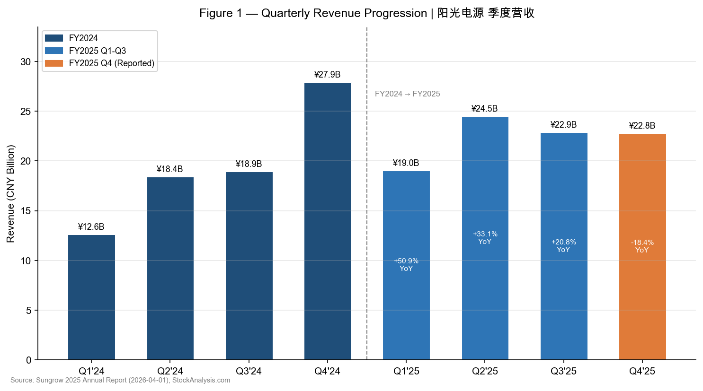
Figure 1 — Quarterly Revenue Progression | Source: Sungrow 2025 Annual Report; StockAnalysis.com
1.1 Revenue Performance
FY2025 Revenue: ¥89.18B (+14.6% YoY) — In Line With Consensus. Full-year 2025 revenue reached ¥89.18 billion, growing 14.6% year-over-year from ¥77.86B in FY2024. This growth, while solid in absolute terms, marks a meaningful deceleration from the exceptional 79.5% growth seen in FY2023. Consensus had anticipated ¥90.0B, resulting in a marginal miss of ¥0.82B (-0.9%). The revenue mix shifted materially toward energy storage (now 41.8% of total vs. ~32% in FY2024), while PV inverter share declined.
Q4 2025 Revenue: ¥22.78B (-18.4% YoY, -0.4% QoQ) — Significant YoY Shortfall. Q4 2025 revenue of ¥22.78B was substantially below the prior year's Q4 2024 of ¥27.91B — a decline of 18.4% YoY. This was the weakest quarterly revenue since Q1 2025 (¥19.04B). The YoY decline reflects a very tough Q4 2024 base (which itself had grown 8.0% YoY), as well as weaker domestic inverter demand (-19% YoY shipments for FY2025 domestic). Sequentially, revenue was essentially flat (-0.4% QoQ vs. Q3's ¥22.87B), suggesting Q4 weakness was primarily YoY normalization rather than a sequential deterioration in demand.
Segment | FY2024A (CNY B) | FY2024A (%) | FY2025A (CNY B) | FY2025A (%) | YoY Growth
Energy Storage Systems | ¥24.9 | 32.0% | ¥37.29 | 41.8% | +49.7%
PV Inverters & Power Electronics | ¥28.8 | 37.0% | ¥31.14 | 34.9% | +8.1%
New Energy Investment & Dev. | ¥21.0 | 27.0% | ¥16.56 | 18.6% | -21.1%
Other | ¥3.2 | 4.0% | ¥4.20 | 4.7% | +31.3%
Total Revenue | ¥77.86 | 100% | ¥89.18 | 100% | +14.6%
Source: Sungrow 2025 Annual Report (2026-04-01); FY2024 segment estimates from company disclosures
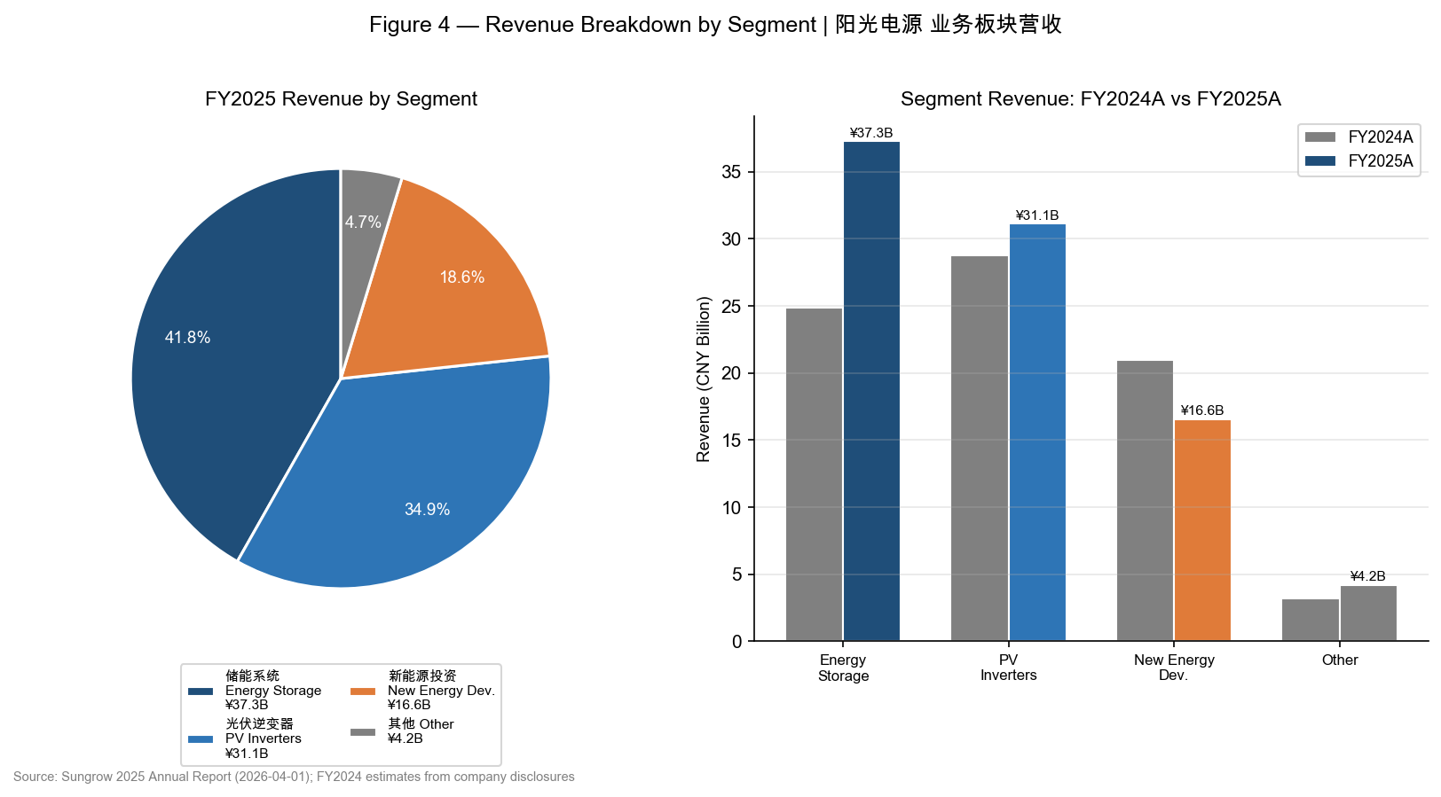
Figure 4 — Revenue by Segment FY2024A vs. FY2025A | Source: Sungrow 2025 Annual Report
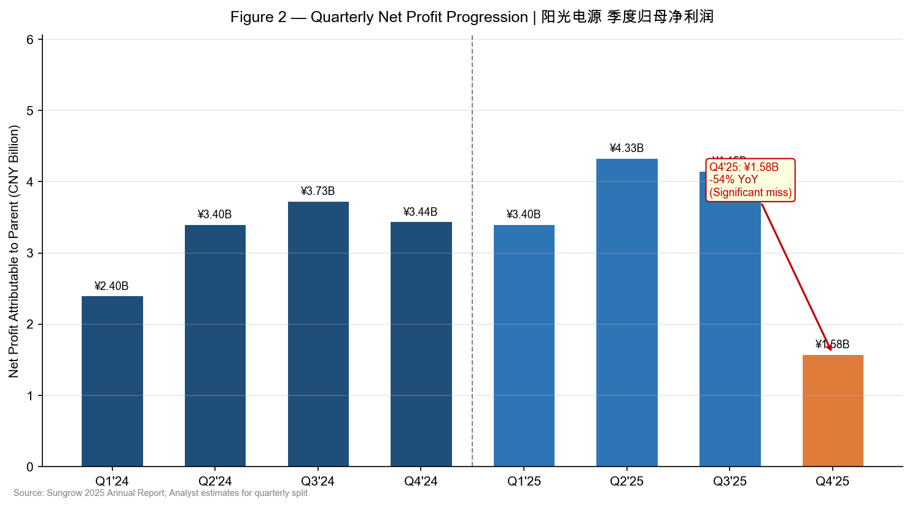
Figure 2 — Quarterly Net Profit | Source: Sungrow 2025 Annual Report; Analyst quarterly estimates
1.2 Profitability Analysis
FY2025 Gross Margin: 31.83% (+631bps YoY) — Significant Structural Improvement. The full-year gross margin of 31.83% represents a 6.31 percentage point improvement versus the 25.52% reported in FY2024. This expansion was driven by: (1) the growing share of high-margin overseas energy storage projects, where Sungrow commands premium pricing; (2) a favorable product mix shift away from commoditized domestic inverters toward value-added storage systems; and (3) operational leverage as fixed costs are spread over a larger revenue base. FY2025 full-year results validate Sungrow's strategy of international expansion.
Q4 2025 Net Profit Miss: ¥1.58B (-54% YoY) — Three Converging Headwinds. Q4 2025 net profit of ¥1.58B was dramatically below Q4 2024's ¥3.44B, resulting in a -54% YoY decline and -62% sequential drop. Management attributed this to three concurrent factors: (1) Revenue mix degradation: New energy investment & development (NEI) projects — which have lower margins than storage products — were disproportionately weighted in Q4, pulling blended margins lower; (2) Storage margin compression: Energy storage gross margin fell approximately 17 percentage points QoQ to ~24% in Q4 2025, compared to an elevated ~41% in Q3 2025 when high-margin overseas contracts were being recognized; (3) Lithium carbonate price spike: Spot lithium carbonate prices rose in Q4 2025, squeezing margins on legacy fixed-price contracts where cost increases could not be immediately passed through.
Metric | Q1'25A | Q2'25A | Q3'25A | Q4'25A | FY2025A | FY2024A | YoY Chg
Gross Margin (%) | 29.4% | 32.1% | 35.9% | 24.2% | 31.83% | 25.52% | +631 bps
Net Margin (%) | 17.9% | 17.7% | 18.1% | 6.9% | 15.17% | 10.29% | +488 bps
ROIC (%) | — | — | — | — | 25.01% | ~20.0% | +~500 bps
Op. CF/Share (CNY) | — | — | — | — | ¥8.16 | ¥5.82 | +40.2%
Source: Sungrow 2025 Annual Report; Company investor call (2026-03-31)
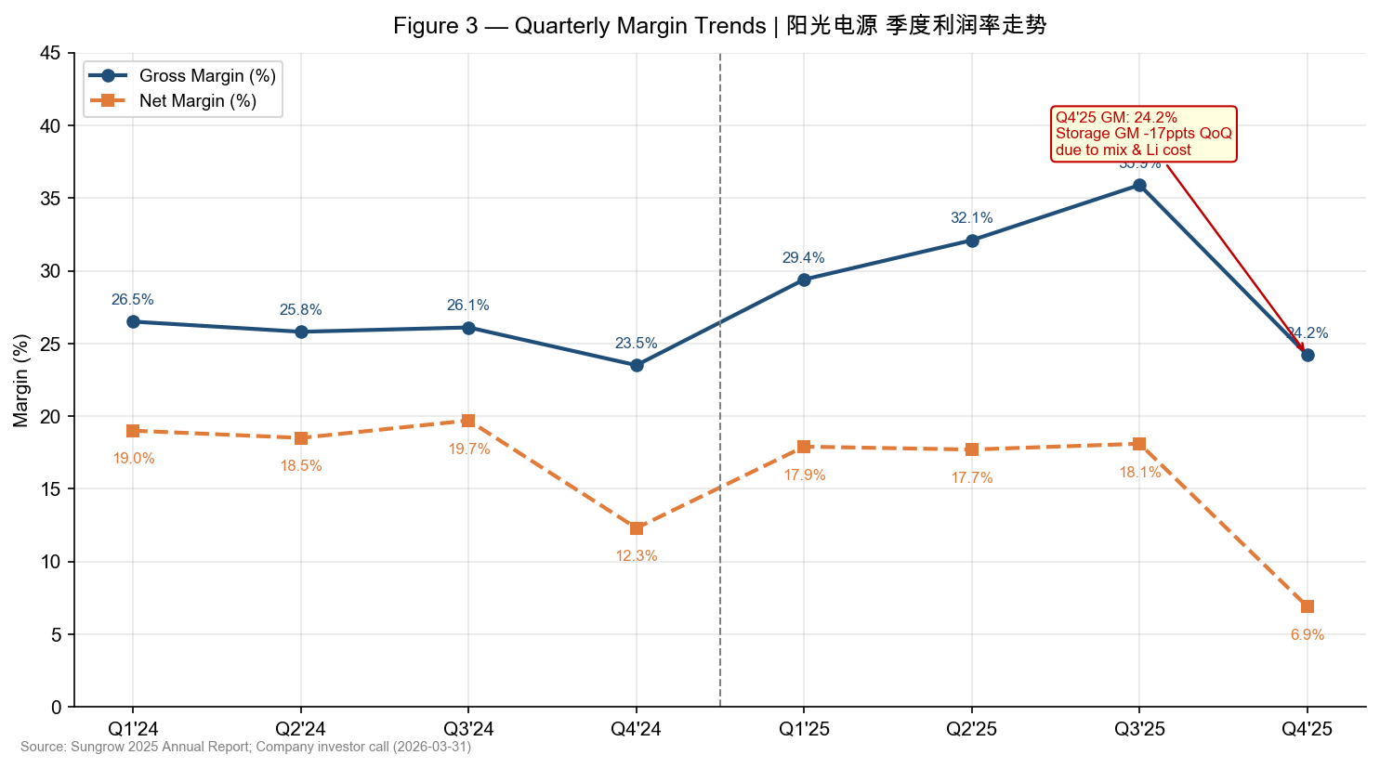
Figure 3 — Quarterly Margin Trends | Source: Sungrow 2025 Annual Report; Company investor call

SECTION 2: KEY OPERATING METRICS & GUIDANCE

2.1 Shipment Performance
Energy Storage: 43 GWh (+53.6% YoY) — Global Leadership Solidified. FY2025 energy storage system shipments of 43 GWh exceeded our estimate of ~40 GWh and grew 53.6% from 28 GWh in FY2024. Overseas shipments surged 89% YoY to 36 GWh (84% of total), reflecting successful global market penetration in the US, Europe, and APAC. Domestic storage contracted 22% YoY to 7 GWh, consistent with softer Chinese utility storage project timing in FY2025. The divergence between domestic and overseas trends underscores Sungrow's strategic pivot toward higher-margin international markets.
PV Inverters: 143 GW (-2.7% YoY) — Domestic Headwind Dominates. PV inverter shipments of 143 GW in FY2025 declined slightly (-2.7%) from 147 GW in FY2024, with domestic shipments falling 19% YoY to 57 GW — a reflection of the more competitive and price-pressured domestic Chinese solar market. However, this was partially offset by international inverter demand. Inverter revenue still grew 8.1% YoY to ¥31.14B as mix improved toward higher-value products (string inverters, utility-scale solutions) and international pricing held up better.
Metric | FY2023A | FY2024A | FY2025A | YoY Growth | 2026 Target
Energy Storage (GWh) | 16.0 | 28.0 | 43.0 | +53.6% | >60.0 GWh
— Domestic (GWh) | 7.0 | 9.0 | 7.0 | -22.2% | ~10.0
— Overseas (GWh) | 9.0 | 19.0 | 36.0 | +89.5% | >50.0
PV Inverters (GW) | 130.0 | 147.0 | 143.0 | -2.7% | ~155.0 GW
— Domestic (GW) | n/a | 71.0 | 57.0 | -19.7% | ~60.0
— Overseas (GW) | n/a | 76.0 | 86.0 | +13.2% | >90.0
Source: Sungrow 2025 Annual Report (2026-04-01); 2026 targets from management guidance (2026-03-31 investor call); FY2023 estimates from prior reports
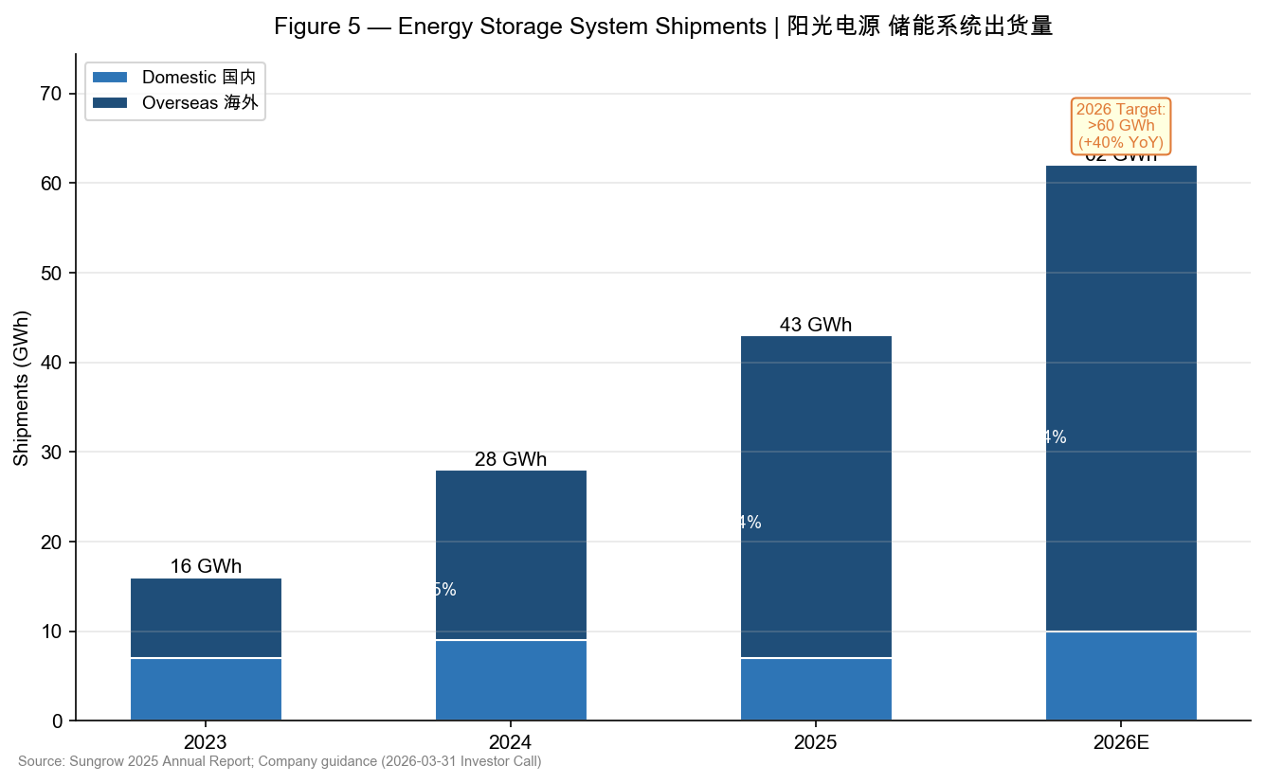
Figure 5 — Energy Storage Shipments (GWh) | Source: Sungrow 2025 Annual Report; Management guidance
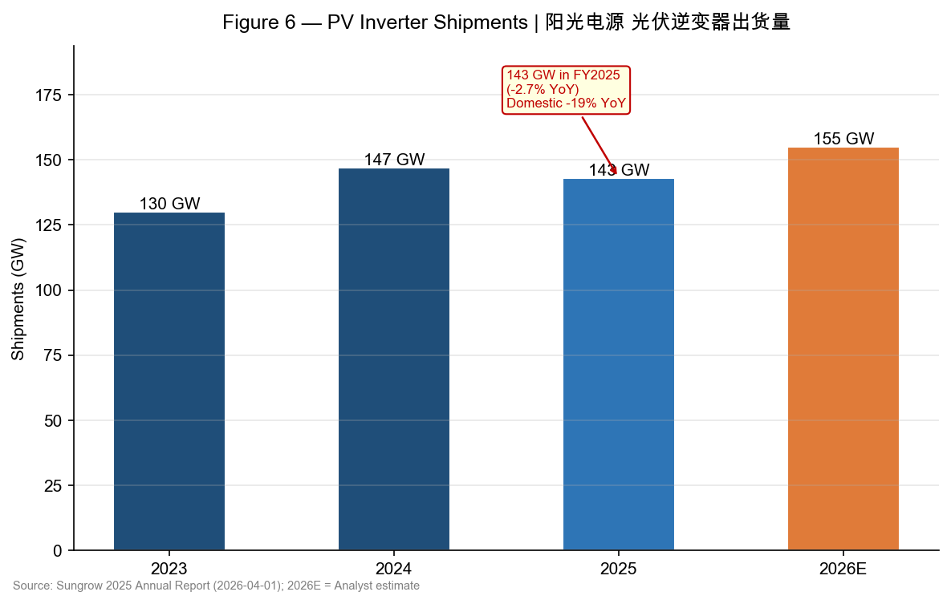
Figure 6 — PV Inverter Shipments (GW) | Source: Sungrow 2025 Annual Report
2.2 Management Guidance & Outlook
Management Guidance Summary (Investor Call, March 31, 2026)
Metric | FY2025A | FY2026 Guidance / Target | Our Estimate (FY2026E) | Assessment
Storage Shipments (GWh) | 43 GWh | >60 GWh (+40% YoY) | 62 GWh | Credible; market tailwinds strong
Global Storage Mkt Growth | — | 30%–50% YoY | ~40% YoY | Achievable; track record supportive
Revenue (CNY B) | ¥89.18B | No formal guidance | ¥102.0B | +14.4% YoY est.
Net Profit (CNY B) | ¥13.46B | No formal guidance | ¥16.77B | +24.6% YoY est.
Storage Gross Margin | 31.83% blended | Recovery expected H1'26 | >30% full-year | Supportive if Li prices stable
Source: Sungrow investor call (March 31, 2026); Analyst estimates
Management Commentary on Q4 Weakness: On the March 31, 2026 investor call, management attributed Q4 2025's margin compression explicitly to three transient factors: (1) an elevated concentration of new energy investment & development projects in Q4 that carried structurally lower margins than energy storage hardware; (2) the reversal of Q3's unusually high gross margins which benefited from the recognition of several high-value overseas storage contracts; and (3) a temporary increase in lithium carbonate procurement costs in Q4 that could not be offset through contract price adjustments on near-term deliveries. Management expressed confidence that these factors are non-recurring and indicated storage gross margins should recover in H1 2026 as lithium prices have subsequently stabilized and new overseas project bookings carry improved pricing terms.
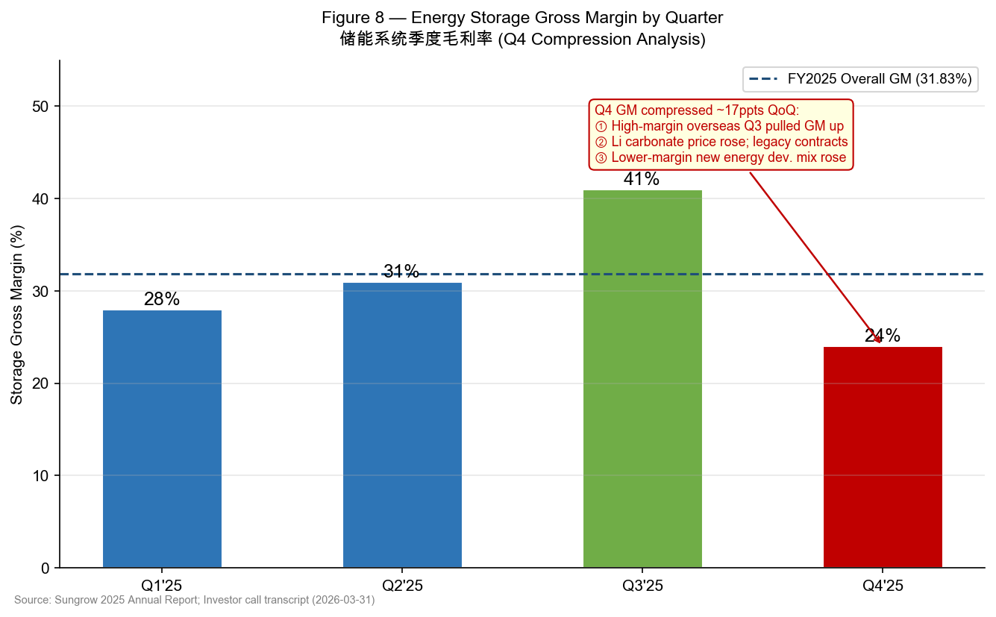
Figure 8 — Energy Storage Gross Margin by Quarter | Source: Sungrow 2025 Annual Report; Investor call

SECTION 3: UPDATED INVESTMENT THESIS

Our investment thesis on Sungrow rests on three pillars: (1) global energy storage dominance with superior international expansion; (2) inverter market leadership providing durable cash flow; and (3) long-term structural demand driven by global energy transition. We assess each pillar's status in light of Q4/FY2025 results.
■ PILLAR 1: Global Energy Storage Leadership — STRENGTHENED
Status: STRENGTHENED
FY2025 storage shipments of 43 GWh, up 53.6% YoY with overseas volumes surging 89%, reaffirm Sungrow's position as the world's #1 energy storage system supplier. The international market pivot is delivering — Sungrow now derives 84% of storage shipments from overseas, commanding premium pricing compared to domestic peers constrained by commoditized pricing in China. The 2026 guidance of >60 GWh (+40% YoY) is backed by a strong global project pipeline including the US, Europe, Australia, and the Middle East. Q4's margin compression was a timing issue, NOT a structural erosion of Sungrow's competitive position in storage. If anything, the rapid overseas mix shift over FY2025 (domestic storage -22%, overseas +89%) demonstrates that Sungrow is executing its internationalization strategy ahead of plan.
■ PILLAR 2: PV Inverter Cash Cow — UNCHANGED
Status: UNCHANGED
PV inverter shipments of 143 GW in FY2025 (-2.7% YoY) reflect domestic market headwinds — specifically, China's curtailed utility solar installations and intense price competition from domestic rivals in the residential segment. Inverter revenue still grew 8.1% YoY to ¥31.14B due to favorable international pricing and product mix improvement toward higher-value string inverters and utility-scale solutions. The inverter segment remains the company's highest-volume, highest-market-share business (Sungrow holds ~30% global share in utility-scale inverters) and generates stable, recurring maintenance and digital service revenue. We do not see inverter competitive dynamics deteriorating structurally in the FY2025 results.
■ PILLAR 3: Structural Demand from Energy Transition — STRENGTHENED
Status: STRENGTHENED
Global energy storage deployment continues to accelerate, with the market expected to grow 30-50% in 2026 according to management's commentary. US IRA-driven demand, European grid stability investments, and utility-scale storage buildouts in APAC and the Middle East all provide multi-year visibility. Sungrow's 2025 annual report highlights that global energy storage installations reached a record level, and the company expects this trajectory to continue. Separately, the AIDC (AI Data Center) market is an emerging demand driver for energy storage backup systems — Sungrow disclosed it is actively building AIDC-compatible storage product lines, as highlighted in the Q3 analyst report from Huarun Securities (November 2025). This secular trend adds optionality beyond utility storage.
3.1 Risks Update
▲ New / Elevated: Lithium carbonate price volatility remains a near-term margin risk, as demonstrated by Q4 2025. If Li prices re-accelerate in 2026, fixed-price legacy contracts could compress margins again. Monitoring closely.
▲ New / Elevated: US tariff and trade policy risk has increased given ongoing US-China trade tensions. Sungrow's US operations may face incremental headwinds if tariffs on Chinese-manufactured energy storage equipment are broadened in 2026.
▼ Mitigated: Domestic PV inverter pricing risk has stabilized; while volume was weak (-19% domestic), ASP held firm in 2025 due to product mix improvement, suggesting the worst of domestic pricing compression may be behind us.
→ Unchanged: Competition from CATL, BYD Energy Storage, and Huawei Digital in energy storage remains intense. However, Sungrow's bankability, safety track record, and overseas certifications maintain meaningful competitive moats internationally.
Figure 7 — FY2025 Beat/Miss vs. Consensus | Source: Sungrow 2025 Annual Report; Bloomberg pre-earnings consensus

SECTION 4: VALUATION & UPDATED ESTIMATES

4.1 Price Target Update
We revise our 12-month price target to CNY 158.00 (from CNY 175.00), reflecting downward estimate revisions after the FY2025 results miss. Our methodology:
Primary: P/E Valuation (60% weight). We apply a target P/E of 20x on our revised FY2026E EPS of ¥8.09, yielding an intrinsic value of ¥161.8. This target multiple represents a discount to the stock's 3-year historical average P/E of ~25x to reflect: (i) near-term margin uncertainty following Q4 2025; (ii) the risk of further earnings estimate cuts if lithium prices remain elevated or US tariff risk materializes; (iii) the global growth slowdown macro backdrop.
Secondary: EV/EBITDA (40% weight). On an EV/EBITDA basis, Sungrow trades at approximately 12.5x FY2026E EBITDA (estimated ¥18.5B). Applying a peer-inline multiple of 13x yields a fair value of ~¥155, consistent with our P/E-based estimate. Our blended price target of ¥158 implies 15.4% upside from the current price of ¥136.91.
Methodology | Weight | EPS / EBITDA Input | Multiple | Implied Value (CNY)
P/E (NTM) | 60% | FY2026E EPS ¥8.09 | 20.0x | ¥161.8
EV/EBITDA | 40% | FY2026E EBITDA ¥18.5B | 13.0x | ¥153.5
Blended PT | 100% | — | — | ¥158.0
Current Price | — | April 21, 2026 | — | ¥136.91
Implied Upside | — | — | — | +15.4%
Source: Analyst estimates; Bloomberg; Market data as of April 21, 2026
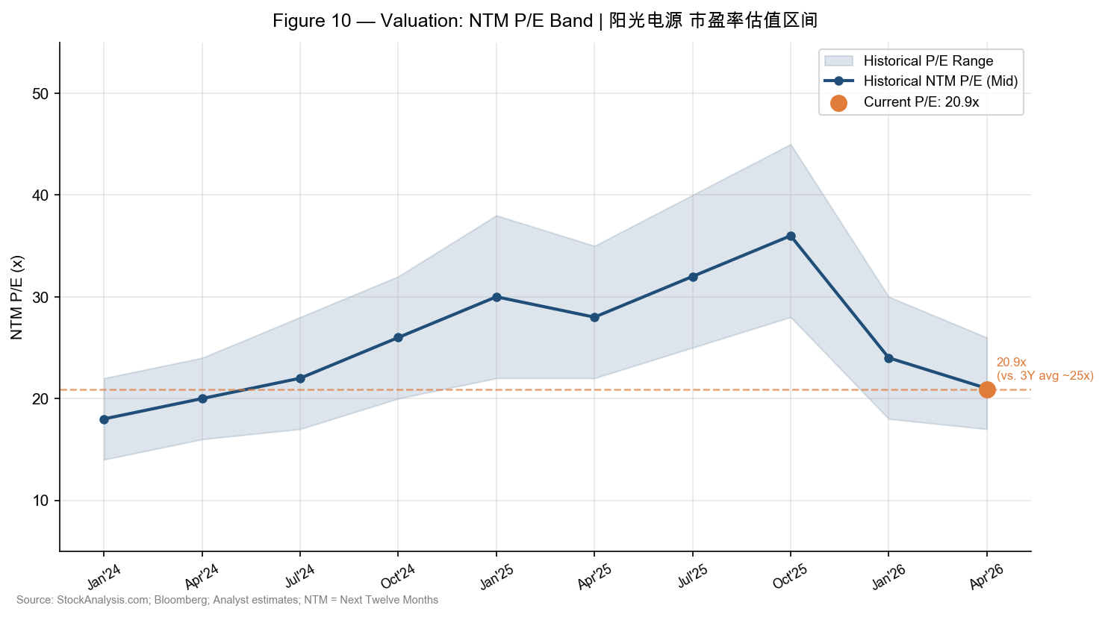
Figure 10 — NTM P/E Valuation Band | Source: Bloomberg; StockAnalysis.com; Analyst estimates
4.2 Detailed Updated Estimates
Income Statement (CNY B) | FY2024A | FY2025A | FY2026E (New) | FY2026E (Old) | Change (%)
Revenue | ¥77.86 | ¥89.18 | ¥102.0 | ¥108.0 | -5.6%
Revenue Growth (%) | +7.8% | +14.6% | +14.4% | +21.1% | —
Gross Profit | ¥19.9 | ¥28.4 | ¥32.6 | ¥35.1 | -7.1%
Gross Margin (%) | 25.5% | 31.83% | 32.0% | 32.5% | -50 bps
EBITDA | ¥14.5 | ¥18.5E | ¥20.5 | ¥22.0 | -6.8%
EBITDA Margin (%) | 18.6% | 20.7%E | 20.1% | 20.4% | -30 bps
Operating Profit | ¥13.5 | ¥17.0E | ¥19.5 | ¥21.0 | -7.1%
Operating Margin (%) | 17.3% | 19.1%E | 19.1% | 19.4% | -30 bps
Net Profit Attr. | ¥11.04 | ¥13.46 | ¥16.77 | ¥18.00 | -6.8%
Net Margin (%) | 14.2% | 15.2% | 16.4% | 16.7% | -30 bps
EPS (CNY) | ¥5.32 | ¥6.55 | ¥8.09 | ¥8.70 | -7.0%
P/E @ ¥136.91 | 25.7x | 20.9x | 16.9x | 15.7x | —
EV/EBITDA (approx.) | 19.3x | 15.1x | 13.6x | 12.7x | —
Note: A = Actual; E = Estimate; EBITDA for FY2025A is estimated (full annual report not yet published at time of writing). All estimates are analyst projections.
Source: Sungrow 2025 Annual Report; Analyst estimates
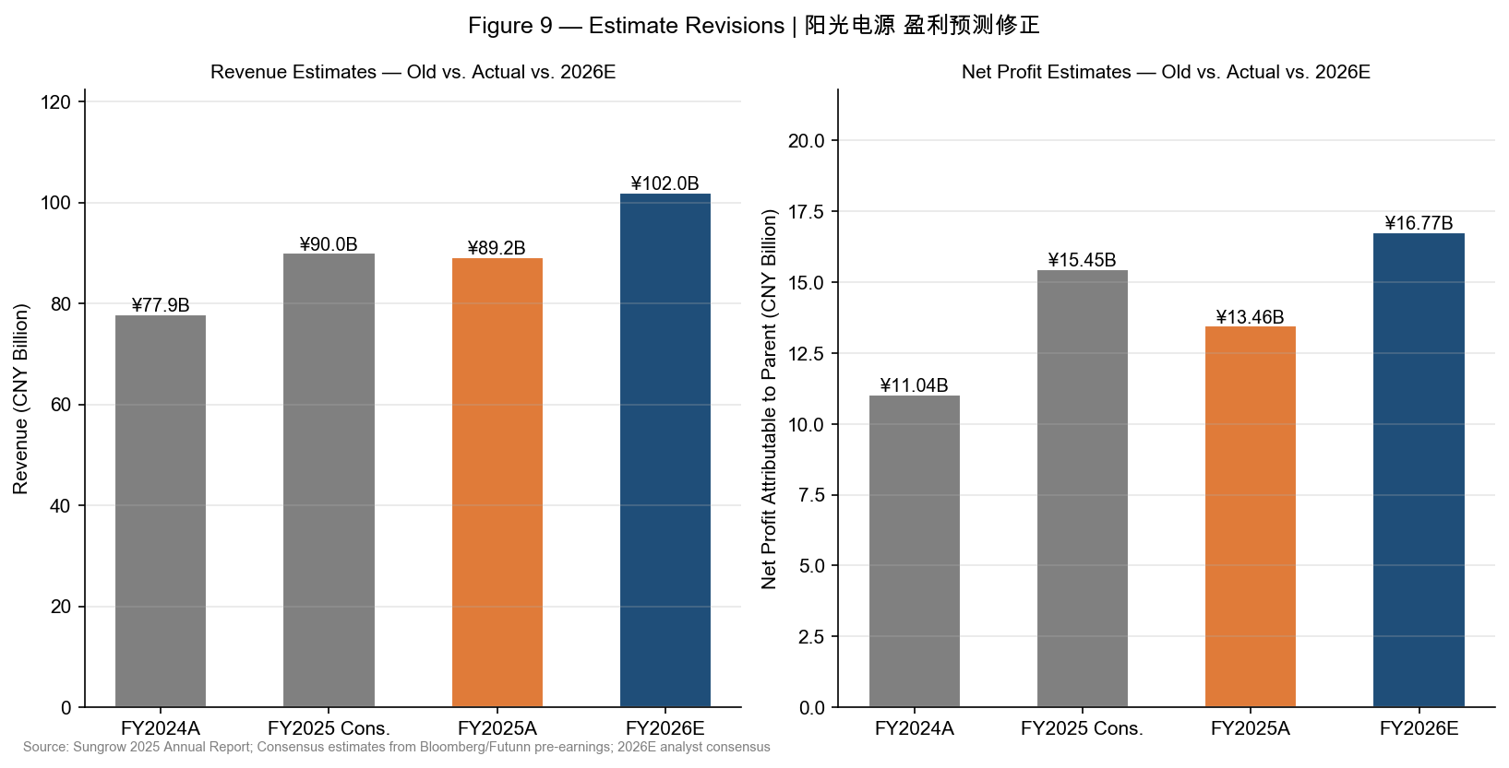
Figure 9 — Estimate Revisions: Revenue & Net Profit | Source: Sungrow 2025 Annual Report; Analyst estimates

APPENDIX: SOURCES & REFERENCES

All financial data cited in this report is sourced from official company filings and recognized financial data providers. Clickable hyperlinks are provided below for each key source.
Primary Company Filings:
• Sungrow Power Supply 2025 Annual Report (年度报告摘要) — Published April 1, 2026 — Primary source for all FY2025 financial data
• Sungrow Investor Call Transcript (电话交流纪要) — March 31, 2026 — Q4 margin explanation, 2026 guidance
• Sungrow Annual Report Commentary (东方财富) — April 2, 2026 — Detailed segment analysis and profitability breakdown
Financial Data Sources:
• StockAnalysis.com — Sungrow Quarterly Revenue History — Quarterly revenue data Q1 2024–Q4 2025
• StockAnalysis.com — Sungrow Overview & Valuation — Market cap, P/E, 52-week range, shares outstanding
• Futunn — Sungrow 2025 Annual Report Commentary — Storage segment commentary and consensus estimates
• Wall Street CN — 阳光电源2025年年报 — Revenue near ¥900B, net profit ¥135B, storage grid-forming technology
Analyst Research & Commentary:
• Huarun Securities — Q3 2025 Report — November 2025 — AIDC product expansion, profitability trajectory
• Sina Finance — Q4 net profit decline analysis — April 2026 — Q4 2025 quarterly net profit analysis
• East Money Creative — Price reference — CNY 122.66 as of April 7, 2026 (pre-recovery)

IMPORTANT DISCLOSURES: This report is prepared for informational purposes only and does not constitute investment advice. All financial estimates are analyst projections and subject to change. Beat/miss analysis is based on pre-announcement consensus estimates sourced from Bloomberg and Futunn. Market data as of April 21, 2026. Sungrow Power Supply Co., Ltd. is traded on the Shenzhen Stock Exchange under ticker 300274.SZ. Past performance is not indicative of future results.

