SK hynix Inc. (Nasdaq: SKHY)
Q2 FY2026 EARNINGS UPDATE
AI memory economics surge; headline earnings require normalization
Published: 2 August 2026 | Delayed post-earnings review (T+4 calendar days)
Initial post-IPO view: OUTPERFORM | Price target: US$175
SKHY close (31 July 2026): US$143.73 | Implied upside: 21.8%
Market capitalization: approximately US$1.02tn | Since-listing range: US$124.80–194.80

EARNINGS SCORECARD
Metric | Reported | Pre-results consensus | Variance
Revenue | KRW79.32tn | KRW84.10tn | -KRW4.78tn / -5.7%
Operating profit | KRW60.54tn | KRW64.10tn | -KRW3.56tn / -5.5%
Operating margin | 76.3% | 76.2% implied | +0.1ppt
Sources: SK hynix 2Q26 release; Yonhap pre-results consensus.

INVESTMENT TAKEAWAYS
- A modest top-line/operating-profit miss against an unusually elevated bar. Revenue and operating profit missed the averages of 14 local brokerages by 5.7% and 5.5%, respectively. The miss does not invalidate the cycle: revenue still grew 51% sequentially and 257% year over year, while operating margin expanded to 76%.
- The quality of operating earnings was high; the quality of reported net income was not. Gross margin reached 83%, but KRW93.92tn of net profit included KRW63.27tn of investment-asset gains. We remove these gains, on an illustrative after-tax basis, from our normalized earnings and valuation.
- HBM4, long-term agreements and leading-edge NAND support a longer, less volatile upcycle. HBM4 shipments began in Q2, HBM4E samples were delivered in the first half, and roughly ten customer LTAs now include pricing, volatility and deposit mechanisms. These improve visibility, although they cannot eliminate memory cyclicality.
- Initial post-IPO OUTPERFORM; US$175 target. Our target rounds a 7.5x multiple on FY2027E normalized ADR EPS of US$23.12. The discount to broader AI infrastructure leaders reflects capital intensity, supply-response risk, governance and ADR/FX complexity.

REVENUE: AI MEMORY PRICING POWER
Q2 revenue reached KRW79.32tn, up 51% QoQ and 257% YoY. The step-up was driven by both volume and price, with DRAM bit shipments growing at a high-single-digit rate and ASP rising approximately 30% sequentially. NAND bit shipments increased in the mid-teens while ASP rose in the mid-50% range, producing an exceptional pricing contribution. The result fell short of the KRW84.1tn pre-release brokerage average, but it still represented the strongest quarter in the eight-quarter history shown below.
Figure 1. Quarterly revenue accelerated sharply into 2Q26
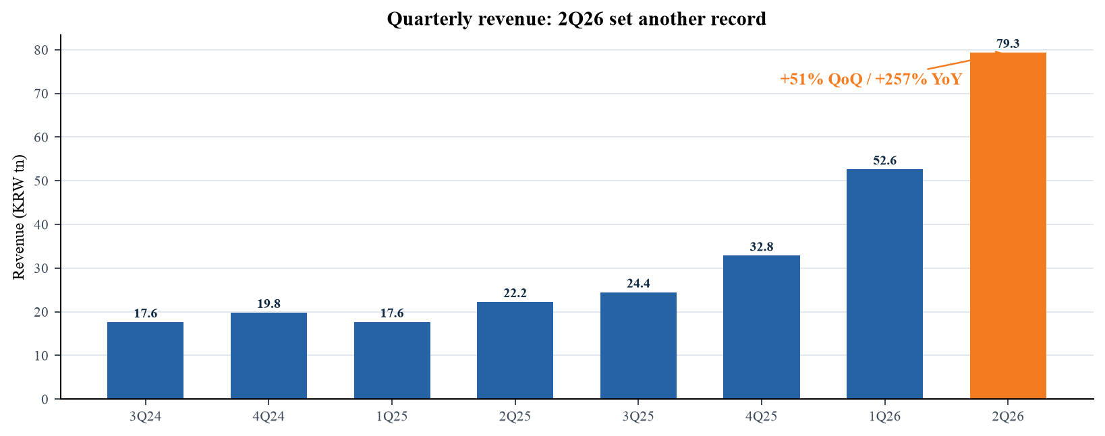
Sources: Company quarterly presentations.
The revenue miss is best interpreted as a mismatch between a very steep expectation curve and delivery timing rather than as demand destruction. AI server memory remains supply constrained, customer qualification schedules are lumpy, and product mix can shift across quarter boundaries. Still, the gap matters because the IPO and the sharp pre-earnings rally had capitalized a near-perfect outcome. In the next two quarters, investors should monitor whether HBM4 volume conversion and NAND pricing allow revenue to reaccelerate without a disproportionate inventory build.
Figure 2. Operating profit expanded faster than revenue
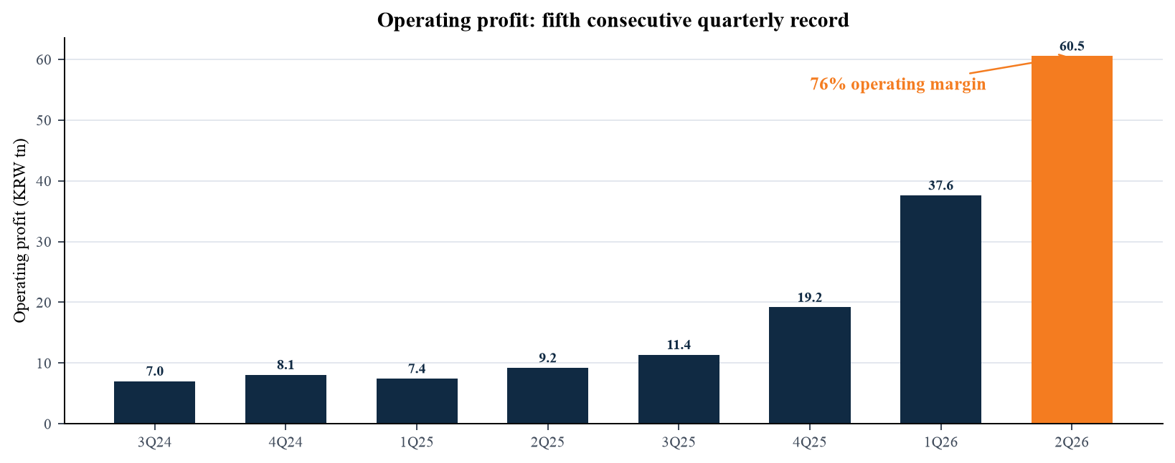
Sources: SK hynix 2Q26 presentation; Prior quarterly presentations.

MARGINS AND EARNINGS QUALITY
Operating profit of KRW60.54tn increased 61% QoQ and 557% YoY, and operating margin expanded four points sequentially to 76.3%. Gross profit reached KRW65.99tn and gross margin 83.2%, while cost of goods sold was only KRW13.33tn. The gap between gross and operating margin remained narrow: SG&A was KRW5.45tn, evidence that revenue growth is scaling through a highly fixed-cost manufacturing platform. EBITDA was KRW64.56tn, equal to an 81% margin.
Figure 3. Gross and operating margins reached new highs
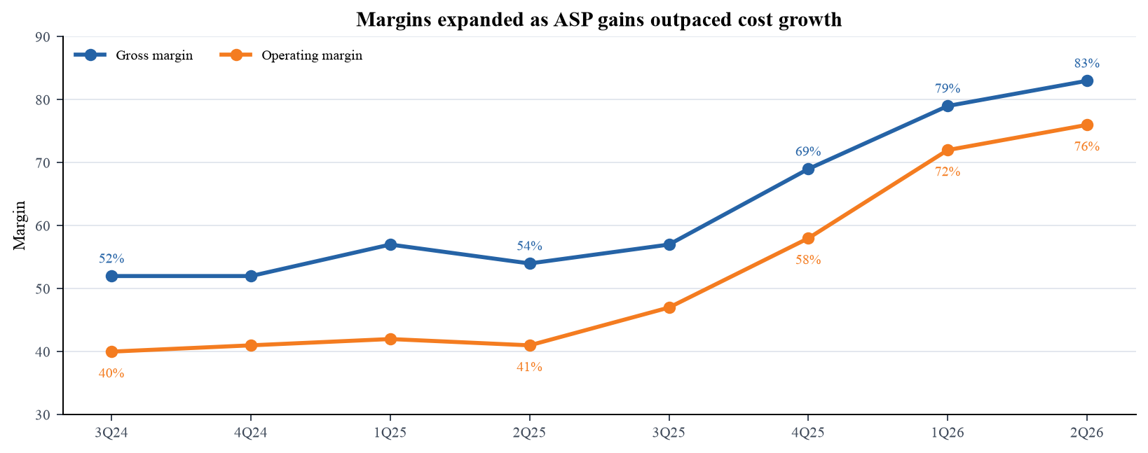
Sources: Company quarterly presentations.
Reported net profit of KRW93.92tn exceeded operating profit because pre-tax income included KRW60.89tn of other non-operating profit, principally KRW63.27tn of investment-asset gains. The quarter therefore cannot be valued on reported EPS of KRW131,478. We estimate normalized Q2 net income at roughly KRW45.5tn by removing the investment gain after applying a 23.5% illustrative tax rate. We use the same method to normalize the KRW9.94tn investment valuation gain disclosed in Q1. This is our analytical adjustment—not a company-reported non-GAAP measure—and actual tax realization may differ materially.
Figure 4. Reported net income was inflated by investment gains
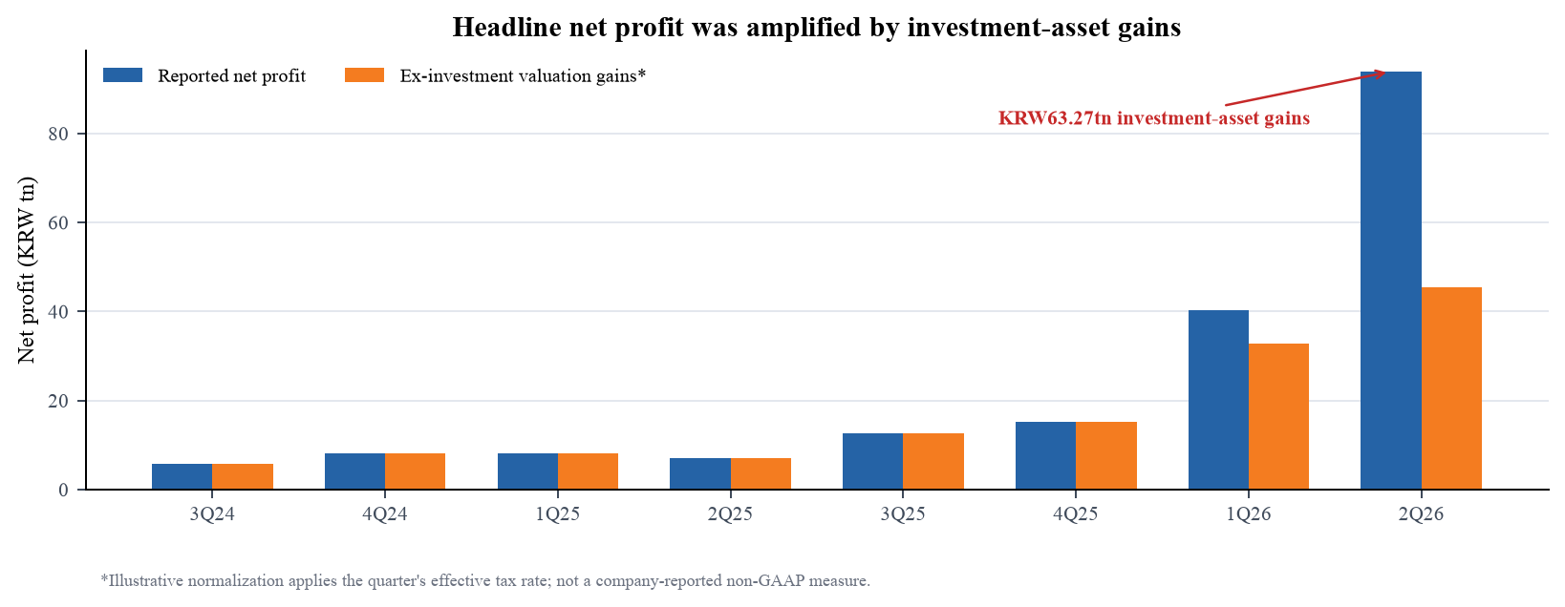
Sources: SK hynix 2Q26 presentation, pp. 6–7; SK hynix 1Q26 presentation.

EXPECTATIONS AND PRODUCT MIX
The reported miss was concentrated in scale, not profitability. Against the KRW84.1tn revenue and KRW64.1tn operating-profit averages published by Yonhap before results, SK hynix missed by KRW4.78tn and KRW3.56tn. The implied consensus operating margin was 76.2%, nearly identical to the 76.3% delivered. This pattern suggests the Street largely understood unit economics but overestimated shipment timing and/or mix. It also explains why the result can be operationally excellent while still disappointing the stock market.
Figure 5. The quarter missed elevated revenue and operating-profit expectations
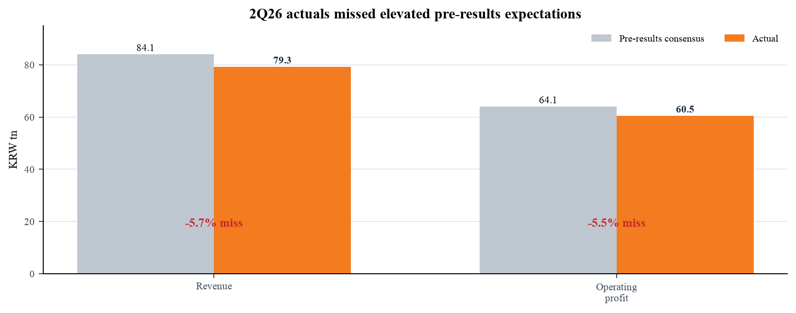
Sources: Yonhap, 26 July 2026; Company release.
Product mix shifted toward NAND: DRAM declined to 73% of revenue from 78% in Q1, while NAND rose to 27% from 21%. This was not negative mix dilution because NAND pricing rose much faster than DRAM pricing and 321-layer products increased their share. Management expects the 321-layer generation to become the largest NAND production share and to account for roughly half of domestic NAND capacity by year-end. The mix shift diversifies the earnings engine but also raises sensitivity to enterprise SSD demand and the speed of industry NAND supply response.
Figure 6. NAND gained share as pricing accelerated
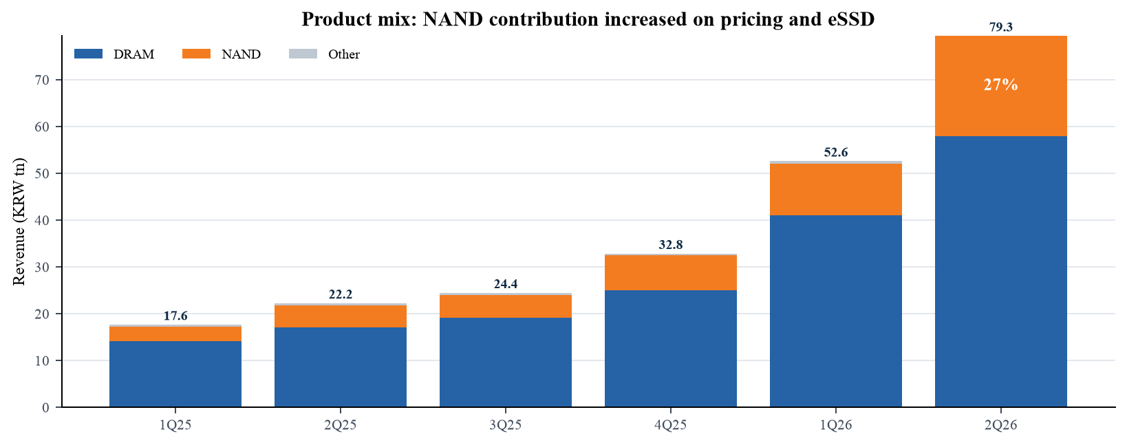
Sources: Company quarterly presentations.

BALANCE SHEET AND CASH FLOW
Cash and short-term investments rose to KRW87.96tn at quarter-end, while interest-bearing debt was KRW18.59tn, leaving approximately KRW69.4tn of net cash. This is a radical improvement from the net-debt position two years earlier and provides strategic capacity for HBM, advanced packaging and leading-edge NAND investment. The US ADR offering added substantial liquidity: the final prospectus shows 177.9m ADSs sold at US$149, each representing 0.1 common share, and approximately US$26.2bn of net proceeds.
Figure 7. Liquidity expanded faster than debt
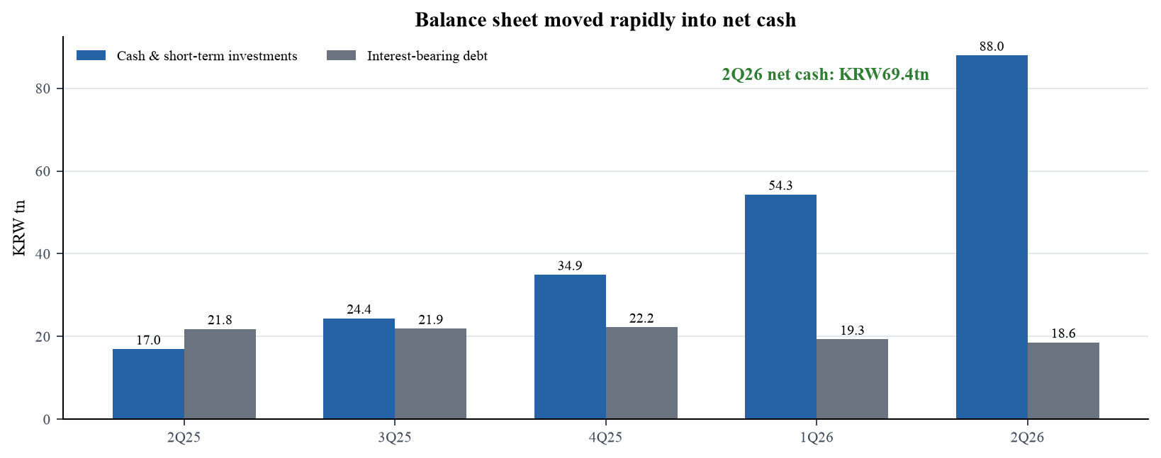
Sources: SK hynix 2Q26 presentation; SEC final prospectus.
Operating cash flow was KRW65.71tn and purchases of property, plant and equipment were KRW10.67tn, implying illustrative free cash flow of KRW55.04tn before other investing items. This exceptional conversion benefited from pricing, but working capital absorbed some cash: accounts receivable reached KRW47.82tn and inventory KRW17.99tn. Receivables are the more important watch item because rapid revenue growth and customer deposits can complicate quarter-to-quarter interpretation. We prefer to judge cash conversion over multiple quarters and against capital commitments, not from a single peak-margin period.
Figure 8. Cash generation remained strong after capital spending
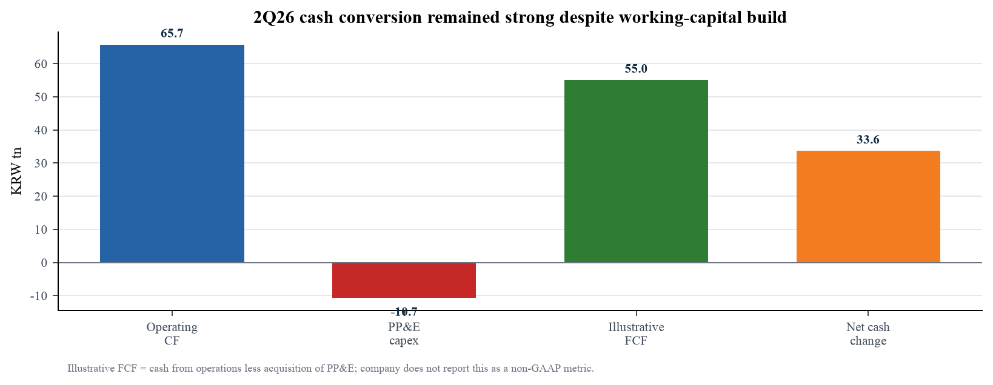
Sources: SK hynix 2Q26 presentation, pp. 9–10.

OUTLOOK, GUIDANCE AND EXECUTION
SK hynix did not provide formal quarterly revenue, EPS or margin guidance. It did provide operating indicators: Q3 DRAM bit shipments are expected to rise approximately 10% QoQ and NAND bits by a low-single-digit percentage. For full-year 2026, management expects DRAM demand growth in the mid-20% range and NAND growth in the high teens. These indicators support continued expansion, but they leave ASP and mix—the two largest profit sensitivities—to investor judgment.
Figure 9. Management expects memory demand to remain robust
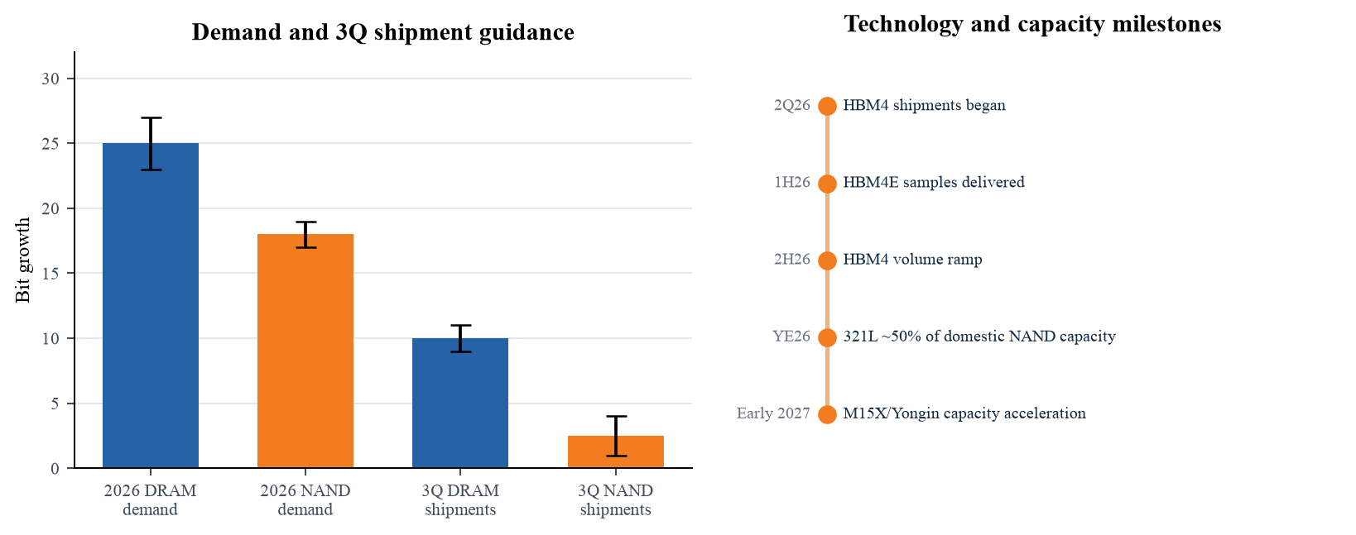
Sources: SK hynix 2Q26 presentation; Earnings-call replay.
- HBM roadmap: HBM4 shipments began in Q2 and should ramp through the second half. HBM4E samples were delivered in the first half, preserving SK hynix's technology cadence as accelerator platforms move to greater bandwidth and power efficiency.
- Contract architecture: Approximately ten customer long-term agreements now use pricing, volatility-sharing and deposit structures. These mechanisms improve demand visibility and capital planning, yet they may defer rather than remove risk if end demand slows.
- Capacity and CapEx: 2026 CapEx is expected in the high-KRW40tn range. M15X and Yongin Fab 1 are being accelerated toward early 2027, while P&T7 and M17 will ramp in phases. The balance sheet can fund this plan, but returns depend on maintaining discipline as competitors add supply.
- Product execution: SOCAMM2 using 1c-nanometer DRAM has begun, while 321-layer NAND is set to become the largest production generation. Qualification, yield and advanced-packaging throughput are the critical operating proof points.
The company did not publish a written transcript with the results; this report uses the official presentation and call replay. Statements attributed to management are paraphrased rather than quoted.
Sources: Official call replay; Company IR.

ESTIMATE REVISIONS
Because this is our initial post-IPO report, the 'old' column below is an external pre-results reference case from Hanwha Securities dated 22 June 2026, not a prior estimate published by us. Our new estimates incorporate the Q2 miss, the Q3 bit-shipment indicators, HBM4 ramp, current NAND pricing and a deliberate normalization of investment gains. We forecast Q3 revenue/operating profit of KRW92tn/KRW72tn and Q4 of KRW101tn/KRW78tn.
KRW tn except EPS | FY26E old* | FY26E new | Change | FY27E old* | FY27E new | Change
Revenue | 339.4 | 324.9 | -4.3% | 506.8 | 420.0 | -17.1%
Operating profit | 266.7 | 248.2 | -6.9% | 419.5 | 315.0 | -24.9%
Normalized net income | 217.3 | 190.2 | -12.5% | 319.0 | 242.0 | -24.1%
Normalized ADR EPS (US$) | 20.75 | 18.16 | -12.5% | 30.46 | 23.12 | -24.1%
Sources: Hanwha pre-results research (old*); Company Q2 materials.
Figure 10. Our post-results estimates are below the external pre-results reference case
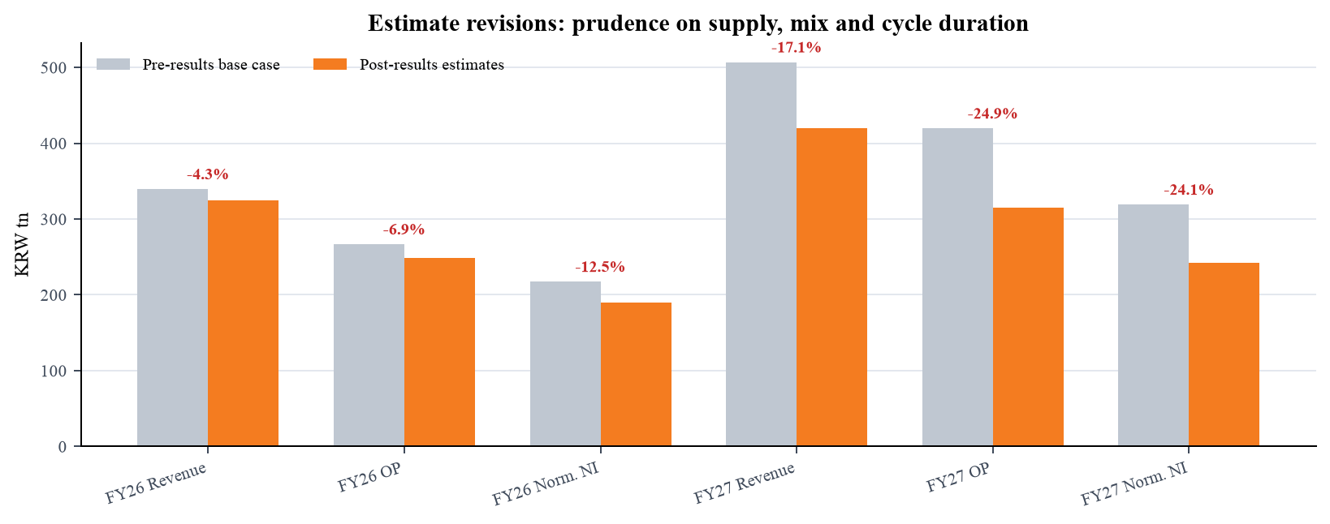
Sources: Hanwha Securities; Our estimates.
The largest reduction is FY2027 operating profit because the pre-results case extrapolated current scarcity economics unusually far. Our FY2027 model still assumes 29% revenue growth and a 75% operating margin, both exceptional. Forecast risk is two-sided: tighter supply and stronger HBM pricing could produce upside, while faster capacity additions, customer inventory digestion or a softer AI infrastructure cycle could cause margins to mean-revert much sooner.
Our quarterly bridge assumes Q3 revenue of KRW92tn on approximately 10% DRAM bit growth, low-single-digit NAND bit growth and continued ASP support, followed by KRW101tn in Q4 as HBM4 volumes and year-end enterprise demand broaden the mix. Operating profit of KRW72tn in Q3 and KRW78tn in Q4 implies margins near 78% and 77%, respectively. Those levels are deliberately below a mechanical extrapolation of Q2 gross-margin expansion: we allow for launch costs, product-transition inefficiency, higher depreciation and a less favorable incremental price/cost spread as the base becomes larger.
For FY2027, the model treats HBM as a structural premium product but not as permanently immune to negotiation. Revenue grows to KRW420tn, while operating profit reaches KRW315tn. The resulting 75% operating margin embeds continued technology leadership and favorable utilization, yet also assumes some normalization from quarterly peak conditions. Normalized net income of KRW242tn is derived from operating earnings and recurring below-the-line items rather than from carrying forward Q2 investment gains. This distinction is central to the valuation: a one-off mark-to-market benefit can strengthen book value and liquidity, but it should not receive an earnings multiple as if it were recurring semiconductor profit.
Sensitivity is unusually high because a one-point change in FY2027 operating margin changes operating profit by roughly KRW4.2tn before tax. Volume and ASP assumptions also interact: stronger pricing may lower customer order urgency or attract supply, while faster bit growth may require lower blended prices. We therefore view the forecast as a disciplined center point rather than a precise prediction. The most useful checkpoints are quarterly HBM qualification and shipment disclosures, the relationship between inventory and sales, CapEx commitments, and whether customer deposits continue to rise alongside long-term agreements.

VALUATION AND PRICE TARGET
SKHY closed at US$143.73 on 31 July, below the US$149 IPO price after trading as high as US$194.80. The price path reflects both the scarcity premium assigned to a newly listed AI-memory leader and the rapid reset when Q2 results missed elevated expectations. Because the ADR has only a short trading history, conventional 52-week statistics are not meaningful; all range references are since listing.
Figure 11. SKHY retraced after the Q2 release
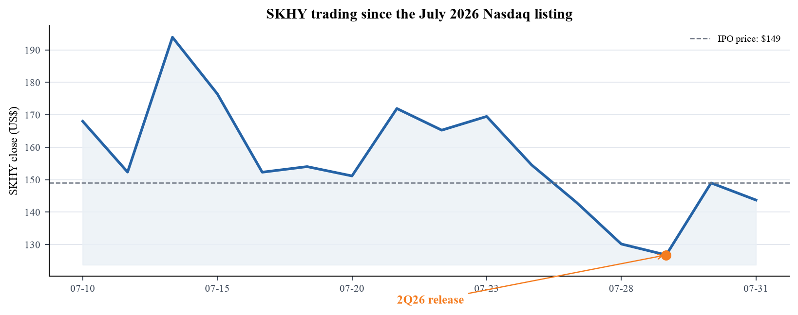
Sources: Yahoo Finance market data via yfinance; SEC final prospectus.
Our US$175 price target is the rounded output of 7.5x FY2027E normalized ADR EPS of US$23.12, implying a base value of approximately US$173. The multiple is intentionally conservative relative to asset-light AI beneficiaries because SK hynix must fund wafer capacity and packaging, operates in a historically cyclical industry, reports in Korean won and exposes ADR holders to governance and currency complexity. It is also above traditional memory-cycle trough multiples because HBM leadership, customer LTAs and net cash improve duration and resilience.
Scenario | FY27E ADR EPS | P/E | Value | Interpretation
Bear | US$18.50 | 6.0x | US$111 | Earlier supply response / margin normalization
Base | US$23.12 | 7.5x | US$173 | Rounded price target: US$175
Bull | US$27.00 | 9.0x | US$243 | HBM scarcity and LTAs extend peak economics
Figure 12. Scenario valuation spans US$111–243 per ADS
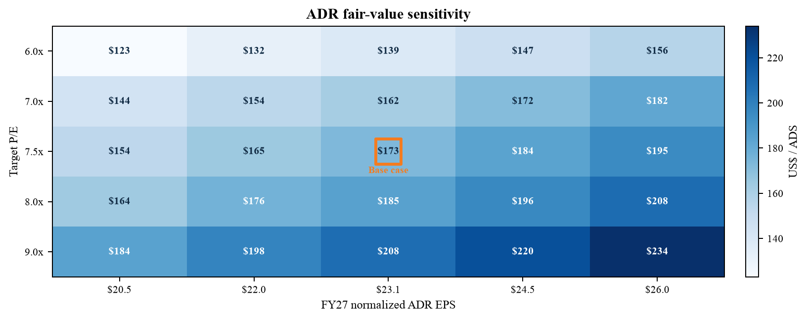
Sources: Company prospectus share data; Our estimates and valuation.

INVESTMENT THESIS, CATALYSTS AND RISKS

Three-pillar thesis
- 1. Structural AI memory intensity. The memory content and bandwidth required per accelerator and AI server continue to rise. HBM4 shipments and HBM4E sampling place SK hynix at the center of this shift, while SOCAMM2 creates an adjacent opportunity in low-power, high-capacity server memory.
- 2. Visibility and technology leadership. Customer LTAs, deposits and volatility-sharing clauses make demand planning more durable than in prior commodity cycles. Leading DRAM nodes, 321-layer NAND and advanced packaging provide a route to retain price and cost leadership, provided execution remains on schedule.
- 3. Balance-sheet transformation. KRW69.4tn of net cash and very strong operating cash flow lower financing risk just as the company accelerates M15X, Yongin Fab 1 and packaging capacity. The stronger balance sheet supports both growth investment and resilience in a future downturn.

Catalyst calendar
- August–October 2026: Evidence of HBM4 volume ramp, 1c DRAM and SOCAMM2 qualification, plus 321-layer NAND mix progression. Q3 results should test the approximately 10% QoQ DRAM bit-growth indicator and low-single-digit NAND shipment growth.
- Second half 2026: Additional HBM4/HBM4E customer qualification, LTA disclosures and customer deposits may improve confidence in FY2027 visibility. AI accelerator launch schedules are the principal external timing variable.
- Early 2027: M15X and Yongin Fab 1 milestones will frame supply growth, capital efficiency and the sustainability of current margins. Phased P&T7 and M17 ramps will determine whether packaging remains a bottleneck or becomes a competitive advantage.

Key risks
- Memory-cycle and supply response: Today's margins are extraordinary. Aggressive capacity additions by SK hynix or competitors could pressure ASPs and compress operating leverage more rapidly than modeled.
- AI demand concentration and customer bargaining power: HBM demand depends on a small number of accelerator and cloud ecosystems. Design changes, delayed deployments or stronger customer negotiating leverage could reduce volume or price realization.
- Execution and capital intensity: HBM4 yields, advanced-packaging throughput, node transitions and fab schedules are technically complex. CapEx in the high-KRW40tn range raises depreciation and the cost of execution errors.
- Accounting, valuation and market-structure risk: Investment gains distort reported net income; ADR trading history is short; KRW/USD moves affect translated EPS; and foreign-private-issuer reporting differs from a US domestic 10-Q cadence.

What would change our view
We would become more constructive if HBM4 qualification broadens across customers without a material yield penalty, customer LTAs convert to deposits and binding volumes, and inventory grows more slowly than revenue while free cash flow remains robust after the announced capacity build. A clearer demonstration that advanced packaging, rather than wafer supply, is the limiting factor would also support a higher multiple because it would reduce the probability of rapid commodity-style oversupply. Conversely, evidence that customers are double ordering, renegotiating price formulas or delaying accelerator deployments would challenge the duration of peak economics even if near-term reported revenue remains strong.
The most important downside trigger is not a single quarterly miss; it is a change in the price/cost trajectory. A sustained sequential ASP decline alongside higher depreciation would compress margins from both directions. We would also revisit the rating if CapEx commitments moved materially above the high-KRW40tn range without corresponding customer commitments, if receivables or inventory repeatedly outgrew sales, or if HBM4E qualification slipped into later platform cycles. The US$175 target therefore carries explicit execution gates. Meeting them could justify migration toward the bull scenario; missing several at once would move valuation closer to the bear case.
Rating framework: OUTPERFORM means expected total return above the analyst's sector benchmark over 12 months. The rating and target are scenario-based opinions, not guarantees. Investors should size positions for memory-cycle volatility and newly listed ADR liquidity dynamics.

SOURCES, METHODOLOGY AND DISCLOSURES
Primary-source hierarchy
Financial statements, operating metrics and management outlook are drawn from SK hynix's 29 July 2026 release, official 2Q26 presentation and official earnings-call replay. Historical quarterly series use the corresponding company presentations. The SEC Form 6-K confirms the call schedule; the final 424B4 prospectus supplies ADS ratio, offering size, price, post-offering share count and net-proceeds data. No official written call transcript was available when this report was prepared.
This report was prepared four calendar days after the release, outside the ideal same-day or 48-hour earnings-update window. The delay allowed incorporation of the first two full post-results trading sessions and the final prospectus share data, but market prices and consensus can change quickly. Readers should treat the stated price, market capitalization, foreign-exchange rate and implied upside as a 31 July 2026 snapshot. Operating and financial data remain anchored to the quarter ended 30 June 2026 unless a later date is explicitly identified.
Consensus and market data
Pre-results consensus is the average of 14 local brokerages reported by Yonhap on 26 July 2026. The external 'old estimate' reference is Hanwha Securities research dated 22 June 2026 and is not our prior coverage. SKHY price, market capitalization and trading-range data were fetched dynamically through yfinance after the 31 July close. The ADR's short history means the displayed range is since listing, not a full 52 weeks.
Analytical conventions
All financial figures are Korean won unless noted. Totals may not add because of rounding. Normalized net income removes disclosed Q1 and Q2 investment-asset valuation gains using an illustrative 23.5% tax rate; it is our estimate and not a company-reported non-GAAP measure. ADR EPS uses 728.8655m post-offering common shares, an ADS ratio of 0.1 common share per ADS and KRW1,436.6 per US dollar. Free cash flow is operating cash flow less purchases of property, plant and equipment and therefore excludes other investing flows. Price target upside excludes dividends.
Important disclosure
This report is independent analytical research prepared for informational purposes only. It is not investment advice, an offer, a solicitation or a fiduciary recommendation. Forecasts and valuation rely on assumptions that may prove incorrect. Memory semiconductors are cyclical, capital intensive and exposed to technology, geopolitical, customer-concentration, currency and supply-chain risks. Readers should review primary filings and obtain professional advice appropriate to their circumstances.

REFERENCE LINKS
- SK hynix 2Q26 earnings release
- Official 2Q26 presentation
- Official earnings-call replay
- SK hynix investor relations
- SEC Form 6-K
- SEC final 424B4 prospectus
- Yonhap pre-results consensus
- Hanwha Securities pre-results research
- SK hynix 1Q26 presentation
- SK hynix 4Q25 presentation
- SK hynix 3Q25 presentation
- SK hynix 2Q25 presentation
- SK hynix 1Q25 presentation
- SK hynix 4Q24 presentation
- SK hynix 3Q24 presentation

