WESTERN DIGITAL CORPORATION

Q1 FY2027 Earnings Update
Beat and raise validates the AI storage cycle while investment intensity tempers the rerating
24 October 2026 | Results released 22 October 2026
Rating: OUTPERFORM | Price target: $620 (prior $600) | Price: $343.67 at 23 Oct. close

Earnings summary
Metric | Reported | Consensus | Variance | YoY
Revenue | $4.381B | $4.145B | +$236M / +5.7% | +55%
Non-GAAP EPS | $4.64 | $4.10 | +$0.54 / +13.2% | +161%
Non-GAAP gross margin | 58.1% | Prior guide 55%-56% | +210-310 bps | +1,420 bps
Sources: WDC Q1 FY2027 release, 22 Oct. 2026; MarketBeat consensus snapshot, 22 Oct. 2026.
■ The quarter beat on both revenue and earnings. Revenue exceeded pre-release consensus by $236m, while non-GAAP EPS beat by $0.54. The gross-margin result was more important than the headline EPS: 58.1% cleared the high end of prior guidance by 210 bps and demonstrated that pricing, capacity mix and disciplined supply remain mutually reinforcing.
■ Q2 guidance resets the earnings run-rate higher. Management guided to $5.1bn of revenue, 60%-61% non-GAAP gross margin and $5.80 non-GAAP EPS at the midpoints. Current Street figures have largely moved to that range, but the guide still establishes a materially stronger base than the framework embedded in our prior FY2027 estimates.
■ The investment debate moves from demand to execution. Cloud remained 88% of revenue and demand visibility extends into 2030-2031. The debate is now whether the 40TB ePMR and HAMR ramps can convert that visibility into exabyte supply without excessive capital intensity, yield loss or cost inflation.
■ We raise the target to $620 and retain Outperform. Our FY2027 revenue and non-GAAP EPS estimates rise to $21.3bn and $25.00. A 24.8x multiple on the revised EPS view supports $620, 80% above the 23 October close. We use a lower multiple than the estimate growth might otherwise justify because capex will run modestly above the normal 4%-6% of revenue range for two years.

Revenue analysis
Revenue of $4.381bn increased 55% YoY and 17% sequentially, beating pre-release consensus of $4.145bn by $236m, or 5.7%. It also exceeded the top of management's prior $4.0bn-$4.2bn range by $181m. The variance was broad rather than dependent on one accounting item: exabytes shipped rose 22% YoY to 248EB, blended price per terabyte increased 28%, and the latest ePMR platform began contributing to the nearline mix. This combination matters because it shows that supply growth and pricing power can coexist when capacity gains lower customers' total cost of ownership.
Cloud revenue reached $3.868bn, up 54% YoY and equal to 88% of total revenue. The 10-Q attributes the gain to more than 20% exabyte growth and an approximately 25% increase in average selling price per exabyte. Client revenue rose 119% to $320m on roughly 15% exabyte growth and approximately 90% higher price per exabyte, while Consumer revenue increased 19% to $193m despite about 30% lower exabytes, as mix and price rose sharply. Consumer volume softness is the clearest sign of elasticity, but at 5% of revenue it does not alter the cloud-led thesis.
The quarter also strengthens the comparability of post-separation WDC. These figures represent the HDD-focused continuing business after the February 2025 Sandisk separation; flash results are not included. Investors should therefore compare the current five-quarter series with WDC's recast continuing-operations presentation rather than combine it with historical consolidated flash revenue. On that consistent basis, quarterly revenue has expanded every quarter from $2.818bn in Q1 FY2026 to $4.381bn in Q1 FY2027.
Figure 1. Quarterly revenue progression
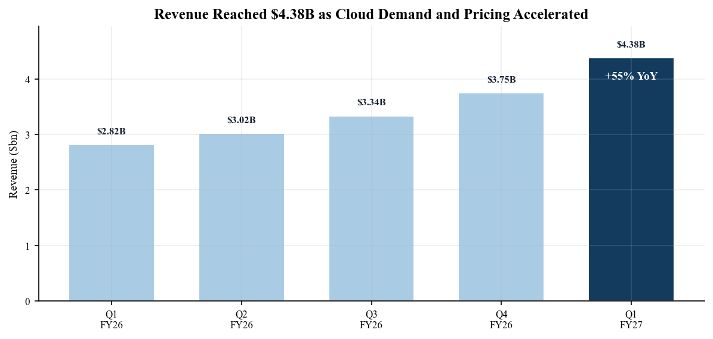
Sources: Q1 FY2027 presentation, slides 4-6; Q1 FY2027 Form 10-Q, filed 23 Oct. 2026.

Profitability and earnings quality
Non-GAAP gross margin reached 58.1%, up 370 bps sequentially and 1,420 bps YoY. Non-GAAP operating margin expanded to 49.1%, up 490 bps sequentially and 1,870 bps YoY. The margin bridge is unusually powerful: higher-capacity products lift revenue per drive, favorable contract and spot pricing increases price per terabyte, and areal-density gains add exabytes without equivalent unit-capacity spending. Management said incremental YoY gross margin exceeded 80%, a result that makes pricing sustainability and transition execution more important than simple unit growth.
Non-GAAP operating expenses were $391m, only 3% above the prior year despite 55% revenue growth. That restraint produced $2.153bn of non-GAAP operating income, up 152% YoY. GAAP operating income was $2.046bn after $70m of stock compensation and $27m of business realignment charges. The narrow $0.01 difference between GAAP and non-GAAP diluted EPS this quarter contrasts with earlier quarters distorted by gains on the retained Sandisk interest and debt-equity transactions; as a result, Q1's $4.63 GAAP EPS and $4.64 non-GAAP EPS provide a cleaner view of current operating economics.
The principal near-term margin risk is not demand but the cost of supplying it. Management expects DRAM and NAND input inflation to limit some cost-per-terabyte improvement, while HAMR heads require more production cycles. Nevertheless, Q2 guidance of 60%-61% gross margin implies another 190-290 bps sequential expansion. We view that guide as credible but not automatically repeatable: continued LTA repricing, spot-market discipline and the 40TB ePMR ramp must offset transition costs and richer component inputs.
Figure 2. GAAP and non-GAAP diluted EPS
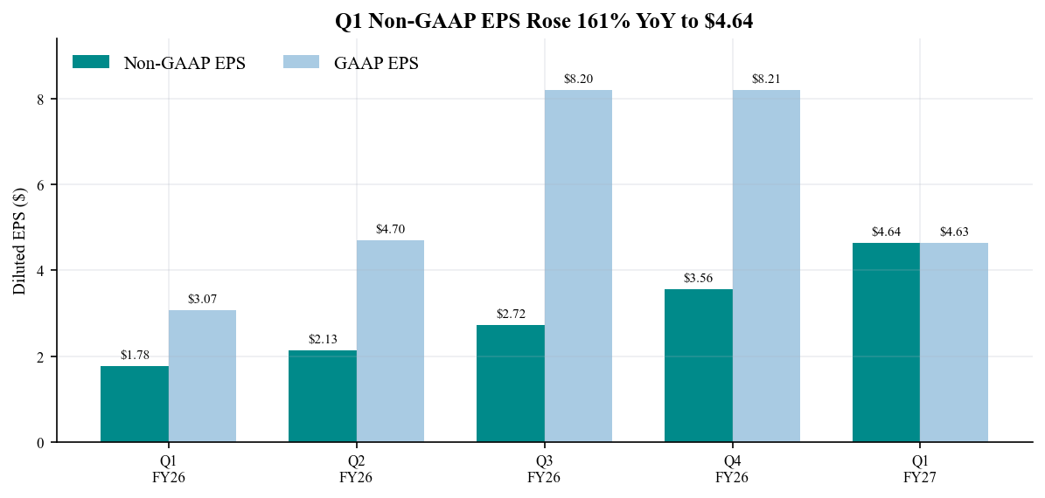
Sources: Q1 FY2027 presentation, slides 6 and 10; Q1 FY2027 earnings release.
Figure 3. Non-GAAP margin progression
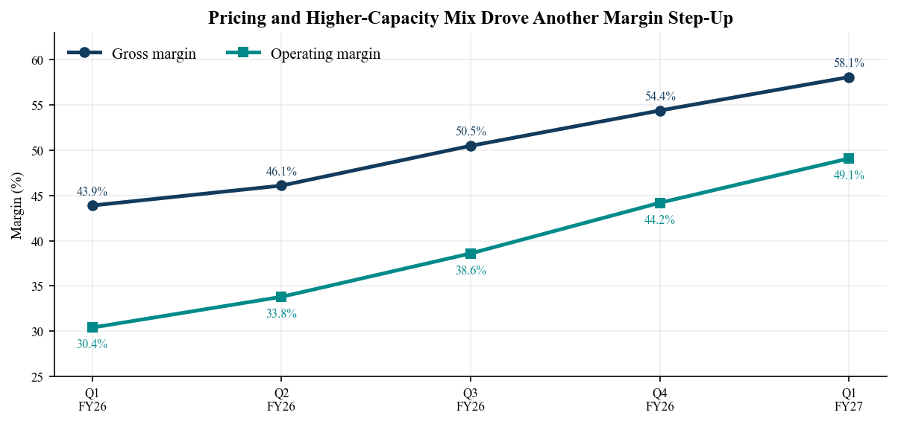
Sources: Q1 FY2027 presentation, slides 5-6; Q1 FY2027 Form 10-Q.

Cash generation and end-market mix
Operating cash flow rose 139% YoY to $1.604bn and free cash flow increased 130% to $1.377bn, equal to 31.4% of revenue. Capital expenditures were $227m, up from $73m a year earlier as WDC invested in production technology and automation. Working capital absorbed $331m, principally through a $269m inventory build and $206m increase in receivables, partly offset by payables and tax timing. The cash conversion is therefore strong despite deliberate inventory preparation for higher demand rather than because working capital temporarily flattered the result.
Capital allocation was substantial: WDC repurchased $1.001bn of shares, paid $56m of common dividends and used $570m to settle convertible-note transactions. Cash ended at $1.314bn, while the revolver balance was $650m and only $141m of convertible principal remained. The resulting roughly $0.5bn net cash position supports the raised $0.175 quarterly dividend and targeted investment, but conversion-related share issuance and equity compensation complicate per-share value creation. We therefore focus on diluted shares and free cash flow per share, not only headline repurchases.
Revenue remains concentrated in Cloud at 88%, with Client at 7% and Consumer at 5%. Cloud concentration creates customer and negotiating risk, but the mix is economically attractive while hyperscaler and AI workloads sustain high-capacity demand. The 248EB shipment total comprised 223EB of nearline and 25EB of non-nearline products. Nearline grew from 183EB a year ago, while non-nearline moved from 21EB, confirming that the volume engine remains enterprise and cloud storage rather than PC replacement.
Figure 4. Quarterly free cash flow
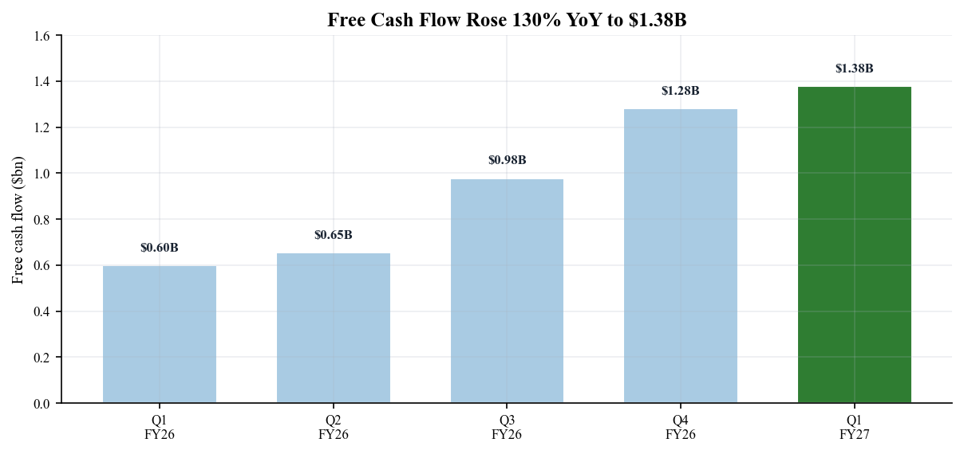
Sources: Q1 FY2027 presentation, slides 6 and 10; Q1 FY2027 Form 10-Q, cash-flow statement.
Figure 5. Revenue mix by end market
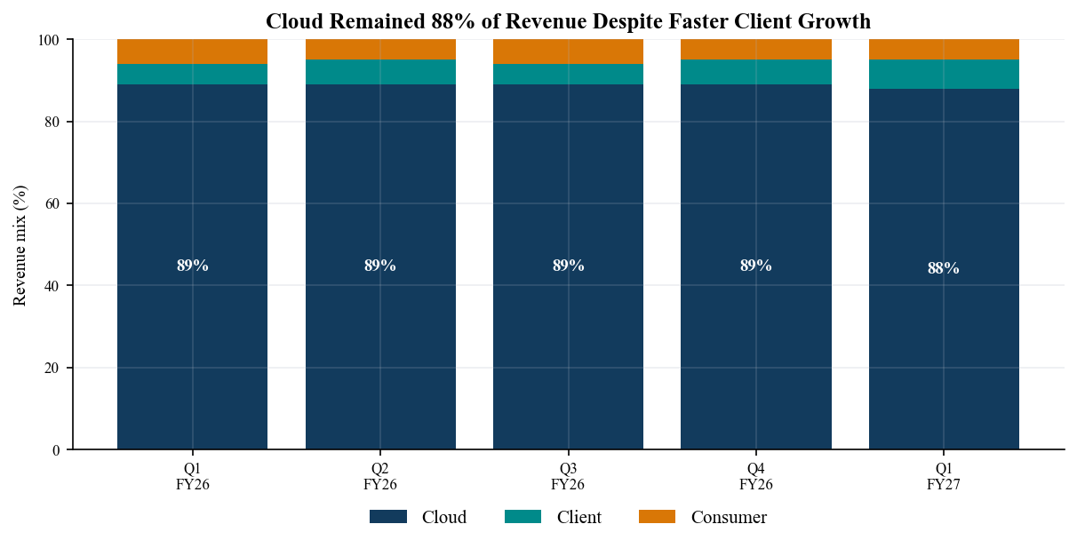
Sources: Q1 FY2027 presentation, slide 4; Q1 FY2027 Form 10-Q, revenue note.

Guidance and near-term outlook
Management guided Q2 FY2027 revenue to $5.1bn plus or minus $100m, representing 66%-72% YoY growth and about 16% sequential growth at the midpoint. Non-GAAP gross margin is expected at 60%-61%, operating expenses at $400m-$410m, other expense near $15m, tax near 17% and diluted shares near 380m. The resulting $5.80 plus or minus $0.20 non-GAAP EPS midpoint implies another 25% sequential increase. Compared with current 23 October consensus of $5.127bn revenue and $5.87 EPS, the guide is broadly aligned after post-release revisions rather than an additional beat still unrecognized by the Street.
The comparison with prior guidance is more revealing. Q1 actual revenue of $4.381bn exceeded the old midpoint by 6.9%, actual gross margin exceeded its midpoint by 260 bps and non-GAAP EPS exceeded its midpoint by 16%. Management has consistently used technology transitions, long-term agreements and constrained unit supply to improve price per terabyte; the Q2 margin guide assumes that mechanism persists. The next validation points are the share of nearline shipments on the newest ePMR platform, price resets as LTAs renew and whether cost inflation remains contained.
We do not extrapolate Q2's 69% YoY revenue growth indefinitely. The base case assumes Q3 and Q4 growth moderates as comparisons become harder, while higher-capacity mix supports gross margin above 60%. Management's comments that customer visibility reaches 2030-2031 are strategically positive but do not constitute firm volume or price guidance. The key analytical distinction is between demand visibility and contracted economics: some LTA volumes have pricing provisions, some exabytes remain uncontracted, and coverage declines farther into the future.
Figure 7. Q1 actual results vs. prior guidance and consensus
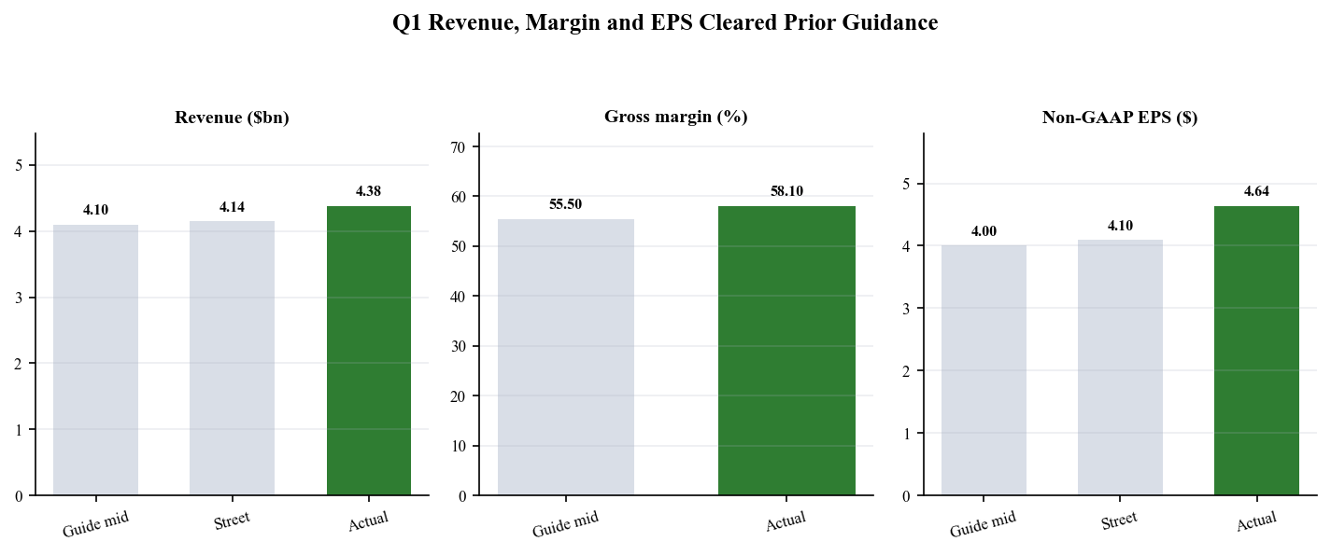
Sources: Q4 FY2026 release and Q1 guidance, 5 Aug. 2026; Q1 FY2027 release, 22 Oct. 2026; MarketBeat pre-release consensus.
Figure 8. Q2 FY2027 guidance vs. current Street
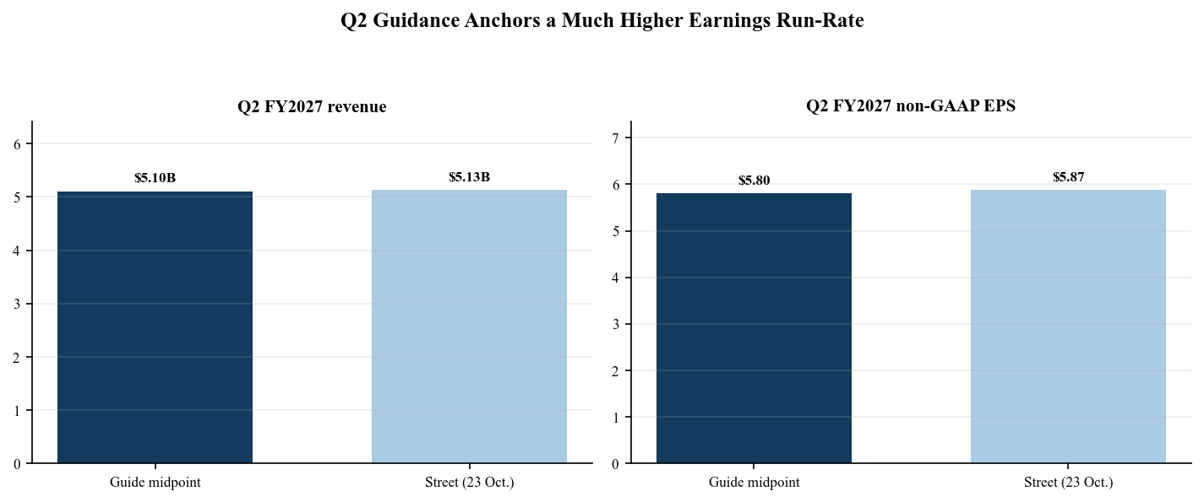
Sources: Q1 FY2027 presentation, slide 7; Longbridge consensus snapshot, 23 Oct. 2026.

Updated investment thesis
■ AI storage demand and customer visibility Strengthened. Cloud revenue grew 54% and remained 88% of sales, while management described demand signals from hyperscalers, AI frontier labs, NeoCloud operators, enterprise users and hybrid-cloud OEMs. Visibility for major customers now extends into 2030-2031. The breadth reduces dependence on any single AI training cycle, although customer concentration remains high and future visibility is not equivalent to firm take-or-pay volume.
■ Technology-led capacity growth Strengthened but execution-sensitive. The newest ePMR platform, delivering up to 40TB, is transitioning faster than previous platforms. Management expects it to represent about 30% of nearline shipments in Q2 and 50% in Q3 FY2027. HAMR volume shipments remain planned for the first half of calendar 2027. If both ramps execute, WDC can accelerate exabyte growth through FY2027-FY2028 while holding unit capacity relatively disciplined.
■ Pricing and margin durability Strengthened. Blended price per terabyte increased 28% YoY, and Q2 gross-margin guidance moves to 60%-61%. Pricing is supported by contractual adjustments on LTAs, higher capacity's customer TCO benefits and tight spot supply for uncontracted exabytes. The strongest challenge is that pricing visibility is shorter than demand visibility; contracts cover only part of future output, and aggressive industry supply additions could eventually erode the present scarcity premium.
■ Capital allocation and per-share compounding Mixed. Free cash flow supports dividends, repurchases and technology investment, but the company will spend modestly above its normal 4%-6% capex-to-revenue range for two years. Convertible-note settlements also issued shares against conversion premiums, while stock compensation continues. The correct scorecard is growth in free cash flow per diluted share after necessary transition investment, not gross buyback dollars.
Overall, the earnings release strengthens the operating thesis more than the stock reaction implies. The 2.97% decline on 23 October appears to reflect fear that elevated capex and input costs mark a cyclical peak. We instead read the call as a deliberate shift toward heads, media and automation needed to lift areal density, not a broad unit-capacity build. That distinction is essential: spending that supports more platters and higher-capacity drives within disciplined unit volumes can preserve pricing, while traditional factory expansion would create a more serious oversupply risk.
Figure 6. Nearline and non-nearline exabytes shipped
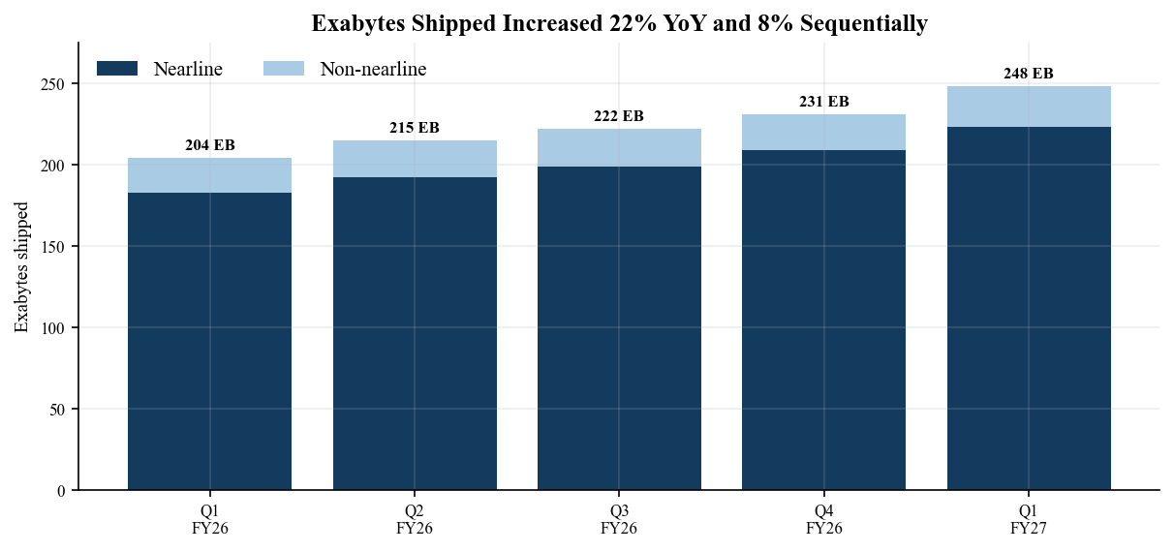
Sources: Q1 FY2027 presentation, slide 5; Q1 FY2027 earnings-call transcript, 22 Oct. 2026.

Estimate revisions
We raise FY2027 revenue to $21.3bn from $19.6bn and non-GAAP EPS to $25.00 from $20.50. The revenue change incorporates Q1's $236m consensus beat, the $5.1bn Q2 guide midpoint and a higher second-half baseline supported by the 40TB ePMR ramp. The EPS increase is larger because gross-margin leverage and restrained operating expenses convert incremental revenue at high contribution margins. Our FY2028 view of $25.0bn revenue and $31.00 EPS assumes exabyte supply acceleration, HAMR qualification and continued pricing discipline, but not indefinite repetition of Q2's 69% growth rate.
Metric | FY2026A | FY2027E prior | FY2027E new | Change | FY2028E
Revenue ($bn) | 12.9 | 19.6 | 21.3 | +8.7% | 25.0
Non-GAAP gross margin | 49.1% | 57.5% | 60.5% | +300 bps | 61.5%
Non-GAAP op. margin | 37.3% | 47.0% | 51.0% | +400 bps | 52.0%
Non-GAAP EPS | $10.22 | $20.50 | $25.00 | +22.0% | $31.00
Free cash flow ($bn) | 3.5 | 5.3 | 5.9 | +11.3% | 7.0
Sources: WDC FY2026 Form 10-K; Q1 FY2027 release and Q2 guidance; Independent estimates, 24 Oct. 2026.
The prior FY2027 baseline is the estimate published in our Q4 FY2026 update rather than a retrospective Street number. The new FY2027 path is intentionally close to current quarterly consensus on Q2-Q4, but it uses a slightly more conservative share-count and cost framework to reflect dilution and transition spending. Our forecast is not company guidance beyond Q2. Quarterly timing can move with customer deployment schedules, and long-term agreements may shift volume between periods without changing full-year demand.
Sensitivity is highest to gross margin. A 100 bp change in FY2027 gross margin, holding revenue and other assumptions constant, changes annual pre-tax profit by roughly $213m and EPS by approximately $0.46 after tax. Revenue upside without pricing discipline would therefore be less valuable than the same revenue delivered through higher-capacity products and controlled unit supply. Conversely, sustained gross margin above 61% would make our $25.00 EPS estimate conservative even if exabyte growth merely tracks the current roadmap.
Figure 9. FY2027 estimate revisions
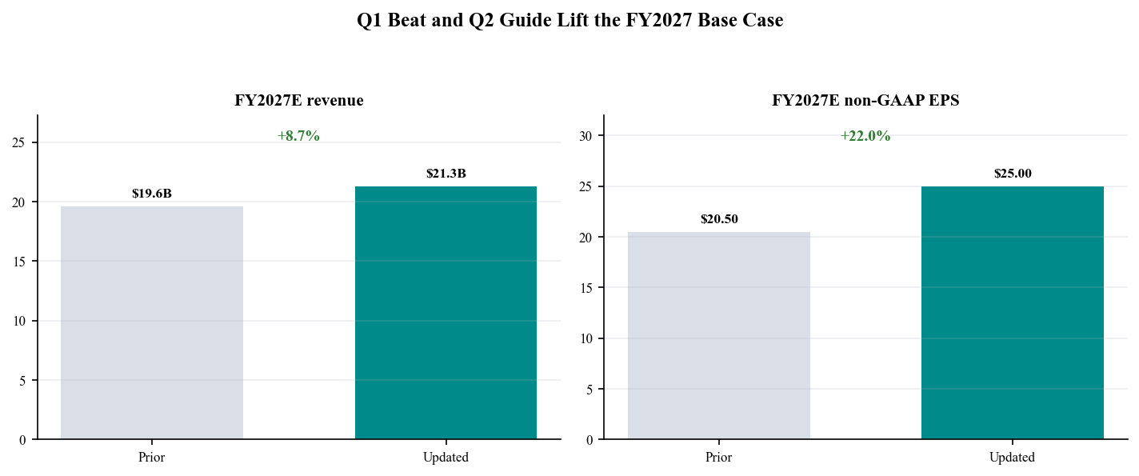
Sources: Prior Q4 FY2026 independent estimates; Q1 FY2027 results and current consensus; Longbridge consensus, 23 Oct. 2026.

Valuation and price target
We raise our price target to $620 from $600, implying 80% upside from the 23 October close of $343.67. The target applies 24.8x to our FY2027 non-GAAP EPS estimate of $25.00. That multiple is above WDC's current roughly 13x trailing earnings multiple but below the valuation implied by the strongest AI infrastructure peers and below Seagate's current premium multiple. The premium to WDC's own current multiple is justified by more than 50% revenue growth, expanding margins and a net-cash balance sheet; the discount to premium peers reflects product-transition, customer-concentration and cycle risk.
Scenario | FY2027 EPS | P/E | Value | Key assumption
Bear | $21.00 | 20.0x | $420 | Pricing normalizes; HAMR ramp slips
Base | $25.00 | 24.8x | $620 | ePMR ramp executes; GM near 60%
Bull | $28.60 | 28.0x | $800 | Supply remains tight; HAMR scales cleanly
Sources: Independent scenario analysis, 24 Oct. 2026; Longbridge price and valuation snapshot, 23 Oct. 2026.
The bear case still sits above the current price because the stock already discounts a sharp margin and multiple reversal. Its $420 value assumes EPS settles near $21 and the market pays only 20x. The bull case requires both sustained scarcity pricing and a clean HAMR ramp, supporting $28.60 of EPS and 28x. We do not probability-weight these endpoints; they are a sensitivity framework showing that technology execution and pricing duration, not terminal revenue growth alone, drive valuation dispersion.
Cross-checking against external sentiment, Longbridge's 23 October institutional snapshot showed 17 strong-buy, four buy and five hold ratings, with a $610 average target, $405 low and $900 high. Our $620 target is therefore close to the updated mean rather than an outlier. The main reason to retain Outperform after the post-earnings decline is asymmetric risk-reward: the base case offers substantial upside, while the bear case requires a material deterioration from the current operating trajectory before falling toward the present market price.
Figure 10. Bear base and bull valuation scenarios
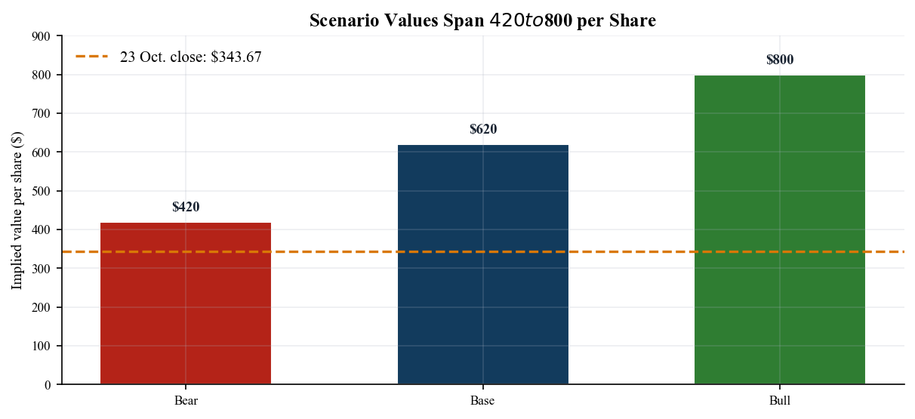
Sources: Independent estimates and scenario analysis, 24 Oct. 2026; Longbridge 23 Oct. close.

Market reaction risks and monitoring
WDC fell 2.97% on 23 October to $343.67 despite the double beat and strong Q2 guide. The reaction suggests investors are looking past the near-term numbers toward the cost of sustaining supply growth. Management expects capex to run modestly above the long-run 4%-6% of revenue range for two years, primarily for heads, media technology and factory automation. The distinction from adding unit capacity is favorable, but it still creates execution risk and reduces near-term free-cash-flow conversion relative to the exceptional Q1 level.
■ Technology transition risk. ePMR must reach about 30% of nearline shipments in Q2 and 50% in Q3, while HAMR is scheduled for first-half 2027 volume shipments. Qualification delays, yield issues or throughput loss would limit exabyte growth and pressure margins.
■ Pricing and supply risk. Current margins depend on LTA price steps, product value and tight uncontracted supply. A competitor-led capacity response, weaker cloud deployments or LTA renegotiation could compress price per terabyte faster than density lowers cost.
■ Customer and product concentration. Cloud is 88% of revenue and large customer deployment schedules can shift regional and quarterly results. Client and Consumer are too small to offset a broad hyperscaler pause.
■ Capital structure and dilution. Convertible settlements simplified debt but used shares for conversion premiums. Repurchases should be evaluated net of dilution, equity compensation and cash needed for technology investment.
■ Input-cost and macro risk. Management highlighted DRAM and NAND inflation. Trade restrictions, supplier concentration, foreign exchange and customer capex cycles remain material sensitivities in the 10-Q.
Our monitoring dashboard for the next report has five items: 40TB ePMR shipment mix, total and nearline exabyte growth, blended price per terabyte, gross margin relative to 60%-61% guidance and capex/free-cash-flow conversion. A clean beat on these measures would support further estimate upside. A revenue beat driven only by pricing, without progress on exabyte supply and technology mix, would be lower quality because it would increase the risk of customer pushback and future share loss.
Figure 11. Adjusted one-year share price and target
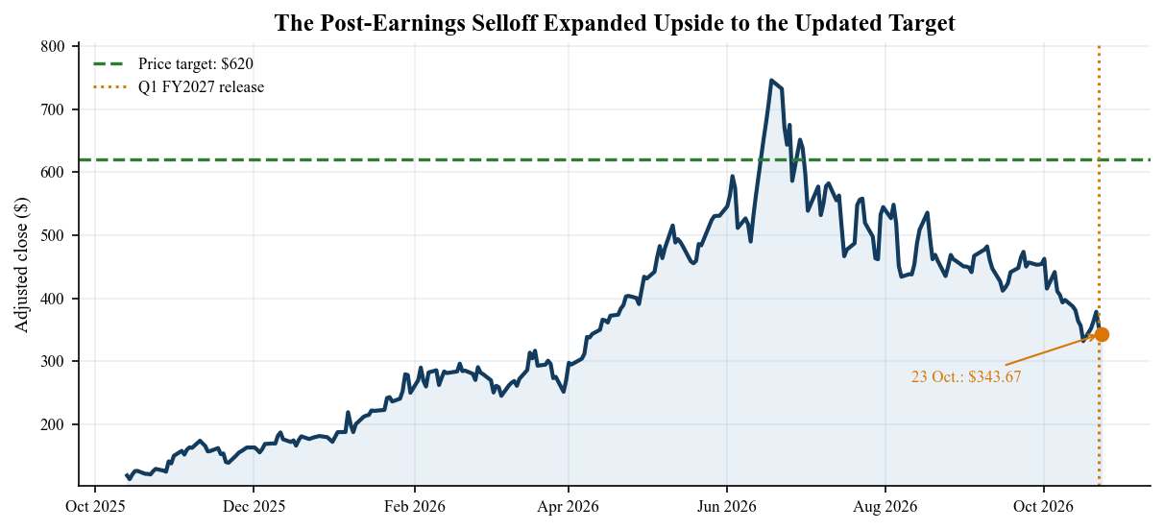
Sources: Longbridge adjusted daily K-line through 23 Oct. 2026; WDC Q1 FY2027 release date.

Sources methodology and disclosures
Today is 24 October 2026. Western Digital Corporation trades on Nasdaq under WDC and files with SEC CIK 106040. The company released Q1 FY2027 results on 22 October 2026 for the period ended 2 October 2026, furnished Form 8-K the same day and filed Form 10-Q on 23 October. The earnings call was held on 22 October at 4:30 p.m. Eastern, matching the release date. These are the latest reported results and fall within the required three-month recency window.
Reported financial statements, end-market revenue, cash flow, debt, share count and risk disclosures are anchored to the earnings release, presentation and Form 10-Q. Management commentary and Q&A use the dated 22 October transcript and WDC webcast page. Pre-release consensus for the beat/miss calculation uses the MarketBeat 22 October snapshot; current forward consensus, rating and target-price context use Longbridge data dated 23 October. The stock-price chart uses Longbridge forward-adjusted daily closes through 23 October.
Western Digital completed the separation of Sandisk on 21 February 2025. Historical quarterly series in this report use WDC's recast continuing-operations HDD presentation and do not combine post-separation WDC with Sandisk flash revenue. Non-GAAP measures follow WDC's definitions and are not substitutes for GAAP. Prior FY2027 estimates come from the earlier Q4 FY2026 update; updated FY2027-FY2028 estimates, scenarios, rating and target are independent analytical judgments rather than company guidance.
This report is independent research for informational purposes only. It is not investment advice, an offer, a solicitation or a fiduciary recommendation. Estimates and valuation scenarios depend on assumptions that may prove wrong. Readers should review the primary filings and consider their objectives, risk tolerance and professional advice before making investment decisions.

Sources and references
• Q1 FY2027 earnings release 22 October 2026
• Q1 FY2027 earnings presentation 22 October 2026
• Form 8-K accession 0001628280-26-066882 filed 22 October 2026
• Form 10-Q accession 0001628280-26-066933 filed 23 October 2026
• Q1 FY2027 earnings call and webcast 22 October 2026
• Q1 FY2027 call transcript 22 October 2026
• Q4 FY2026 release and prior Q1 guidance 5 August 2026
• MarketBeat pre-release consensus snapshot 22 October 2026
• Longbridge market consensus rating valuation and price data 23 October 2026
• WDC earnings documents archive

