TEST HANDOUT – DO NOT REVIEW ☺

Module 6: Understanding Uncertainty in Ecological Forecasts - Student Handout



### Name:

### Student ID:

#### Completed on:

#### Copy-paste your save progress link from the Shiny app here for ease of reference:

# Learning Objectives:

By the end of this module, you will be able to:

* Define ecological forecast uncertainty
* Explore the contributions of different sources of uncertainty (e.g., model parameters, model driver data) to total forecast uncertainty
* Outline how multiple sources of uncertainty are quantified
* Identify ways in which uncertainty can be reduced within an ecological forecast
* Describe how forecast horizon affects forecast uncertainty
* Explain the importance of specifying uncertainty in ecological forecasts for application

# Why macrosystems ecology and ecological forecasting?

**Macrosystems ecology** is the study of ecological dynamics at multiple interacting spatial and temporal scales (e.g., Heffernan et al. 2014). For example, *global* climate change can interact with *local* land-use activities to control how an ecosystem changes over the next decades. Macrosystems ecology recently emerged as a new sub-discipline of ecology to study ecosystems and ecological communities around the globe that are changing at an unprecedented rate because of human activities (IPCC 2013). The responses of ecosystems and communities are complex, non-linear, and driven by feedbacks across local, regional, and global scales (Heffernan et al. 2014). These characteristics necessitate novel approaches for making predictions about how systems may change to improve both our understanding of ecological phenomena as well as inform resource management.

**Forecasting** is a tool that can be used for understanding and predicting macrosystems dynamics. To anticipate and prepare for increased variability in populations, communities, and ecosystems, there is a pressing need to know the future state of ecological systems across space and time (Dietze et al. 2018). Ecological forecasting is an emerging approach which provides an estimate of the future state of an ecological system with uncertainty, allowing society to prepare for changes in important ecosystem services. Ecological forecasts are a powerful test of the scientific method because ecologists make a hypothesis of how an ecological system works; embed their hypothesis in a model; use the model to make a forecast of future conditions; and then when observations become available, assess the accuracy of their forecast, which indicates if their hypothesis is supported or needs to be updated. Forecasts that are effectively communicated to the public and managers will be most useful for aiding decision-making. Consequently, macrosystems ecologists are increasingly using ecological forecasts to predict how ecosystems are changing over space and time (Dietze and Lynch 2019).

In this module, students will generate an ecological forecast for a NEON site and quantify the different sources of uncertainty within their forecast. This module will introduce students to the conceptof uncertainty within an ecological forecast; where uncertainty in a forecast comes from; how uncertainty can be quantified within a forecast; and how uncertainty can be managed.

## Module overview:

* Introduction to Ecological Forecasting: pre-readings and PowerPoint in class
* Activity A: Build different models to simulate water temperature for their chosen NEON site.
* Activity B: Generate multiple forecasts of water temperature with different sources of uncertainty and examine how uncertainty propagation differs.
* Activity C: Quantify and partition the uncertainty for their forecasts with different models and make management decisions using an ecological forecast.

## Today’s focal question: *Where does forecast uncertainty come from and how can it be quantified and reduced?*

To address this question, we will introduce ecological forecasts and the iterative forecasting cycle. We will build a model that forecasts water temperature with uncertainty. We will then explore the different sources of uncertainty associated with our forecast predictions. In this module, we will use our model to examine where forecast uncertainty comes from and how it propagates through time due to driver data, model parameters, and initial conditions. We will then quantify the sources of uncertainty in forecasts and compare between models and then make a management decision using information from a forecast.

We will be using ecological data collected by the National Ecological Observation Network (NEON) to tackle this question. NEON is a continental-scale observatory designed to collect publicly-available, long-term ecological data to monitor changing ecosystems across the U.S. Water temperature exerts a major influence on biological activity and growth, has an effect on water chemistry, can influence water quantity measurements, and governs the kinds of organisms that live in water bodies.

## R Shiny App:

The lesson content is hosted on an R Shiny App at <https://macrosystemseddie.shinyapps.io/module6/>.

This can be accessed via any internet browser and allows you to navigate through the lesson via this app. You will fill in the questions below on this handout as you complete the lesson activities.

## Optional pre-class readings and video:

Webpages:

* [NOAA Ecological Forecasts](https://oceanservice.noaa.gov/ecoforecasting/noaa.html#:~:text=What%20is%20ecological%20forecasting%3F,%2C%20pollution%2C%20or%20habitat%20change.)
* [Ecological Forecasting Initiative](https://ecoforecast.org/about/)

Articles:

* Dietze, M. and Lynch, H. 2019. Forecasting a bright future for ecology. *Frontiers in Ecology and the Environment*, *17*(1), 3. <https://doi.org/10.1002/fee.1994>
* Dietze, M.C., et al. 2018. Iterative near-term ecological forecasting: Needs, opportunities, and challenges. Proceedings of the National Academy of Sciences, 115(7), 1424–1432. <https://doi.org/10.1073/pnas.1710231115>
* Jackson, L.J., Trebitz, A.S., & Cottingham, K.L. 2000. An introduction to the practice of ecological modeling. BioScience, 50(8), 694. [https://doi.org/10.1641/0006-3568(2000)050[0694:aittpo]2.0.co;2](https://doi.org/10.1641/0006-3568(2000)050%5B0694:aittpo%5D2.0.co;2)

Videos:

* NEON's [Ecological Forecast: The Science of Predicting Ecosystems](https://www.youtube.com/watch?v=Lgi_e7N-C8E&t=196s&pbjreload=101)
* Fundamentals of Ecological Forecasting Series: [Why Forecast?](https://www.youtube.com/watch?v=kq0DTcotpA0&list=PLLWiknuNGd50Lc3rft4kFPc_oxAhiQ-6s&index=1)

## Pre-class activity: Explore how uncertainty in predictions can affect decision-making

Read the following paper, which you can either access independently online or obtain from your instructor:

*Pielke, R. A. (1999). Who decides? Forecasts and responsibilities in the 1997 Red River flood. Applied Behavioral Science Review, 7(2), 83–101.*

#### Refer to the paper you read to answer the questions below.

1. Ahead of the 1997 Red River flood in East Grand Forks, the National Weather Service (NWS) provided two river crest predictions of 47.5 and 49 ft. How were these two different predictions made? (What was the difference between the two predictions?).

* **Answer:**

1. Pielke reports that many people misinterpreted the two river crest predictions provided by the NWS. Describe two ways in which the river crest predictions were incorrectly interpreted.

* **Answer:**

1. The NWS did not quantify or report the uncertainty associated with its river crest predictions for the 1997 Red River flood event. Referring to Fig. 2 in the paper, what do you think would be a reasonable estimate of the uncertainty associated with NWS river crest predictions? Explain your reasoning.

* **Answer:**

1. Pielke concludes that “Confusion about the uncertainty of the [river crest] predictions led to misplaced responsibility for flood fight decision making.” Explain what is meant by this statement in your own words.

* **Answer:**

1. Reflecting on what you have read, explain how reporting, or failing to report, the uncertainty associated with future predictions of natural phenomena can affect decision-making.

* **Answer:**

Now navigate to the [Shiny interface](https://macrosystemseddie.shinyapps.io/module5) to answer the rest of the questions.

The questions you must answer are written both in the Shiny interface as well as in this handout. As you go, you should fill out your answers in this document.

# Think about it!

Answer the following questions:

1. What is meant by the term ‘uncertainty’ in the context of ecological forecasting?

* **Answer:**

1. How do you think knowing the uncertainty in a forecast helps natural resource managers? For example, if a drinking water manager received a toxic algal bloom forecast with high vs. low uncertainty in a bloom prediction, how might that affect their decision-making?

* **Answer:**

# Activity A - Build Models and Generate Forecasts

Build different models to simulate water temperature for your chosen NEON site.

## Objective 1: Select and view a NEON site

Select a NEON site from the table, then click on the ‘View latest photo’ button to load the latest image from that site. Follow the link at the bottom of the ‘About Site’ section to find out more about the site.

1. Fill out information about your selected NEON site:
   1. Name of selected site:
   2. Four letter site identifier:
   3. Latitude:
   4. Longitude:
   5. Lake area (km2):
   6. Elevation (m):

## Objective 2: Explore water temperature

Explore the water and air temperature data measured at the selected site. This is data that has been downloaded from the NEON Data Portal. The variables shown have been selected for this module but there are a wide range of variables collected at each NEON site.

1. List two potential impacts on lakes and inland water bodies as a result of increasing water temperature.

* **Answer:**

1. Describe any patterns you see in the surface water temperature data for your lake.

* **Answer:**

1. Fill out the table in your Word document with the summary statistics of water temperature:

* *Table 1. Water Temperature Statistics*

| Variable | Mean | Minimum | Maximum |
| --- | --- | --- | --- |
| Surface water temperature |  |  |  |

1. Fill out the table in your Word document with the summary statistics of air temperature:

* *Table 2. Air Temperature Statistics*

| Variable | Mean | Minimum | Maximum |
| --- | --- | --- | --- |
| Air temperature |  |  |  |

1. Assess a possible relationship between air and water temperature data at your lake.
   1. Click ‘Download plot’ to save the plot of air and water temperature at your lake to your computer; then, copy-paste it into your report.
   * *Please copy-paste your Q-8a-plot.png image here.*
   * *Figure 1. Time series of air and water temperature for your selected NEON lake.*
   1. Do you think there is a relationship between air temperature and water temperature at this lake? Explain your reasoning.
   * **Answer:**

## Objective 3: Build models

Use observed water temperature and air temperature data to build linear regression models to predict water temperature.

1. Describe, in your own words, the difference between a linear regression model and a multiple linear regression model.

* **Answer:**

1. Based on your exploration of water and air temperature data at your lake site in the previous objective, do you think it is reasonable to use air temperature as an independent variable in a model to predict water temperature? Why or why not?

* **Answer:**

1. Assess the persistence model predictions compared to observations.
   1. Click ‘Download plot’ to save the plot of persistence model predictions and water temperature observations at your lake to your computer; then, copy-paste it into your report.
   * *Please copy-paste your Q-11a-plot.png image here.*
   * *Figure 2. Time series of persistence model predictions and water temperature observations for your selected NEON lake.*
   1. Based on the plot of observations and model predictions, do you think the persistence model does a good job of predicting model temperature? Why or why not?
   * **Answer:**
2. Let’s pretend a lake manager has asked you to provide a 30-day forecast of water temperature. Do you think a persistence model would be a good choice for generating such a forecast? Why or why not?

* **Answer:**

1. Assess the linear relationship between yesterday and today’s water temperature.
   1. Click ‘Download plot’ to download the scatterplot of today’s water temperature vs. yesterday’s water temperature and copy-paste it into your report.
   * *Please copy-paste your Q-13a-plot.png image here.*
   * *Figure 3. Scatterplot of today’s water temperature observations versus yesterday’s water temperature observations for your selected NEON lake.*
   1. Does today’s water temperature exhibit a positive or negative linear relationship with yesterday’s water temperature? Record your answer in your report.
   * **Answer:**
2. Assess the linear relationship between air and water temperature.
   1. Click ‘Download plot’ to download the scatterplot of today’s water temperature vs. today’s air temperature and copy-paste it into your report.
   * *Please copy-paste your Q-14a-plot.png image here.*
   * *Figure 4. Scatterplot of today’s water temperature observations versus today’s air temperature observations for your selected NEON lake.*
   1. Does today’s water temperature exhibit a positive or negative linear relationship with today’s air temperature? Record your answer in your report.:
   * **Answer:**
3. In a scatterplot of a perfect linear relationship, all the points fall exactly on the 1:1 line (see example figure to the right). Knowing this, assess the linear relationships between: 1) today’s water temperature and yesterday’s water temperature; and 2) today’s water temperature and today’s air temperature. Which plot do you think exhibits a stronger linear relationship, and why?

* 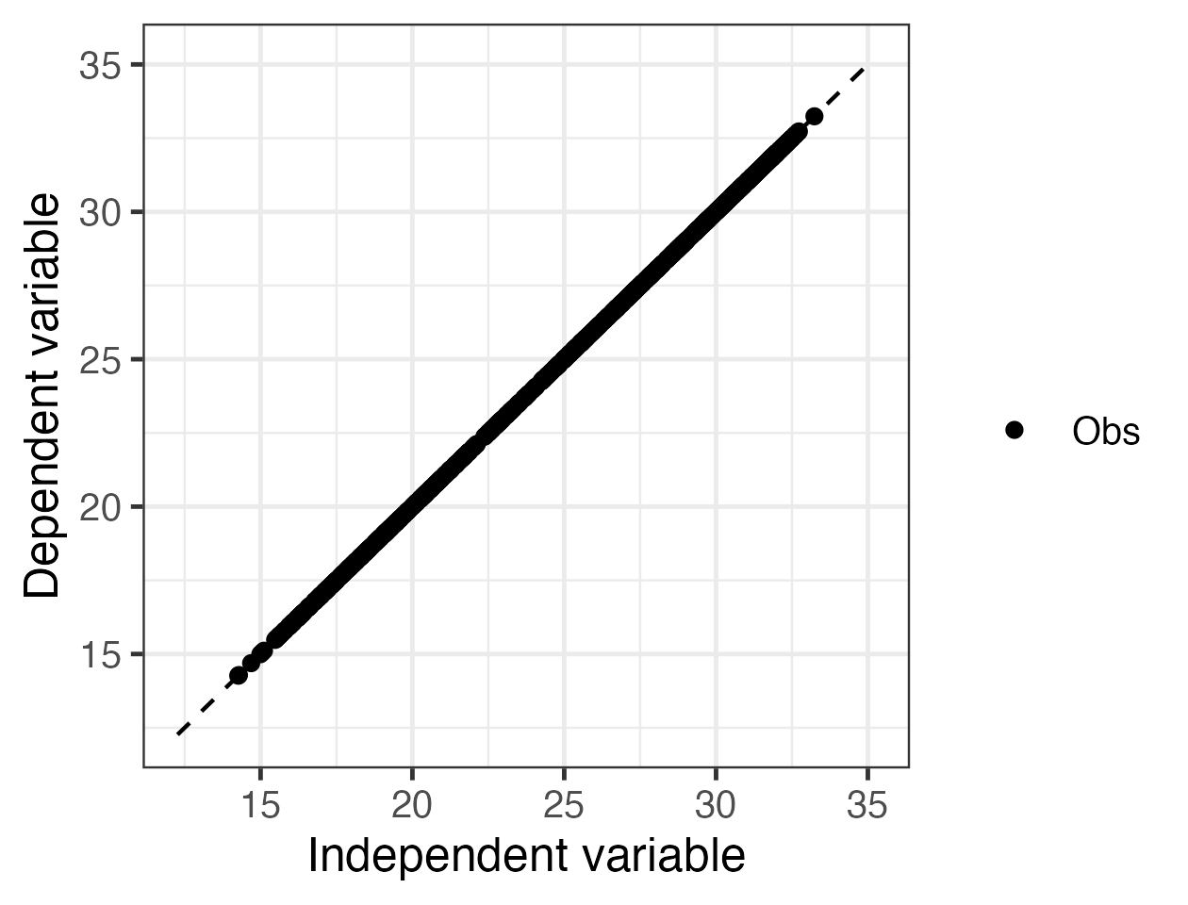
* Example of perfect linear relationship
* **Answer:**

1. Interpret the parameters of the linear regression models.
   1. Record the values of the model parameters for BOTH linear models in the Q16a table in your report.
   * *Table 3. Linear Regression Parameters*

| Model | Slope (m) | Intercept (b) |
| --- | --- | --- |
| Water temperature |  |  |
| Air temperature |  |  |

* 1. A positive linear regression model with a perfect fit has a slope (m = 1) and an intercept (b = 0). Knowing this, use the parameter values of your two linear regression models to assess the fit of: 1) the model using yesterday’s water temperature to predict today’s water temperature; and 2) the module using today’s air temperature and today’s water temperature. Which model do you think exhibits a better fit, and why?
  + **Answer:**

1. Interpret the parameters of the multiple linear regression model.
   1. Record the values of the model parameters for multiple linear regression model in the Q17a table in your report.
   * *Table 4. Multiple Linear Regression Parameters*

| Model | β0 | β1 | β2 |
| --- | --- | --- | --- |
| Water temp. and air temp. |  |  |  |

* 1. Because both of our independent variables have the same units (degrees Celsius), we can compare the values of the coefficients to understand which independent variable has a stronger relationship with the dependent variable. Knowing this, is yesterday’s water temperature or today’s air temperature more strongly associated with today’s water temperature?
  + **Answer:**

1. Assess the model fits.
   1. Click ‘Download plot’ to download the timeseries of all model predictions and water temperature observations and copy-paste it into your report.
   * *Please copy-paste your Q-18a-plot.png image here.*
   * *Figure 6. Time series of model predictions and water temperature observations for your selected NEON lake.*
   1. Which model do you think will produce the best forecasts of water temperature? Why?
   * **Answer:**

## Objective 4: Generate Forecasts

Generate multiple forecasts of water temperature.

1. Use your forecasts to estimate future water temperature.
   1. Click ‘Download plot’ to download the plot of deterministic forecasts and copy-paste it into your report.
   * *Please copy-paste your Q-19a-plot.png image here.*
   * *Figure 7. Deterministic water temperature forecasts for your selected NEON lake.*
   1. Using the forecasts you have generated, what is your best estimate of what the water temperature will be 7 days in the future? Explain your reasoning.:
   * **Answer:**
2. Describe, in your own words, the difference between a deterministic and a probabilistic forecast.

* **Answer:**

# Activity B - Explore Forecast Uncertainty

Generate multiple forecasts of water temperature and examine how different sources of uncertainty affect the different models.

## Objective 5: Process Uncertainty

Explore how process uncertainty affects the different models when forecasting water temperature.

1. What are model residuals?

* **Answer:**

1. Briefly explain, in your own words, how the residuals of a model can be used to generate a process uncertainty distribution.

* **Answer:**

1. Define ‘ensemble forecast’ in your own words.

* **Answer:**

1. Interpret the process uncertainty distribution plot.
   1. Click ‘Download plot’ to download the process uncertainty distribution figure and copy-paste it into your report.:
   * *Please copy-paste your Q-24a-plot.png image here.*
   * *Figure 8. Distributions of process uncertainty for all four models.*
   1. Examine the plot of process uncertainty distributions on the right. Which model do you think has the smallest amount of process uncertainty? Explain your reasoning.:
   * **Answer:**
2. Describe how forecast uncertainty changes into the future.
   1. Click ‘Download plot’ to download the plot of forecasts with process uncertainty and copy-paste it into your report.
   * *Please copy-paste your Q-25a-plot.png image here.*
   * *Figure 9. Water temperature forecasts with process uncertainty for your selected NEON lake.*
   1. Examine the plot of forecasts with process uncertainty. How does uncertainty change as the forecast goes farther into the future?:
   * **Answer:**
3. You have learned that process uncertainty arises when our models do not perfectly represent what is occurring in the real world. Knowing this, describe one way that you think process uncertainty in our water temperature forecasts could be reduced.

* **Answer:**

## Objective 6: Parameter Uncertainty

Explore how parameter uncertainty affects the different models when forecasting water temperature.

1. Compare the parameter values of the two models.
   1. Record the parameter values for the models fit to one and two years of data in the Q27a table your report.
   * *Table 5. Parameters for Linear Regressions Fit to Different Datasets*

| Model | Slope (m) | Intercept (b) |
| --- | --- | --- |
| 1 year model |  |  |
| 2 year model |  |  |

* 1. How do the parameter values of the models fit to one year vs. two years of data compare? Why do you think this might be?
  + **Answer:**

1. Assess the contribution of parameter uncertainty across models.
   1. Click ‘Download plot’ to download the plot of forecasts with parameter uncertainty and copy-paste it into your report.
   * *Please copy-paste your Q-28a-plot.png image here.*
   * *Figure 10. Water temperature forecasts with parameter uncertainty for your selected NEON lake.*
   1. Which model is affected most by the addition of parameter uncertainty? Why do you think that is?
   * **Answer:**
2. You have learned that parameter uncertainty arises when we do not have enough data or when our data do not accurately represent the true relationship between environmental variables. Knowing this, describe one way that you think parameter uncertainty in our water temperature forecasts could be reduced.

* **Answer:**

## Objective 7: Initial Conditions Uncertainty

Explore how initial conditions uncertainty affects the different models when forecasting water temperature.

1. What initial conditions from your chosen lake site are required to run the forecast models we are using today?

* **Answer:**

1. One of the four models we are using for forecasting does not require any initial conditions. Which one is it? Explain how you know.

* **Answer:**

1. Assess the contribution of initial conditions uncertainty across models.
   1. Click ‘Download plot’ to download the plot of forecasts with initial conditions uncertainty and copy-paste it into your report.
   * *Please copy-paste your Q-32a-plot.png image here.*
   * *Figure 11. Water temperature forecasts with initial conditions uncertainty for your selected NEON lake.*
   1. Which model had the least initial conditions uncertainty, and why?
   * **Answer:**
2. You have learned that initial conditions uncertainty arises from observation error and missing observations. Knowing this, describe one way that you think initial conditions uncertainty in our water temperature forecasts could be reduced.

* **Answer:**

## Objective 8: Driver Uncertainty

Explore how driver uncertainty affects the different models when forecasting water temperature.

1. Assess the contribution of driver uncertainty across models.
   1. Click ‘Download plot’ to download the plot of forecasts with driver uncertainty and copy-paste it into your report.
   * *Please copy-paste your Q-34a-plot.png image here.*
   * *Figure 12. Water temperature forecasts with driver uncertainty for your selected NEON lake.*
   1. Why do only two of the models exhibit driver uncertainty in their water temperature forecasts?
   * **Answer:**
2. You have learned that driver uncertainty arises because we cannot perfectly know what the future values of our model inputs will be. Knowing this, describe one way that you think driver uncertainty in our water temperature forecasts could be reduced.

* **Answer:**

# Activity C - Managing Uncertainty

Quantify and partition the uncertainty for forecasts made using different models and make management decisions using an ecological forecast.

## Objective 9: Quantify Uncertainty

Generate forecasts of water temperature with total forecast uncertainty and quantify the uncertainty at each forecast horizon and its source.

1. Describe the sources of uncertainty for model 1.
   1. Record the name of the model you chose.
   * **Answer:**
   1. Click ‘Download plot’ to download the plot of quantified uncertainty for model 1 and copy-paste it into your report.
   * *Please copy-paste your Q-36b-plot.png image here.*
   * *Figure 13. Total forecast uncertainty partitioned among process, parameter, initial conditions, and driver uncertainty for model 1.*
   1. Which source of uncertainty contributes the most to total forecast uncertainty for this model?
   * **Answer:**
2. Describe the sources of uncertainty for model 2.
   1. Record the name of the model you chose.
   * **Answer:**
   1. Click ‘Download plot’ to download the plot of quantified uncertainty for model 2 and copy-paste it into your report.
   * *Please copy-paste your Q-37b-plot.png image here.*
   * *Figure 14. Total forecast uncertainty partitioned among process, parameter, initial conditions, and driver uncertainty for model 2.*
   1. Which source of uncertainty contributes the most to total forecast uncertainty for this model?
   * **Answer:**
3. Compare how the sources of uncertainty differed between your forecasts. Explain why each of the uncertainties (process, parameter, initial conditions & driver) is different between your models.

* **Answer:**

## Objective 10: Management Scenario

As a water resource manager you will use forecasts to make decisions about water releases from a reservoir. With your partner you will explore how forecast uncertainty affects your decisions.

1. Did the uncertainty visualization affect your decision? How?

* **Answer:**

1. Can you think of any potential risks when using a forecast without all soures of uncertainty included?

* **Answer:**

*This module was developed by: Moore, T.N., M.E. Lofton, C.C. Carey, and R.Q. Thomas. 31 July 2023. Macrosystems EDDIE: Ecological Forecast Uncertainty. Macrosystems EDDIE Module 6, Version 2.* <http://module6.macrosystemseddie.org>*. Module development was supported by NSF grants DEB-1926050 and DBI-1933016.* *This app was last updated on: 2023-09-21*