**How to use Dongle**

First install the dongle driver

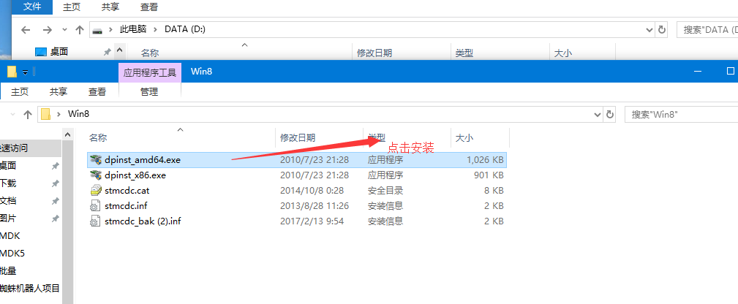

驱动安装成功后。插上dongle，到设备管理器下面找到dongle的串口。如下图：

After installed driver successfully. Plug the dongle and go find the dongle serial port like below pic:

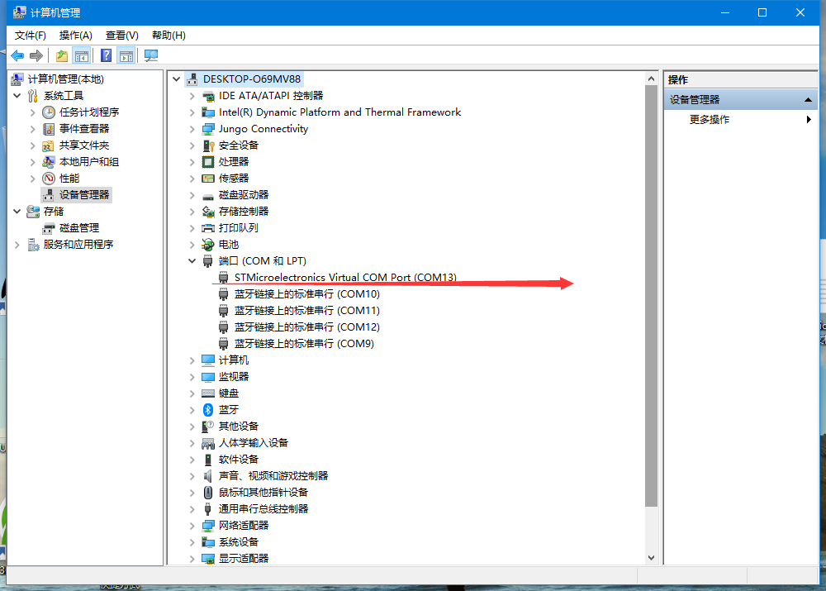

我们这个选择带有 ‘STM’字样的COM，我这是COM13

Choose COM with 'STM' on it. calling it COM13

然后打开串口调试软件（这个网上很多），我们这用的XCOM，XCOM需要安装.net framework 4.0,如果你的电脑没有安装过.net framework 4.0，请先安装：dotNetFx40_Full_x86_x64.exe,再运行 XCOM 软件。

打开这个软件

If you don’t have ”.net framework 4.0” on your computer, please install: “dotnetfx40_full_x86_x64.exe”, and then run XCOM software.

Choose this software

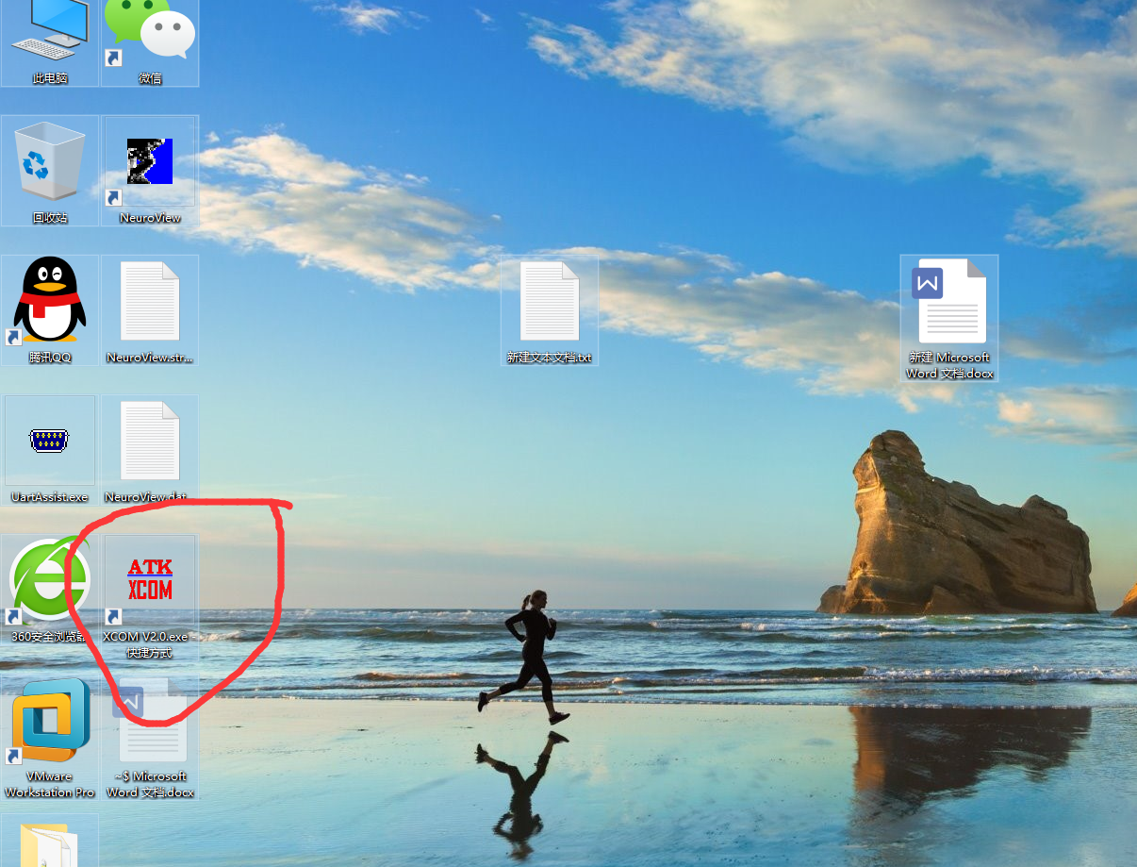

The interface is as follows:

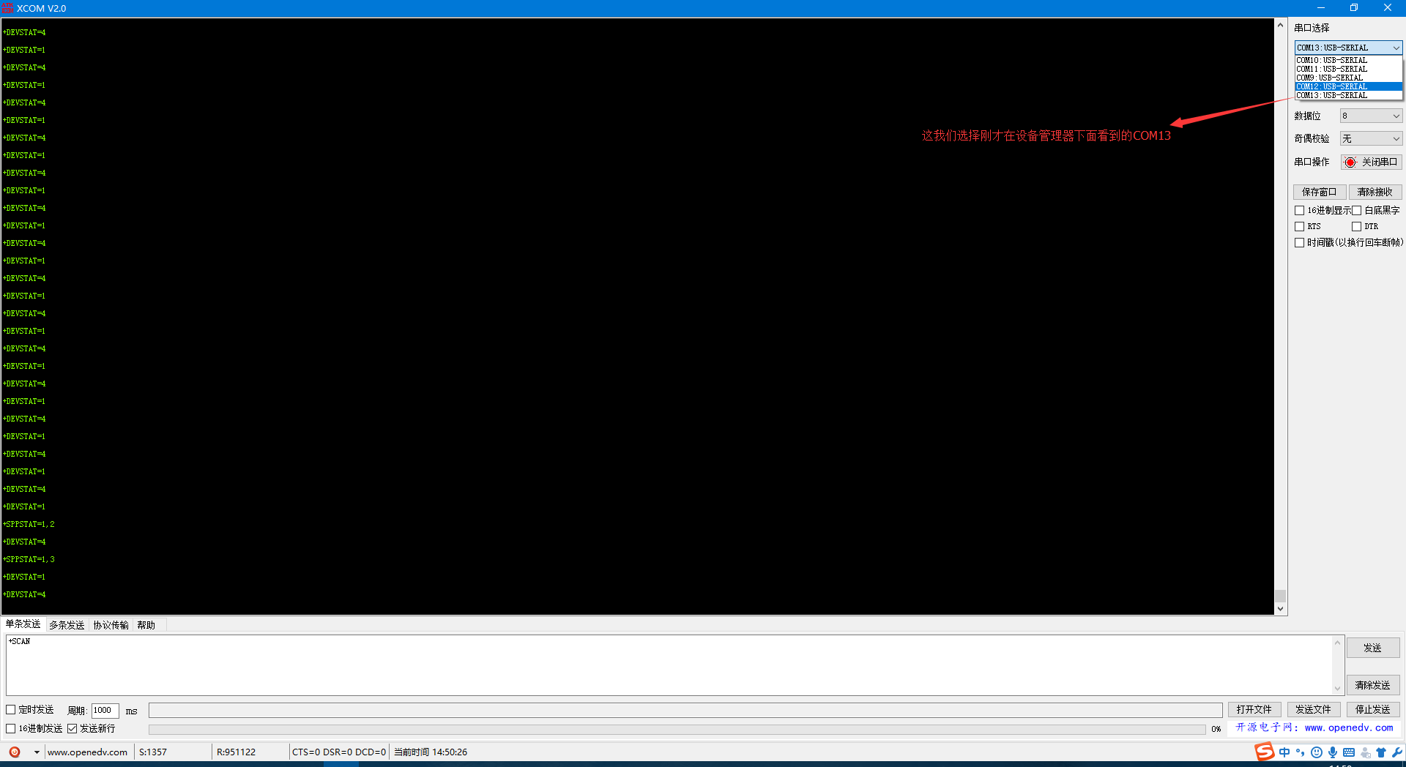

我们的dongle有两种模式自动连接和手动连接（默认是手动连接）

Our dongle has two modes: automatic connection and manual connection (the default is manual connection)

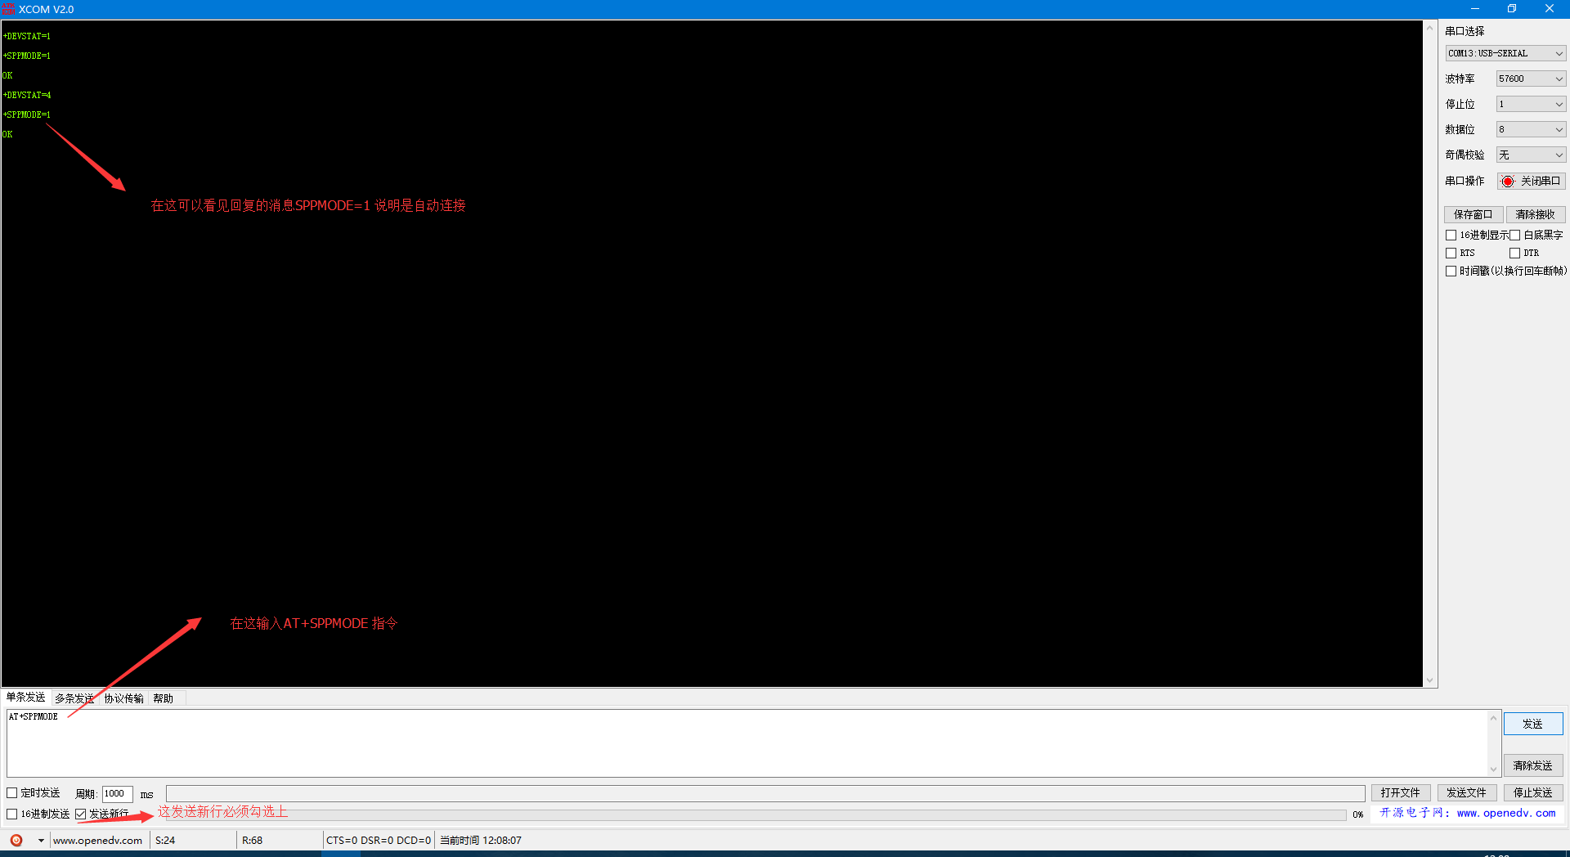

自动连接：在串口输入框输入AT+SPPMODE看看回显的是多少

出厂默认AT+SPPMODE是0要改成1才能自动连接。

在串口输入框输入AT+SPPMODE=1

AT+NAME 指定的名字了AT+NAME=BrainLink

Automatic connection: type “AT+SPPMODE” in the serial input box to see how much is echoed.

The “AT+SPPMODE “from factory default is 0, which needs to be changed to 1 to get automatic connection.

Enter “AT+SPPMODE=1” in the serial input box

“AT+NAME” specifies the name of” AT+NAME=BrainLink”

如果要显示设备的名字和MAC，dongle必须设置为手动连接模式，

手动连接模式：

在串口输入框输入AT+SPPMODE=0。

然后在串口输入框输入AT+SCAN=1，如下图

To display the device name and MAC, dongle must be set to manual connection mode,

Manual connection mode:

Input r” AT+SPPMODE=0” in the serial input box.

Then input” AT+SCAN=1 in” the serial input box, as shown in the pic below

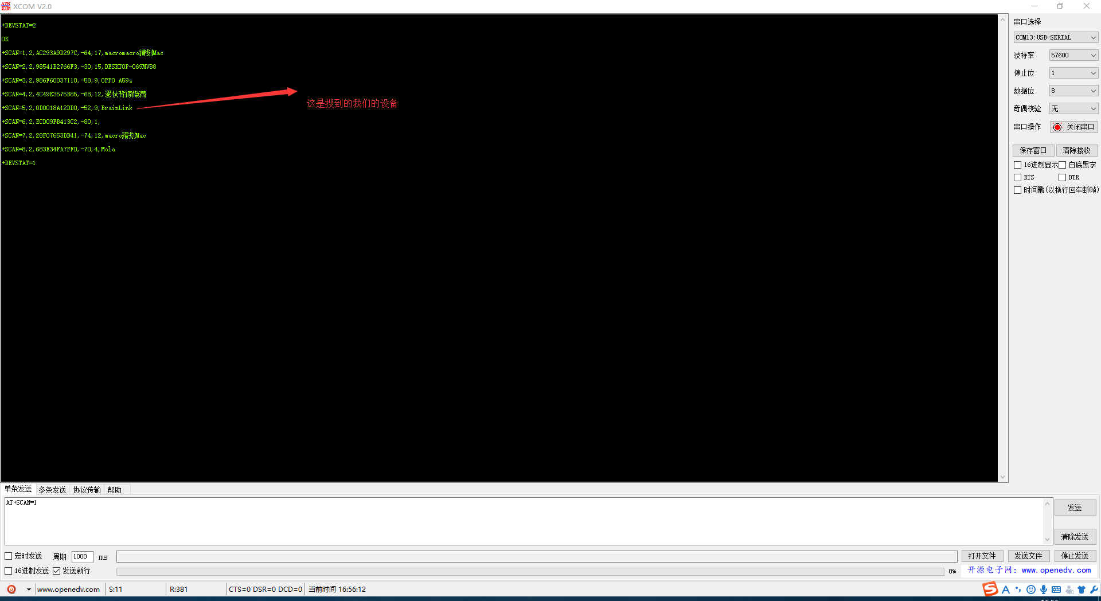

在回显框里可以看到，SACN=P1,P2,P3,P4,P5,P6有6个参数

P1：ASCII(1~8)设备序号

P2：ASCII(0-2) [类型：2为CLASSIC设备；0-1为BLE设备]

P3：ASCII(12Bytes)[设备MAC地址]

P4: ASCII(-127~0) [设备信号强度]

P5：ASCII(1~31)[P6长度]

P6：UTF8(1~31)[设备名称]

In the echo box, you can see that “SACN=P1,P2,P3,P4,P5, and P6” have 6 parameters

P1: ASCII(1~8) device number

P2: ASCII(0-2) [type: 2 CLASSIC devices; 0-1 BLE devices]

P3: ASCII(12Bytes)[MAC address]

P4: ASCII(-127~0) [device signal strength]

P5: ASCII(1~31)[P6 length]

P6: UTF8(1~31)[device name]

接下来就是手动连接

在输入框输入AT+SPPCONN=MAC

Next comes the manual connection

Enter” AT+SPPCONN=MAC” in the input field

+SCAN=2,2,0D0018A12DD0,-42,9,BrainLink. 这是扫描到BrainLink设备(This means find the BrainLink device)

MAC = 0D0018A12DD0

在输入框输入AT+SPPCONN=0D0018A12DD0

Enter “AT+SPPCONN=0D0018A12DD0” in the input field

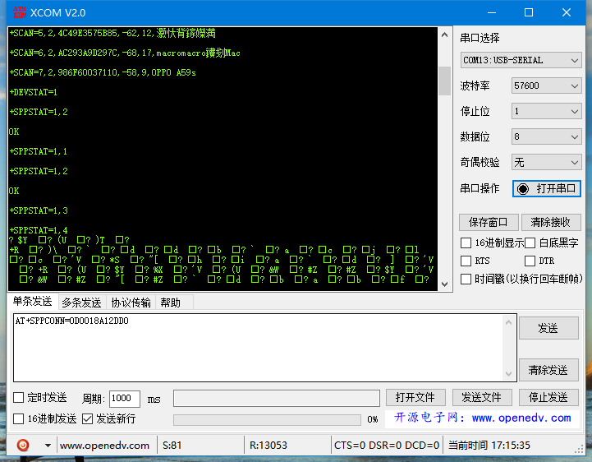

会回显OK，然后可以看到有数据发出来了

Shows “OK”, and you will find the data output.