Тербования для

Приложения на Линуксе по поиску файлов по заданной строке.

UI
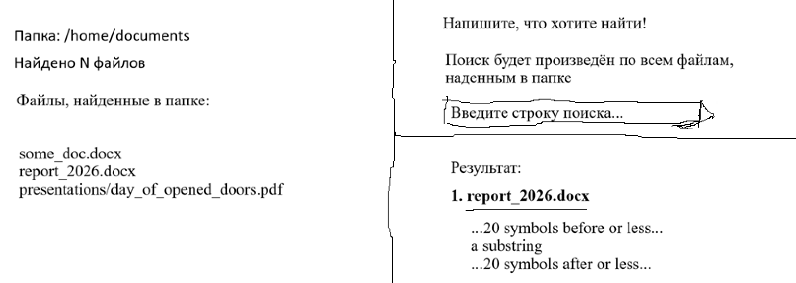

Функциональные требования
Now I need to write an application for Alt Linux.
What it has to do:
- it has to have a UI and installation on a system as an external app through Flatpak
- has to implement scanning through all the files and subfolders within the given path(which is always a folder)
- the initial given path is /home/documents (currentPath) and the applciation is ready to look for the files and subfolders in there. The UI shows that with a label: "Folder: /home/documents"
- if the user doesn't want to search through the documents in that path, he has to select another folder by clicking on a button on the UI and choosing another folder through dialogue window (changing the currentPath)
– the label after the folder is: "N files are found" where N – count of files inside of the chosen directory(currentPath) considering all of the documents in subfolders(and their subfolders)
– the numbered list after that shows the found files within the current path(foundDocumentsList) in the form of relative path, not an absolute one(if the document is at /home/documents/some_doc.docx, the list just shows some_doc.docx; if file's at /home/documents/presentations/day_of_opened_doors.pdf, the list on the UI shows presentations/day_of_opened_doors.pdf)
– the search works as follows: it searches for a string match in all of the documents found (foundDocumentsList) of a currentPath(the of /home/documents, for example, and all subfolders)
- the user types in his substring he wants(searchStr) and searches the documents according to the entered substring
- there has to be an input on the UI that allows to write the text
- once the user starts typing, the method that searches the documents is invoked and the loop through foundDoucmentsList is started.
- the app has to support documents types like .txt, .docx, .pdf and other popular documents types
- in order to start search (by searchStr) in a document, the app has to implement OCR using tesseract-rs to extract the text from each document
- then a search operation to a current file in a loop is performed
- if the substring found in the file, we have to start maintaining the array of data. We can define a variable that will store the array of occurences in the file. If there's a native function that will return the occurences and its starting position index in a string(string appeared after extracting text ussing tesseract-rs), then use that. If there's no a native function doing that, implement it yourself. The array of data we have to maintain includes the relative path of a file and all the occurences following searchStr. After getting all occurences and their positions in a string, the document has to be added to an array of found documents(documentsMatchedTheSubstring) which is of struct with the following schema: String docRelativePath, List<String> searchStrOccurs(or descirbed in json-like format: [{String formattedDocOccurance}] formattedDocOccurance – ...20 symbols before searchStr... + searchStr + ...20 symbols after searchStr... .
- if the substring not found in the document(not included even once), then the iteration goes to the next document
- by the end of that loop, there has to be a set of documents(documentsMatchedTheSubstrings). That set has to be rendered on the UI under the search bar. Render all the information provided by documentsMatchedTheSubstring in the list
- the following format of each of the documents that matched the substring pattern entered by the user is strict(formattedDocOccurance): they all(documentsMatchedTheSubstring) are in a numbered list, bold; firstly, the name of the file goes like in foundDocumentsList – relative to the currentPath; after that, starting from a new line, goes the following pattern: the first 20 characters before the substring if the count of characters is >= 20, otherwise, that count which is less than 20 is shown. Then the substring itself, and the 20 characters in a document next to it; if there's less characters than 20 after the substring, that count of characters is also shown. This pattern is created earlier while looping through the occurences. Select the relative path of a doc with bold and leave this pattern of occurences as plain text
- the relative path of a file has to be clickable and look like a link. Once the user clicks on it, it becomes visited opened in LibreOffice. Once that, inside of LibreOffice we have to put a substring we entered in our app for LibreOffice to search for the match of that paraticular string. I'll provide external instructions on how to integrate with LibreOffice later. But for the moment, make the clicked file in foundDocumentsList opened in nautilus.
- Since the start of the search(the user entered the first symbol) start showing the circle progress bar that rotates until the finish of the search. The finish of the search is established in the end of looping through the foundDocumentsList. In the end show the green indicator of success that everything is done properly.

