Help documnet for verification of Numerical Account for A52 for the year 2012-13
- Select Fixed Assets Monitoring under Financial Accounting

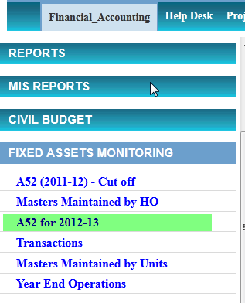

- Select A52 for 2012-13

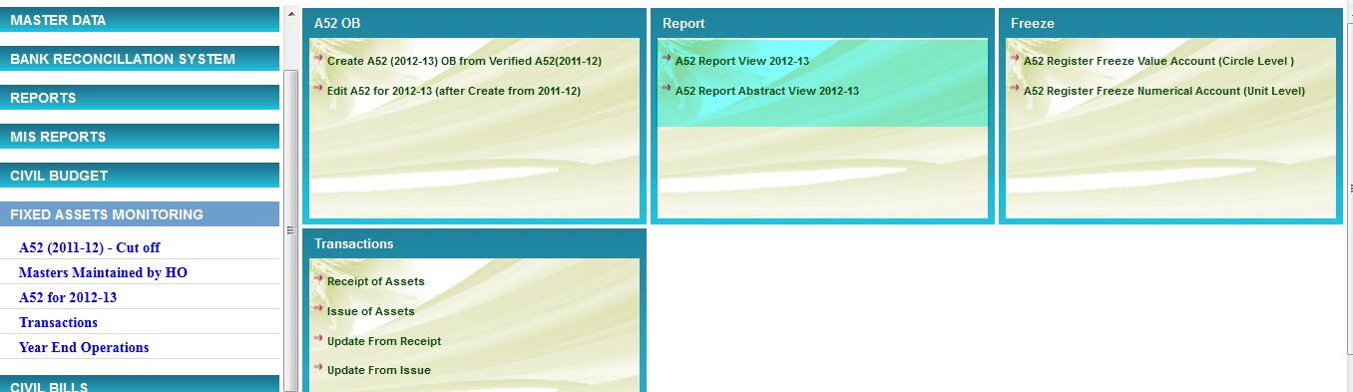

A52 Report for Verification

- Select A52 Report View 2012-13

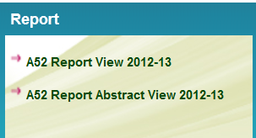

- Enter the following Options and press submit
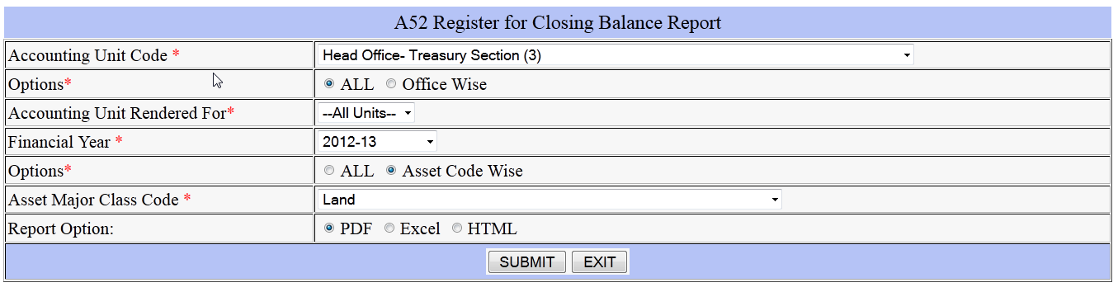

- Check the report displayed for your office either by taking the print out or verifying in the screen against the register. Sample report is pasted below
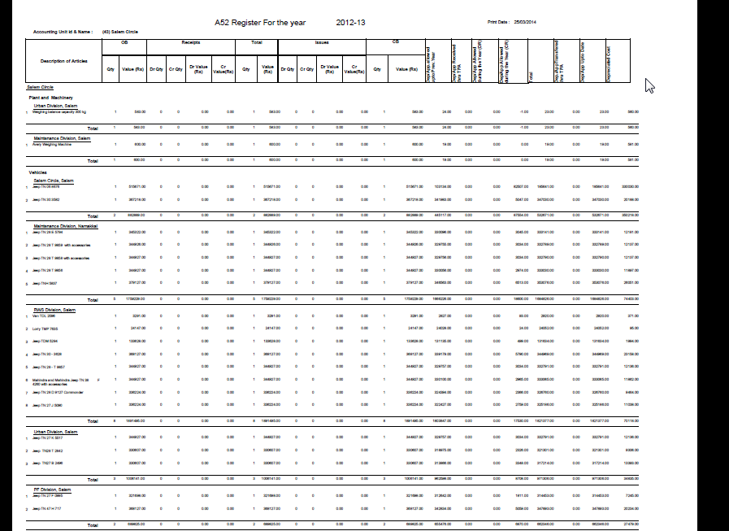
- If there is any problem, like error in automatically calculated depreciation please give help desk or send mail to twadboard@dataone.in

Edit Option for making correction at user end

- For any corrections, like entering the transfer proforma receipts , transfer proforma issues please select the option Edit A52 for 2012-13 (after create from 2011-12) available in A52 2012-13
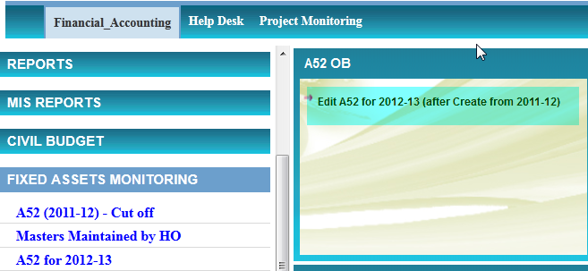

- In Edit Screen, In General Part, Select Accounting Unit Code, Accounting for office Code, Financial year, Major Asset Code and click GO Button
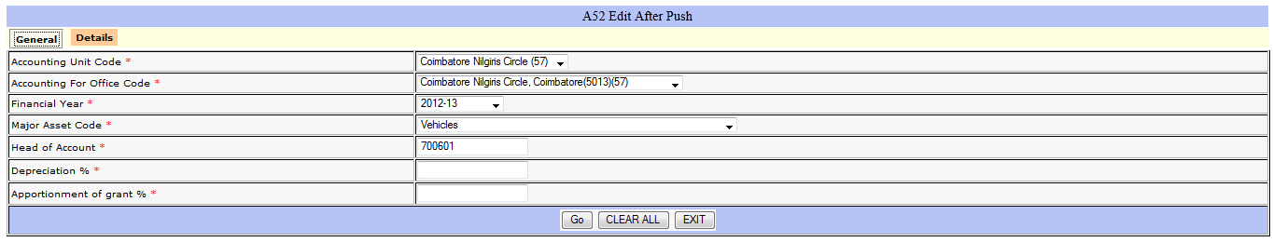

In details part, the available entries for the selected option will be displayed. Edit the entry for which corrections to be done and do the required changes, check for the values automatically calculated and click update.

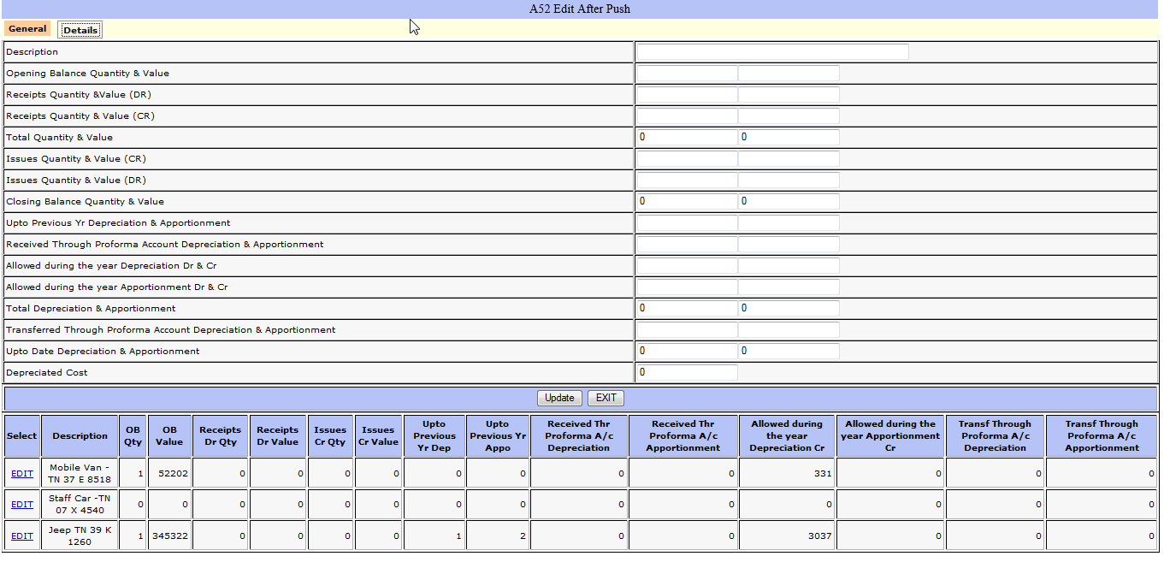

Transactions, Receipts and Issues during the year

- The transaction menu, available in A52 for 2012-13, contains screen for adding the receipts and issues and updating the same in already created A52 register for the year 2012-13

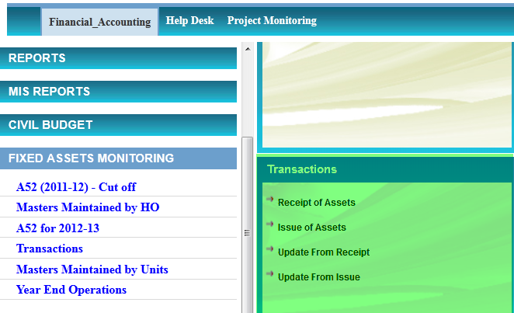

- For any additions during the year, select the Receipt of Assets, available in the Transactions Menu. Fill up the required information and Press Add.

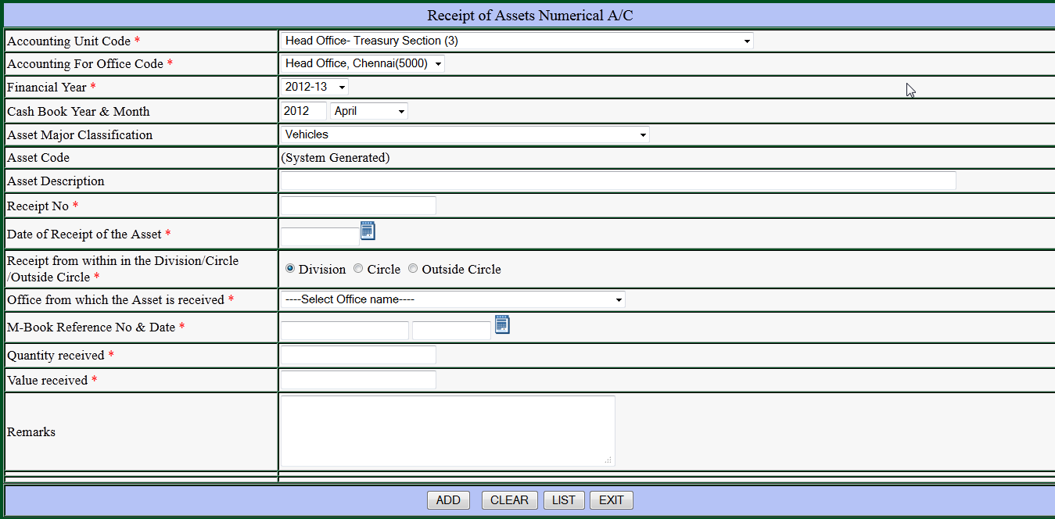

- After adding, select Update from receipt, this will update the A52 Register. Subsequently edit and make corrections in the depreciation column for the added item(s)
- For any Issues during the year, select the Issue of Assets, available in the Transactions Menu. Select the asset code is which is issued and fill up the other required information and Press Add.
- After adding, select Update from issues, this will update the A52 Register. Subsequently edit and make corrections in the depreciation column for the issued item(s)

Freeze Numerical Account and Value Account

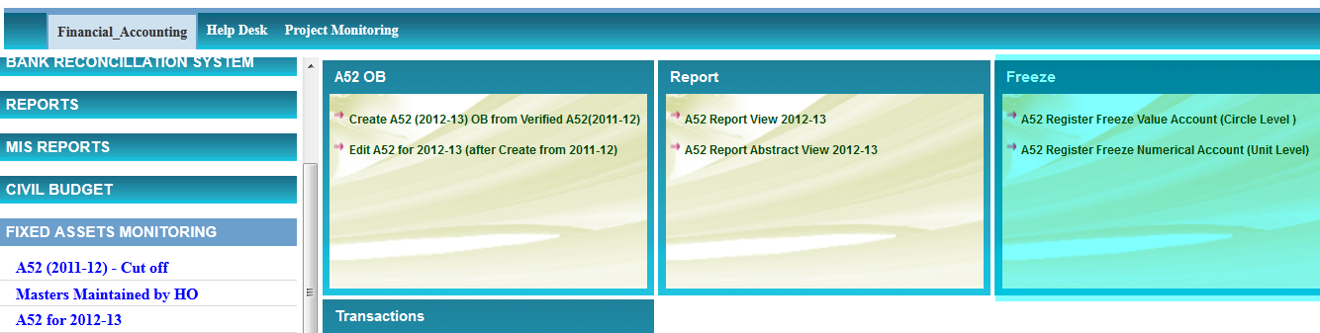

- If the uploading is correct, please freeze the numerical account by selecting the following
A52 Register Freeze Numerical Account (Unit Level) for individual units , including the circle
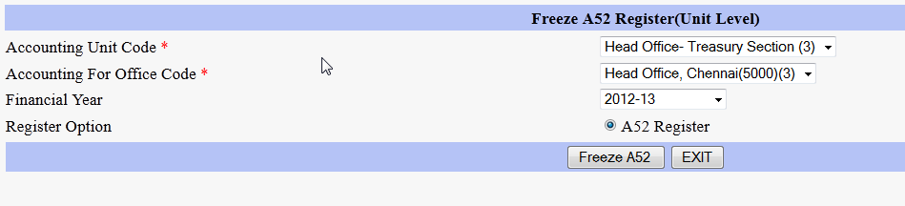
- Once all the office s, including the circle, freezes Numerical Account Circle has to freeze Value Account by selecting A52 Register Freeze Numerical Account (Unit Level) 