BANK RECONCILIATION SYSTEM
(Step by Step User Document ver 1.0)

Contents
Bank Reconciliation System - General - 4 -
Steps in the BRS System for the Bank Accounts maintained at accounting units - 4 -
Step by Step Documentation - 6 -
Fix Start Month and Year - 7 -
OPENING BALANCE ENTRY - 10 -
PART 1, 2A and 2B Opening Balance. - 10 -
OB for the pending details of not remitted / withdrawn entries, but shown in the pass sheet (part 2 – 5b and part 1 5c breakup). - 12 -
How to change the already entered and saved detail - 14 -
OB for the pending details of not acknowledged / not encashed entries of cash book transaction (5a) - 15 -
To remove the entry taken erroneously for OB - 17 -
Freeze the OB details entered for not acknowledged / not encashed entries. - 17 -
Freeze the OB details entered for Not remitted / withdrawn entries but shown in the pass sheet( (part 2 – 5b and part 1 5c breakup). - 18 -
Push the Entered OB details for further reconciliation. - 19 -
Pushing not acknowledged / not encashed cashbook entries for further reconciliation. - 20 -
Pushing amount Not remitted / withdrawn but shown in the pass sheet (5b) entries for further reconciliation. - 21 -
MONTHLY RECONCILIATION - 24 -
Monthly Reconciliation - 25 -
Overview - 25 -
Reconcile Current Month - 25 -
Reconcile Cash Book Transactions - 27 -
Entry of Not remitted / Not withdrawn entries but found in the pass sheet - 29 -
To clear the previous not remitted / not withdrawn entries - 30 -
BRS Reconcile previous month - 32 -
How to make changes for the already entered transactions- EDIT Reconciliation - 33 -
Authorization - 33 -
Edit the authorized entries - 35 -
Reconcile From Journal - 37 -
Enter Follow up Action - 39 -
Monthly Freeze - 41 -
BRS LIST - 42 -
BRS Reports - 43 -
BRS SAMPLE REPORTS - 44 -
GLOSSORY - 54 -

Bank Reconciliation System - General

The Bank Reconciliation system enables users to reconcile the cash book transaction against the pass book details and generate reports

Steps in the BRS System for the Bank Accounts maintained at accounting units
1. Start
- Fix the , Start month and year
2. Enter OB
- Enter Opening Balance for part 1, part 2a and part 2b
- Enter OB with respect to Cash Book Transaction- 5a entries
- Enter OB with respect to Not remitted / Not withdraw but found in Pass sheet entries (5c in Part1, 5b in part2)
- Freeze OB for Cash Book transactions
- Freeze OB for Not remitted / Not withdraw but found in Pass sheet Transactions Transactions
- Push Cash Book Transactions OB for further reconciliation
- Push Bank Transactions (Non-Cash Book) OB for Further Reconciliation
3. Every month Reconciliation
With the Pass Sheet start the reconciliation
- Reconcile the transactions where Cash book month & year = Pass sheet Month & year
- Reconcile the transactions of earlier months pending for reconciliation (Cash book month & year < Pass sheet Month & year)
- Reconcile from Journal for any adjustments made as journal for the bank account
4. Print Schedules and Reports
5. Freeze Part 1, part 2a , part 2b report
6. Freeze Monthly BRS

Step by Step Documentation

Fix Start Month and Year

The accounting units have multiple bank account numbers and for each bank account number SSWB statement has to be generated.
To start with, the accounting unit has to decide/ as per the instruction from Head office, from which year and month the BRS system for a bank account should be taken to online system. Accordingly they can fix the month and year from which the SSWB statement is going to be generated from TWADNEST ONLINE.
For this select the following menu
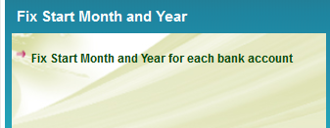

On selecting the item Fix start month and year the following menu will be displayed (the accounting unit code and accounting for office name will vary depending upon the logged in office)
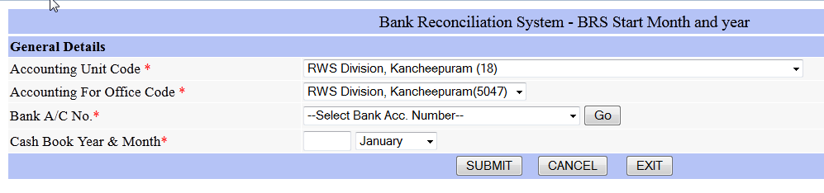
On clicking the Go button provided in Bank account number column, the bank accounts maintained by the accounting units will be displayed. Select the required bank account number.

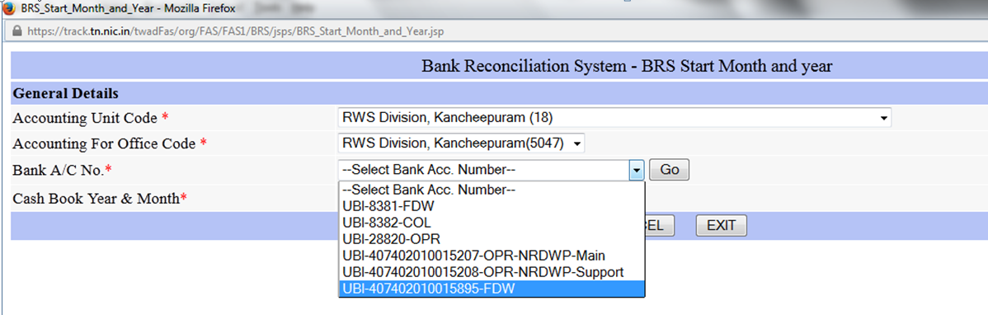
Select the account number for which the start month and year is going to be fixed. On selecting the account number the following message box will be displayed
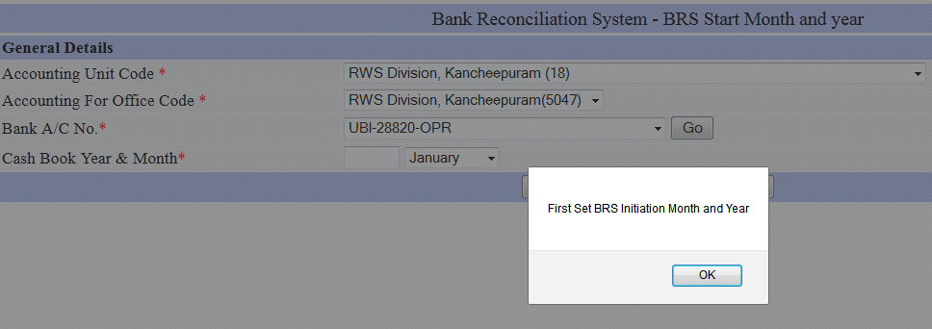

Click OK. Then enter the Start Year and Month.
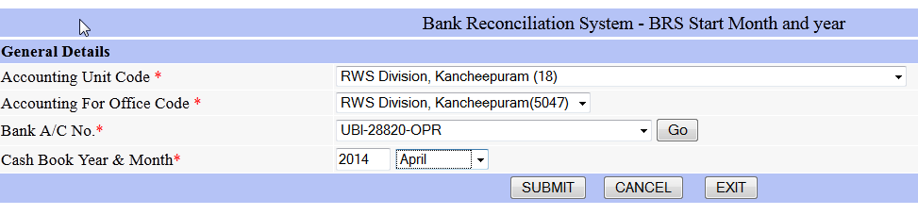

OPENING BALANCE ENTRY
(ONLY ONE TIME)

OPENING BALANCE ENTRY

After fixing the start month and year, User has to enter the opening balance (only one time) for the bank account number selected. For this user has to select the following menu


The available items in this menu are explained one by one in the following section.

PART 1, 2A and 2B Opening Balance.

To enter the details for this please select 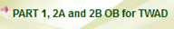 Under the BRS OB (One time). On selecting this menu item, following screen will be displayed
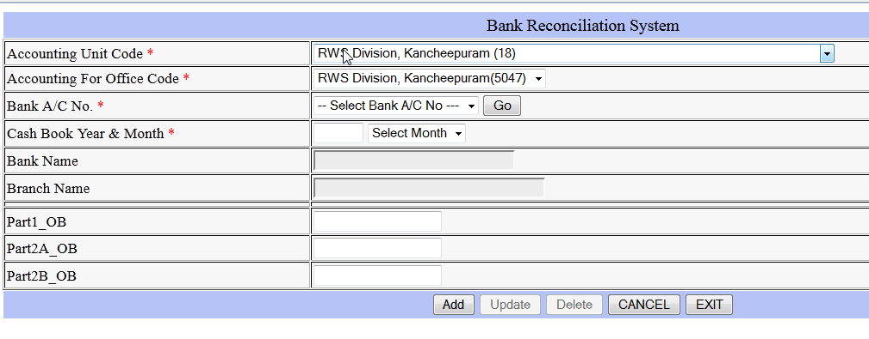
On clicking the Go button provided in Bank account number column, the
bank accounts maintained by the accounting units will be displayed. Select the required bank account number.

If any of the account number for which the start month and year is not fixed the following error message will be displayed

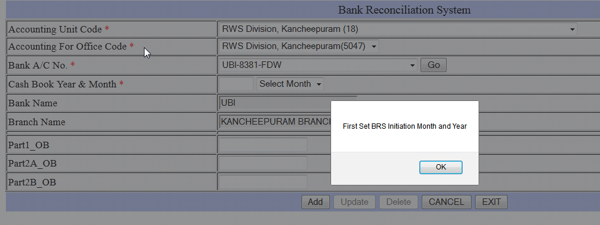

On selecting the account number for which the start month and year is fixed the following screen will be displayed. In the following example, start month and year is fixed as April’2014 and hence the line 5 of previous month ie. March ‘2014 has to be entered.

For Regular Collection Account Par1 Ob is to be entered. For regular operation Account Part2a Ob and Part 2b Ob is to be entered.

Press Add to save to the details entered

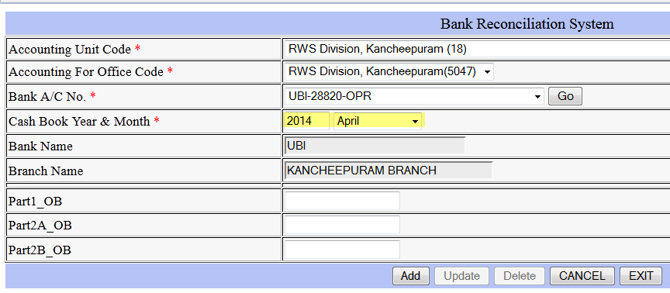

OB for the pending details of not remitted / withdrawn entries, but shown in the pass sheet (part 2 – 5b and part 1 5c breakup).
To enter these details, user has to select the following menu item from BRS OB (One time)
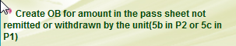

On selecting this menu, the following screen will be displayed.
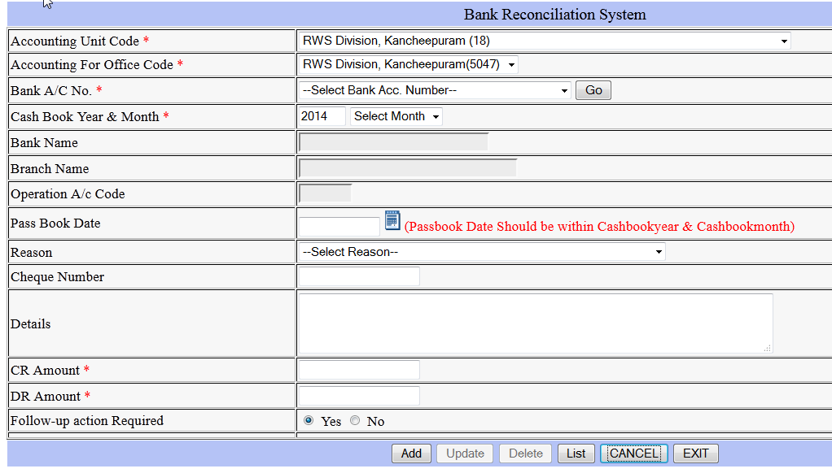
If any of the account number for which the start month and year is not fixed the following error message will be displayed
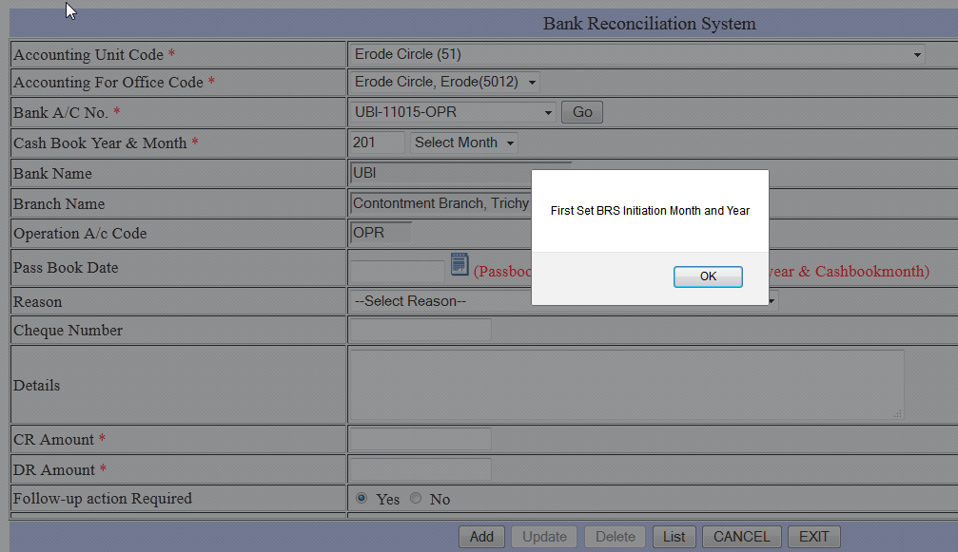

The cash book Year and Month entered / selected should be less than the start month and year otherwise following error message will be displayed.
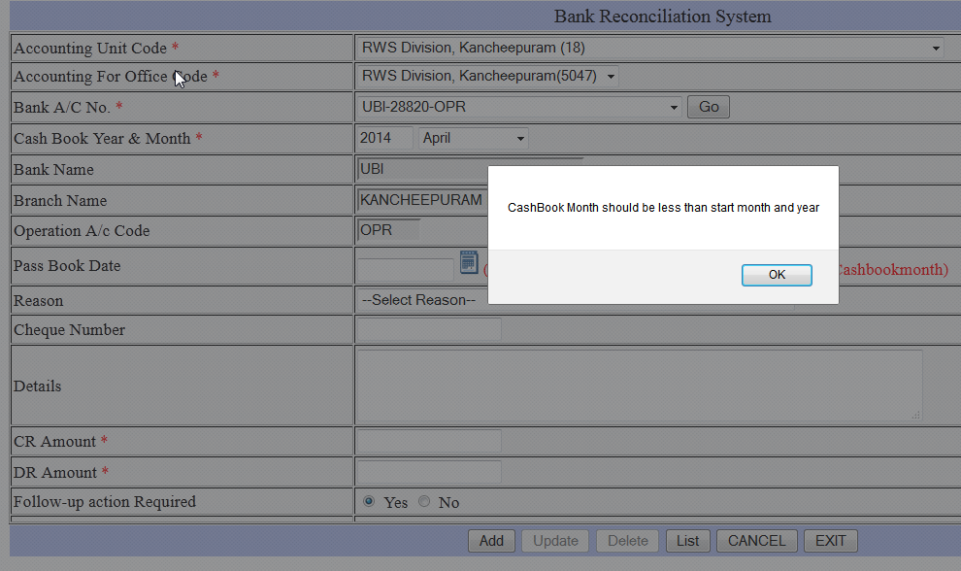

After entering the cash book year and month

the following details to be entered

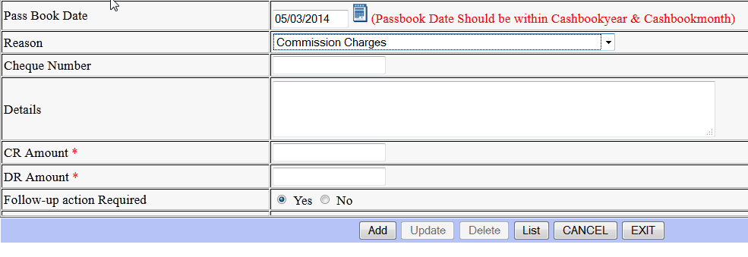
- The pass book date should be within the cash book year and month. For example, if the cash book month and year is March’2014 , the date should be between 01/03/2014 and 31/03/2014.
- Select the Reason(transaction type)
- Enter the cheque number if available
- Enter details if any
- Enter either CR amount or DR amount. Both amount should not be entered simultaneously
- After entering the details press Add.
Repeat the procedure for all part 2- 5b / Part 1 – 5c breakup.

How to change the already entered and saved detail

If already entered details require correction /removal Select Bank Account number, enter cash book yr & month and then click list. For the required entry press Edit
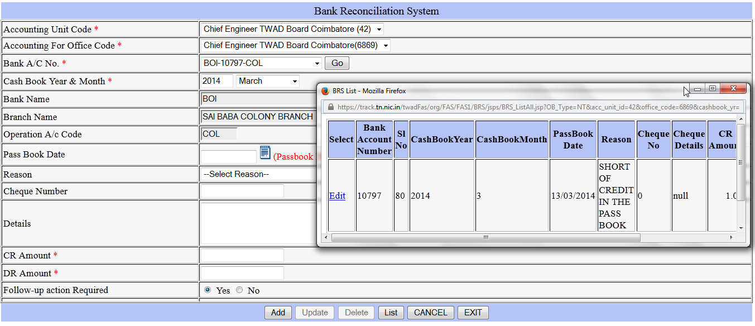
The selected entry will be displayed as follows.
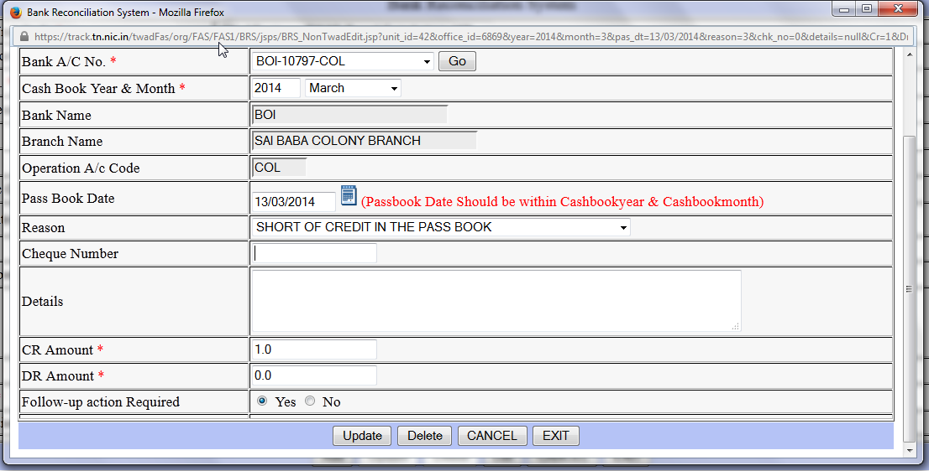

For corrections, make the changes and click update. For removal click delete

OB for the pending details of not acknowledged / not encashed entries of cash book transaction (5a)

To enter these details, user has to select the following menu item from BRS OB (One time)

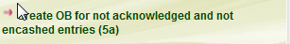
On selecting this menu, the following screen will be displayed.
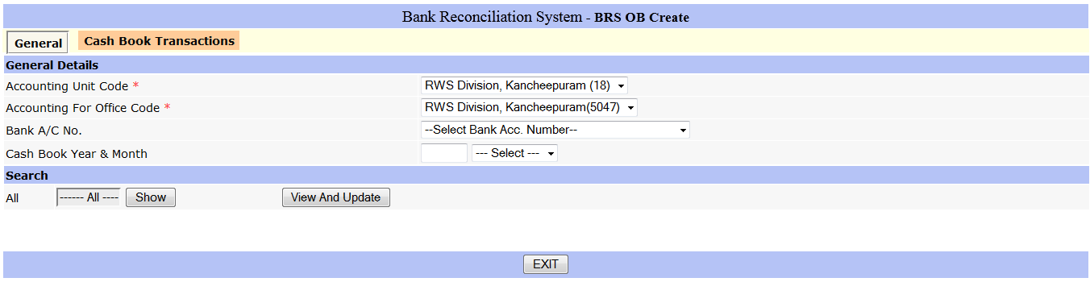
Select the account number. The Cash book month and year will be displayed. The automatically displayed month will be one month before the start month & year fixed by the user. If required, user can change the month and year for which the entries not acknowledged / not encashed entries to be made.
After entering the cash book year & month, press Show button available below the search bar
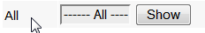
The cash book transactions available for the selected month will be displayed in the tab. On selecting this tab, the details will be displayed as follows

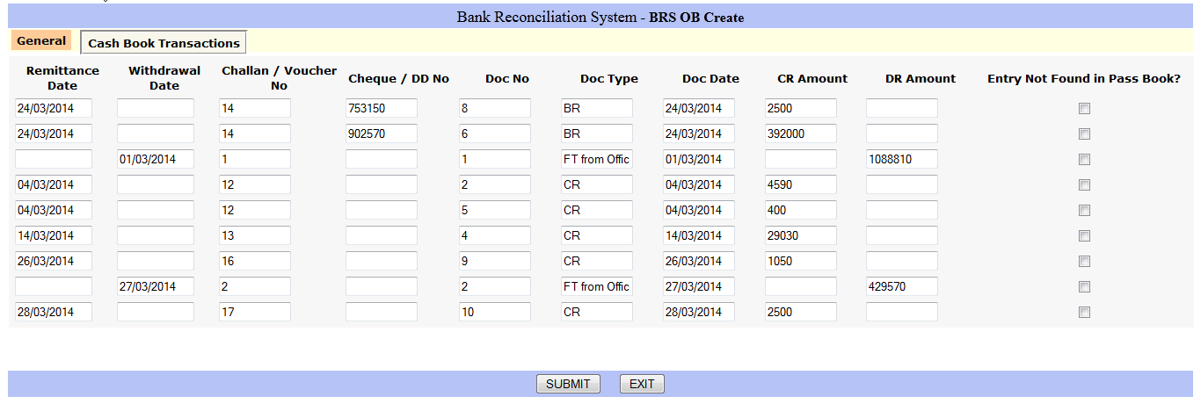

User has to select the entries for which the bank has not acknowledged, by clicking the box given below the heading ‘Entry Not Found in Pass Book’.
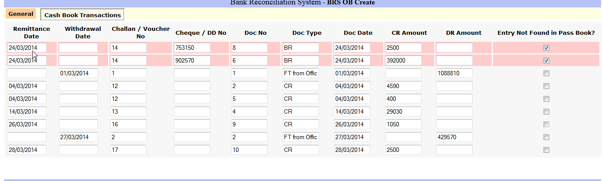

Press Submit to save the details.

Repeat the process for all pending acknowledgment months by changing the cash book year and month in General tab

To remove the entry taken erroneously for OB

If already remitted / enchased entry is erroneously taken for OB, user can remove the same from by clicking the View and update available in the General Tab

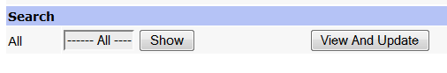
On Clicking the View and Update button, the entries already taken for OB will be displayed.
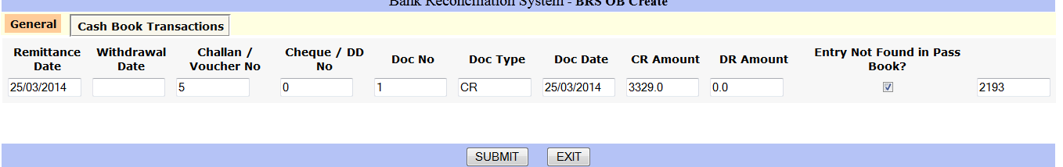

To remove the entry, clear the tick mark by clicking the box provided under the column Entry not found in the pass book and press submit.

Freeze the OB details entered for not acknowledged / not encashed entries.

To freeze, user has to select the following menu item from BRS OB (One time)
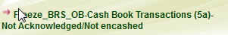
On selecting this menu, the following screen will be displayed.

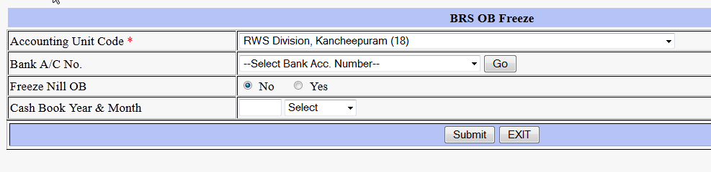
On clicking the Go button provided in Bank account number column, the bank accounts maintained by the accounting units will be displayed. Select the required bank account number.

Choose either Freeze Nil OB as Yes Or NO

If all the cash book transactions are either Acknowledged / Encashed then there will not be any opening balance for this category. Hence Select Yes for Freeze Nil OB

If the details pending for not acknowledged or not encashed are entered in Opening balance screen, then select NO for Press Freeze NIL OB.

Cash book year and month

Enter the cash book year and month up to which the Details are entered.

Press Submit

Freeze the OB details entered for Not remitted / withdrawn entries but shown in the pass sheet( (part 2 – 5b and part 1 5c breakup).

To freeze these details, user has to select the following menu item from BRS OB (One time)

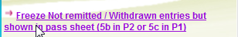

On selecting this menu, the following screen will be displayed.

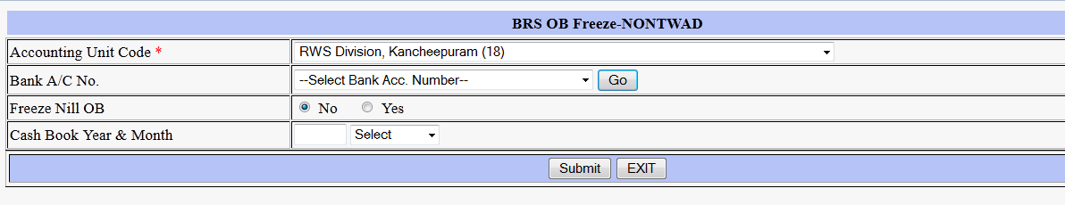
On clicking the Go button provided in Bank account number column, the bank accounts maintained by the accounting units will be displayed. Select the required bank account number.

Choose either Freeze Nil OB as Yes Or NO

If direct pass sheet bank transactions (ie not remitted / not withdrawn entries) are not pending Select Yes for Freeze Nil OB

If the details pending for not remitted or not withdrawn are entered in Opening balance screen, then select NO for Press Freeze NIL OB.

Cash book year and month

Enter the cash book year and month up to which the Details are entered.

Press Submit

Push the Entered OB details for further reconciliation.

The following two menu items to be executed

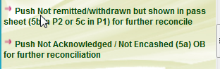

Pushing not acknowledged / not encashed cashbook entries for further reconciliation.

Select the following menu item from BRS OB (One time)

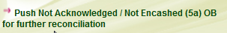

On selection , the following screen will be displayed
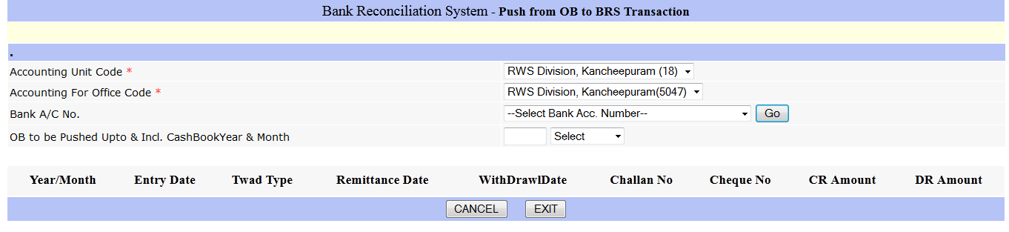

On clicking the Go button provided in Bank account number column, the bank accounts maintained by the accounting units will be displayed. Select the required bank account number

Enter the cash book year and month up to which the Details are entered.

If BRS OB is not freezed, the following screen will be displayed.
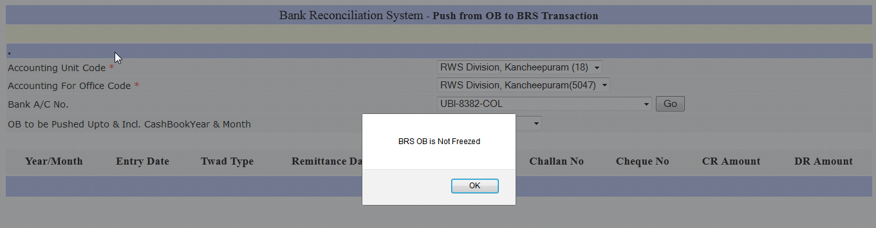

Otherwise The Details entered in OB will be displayed.

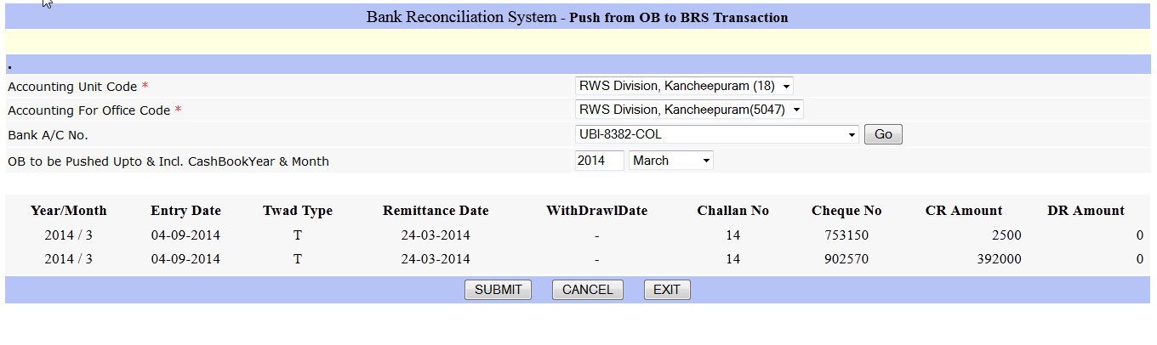

Please check the details displayed.

If any errors/omission found, please unfreeze BRS OB (Non TWAD) using the menu item 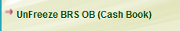

If found ok Press Submit

Pushing amount Not remitted / withdrawn but shown in the pass sheet (5b) entries for further reconciliation.

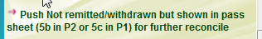

On selection , the following screen will be displayed

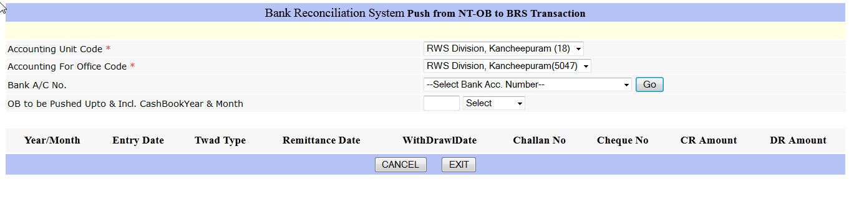
On clicking the Go button provided in Bank account number column, the bank accounts maintained by the accounting units will be displayed. Select the required bank account number

Enter the cash book year and month up to which the Details are entered.

If BRS OB is not freezed, the following screen will be displayed.

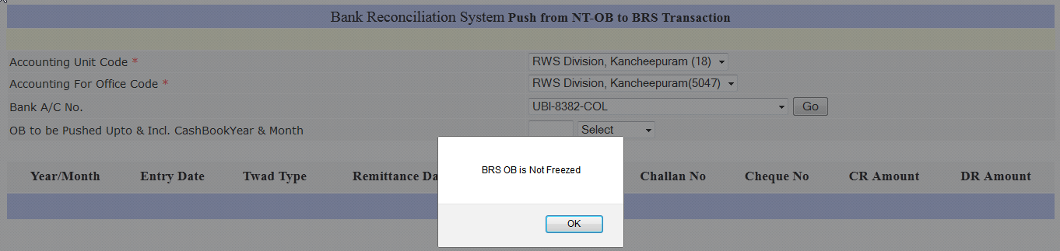

Otherwise The Details entered in OB will be displayed.

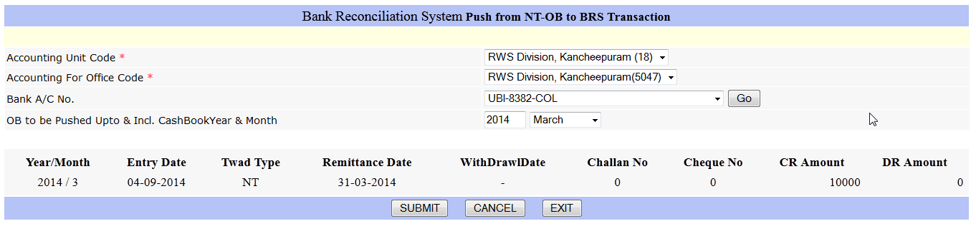

Please check the details displayed.

If any errors/omission found, please unfreeze BRS OB (Non TWAD) using the menu item 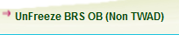

If found ok Press Sumbit

MONTHLY RECONCILIATION

Monthly Reconciliation

After completing the One time Opening Balance Entry , Freeze and Push OB, the actual reconciliation starts.
For monthly reconciliation, select the menu in Unit Operations->Bank Reconciliation System->

Overview

- Receipts/ issues during the cash book month of april’2014 may be acknowledged/encashed in the month of april’2014 itself. Such transactions should be reconciled using reconcile current month
- Receipts / Issues during the earlier cash book month such as Feb’2014 or March’2014 may be acknowledged / encashed in the month of April’2014. These transactions should be reconciled using Reconcile previous month
- There may be certain Journal Adjustments made in the cash book transactions for bank head of account. The account for this in SSWB Schedules user has to select the option Reconcile from Journal

Reconcile Current Month

Select the following menu


On Selection of the above menu, the following screen will appear.
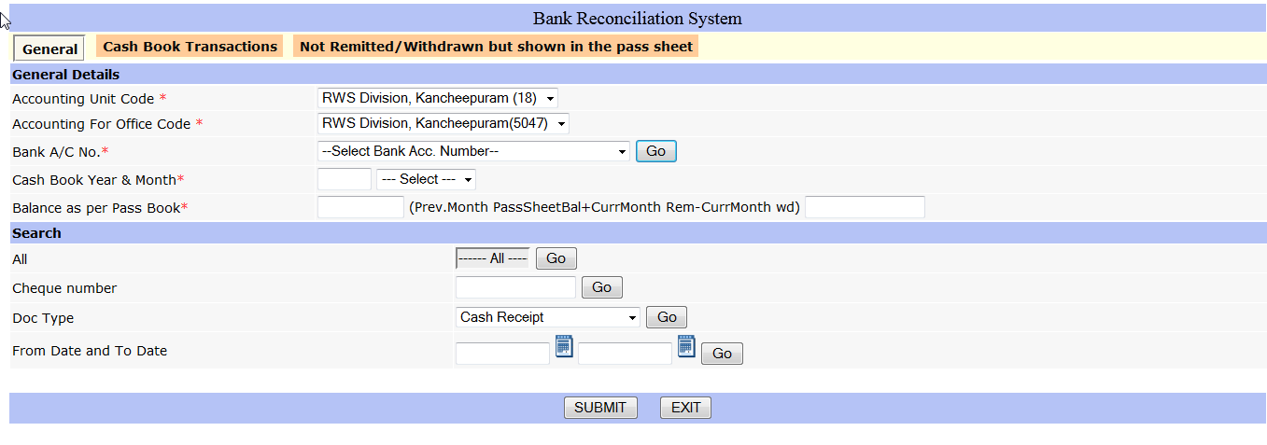
On clicking the Go button provided in Bank account number column, the bank accounts maintained by the accounting units will be displayed. Select the required bank account number.

The cash book year and month will be automatically displayed (initially it will be start month and year fixed by the user, subsequently the month will be incremented automatically)

In General tab, enter the pass sheet balance in the box provided against balance as per pass book

Display of Cash Book Transactions for Reconciliation

User can use the search criteria to display the Cash book transactions for the purpose of reconciliation

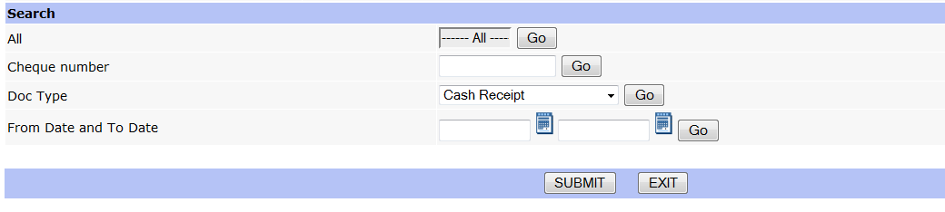

All - Click GO button to view all cash book transactions in the cash book yr and month.
Cheque Number – Enter Cheque number and click GO to view the transactions for a particular cheque number available in the cash book year and month
Doc Type: Select a particular doc type to view the transactions for the selected type,
From Date and To Date: Enter from Date and To Date and click Go to view transactions in the selected period

Reconcile Cash Book Transactions

Click the Tab Cash Book Transactions. On click the following screen will be displayed based on search criteria entered in General Tab
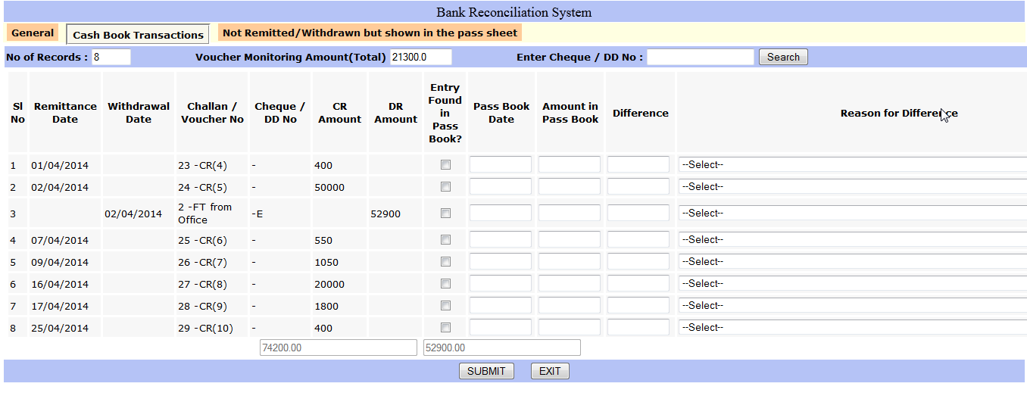

The Cash book reconciliation can be visualized as two parts. The first part, staring from ‘sl no’ to ‘Dr Amount’ which is displayed from cash book entries made by the user.
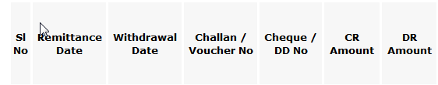

The second part is for reconciling these cash book entries. It starts from the column ‘entry found in pass book’ to column ‘is it a clearing entry for excess / short debit or credit’
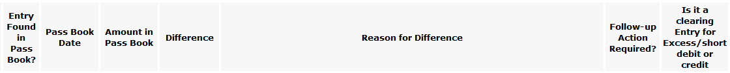

If a particular cash book entry is found in the Pass Sheet, user has to click the box provided under the column ‘entry found in pass book’ . Pass book date, amount found in pass book will be automatically displayed from the cash book details.
Depending on the entry in the pass sheet, user has to change the pass book date and amount found in the passbook
If the cash book amount and the pass book amount is not equal, the difference will be displayed and the column ‘follow up action required’ will be automatically selected. User has to select the Reason for difference
To save, user has to press submit.
Submit may be pressed at any point of time for saving the work done so far.
The following column will be explained separately(Click here to know how)
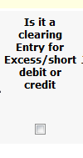

Entry of Not remitted / Not withdrawn entries but found in the pass sheet

There may be certain entries like commission charges/ other charges/ interest credit / wrong credit / wrong debit found in the pass sheet but not remitted or withdrawn by the unit. These details has to be entered using the tab ‘Not remitted/withdrawn but shown in the pass sheet’

On clicking the tab following screen will be displayed
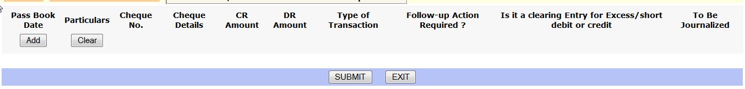
Click the Add button. On click a blank row will be displayed
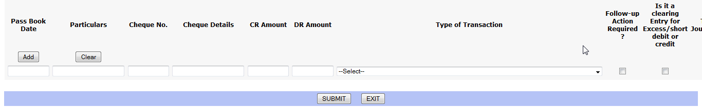
Enter Pass book date, particulars, cheque number, cheque details, cr amount or dr account, type of reason, follow up action required(Y/N).
For another such entry press add again and enter details. Continue this process till all details, which are not remitted or not withdrawn by the unit but found in the pass sheet, are entered.
Press Submit to save
The following column is be explained separately(Click here to Know How)


To clear the previous not remitted / not withdrawn entries

Clearing entry for excess / short debit or credit
The details not remitted / not withdrawn by the unit but found in the pass sheet may be cleared either through cash book or through another, reversed, pass sheet entry.
For example commission charges debited in previous month pass sheet may be credited in current month pass sheet. While making such entries enter the details in the following screen displayed under the tab Not remitted / Not withdrawn entries but found in the pass sheet


After entering the details up to Type of transaction, click the box under the column ‘Is it a Clearing entry for Excess / Short Debit or Credit’
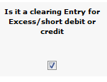
On clicking, the entries matching the following criteria will be displayed
- the existing (already entered) not remitted/not withdrawn entries, for which follow up action to be taken is marked and
- If clearing entry is cr, the earlier debit entries will be displayed or
if the clearing entry is dr the earlier credit entries will be displayed

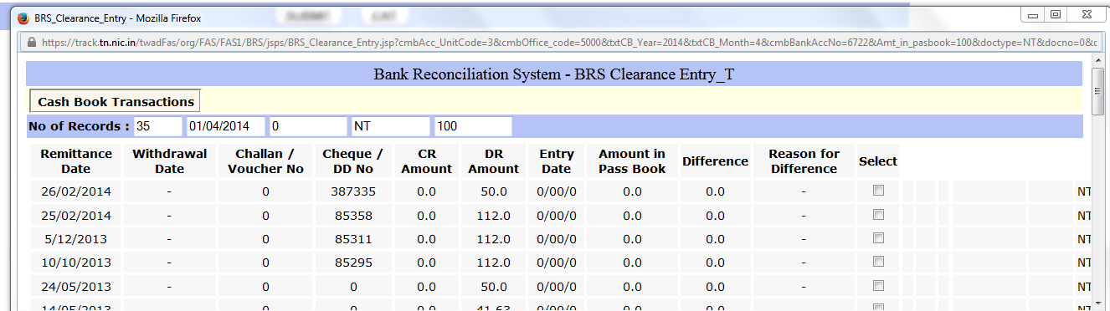
User has to select the matching entries and press update for linking the entries.

If the amount entered is not equal to the selected entries, then the following message will be displayed.
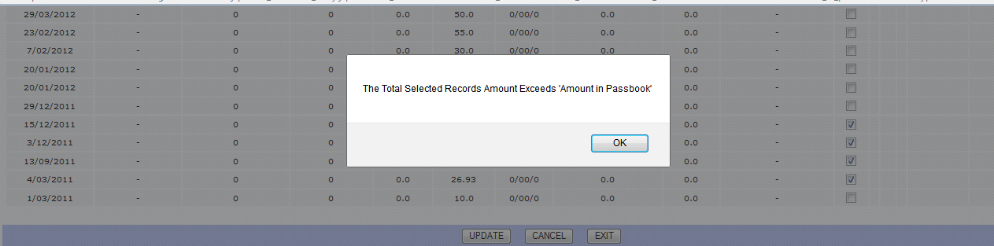

Note: The previous month Not remitted / not withdrawn entries may be cleared in Cash book , for example interest credited in pass sheet accounted for in current month through cash book. For such cases use the Is it a Clearing Entry for Excess / Short Debit or Credit’ provided in Cash Book Transactions Tab

BRS Reconcile previous month

There may be certain transactions which are not remitted or encashed in the same month of receipt/issue but remitted/encashed in the subsequent months. (Such transactions, initially (one time) would have been pushed using OB screen. Subsequently, the not remitted / not encashed entries will be taken care of automatically.)
For example, in the pass sheet of April’2014 there may be entries which are received / Issued during the earlier cash book month such as Feb’2014 or March’2014.
These transactions should be reconciled using Reconcile previous month Cash Book
To reconcile such transactions, select the menu 
On selection of this menu, the following screen will appear
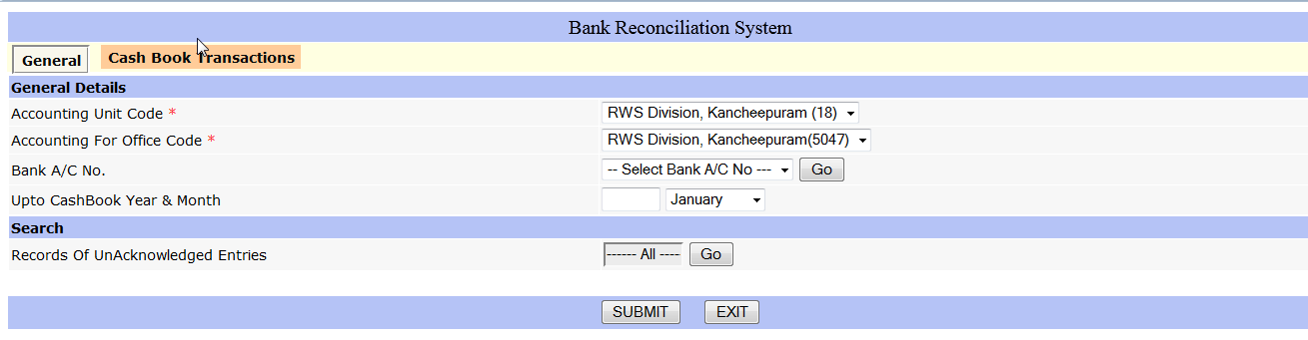
on clicking the ‘GO’ button available by the side of the bank a/c number selection box, the bank a/c number for the logged in office will be displayed.
User has to select the bank account number for which the reconciliation is to be done
On selecting the bank account number, the cash book month and year will be automatically displayed.
Then user has to click the GO button provided in the search
On click, the transaction which are not remitted or not encashed up to the cash book month and year will be displayed.
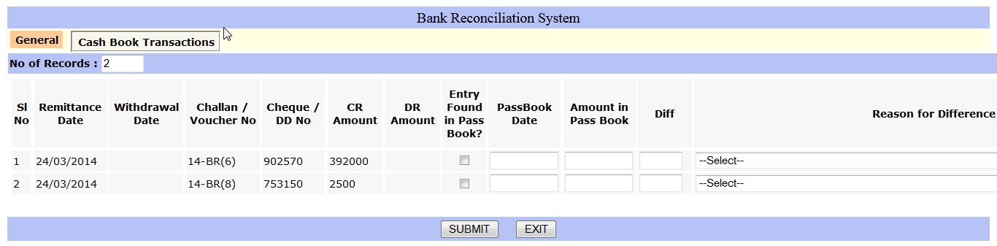
Click the box under the column ‘Entry Found in Pass Book’, Enter the Pass book Date and press submit.

How to make changes for the already entered transactions- EDIT Reconciliation

Authorization

To make changes in the already reconciled transactions, select Authorization menu available in BRS->BRS Authorization
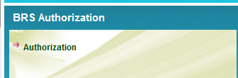

On selecting the above menu, following screen will be displayed
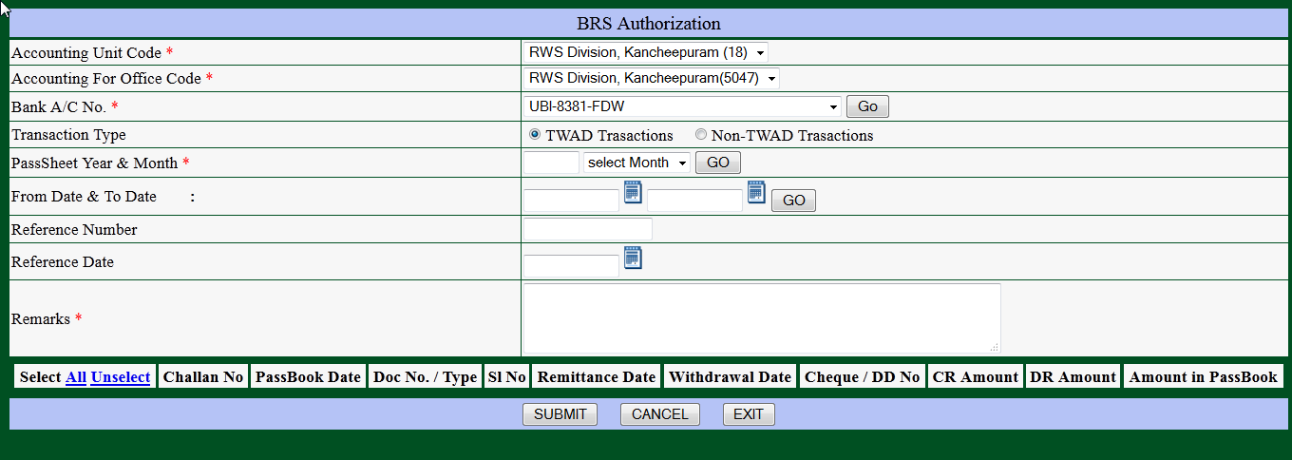

Select the required account number. If Cash book transaction reconciled is to be changed, select the option 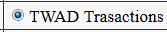 or if not remitted / not withdrawn entries are to be changed select the option 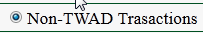
as transaction type. Then enter the Pass Sheet year and month. Click the GO button provided near the year and month .Alternatively user can enter the period and press the GO button provided near the Period.
On click of GO button, details found in the transaction type will be displayed.
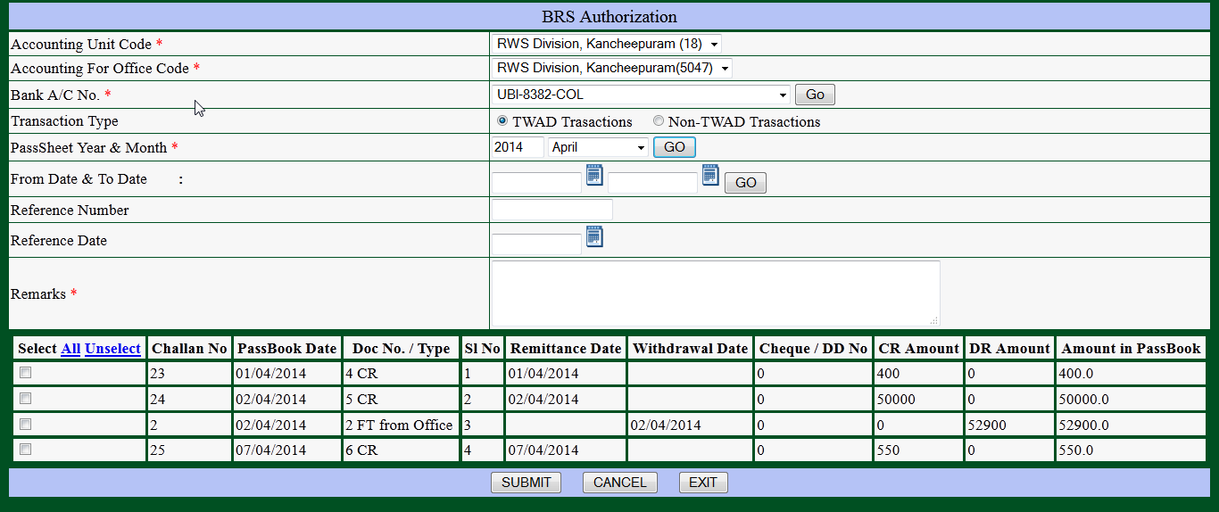

Select the entries required for change by clicking the box provided under the column . Press submit.
Note: At a time, either TWAD or Non TWAD transactions can be authorized. If user wants to authorize both TWAD and Non TWAD transactions, first select TWAD transactions, press Submit and Then select Non TWAD transactions and then press Submit.

Edit the authorized entries

For editing the authorized entries, select the menu available under.

On selection of the ‘Edit the Reconciliation Made’ the following screen will be displayed.

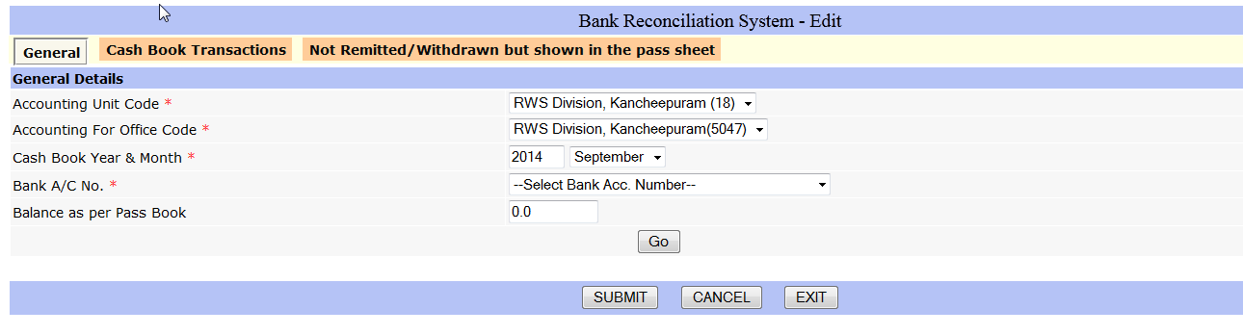
Select cash book year and month, select bank account number. Click Go Button to view the entries authorized for edit

For making corrections in the Cash Book transactions select the tab Cash book transactions.

Edit reconciled cash book transactions

On selecting the the following screen will be displayed
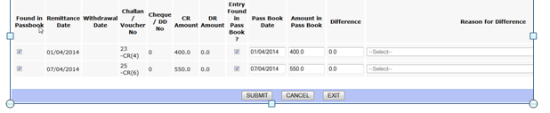

The only change user can make here is to uncheck the found in pass book, so that it will be displayed again for reconciliation. For this click the 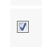 box provided under found in pass book and then submit.

Edit the not remitted / not encashed entries but found in pass sheet

Select ‘Not Remitted / Withdrawn but shown in the pass Sheet’
On selecting tab the following screen will be displayed. User can make any change. If the user wants to delete an entry, the check box provided under the column Delete is to be clicked. So any record with the tick mark column will be deleted. Hence check before Submit
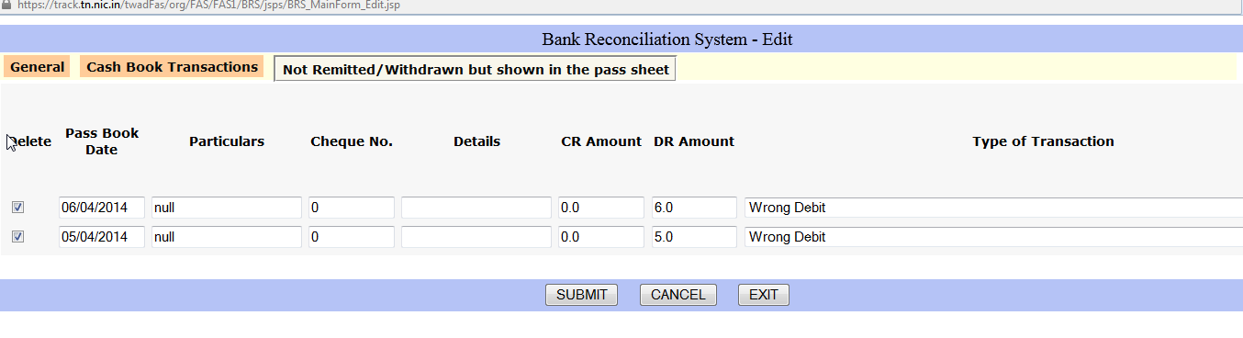

Reconcile From Journal

If any transaction is booked in journal for the bank head, those records will be displayed in Reconcile from Journal.
For this please select the menu


On selection of the menu the following screen will be displayed.
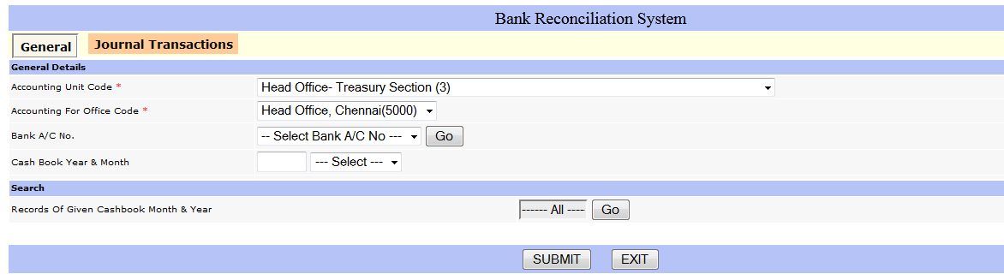

on clicking the ‘GO’ button available by the side of the bank a/c number selection box, the bank a/c number for the logged in office will be displayed.
User has to select the bank account number for which the reconciliation from journal is to be done
On selecting the bank account number, the cash book month and year will be automatically displayed.
Then user has to click the GO button provided in the search
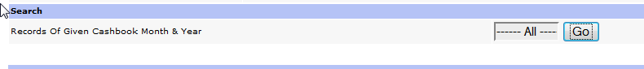
If Records are not available, then the following message will be displayed.
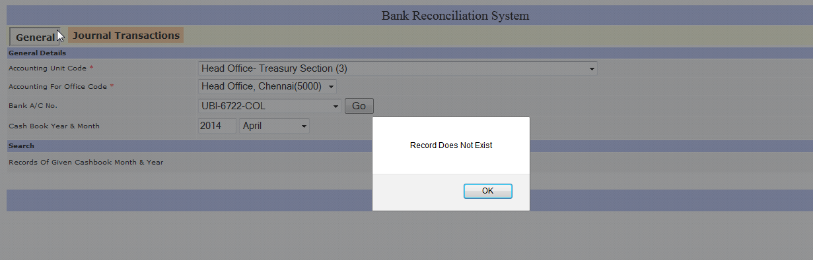
Otherwise the entries booked in journal will be displayed in the 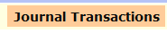 tab
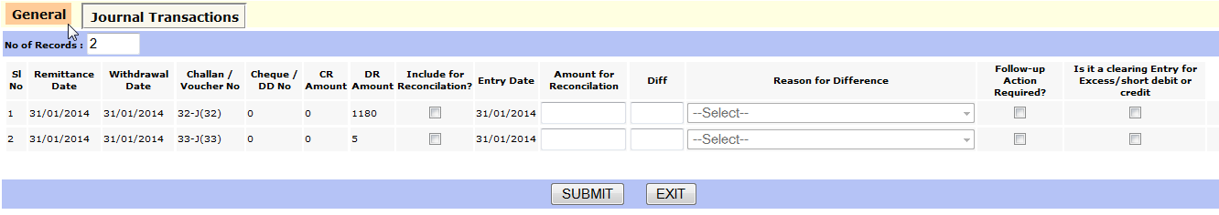
If a particular journal records is to be included for reconciliation, click the box provided under to column “Include for Reconciliation”. Press submit to Save

Enter Follow up Action

There may be entries such as wrong debit / wrong credit / excess debit / short credit etc. Users have marked them for follow up action.
To enter the date of follow up action taken and the follow up description user has to select the menu item available in Monthly reconciliation menu.
On selecting this item, the following user interface will be displayed
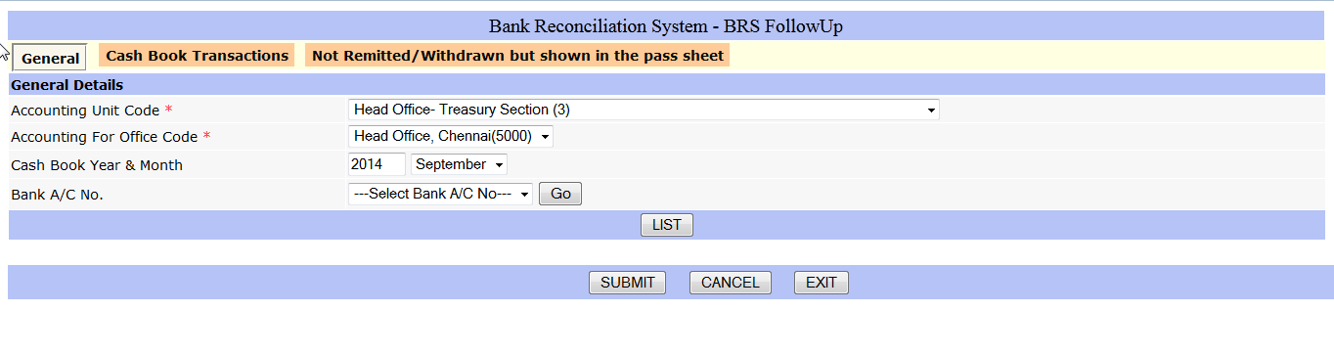
Enter the Cash book year and month during which the pass entries are available.
On clicking the ‘GO’ button available by the side of the bank a/c number selection box, the bank a/c number for the logged in office will be displayed.
User has to select the bank account number for which the Follow up action is to be done
Then User has to Click the 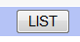 button provided.
The entries for which follow up action will be available in the tabs Cash book Transactions or Not remitted / Withdrawn but shown in the pass sheet depending on the case. User has to enter the Action taken date and the action taken for each item and press submit

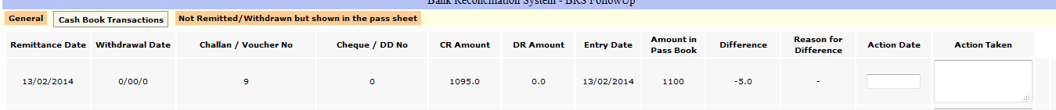
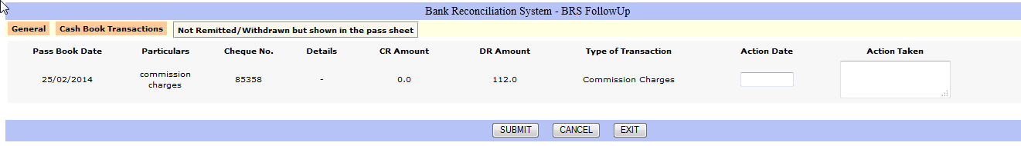

Monthly Freeze

Every month , user has to freeze three reports Part 1, Part 2a and part 2b. For this purpose, a button is provided in the respective report screen.

After freezing the above reports , user has to freeze Monthly BRS freeze provided under BRS Month end operation. If cash book transactions / pass sheet transactions are nil for a month, user has to select Nil Freeze Monthly BRS or other wise user has to select Freeze Monthly BRS.

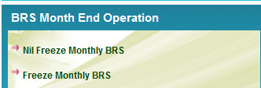

BRS LIST

The following list are available for the purpose of View

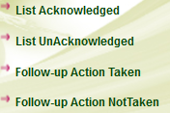

BRS Reports

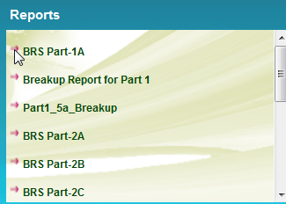

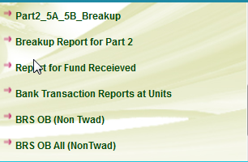

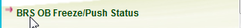

BRS SAMPLE REPORTS

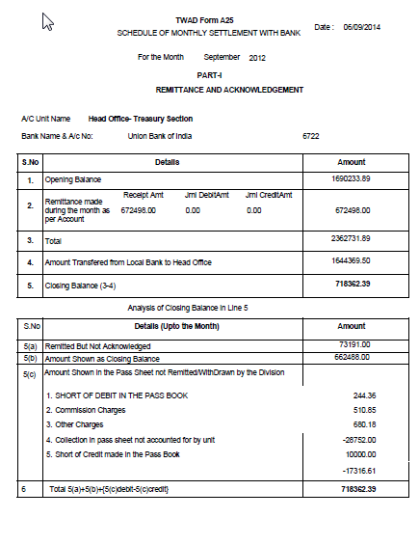
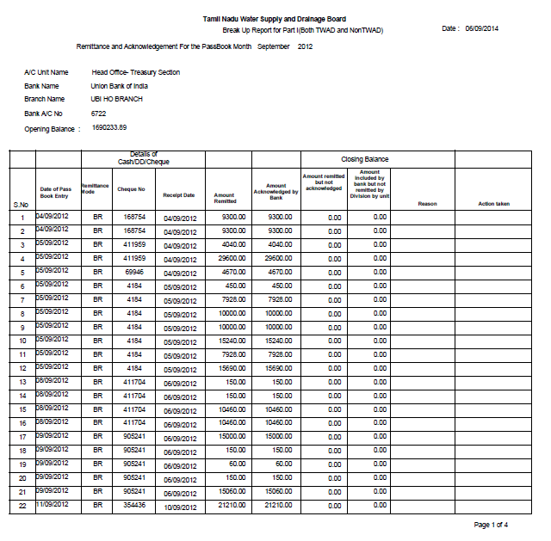

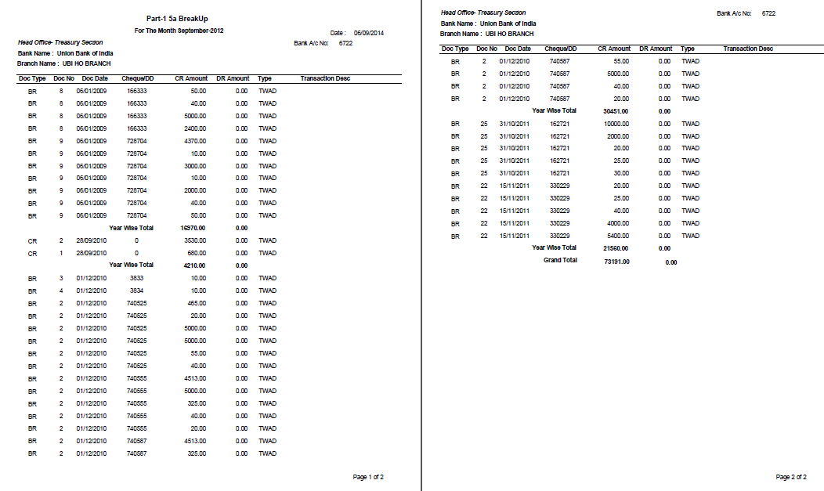

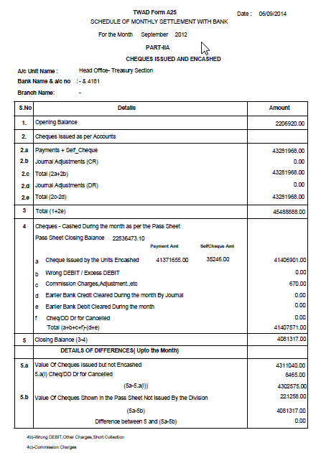

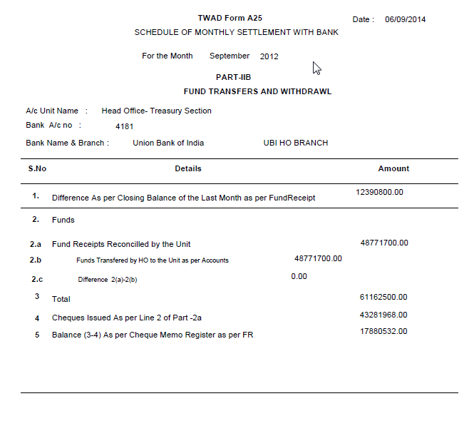
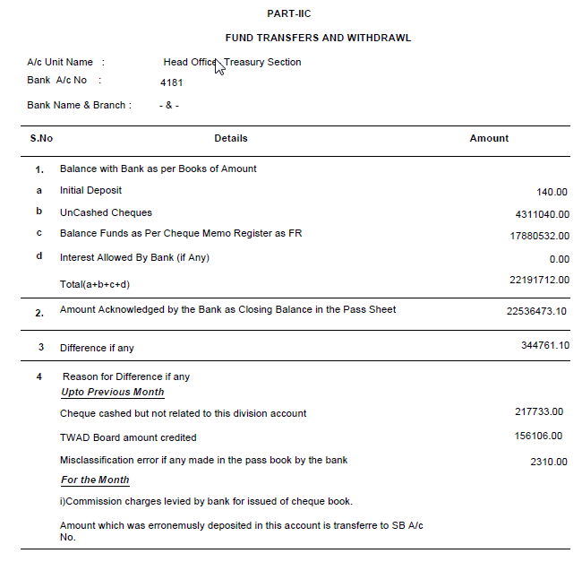

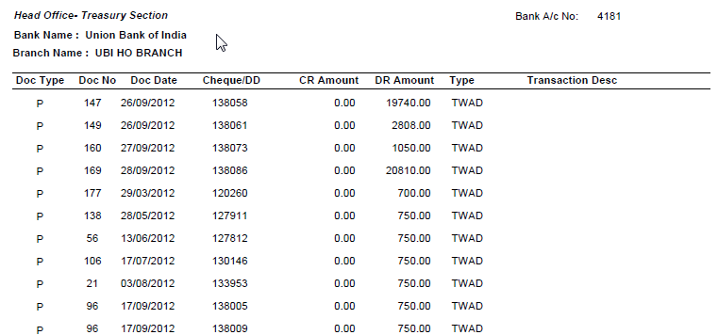

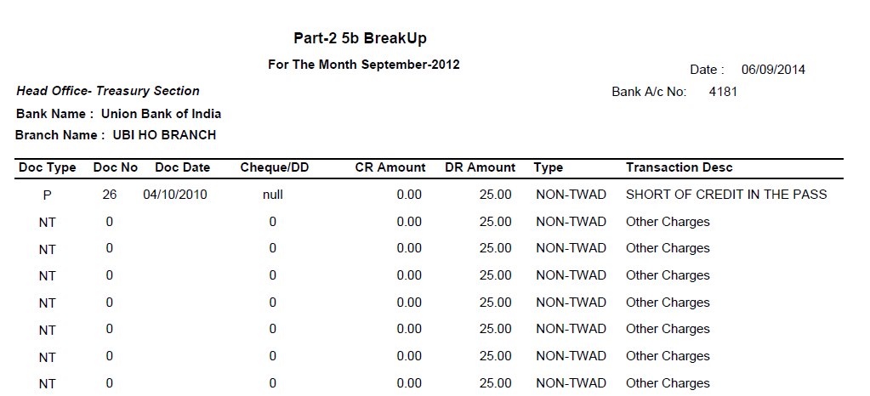

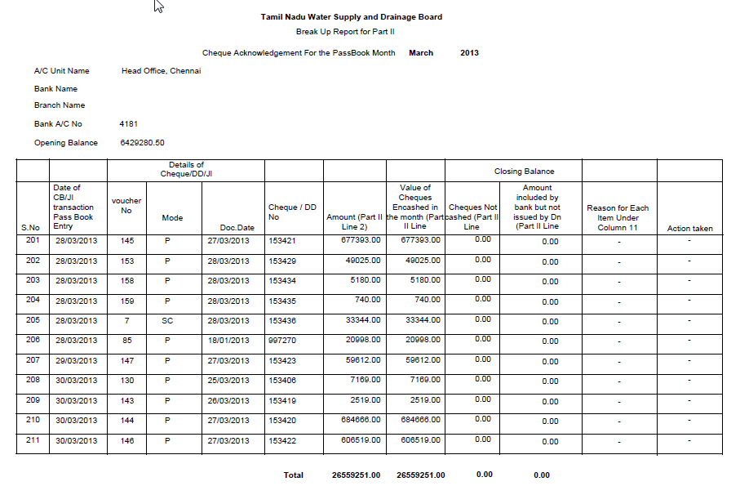
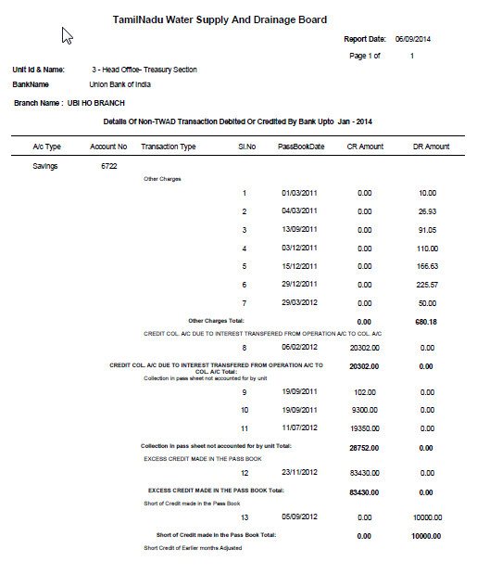

GLOSSORY

Cash book transaction – Actual Receipt and Payment entered in FAS->Unit Operations
Bank Transaction – Entries found in the pass sheet but not remitted or withdrawn by the unit
Acknowledged entries – Cash book entries reconciled against pass sheet
Not acknowledged / not encashed entries - Cash book entries which are not yet reconciled against pass sheet
Not remitted entries – Credit Entries found in the pass Sheet but not remitted by the unit
Not withdrawn entries - Debit Entries found in the pass Sheet but not remitted by the unit
TWAD transactions - Actual Receipt and Payment entered in FAS->Unit Operations
Non TWAD Transactions - Entries found in the pass sheet but not remitted or withdrawn by the unit

