Civil bill –GPF Bill flow – from Bill Token Register Entry to Cheque Memo and Final Payment
Pre-requisite
- GPF Sanction Proceeding should have been entered and validated in TWADNEST/GPF System
- Drawing Officer Details should be entered in TWADNEST->FAS->Civil Bills->Civil Bills Unit wise Master-> drawing officer details
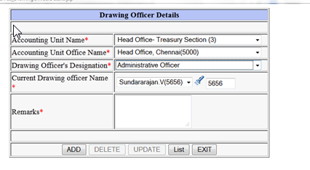
Bill To Voucher

- Select Bill Token Register Entry Civil Bills->Transaction->Bill Token Register Entry (with Computer generated sanction Proceeding)
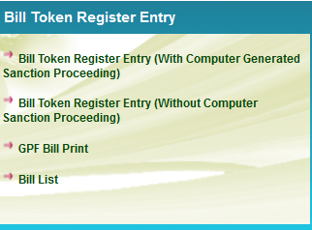

- In the following UI, Enter Proceeding Month, Select Proceeding Year. Then Select Major Type as Miscellaneous, Minor Type as GPF and Select Sub type. The validated proceedings will be displayed. Select the appropriate proceeding. On selection, the details from Proceedings will be displayed. Enter Bill Date, Bill processing done by . Check the details displayed and press Submit
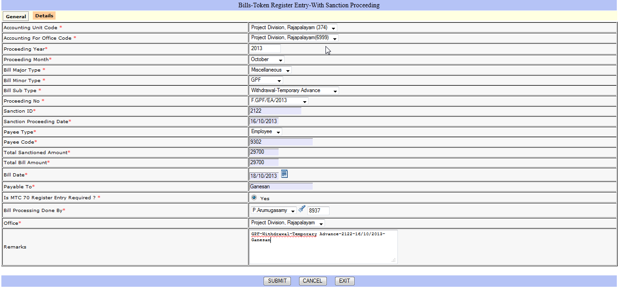
- After making the above entry, Bill can be printed using the GPF Bill Print Option. The output generated will be as follows
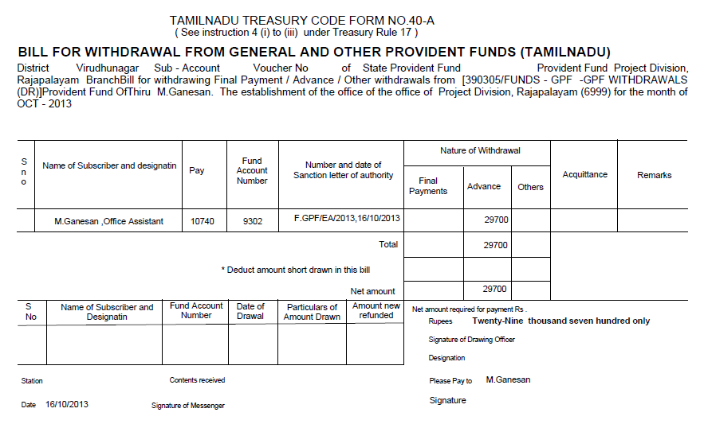

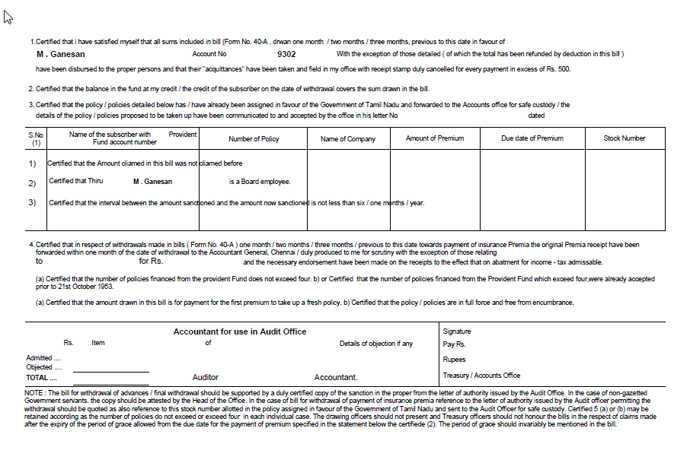
- Next step is checking memo of payment . Select Memo of payment using the following menu. Civil Bill ->Transactions -> Memo Of Payment Entry
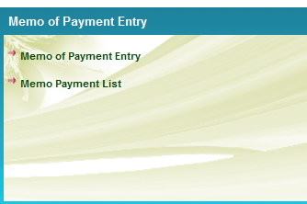
- On Selection the following screen will be displayed. Select the Bill number and Check the details in General and Detail part . Enter Remarks if any and press Submit
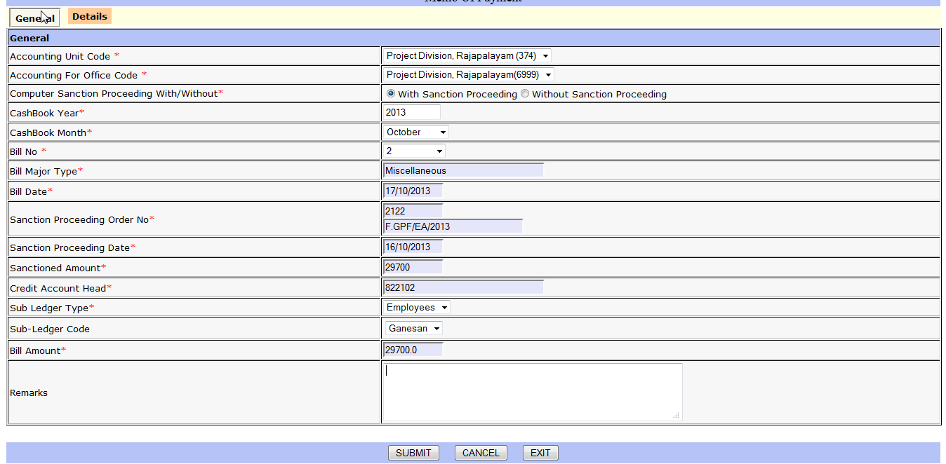
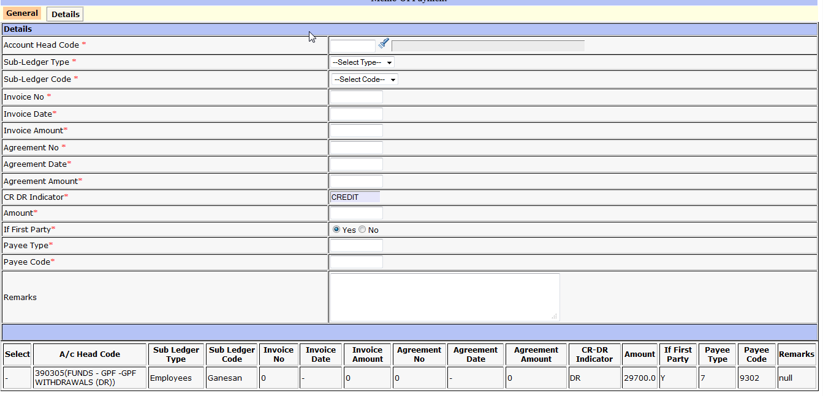

- Next step is bill scrutiny. For this Select Civil Bill ->Transactions -> Bill Scrutiny
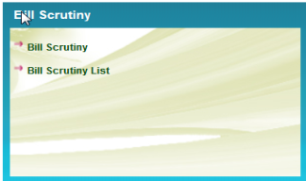
- On Selection of Bill scrutiny the following screen will be displayed. Select the Bill Number
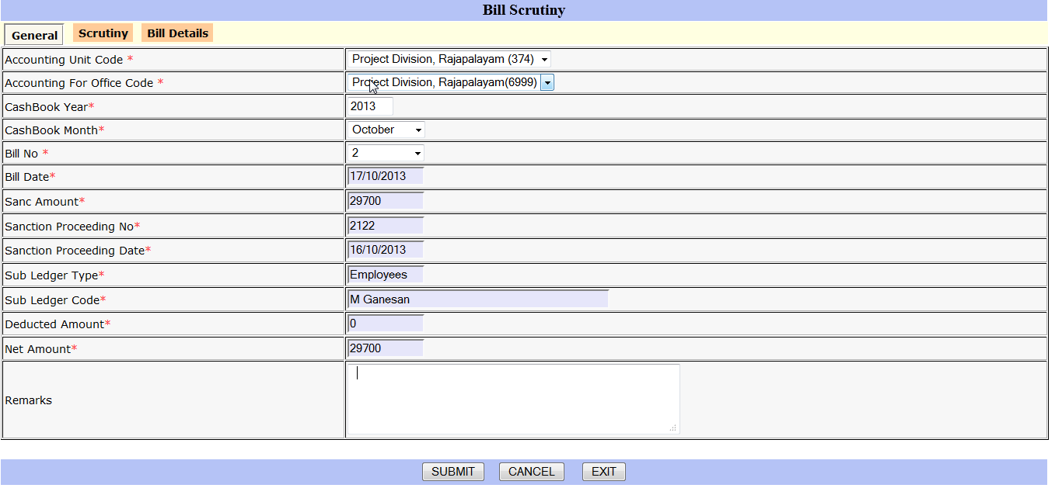
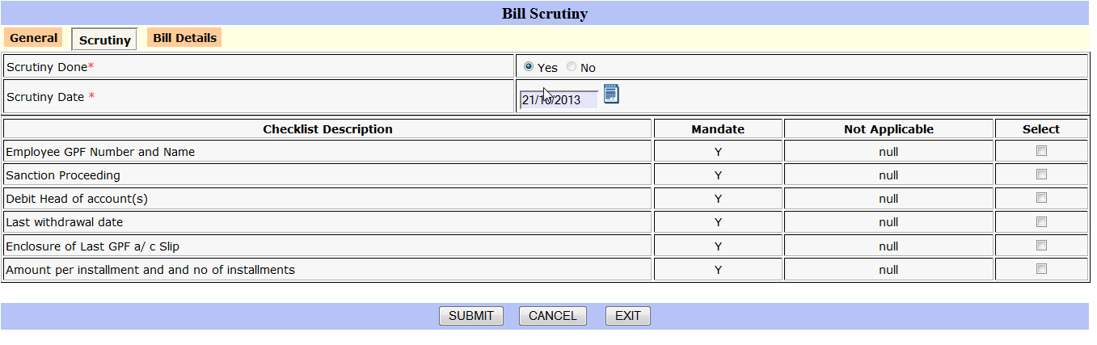
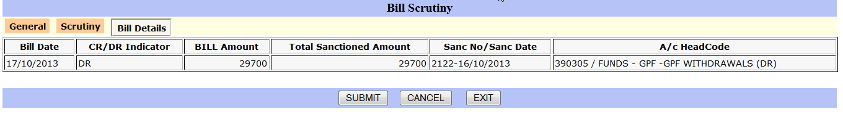
In General Part Enter Remarks, if any. In Scrutiny tab, enter the scrutiny date, and select the checking done. Details can be viewed in Bill Details Part.
- Next step is to prepare pass order preparation. For this Select Civil Bill ->Transactions -> Pass Order-> Pass Order Preparation

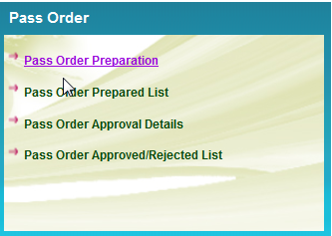

- On selecting Pass Order Preparation, the following screen will be displayed. Select the Bill for which pass order is to be prepared. Enter Pass Order Preparation Date, employee id of the officer who is preparing the pass order. Enter Remarks if any and press submit.
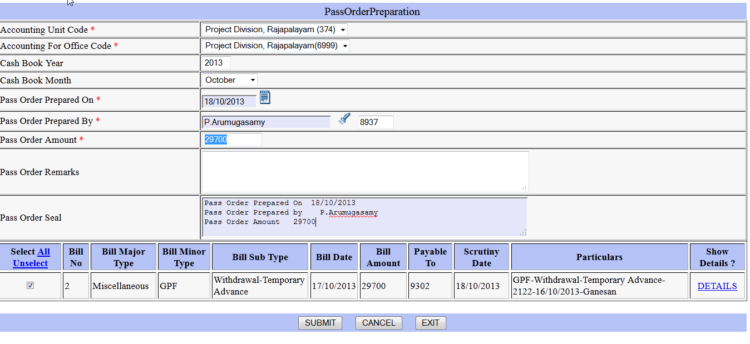

- Next step is Pass order approval. For this Select Civil Bill ->Transactions -> Pass Order-> Pass Order Approval Details

- On selection of pass order number, the following screen will be displayed. The Drawing officer employee id will be displayed from the master. (If the drawing officer employee id is not entered in the master, enter in Civil Bills->Civil Bills Unit wise Master->drawing officer details.) Select Approved / Rejected and date of approval or date of rejection and press update.

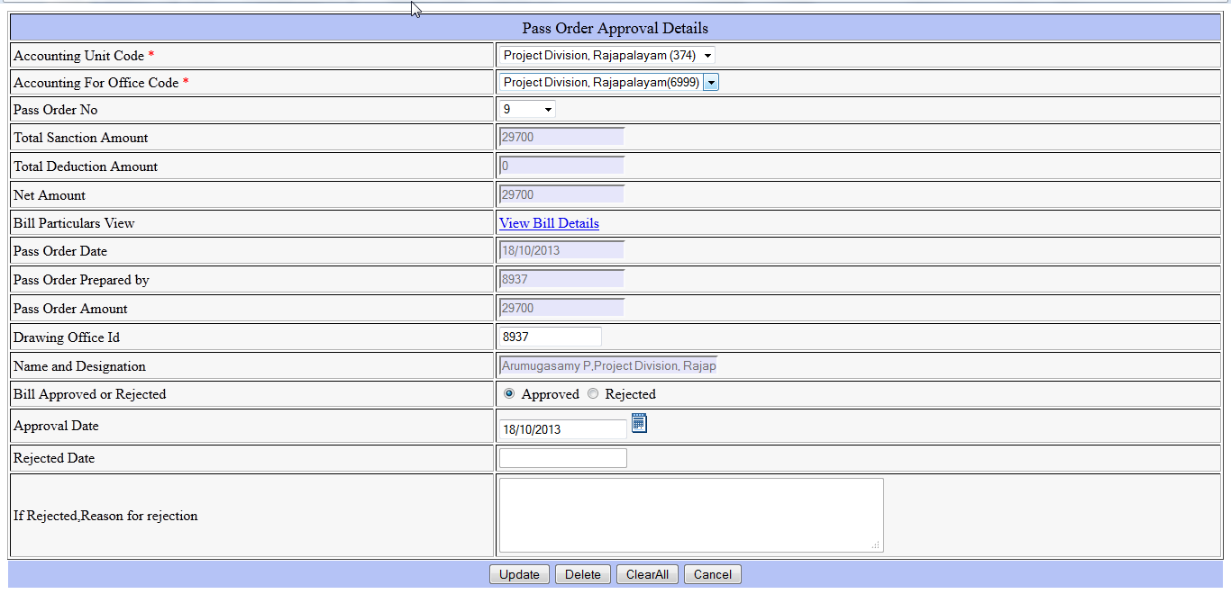
- Next step after Pass Order Approval, is to enter details about MTC 70 Register Entry. For this select Civil Bill ->Transactions -> MTC-70 -> MTC 70 Register Entry
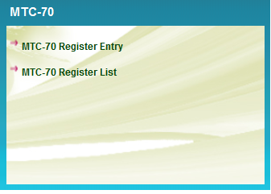
- On selection the following screen will be displayed. Select Bill number, Enter MTC – 70 Entry Date, MTC – 70 Entry Done by and remarks if any and press submit
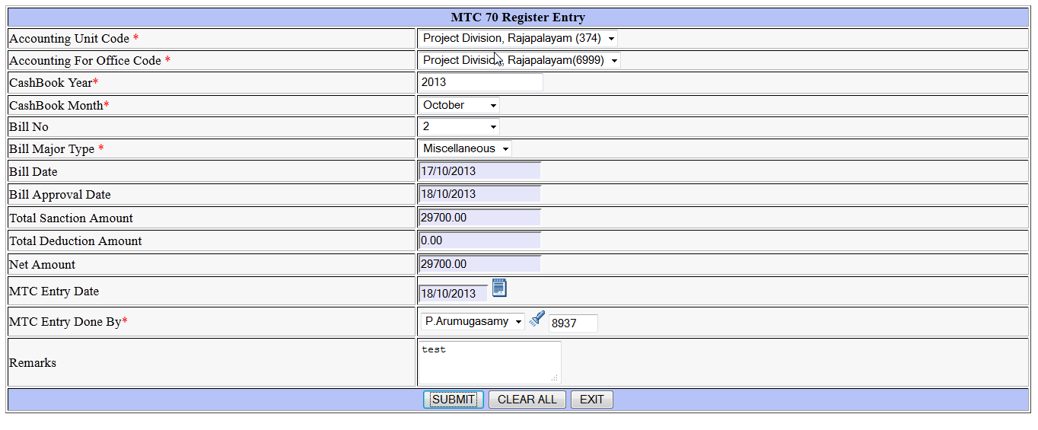

- Next step is Cheque Memo and Voucher Creation. For this Select Civil Bill ->Transactions -> Cheque Memo -> Cheque Memo from Original Bills
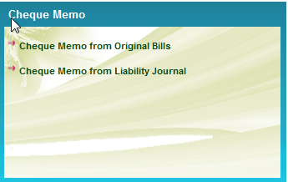
- On selection, the following screen will be displayed. Here Select Memo Type as Employee, month, Payee type and Payee Code. Enter Voucher date and cheque number. Cheque date will be same as Voucher date. Check the Credit head of account, Bank Account number and debit head in details part and press Submit. Once submitted, payment voucher will be created
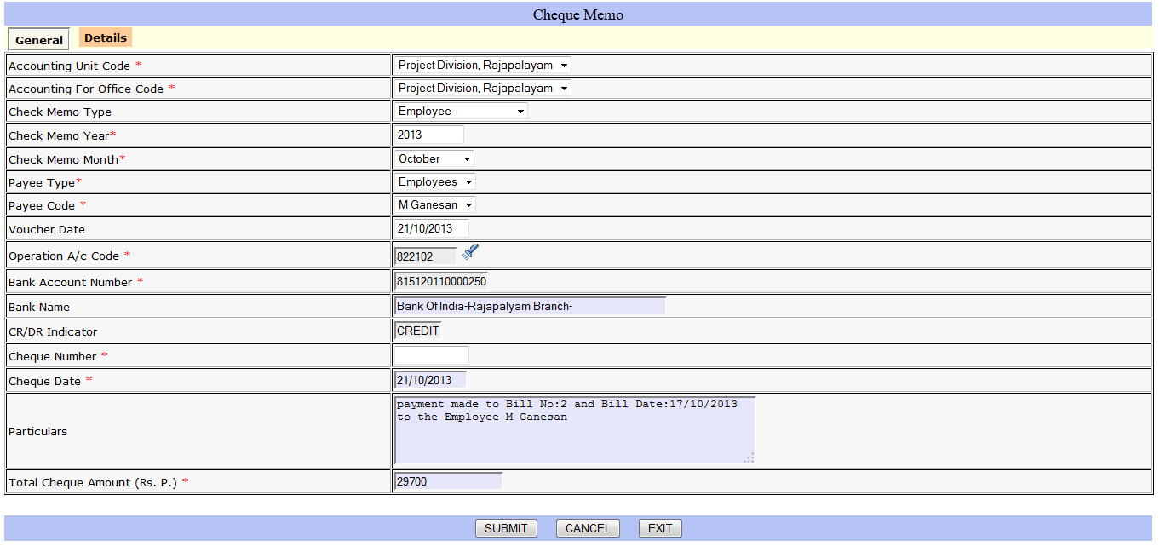
- Check the voucher details created using List of Final Payment entry.

