Steps for entering Payment against pending bill

- Select Financial Accounting-> Unit Operations-> Payment
- In Payment menu , following menu item is available
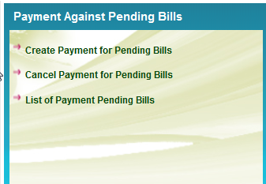
- For Creating a payment

Select ‘Create Payment for Pending Bills’, the following screen will be displayed

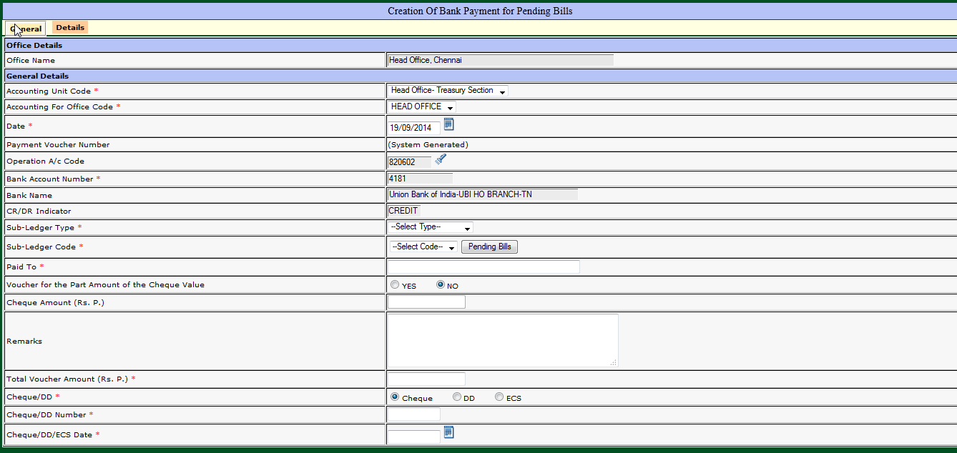

In General Part, after entering Voucher date and bank details, Select Sub ledger type and code for which payment is to be made. Then click the pending bills button 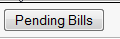 provided near the subledger code. The details for the selected subledger code will be displayed from LJV. The CR indicator in LJV is reversed as DR and displayed in the details.
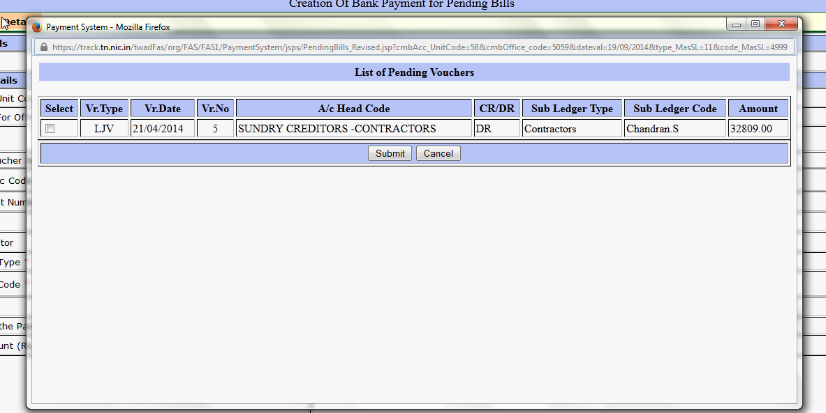

Select one or more items for which payment is being made now and press submit to confirm the selection
The total amount is computed and displayed in the general part.
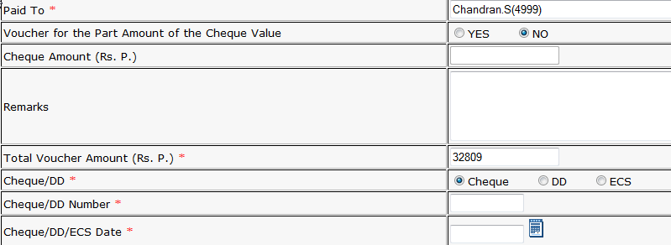

In the General Part , enter cheque details and press submit to save the Voucher.

Note: The payment voucher entered against Pending bill cannot be modified. For any Changes, user has to cancel the voucher, using the regular authorization and re-enter.

