General Flow for TDA/TCA

Step 1. Originate

TDA/TCA Through Journal
- User has to create the originating entry through TDA/TCA originating
- Create and Post TDA/TCA Journal – After doing this step only, user will be able to generate TB

TDA Through Payment

- Enter Payment and verify payment
- Post TDA/TCA from Payment – After doing this step only, user will be able to generate TB

TCA Through Receipt

- Enter Receipt, prepare challan and verify remittance
- Post TDA/TCA from receipt – After doing this step only, user will be able to generate TB

TCA Through pay roll Journal

- Enter Journal and verify journal
- Post TDA/TCA from payroll Journal – After doing this step only, user will be able to generate TB

Step 2. Acceptance

If TDA/TCA raised by other unit , manual copy received and it is to be accepted by you

- First ensure, originating details has been entered in the FAS ONLINE.
- Check for the Journal number and date
- If it has been originated before April 2011. Accept through TDA/TCA Cut off
- If it has been originated during or after April 2011 use the TDA /TCA System
- Select Create acceptance
- Create and Post TDA/TCA Journal – After doing this step only, user will be able to generate TB

Step 3 Suspense Head Clearance

If TDA/TCA originated by you is accepted at the other end and manual copy for acceptance is received, suspsense heads has to be cleared.

- First ensure, the acceptance details has been entered in the FAS ONLINE.
- Check for the Journal number and date
- If it has been originated by you before April 2011. Suspense head clearance has to be done through TDA/TCA Cut off
- If it has been originated by you during or after April 2011 use the TDA /TCA System
- Select Suspense head clearance. Enter the journal date and particulars. On submit a journal is created

Transfer Debit Advice (TDA) / Transfer Credit Advice (TCA) System

This module will help the accounting unit when the transactions between two or more divisions, which require the account settlement, are mainly of the following kinds.
- Services rendered by one Division to another
- Assets transferred from one division to another
- Cash recoveries made from employees, contractors, etc as also revenue released by one Division on behalf of another division.
Settlement of accounts can either by done through cashbook or adjusted by journal entries. This system can be used to achieve the above purpose and both are explained below.

The originating division should create the TDA/TCA in the form shown below along with necessary details.

TDA/TCA Originating System –Through Journal- Create

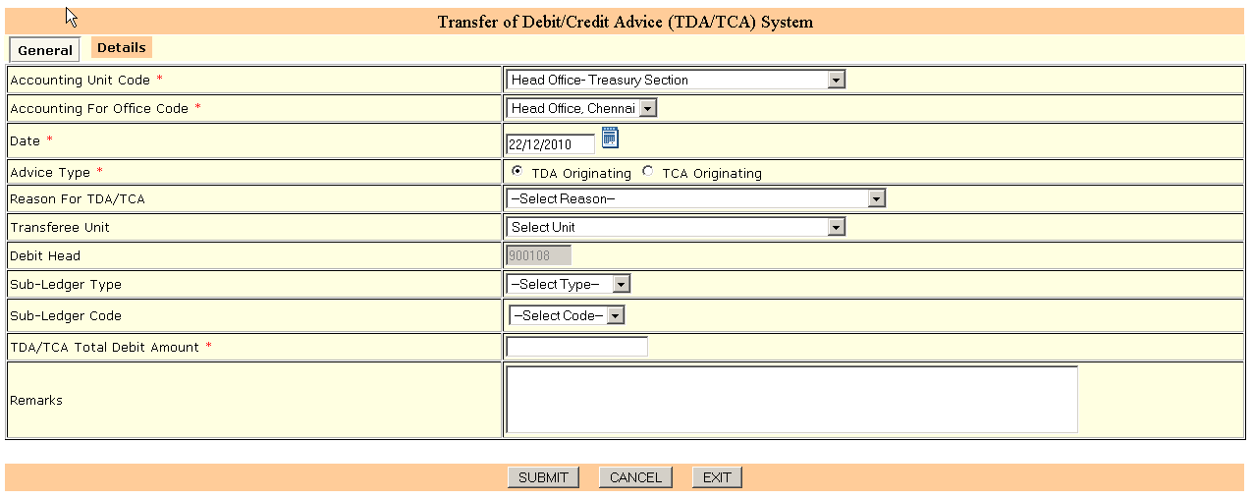

The user has to select the Advice Type as TDA/TCA and should also enter the reason for TDA/TCA, to which office it is getting raised etc. The account head will be fixed accordingly as per the type chosen. The first record in the Details part will be displayed automatically as per the details entered in the General Part. In the details part the user has to press ‘ADD’ button to add this into the grid. The user may continue entering the other details as similar to other systems. After entering the required details finally the user may have to press ‘SUBMIT’ button.

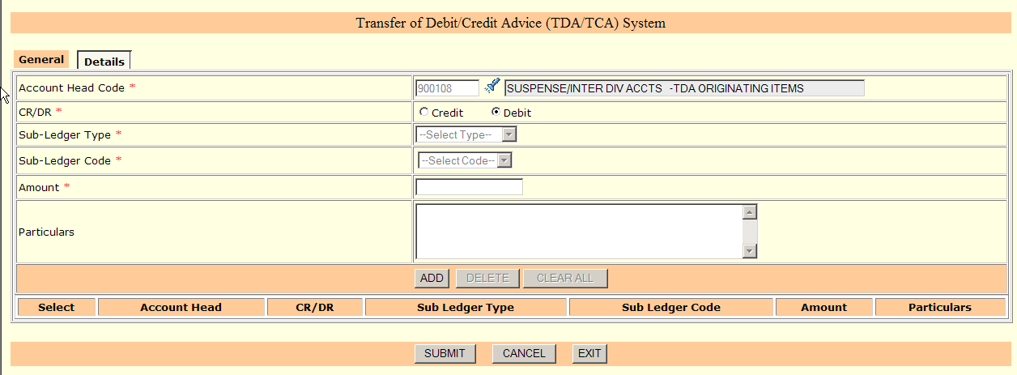

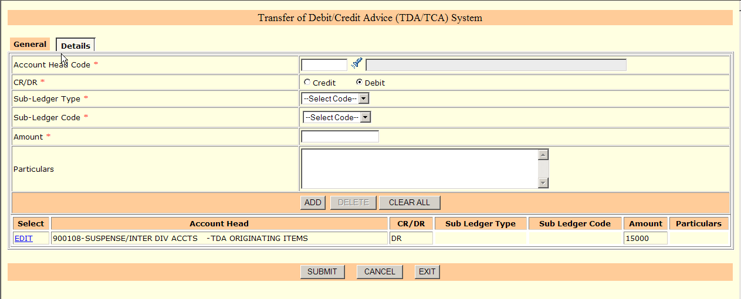

TDA/TCA Originating System - Through Journal – Authorization

The Edit/Cancel can be done after authorization.

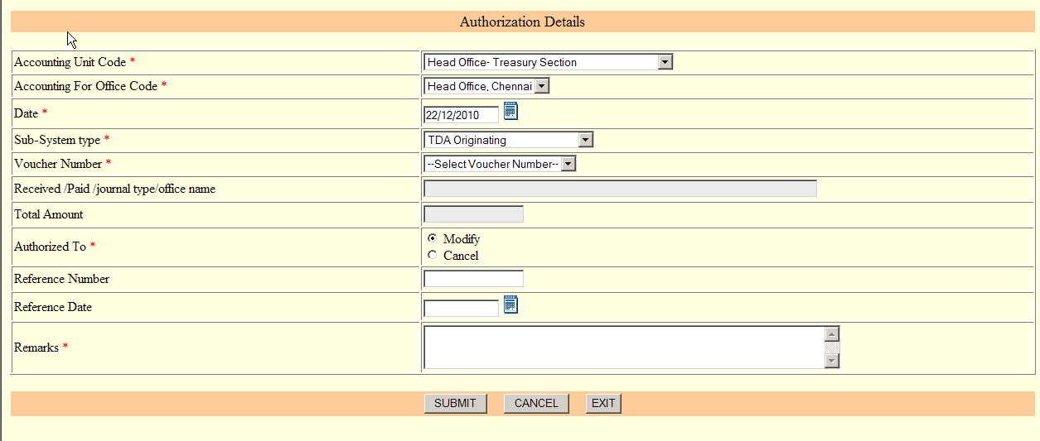

TDA/TCA Originating System - Through Journal – Edit

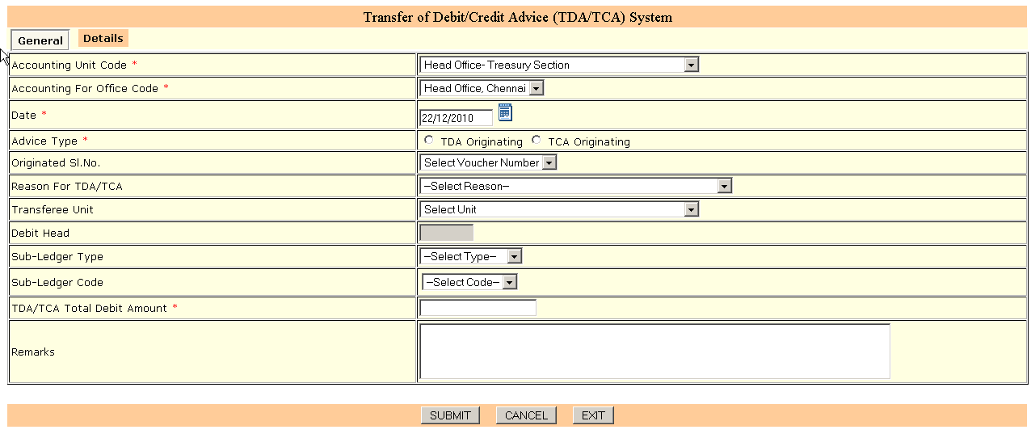

The authorized voucher no. will be displayed under ‘Originated SL.no’ drop-down box which can be selected and the modifications can be done.
TDA/TCA Originating System - Through Journal – Cancel

Similarly the ‘Cancel’ option can also be done after the voucher is authorized through the authorization system. The originating voucher will be allowed for ‘Authorisation’ till the ‘Acceptance’ is created. Once ‘Acceptance’ is created by the accepting unit, the voucher cannot be modified/cancelled.
Post Journal for the TDA/TCA Originating

Once TDA/TCA is originated, the originating unit should post the journal. After this only the ‘Acceptance’ can be enabled for the raised unit. The user can select the ‘Journal Type’ as TDA Originating Journal and on pressing ‘Go’ the raised vouchers will be displayed the grid shown below. The user can select them and on ‘SUBMIT’ the journals will automatically be created in the system.
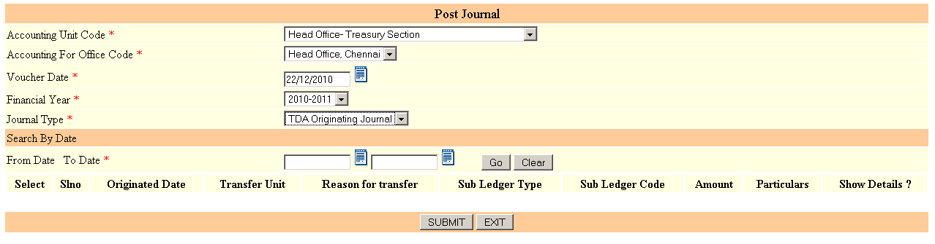
The journal created in this automatic way cannot be cancelled by ‘Authorisation’ menu but will be cancelled once the TDA/TCA Originating Voucher is cancelled. The originating voucher will be allowed for ‘Authorisation’ till the Acceptance is done.

TDA/TCA Accepting System - Create

This module will be used by the unit which has any TDA/TCA raised against them which will be automatically listed in the originated Sl. No. column. The details will be displayed and the account head will also be displayed automatically by the system.

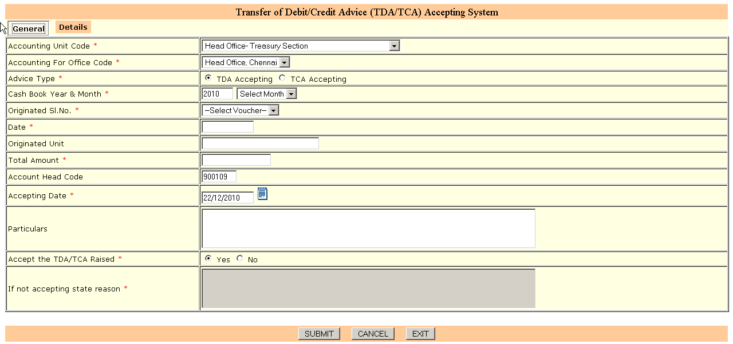

As in the case of ‘Originating Details’ part the first record will be displayed and can be added by pressing ‘ADD’ button. The other details can be added in the usual way.
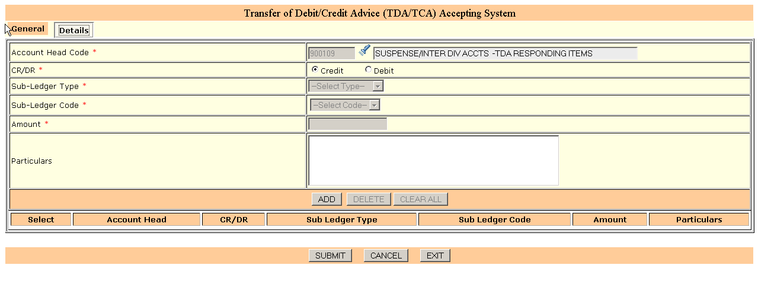
Finally ‘SUBMIT’ can be pressed to save the details.
TDA/TCA Accepting System – Edit

The ‘Edit’ option can be done after ‘Authorisation’ is allowed.

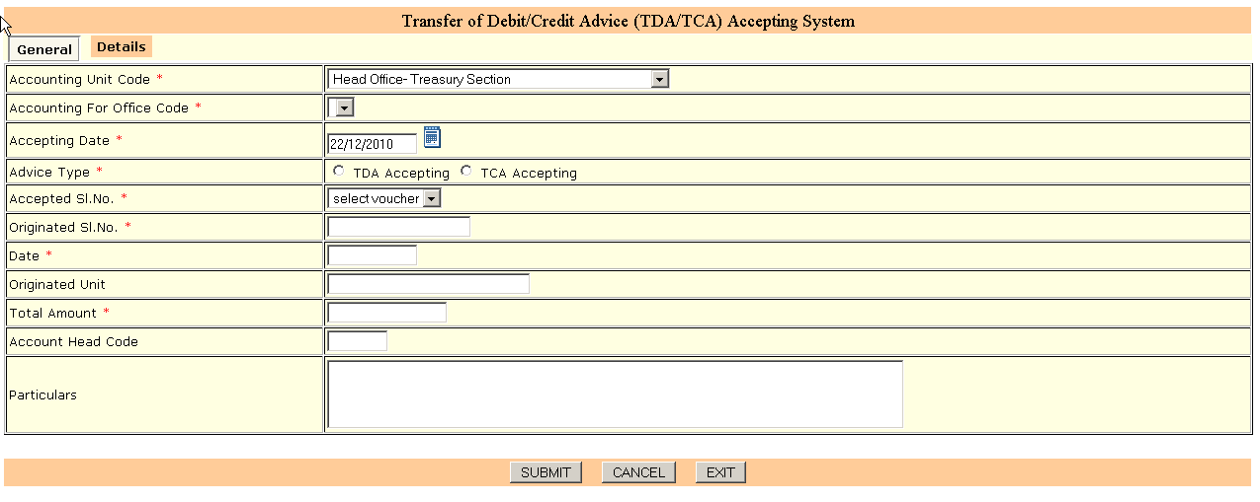
TDA/TCA Accepting System – Cancel

The ‘Cancel’ option can be done after ‘Authorisation’ is allowed.
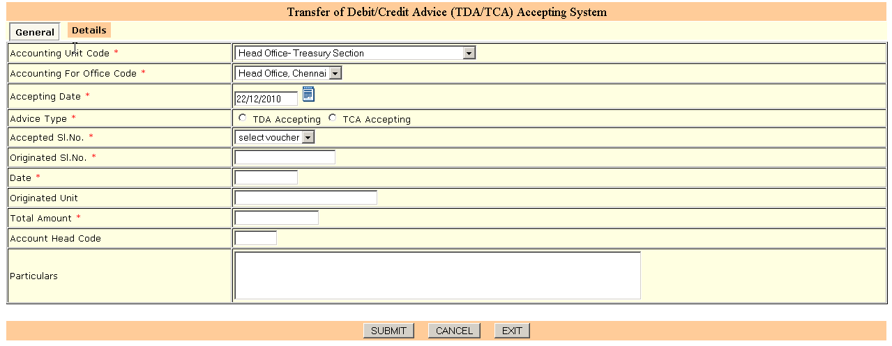
Post Journal for the TDA/TCA Accepted

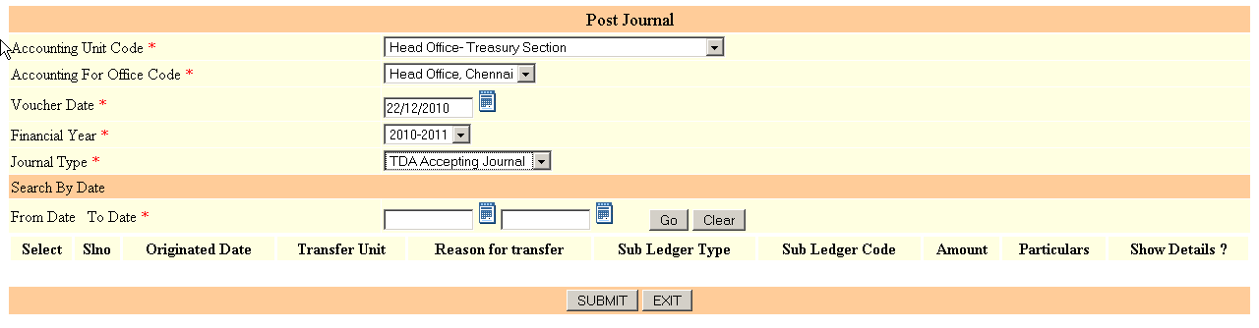
The ‘TDA/TCA Accepting Journal can be posted with this menu by selecting the Journal Type in the column. The ‘Accepting’ voucher nos will be displayed in the grid shown below and the user can select them and ‘Go’ for the generating journals.
The journal created in this automatic way cannot be cancelled/modified through Authorisation, but will be cancelled once the ‘Authorisation’ is given for the TDA/TCA Accepting Voucher.
TDA/TCA Responding System- Suspense head clearance by the originating unit – Create

This menu will be used by the ‘TDA/TCA Originating Unit’ to respond to the ‘TDA/TCA Accepting’ voucher no.

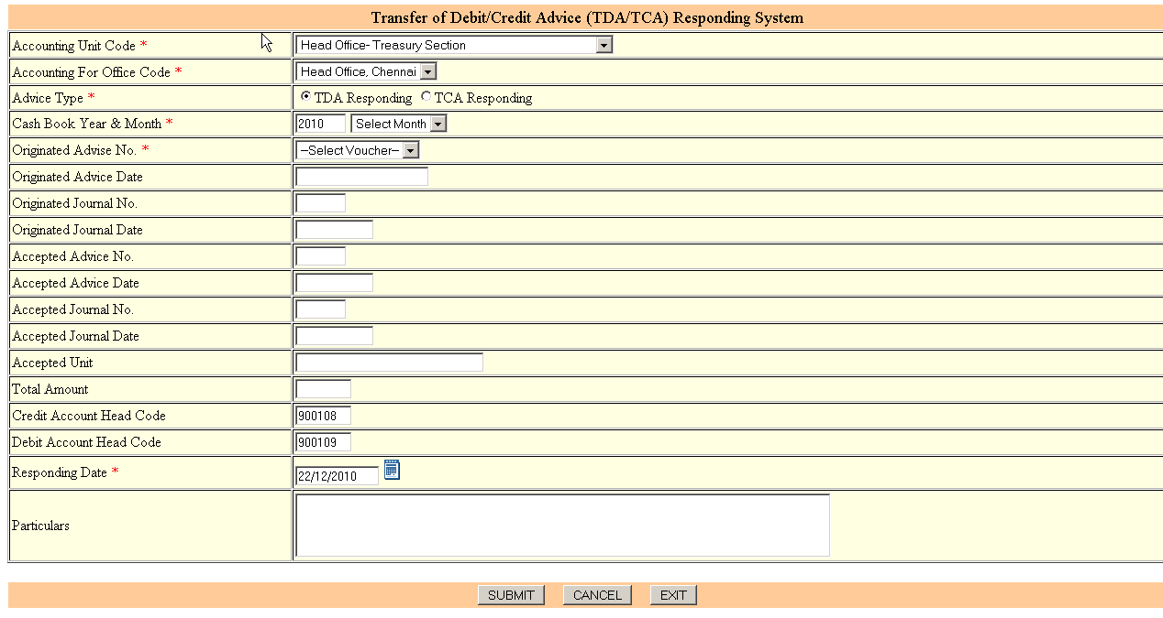

On selection of Originated Advice No. the other details shown below this column will be displayed automatically by the system. The Responding can be done only after TDA/TCA Accepting Journal is posted.
On ‘Submit’ one TDA/TCA Responding Journal will be automatically by the system.

TDA/TCA Responding System – Edit/Cancel

The ‘Edit’/’Cancel’ can be done after Authorisation is allowed through system.

Verify TDA/TCA

This option is given to verify the TDA/TCA vouchers.
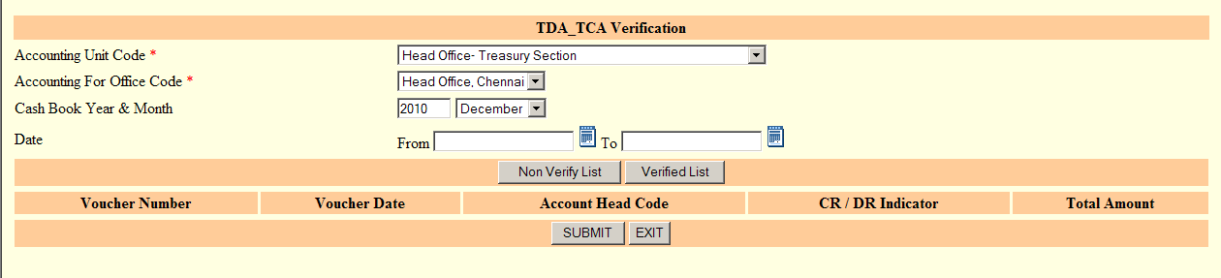

For the selected Cash Book Year & Month, the user can press the ‘Non Verify List’ to see the list and on ‘SUBMIT’ the details can be verified. On the other hand ‘Verified List’ will display the TDA/TCA Details already verified.

Posting TCA Receipt to TCA Register
If TCA is originated through receipt user has to
- First enter the receipt
- Make remittance, by preparing challan
- Verify the remittance
- Post in the TCA Register by using the following screen.
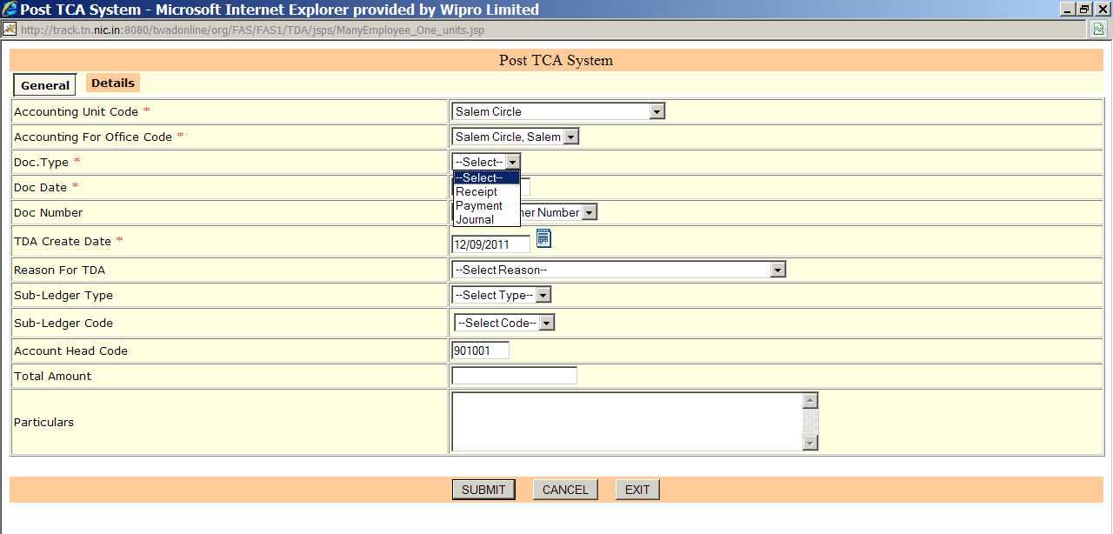
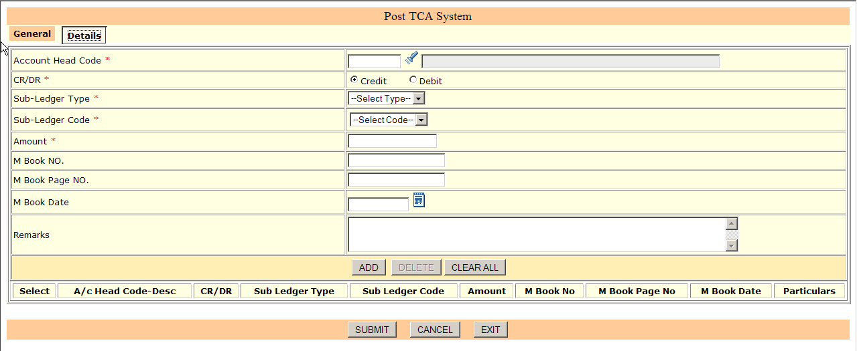
- User has to select the type as ‘Receipt’,
- Enter the Receipt date.

Then the system will display the document number if available.
- In the general part the details will be displayed for 901001. User has to select the reason, enter the particulars if any.
- Then in the details part , user has to press the ‘Add’ Button, filling up the required information for 901001. Press Add.
- Enter the contra head information. Press add.
When the DR and CR tallies user has to press SUBMIT Button
Note: Posting the TCA information from Receipt into TCA Register will not create any additional Accounting transaction.
Posting TCA in Payroll Journal to TCA Register
If TCA is originated through receipt user has to
- First enter the journal
- Verify the Journal
- Post in the TCA Register by using the following screen.



- User has to select the type as ‘Journal’,
- Enter the Journal date.

Then the system will display the document number if available.
- In the general part the details will be displayed for 901001. User has to select the reason, enter the particulars if any.
- Then in the details part , user has to press the ‘Add’ Button, filling up the required information for 901001. Press Add button.
- Enter the contra head information. Press ADD button.
When the DR and CR tallies user has to press SUBMIT Button
Note: Posting TCA information from the payroll Journal into TCA Register will not create any additional Accounting transaction.

Posting TDA from payment to TCA Register
If TDA is originated through payment user has to
- First enter the payment
- Verify the payment
- Post in the TDA Register by using the following screen.



- User has to select the type as ‘Payment’,
- Enter the payment date.

Then the system will display the document number if available.
- In the general part the details will be displayed for 900108. User has to select the reason, enter the particulars if any.
- Then in the details part , user has to press the ‘Add’ Button, filling up the required information for 900108. Press Add button.
- Enter the contra head information. Press ADD button.
When the DR and CR tallies user has to press SUBMIT Button
Note: Posting TDA information from the payment into TDA Register will not create any additional Accounting transaction.
TDA / TCA Cut off Entry Procedure

General Instructions

- For the Items, whether TDA or TCA, originated before April 2011, acceptance has to be given through TDA/TCA Cut off journal
- Similarly the Items, originated before april 2011 and accepted before or after April 2011 , suspense head clearance has to be given through TDA/TCA Cut off journal.
- Wherever document number is asked for, the online FAS document number is to be given.

Procedure for entering TDA Acceptance

While crediting the TDA acceptance head, 900109, following information have to be entered

User has to enter Originating Year, Originating Month, Originating Unit, Document type in which the Originating head 900108 has been debited. If a record is available it will be populated.

User has to select the document number.

For the contra head, the above details are not required.

Procedure for entering TCA Acceptance

While debiting the TCA acceptance head, 901002 following information have to be entered.

User has to enter Originating Year, Originating Month, Originating Unit, Document type in which the Originating head 901001 has been credited. If a record is available it will be populated.

User has to select the document number.

For the contra head, the above details are not required.

Procedure for entering TDA Suspense Head Clearance

While crediting the TDA originating head, 900108 following information have to be entered

User has to enter Accepted Year, Accepted Month, Accepting Unit, Document type in which the TDA Accepting head 900109 has been Credited. If a record is available it will be populated.

User has to select the document number.

For the contra debit, the above details are not required.

Procedure for entering TCA Suspense Head Clearance

While debiting the TCA originating head, 901001 following information have to be entered

User has to enter Accepted Year, Accepted Month, Accepting Unit, Document type in which the TCA Accepting head 901002 has been debited. If a record is available it will be populated.

User has to select the document number.

For the contra credit, the above details are not required.

