TPA System Flow

Please follow the steps given below for TPA Originating and TPA Accepting.

Select from the following Menu :

- TPA ORIGINATING

- In online FAS , the TPA originating is categorized into two types viz.
- On closure/shift/restyle / redeployment where the complete accounts of the closing unit is handed over to another unit.
For this type of originating, Head Office accounts wing has to authorize the unit getting closed for creating TPA Credit / TPA Debit / Both as the case may be.

- Others

- Accordingly user has to select either
Create TPA Originating For Closure-Shift-Restyle-Redeployment
OR
Create TPA Originating – Others
- Make the entries
- Verify the originating Details
- Freeze
- At this stage, journal will not get created for the originating entry made

- Internal Audit Verification

For the entries made with respect to the closure of a unit, corresponding Internal Audit wing has to verify the originating entries
- TPA ACCEPTANCE

- TPA –for closure of a unit
Once the internal audit wing verifies the originating entry, user will be able to accept
- TPA-Others
Once the originating unit freeze, user will be able to accept for TPA-Others
- First the accepting unit has to select the Subledger Move option, for creating the master entries for the Subledgers used by the originating unit
- Then user has to select the Create acceptance
- On submit, two journals , one for the originating unit and another for the accepting unit will be created simultaneously

Screen Shots for TPA-Others

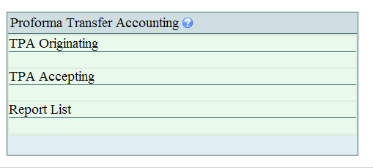

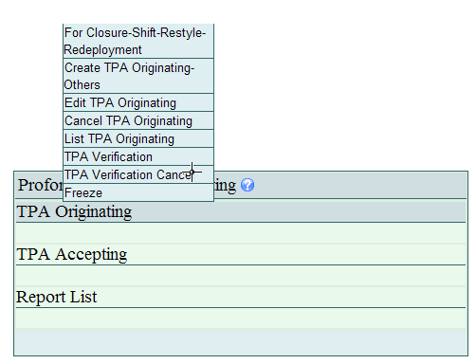

Choose the option Create TPA Originating – Others

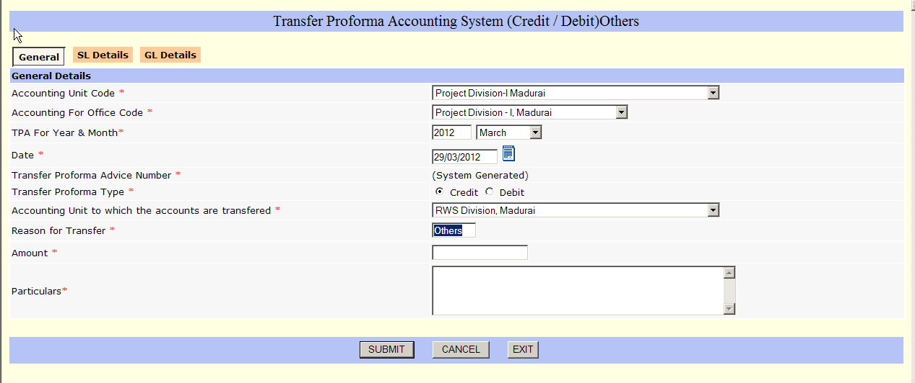

Enter the Date, Transfer Type (CR/DR) and Select the Unit to which the Proforma Accounts to be transferred. The reason will be displayed as ‘Others’ automatically which need not be changed.
Particulars column is mandatory.
In SL Details Tab, the form will be displayed as shown below.
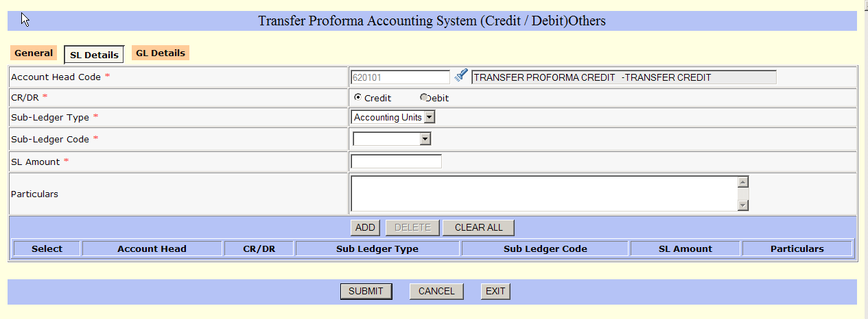
For each a/c head, enter CR/DR and the Sub-Ledger Details along with the amount and particulars. After completing all SL details go for entering GL Details. The screen will be displayed as below:

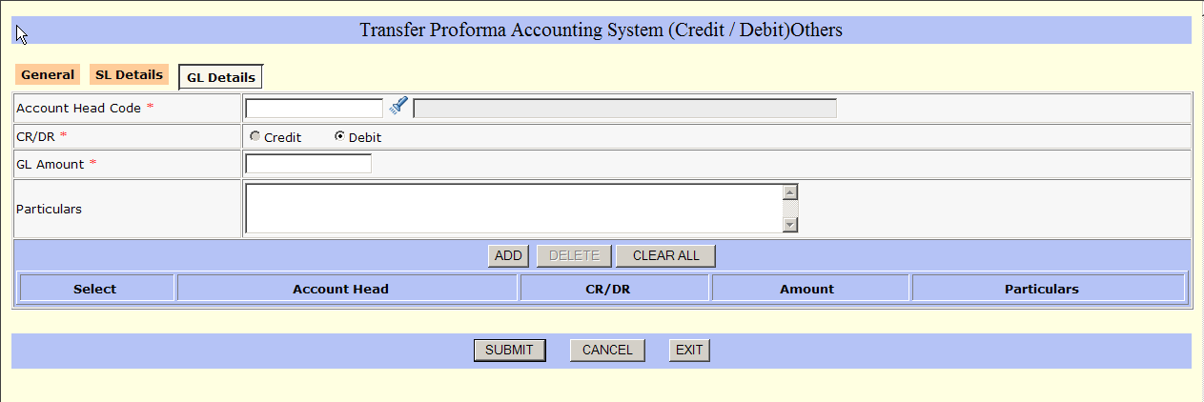

GL Details should have all the heads which were entered in the SL Details screen. Otherwise SUBMIT will give error and the TPA Advice number will not be stored. Also, the total amount of all SL Entries should tally with the total amount of GL entries. Pl ensure this.
After the above press SUBMIT the advice will be generated by the system.

Edit / Cancel will be through ‘Authorisation’ Menu only
List will show the list of TPA Advices

