Steps for updating the BRS Status Every Month
- Select Financial Accounting System
- Month End Operations Regular. In the following menu
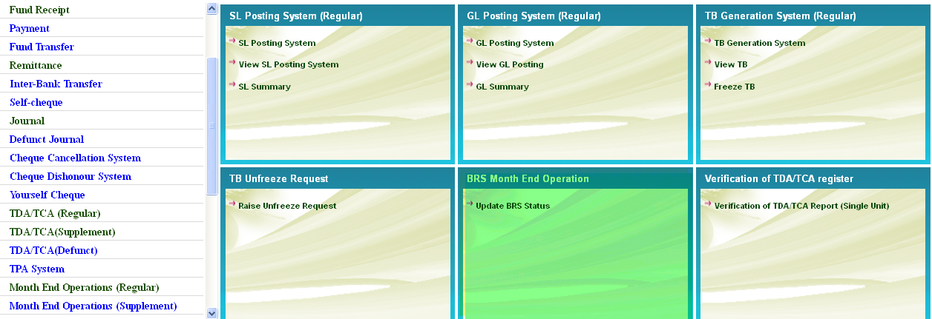
- Select Update BRS Status
- On Selection the following screen will be displayed
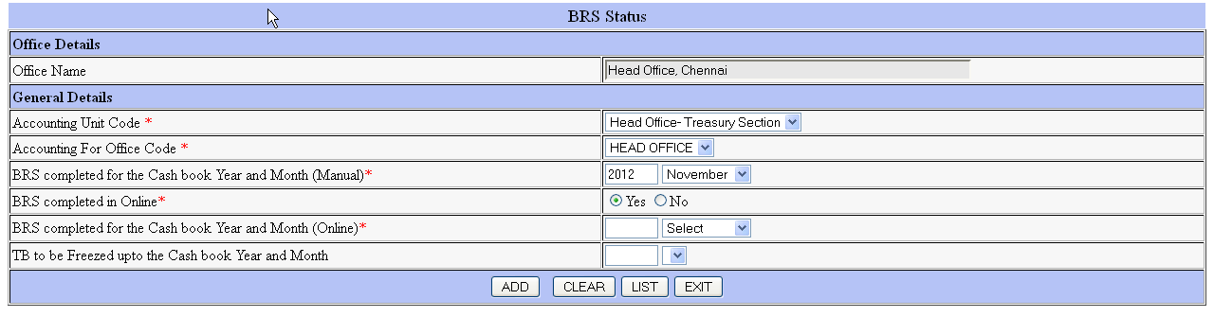
- Enter the Year and Month up to which the SSWB has been sent to BRS Section , Head Office
- Select Yes / No for BRS Completed Online
- If Yes, enter Year and month up to which BRS has been freezed online
- Select / Enter the month and year for which TB is to be freezed

