Verification of TDA/TCA Register against Transactions
- Select Financial Accounting System
- Month End Operations Regular. In the following menu, Select Verification of TDA/TCA Register and Transaction – Every Month

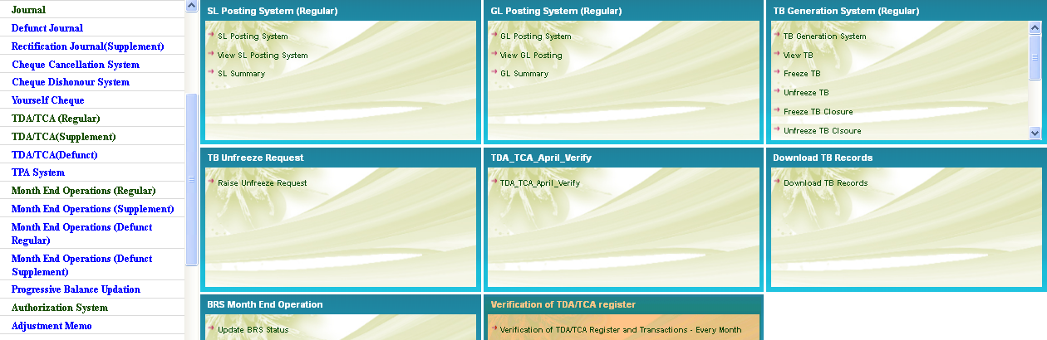
- On Selection the following screen will be displayed
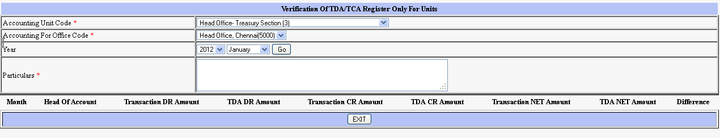
- Enter the Year and Month for which the TB is to be generated
- If there is any difference between TDA/TCA register and transactions for the heads 900108,900109, 901001 or 901002 the following screen will appear
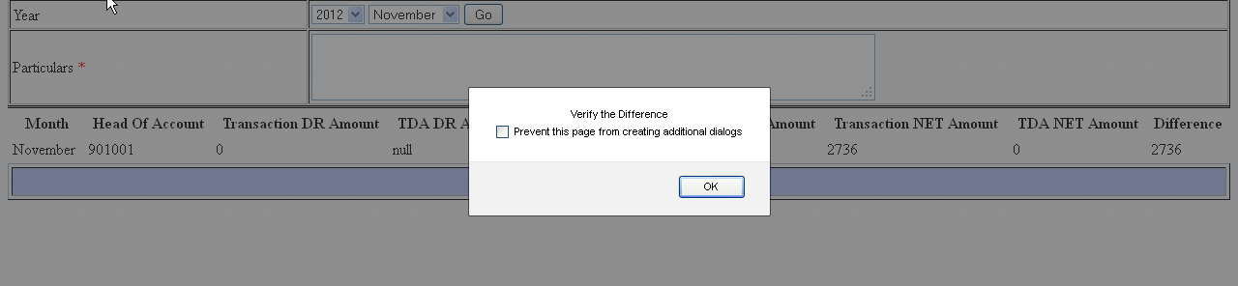
- Check the details in TDA/TCA System and in Transaction. Rectify the same. After rectification, again select the Verification menu
- If there is NO difference between TDA/TCA register and transactions for the heads 900108,900109, 901001 and 901002 the following screen will appear
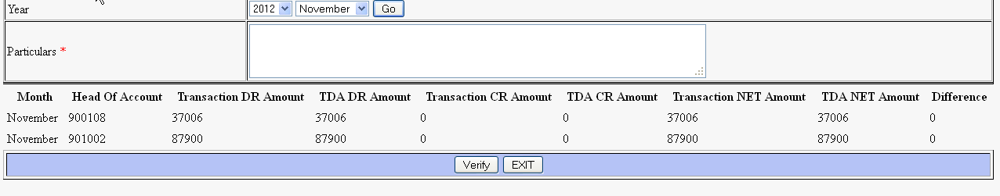

- Enter particulars (Verified) and press verify.

