Length Estimation Accuracy Progression
A staged maturation plan for AI-assisted steelhead measurement

Prepared for: The Conservation Angler (TCA) — George Pess, John McMillan, and collaborators
Prepared by: Mad Thinker, Inc.
Species focus: Steelhead (Oncorhynchus mykiss)
Status: Draft — for TCA review
Date: May 2026

Executive summary
Mad Thinker is building Epic Waters, an AI-assisted catch-reporting system that produces fish-length estimates from photographs taken in the field. This white paper sets out a four-phase plan for maturing the steelhead length estimator from a heuristic baseline into a scientifically defensible measurement instrument, and asks The Conservation Angler to weigh in on the seven open methodological decisions that gate Phase 3.
The program has already moved from a geometric heuristic (Phase 1, roughly 60% of predictions within ±10% of measured fork length) to a species-specific gradient-boosted regressor trained on a small set of paired captures (Phase 2, roughly 85%). Phase 3 is now in flight: a richer 26-feature model is being paired with a structured ground-truth protocol developed jointly with TCA. Phase 4 will retrain the model against the larger, richly annotated Phase 3 corpus, with the long-term goal of meeting the publishable scientific threshold of ±1 cm of true fork length.
The bottleneck on scientific maturation is not modeling capacity; it is the volume and quality of paired prediction-and-actual data. The TCA partnership is therefore the rate-limiting step, and the methodological choices made for the coming season will determine whether Epic Waters data is eligible for peer-reviewed use in population studies, growth-rate analysis, and length-at-age work.

Accuracy progression at a glance
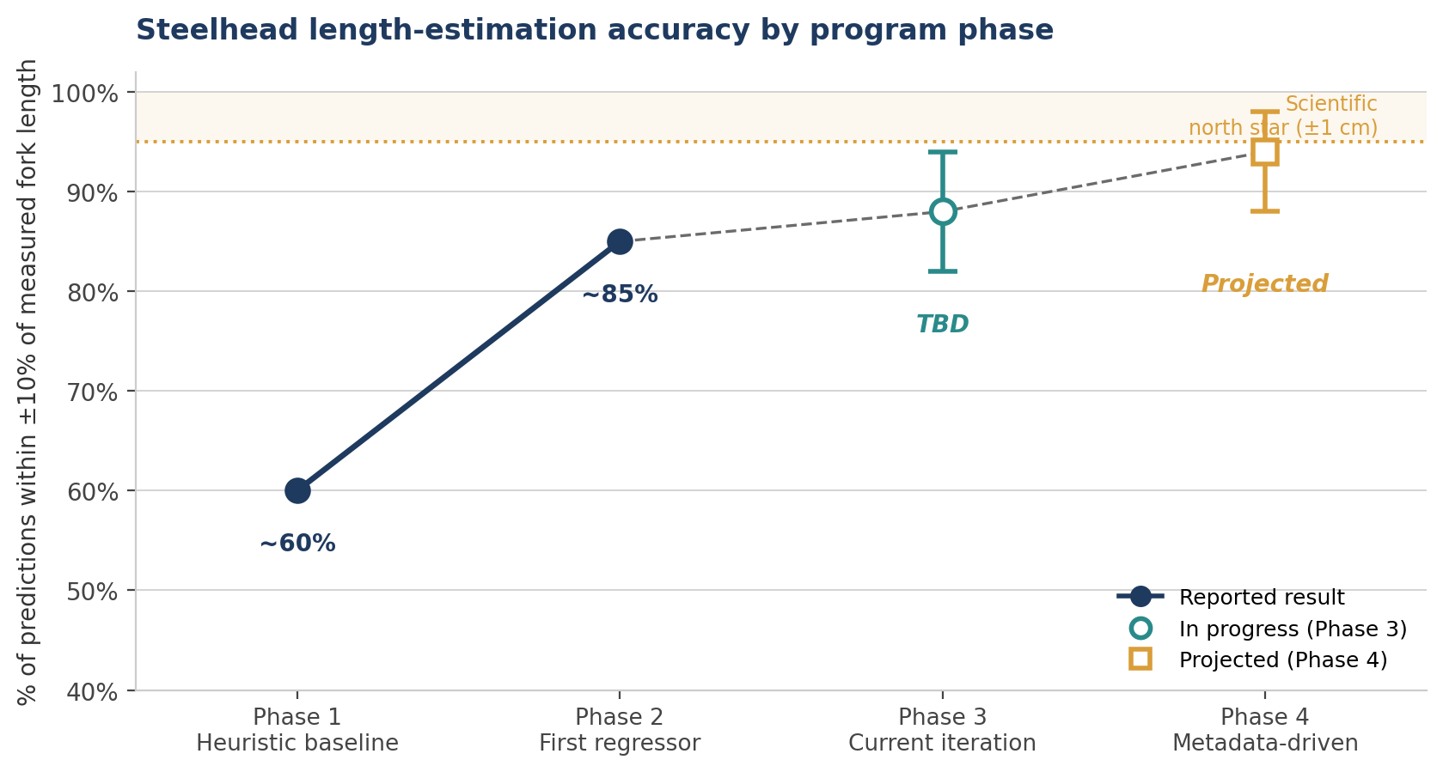
Figure 1. Phases 1 and 2 are reported results. Phase 3 is currently in progress; the range shown is provisional and will be replaced with the season's measured value. Phase 4 is a projection that depends on the volume and quality of Phase 3 ground truth.

Terminology and headline metric
Before reading the phase-by-phase results, three terms should be fixed in a shared definition so that any number cited in this document — and in future communications between Mad Thinker and TCA — is unambiguous.
Length. All length figures in this paper refer to fork length, the standard fisheries-science measurement from the snout to the fork of the tail. If TCA prefers total length as the reporting standard, the headline numbers in this document and the dataset schema will need to be updated accordingly.
Ground truth. Ground truth is qualified by source throughout the document. Where the source is unclear or mixed (notably in Phase 1), this is called out explicitly. The four sources distinguished are angler-reported, tape-measured, board-measured, and professionally measured.
Accuracy. For the purposes of this draft, accuracy is the percentage of predictions falling within ±10% of measured fork length. This is a working definition. TCA may prefer a stricter metric (e.g., percentage within ±1 cm, mean absolute error in centimetres, or a tiered reporting system); if so, every headline number in this paper will be recomputed against the agreed metric before the dataset is publicly cited.
Scientific north star
±1 cm of true fork length. This is the threshold at which Epic Waters data becomes publishable for population studies, growth-rate analysis, and length-at-age work. Every phase below is positioned visually and narratively against this threshold.

Phase 1 — Heuristic baseline with person reference
Time window: Haida Gwaii 2026 winter steelhead season, weeks 1–4
Method: Geometric heuristics using a person in the frame as the scale reference. No trained model.
Ground truth source: Pending TCA confirmation — angler tape, on-site biologist measurement, or measuring board.
Sample size: Predictions and actuals logged for early-season catches.
Result: Approximately 60% of predictions within ±10% of measured fork length.

Why this phase mattered
Phase 1 established the baseline measurement pipeline and validated that paired prediction-and-actual capture was operationally feasible during a real steelhead season. It produced the first labeled dataset for model training. The heuristic was never expected to meet scientific standards; its purpose was to bootstrap ground truth collection.

Known limitations
- The person-as-scale-reference assumes a body proportion that in practice varies meaningfully across anglers.
- There is no correction for camera angle, fish curvature, or capture distance.
- Inference is single-image and unfiltered by capture quality.

Phase 2 — First trained regressor
Method: First iteration of a steelhead-specific gradient-boosted regressor, trained on the ground-truth pairs collected in Phase 1.
Ground-truth volume at training: ~50 steelhead with paired prediction and actual.
Result: Approximately 85% of predictions within ±10% of measured fork length.

Why this phase mattered
Phase 2 demonstrated that a species-specific learned model meaningfully outperforms heuristic estimation, even with a very small training set. It also established the per-species training pattern that the program will follow for every additional species: a new species enters in a heuristic phase and progresses along the same maturity path that steelhead is now extending.

Known limitations
- A 50-fish training set is small; the model is likely overfit to Haida Gwaii winter-steelhead body morphology and to the capture conditions of that season.
- No prediction uncertainty is quantified — every estimate is a point estimate.
- Feature engineering is limited: no hand reference, no person detection in the regressor itself, no derived ratios.

Phase 3 — Current iteration: expanded model and structured ground-truth protocol
Phase 3 advances on two tracks in parallel. Track A is a more sophisticated model. Track B is a more rigorous data-collection protocol developed jointly with TCA. The two tracks are intentionally separated below so that improvements on each can be assessed independently in retrospect.

Track A — Model improvements
Method: Second iteration of the gradient-boosted regressor, retrained on an expanded ground-truth set.
Ground-truth volume at training: ~100 steelhead.

New model inputs (the 26-feature vector)
Feature group | Features
YOLOv8 fish box | width, height, area, aspect ratio, detection confidence, diagonal fraction
YOLOv8 person box | width, height, aspect ratio
ViT species classifier | species index, species confidence
MediaPipe hand landmarks | hand detected (flag), finger width (px), finger length (px), pixels-per-inch from finger
Derived ratios | fish-to-person ratio, fish-to-finger ratio, pixel length-to-person, fish width/height/area-to-person ratios, fish inches from finger, fish pixel length

Why these features matter scientifically
The hand and finger features provide a second, independent scale reference alongside the person detection. This reduces dependence on any single scale assumption and gives the model the geometric information it needs to be more robust to capture variation — different anglers, different distances, different framing — than Phase 2 could be.

Track B — Ground-truth protocol improvements (in partnership with TCA)
Model improvements compound only as fast as paired prediction-and-actual data accumulates with known provenance. For the upcoming season, the following collection protocol is proposed for joint adoption.
- TCA supplies measuring tapes to participating citizen scientists.
- Standardized photo-capture instructions are provided to anglers.
- Predictions and actuals are logged together with the photo and its metadata.
- Keypoint-detection quality is stored alongside each capture for downstream stratification.

Additional metadata captured for future retraining
The following metadata will be recorded at capture time. Some of these fields will become Phase 4 model features; others will be used as analytical slicers for residual-error analysis or as inclusion criteria for publication-grade subsets.
- Hardware: phone model, iOS version, camera used (wide / ultrawide / telephoto), focal length, ISO, aperture.
- Geometry: device pitch / roll / yaw at capture, and a camera-to-fish distance estimate where available.
- Environmental: ambient light, flash used, time of day, location, and weather joined post-hoc from location and time.
- Fish-level: pose flags (straightness, orientation, occlusion) and grip class (board, cradle, vertical-by-wrist, vertical-by-tail).
- Keypoint detail: full per-landmark coordinates and confidence scores for both the fish and the hand.
- Citizen scientist: anonymized angler ID, session ID, and training-completion status.
- Inference provenance: model versions, timestamps, and raw model outputs before post-processing.
- Ground-truth provenance: who read the tape, tape resolution, whether the tape is visible in the photo, and an angler-confidence flag.

Expected outcome of Phase 3
A significantly larger and richer ground-truth set by the end of the season, enabling a Phase 4 retraining with the metadata available as either model features or analytical slices. The single most important thing about Phase 3 is not its headline accuracy number — that will land where the data permits — but the volume and discipline of the data it leaves behind.

Decisions requested from TCA before the season begins
Each of the following has downstream implications for data quality and for the eventual scientific defensibility of the Epic Waters dataset. These are distinct from the rest of the document: they are not reports of work done, they are open methodological questions that Mad Thinker is asking TCA to resolve jointly.
Decision 1 — Measurement accuracy target and metric definition
What is the headline accuracy metric Epic Waters reports against? Options include percentage within ±1 cm, percentage within ±10% of fork length, mean absolute error in centimetres, or a tiered reporting system. The ±1 cm threshold is the scientific north star, but the metric used to report progress toward it should be agreed in advance.

Decision 2 — Ground-truth measurement standard
Confirm fork length (snout to fork of tail) measured with the fish straight on a flat surface. Confirm tape resolution standard (millimetre vs. half-inch). Decide whether measurement is taken pre- or post-photograph. Decide whether a measuring board is preferred over freehand tape where one is available.

Decision 3 — Tape-in-frame requirement
Should the measuring tape be visible in the photo as a permanent audit trail of the ground truth, or is angler-reported measurement sufficient? Tape-in-frame allows independent verification and detection of tape-reading errors, but adds capture friction at the riverbank.

Decision 4 — Inter-rater reliability protocol
For a subset of fish, should two anglers independently measure the same fish to establish the noise floor of citizen-science ground truth? This is the methodological step that lets Epic Waters cite a defensible accuracy floor for any model — without it, the model can only be evaluated against a moving target.

Decision 5 — Reference subset with professional measurement
Can a small number of fish per season (target: 50–100) be measured by a TCA fisheries professional with research-grade tools, as a tertiary calibration check on citizen-science measurements? This gives the dataset a published-grade anchor without requiring every capture to meet that bar.

Decision 6 — Exclusion criteria
What captures should be excluded from training and reporting? Mad Thinker proposes: tape not visible, fish clipped at the frame edge, hand not detected, motion blur detected, extreme camera angle, multiple fish in frame. TCA should weigh in on what is scientifically acceptable, and on whether excluded captures should still be retained for diagnostic analysis.

Decision 7 — Formal protocol document
Should Mad Thinker and TCA co-author a versioned written protocol covering all of the above, to serve as the methods section for future publications? Strongly recommended; flagged here for explicit agreement and assignment of an editor.

Phase 4 — Metadata-driven retraining and accuracy expansion
Phase 4 retrains the gradient-boosted regressor against the full Phase 3 metadata corpus. Capture context — camera, angle, lighting, grip — and angler identity become either model features or stratification variables, and quality flags become formal inclusion criteria.

Hypotheses to test
- Capture geometry (device pitch / roll, camera-to-fish distance) accounts for meaningful residual error in Phase 3 predictions.
- Camera type (wide vs. ultrawide) introduces a systematic bias that can be corrected via per-camera calibration.
- Per-angler systematic bias is large enough to warrant treating angler as a random effect.
- Hand-as-scale-reference accuracy degrades predictably with grip pose, allowing pose-conditional models.

Levers under evaluation for Phase 4 and beyond
Lever | Description | Hardware required
Prediction uncertainty | Quantile-regression variant of the regressor produces a confidence interval per prediction. | None
Multi-frame fusion | Burst capture combined into a single estimate, reducing single-frame variance. | None
Capture-time guidance | App rejects low-quality captures at the moment of capture (angle, blur, occlusion). | None
Calibration card option | Optional printable known-dimension reference card for highest-accuracy captures. | Printed card
LiDAR depth fusion | True 3D distance to fish keypoints via ARKit sceneDepth on Pro iPhones. | iPhone Pro
Stereo from motion | Short video sweep enables structure-from-motion scale recovery on any phone. | None
External hardware | BLE-paired measuring board with fiducials for a lodge-grade scientific subset. | Custom hardware

Entry criteria
A sufficient volume of Phase 3 ground truth with complete metadata to enable meaningful slicing. The current target is roughly 300 or more steelhead captures with complete metadata before Phase 4 retraining is run as a publishable exercise rather than an internal experiment.

Cross-phase principles
Three principles run across every phase of the program and should be treated as constants when interpreting any of the above.
- Species-specific models. Each species gets its own gradient-boosted regressor trained on its own ground truth. New species start in a heuristic phase and progress through the same maturity path. Steelhead is the lead species and the template for the program.
- Ground truth is the bottleneck. Model improvements compound only as fast as paired prediction-and-actual data accumulates. The TCA partnership is the rate-limiting step on scientific maturation, not modeling capacity.
- Metadata captured today enables models built tomorrow. Phase 3 captures the metadata that Phase 4 will use as features. Anything not captured now becomes a permanent gap in the dataset.

Appendix — Open questions beyond the TCA decisions
The following questions do not need to be resolved before the season begins, but should be tracked in the project log so they are not lost as the program scales.
- How is multi-capture-per-fish reconciled? For example, three photos of the same fish from different angles — best capture, median, or weighted average?
- How are model versions and their corresponding accuracy reports versioned for publication?
- What is the data-governance model for citizen-science contributions — who owns the photos, who can publish derived statistics, what is the consent model with anglers?
- At what point does the Epic Waters dataset become eligible for formal peer-reviewed publication, and who leads that effort?
Draft prepared by Mad Thinker, Inc. — for TCA review and methodological sign-off. Numbers, ground-truth source attributions, and the accuracy metric in this draft are subject to revision following the decisions requested above.

