Lab 1: Set Up Environment and Test Basic Software

孙济宸 520030910016

1. Ping: ICMP protocol

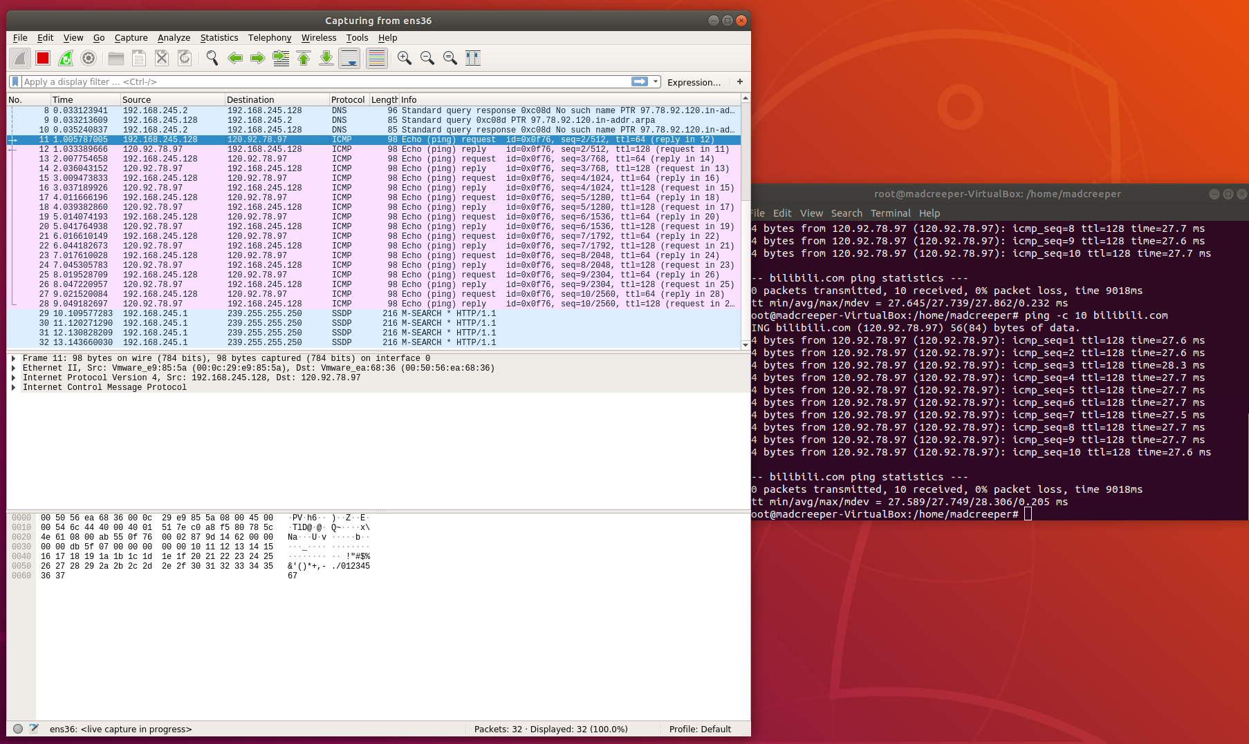

Traceroute: UDP & ICMP protocol

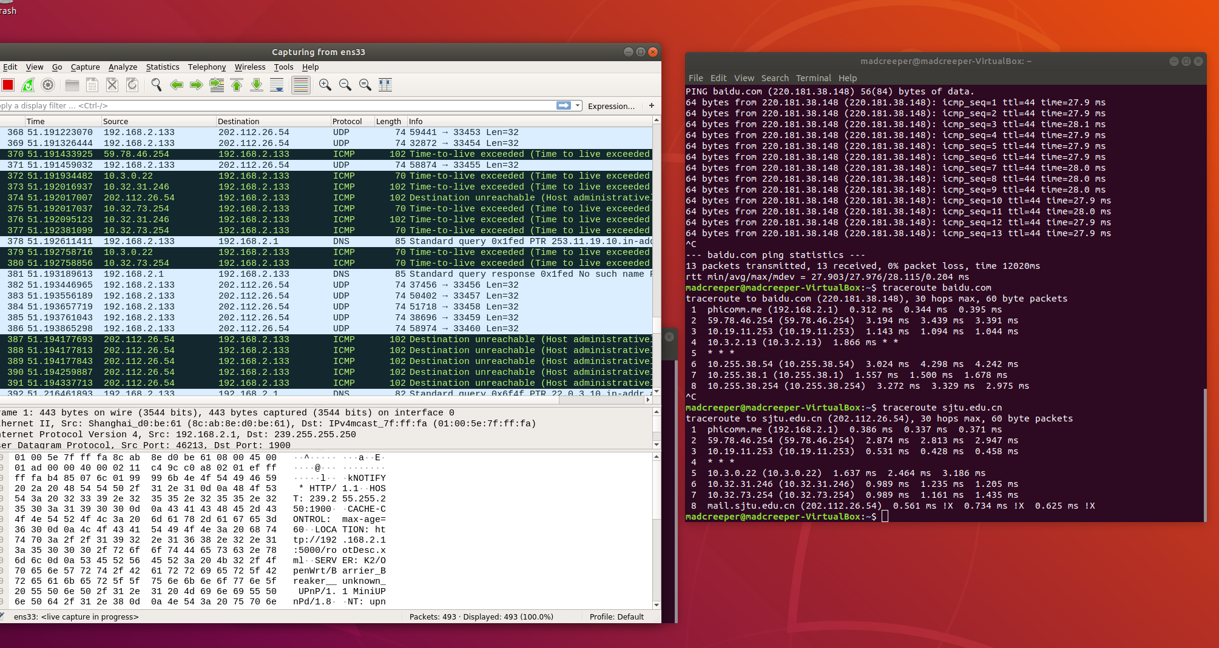

1. IP address of baidu.com: 220.181.38.148

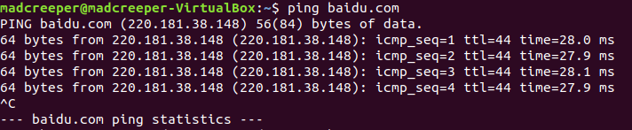

1. baidu.com: avg = 28ms

mit.edu: avg = 219ms

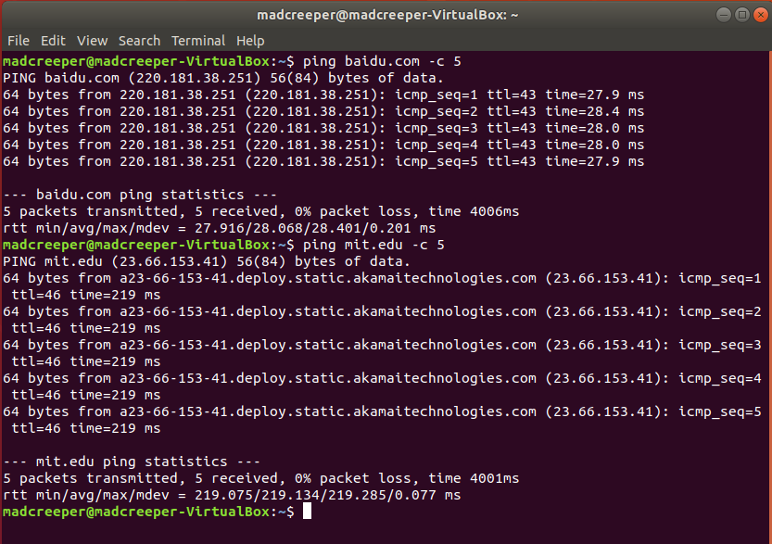causes: physical distance, more jumps, firewall,, etc.

1. TCP bandwidth between 2 VMs:

The bandwidth is 3.07 Gbits/sec

Client:

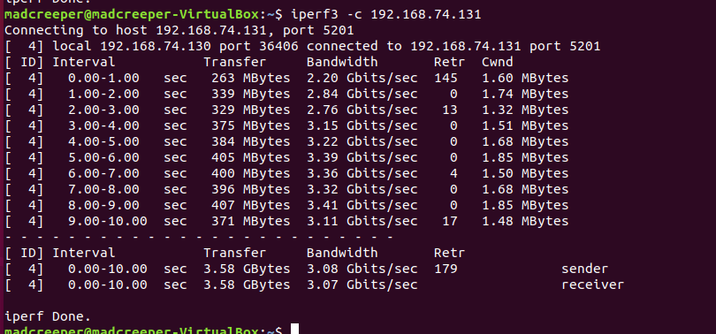

Server:

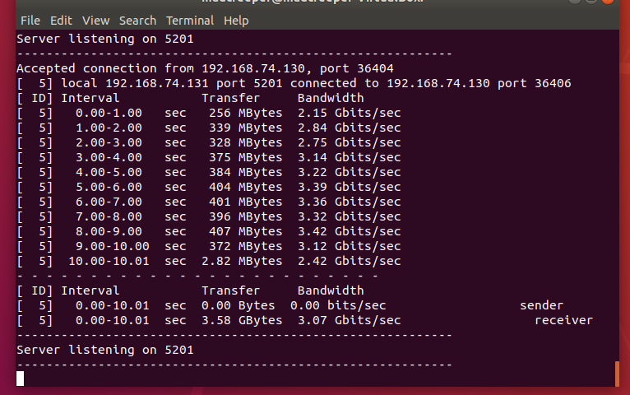

1. SSH login

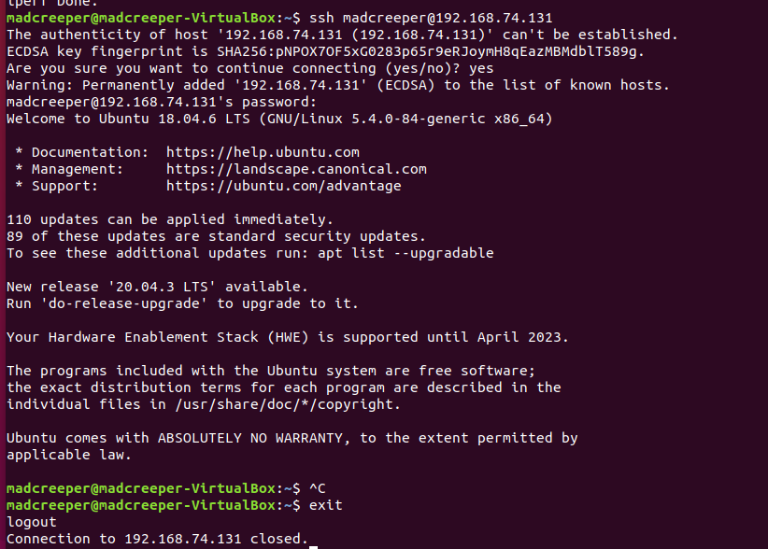

1. SCP file copy

Server: first use chmod, or copy shows ‘Permission Denied’



Host:

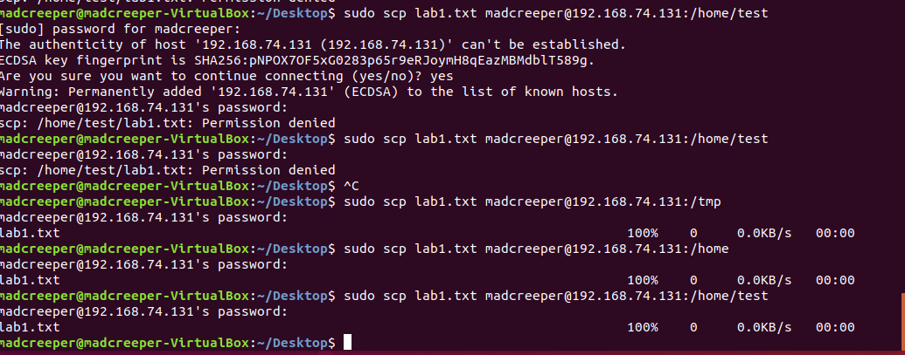

Server (After copy):

