Lab2 Mininet

1.

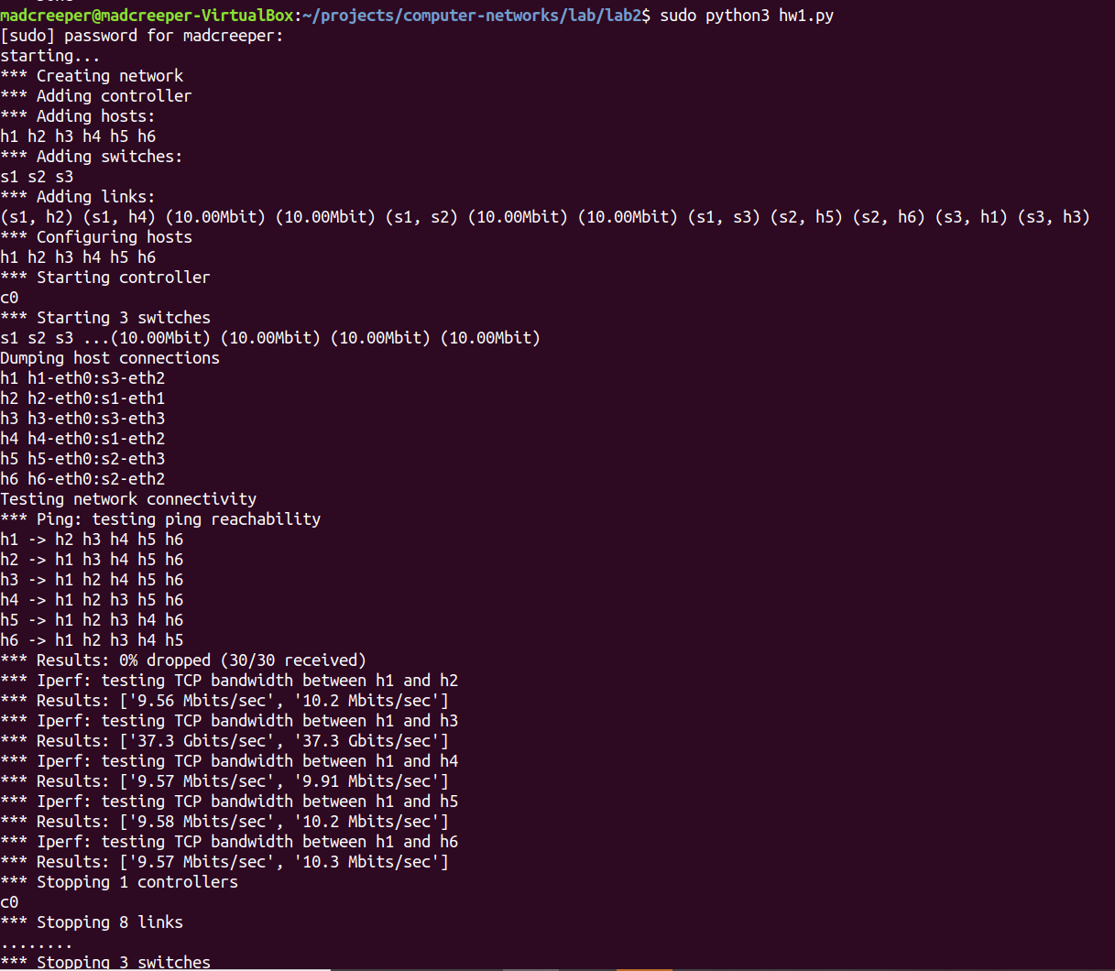

2.

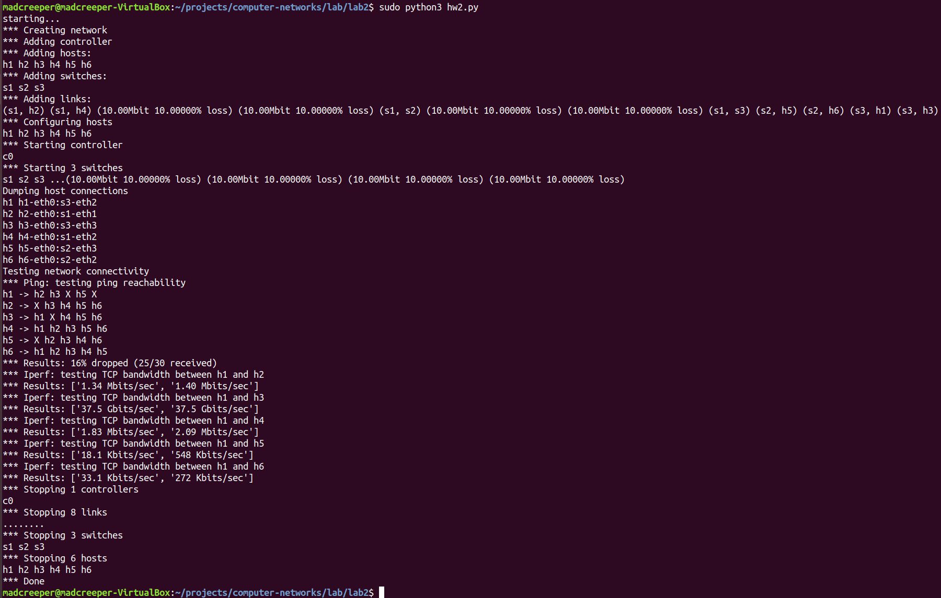Iperf passing links with packet loss is significantly slower.

3.

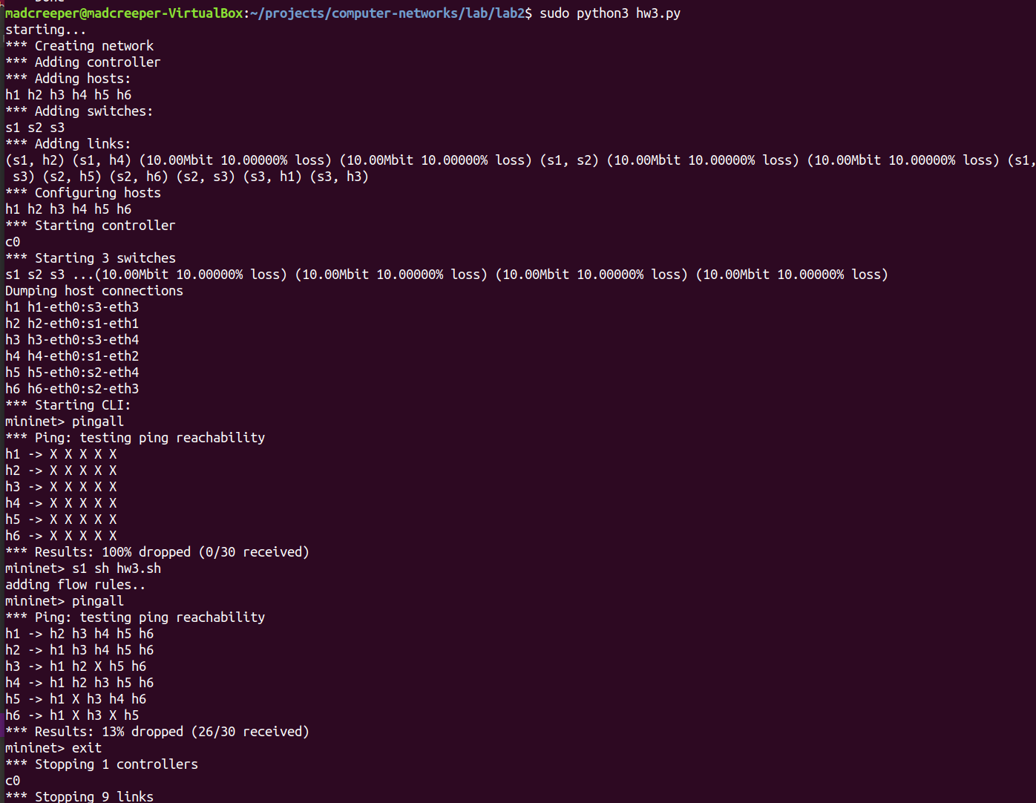

After adding the new link, pingall shows all host pairs are unreachable. The new link generates a loop in the network, and without flow control the traffic can get stuck in the loop and never reach destination.

The solution: I added flow rules to s1 so that the traffic no longer loops. You can see after adding flow rules, the network now works as intended.

