Lab3 Socket Programming

孙济宸 520030910016

1. TCP chatroom

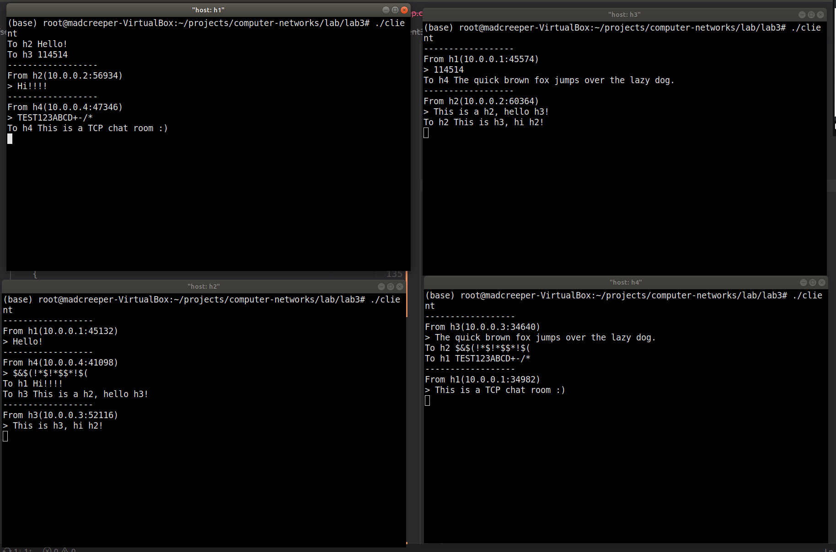I used poll() to poll from stdin and TCP socket to allow client to both recv()ing incoming messages from socket and send()ing messages by taking keyboard input to the socket. The socket type is SOCK_STREAM for TCP. For this lab, the IP address of each client is hard-coded, and one TCP connection is only used by one message.

1. UDP chatroom

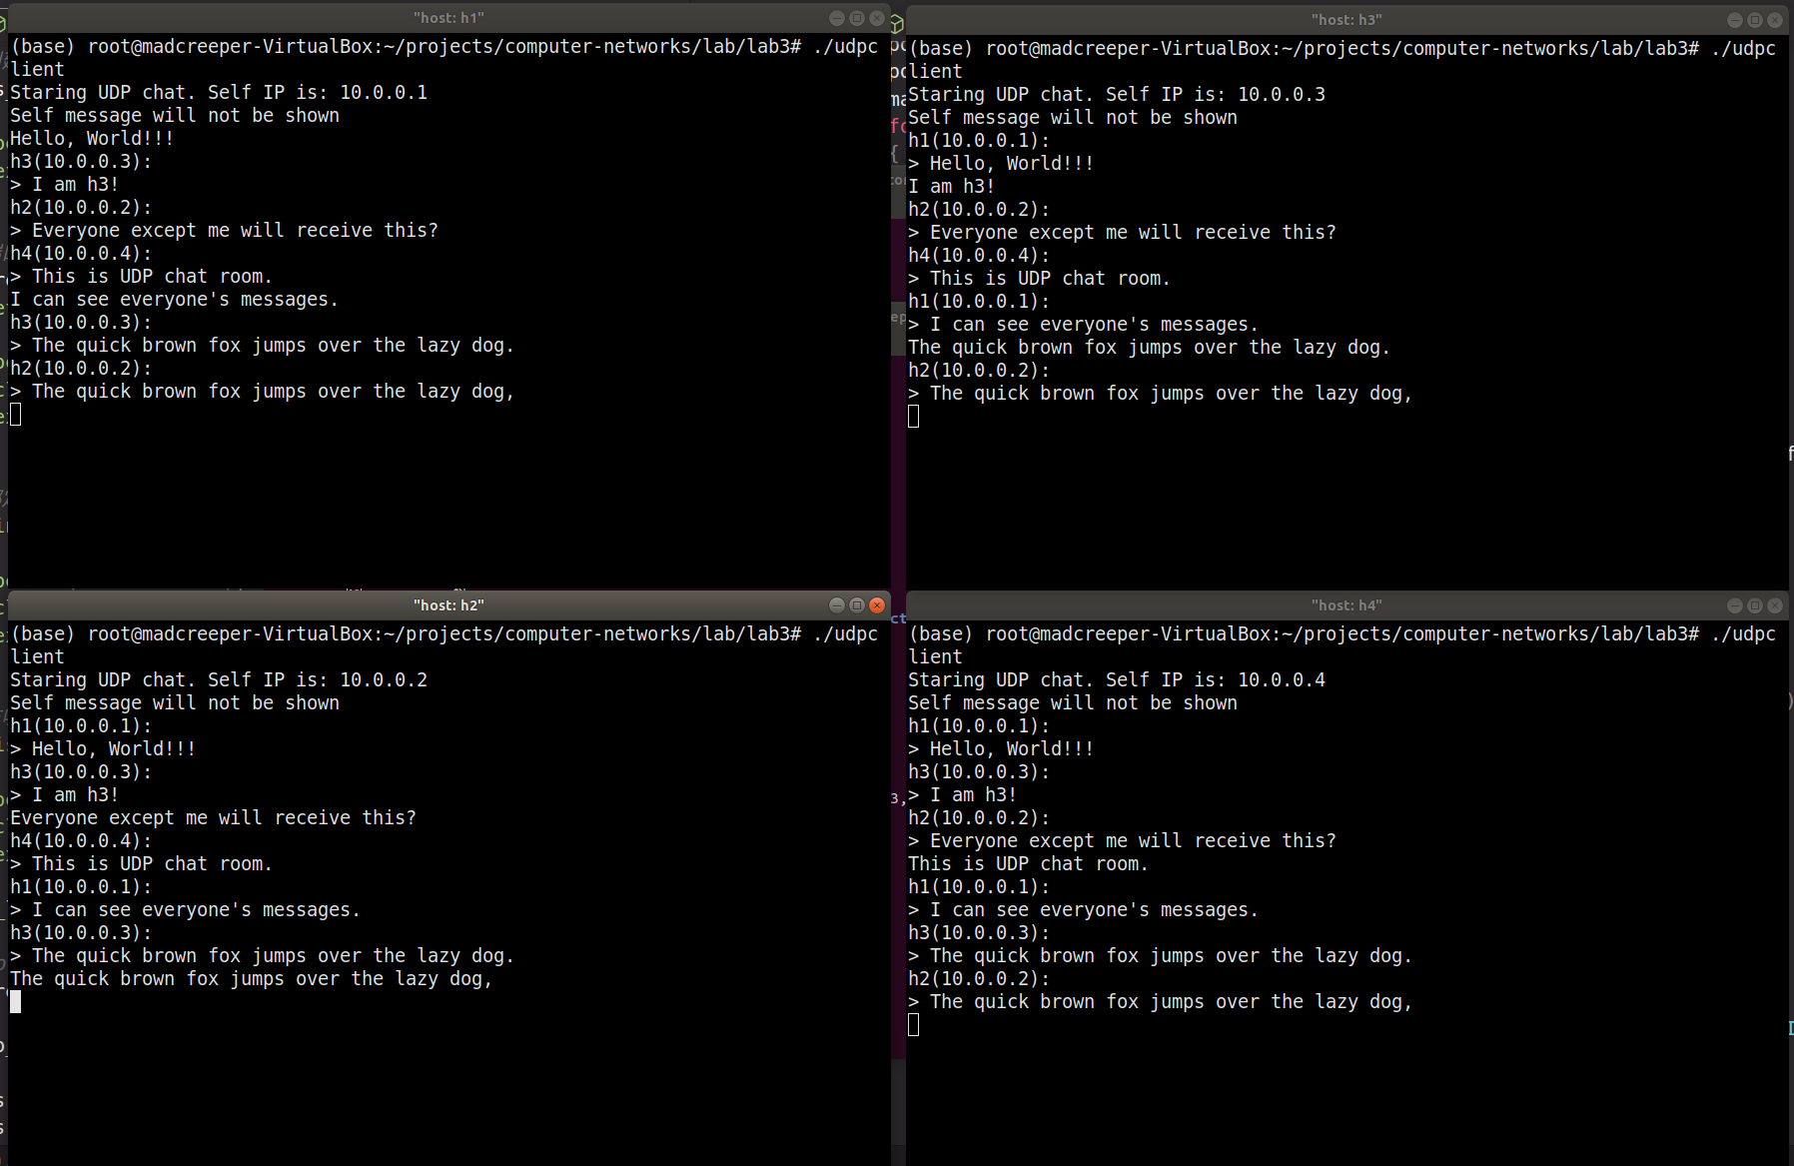For UDP chatroom, poll() is also used. The socket type is SOCK_DGRAM for UDP. Messages are sent via sentto() and recvfrom() sockets that are bound to the broadcast IP, in this case 10.255.255.255. For filtering out the client’s own messages from showing, I used getifaddrs() so each client knows its own ip and can filter the messages by sender IP.

……