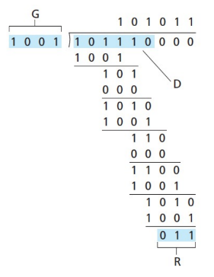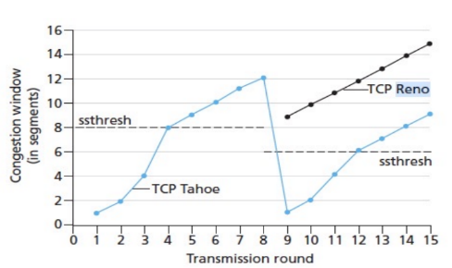 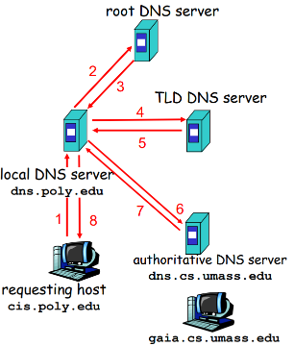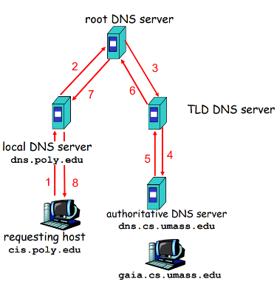

**DHCP:** Client: DHCP discover (broadcast), server DHCP offer, client DHCP request, server DHCP ACK.

Server returns IP address, address of first hop router, name and IP of DNS server, network mask.

**NAT:** maintains NAT translation table

(src IP, port#)—(NAT IP, new port#)

**IP datagram:** ver, len, TTL, upperlayer, header checksum, src IP, dest IP, *fragment offset.*

MTU limits largest link-level frame; fragments within net, reassembled at destination.

**C**lassless**I**nter**D**omain**R**outing: subnet arbitrary x bits, e.g. 200.23.16.0/23, first 23 bits is subnet IP.

**Switching:** decentralized, destination based: Longest prefix matching, forward to interface with longest address match. **Switching Fabrics:** Memory, bus, crossbar.

Scheduling (choose next packet to send on link): FIFO; priority (hi and low priority queue, hi prio does not interrupt if low prio is being processed); Round Robin (Scan from different class queues); WFQ (each queue has a weight)

**Switching:** decentralized, destination based: Longest prefix matching, forward to interface with longest address match. **Switching Fabrics:** Memory, bus, crossbar.

Scheduling (choose next packet to send on link): FIFO; priority (hi and low priority queue, hi prio does not interrupt if low prio is being processed); Round Robin (Scan from different class queues); WFQ (each queue has a weight)

**TCP congestion control:** sending rate≈cwnd / RTT initiallyslow start (exponential, double cwnd every RTT). When over sstheresh, grow linearly (+1 per RTT) .

When **loss detected** (Timeout or 3 DUP ACK),

ssthersh = 1/2*cwnd_before_loss.

**TCP Tahoe:** Timeout or 3 DUP ACK: set cwnd to 1.

**TCP Reno:** Timeout: set cwnd to 1;

3 DUP ACK: cwnd_new = 1/2*cwnd + 3.

**TCP Throughput.** Ignore slow start, let window size when loss occurs = W. avg. window size is 3W/4;

thruput= 3/4*W/RTT.

**Causes of congestion:** lost packets (buffer overflow), timeout caused by queing. **Costs:** reduced goodput (useful throughput), unneeded retransmissions, upstream capacity wasted.

**TCP Close connection:**

1. Client: decides to close, no longer send, can recv. FINbit=1, seq=x. 🡪

2. Server: ACKbit=1, ACKnum=x+1. Can still send some data. 🡨

3. Server done sending, can no longer send data. FINbit=1, seq=y. 🡨

4. Client ACKbit=1, ACKnum=y+1. 🡪Client waits for 2*max segment life before closing. (in case ACK is lost). Server closes when receiving this ACK.

**TCP 3-way Handshake:**

1. Client: choose init seq# x. send SYN

🡪SYNbit=1, seq=x.

2. Server: choose init seq# y. send SYNACK. 🡨SYNbit=1, ACKbit=1, Seq=y, ACKnum=x+1.

3. Client knows server is alive. Sends ACK for SYNACK: ACKbit=1, ACKnum=y+1. + **may contain some data**.

4. Server knows client is alive.

**TCP Flow Control:** Sender won’t overflow receiver. Receiver “advertises free buffer space (rwnd) in TCP header. Sender limits unACKed (in-flight) data to rwnd.

**Circuit Switching: FDM:** Each user uses one freq band. **TDM:** each user uses timeslot for full bw.

**Packet Switching:** use as needed, full bw used. Statistical MUXing: shared on demand.

$$Pr(users>=bound){{=∑}_{i=bound}^{\begin{aligned} \\ N\end{aligned}}C_{N}^{i}p}^{i}{\left(1-p\right)}^{N-i}$$

**Packet Delay:** d_trans= L(packet len) / R(BW)

d_prop=physical link len / prop speed

d_queue=La/R (a: avg packet arrv. Rate) ->1, d-> inf

d_proc: checksum, forwarding, etc. **Throughput:** bottleneck link.

**TCP:**  **seq num**: number of first Byte in segment data.

**ACK num**: seq # of next Byte expected from other side.

**Cumulative ACK**: ACK = n means all bytes < n has been received. **SampleRTT**: measured RTT (send~ ACK)

EstimatedRTT = (1- α)*EstimatedRTT + α*SampleRTT

DevRTT = (1-β)*DevRTT +β*|SampleRTT-EstimatedRTT|

TimeoutInterval = EstimatedRTT + 4*DevRTT (safety margin)

**TCP delayed ACK**: recv in-order segment, wait 500ms b4 ACK. If another in-order segment arrives, send immediately.

**Out of order**: higher than expected seq#, gap detected: send DUP ACK. **Fast retransmit**: sender sends many segments at once. If 3 DUP ACKs are received (not incl. the 1st correct one), one of the segments is lost, so immediately retransmit.

**UDP:** Datagram, connectionless; simple, no congestion control=as fast as desired. Used by: streaming, DNS, SNMP, DHCP. **Format:** src port#, dest port#, length (incl. header), checksum, actual data (message).

**Checksum: Sender:** treat segment as 16-bit integers, add them together (wrap around if overflow), and take 1’s complement *(反码)* and put into checksum field. **Receiver:** sum of all 16-bit integers should be 16’b1, otherwise error has occurred.

**MUX:** gather data from multiple sockets, envelope with header (src port, dest port) **DeMUX:** deliver recved segments to correct socket (using port num). **UDP socket:** use 2-tuple to direct to socket. (dest IP, dest port num). (Doesn’t care about src IP or port). **TCP socket:** (src IP, src port, dest IP, dest port). All 4 values to direct to correct socket, support many TCP sockets on one host (port num differs).

**DNS:** Distributed, hierarchical. Root DNS servers: contacted by local name servers, contacts authoritative name server if mapping not known.

**Top-level domain (TLD)** servers: org, net, edu, uk, fr, edu, etc. **Authoritative** DNS servers: organization servers, e.g. Web. Email.

Iterative: burden on local DNS server

Recursive: burden on contacted name server. **Caching:** server learns mapping. TLD servers cached in local NS.

**RR format: (name, value, type, ttl)**

A: (name, value)=(hostname, address)

NS: =(domain, hostname of authoritative name server of domain)

CNAME: =(alias, canonical (real) name)

MX: (name, name of mail server)

**Inserting records to TLD:(register at registrar):**

(networkutopia.com, dns1.networkutopia.com, NS)

(dns1.networkutopia.com, 212.212.212.1, A)

**FTP:** Out of band control (21: TCP control connection, 20: TCP data connection). Client sends control command, server opens TCP data connection and transfer file. Server maintains state: current dir, auth.

**Network Edge:** hosts run apps; C-S model: web c-s, email c-s; p2p: skype, BitTorrent

Data rate= Bandwidth*log2(1+S/N). signal2noise ratio

**Protocol**: format & order of messages exchanged between two or more communicating entities; actions taken on the transmission and/or receipt of a message or other event.

OSI 7-layer: application, presentation, session, transport, network, data link, physical. 5-layer: w/o presentation, session layer.

**Web Cache:** Typically installed in LAN, client sends request to cache server, if hit then OK, otherwise request origin server. Pros: ↓response time, traffic on access link, effectively deliver content. **Cache server conditional GET:** if object not modified, don’t send.

**HTTP Methods:** GET, POST, HEAD (ask server to leave requested object out of response), PUT(upload file), DELETE **HTTP Response:** 200 OK, 301 Moved Permanently, 400 Bad Request, 404 Not Found, 500 HTTP Version Not Supported.

**Cookies:** User saves cookie file, server saves cookie ID. Keeps state of user (auth, shop cart, session state, recommendations, etc.)

**Web:** objects (HTML file, JPEG, js, etc.) has a URL.

**HTTP:** “stateless”. **Nonpersistent:** one TCP connection per object. Time= 2RTT+ file transmission time. **Persistent: w/o pipelining:** 1RTT for TCP,then 1 RTT for each obj(incl.HTML) **w/:** 1RTT for TCP, 1 RTT for HTML, then request all objects on page(~1RTT).

**Process:** program running within a host. Use socket to sned/recv messages

**Port num** to distingtuish processes on same host.

**Service model:** connection(less)? Reliable? VoIP: C, NR; RUDP: R, CL

Author: https://madcreeper.github.io/

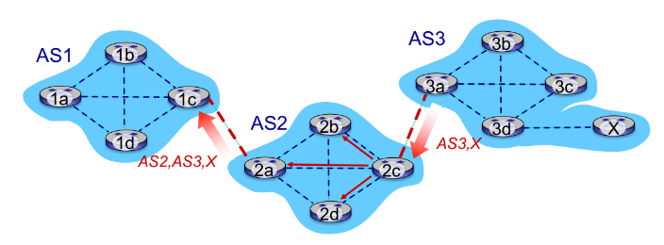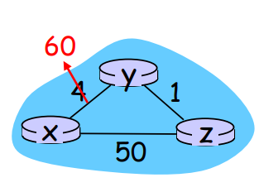

**OSPF:** uses link state, floods OSPF LS advertisements to all other routers in entire AS. Hierarhchical OSPF: areas + backbone, node only knows detailed area topology, area border routers summarize distances to own area, advertise to other border routers.

They are connected by backbone routers, and a outgoing boundary router.

**Routing Algos: Link state:** Each node knows whole net topology. Use Dijkstra’s Algo. Oscillations possible.

**Distance Vector:** node x updates DV using B-F equation:

$$D_{x}(y) ← \min_{v}\{c(x,v) + D_{v}(y)\}$$

Each node: **maintains its and its neighbors’ distance vectors.** Wait for change in local link cost or neighbor, recompute DV, if DV changed, notify neighbors.

**Count to infinity problem:** Y routes thru Z to get to X. (6). Z routes thru Y to get to X. (7). ……

Use **poisoned reverse.** (problem persists in complex nets).

**BGP. eBGP:** obtain subnet reachability information fromneighboring ASes. **iBGP:** propagate reachability information to all AS internal routers.

BGP route selection:

1. local preference value attribute: policy decision

2. shortest AS-PATH

3. closest NEXT-HOP router: hot potato routing

4. additional criteria

hot potato routing: don’t worry about inter-domain cost, choose gateway with least intra-domain cost.

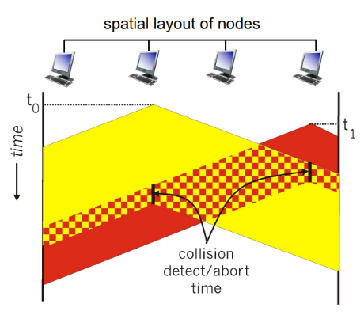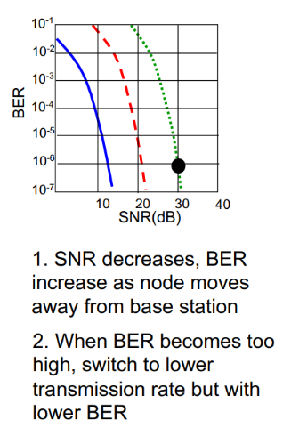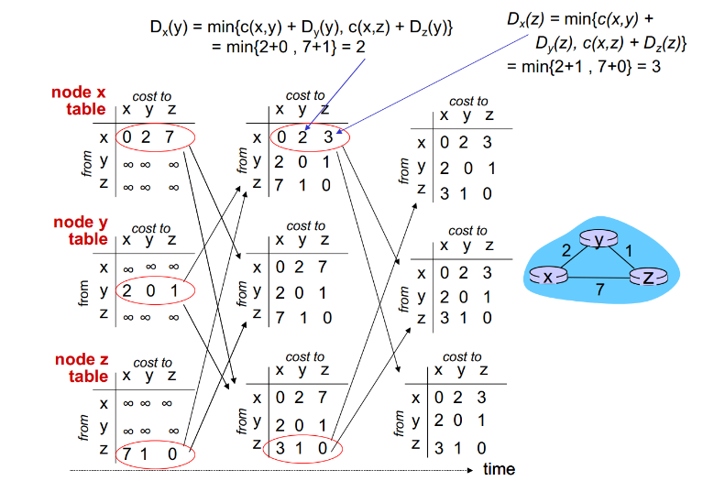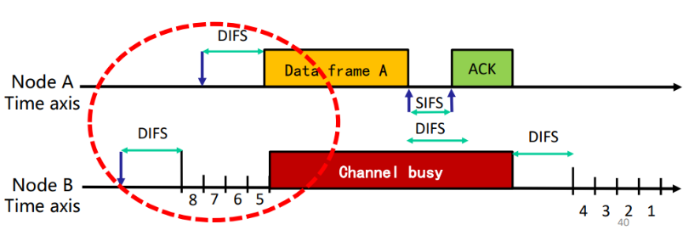

Author: https://madcreeper.github.io/

**Wireless links:** 802.11, LTE, CDMA, GSM… Infrastructure mode: bases stations, connected to infrastructure; ad hoc mode nodes talk to other nodes in range. Characteristics: decreased signal strength, interference, multipath propagation.

802.11: host associate with AP. Passive scanning: APs send beacon frames, host replies to selected AP

Active scanning: host device probe request frame, Aps reply, host selects

• scans channels, listening for beacon frames containing AP’s name (SSID) and MAC address • selects AP to associate with • may perform authentication • will typically run DHCP to get IP address in AP’ s subnet

Mobility: H1’s IP address can remain same within same subnet when moving among APs, switch remembers switch port to H1

**802.15:** adhoc, master/slaves, <10m, Bluetooth devices.

base station, mobile dynamically change transmission rate (physical layer modulation technique) as mobile moves, SNR varies

**VLAN:** Dynamically assign ports on switch into multiple VLANs.; multiple switches, same network, using “trunk port”. Frames have “VLAN ID” info header. Forwarding via routing.

**ARP:** Toget MAC address of B, A broadcasts ARP query. B receives ARP packet, replies to A with B’s MAC address. A caches B in ARP table until timeout.

**Ethernet frame:** preamble: 7Bytes of 10101010 and 1Byte 10101011, used to sync receiver, sender clock rates. Dest addr, src addr, type (IP), payload, CRC. Is **connectionless, unreliable.**

**Switch: self-learning.** Record sender/MAC address pair in switch table when receiving a packet.

**Taking turns: polling**. Master node polls from “dumb” slave nodes. Cons: polling overhead, latency, single PoF. **Token passing:** in a ring, pass token, one with token can speak. Same cons as polling. Used in Bluetooth.

**CSMA:** Listen before transmit, if channel busy, defer transmission. Collision: entire packet transmission time wasted.

**CSMA/CD:** Abort when collision detected. After aborting, enter binary (exponential) backoff: randomly chooses K from $\{0, 1, 2, …, 2^{m}-1$}, where m is # of collisions, wait K*512 bit times, and then start sensing. Efficiency= $1/(1+5t_{prop}/t_{trans})$. Used in Ethernet.

**CSMA/CA:** no collision detection because hidden terminal, fading in wireless networks. ACK: hidden terminal. Backoff timer: Binary exponential backoff, avoid continuous collisions. DIFS > SIFS: higher priority for ACK, avoid unnecessary collision. Used in 802.11.

**M**ultiple **AC**cess protocols: 1. channel partitioning (FDMA, TDMA). 2. Random Access. **Slotted ALOHA:** synchronized, one node can try to send new frame in next slot, if no collision then OK, if collision, retransmit in each subsequent slot with prob. P until success. With N nodes, the prob of any node successful is $Np{(1-p)}^{N-1}$. Max efficiency as N→∞is 1/e=0.37. **Pure ALOHA:** No synchronization, send immediately. Efficiency: $p{(1-p)}^{N-1}{(1-p)}^{N-1}$ =0.18 for optimum p and N→∞.

**2d parity:** n*n matrix, correct 1 bit error.

**CRC:** data bits **D**, r+1 bit generator, **G**; r bit CRC **R. <D,R>** exactly divisible by G (modulo 2). can detect all burst errors less than r+1 bits. (D << r XOR R).

R = remainder[(D << r) / G ]

**ICMP:** carried in IP datagrams, used for error reporting, echo reply and request (ping).