Many Labs´ Application

User Manual

Authors:

Bárbara Pinto

Diogo Gaspar

João Pacheco

Luís Moreira

Tomás Cancela

Glossary

|  |  |
| --- | --- |
| Terms, Expressions and Acronyms | Description |
| Category | **Parameter Category**: aggreggates several parameters for presentation/reporting purposes. |
| CCN | Acronym for **Citizen Card Number**. |
| CCT | Acronym for **Clinical Chemistry Technologist**: Performs the chemical analysis. |
| Chemical Analysis | Study of the chemical composition (parameters) of a given sample |
| Client | Person with a lab order prescribed by a doctor. |
| Collection Method | Process in which a sample is extracted from the body (ex. swab, syringe). |
| Diagnosis | Condition or disease raised by a specialist doctor according to a given test result. |
| DIN | Acronym for **Doctor Index Number**. |
| Hemogram | Exam that evaluates the blood cells. |
| HQ | Acronym for **Headquarters**. |
| Lab Order | Contains the type of test and parameters to be measured. |
| LC | Acronym for **Lab Coordinator**: Checks the chemical test and associated diagnosis made and confirms if everything was done correctly. |
| LR | Acronym for **Laboratory Receptionist**. |
| MLT | Acronym for **Medical Lab Technician**: Person who collects the samples. |
| NHS | **National Healthcare Service**. |
| Parameter | Chemical component to be measured in a given sample. |
| PLT | Acronym for **Platelets**. |
| RBC | Acronym for **Red Blood Cells**. |
| Sample | Matter extracted from the body of a client to aid in the process of a medical diagnosis (ex. blood or swab sample). |
| SD | Acronym for **Specialist Doctor**: Analyzes the results of the chemical analysis and writes a report. |
| SOC | Acronym for **Standard Occupational Classification**: A code assigned to a job based on the skills and qualifications needed. |
| Swab | Method for collecting nasal samples (used in Covid-19 tests). |
| Test | Sequential process of sample collection, chemical analysis and diagnosis of a condition or disease (ex. blood or Covid test). |
| Test Report | Written document by a specialist doctor that includes test details and the diagnosis. |
| TIN | **Tax Identification Number**. |
| WBC | **White Blood Cells**. |

Table of Contents

Introduction 4

Purpose and Scope 4

System Overview 4

System Requirements 4

Software Installation 4

System Features 5

By Functionality 5

By User 5

Troubleshooting 24

1. Some tests don’t have a reference value 24

2. Failed to complete a Client or Employee registration 24

3. Failed to import clinical tests from file 24

4. Cannot view performed tests or test results 25

FAQs 25

1. How do I login? 25

2. How do I change my password? 25

3. How do I create a new employee role? 25

4. How can I sort clients in the results view? 26

Annex A. MATCP 27

Annex B. MDISC 28

# Introduction

## Purpose and Scope

This application is intended to manage the clinical analyses performed in *Many Labs* laboratories, from the sample collection phase to the results availability.

The application’s scope covers data of all:

* Clients,
* Employees,
* Laboratories,
* Test types,
* Test categories and parameters,
* Samples,
* Chemical analysis,
* Diagnosis and reports,

It also provides integrated modules for:

* Sending reports to the NHS,
* Providing reference values for test parameters,
* Generating barcodes,
* Sending e-mails and SMS

## System Overview

System Requirements

|  |  |
| --- | --- |
|  | Minimum requirements |
| RAM | 8 GB |
| Processor | Pentium 2 266 MHz |
| Memory | 128 GB |
| Installed Platform | Java Virtual Machine |

## Software Installation

No installation required. Simply download the *.jar* file and run it on your computer.

# System Features

## By Functionality

I intend to...

Register a new item in the application

Register a Client

Register an Employee………………………………………………………………………………………………………8

Register a Clinical Analysis Laboratory

Register a new Test Type

Register a new Parameter

Register a new Parameter Category

Perform daily operations

Record a test to be performed to a client

Record the samples collected in the scope of a given test

Record the results of a given test………………………………………………………………………………….14

Record a diagnosis and report for a given test

Validate the work done by the clinical chemistry technologist and specialist doctor

Consult information

Consult the tests performed by a particular client

Consult all the tests performed and analyse the overall performance of the company

Import information

Import clinical tests from CSV file

Send information to the NHS

Automatic daily Covid-19 reports

Custom Covid-19 report

## By User

I am a...

Administrator

Register an Employee………………………………………………………………………………………………………8

Register a Clinical Analysis Laboratory

Register a new Test Type

Register a new Parameter

Send a custom Covid-19 report

Client

View the results of the tests I have performed………………………………………………………………17

Update my personal data………………………………………………………………………………………………18

Clinical Chemistry Technologist

Record the results of a given test………………………………………………………………………………….14

Consult the tests performed by a particular client

Laboratory Coordinator

Validate the work done by the clinical chemistry technologist and specialist doctor

Consult all the tests performed and analyse the overall performance of the company

Import clinical tests from CSV file

Medical Laboratory Technician

Record the samples collected in the scope of a given test

Receptionist

Record a test to be performed to a client

Register a Client

Specialist Doctor

Record a diagnosis and report for a given test

US3: As a receptionist of the laboratory, I want to register a client

### Register an Employee

This feature is only available to users logged in as **Administrator**.

To register an employee you will need the following information:

|  |  |  |
| --- | --- | --- |
|  |  | Acceptance Criteria |
| Full Name | Mandatory | Non empty |
| Address | Mandatory | Non empty |
| Phone Number | Mandatory | 11 digits |
| E-mail | Mandatory | Standard e-mail format |
| SOC Code | Mandatory | 4 digits |

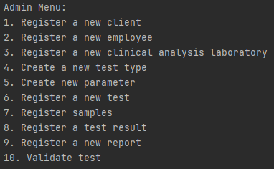**Step 1:** Select option “Register a new employee”.

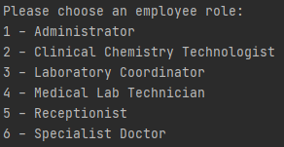**Step 2:** Select an employee role.

**Step 3:** Insert information and confirm.

Once the employee has been successfully registered, a text file will be generated in the folder “SMS -Emails” with the new user login credentials.

***Related issues:*** *Failed to complete a Client or Employee registration*

US8: As an administrator, I want to register a new clinical analysis laboratory stating which kind of test(s) it operates

US9: As an administrator, I want to specify a new type of test and its collecting methods

US10: As an administrator, I want to specify a new parameter and categorize it

US4: As a receptionist of the laboratory, I intend to register a test to be performed to a registered client

US5: As a medical lab technician, I want to record the samples collected in the scope of a given test

### Record the results of a given test

This feature is only available to users logged in as **Clinical Chemistry Technologist**.

**Step 1:** Select the option “Record Test Results”

**Step 2:** Type the sample barcode associated with the test

**Step 3:** Select the parameter to record results for

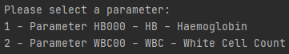

**Step 4:** Type the value and associated metric. Confirm.

**Step 3-4 must be repeated for each parameter associated with the test, otherwise the results will be incomplete and discarded by the application.**

US14: As a specialist doctor, I intend to make the diagnosis and write a report for a given test

US15: As a laboratory coordinator, I want to validate the work done by the clinical chemistry technologist and specialist doctor

### View the results of the tests I have performed

This feature is only available for users logged in as **Client**.

**Step 1:** Select the option “View Test Results”

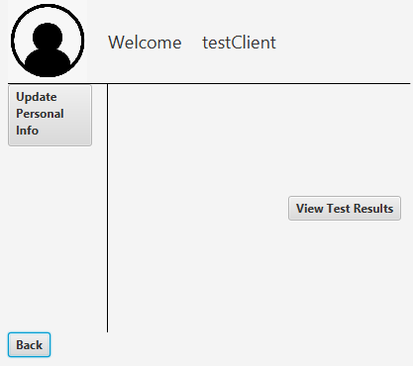

**Step 2:** Select a test type from the available list and click “View” to proceed

**Step 3:** Consult your result details!

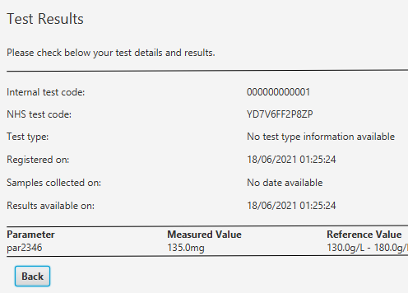

***Related issues:*** *Cannot view performed tests or test results*

### Update my personal data

This feature is only available for users logged in as **Client**.

**Step 1:** Select the option “Update Personal Info”



**Step 2:** Fill in the fields you wish to change and click “Save Changes”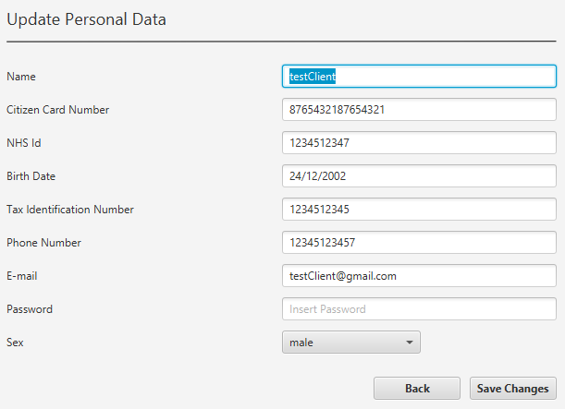

**Step 3:** You will be prompted with a confirmation screen. After you confirm, a validation will be done and some invalid changes may be rejected.

You will see an error screen and may re-edit your data.US13: As a clinical chemistry technologist, I intend to consult the historical tests performed by a particular client and to be able to check tests details/results

US16: As a laboratory coordinator, I want to have an overview of all the tests performed by Many Labs and analyse the overall performance of the company

US17: As a laboratory coordinator, I want to import clinical tests from a CSV file

US18: As an Administrator I want to send the Covid-19 report to the NHS at any time

US19: The Many Labs company wants to send to the NHS daily reports of Covid-19 data, including the number of observed values and estimated values

# Troubleshooting

## Some tests don’t have a reference value

The reference value APIs only generate reference values for the following parameters:

* HB000 //Haemoglobin (HB)
* WBC00 //White Cell Count (WBC)
* PLT00 //Platelet Count (PLT)
* RBC00 //Red Blood Count (RBC)
* MCV00 //Mean Cell Volume (MCV)
* MCH00 //Mean Cell Haemoglobin (MCH)
* MCHC0 //Mean Cell Haemoglobin Concentration (MCHC)
* ESR00 //Erythrocyte Sedimentation Rate (ESR)
* IgGAN //IgC antibodies

When a parameter is registered in the application, the code must match exactly the corresponding code in the list above.

## Failed to complete a Client or Employee registration

Please check if the inputted information is valid, such as:

* All mandatory fields are filled,
* Phone number has the correct number of digits,
* Citizen card number, TIN, NHS ID and other identification numbers follow the standard UK format,
* E-mail follows the standard [name@emailprovider.extension](mailto:name@emailprovider.extension) format.

If all the information is correct, the error may be caused by a duplicated entry. Please check if any of the registered clients/employees share the same e-mail or personal identification numbers.

## Failed to import clinical tests from file

Please check if the import file has the extension *.csv* and is not password protected. Any other file formats are not supported.

The file must have, **at least**, the following headers (in no particular order, but they must match exactly as below):

* Test_Code
* NHS_Code
* Lab_ID
* CitizenCard_Number
* NHS_Number
* TIN
* BirthDay
* PhoneNumber
* Name
* Email
* Address
* TestType
* Category
* *A parameter code* *(e.g.* HB000*)*
* Test_Reg_DateHour
* Test_Chemical_DateHour
* Test_Doctor_DateHour
* Test_Validation_DateHour

## Cannot view performed tests or test results

If no tests show up on the View Test Results menu, please check:

1. If you received an SMS or e-mail notification:

There are no tests registered under your client account. *Please contact the lab in which you performed the test(s) to verify the situation.*

1. If you didn’t receive an SMS or e-mail notification:

The tests performed don’t have results available yet. *Please wait for a notification or contact the lab in which you performed the test(s) to get an update.*

*.*

If you encounter any other issues, please contact a member of the development team:

Bárbara Pinto | 1191507@isep.ipp.pt

Diogo Gaspar | 1200966@isep.ipp.pt

João Pacheco | 1200996@isep.ipp.pt

Luís Moreira | 1200973@isep.ipp.pt

Tomás Cancela | 1200985@isep.ipp.pt

FAQs

## How do I login?

If you already have a registered e-mail, please check your e-mail or text messages for your login password.

If you are not registered, please contact an Administrator (if you’re an employee) or head to a lab receptionist to be registered.

## How do I change my password?

This version of the application does not support password or e-mail changes. Once an e-mail and password is assigned to you, it is permanent.

## How do I create a new employee role?

The application supports the following roles:

* Receptionist
* Administrator
* Laboratory Coordinator
* Medical Lab Technician
* Clinical Chemistry Technologist
* Specialist Doctor

If you wish to add a new role, please contact the development team (check Troubleshooting for contact details).

## How can I sort clients in the results view?

The results may be ordered by:

* Client TIN,
* Client name

You may choose which view the application displays by changing the field --- on the configuration file -----.

# Annex A. MATCP

# Annex B. MDISC