Computer Architecture and Organization
Assignment Report — Synchronous FIFO Buffer

GitHub Repository:
https://github.com/MadDog-OfShimano/-8x8-Synchronous-FIFO-Buffer

Score Table
Digital Design (25 pts) | Verilog Implementation (25 pts) | Verilog Testbench (25 pts) | Report & Presentation (25 pts)

Total (100 points)

Group Member(s)
# | Full Name | Student ID | Signature
1 | *** ****** | 23040102009

*Name omitted for anonymity

1. Project Description
Project Title: Synchronous FIFO Buffer (8 entries × 8-bit)

A FIFO (First-In First-Out) buffer stores data in the order it arrives and outputs it in the same order. It is commonly used to transfer data between modules operating at different speeds. This project implements a synchronous FIFO in Verilog with 8 entries of 8 bits each, featuring overflow and underflow protection, combinational status flags, and simultaneous read and write support.

1.1 Key Features
- Depth: 8 entries, each 8-bit wide (64 bits total storage)
- Single clock domain — fully synchronous design
- Automatic overflow protection: write ignored when full
- Automatic underflow protection: read ignored when empty
- Simultaneous read and write supported in same clock cycle
- 3-bit pointers with automatic wrap-around (7 → 0)
- 4-bit entry counter for accurate full/empty detection
- Combinational full/empty flags — zero latency status

2. Digital Design

2.1 Block Diagram

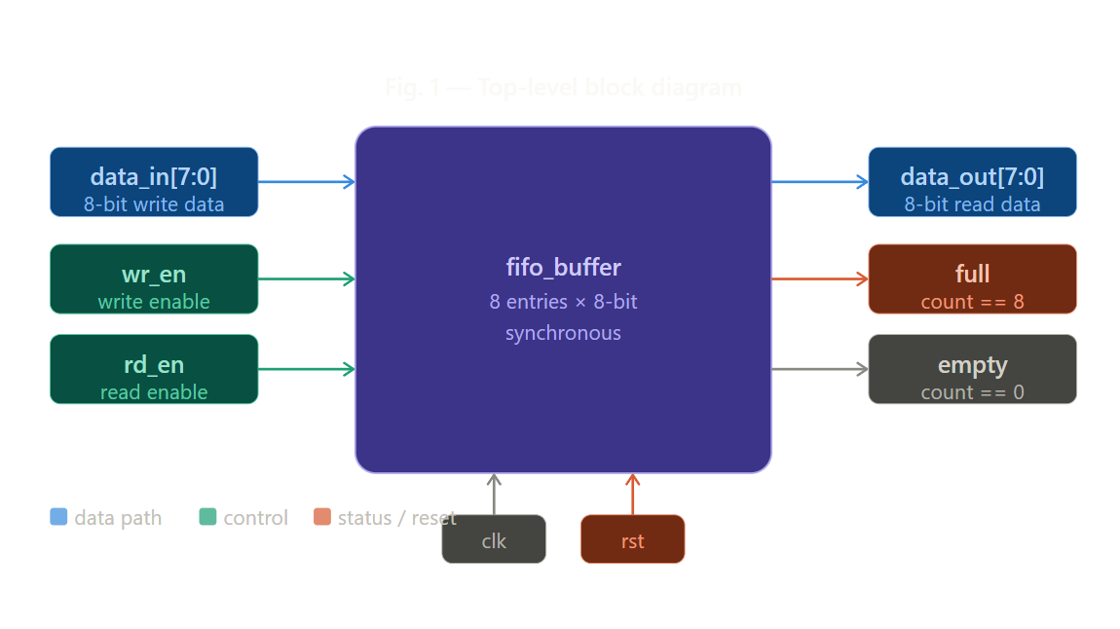

2.2 Internal Architecture

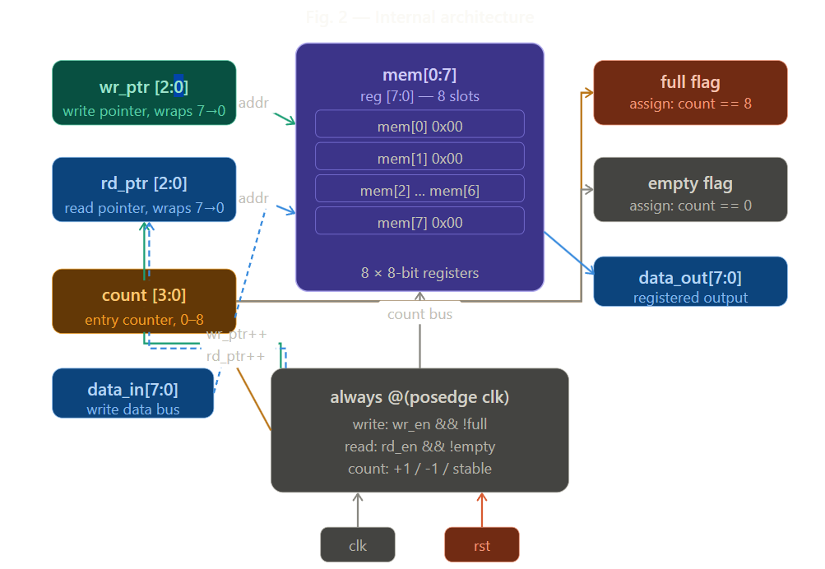

2.3 Design Explanation
The FIFO uses a register array (mem[0:7]) as internal storage.
Two 3-bit pointers, wr_ptr and rd_ptr, track write and read positions and wrap automatically from 7 to 0, forming a circular buffer.
A 4-bit count register increments on writes, decrements on reads, and holds steady during simultaneous operations. The full and empty flags are combinational, asserting when count equals 8 or 0 respectively. All state updates are synchronous to the rising edge of clk. Asserting rst clears all registers in one cycle.

2.4 Signal Description Table
Signal | Direction | Width | Description
clk | Input | 1-bit | Clock signal. All state updates occur on rising edge.
rst | Input | 1-bit | Active-high synchronous reset. Clears all registers.
wr_en | Input | 1-bit | Write enable. Asserted to write data_in into FIFO.
rd_en | Input | 1-bit | Read enable. Asserted to read data from FIFO.
data_in | Input | 8-bit | Data bus carrying the byte to be written into memory.
data_out | Output | 8-bit | Data bus carrying the byte read from memory.
full | Output | 1-bit | Combinational flag. High when count == 8 (FIFO full).
empty | Output | 1-bit | Combinational flag. High when count == 0 (FIFO empty).

3. Verilog Implementation
File: fifo_buffer.v | Language: Verilog | Tool: Icarus Verilog (iverilog)

module fifo_buffer (
input wire clk,
input wire rst,
input wire wr_en,
input wire rd_en,
input wire [7:0] data_in,
output reg [7:0] data_out,
output wire full,
output wire empty
);
reg [7:0] mem [0:7];
reg [2:0] wr_ptr;
reg [2:0] rd_ptr;
reg [3:0] count;

assign full = (count == 4'd8);
assign empty = (count == 4'd0);

always @(posedge clk) begin
if (rst) begin
wr_ptr <= 3'd0; rd_ptr <= 3'd0;
count <= 4'd0; data_out <= 8'd0;
end else begin
if (wr_en && !full) begin mem[wr_ptr] <= data_in; wr_ptr <= wr_ptr + 1; end
if (rd_en && !empty) begin data_out <= mem[rd_ptr]; rd_ptr <= rd_ptr + 1; end
case ({wr_en && !full, rd_en && !empty})
2'b10: count <= count + 1;
2'b01: count <= count - 1;
default: count <= count;
endcase
end
end
endmodule

4. Verilog Testbench
File: fifo_tb.v | Simulation tool: iverilog + vvp | Waveform: GTKWave

The testbench verifies correct operation through 8 test scenarios:
- Test 1 — Reset: verifies FIFO initialises to empty state
- Test 2 — Write 3 bytes (0xAA, 0xBB, 0xCC): basic write operation
- Test 3 — Read 3 bytes: verifies FIFO order (AA → BB → CC)
- Test 4 — Fill to capacity: writes all 8 slots, checks full flag
- Test 5 — Overflow protection: write when full is safely ignored
- Test 6 — Drain completely: reads all 8 entries in insertion order
- Test 7 — Underflow protection: read when empty is safely ignored
- Test 8 — Simultaneous read + write: count stays stable

4.1 Testbench Console Output
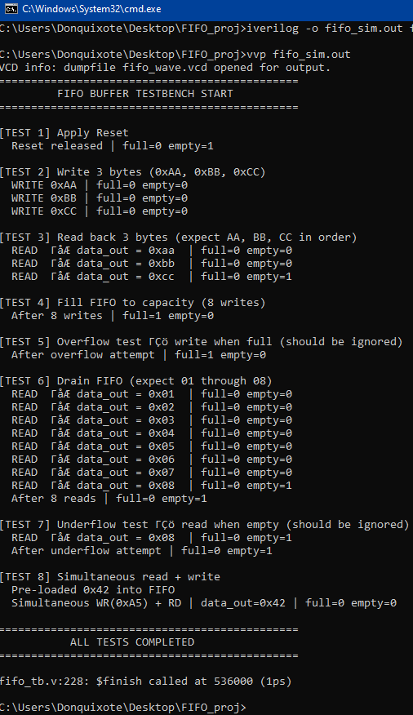

4.2 GTKWave Waveform
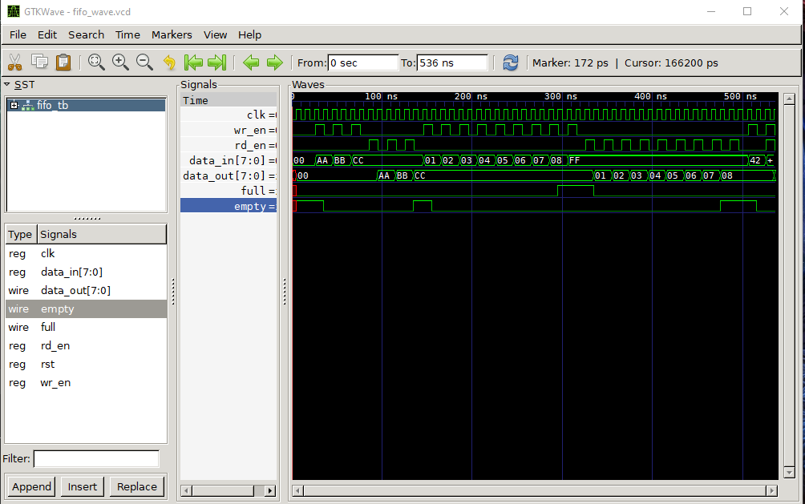
waveform above shows all 8 test scenarios executed in sequence. Key observations:
- data_out follows data_in with one clock cycle latency (registered output)
- full flag asserts exactly when the 8th entry is written
- empty flag asserts immediately after the last entry is read
- Overflow and underflow attempts produce no state corruption

5. Conclusion
This was quite a simple assignment but it was very enjoyable, especially getting to visually see my verilog work in gtkwave. The most difficult part for me was trying to get gtkwave on linux, which I solved by switching to windows.

6. References
Icarus Verilog documentation — https://iverilog.fandom.com/wiki/Getting_Started
- GTKWave user guide — https://gtkwave.sourceforge.net
- Chu, P.P. (2008). FPGA Prototyping by Verilog Examples. Wiley.
- https://www.youtube.com/watch?v=VvqsPHshZSk

