Data
Data is a collection of raw facts, figures, observations, or other information, such as numbers, text, images, or videos, that can be processed and analysed to gain insights or make decisions.
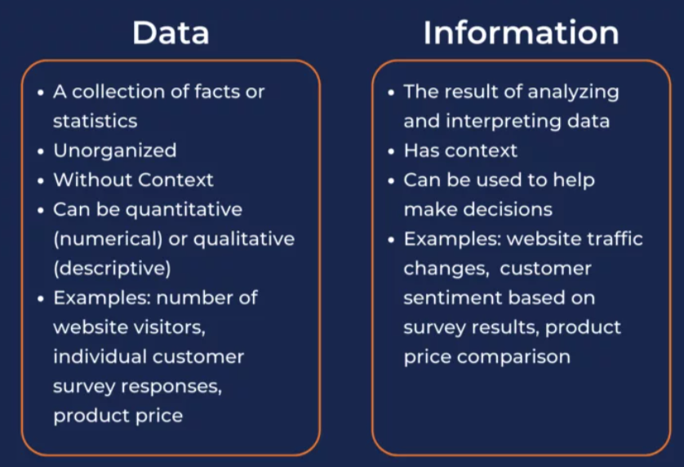
Dataset Types
Structured Data
This data is highly organized and easily queriable.
1. Record
The most basic unit of structured data.
- Description: A collection of fields (attributes, features) pertaining to a single entity. Each field holds one value.
- Example: A single patient record in a hospital database with fields: {Patient_ID: 101, Name: "Jane Doe", Age: 42, Diagnosis: "Hypertension"}.
- Data Science Relevance: The fundamental building block for most datasets. Dataframes in pandas (Python) are essentially collections of records.
2. Data Matrix
The most common form of a dataset in classical statistics and machine learning.
- Description: A rectangular table (like a spreadsheet or matrix) where:
  - Rows represent individual instances, objects, or observations (e.g., customers, products, time points).
  - Columns represent attributes, features, or variables (e.g., age, price, temperature).
  - Each cell [i, j] contains a value (often numeric) of feature j for instance i.
- Example: The classic Iris dataset, with rows for each flower and columns for sepal length, sepal width, petal length, petal width, and species.
- Data Science Relevance: The direct input for most machine learning algorithms (linear regression, SVM, random forest, etc.).
3. Document Data
A specific and extremely common type of record-based data.
- Description: A collection of documents, where each document is represented as a "bag-of-words" or a term vector. Each record (document) has a very large number of attributes (words), most of which are zero (if the word is not present in the document).
- Example: A dataset of news articles. Each article is a record. The features are all unique words across all articles, and the values are word counts or TF-IDF scores.
- Data Science Relevance: The starting point for text mining, sentiment analysis, topic modeling, and spam detection. Requires techniques like tokenization and vectorization.
4. Transaction Data
A special type of data matrix common in market basket analysis.
- Description: Each record (row) consists of a transaction ID and a set of items associated with that transaction. The data is often sparse (many empty cells) because each transaction only contains a few items.
- Example: Supermarket checkout data: Transaction 101: {Milk, Bread, Eggs}, Transaction 102: {Bread, Cheese}.
- Data Science Relevance: The foundation for association rule learning and frequent itemset mining (e.g., the Apriori algorithm) to discover patterns like "customers who buy X also buy Y."
5. Ordered Data
Data where the order or sequence of instances matters.
- Description: This isn't a standalone type but a property of other types. The data points have a meaningful order, such as being sorted by a key attribute like time or a unique ID.
- Example: Time series data (ordered by time) or data sorted by customer ID (where ID might be assigned sequentially).
- Data Science Relevance: Violating the order can destroy meaningful patterns (e.g., shuffling time series data makes it useless). Important for time series analysis and auto-regressive models.
6. Spatial Data
Data that has geographic or spatial coordinates attached to it.
- Description: Each record has associated spatial information, such as latitude/longitude, address, or ZIP code.
- Example: The location of trees in a forest, real estate listings with addresses, the path of a delivery truck.
- Data Science Relevance: Requires specialized techniques for spatial analysis: spatial autocorrelation, kriging, and spatial clustering. Used in GIS, logistics, and environmental modeling.
7. Temporal Data
Data where time is a primary dimension.
- Description: Each data point is associated with a time stamp or a time interval. A special and very important case of ordered data.
- Example: Stock prices recorded daily, hourly temperature readings, ECG heart monitor data.
- Data Science Relevance: Analyzed using time series analysis techniques: trend analysis, seasonality decomposition, forecasting (ARIMA, LSTM networks).
8. Sequential Data
A generalization of temporal data where the order is critical, but the "steps" aren't necessarily uniform in time.
- Description: A sequence of events or items, often with no fixed time stamp. The focus is on the sequence itself.
- Example: Clickstream data from a website (e.g., Homepage -> Product Page -> Add to Cart -> Checkout), DNA sequences.
- Data Science Relevance: Used in sequence mining and modeled with algorithms like Hidden Markov Models (HMMs) or Recurrent Neural Networks (RNNs).
9. Genetic Sequence Data
A highly specialized and critical type of sequential data.
- Description: Data representing biological sequences, most commonly DNA (composed of nucleotides A, T, C, G) or protein sequences (amino acids).
- Example: The human genome, a gene sequence for a specific protein.
- Data Science Relevance: A cornerstone of bioinformatics. Involves sequence alignment (BLAST), pattern searching, phylogenetic tree construction, and using ML for predicting gene function or disease propensity.

Unstructured Data
This data lacks a pre-defined data model and is often more complex to process.
1. Image Data
- Description: Data represented as a grid of pixels. Each pixel has numerical values representing color/intensity (e.g., RGB values).
- Example: Photographs, medical scans (X-rays, MRIs), satellite imagery.
- Data Science Relevance: The domain of computer vision. Techniques involve convolutional neural networks (CNNs) for tasks like classification, object detection, and image segmentation.
2. Audio Data
- Description: A representation of sound, typically as a time-series waveform where the amplitude of the sound is recorded over time. Can also be represented as a spectrogram (which adds frequency information).
- Example: Speech recordings, music, sonar data.
- Data Science Relevance: Processed for speech-to-text, music recommendation, sound event detection, and sentiment analysis from tone of voice. Uses RNNs and CNNs on spectrograms.
3. Textual Data
- Description: Written language. While it has an inherent sequence (order of words), it lacks the rigid structure of a database table. This is the rawest form of data that gets transformed into Document Data (a structured form) for analysis.
- Example: Social media posts, emails, books, news articles, PDF reports.
- Data Science Relevance: The field of Natural Language Processing (NLP). Tasks include machine translation, sentiment analysis, text summarization, and chatbot development, using models like transformers (BERT, GPT).
4. Graph Data
- Description: Data represented as a collection of nodes (vertices, entities) and edges (links, relationships) between them. The structure is complex and non-tabular.
- Example: Social networks (nodes are users, edges are friendships), the internet (nodes are webpages, edges are hyperlinks), molecular structures.
- Data Science Relevance: Analyzed using graph theory and graph neural networks (GNNs). Tasks include community detection, influencer identification, fraud detection (finding suspicious link patterns), and knowledge graph reasoning.
5. World Wide Web
- Description: The entire web is a massive, interconnected, and complex dataset. It contains all the types mentioned above: text (content), graphs (link structure), images, audio, and video. It is the ultimate example of unstructured and interconnected data.
- Example: The entire internet.
- Data Science Relevance: Web mining involves:
  - Web Content Mining: Extracting useful information from web pages (text, images).
  - Web Structure Mining: Analyzing the graph structure of hyperlinks to understand the relationships between sites (e.g., Google's PageRank algorithm).
  - Web Usage Mining: Analyzing user clickstream data (sequential data) to understand user behavior.

