Data Science
Data science is a multidisciplinary field that uses scientific methods, processes, algorithms, and systems to extract knowledge and insights from structured and unstructured data. It is a fusion of various disciplines, including statistics, mathematics, and computer science, applied to a specific domain or business problem.
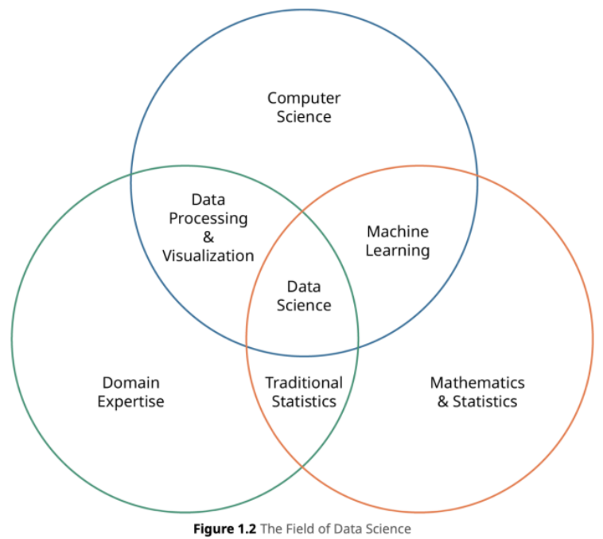

Data Science Roles & Growth
- Data Analyst:
  - Focus: The "storyteller." Analyzes historical data to identify trends, create reports (dashboards, visualizations), and answer specific business questions.
  - Key Skills: SQL, Excel, BI tools (Tableau, Power BI), basic statistics.
- Data Scientist:
  - Focus: The "problem-solver." Uses advanced statistical and machine learning models to build predictive capabilities, uncover deeper insights, and solve complex problems.
  - Key Skills: Python/R, SQL, statistics, machine learning, experimental design.
- Machine Learning Engineer:
  - Focus: The "builder." Takes models created by data scientists and focuses on deploying them into production systems at scale, ensuring they are efficient, reliable, and maintainable.
  - Key Skills: Software engineering, MLOps, cloud platforms (AWS, GCP, Azure), deep learning, model deployment.
- Data Engineer:
  - Focus: The "architect." Builds and maintains the data infrastructure (pipelines, databases, data warehouses) that allows for the collection, storage, and processing of large volumes of data.
  - Key Skills: Big Data technologies (Spark, Hadoop), cloud data services, SQL/NoSQL databases, data pipeline tools (Airflow).
Other common roles: Business Intelligence (BI) Developer, Data Architect, AI Research Scientist.
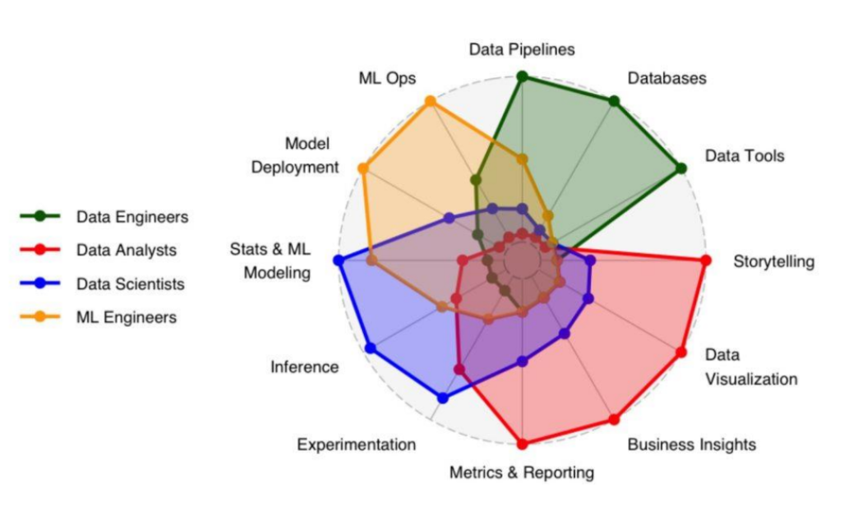

Data Science Applications
Data science has become integral to many industries, providing a powerful toolkit for extracting insights, automating processes, and making data-driven decisions. Here are some of its key applications.
Finance
Data science helps the finance industry manage risk, detect fraud, and optimize trading.
- Fraud Detection: Machine learning algorithms analyze transaction data in real time to identify unusual patterns that may indicate fraudulent activity, like a credit card purchase in a new, distant location.
- Algorithmic Trading: Data scientists build models that predict stock price movements and automatically execute trades at high speeds, often faster than human traders can react.
- Risk Assessment: Banks and lending institutions use data science to evaluate the creditworthiness of loan applicants by analyzing a wide range of data points, including financial history and market trends.

Healthcare
In healthcare, data science is used to improve patient outcomes, streamline operations, and accelerate research.
- Predictive Diagnostics: Machine learning models can analyze medical images (like X-rays or MRIs) and patient data to assist doctors in the early detection and diagnosis of diseases like cancer with high accuracy.
- Personalized Medicine: By analyzing a patient's genetic data, lifestyle, and medical history, data science helps doctors tailor treatment plans and drug dosages for better effectiveness.
- Drug Discovery: Data science can simulate how different compounds will interact with the human body, significantly speeding up the drug development process and reducing the cost of clinical trials.

E-commerce and Retail
E-commerce companies use data science to personalize the customer experience and optimize their business operations.
- Recommendation Systems: Algorithms analyze a user's browsing and purchase history, as well as the behavior of similar users, to suggest products they are likely to buy. This is what powers features like "Customers who bought this also bought..."
- Price Optimization: Data science models can dynamically adjust product prices in real time based on factors like demand, competitor pricing, and inventory levels to maximize profit.
- Inventory Management: By forecasting consumer demand, retailers can use data science to optimize their inventory levels, ensuring they have enough stock without overstocking and incurring unnecessary costs.

Marketing
Data science enables marketers to create more effective and targeted campaigns.
- Customer Segmentation: Data is used to divide a customer base into distinct groups based on demographics, behavior, and preferences. This allows for highly targeted marketing messages.
- Sentiment Analysis: By analyzing customer feedback from social media, reviews, and surveys, data science can determine public opinion about a product or brand, helping companies respond to customer concerns and improve their reputation.
- Predictive Analytics: Marketers use data to predict which customers are most likely to leave (churn prediction) or which leads are most likely to convert into paying customers, allowing them to focus their efforts where they will be most effective.

Data Science Lifecycle
Business Understanding: This initial phase is about defining the project's objectives from a business perspective. What problem are we trying to solve? What are the success criteria? This step involves collaborating with stakeholders to ensure the data science work is aligned with business goals.
Data Understanding: Here, the focus shifts to the data itself. You identify and collect the necessary data, explore its properties, and check its quality. This phase helps in discovering initial insights and identifying potential data issues like missing values or inconsistencies.
Data Preparation: This is often the most time-consuming phase. It involves cleaning, transforming, and preparing the data for modeling. Tasks include handling missing values, dealing with outliers, feature engineering (creating new variables), and formatting the data into the correct structure for analysis.
Modeling: In this stage, you select and apply various data modeling techniques (e.g., machine learning algorithms like linear regression, decision trees, or clustering). You train models on the prepared data and tune their parameters to achieve the best performance.

