Data Warehouse and Data Mining

Assignment

**Madhav Ganesan**

**125156066**

Data Warehouse and Data Mining

Assignment

Madhav Ganesan

125156066

**Topic: Supremum Distance**

Definition:

The Supremum distance, also known as the **Maximum** **metric**/**Chebyshev distance/** **L∞ metric**, is a metric used to measure the distance between two functions or sequences. It is defined as the supremum (least upper bound) of the absolute differences between corresponding elements of the two sequences or functions. It is named after Pafnuty Chebyshev and is defined as the greatest of the absolute differences along any coordinate dimension between two points.

Formula:



Application:

This metric is useful in various applications, including chessboard distance calculations in chess, as well as in warehouse logistics and electronic Computer-Aided Manufacturing (CAM) applications where movements are restricted to certain axes. It provides a measure of distance that considers the maximum difference between coordinates, making it suitable for scenarios where movements can occur in multiple directions.

Code Implementation:

Top of Form

    function calculateSupremumDistance() {

        const xDataInput = document.getElementById('xData').value;

        const yDataInput = document.getElementById('yData').value;

        const xData = xDataInput.split(',').map(Number);

        const yData = yDataInput.split(',').map(Number);

        const fileInput = document.getElementById('csvFile');

        const file = fileInput.files[0];

        const reader = new FileReader();

        reader.onload = function(event) {

            const csvData = event.target.result.split('\n');

            const csvXData = csvData.map(row => Number(row.split(',')[0]));

            const csvYData = csvData.map(row => Number(row.split(',')[1]));

            let tableContent = '<table><tr><th>X</th><th>Y</th><th>Supremum Distance</th></tr>';

            let chartData = [];

            for (let i = 0; i < csvXData.length; i++) {

                const diff1 = Math.abs(xData[0] - csvXData[i]);

                const diff2 = Math.abs(yData[0] - csvYData[i]);

                const maxDiff = Math.max(diff1, diff2);

                tableContent += `<tr><td>${csvXData[i]}</td><td>${csvYData[i]}</td><td>${maxDiff}</td></tr>`;

                chartData.push({ x: csvXData[i], y: csvYData[i], maxDiff: maxDiff });

            }

            tableContent += '</table>';

            document.getElementById('result').innerHTML = tableContent;

            const ctx = document.getElementById('myChart').getContext('2d');

            const scatterChart = new Chart(ctx, {

                type: 'scatter',

                data: {

                    datasets: [{

                        label: 'Scatter Plot',

                        data: chartData,

                        backgroundColor: 'rgba(75, 192, 192, 0.2)',

                        borderColor: 'rgba(75, 192, 192, 1)',

                        borderWidth: 1

                    }]

                },

                options: {

                    scales: {

                        x: {

                            type: 'linear',

                            position: 'bottom',

                            title: {

                                display: true,

                                text: 'X-axis'

                            }

                        },

                        y: {

                            type: 'linear',

                            position: 'left',

                            title: {

                                display: true,

                                text: 'Y-axis'

                            }

                        }

                    }

                }

            });

        };

        reader.readAsText(file);

    }

Sample Input and Output:

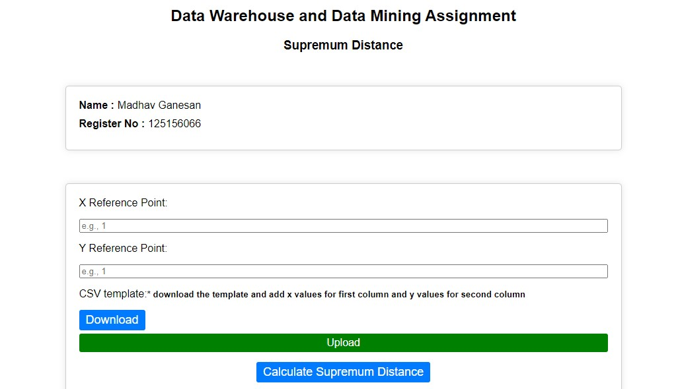

**Table:**

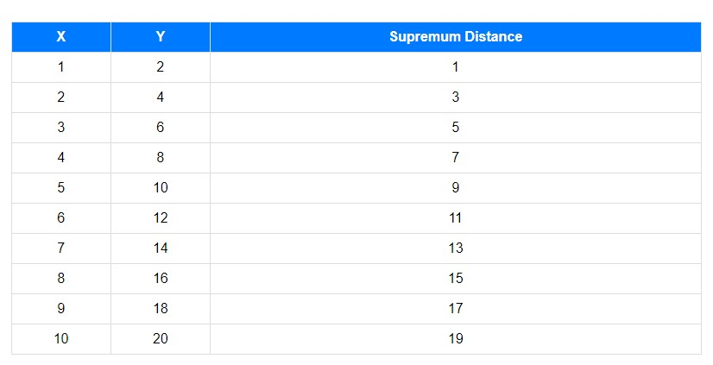

Graph:

