7

4

2

1

3

5

9

8

6

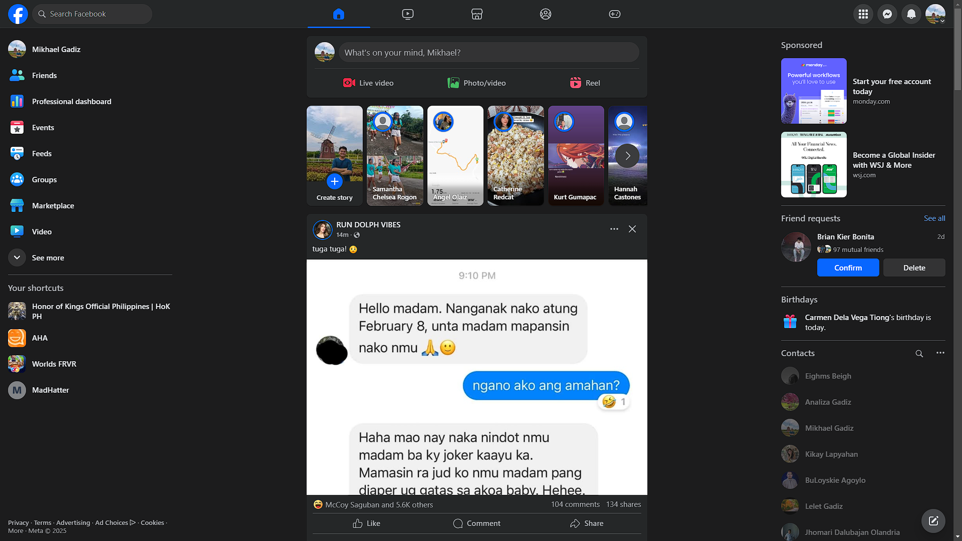

c

c

10

11

1. Logo of the website

2. Search bar

3. sidebar

4. section for facebook stories

5. navigation bar

6. section for status update

7. main content of facebook

8. section for ads

9. aside

10. footer

11. section for birthday and active people

(Explanation)

I broke down Facebook’s layout by identifying its key sections: header, sidebar, main content, stories section, ads section, and footer. The header contains the logo, search bar, and quick access icons for notifications and messages. The sidebar provides navigation links to different features like the News Feed, Groups, and Marketplace. The main content area displays posts, status updates, and shared media, while the **stories section** highlights short-form content at the top. The ads section is positioned to blend with user interactions, and the **f**ooter contains additional links and settings.

I used boxes to visually separate these sections, making it easier to understand the structure and how users interact with each part. This breakdown helped me see how Facebook balances content, social interactions, and advertisements while maintaining a clean and engaging interface.